Challenges of Using Waterfall in Analytics Projects: Changing Requirements, Delayed Feedback, and Data Uncertainty

Aanchal Malhotra
MS in Information Management, University of Illinois
IS 594 Project Management
Dr. Bradly Alicea
December 16, 2025

Introduction
Analytics projects have become central to organizational decision making across industries, including finance, healthcare, education, and marketing. These projects are often managed using traditional project management methodologies such as Waterfall (as shown in Figure 1), which were originally designed for predictable engineering environments. However, analytics work is exploratory in nature, involving iterative learning, evolving questions, and uncertain data inputs. As a result, a mismatch frequently arises between the structure imposed by Waterfall and the realities of analytics projects. Understanding this mismatch is important because inappropriate project management approaches can lead to inefficiencies, rework, and failed analytics initiatives.
Figure 1
Linear waterfall process flow
Requirements
Design
Implementation
Testing
Deployment
Maintenance

Applying Waterfall project management to analytics projects is difficult due to changing requirements, delayed feedback, and uncertain data. These challenges stem from fundamental assumptions embedded in the Waterfall methodology that do not hold in data-driven and discovery-oriented work.
This paper examines each of these challenges in turn by analyzing requirement volatility in analytics projects, the timing and value of stakeholder feedback, and the impact of data uncertainty on project execution. By unpacking these three factors, the paper demonstrates why Waterfall struggles in analytics contexts and why alternative approaches are necessary.
To support this argument, the paper begins with a literature review of project management methodologies and analytics frameworks. It then analyzes each of the three barriers in depth. Finally, it shows why iterative analytics methods such as CRISP DM offer a better fit and explains how a hybrid governance approach can combine flexibility with necessary project discipline.
The aim of the paper is to help readers understand why Waterfall breaks down when used for insight driven projects and to offer a clear alternative that aligns with the realities of data work.

Literature Review
The challenges associated with applying Waterfall to analytics projects did not emerge in isolation. They reflect broader historical developments across project management, software engineering, and data science. This literature review motivates the problem by outlining the historical origins of the Waterfall methodology, examining how project management research has identified requirement uncertainty and feedback timing as persistent challenges, and drawing on analytics and data science literature to show how data-driven work fundamentally differs from traditional engineering projects.
Early project management literature positioned Waterfall as a disciplined and structured process for managing complex systems. Royce described Waterfall as a model that reduces risk by enforcing detailed documentation and verification at each stage of development. Subsequent scholarship reinforced this perspective, emphasizing that Waterfall performs well in environments where uncertainty is low and system behavior can be specified in advance. In such settings, the linear sequencing of phases supports predictability, control, and accountability.
Project management researchers have frequently highlighted the advantages of Waterfall in domains such as construction, manufacturing, and large-scale infrastructure projects. In these environments, most design decisions must be finalized before execution begins, and late changes are costly or infeasible. Waterfall’s emphasis on early requirement definition enables more accurate estimation of cost, schedule, and risk. As a result, many organizations continue to rely on Waterfall as a default project management methodology.
In contrast, most recent analytics and data science literature describes a fundamentally different project environment. Analytics work is exploratory and discovery-driven, requiring teams to engage in iterative cycles of exploration, modeling, evaluation, and refinement. These projects cannot be categorized and segmented into pre-defined stages or phases as they do not necessarily adhere to these timelines. The approach of assuming that each phase is completed and only then does the project move onto the next one does not help produce effective results when it comes to analytics and modeling projects.
Frameworks such as CRISP-DM and SEMMA emphasize that understanding develops gradually through interaction with data rather than through upfront specification. As insights emerge, analytical goals and stakeholder expectations often evolve, making rigid phase-based planning difficult to sustain.

Research on project failure consistently identifies incorrect or incomplete requirements as a major contributing factor. Scholars note that stakeholders often struggle to articulate analytical needs before seeing intermediate results or prototypes. This limitation is especially pronounced in analytics projects, where teams frequently do not know what patterns, relationships, or anomalies exist in the data until initial analysis is performed. Requirement instability is therefore not an exception in analytics work but a structural characteristic.
Another recurring theme in the literature is data quality and uncertainty. Studies show that data issues such as missing values, inconsistent formats, bias, and unexpected errors are often discovered only during exploratory analysis. These challenges undermine the Waterfall assumption that inputs remain stable throughout the project lifecycle. Because analytics teams must continuously revisit data preparation and modeling decisions as new issues surface, linear execution models struggle to accommodate this uncertainty.
Scholars also emphasize the role of feedback timing in analytics projects. In traditional Waterfall projects, feedback is typically gathered during early design and validation phases. In analytics, however, the most meaningful feedback emerges only after models and analyses produce results that stakeholders can interpret. This delayed feedback loop conflicts with Waterfall’s expectation of early validation and often leads to rework when new insights prompt changes in direction.
Figure 2 illustrates the contrast between the linear Waterfall process and the iterative cycles typical of analytics workflows. While Waterfall progresses through fixed phases with limited backward movement, analytics projects repeatedly revisit exploration, modeling, and evaluation as understanding evolves.
Figure 2
Comparison of waterfall and iterative analytics cycles
Plan
Build
Deliver
Waterfall

Analytics

Prior research on analytics and information systems projects also highlights the consequences of methodological misalignment. Studies on analytics project failure frequently report high rates of rework, stakeholder dissatisfaction, and abandoned initiatives when exploratory work is managed using rigid, linear processes. Researchers note that analytics teams are often forced to commit to timelines, models, or success metrics before sufficient understanding of the data exists. This premature commitment increases the likelihood that early assumptions will later be invalidated.
Comparative studies of analytics frameworks further emphasize that methodologies designed specifically for data-driven work prioritize iteration over upfront specification. Unlike traditional project management approaches, analytics frameworks treat changing objectives and data issues as expected conditions rather than exceptions. This distinction suggests that failures in analytics projects are not solely technical in nature, but are often rooted in governance and management choices. These findings reinforce the argument that applying Waterfall to analytics projects introduces structural risk by constraining learning in environments where discovery is essential.
Across these bodies of literature, a consistent message emerges. Waterfall is effective when problems are well understood, requirements are stable, and inputs are predictable. Analytics projects operate under fundamentally different conditions characterized by uncertainty, learning, and evolving objectives. The misalignment between these assumptions defines the core problem examined in this paper and provides the foundation for the analysis in the following sections.

Changing Requirements
Waterfall struggles in analytics projects because it assumes requirements can be fully defined at the outset, while analytics work requires requirements to evolve as understanding develops through data exploration.
Stakeholders usually start with broad questions. For example, a stakeholder might ask why donor engagement is decreasing or how to predict customer churn. These questions are not detailed enough for Waterfall because they do not specify which variables matter, which model type is appropriate, or what form the insight should take. Analysts can answer these questions only after exploring the data.
Exploration reveals new information that changes stakeholder expectations. An analyst may discover that a variable considered important does not correlate with the target outcome. Stakeholders may shift focus after seeing initial visualizations. A model may reveal patterns that were unexpected. Each discovery reshapes the direction of the project.
In Waterfall, these changes are treated as deviations. Requirements must be rewritten. Designs must be updated. Timelines must shift. Testing plans must change. Every adjustment adds cost and introduces delays. The method becomes harder to manage because it is not designed to accommodate learning during execution. This pattern of requirement change is illustrated in Figure 3.

Figure 3
Requirements evolution loop in analytics projects

Changing requirements also arise from technical limitations. Data may not support the initial modeling plan. A critical feature might be missing or incomplete. The original goal may be impossible to achieve with available information. These discoveries force analysts to redefine the problem. Waterfall treats this as rework rather than natural progress.
The core issue is that analytics is a learning driven process. Requirements become clearer only after exploration. Waterfall cannot support this evolution, which makes it unsuitable for most analytics initiatives.

Delayed Feedback
Waterfall is poorly suited to analytics projects because it expects stakeholder feedback before implementation, whereas meaningful feedback in analytics can only occur after analytical results are produced.
In the requirement stage of Waterfall, stakeholders are expected to define their needs and approve documentation. This is difficult in analytics because stakeholders often do not know what they want until they see concrete outputs. A stakeholder might think they want a certain type of model, but after reviewing the output they realize they need a different approach. They might believe a certain variable is important until a visualization shows it is not. These insights are available only after modeling.
When Waterfall is applied, stakeholders review results late in the project. If they request changes, the team must revise earlier phases. This forces analysts to redo modeling, adjust data preparation, or redesign evaluation strategies. The cost of rework increases as the project progresses.
Delayed feedback is not a failure of planning. It is inherent to analytics. Insight generation happens after analysis, not before. Waterfall positions stakeholder involvement at the wrong point in the process. As a result, analytics teams face frustration, scope creep, and misalignment. The method forces stakeholders to guess their preferences instead of reacting to real outputs.
The timing mismatch creates an environment where Waterfall restricts communication rather than supporting it. Analytics thrives on iterative feedback. Waterfall limits it. This difference in feedback timing is illustrated in Figure 4.
Figure 4
Timing differences in feedback between waterfall and analytics projects

Uncertain Data
Waterfall struggles in analytics projects because it assumes data inputs are stable and well understood from the outset, whereas data quality, completeness, and relevance are often discovered only through exploration.
Common data issues include missing values, inconsistencies, incorrect formats, and more as summarized in Figure 5. Teams often discover these problems only after they begin cleaning and transforming the data. Waterfall expects teams to account for these issues during initial planning, which is unrealistic without exploration.
Figure 5
Sources of data uncertainty in analytics work

Analytics projects also rely on data from multiple sources. These sources may update at different frequencies or contain conflicting information. Sometimes new data becomes available in the middle of a project, or old data is found to be invalid. Each discovery affects the modeling approach.
When a data problem appears in Waterfall, earlier stages must be revised. The requirements may no longer be achievable. The design may be incorrect. The implementation plan may not work. This cycle introduces delays and increases cost.
Data uncertainty is not an exception. It is a defining feature of analytics. Any methodology that assumes perfect knowledge at the start will struggle in environments where understanding improves through discovery.
CRISP DM and Iterative Methods
The challenges identified in the previous sections suggest the need for analytics methodologies that explicitly support iteration, learning, and uncertainty.
CRISP DM is one of the most widely used analytics methodologies. It is iterative and cyclical. It consists of six phases: business understanding, data understanding, data preparation, modeling, evaluation, and deployment. Teams move back and forth between these phases as needed.
This iterative nature aligns with how analytics works. Requirements evolve naturally, not as exceptions. Stakeholder feedback occurs after results are available, which is when feedback is most meaningful. Data uncertainty is addressed in dedicated stages, not as unexpected problems.

Figure 6
CRISP DM iterative cycle overview

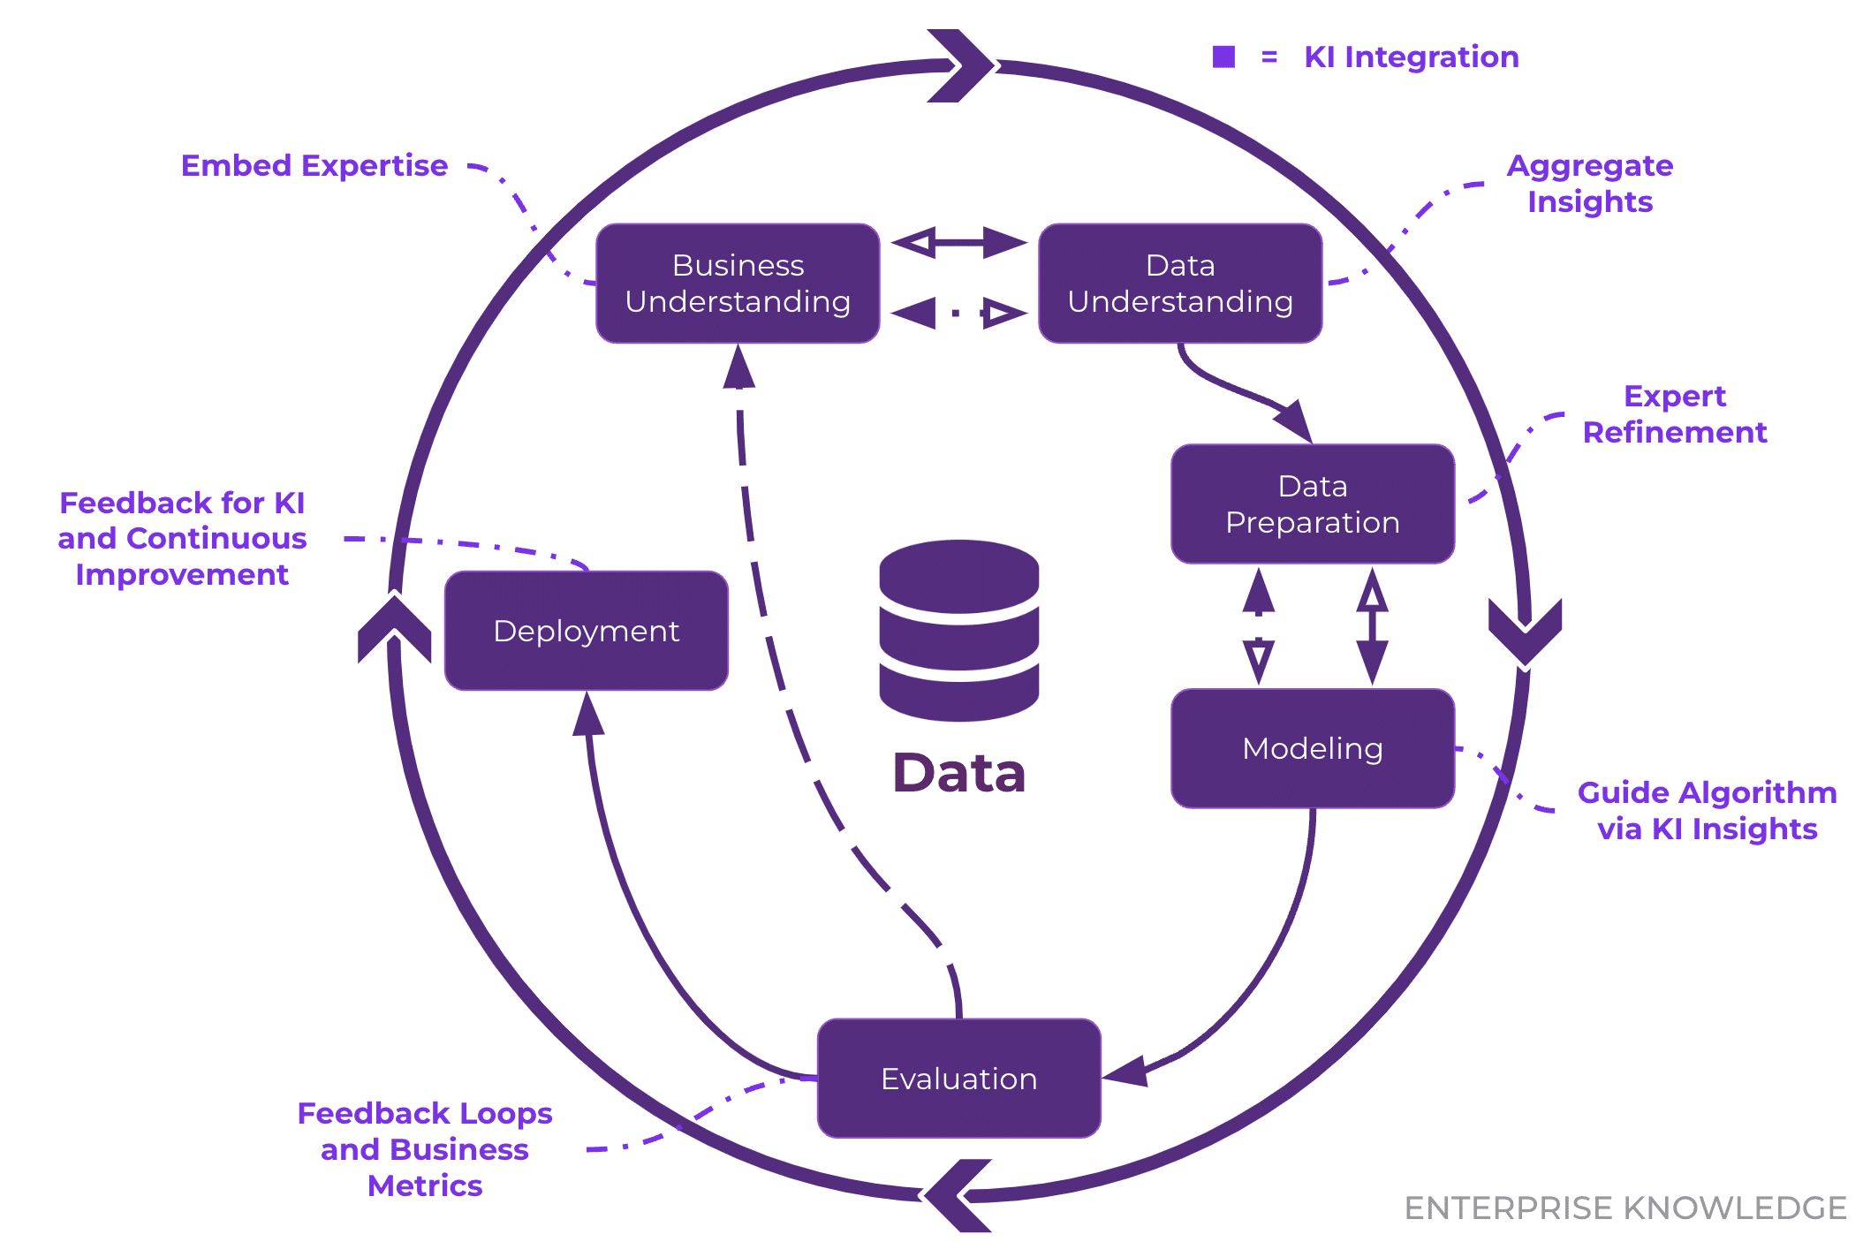

Note. Adapted from Understanding the role of knowledge intelligence in the CRISP-DM framework: A guide for data science projects, by K. Schultz, 2025, Enterprise Knowledge. https://enterprise-knowledge.com/understanding-the-role-of-knowledge-intelligence-in-the-crisp-dm-framework-a-guide-for-data-science-projects/

CRISP DM also supports transparency because each cycle produces intermediate outputs. Stakeholders see progress and can refine their expectations. This prevents misalignment and minimizes rework. Unlike Waterfall, CRISP DM does not assume that the problem can be fully defined upfront. It acknowledges that learning drives progress.
While CRISP-DM addresses how analytics work should be performed, organizations must also consider how such iterative processes are governed at the project level.

Hybrid Governance Approach
Even though analytics requires iteration, organizations still need structure. Deadlines, budgets, roles, and communication plans must be defined. A hybrid governance model combines the structure of project management with the flexibility of iterative analytics work.
A hybrid governance model can be conceptually represented as the integration of two complementary layers. The first layer focuses on project governance, including milestone planning, budget control, role definition, and reporting structures. The second layer represents the iterative analytics workflow, where teams engage in data exploration, modeling, evaluation, and refinement in repeated cycles. Hybrid governance connects these layers by allowing analytics teams to operate iteratively within predefined managerial boundaries. This structure ensures accountability and coordination at the organizational level while avoiding the rigidity that limits learning in purely linear approaches. Figure 7 illustrates how hybrid governance combines traditional project oversight with iterative analytics workflows.

Figure 7
Hybrid Governance Model for Analytics Projects
Hybrid Governance

Iterative analytics work
Project Milestones

In this approach, the project manager defines milestones, deliverables, and review points. The analytics team operates iteratively within these boundaries. Stakeholders participate at regular intervals rather than only at the beginning or end.
This model retains control while allowing discovery. It prevents uncontrolled exploration but still supports learning. Many organizations adopt this blended approach because it balances predictability with adaptability.
Together, CRISP-DM and hybrid governance models illustrate how analytics projects can remain disciplined without forcing discovery-driven work into rigid linear structures.

Conclusion
Waterfall succeeds in environments where requirements remain constant, feedback can be gathered early, and inputs do not change over time. Analytics projects violate all three of these assumptions. Requirements evolve as insights emerge from data exploration, stakeholder feedback becomes meaningful only after analytical results are produced, and data quality and relevance cannot be fully understood at the start of a project. These characteristics make analytics fundamentally incompatible with linear, phase-based project management approaches.
For these reasons, Waterfall is not well suited to analytics work. Iterative methodologies such as CRISP-DM align more closely with how analytics projects generate value by supporting learning, refinement, and adaptation throughout the project lifecycle. At the organizational level, hybrid governance models offer a practical way to balance the need for structure, accountability, and deadlines with the flexibility required for discovery-driven analysis. Selecting project management approaches that reflect the realities of analytics improves communication, reduces rework, and increases the likelihood of successful data-driven outcomes.
Future work could extend this analysis by empirically evaluating analytics project outcomes across different management approaches. Industry-specific studies could examine how methodological fit varies in domains such as healthcare, finance, or education, where data availability and regulatory constraints differ. Additional research may also explore how organizations operationalize hybrid governance models in practice, including how decision rights and accountability are distributed between project managers and analytics teams. Such studies would provide quantitative evidence to complement the conceptual arguments presented in this paper.

References
Aina, T. S., Akinte, O. O., Awelewa, A. J., & Adelakun, D. O. (2022). Critical evaluation of waterfall project management methodology: A case study of digital management conference project. International Journal of Advanced Multidisciplinary Research and Studies, 2(3), 266–269. https://www.researchgate.net/publication/361092440
Enterprise Knowledge. (n.d.). Understanding the role of knowledge intelligence in the CRISP-DM framework: A guide for data science projects. https://enterprise-knowledge.com/understanding-the-role-of-knowledge-intelligence-in-the-crisp-dm-framework-a-guide-for-data-science-projects/
Henriquez, Y., & O’Toole, B. (2024). A review of project management methodologies in STEM. University of Nevada, Las Vegas. https://oasis.library.unlv.edu/cgi/viewcontent.cgi?article=1000&context=eed_ug_research
Kailasateena. (2020). CRISP-DM for agile and waterfall methodologies. Medium. https://medium.com/@kailasateena/crisp-dm-for-agile-and-waterfall-methodologies-fa1c282d2c06
Ruel, H. J. M., Bondarouk, T., & Smink, S. (2010). The waterfall approach and requirement uncertainty: An in-depth case study of an enterprise systems implementation at a major airline company. International Journal of Information Technology Project Management, 1(2), 43–60. https://doi.org/10.4018/jitpm.2010040104
Schröer, C., Kruse, F., & Gómez, J. M. (2021). A systematic literature review on applying CRISP-DM process model. Procedia Computer Science, 181, 526–534. https://doi.org/10.1016/j.procs.2021.01.199
Thesing, T., Feldmann, C., & Burchardt, M. (2021). Agile versus waterfall project management: A decision model for selecting the appropriate approach. Procedia Computer Science, 181, 746–756. https://doi.org/10.1016/j.procs.2021.01.227
DataScience-PM. (n.d.). Managing data analytics projects. https://www.datascience-pm.com/managing-data-analytics-projects/
Shimaoka, A. M., Ferreira, R. C., & Goldman, A. (2019). The evolution of CRISP-DM for data science: Methods, processes and frameworks. Tilburg University. https://repository.tilburguniversity.edu/server/api/core/bitstreams/2420c787-9180-4b53-844d-21b734a9daf9/content

