Week 5: Deployment, Documentation, and Presentation
Deployment strategy, technical documentation, user manual, and presentation script for the AI Health Companion ML application
Prepared by: Aanchal | Role: Virtual Machine Learning Assistant Intern | Series: 60 Days of AI
Item | Detail
Project | AI Health Companion: full-stack ML web application (symptom text in, likely-condition guidance out)
Tech stack | Python, scikit-learn RandomForest, NLP-based symptom extraction, FastAPI, React + Vite
Document purpose | Dual use: (1) technical reference for deployment and maintenance, (2) script and slide outline for a stakeholder presentation
Audience | Developers, reviewers, mentors, and non-technical stakeholders
Status | Version 1.0 (MVP deployment plan)

Contents
- 1. Executive Summary
- 2. Introduction: Project Journey and Why Deployment Matters
- 3. Deployment Strategy
- 4. Technical Documentation (architecture, flows, API, structure)
- 5. User Manual
- 6. Troubleshooting Guide
- 7. Maintenance and Monitoring Guidelines
- 8. Presentation Preparation (summary, slides, script, Q&A)
- 9. Conclusion
- Appendix: Glossary

1. Executive Summary
AI Health Companion is a full-stack machine learning application. A user describes their symptoms in plain language; the system extracts the symptoms using natural language processing (NLP), passes them to a trained RandomForest classifier, and returns the most likely conditions with a confidence score and a clear reminder to consult a medical professional. The backend is built with FastAPI and the interface with React and Vite.
This document explains how the model moves from a notebook to a reliable, secure, publicly accessible service. It recommends a containerized deployment: the FastAPI service packaged in Docker and hosted on a managed cloud platform, with the React frontend served from a static hosting provider and a CI/CD pipeline that tests, builds, and releases every change automatically.
Key takeaways for stakeholders
1. A model creates value only when people can use it, so deployment is a core phase, not an afterthought. 2. Docker plus a managed cloud platform gives a low-cost, repeatable, and scalable launch. 3. Testing, monitoring, and a retraining plan keep the model trustworthy after launch. 4. The application is an educational decision-support tool and not a medical diagnosis system; this limitation is built into the product and the documentation.

2. Introduction: Project Journey and Why Deployment Matters

2.1 The project journey so far
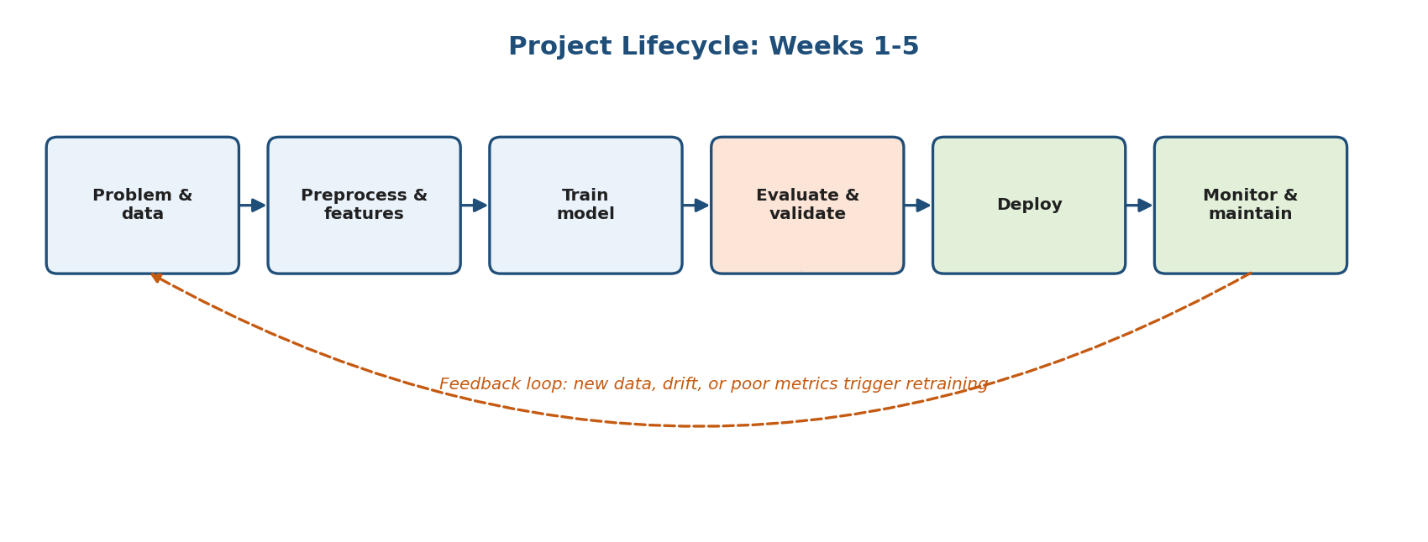
Figure 1: End-to-end ML project lifecycle with retraining feedback loop
Phase | Focus | Outcome for this project
Weeks 1-3 | Problem definition, data preparation, feature engineering, model training | A RandomForest classifier trained on symptom features, plus an NLP step that converts free text into model-ready features.
Week 4 | Evaluation, validation, testing | A metric plan (recall, precision, F1, PR-AUC), cross-validation, error analysis, and edge-case tests that define "good enough to ship".
Week 5 | Deployment, documentation, presentation | This document: how to release, run, explain, and maintain the system.

2.2 Why deployment matters
- Delivers value: an unused model has zero impact; deployment turns predictions into a product.
- Exposes real-world behavior: real users send messy, unexpected inputs that no offline dataset fully captures.
- Introduces new requirements: latency, availability, security, privacy, cost, and version control are as important as accuracy.
- Closes the loop: production feedback and monitoring tell us when to retrain or fix the model.
- Enables collaboration: documented, reproducible deployments let teammates and reviewers run and trust the system.

2.3 Scope and responsible-use note
Because the application deals with health-related text, the deployment plan includes extra safeguards: a visible medical disclaimer, no storage of personally identifying information by default, encrypted traffic, and a "low confidence" path that directs users to a professional. The system supports learning and awareness only and must not replace professional medical advice.

3. Deployment Strategy

3.1 Deployment options compared
Option | Description / examples | Strengths | Trade-offs
PaaS (managed app hosting) | Render, Railway, Heroku-style platforms; push code or a Docker image | Fastest to launch, automatic HTTPS, simple scaling, low ops effort | Less control; cost rises with traffic; vendor limits
Serverless containers | Google Cloud Run, AWS App Runner, Azure Container Apps | Pay per use, scales to zero, runs any Docker image | Cold starts; model load time on first request
IaaS (virtual machine) | AWS EC2, Google Compute Engine, Azure VM, DigitalOcean | Full control, predictable cost, any software | You manage OS patches, security, scaling, uptime
Managed ML platform | AWS SageMaker, Vertex AI, Azure ML endpoints | Built-in model registry, autoscaling, monitoring, A/B | Higher cost and learning curve; may be overkill for an MVP
Function-as-a-Service | AWS Lambda, Cloud Functions | Very cheap at low volume, no servers | Package size and memory limits can restrict ML libraries
On-premises | Own servers or institutional data center | Maximum data control and privacy; no cloud fees | Upfront hardware cost, maintenance burden, harder scaling
Edge / on-device | Mobile app or browser (ONNX, TF Lite) | Offline use, lowest latency, data stays on device | Model size limits; harder to update; more engineering

3.2 Serving patterns and release strategies

How predictions are served
- Real-time (online) inference: an API returns a prediction in milliseconds to seconds. This fits our symptom checker.
- Batch inference: predictions are computed on a schedule for many records (e.g., nightly reports).
- Embedded inference: the model ships inside the client application.

How new versions are released
Strategy | How it works | When to use
Blue/green | Run old (blue) and new (green) versions side by side; switch traffic at once; switch back to roll back. | Fast, low-risk cutovers with instant rollback.
Canary | Send a small share of traffic (5-10%) to the new version; increase if metrics stay healthy. | Detect problems with limited user impact.
Shadow | New model receives real requests but its answers are logged, not shown to users. | Validate a new model safely against live data.
A/B test | Split users between two models and compare outcome metrics. | Choose the better model using real results.

3.3 Recommended approach for AI Health Companion
Component | Recommendation and justification
Backend (FastAPI + model) | Docker container on a managed platform (Render / Cloud Run / Railway). Justification: reproducible environment, HTTPS and autoscaling handled for us, low cost for an MVP.
Frontend (React + Vite) | Static build deployed to Vercel or Netlify with a CDN. Justification: free tier, global caching, automatic deploys from GitHub.
CI/CD | GitHub Actions: run tests, check the model metric gate, build the image, deploy to staging, smoke test, promote.
Release strategy | Staging then production, with blue/green style rollback to the last working image.
Upgrade path | If traffic or compliance needs grow: move to Kubernetes or a managed ML platform; for strict data-residency needs: on-premises or private cloud using the same Docker image.

3.4 Required environment and tools
Category | Tools | Purpose
Language / runtime | Python 3.11, Node.js 18+ | Run backend and build frontend
ML libraries | scikit-learn, pandas, numpy, joblib, NLP library (e.g., NLTK / spaCy) | Model, features, and model file loading
Backend framework | FastAPI, Uvicorn, Pydantic | REST API, ASGI server, input validation
Frontend | React, Vite, fetch / axios | User interface and API calls
Containerization | Docker, Docker Compose | Portable, identical environments
Version control | Git, GitHub | Source history, collaboration, CI trigger
CI/CD | GitHub Actions, pytest, flake8 / ruff | Automated testing and release
Hosting | Render / Cloud Run / Railway; Vercel / Netlify | Run the API; serve the web app
Web server / proxy | Nginx or platform load balancer, TLS certificates | HTTPS, routing, rate limiting
Monitoring | Platform logs, UptimeRobot, Sentry, Prometheus/Grafana (optional) | Availability, errors, performance
Testing / docs | pytest, Postman, FastAPI auto docs (Swagger UI at /docs) | API tests and interactive documentation

3.5 Step-by-step deployment procedure

Step 1: Prepare and freeze the model
- Retrain on the final dataset using the validated pipeline; confirm metrics meet the Week 4 acceptance thresholds.
- Save the model (and any vectorizer or label encoder) with joblib: joblib.dump(model, "models/model.joblib").
- Record the model version, training date, library versions, and metrics in a model card (see Section 4.4).

Step 2: Build the API
A minimal illustrative FastAPI service (adapt names to the project code):
import os, joblib
from fastapi import FastAPI
from fastapi.middleware.cors import CORSMiddleware
from pydantic import BaseModel, Field

app = FastAPI(title="AI Health Companion API", version="1.0.0")
app.add_middleware(CORSMiddleware,
allow_origins=os.getenv("ALLOWED_ORIGINS", "http://localhost:5173").split(","),
allow_methods=["GET", "POST"], allow_headers=["*"])

model = joblib.load("models/model.joblib") # load once at startup

class SymptomRequest(BaseModel):
text: str = Field(min_length=3, max_length=1000)

@app.get("/health")
def health():
return {"status": "ok", "model_version": "1.0.0"}

@app.post("/predict")
def predict(req: SymptomRequest):
features = extract_symptoms(req.text) # NLP step from the project
probs = model.predict_proba([features])[0]
top = probs.argsort()[::-1][:3]
return {"predictions": [
{"condition": model.classes_[i], "confidence": round(float(probs[i]), 3)}
for i in top],
"disclaimer": "Educational use only. Consult a doctor."}

Step 3: Pin dependencies and test locally
- Create requirements.txt with exact versions (pip freeze inside a clean virtual environment). Using the same scikit-learn version for training and serving avoids model-loading errors.
- Run locally: uvicorn main:app --reload and open http://localhost:8000/docs to try the endpoints.
- Run pytest for unit tests (input validation, known-answer predictions, edge cases from Week 4).

Step 4: Containerize with Docker
FROM python:3.11-slim
WORKDIR /app
COPY requirements.txt .
RUN pip install --no-cache-dir -r requirements.txt
COPY . .
EXPOSE 8000
CMD ["uvicorn", "main:app", "--host", "0.0.0.0", "--port", "8000"]

Build and test the image locally: docker build -t health-companion-api . then docker run -p 8000:8000 health-companion-api. Add a .dockerignore (exclude .git, venv, notebooks, raw data) to keep the image small.

Step 5: Deploy the backend
- Push the code to GitHub and connect the repository to the hosting platform (Render, Cloud Run, or Railway).
- Select the Dockerfile as the build method and set the health-check path to /health.
- Add environment variables in the platform dashboard (ALLOWED_ORIGINS, MODEL_VERSION, LOG_LEVEL). Never commit secrets to Git.
- Deploy, wait for the health check to pass, and note the public HTTPS URL of the API.

Step 6: Deploy the frontend
- Set VITE_API_URL to the deployed API URL in the frontend environment settings.
- Build with npm run build; connect the repository to Vercel or Netlify (build command npm run build, output directory dist).
- Add the deployed frontend URL to the backend ALLOWED_ORIGINS so that CORS permits requests.

Step 7: Verify, release, and automate
- Run an end-to-end smoke test on the live site: submit a typical symptom text, an empty input, and a very long input; confirm correct responses and error messages.
- Enable the CI/CD pipeline (Figure 2) so that every merge to main is tested, built, and deployed automatically.
- Keep the previous image tagged so that you can roll back in minutes if the new release misbehaves.
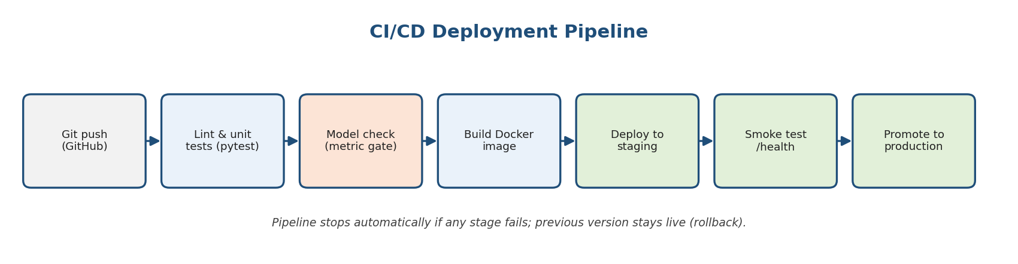
Figure 2: CI/CD pipeline with automated quality gates and rollback

3.6 Security, performance, and scalability
Area | Measures
Security | HTTPS only; strict CORS allow-list; input length and type validation; rate limiting; secrets in environment variables; dependency scanning; run the container as a non-root user.
Privacy | Do not log raw symptom text with identifiers; avoid storing user data by default; publish a short privacy notice; encrypt any stored data.
Performance | Load the model once at startup (not per request); target response time under 1-2 seconds; keep the model file compact; cache repeated requests if useful.
Scalability | Stateless API so that multiple container instances can run behind a load balancer; set autoscaling limits; use multiple Uvicorn/Gunicorn workers on larger instances.
Reliability | Health endpoint, automatic restarts, uptime monitoring, tagged images for rollback, and graceful error responses.
Cost control | Start on a free or low tier; set budget alerts; scale to zero when idle where the platform allows.

3.7 Pre-launch checklist
- Checked: Model metrics meet the agreed acceptance thresholds (Week 4 plan).
- Checked: All unit and edge-case tests pass in CI.
- Checked: Dependency versions pinned; Docker image builds from a clean checkout.
- Checked: Health endpoint, logging, and uptime alert configured.
- Checked: Medical disclaimer visible in the UI and API response.
- Checked: CORS, HTTPS, and rate limiting verified on the live URL.
- Checked: Rollback procedure tested at least once.
- Checked: README, API docs, and user manual published.

4. Technical Documentation

4.1 System architecture
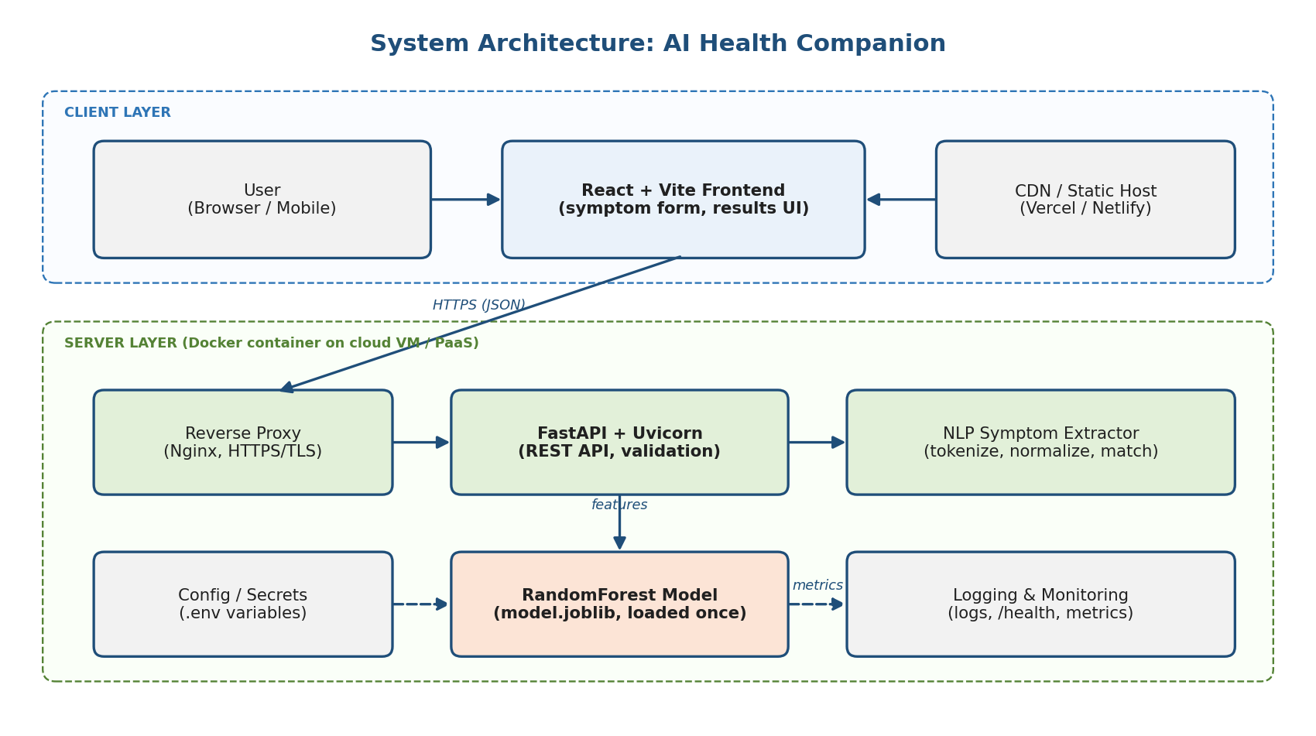
Figure 3: High-level system architecture (client layer and server layer)
Component | Responsibility
React + Vite frontend | Collects symptom text, calls the API, and shows predictions, confidence, and the disclaimer; handles loading and error states.
Reverse proxy / load balancer | Terminates HTTPS, forwards requests to the API, and can apply rate limits.
FastAPI service | Defines the REST endpoints, validates input with Pydantic, orchestrates NLP and prediction, and formats responses.
NLP symptom extractor | Cleans the text and maps phrases to the symptom features that the model expects.
RandomForest model | Loaded once from model.joblib; returns class probabilities for the extracted symptoms.
Config / secrets | Environment variables for allowed origins, model version, and log level.
Logging and monitoring | Records errors, latency, request counts, and prediction distributions for health checks and drift detection.

4.2 Request flow
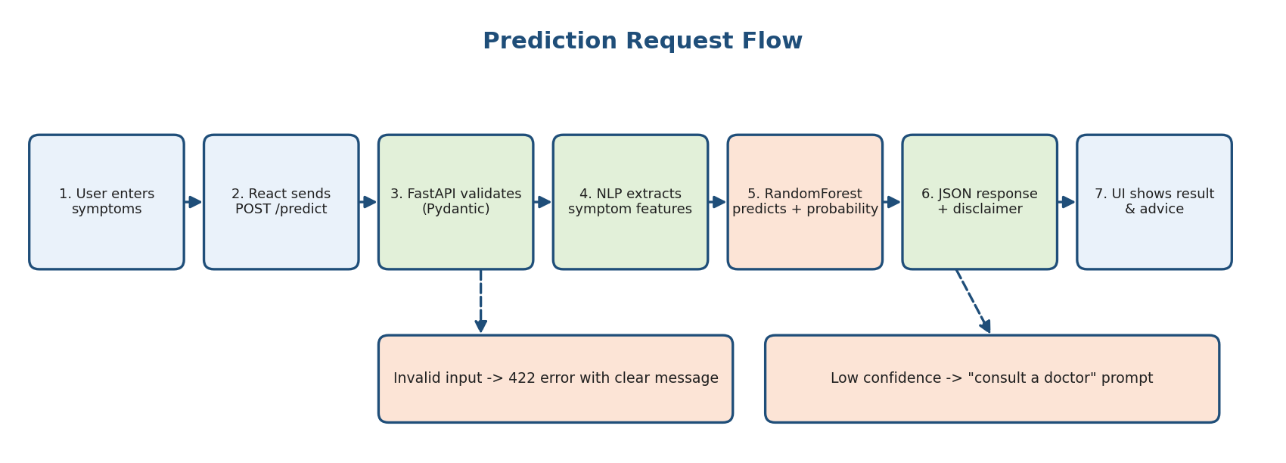
Figure 4: Flowchart of a single prediction request, including error and low-confidence paths

4.3 API reference
Method | Endpoint | Purpose | Notes
GET | /health | Liveness check | Returns status and model version; used by the platform and uptime monitor.
POST | /predict | Return likely conditions | Body: JSON with text (3-1000 characters). Returns top predictions with confidence.
GET | /docs | Interactive Swagger UI | Auto-generated by FastAPI; can be disabled in production if desired.

Example request
POST /predict
Content-Type: application/json

{ "text": "I have a headache, fever and body aches since two days" }

Example response (illustrative values)
{
"predictions": [
{ "condition": "Condition A", "confidence": 0.62 },
{ "condition": "Condition B", "confidence": 0.21 },
{ "condition": "Condition C", "confidence": 0.09 }
],
"disclaimer": "Educational use only. Consult a doctor."
}

Error responses
Code | Meaning | Typical cause
200 | Success | Valid input processed.
422 | Validation error | Missing, too short, or too long text.
429 | Too many requests | Rate limit exceeded.
500 | Server error | Model file missing, version mismatch, or unhandled exception.
503 | Service unavailable | Container starting up or overloaded.

4.4 Model card (record before every release)
Field | What to record
Model and version | RandomForestClassifier, version number, date trained, file name and checksum.
Training data | Source, size, date range, class distribution, known gaps or biases.
Features / NLP step | Symptom vocabulary, text preprocessing rules, handling of unknown words.
Evaluation results | Cross-validation mean and standard deviation; test-set precision, recall, F1, PR-AUC; per-class and subgroup results (see Week 4 method).
Intended use | Educational symptom awareness and decision support.
Limitations | Not a diagnosis; limited symptom vocabulary; performance depends on training data; may be unreliable for rare conditions or unclear input.
Library versions | Python, scikit-learn, NLP library, FastAPI versions used in training and serving.

4.5 Recommended project structure
ai-health-companion/
|-- backend/
| |-- main.py # FastAPI app and routes
| |-- nlp.py # symptom extraction logic
| |-- models/model.joblib # trained RandomForest
| |-- tests/ # pytest unit and edge-case tests
| |-- requirements.txt
| `-- Dockerfile
|-- frontend/
| |-- src/ # React components
| |-- .env.example # VITE_API_URL=...
| `-- package.json
|-- .github/workflows/ci.yml # CI/CD pipeline
|-- docs/ # model card, manual, diagrams
`-- README.md # setup, run, deploy instructions

4.6 Technical documentation best practices
- Keep a README with prerequisites, setup, run, test, and deploy commands that a new teammate can follow in under 15 minutes.
- Document every environment variable in .env.example (without real secrets).
- Keep diagrams and the model card in the repository so they are versioned with the code.
- Maintain a CHANGELOG that links each release to its model version and metrics.
- Use docstrings and type hints; FastAPI turns them into live API documentation automatically.

5. User Manual

5.1 For end users

What the application does
AI Health Companion reads a short description of how you feel and suggests conditions that match your symptoms. It is meant to help you understand possible causes and decide whether to seek care. It cannot examine you and it does not replace a doctor.

How to use it
- Open the web application in any modern browser on a phone or computer.
- Describe your symptoms in the text box in your own words, for example: "I have a sore throat, mild fever and cough for three days". More detail (duration, severity) gives better results.
- Click "Check" (or the submit button) and wait a moment while the result loads.
- Read the results: you will see up to three possible conditions with a confidence value for each, and a reminder to consult a professional.
- Decide the next step: use the result as information only. If symptoms are severe, getting worse, or you are worried, contact a doctor or local emergency services.

Understanding the results
Item shown | Meaning
Condition name | A condition whose usual symptom pattern resembles what you described.
Confidence (e.g., 62%) | How strongly the model favors that condition compared with the others. It is not a medical probability that you have it.
Low-confidence message | The input was unclear or did not match known patterns well; add detail or see a professional.
Disclaimer | Reminder that the tool is educational and not a diagnosis.

Tips and limitations
- List symptoms clearly and avoid unrelated text; use simple words.
- The tool knows a limited set of symptoms and conditions; rare conditions may not appear.
- Never delay or skip medical care because of a result from this tool.
- Do not enter names, phone numbers, or other personal identifiers.

5.2 For developers and administrators
Task | Command / action
Run backend locally | cd backend && pip install -r requirements.txt && uvicorn main:app --reload
Run frontend locally | cd frontend && npm install && npm run dev (opens at http://localhost:5173)
Run tests | cd backend && pytest
Build and run Docker image | docker build -t health-companion-api . then docker run -p 8000:8000 health-companion-api
Check service health | Open /health on the API URL; expect {"status": "ok"}
View API docs | Open /docs on the API URL
Update the model | Retrain, evaluate, update model card, replace model.joblib, bump version, merge to main; CI/CD deploys it.
Roll back | Redeploy the previous tagged Docker image from the platform dashboard.

5.3 Frequently asked questions
Question | Answer
Is this a diagnosis? | No. It is an educational tool. Only a qualified doctor can diagnose.
Is my data stored? | By default, no personal information is stored; only anonymous technical logs are kept.
Why did I get a low-confidence message? | The text may be too short, vague, or outside the symptoms the model knows. Add detail.
How accurate is it? | Accuracy is measured with cross-validation and a held-out test set (see model card); results are never guaranteed for an individual.
What should I do in an emergency? | Contact local emergency services immediately; do not use this tool.

6. Troubleshooting Guide
Symptom | Likely cause | Fix
Frontend shows "Network error" or blank results | Wrong VITE_API_URL, API down, or CORS blocked | Check the API URL, open /health, and add the frontend URL to ALLOWED_ORIGINS.
Browser console shows CORS error | Frontend origin missing from the allow-list | Update ALLOWED_ORIGINS (no trailing slash) and redeploy the backend.
API returns 422 | Input missing, too short, or too long | Validate on the client; show a helpful message.
API returns 500 on startup or predict | Model file missing or scikit-learn version mismatch | Confirm model.joblib is in the image; match library versions to those used in training.
ModuleNotFoundError in the container | Dependency missing from requirements.txt | Add and pin the package, rebuild the image.
Container exits immediately | Wrong start command or port | Check the CMD, bind to 0.0.0.0, and match the platform port.
First request is very slow | Cold start while the model loads | Keep one instance warm, load the model at startup, or use a lighter model.
Predictions look wrong after an update | New model or changed preprocessing | Compare against the golden test set; roll back to the previous image; investigate.
Low confidence for clear inputs | Symptom vocabulary gap in the NLP step | Add synonyms and phrases, and retrain with more examples.
High latency or timeouts | Under-sized instance or heavy model | Increase resources, add workers, shrink the model (fewer trees, compression).
Build fails in CI | Failing test, linter error, or metric gate | Read the failing stage log, fix, and push again; the previous release stays live.

7. Maintenance and Monitoring Guidelines

7.1 What to monitor
Category | Signals | Action trigger
Availability | Uptime checks on /health, restart counts | Alert if the service is down for more than a few minutes.
Performance | Response time (median and 95th percentile), error rate, CPU and memory | Alert on sustained slowdowns or error spikes.
Input data drift | Length and vocabulary of requests, share of unknown symptoms | Investigate when distributions shift from training data.
Prediction drift | Distribution of predicted conditions and confidence levels | Review if some classes suddenly dominate or confidence falls.
Model quality | Feedback ratings or labeled samples, when available | Retrain if quality falls below the acceptance threshold.
Cost and usage | Request volume, platform bill | Adjust scaling and budget alerts.

7.2 Routine maintenance schedule
Frequency | Tasks
Daily / automatic | Uptime checks, log review for errors, automatic restarts.
Weekly | Review error and latency dashboards; read sampled low-confidence cases; check platform alerts.
Monthly | Update dependencies and base image; run vulnerability scans; re-run the full test suite and golden test set; review costs.
Quarterly (or on drift) | Retrain with new data; re-evaluate using the Week 4 protocol (cross-validation, error analysis, subgroup checks); update the model card; release through staging and canary.
Annually | Review architecture, security posture, privacy notice, and hosting choice; archive old model versions.

7.3 Versioning, rollback, and incident response
- Version everything: code (Git tags), model files (version number and checksum), data snapshots, and Docker images.
- Rollback plan: keep the last two stable images; redeploy the previous one if the smoke test or monitors fail.
- Incident steps: detect (alert) then contain (roll back or disable the endpoint) then diagnose (logs, recent changes) then fix and test then release then write a short post-incident note describing the cause and the prevention.
- Backups: back up model artifacts, training data, and configuration to separate storage.
- Retraining loop: collect new, consented, de-identified data; retrain; evaluate against the current production model; promote only if it is better on the primary metric without harming any subgroup.

8. Presentation Preparation

8.1 Executive summary (60-second pitch)
Speaker script
"Good morning. Many people search the internet when they feel unwell and find confusing results. AI Health Companion lets someone describe their symptoms in plain words and instantly receive the most likely matching conditions, with a confidence score and a clear recommendation to consult a doctor. Behind the scenes, natural language processing turns the text into features and a RandomForest model makes the prediction, served through a FastAPI backend to a React web interface. We validated the model with cross-validation and error analysis, and we are deploying it in Docker on a managed cloud platform with automated testing and monitoring so it stays reliable. It is an educational tool, built with safety and privacy in mind, and ready to grow."

8.2 Slide outline (12 slides, about 12-15 minutes)
# | Slide title | Key content | Time / visual
1 | Title | Project name, your name and role, one-line value statement. | 0:30 / logo or screenshot
2 | The problem | Why people need quick, understandable symptom guidance; risks of misinformation. | 1:00 / one striking statistic or story
3 | Our solution | Text in, ranked conditions and confidence out; always with a disclaimer. | 1:00 / UI screenshot
4 | Project journey | Lifecycle from data to deployment (Figure 1). | 1:00 / lifecycle diagram
5 | Data and model | Dataset summary, NLP extraction, RandomForest and why it was chosen. | 1:30 / simple model diagram
6 | Evaluation results | Chosen metrics and why (recall, precision, F1); cross-validation; error analysis findings. | 1:30 / metrics table and confusion matrix
7 | System architecture | Frontend, API, NLP, model, hosting (Figure 3). | 1:30 / architecture diagram
8 | Deployment plan | Docker, managed cloud, CI/CD, rollback (Figure 2). | 1:30 / pipeline diagram
9 | Live demo | Submit 2-3 sample inputs including an unclear one; show the low-confidence path. | 2:00 / live site or recorded video
10 | Challenges and lessons | Top challenges and how they were handled (Section 8.3). | 1:30 / three bullet cards
11 | Risks, ethics, and next steps | Disclaimer, privacy, monitoring, retraining; roadmap (more symptoms, multilingual input, user feedback). | 1:30 / roadmap graphic
12 | Thank you and Q&A | Key takeaways recap, GitHub link and contact details. | 0:30 / contact slide

8.3 Challenges and how the design addresses them
Challenge | Approach and lesson
Turning free text into model features | Use a dedicated NLP step with normalization and a symptom vocabulary; lesson: input quality limits model quality, so test with messy real phrasing.
Choosing metrics for a health-related task | Prioritize recall with precision as a guardrail and use PR-AUC; lesson: accuracy alone hides missed cases.
Environment mismatch between development and production | Pin dependencies and use Docker; lesson: "works on my machine" is not a deployment strategy.
Connecting frontend and backend securely | Strict CORS allow-list, HTTPS, environment-based configuration; lesson: configuration errors are the most common launch bug.
Trust and safety | Disclaimers, low-confidence path, no personal data stored; lesson: responsible design is part of the product.
Staying accurate after launch | Monitoring, drift checks, and scheduled retraining; lesson: deployment is the start of the model's life, not the end.

8.4 Key takeaways to close with
- End-to-end thinking: data, model, evaluation, deployment, and maintenance are one connected lifecycle.
- Evaluate honestly: the right metrics, validation, and error analysis make claims believable.
- Deploy reproducibly: containers, CI/CD, and rollback make releases safe and boring.
- Document for others: architecture, API, manual, and model card make the work reusable.
- Build responsibly: health-related AI needs humility, transparency, and privacy.

8.5 Anticipated questions and suggested answers
Likely question | Suggested answer
Why RandomForest instead of deep learning? | It performs well on structured symptom features with limited data, trains fast, is easier to explain, and is cheap to host; deep models can be explored if data grows.
How do you know it works? | Cross-validation on training data, a single untouched test set, per-class metrics, error analysis, and edge-case tests.
Is it safe to give health information? | It is positioned as education only, shows a disclaimer every time, refers low-confidence cases to professionals, and stores no personal data.
How will it scale? | The API is stateless in a container, so more instances can be added behind a load balancer; the platform handles autoscaling.
What happens when the model gets outdated? | Monitoring detects drift and the quarterly retraining loop updates the model through staging and canary release.
What would you do next? | Expand the symptom vocabulary, add multilingual input, collect user feedback ratings, and evaluate a managed ML platform.

8.6 Presentation delivery tips
- Lead with the user problem, not the technology; show the live demo early enough to leave time for questions.
- One message per slide, large visuals, minimal text; keep the detailed tables in this document as handouts.
- Prepare a recorded demo video as a backup in case of connectivity problems.
- Rehearse with a timer; keep 2-3 minutes spare for questions.
- Tailor depth to the audience: business view (value, risk, cost) for stakeholders; technical view (architecture, metrics) for reviewers.

9. Conclusion
Deployment, documentation, and communication complete the machine learning lifecycle. By packaging the AI Health Companion in a reproducible container, releasing it through an automated and reversible pipeline, documenting its architecture, API, and use, and planning how it will be monitored and retrained, the project moves from a working model to a dependable product. The accompanying presentation outline allows the same work to be explained clearly to both technical and non-technical audiences. Most importantly, the plan keeps safety, privacy, and honest communication of limitations at the center of the system.

Appendix: Glossary
Term | Definition
API (REST) | A set of web endpoints that programs use to exchange data, usually as JSON over HTTP.
CI/CD | Continuous Integration / Continuous Delivery: automatic testing, building, and releasing of code.
Container (Docker) | A lightweight, portable package holding code, libraries, and settings so it runs identically anywhere.
CORS | Browser security rule controlling which websites may call an API.
Data / concept drift | Change over time in input data or in the relationships the model learned, reducing accuracy.
Inference | Using a trained model to make predictions on new data.
Model card | A short document describing a model's purpose, data, performance, and limitations.
Canary / blue-green | Release strategies that limit risk by gradual rollout or by keeping a standby version.
NLP | Natural Language Processing: techniques for turning human language into structured data.
Rollback | Returning to the previous working version after a faulty release.

