Covid-19 Analysis

Prepared for: Story Telling with Data (Case Study).

Prepared by: Aanchal Bafna(A004) **&** Akansha Gupta(A051)

Introduction

The World Health Organization announced a COVID-19 pandemic in March 2020, posing enormous global problems. Tracking its spread and understanding patterns across regions is critical for managing public health responses and assessing policy success.

This Tableau dashboard collects and visualizes COVID-19 data, allowing users to examine infection trends, analyse healthcare reactions, and understand vaccination rollouts.

The COVID-19 dashboard provides a comprehensive, interactive view of pandemic metrics—cases, deaths, recoveries, and vaccinations—enabling real-time tracking and data-driven analysis of global health responses. Its user-friendly design supports policymakers, healthcare professionals, and the public in understanding and managing COVID-19 impacts effectively.

By offering a complete visual examination of these crucial variables, the dashboard enables users to get insights for better pandemic management and future readiness.

Overview of Dataset

The datasets used in this dashboard contains several critical COVID-19 indicators, sourced from reliable public health organizations, including the World Health Organization (WHO) and national health departments.

Key Features include:

* **Confirmed Cases**: Cumulative counts of COVID-19 cases, offering insights into regions with high and controlled infection rates.
* **Deaths**: Mortality data to assess the impact and severity of COVID-19 across different regions.
* **Recoveries**: Recovery numbers that provide insight into healthcare response effectiveness.
* **Vaccinations**: Data on vaccination rates and rollouts, indicating each region's progression toward herd immunity.

The dataset is structured to facilitate comparisons across countries and over time, highlighting trends and shifts in infection patterns and allowing for an analysis of healthcare and policy response effectiveness.

You can access this dataset using this link:

View of the Dashboard

* **Objective of Building the Covid-19 Dashboard:**

1. **Monitor Pandemic Progression**: To provide a real-time view of COVID-19 spread, showing infection rates, recoveries, and deaths, enabling users to track the virus’s impact globally and locally.
2. **Support Data-Driven Decision Making**: To aid policymakers and healthcare professionals by visualizing key metrics, fostering informed decisions on interventions and resource allocation.
3. **Analyse Vaccination Efforts and Outcomes**: To display vaccination progress across countries, illustrating its impact on case trends and assisting in evaluating public health efforts.
4. **Enhance Public Awareness and Transparency**: To make COVID-19 data accessible to the public, improving understanding of pandemic dynamics and encouraging responsible health behaviours.
5. **Enable Cross-Country Comparisons**: To compare COVID-19 metrics between regions, offering insights into the effectiveness of different health policies and responses.

* **Overview of Columns Used:**

1. **Longitude:**
   * Indicates geographical locations for mapping data distribution.
2. **Date:**
   * Captures the timeline for data collection, enabling trend analysis.
3. **Gender:**
   * Categorizes data by gender for demographic analysis of vaccination and testing**.**
4. **Age Group:**
   * Segments the population into age categories to assess vaccination uptake.

**Different Measure Values**

1. Dose Administration (First and Second):
   * Tracks the number of first and second vaccine doses given, showing vaccination progress.
2. Dose Administration by Vaccine Type (CoviShield, CoVaxin, Sputnik):
   * Breaks down vaccine administration by type, highlighting public preference and distribution.
3. State-wise Testing Details (Positive, Negative, Total Samples):
   * Provides insights into testing outcomes, including positive and negative cases, to evaluate testing effectiveness**.**

* **Dashboard Design for COVID-19**

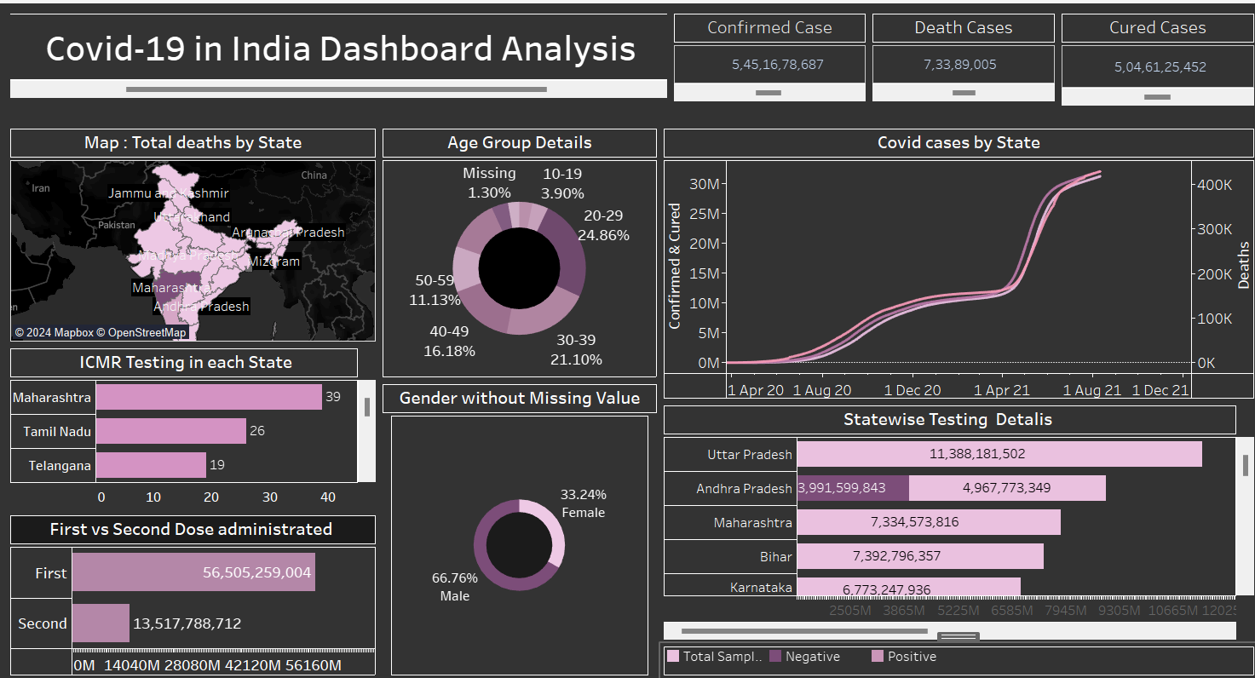

Interpretation of Graphs

**1.Total Death by State(Map)**

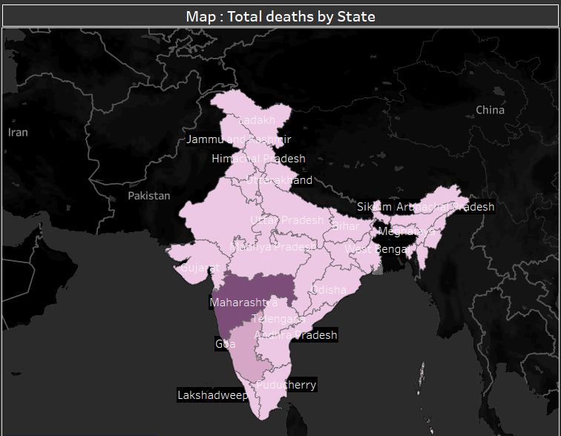

**Purpose**:  
To visualize the geographic distribution of COVID-19 deaths across Indian states, highlighting areas with higher mortality rates.

**Key Insights**:

* **High Impact**: Maharashtra has the highest death toll, indicated by the darkest shade.
* **Lower Impact**: Northern and northeastern states show lighter shades, indicating fewer deaths.
* **Regional Variation**: The map reveals disparities in COVID-19 impact, useful for targeting resources and informing public health policies.

**2.Covid Cases by State(Line)**

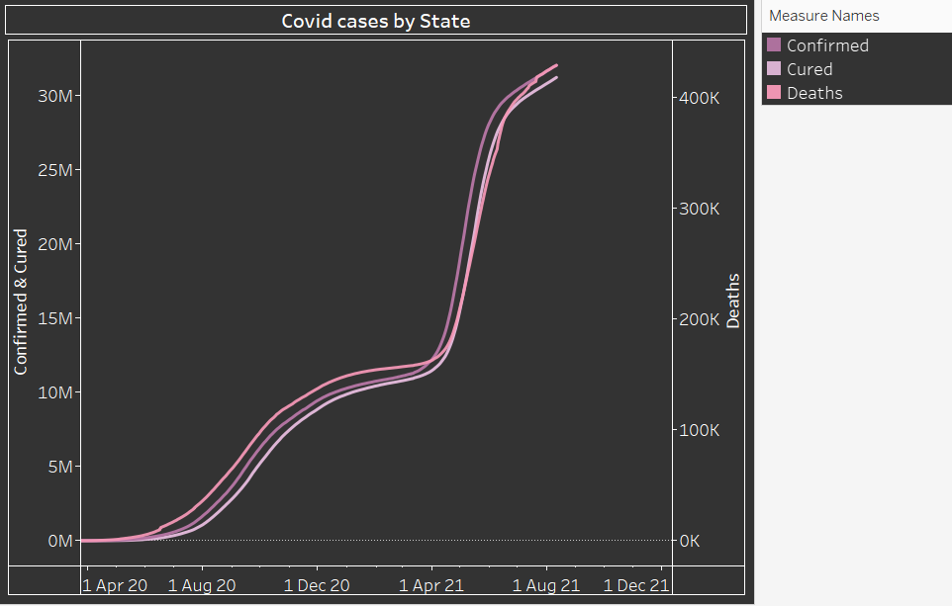

**Purpose**:  
To show the trends in COVID-19 cases, recoveries, and deaths over time across Indian states.

**Key Insights**:

* **Sharp Rise**: All metrics (confirmed, cured, and deaths) increased significantly around mid-2021, likely reflecting the second wave.
* **High Recovery Rate**: The "Cured" line closely follows the "Confirmed" line, indicating a high recovery rate.
* **Deaths**: The death toll remains much lower than confirmed and cured cases, though it increased alongside the rise in cases.

**3.First vs Second Dose administration(Bar)**

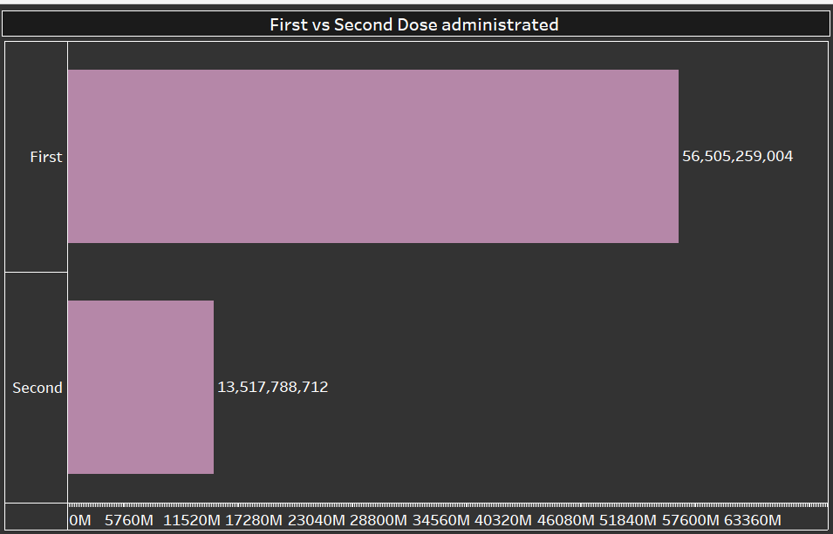

**Purpose**:  
To compare the number of first and second COVID-19 vaccine doses administered.

**Key Insights**:

* **First Dose**: A total of 56.5 billion first doses were administered, indicating extensive initial coverage.
* **Second Dose**: Only 13.5 billion second doses were administered, showing a large gap between first and full vaccination completion.
* **Vaccine Rollout**: The difference highlights the need to increase second dose coverage to achieve full vaccination rates.

**4.Doses Administration by Vaccine(Bar)**

**Purpose**

This graph displays the number of COVID-19 vaccine doses administered by vaccine type to provide an overview of vaccination distribution.

**Key Insights**

1. **CoviShield** is the most widely administered vaccine, with a total of **61,932,459,831 doses**.
2. **Covaxin** ranks second, with **7,961,424,903 doses** administered.
3. **Sputnik V** has the fewest doses administered, at **28,918,434** doses.

This indicates a significant preference for CoviShield in the vaccination campaign, with Covaxin and Sputnik V being used less frequently.

**5.Age Group Details(Pie)**

**Purpose**

This chart shows the distribution of COVID-19 vaccinations across different age groups, providing insights into age-based vaccination coverage.

**Key Insights**

1. The 20-29 age group has the highest vaccination rate, accounting for 24.86% of the total.
2. The 30-39 age group follows closely, with 21.10% of vaccinations.
3. The 40-49 age group makes up 16.18%, and the 60-69 age group accounts for 12.86%.
4. Younger individuals (10-19 years) represent 3.90%, while data for 1.30% of individuals is missing.

This distribution suggests higher vaccine uptake among younger adults, particularly those aged 20-39.

**6.Gender without Missing Value (Donut)**

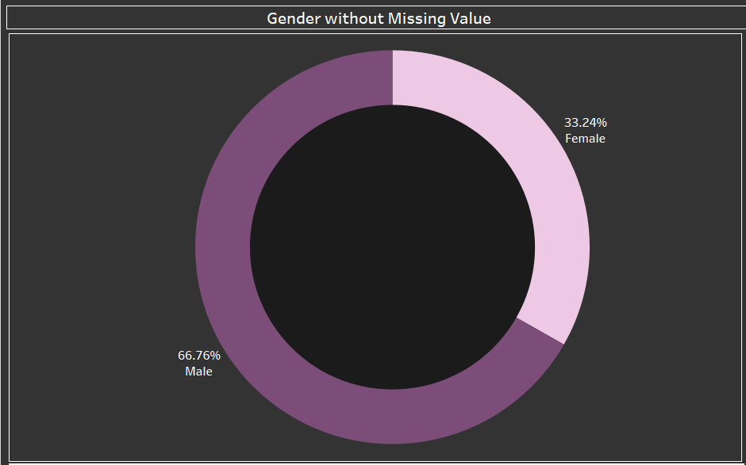

**Purpose**

To show the gender distribution of COVID-19 vaccinations and identify potential disparities.

**Key Insights**

1. **Higher Male Vaccination**: Males account for **66.76%** of vaccinations, while females represent **33.24%**.
2. **Potential Gender Gap**: The disparity suggests a need for targeted efforts to improve vaccine access and uptake among women.
3. **Data Completeness**: This analysis excludes missing gender data, which may affect overall insights.

**7.ICMR Testing in each State (Bar)**

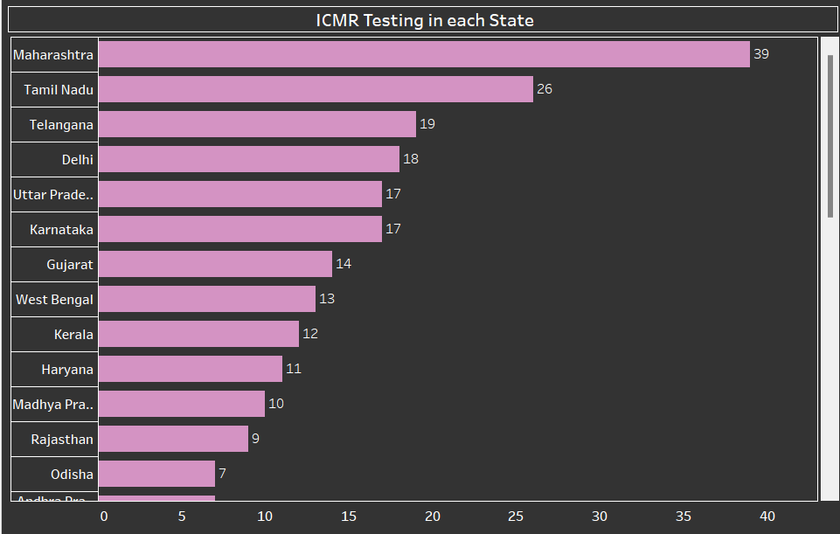

**Purpose**

This bar graph shows the number of ICMR testing centres in each state. The graph is ordered with Maharashtra having the highest number of testing centres and Odisha having the least.

**Key Insights:**

* **Maharashtra has the highest number of ICMR testing labs with 39.** This is likely due to the state having the highest number of COVID-19 cases in India.
* **Tamil Nadu has the second highest number with 26.**
* **Telangana and Delhi have 19 and 18 labs respectively.**
* **Several states have fewer than 15 labs.**

These insights suggest that some states may have limited testing capacity compared to others. This could have implications for the accuracy of COVID-19 case counts and the ability to track the spread of the virus.

**8.Statewise Testing Details(Bar)**

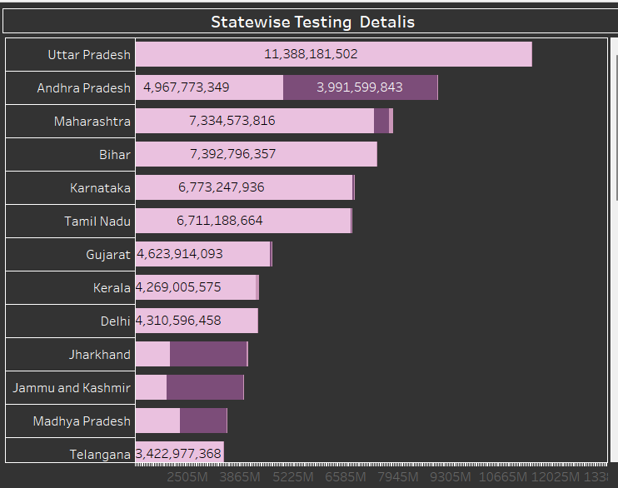

**Purpose:**

The purpose of this graph is to provide a visual overview of the number of COVID-19 tests conducted in different Indian states. This information can be used to track the progress of testing efforts, identify states with a high testing capacity, and compare the testing rates of different states.

**Key Insights:**

* Uttar Pradesh has the highest number of COVID-19 tests conducted, suggesting a high level of testing capacity.
* States with the highest test counts also have larger populations, likely due to a greater number of people to test.
* There's a significant variation in testing capacity across different states, possibly due to factors like resource availability, population density, and government policies.

This is a chart of state-wise testing, so the number shown represents the total number of tests conducted in each state. The purpose of these lines is to show the order of states in terms of testing volume, with Uttar Pradesh having the highest number of tests and Telangana having the lowest.

* **Flow Chart:**

Data Collection

Import Data

Data Preprocessing

Data Formatting

Data Cleaning

Data Analysis and aggregation

Data Merging

Insights and Reporting

Data Visualization

ICMR Testing for each state

Gender

Age Group

Vaccine Dose Administration

State Wise Testing Details

First Dose vs Second Dose

Conclusion:

* India has made significant progress in managing COVID-19, with over 500 million recoveries and a robust vaccination effort. While the total number of confirmed cases and deaths remains high, the country's recovery rate is promising. The distribution of cases across age groups and genders provides insight into the demographics most affected, while testing data highlights India's large-scale testing efforts.
* Going forward, continued attention to vaccination coverage, especially in the second dose, and targeted interventions in high-caseload states will be crucial to sustaining the fight against COVID-19.