Feasibility Analysis
Predictive Autoscaling Engine for Cloud Workloads
Platform target: Kubernetes (cloud-agnostic)

1. The Problem
Kubernetes' built-in Horizontal Pod Autoscaler (HPA) is reactive: it only adds replicas after a metric such as CPU utilization or request rate has already crossed a threshold. Between that trigger and the moment new pods are Running and Ready, there is an unavoidable lag - the metrics-server averaging window (typically 15-60s), the scheduler and image-pull time, and the application's own startup/warm-up time (JVM/DB-connection-pool warm-up can add tens of seconds). During that window, the existing pods absorb the extra load, which is exactly when users see elevated latency, timeouts, or dropped requests.
Many production workloads are not random walks - they have predictable structure: a checkout service that spikes every day at 9am and 6pm, a batch-triggered API that surges right after a nightly job, or a ticket-sales page that ramps sharply at a known on-sale time. A purely reactive controller throws away this predictability: it waits for the spike to already be hurting the system before it starts scaling. The case for this project is that a lightweight forecasting layer, sitting alongside the existing HPA rather than replacing it, can start scaling before the spike arrives and fall back cleanly to today's reactive behaviour whenever its predictions cannot be trusted.

2. Proposed Solution
The proposed system runs two independent autoscaling arms side by side and lets a simple arbiter pick the larger of the two recommendations every cycle. A Reactive Arm checks, every 15 seconds, whether pods are already Pending or CPU is already high, and reacts immediately. A Predictive Arm checks, every 30 seconds, what a short-horizon forecast (Holt-Winters) expects load to look like a few minutes ahead, and recommends capacity before the spike lands. The Arbiter simply takes target = max(reactive_target, predictive_target); it never lets a stale or over-cautious arm undercut the other. This mirrors the core idea in AgileSphere, a 2026 IEEE Access paper on predictive-reactive Kubernetes autoscaling by Habibi, Rawat, and Leon-Garcia (University of Toronto / TELUS), whose central finding was that combining a fast reactive arm with a forecasting arm mainly reduces run-to-run variance in scaling behaviour, not just the average backlog - a claim this project can test directly on its own small cluster.
The second idea borrowed from that paper is a warm reserve pool. A handful of extra Kubernetes worker nodes are created but kept cordoned (marked unschedulable) from the start, with the sample application's container image already pulled onto them. When the Arbiter decides more capacity is needed, instead of only changing the pod replica count and hoping a node has room, it also uncordons a reserve node so a schedulable target actually exists immediately - the same mechanism the paper calls RsV promotion, reported there at roughly 4 seconds versus 60-180 seconds for a brand-new cloud VM. On a local kind/minikube cluster this becomes a single free kubectl command, not a new piece of infrastructure.

3. What We Actually Build
- Sample application - a small stateless HTTP service deployed to Kubernetes, used as the thing being autoscaled.
- Reactive Arm - a fast loop (every 15s) that reads current pending-pod count and CPU from Prometheus and, if either crosses a threshold, computes an immediate target replica count.
- Predictive Arm - a slower loop (every 30s) that pulls the last ~30 minutes of metrics from Prometheus, forecasts load 2-5 minutes ahead with Holt-Winters (statsmodels), and computes a look-ahead target replica count.
- Arbiter - one small function that takes target = max(reactive_target, predictive_target), clamps it to [minReplicas, maxReplicas], and is the only place that calls the Kubernetes API to patch Deployment.spec.replicas.
- Warm reserve pool manager - logic inside the Arbiter that, alongside changing the replica count, uncordons a pre-warmed reserve node when more schedulable capacity is needed and cordons the least-needed node back into reserve when demand drops.
- Per-arm safety check - each arm wraps its own computation in a try/except; if Prometheus is unreachable or a computation fails, that arm simply contributes nothing for this cycle rather than crashing the whole system.
- Load test harness - k6 scripts that generate steady, spike, and repeating diurnal traffic patterns against the sample service, used to evaluate prediction accuracy, reaction speed, and run-to-run stability.

4. Architecture
Traffic hits the Application Deployment; Prometheus scrapes it; the Reactive and Predictive arms both read from Prometheus independently and on their own schedules; the Arbiter combines their two recommendations with a simple max() and is the single point that ever changes cluster state - both the pod replica count and which reserve nodes are cordoned or uncordoned.
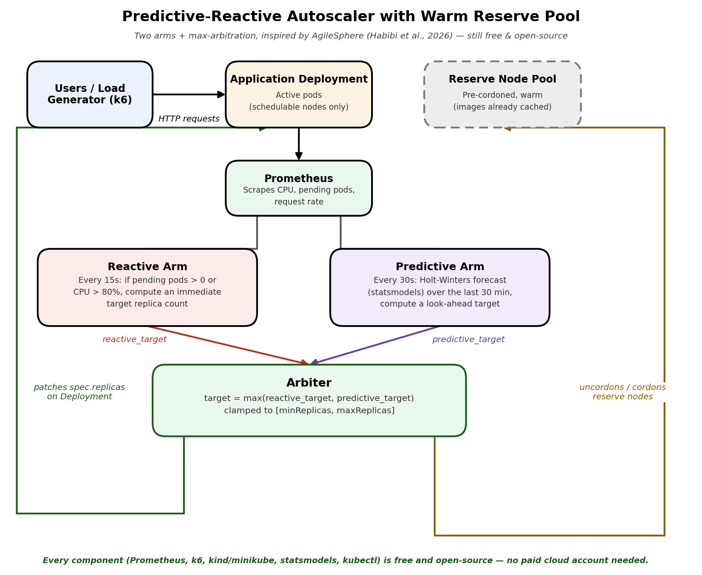
Figure 1 - Two arms feed one arbiter, which is the only component that ever changes the cluster.

5. One Control-Loop Cycle, Start to Finish
- Scrape: Prometheus continuously scrapes request rate, CPU, and pending-pod count from the application pods (default interval 15s).
- Reactive check (every 15s): the Reactive Arm reads the latest values; if pending pods > 0 or CPU is above threshold, it computes reactive_target immediately.
- Predictive check (every 30s): the Predictive Arm reads the last ~30 minutes of history, runs Holt-Winters, and computes predictive_target for T+2min.
- Arbitrate: the Arbiter computes target = max(reactive_target, predictive_target), clamped to [minReplicas, maxReplicas].
- Act on pods: it calls the Kubernetes API to set Deployment.spec.replicas to target - the same effect as kubectl scale.
- Act on nodes: if target requires more schedulable capacity than is currently active, it uncordons the next reserve node (or cordons one back into reserve if capacity is no longer needed).
- Converge: the scheduler places the new pods onto the now-schedulable node(s), which already have the application image cached, so they become Ready in a few seconds rather than minutes.

6. What Happens When Things Go Wrong
Each arm fails independently and safely, so there is no single point of failure. The Reactive Arm and Predictive Arm each wrap their own Prometheus query and computation in a try/except; if either fails - Prometheus is briefly unreachable, a query times out, the forecast library throws - that arm simply reports 'no recommendation' for this cycle instead of crashing or guessing. The Arbiter then takes the max of whichever arm(s) did succeed. If both arms fail in the same cycle, the Arbiter makes no change at all and logs a warning; the current replica count and node state are left exactly as they were, and the whole loop simply tries again in 15 seconds.
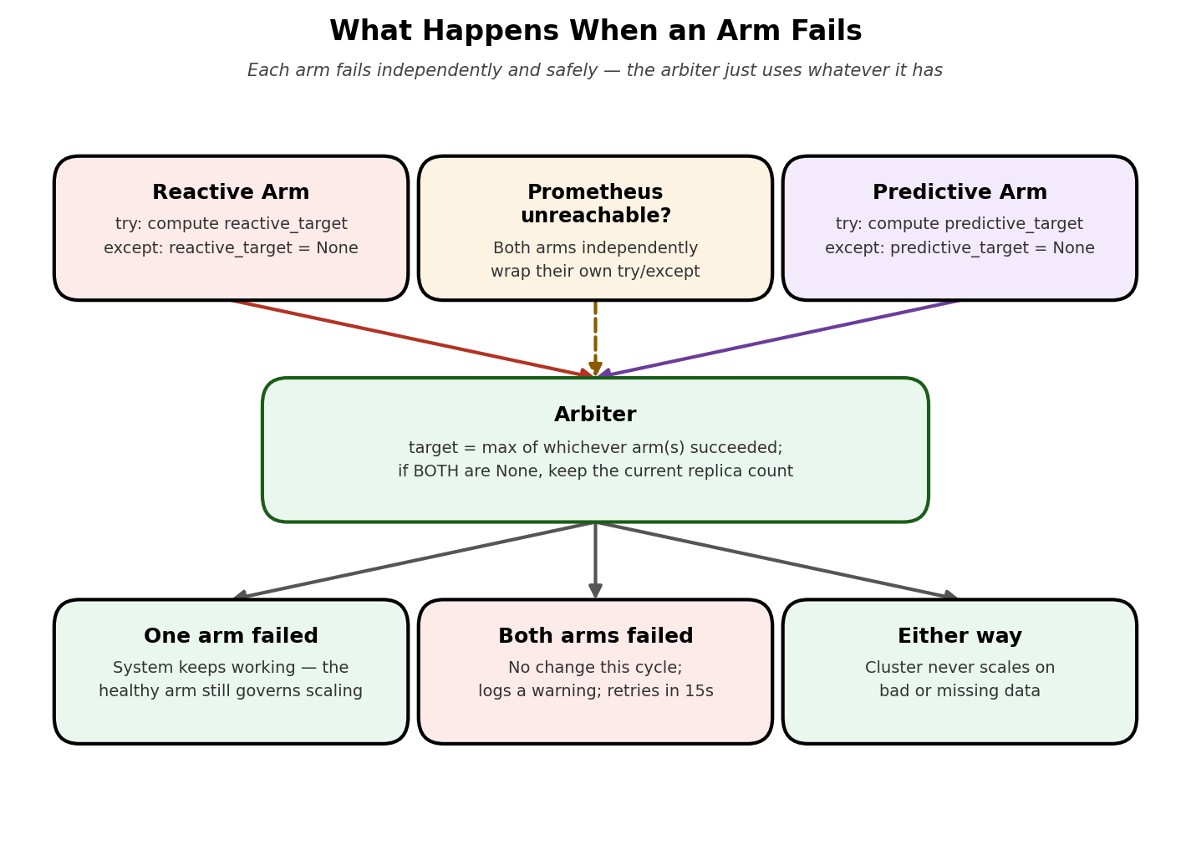
Figure 2 - Failure is handled per-arm; the cluster is never left in an inconsistent state.

7. Infrastructure Required - Everything Is Free
Every tool below is free and open-source and runs entirely on a personal laptop through a local Kubernetes cluster - there is no paid cloud account, managed-service bill, or API key required anywhere in this project. The warm-pool mechanism adds no new tooling at all: it is just kubectl cordon/uncordon, which ships with Kubernetes itself.
Component | Tool | License / Cost | Purpose
Kubernetes cluster | kind (Kubernetes in Docker) or minikube, created with a few extra worker nodes | Apache-2.0, free | Runs everything locally; extra nodes become the reserve pool
Metrics store | Prometheus | Apache-2.0, free | Collects CPU / pending-pod / request-rate metrics
Reactive + Predictive logic | Python 3 + statsmodels (Holt-Winters) | BSD, free | Computes both arms' target replica counts
Cluster access | Official Kubernetes Python client | Apache-2.0, free | Patches spec.replicas and cordons/uncordons nodes
Load generator | k6 | AGPL-3.0 (CLI is free), free | Produces steady / spike / diurnal traffic
Dashboard (optional) | Grafana OSS | AGPL-3.0, free | Nice-to-have graph of both arms' targets over time - not required for the core demo
Because the whole stack is self-hosted and open-source, this project can be built and demoed entirely offline on a single laptop with Docker installed - there is no dependency on AWS/Azure/GCP credits, quota approval, or any account sign-up.

8. Four-Week Implementation Plan
Week | Work / Review
Week 1 | Foundation: create a kind/minikube cluster with extra worker nodes, cordon the extras to form the reserve pool, deploy the sample HTTP service, install Prometheus. Review: cluster running with reserve nodes visible as cordoned.
Week 2 | Reactive arm + baseline: build the Reactive Arm and the k6 load generator (steady ramp + spike); measure reaction time and reserve-node promotion time (idle uncordon-to-Ready latency). Review: reactive scaling and node promotion both working end to end.
Week 3 | Predictive arm + arbiter: build the Predictive Arm (Holt-Winters) and the max-based Arbiter combining both targets. Review: both arms visibly contribute, and the higher of the two always wins.
Week 4 | Safety & validation: add the per-arm try/except safety checks; run the comparative experiments below, including killing each arm independently and disconnecting Prometheus; prepare graphs and the final demo. Review: variance-reduction result and safe degradation both demonstrated.

9. Feasibility Assessment
- Local Kubernetes + Prometheus setup - High: entirely open-source, runs on a laptop via kind/minikube in minutes; adding a few extra cordoned nodes is one extra flag at cluster-creation time.
- Reactive Arm - High: a simple threshold check against numbers Prometheus already exposes; the easiest component to build and to reason about.
- Predictive Arm - High: Holt-Winters via statsmodels is a few lines of code; no GPU or heavy ML infrastructure needed.
- Arbiter (max-arbitration) - High: a single, well-defined function; this is deliberately simpler than AgileSphere's full monotone-max reconciler with typed desired-state objects, while keeping the same core guarantee that neither arm can undercut the other.
- Warm reserve pool (cordon/uncordon) - Medium/High: conceptually simple and uses only built-in kubectl commands, but does add a second kind of action (node-level, not just pod-level) that needs its own small piece of bookkeeping (which reserve node is next in line).
- Load generation & realistic traffic patterns - High: k6 makes steady, spike, and repeating diurnal patterns straightforward to script.
- Overall - High feasibility, still very achievable solo within four weeks on a personal laptop. The two-arm-plus-reserve-pool design is a deliberate, modest step up in scope from a single-script autoscaler, but every added piece is a small, well-documented primitive (a second timed loop, a max() call, a kubectl cordon/uncordon) rather than new infrastructure - it stays free, self-hosted, and buildable by one person.

10. How We Will Prove It Works
- Scaling-lag comparison - apply an identical synthetic spike (RPS 50 -> 500 over 2 minutes) with the autoscaler off vs. on; measure time-to-adequate-capacity and request error/latency during the transition.
- Variance-reduction test (mirrors AgileSphere's headline finding) - run the same workload trace across N independent trials for (a) reactive-only, (b) predictive-only, and (c) both arms combined; compare the run-to-run standard deviation of pending-pod-time, not just the mean, to see whether combining arms stabilizes behaviour the way the paper reports.
- Reserve-pool promotion latency - time from the Arbiter's uncordon decision to the new pod reaching Ready, repeated across all reserve nodes, compared against the time to schedule onto a node that was already active (this is the project's own version of the paper's RsV latency measurement).
- Forecast accuracy - feed a repeating daily traffic pattern over several simulated days; measure forecast error (MAPE) at the T+2min horizon.
- Fallback safety - kill each arm independently (and then both together, and then Prometheus itself) and verify the Arbiter degrades gracefully every time - continuing on the healthy arm, or freezing the replica count with a logged warning if both are down.
- Stability - count scale-up/scale-down and cordon/uncordon events under noisy load to confirm the min/max bounds prevent excessive churn.

11. Related Work
This design is directly informed by AgileSphere: Predictive-Reactive Kubernetes Cluster Autoscaling With Warm-Pool Node Promotion (Habibi, Rawat, and Leon-Garcia, IEEE Access, 2026), which evaluates a similar two-arm-plus-reserve-pool idea on a live k3d/k3s testbed. Their full system is considerably larger in scope than this mini-project - it includes several custom Go microservices, a trained transformer-based forecasting model, and a multi-cloud resource marketplace - but its two central, empirically-supported claims are exactly what this project borrows and re-tests at a much smaller scale: (1) that combining a fast reactive controller with a forecasting controller under simple max-based arbitration mainly reduces variance in scaling behaviour rather than just the average backlog, and (2) that pre-cordoned warm reserve nodes can cut node-promotion time by more than an order of magnitude compared to provisioning brand-new capacity.

