**“IMPACT OF E-COMMERCE ON TRADITIONAL RETAILERS”**

**Mini Live Project**

**DISSERTATION**

**&**

**PROJECT**

**A report submitted in partial fulfillment**

**Of the Requirement**

**for the award of the degree of**

**B.COM CFA**

# ……………………………………………………………………

**Supervisor Student Name**

## Dr. Aruna Bhat Ma’am Aanchal Tomar

**Submitted To:**

**Mrs. Preeti Sharma Ma’am (Roll NO 212013002)**

**SCHOOL OF BUSINESS STUDIES**

**COER UNIVERSITY**

**ROORKEE, DISTRICT, HARIDWAR, UTTARAKHAND**

**2024**

## CONTENTS

|  |
| --- |
| * **Acknowledgement** |
| * **Declaration** |
| * **Introduction** |
| * **Literature Review** |
| * **Research Methodology** |
| * **Data Analysis and Result** |
| * **Discussion and Conclusion** |
| * **Limitation and future scope** |
| * **Suggestion** |
| * **References** |
| * **Questionnaire** |
| * **Bibliography** |

# ACKNOWLEDGEMENT

I would like to take the opportunity to express my sincere gratitude to all people who have helped me with sound advice and able guidance. Above all, I express my eternal gratitude to the Lord Almighty under whose divine guidance; I have been able to complete this work successfully. For providing proper help and encouragement in the preparation of this report.

I am thankful to **Dr. Aruna Bhat Ma’am**, Class teacher for her cordial support, valuable information and guidance, which helped me in completing this task through various stages, and providing proper help and encouragement in the preparation of this report

I would like to express my gratitude to all the faculties of the Department for their interest and cooperation in this regard.

I extend my hearty gratitude to the librarian and other library staffs of my college for their wholehearted cooperation.

I express my sincere thanks to my friends and family for their support in Completing this report successfully.

# DECLARATION

I, Aanchal Tomar, hereby declare that the project work entitled “Mini Live Project” record of Independent and bonafide project work carried out by me under the supervision and guidance of Dr. Aruna Bhat Ma’am Assistant Professor, Department of Commerce, university of engineering and technology Roorkee. The information and data given in the report is authentic to the best of my knowledge. The report has not been previously submitted for the award of any Degree, Diploma, Associateship or other similar title of any other university or Institute.

Place: Roorkee. Aanchal Tomar

Date:………………….. B.com CFA

## INTRODUCTION

The rise of e-commerce has completely transformed the retail industry over the last decade. E-commerce has revolutionized the way consumers shop by providing a more convenient and efficient shopping experience*.* Online shopping has become increasingly popular and has led to a decline in traditional brick-and-mortar stores. In this article, we will discuss **the impact of e-commerce on traditional retail.**

Social Impact: E-commerce **has enabled consumers to shop from the comfort of their homes.** Online shopping provides the convenience of shopping 24/7 without the need to leave the house. Consumers can easily browse through a wide variety of products and compare prices with just a few clicks. This has led to a decline in foot traffic for traditional retail stores.With fewer customers coming to the stores, traditional retailers are struggling to remain profitable.

Problem: e-commerce has allowed consumers to **purchase products at lower prices.** Online retailers are able to offer lower prices than traditional retailers due to lower overhead costs. With lower prices, consumers are more likely to choose e-commerce over traditional retail stores. This has put pressure on traditional retailers to lower their prices, which has reduced their profit margins.

Solution: e-commerce has provided**consumers with a wider variety of products to choose from**. Online retailers are not limited by the physical space of a store and can offer a wider range of products. *This*has made it more difficult for traditional retailers to compete, especially in niche markets where online retailers have a wider selection of products.

E-commerce platforms often boast lower overhead costs and the ability to reach a global audience, providing them with a competitive edge in terms of pricing and market reach. This fierce competition has compelled traditional retailers to reevaluate their pricing strategies and streamline their operations to remain competitive.

E-commerce has also presented opportunities for traditional retailers to innovate and enhance the customer experience. Many brick-and-mortar stores have integrated online platforms into their business models, offering omnichannel shopping experiences that blend the convenience of online shopping with the tactile experience of in-store browsing. Additionally, some retailers have leveraged technology such as augmented reality and virtual reality to create immersive shopping experiences that differentiate them from their online counterparts.

In conclusion, while e-commerce has undoubtedly disrupted traditional retail, it has also spurred innovation and forced traditional retailers to evolve to meet the changing needs and expectations of consumers. The future of retail lies in a harmonious integration of digital and physical channels, where traditional retailers leverage technology to enhance the customer experience and stay relevant in an increasingly digital world. E-commerce has **changed the way consumers shop.** Consumers are no longer limited to shopping during traditional store hours. With the rise of e-commerce, consumers can shop at any time of the day or night. This has led to a decline in foot traffic for traditional retailers, who are only able to attract customers during store hours.

## LITERATURE REVIEWS

A literature review is an overview of the previously published works on a topic. critical and comprehensive summary of existing scholarly literature on a specific topic or research question. It serves several purposes within academic and research contexts. A literature review provides an overview of the current state of knowledge on a particular subject. It helps researchers identify what has already been studied, what gaps exist in the literature, and what questions remain unanswered. By synthesizing and analyzing existing research findings, a literature review contextualizes the researcher's own study within the broader academic discourse. It helps establish the relevance and significance of the research question or topic being investigated. through the examination of multiple studies, a literature review enables researchers to identify trends, patterns, and inconsistencies in the literature. This can help guide the direction of future research and highlight areas where further investigation is needed.

* According to to Al-Weshah and Al-Zubi [7], the Jordanian government should plan strategies to achieve and raise national awareness of the Internet and e- commerce by increasing investment in the ICT infrastructure.
* According to (Byrnes, 2007), By utilizing multi-channel technology, salespeople have seen growth in their sales. The Internet provides consumers with the capabilities to shop around the clock, from any location, as well as easily access research about product's attributes and competitive pricing. Nader Shafii, a personal shopper for Nordstrom, keeps 5,000 customers in a database and routinely reaches out to 500 of them. He says he's selling 37% more merchandise as a result.
* According to (Eastin, 2002) and (Huang, 2019), As e-commerce company does not have physical space constraint, so it can provide information about large number of products to the consumers. From books and stationery to clothes and jewellery, home appliances to decoration articles, anything and everything can be accommodated on a single website for sale to a prospective consumer.
* According to(Chappell & Feindt, 1999) Quality benefits of e-commerce use could include the improved flow of information, new products and customer services, improved availability, improved market transparency, and reduced errors in information processing (Ng et al., 1998; OECD, 1999). Regarding customer services, the interaction between the customer and the retailer has never been as important as it is today, and the interactive nature of the web can support such interactions (Hoffman, Novak, & Chatterjee, 1995).
* According to (Poon & Swatman, 1999) increased sales and profitability via e-commerce have been discussed extensively, the actual benefits are still extremely contentious. Even for those who admit gaining short-term benefits such as increased sales, such advantages are marginal and often circumstantial. There is currently no reliable way of estimating sales delivered to consumers electronically versus those delivered using traditional methods, and likewise no measurement of e-commerce retail sales (Haltiwanger & Jarmin, 1999). Sales and online transactions may generate only a fraction of overall sales, perhaps due to the fact that certain goods are not easily purchased over the Internet, or that they require some form of face-to-face interaction in addition to the web presence.
* According to (Mustafa et al., 2022; Verma et al., 2023) , Traditional retailers have been compelled to explore and adopt digital retail strategies to remain competitive and relevant in an increasingly digital world. E-commerce has proven to be a game-changer for the retail sector, offering numerous benefits such as expanded market reach, convenience, cost-efficiency, and enhanced customer experiences.
* According to (Gommans et al., 2001; Smith and Brynjolfsson, 2008), While customers’ habits change from traditional towards online shopping, brand image remains a key factor affecting those habits and thus the success of e-commerce companies. E-commerce is a relatively new industry compared to traditional brick-and-mortar retailing.
* According to (Epstein, 2004), Decreases in the amount of same store sales indicate another major challenge for retailers, which is the possibility of reduced in-store traffic as a result of successful Internet marketing. In reality, e-commerce is sometimes about "stealing your own customers". As customers become accustomed to the ease, value, and convenience of online shopping, they may forgo traditional shopping trips. The challenge is to stay connected with those customers who may purchase infrequently or who only choose to shop through one of the company's channels.
* According to Dong (2018), Dong finds that as a new sales model, e-commerce will have a series of impacts on the traditional retail industry. E-commerce has attracted some customers of the traditional retail industry, reduced the sales profits of the traditional retail industry, and led to the common phenomena such as the closure of supermarkets and the idleness of commercial houses.
* According to (Birkin & Clarke, 2002), e-commerce is a channel which serves an additional source of customers who are fairly inexpensive to service. This new channel has been exploited by retailers, both existing players and new entrants .The common perception of Internet retailing is as Ha single homogenous activity- the selling of goods and services via the worldwide web".
* According to the current research by (Nielsen, 2018)., which has devoted itself to online purchases in Slovakia, the most significant part of the shopping cart is mainly fashion, more books, music, office supplies, but also travel. Slovakian also buy tickets and personal hygiene products, respectively, cosmetics. The percentage of online purchases of individual types of goods shown in the following graph.
* According to (Sachenko, 2019), The main advantages of using the Internet include availability, immediate information, and search services. E-commerce or e-commerce is buying and selling products or services through electronic systems such as the Internet or similar computer networks. Electronic banking is also an integral part of e-commerce. When using internet banking, the client can execute multiple payment orders in his bank account without time and space constraints.

**Research Methodology**

A research methodology describes the techniques and procedures used to identify and analyze information regarding a specific research topic. It is a process by which researchers design their study so that they can achieve their objectives using the selected research instruments.

Research methodology provides a structured approach to understanding the impact of e-commerce on traditional retailers. The study is based on both primary data and secondary data**. Data collection**, Primary data directly collected through questionnaire. A structured questionnaire is designed to gather insights directly from traditional retailers and customers. Data was also collected from secondary sources. Secondary source includes books, company data, Information about topic from internet and review of existing literature, market reports, and industry publications for contextual understanding and comparison.

**Sampling strategy and technique** employed is likely stratified random sampling, where retailers and customers are categorized based on criteria such as age. **Sample size**, the study’s generalizability may be limited by the sample size and representatives of the respondents In **Data analysis** both quantitative and qualitative analysis is done. In Quantitative analysis, data is presented through charts, graphs and summary statistics. In Qualitative analysis, thematic analysis of open-ended responses to identify common themes and emerging patterns.

The data collection process is extensive and systematic, encompassing a comprehensive search strategy. Keywords, including "e-commerce impact on traditional retailers”.

**Data Analysis and Results**

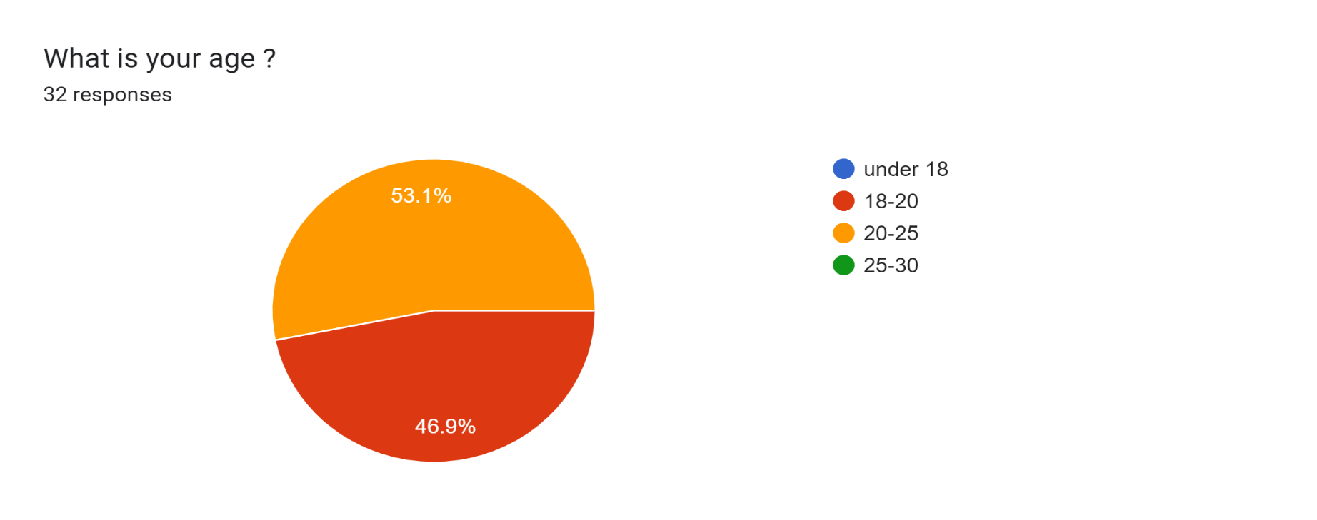

* Majority of the respondent belong to the 18-20 age group and 20-25 age group in which 53.1% are 20-25 age and 46.9% are 18-20 age.

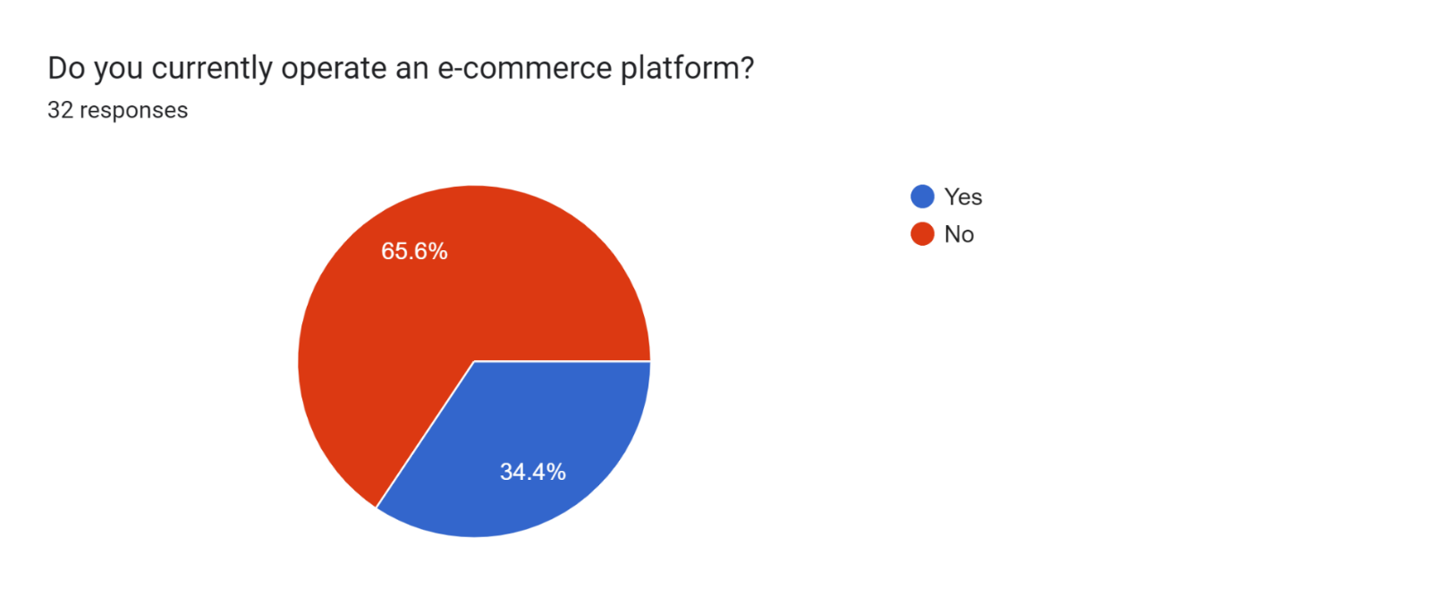

* Majority of the respondents 65.7% are not operate e-commerce platform and 34.4% said they are not engage in operating e-commerce platform.

Forms response chart. Question title: What do you prefer for shopping?
. Number of responses: 32 responses.

* Out 100% of the respondents, 46.9% choose both /depends, and others 34.4% prefer online shopping and other 18.8% offline shopping.

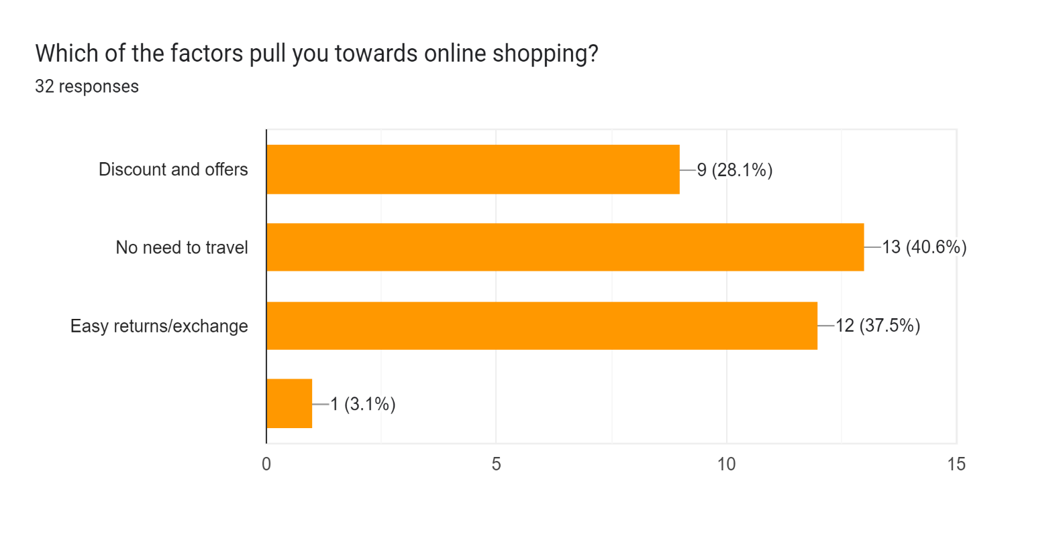

* Out of the 100% of the Respondent, 40.6% of the respondent prefer no need to travel factor, 37.5% choose easy return exchange , 28.1% choose discount and offers and 3.1% choose other factors which attract toward shopping online.

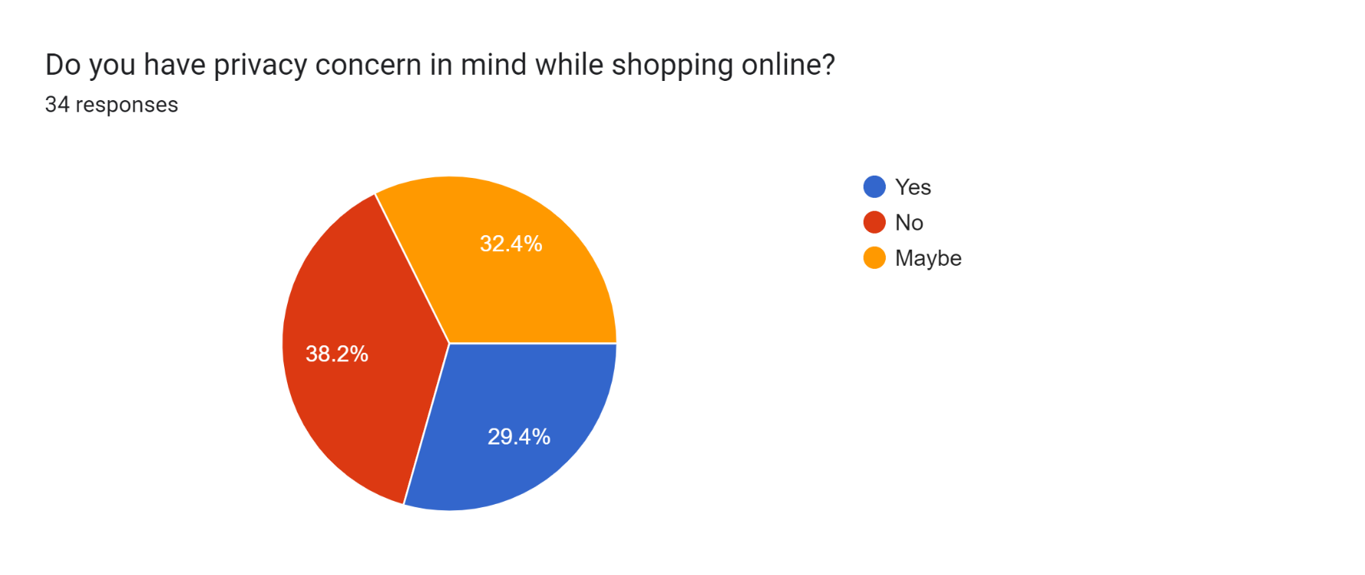

* Out of the 100%, 32.1% respondents are Not sure about the privacy concern while shopping online, while 38.2% said No they don’t any privacy concern and 32.4% said ‘Yes’ they have privacy concern in mind while shopping online.

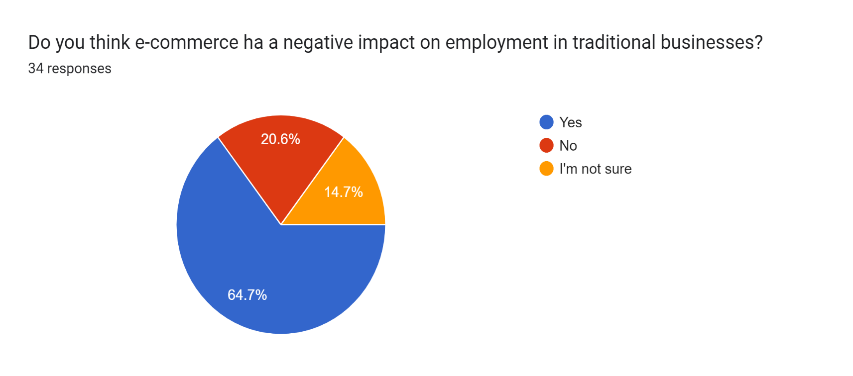

* Majority of the respondents, 64.7% said ‘Yes’ that e-commerce has a negative impact on employment in traditional businesses and other 20.6% said No and rest 14.7% said they are not sure.

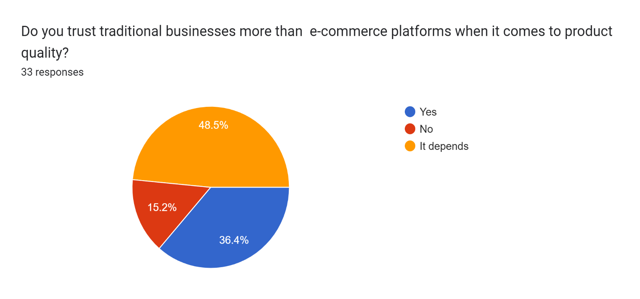

* Out of the 100%, 48.5% said “It depends” to trust more traditional retailers more than e-commerce platform, 36.5% said “Yes” they more traditional businesses than the e-commerce platform 15.2% said “NO”.

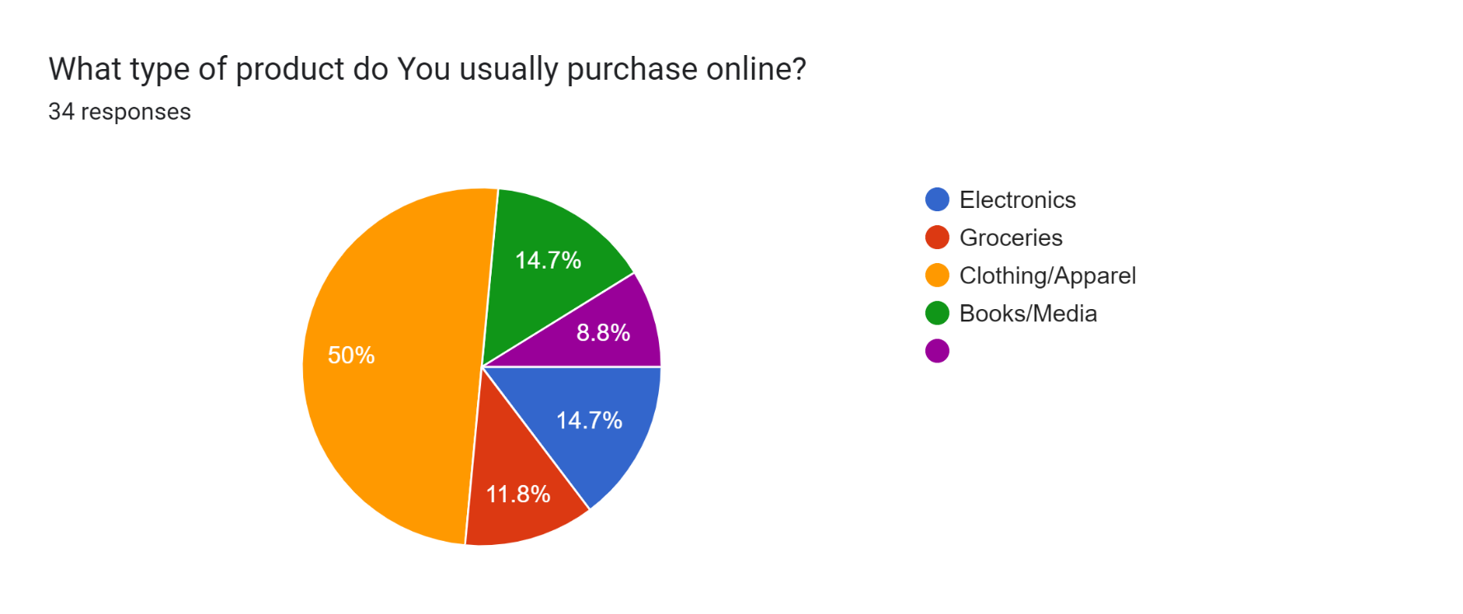

* Majority half of the respondents 50%, they usually purchase clothing/apparel through online and rest 14.7% purchase books/media, 14.7% purchase electronics,14.7% choose others.

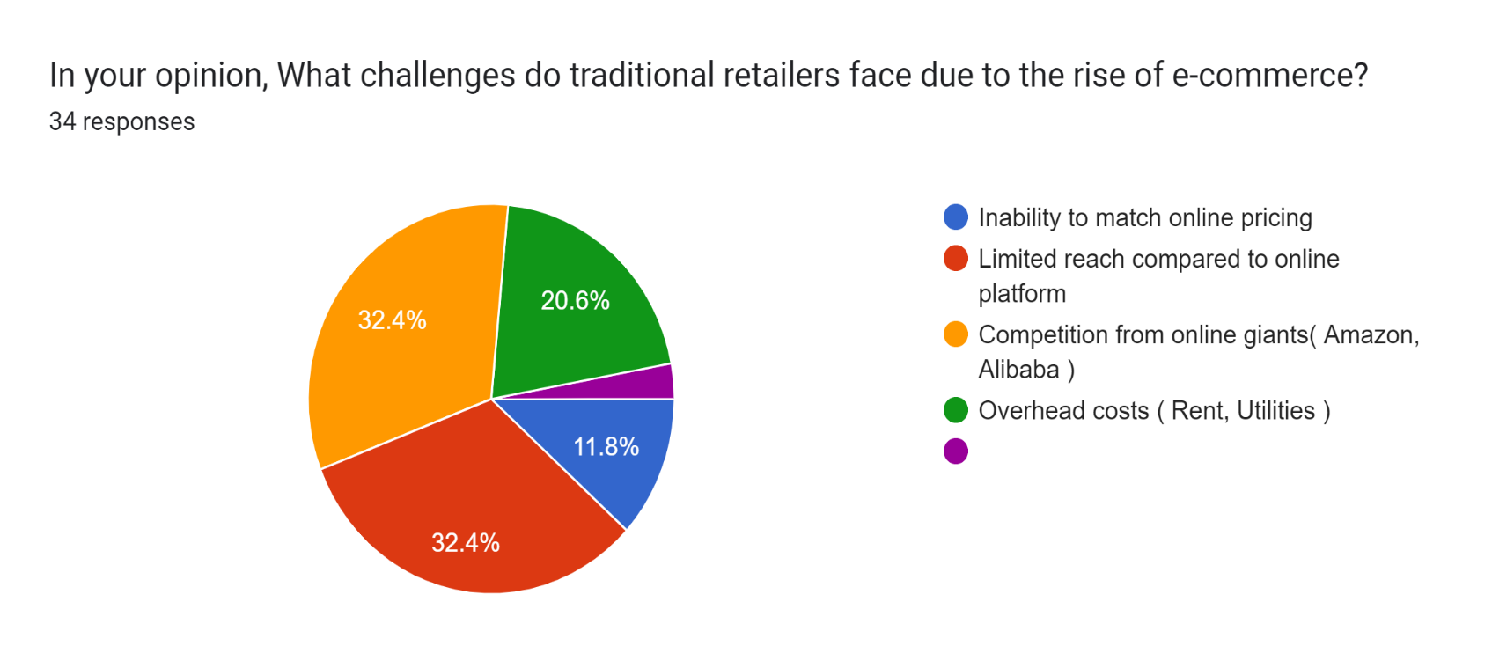

* Challenges faced by traditional retailers due to rise of e-commerce, majority of the respondents agreed with 2 reasons with the same percentage 32.4%, “limited reach compared to online platform” and “competition from online giants (Amazon, Alibaba).

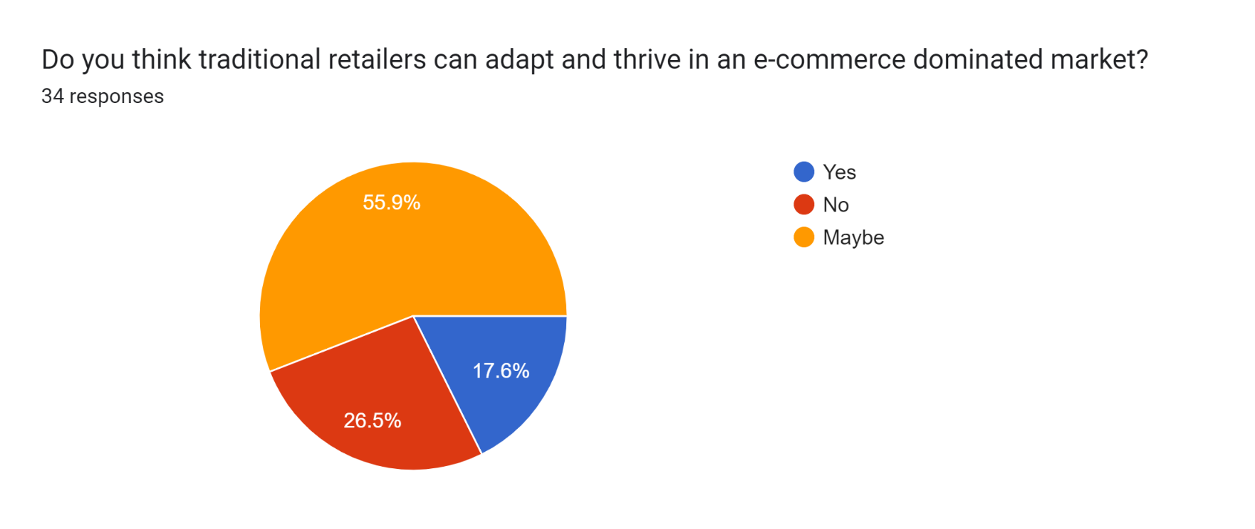

* Majority of the respondents, 55.9% agreed that traditional retailers can adopt and thrive in e-commerce dominated market, rest 26.5% said “NO” and 17.6% agreed and said “Yes”.

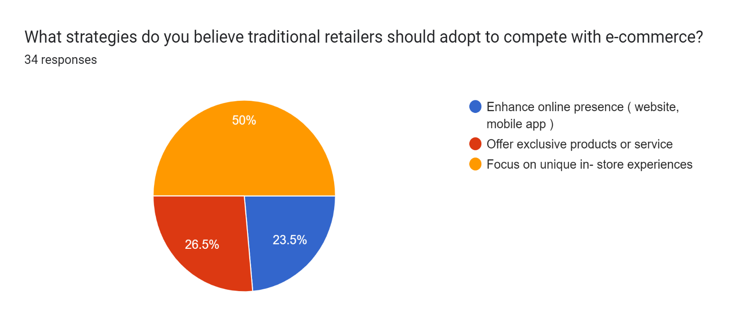

* Out of the 100%, 50% respondents believe that traditional retailers can compete with e-commerce by “Focus on unique products or service”, 26.5% respondents said by “Offer exclusive products or service” help to compete with e-commerce and 23.5% choose “Enhance online presence (website ,mobile app).

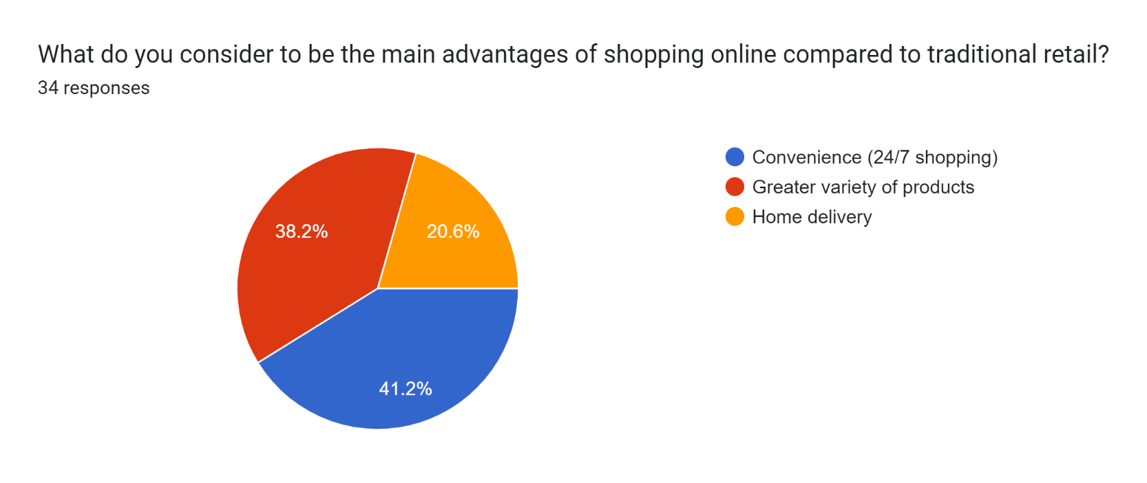

* Majority of the respondents 41.2% agreed with “Convenience (24/7 shopping)” is the main advantage of online shopping, rest of the respondents 38.2% agreed with “Greater variety of products” and 20.6% with “Home delivery”.

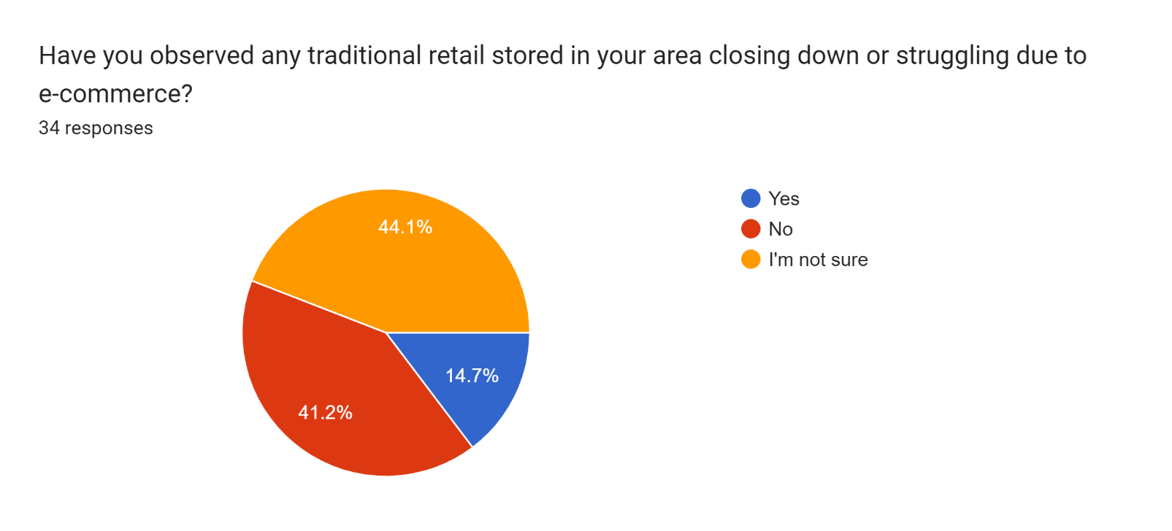

* Out of the 100% respondents, 44.1% are not sure about the closing down or struggling of traditional retail store due to rise in e-commerce, 41.2% said “NO” and rest 14.5% said “Yes”.

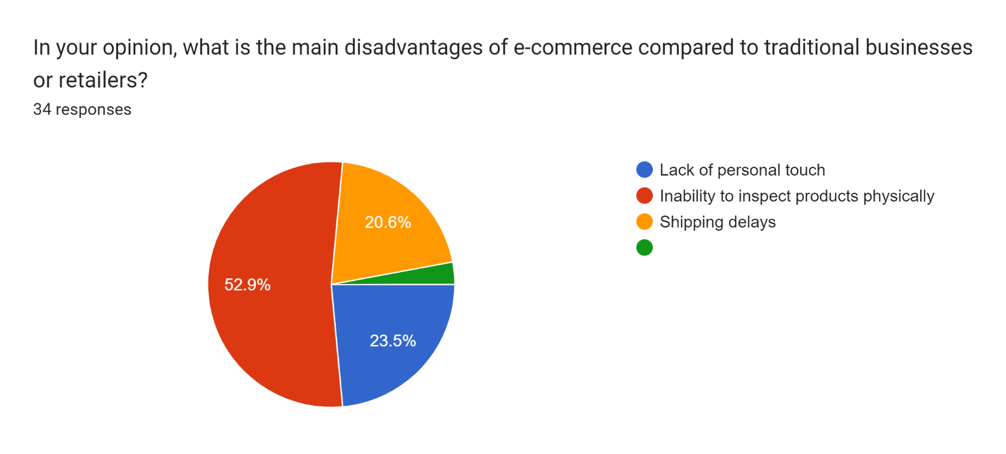

* Majority of the respondents 52.9% agreed “Inability to inspect product physically” is the main disadvantage of e-commerce and 23.5% respondents give different answer “lack of personal touch” and 20.6% said “Shipping delays”.

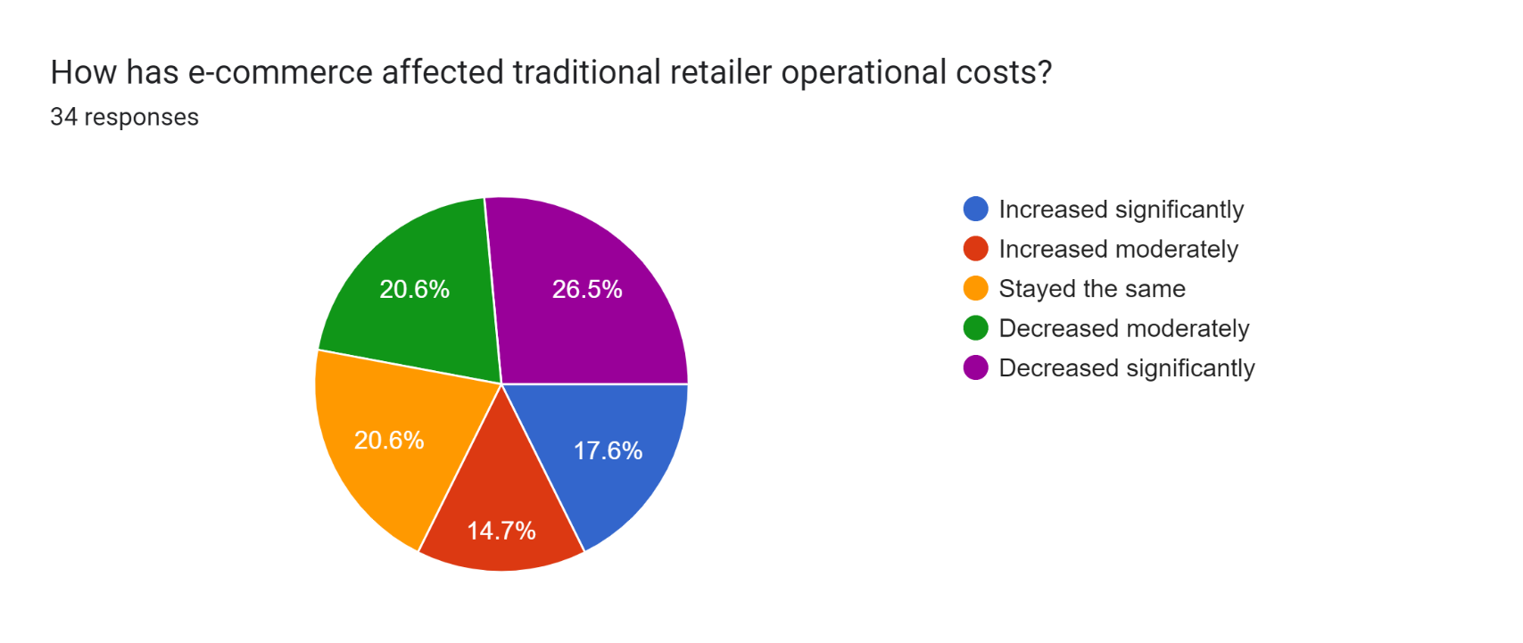

* Out of the 100% of the respondents, 26.5% agreed that the operational cost of traditional retailer will “decreased significantly” and other 20.6% respondents said “stayed the same” and with same percentage 20.6% respondents said “Decreased moderately”.

**Discussion and Conclusion**

In conclusion, the rise of e-commerce has had a **significant impact on traditional retail**. E-commerce has provided consumers with a more convenient, efficient, and affordable shopping experience. Traditional retailers are struggling to compete with online retailers, who are able to offer lower prices, a wider selection of products, and a more convenient shopping experience*.* As the retail industry continues to evolve, it will be interesting to see how traditional retailers adapt to the rise of e-commerce.

E-commerce, on the other hand, still needs to spread its wings and develop large enough to reach the most remote regions in order to give goods and services to everyone who can use an E-commerce platform. Existing and growing small- and large-scale traditional commerce retailers are facing significant challenges as a result of e-commerce. To avoid further problems and confusion among traditional commerce applicants, they will need to modify their commercial activities and adapt a hybrid of traditional commerce and E-commerce.

The emergence and rapid expansion of ecommerce have fundamentally reshaped the landscape of traditional retail, ushering in an era of profound change and adaptation. One of the most significant impacts has been the transformation of consumer behavior, with a growing preference for the convenience and accessibility offered by online shopping platforms. This shift has posed a formidable challenge to traditional retailers, compelling them to rethink their strategies and operations to remain competitive in an increasingly digital marketplace.

traditional retailers have invested heavily in technology and logistics to improve their ecommerce capabilities. This includes upgrading their websites for better functionality, implementing advanced inventory management systems, and enhancing fulfillment capabilities to meet the demands of online shoppers. By prioritizing these investments, retailers have been able to enhance operational efficiency, optimize inventory management, and deliver a more personalized shopping experience to customers.

In conclusion, the impact of ecommerce on traditional retailers has been profound and multifaceted. While the rise of online shopping has presented significant challenges, it has also created opportunities for retailers to innovate, adapt, and thrive in the evolving retail landscape. By embracing digital transformation, investing in technology and logistics, and integrating online and offline channels effectively, traditional retailers can position themselves for long-term success in the digital age.

**Limitation and Future Scope**

1. In our research we have done our study on “IMPACT OF E-COMMERCE ON TRADITIONAL RETAILERS” So it can also be applied on other sectors.

2. Limited no. of Respondents - Sample size of respondents is limited as our respondents are only students we can even take suggestions from our friends and family members also.

3. Limited no. of tools used in our research paper, like we only use the Google forms. In this we can also use other statistical tools.

4. Financial constraint - Insufficient fund tends to impede the efficiency of the Researcher in sourcing for the relevant materials, literature or information and in the process of data collection (Internet, questionnaire and interview).

5. Time constraint - The researcher will simultaneously engage in this study with other academic work. This consequently will cut down on the time devoted for the research work.

**Suggestion**

Study region of the research is limited as the area of our study is Roorkee and Haridwar. We can also take other area or we can do comparison of data from Uttar Pradesh and Uttarakhand.

• In our research paper Limited no. of tools used, like we only use the Google form (Questionnaire). In this we can also use other statistical tools.

We also don’t have much knowledge of our research as we do not have any experience.

• We should study in details for better understanding and gaining knowledge and explore related to E-commerce and it’s impact on emerging market.

**Refrences**

* G. Al-Weshah and K. Al-Zubi, "E-business enablers and barriers: empirical study of SMEs in Jordanian communication sector", Global Journal of Business Research, vol. 6, no. 3, pp. 1-15, 2012.
* Byrnes, N. (2007, December 17). More Clicks At the Bricks. Business Week, Retrieved April 5, 2009, from Business Source Premier database.
* Eastin, M. S. (2002). Diffusion of e-commerce: an analysis of the adoption of four e-commerce activities. Telematics and informatics, 19(3), 251-267. Huang, H. J., Yang, J., &Zheng, B. (2019). Demand effects of product similarity network in e-commerce platform. Electronic Commerce Research, 1-31.
* Mustafa, S., Hao, T., Qiao, Y., Kifayat Shah, S., & Sun, R. (2022). How a successful implementation and sustainable growth of e-commerce can be achieved in developing countries; a pathway towards green economy. Frontiers in Environmental Science, 10.
* Smith, M. D. and Brynjolfsson, E. (2001). Consumer decision-making at an internet shopbot: Brand still matters. Journal of Industrial Economics, 49 (4), 541–558.
* Dong G (2018) Spatial characteristics of e-commerce in China and its impact on the real economy-statistical measurement.
* S. Poon et al.[An exploratory study of small business Internet commerce issues](https://www.sciencedirect.com/science/article/pii/S0378720698000792) **Information and Management** (1999)
* Chappell, C., & Feindt, S. (1999). Analysis of e-commerce usage in SMEs. Kite Project,...P. Cragg et al.
* Birkin, M., Clarke, G., & Clarke, M. (2002). Retail Geography and Intelligent Network Planning. West Sussex: John Wiley & Sons, Ltd.
* Epstein, M. (2004). Implementing E-Commerce Strategies: A Guide to Corporate Success after the Dot. Com Bust. Westport: Praeger Publishers.
* Nielsen. (2018). Online nakupovanie: móda na prvom mieste. Retrieved March 14, 2019.
* Sachenko, A. (2019). Electronic commerce systems. Retrieved March 22, 2019.

**Questionnaire**

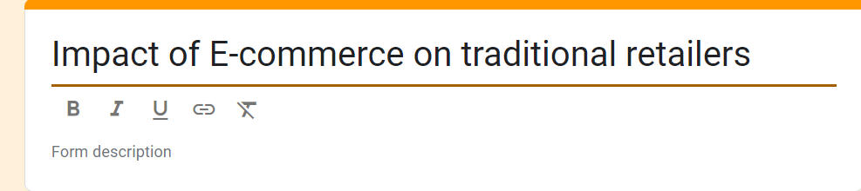

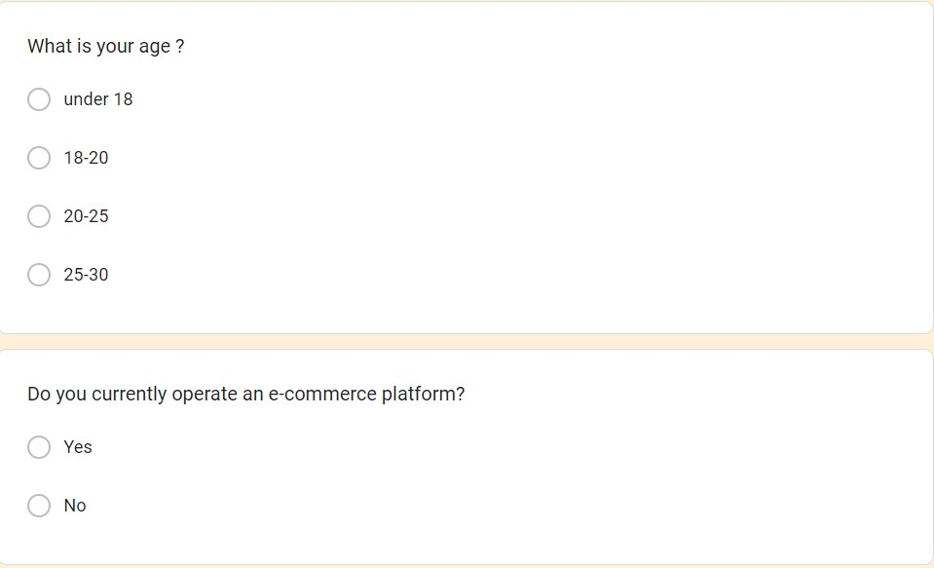

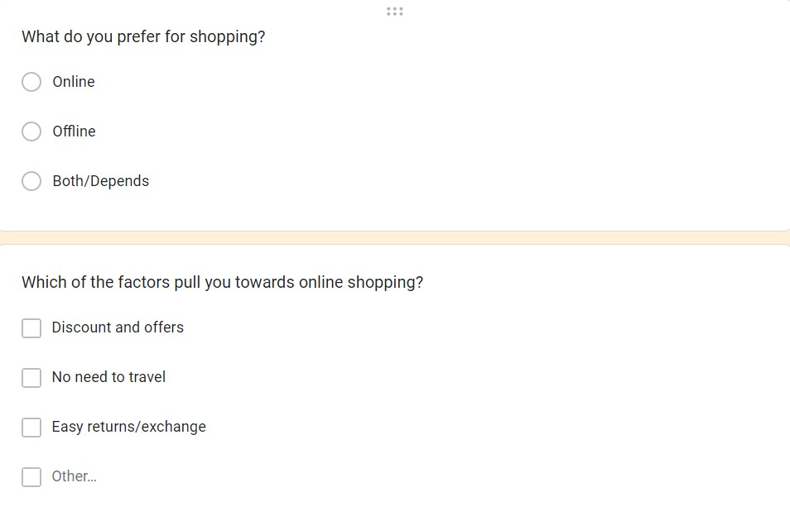

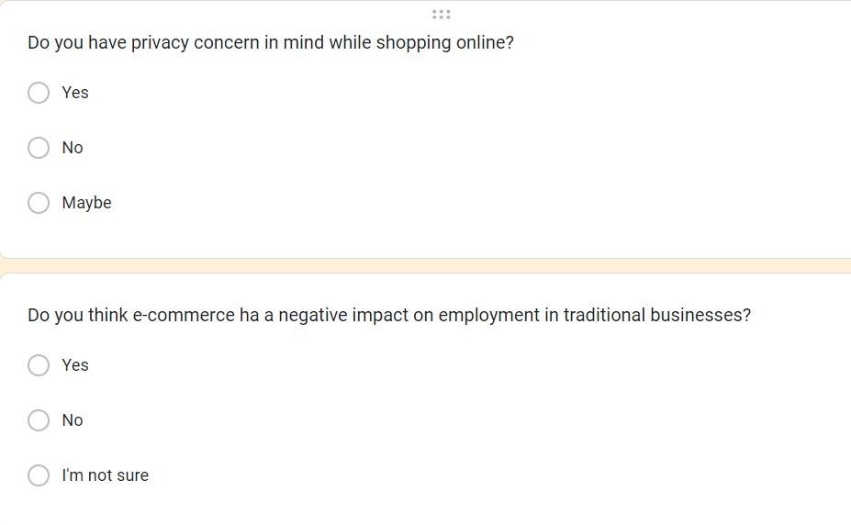

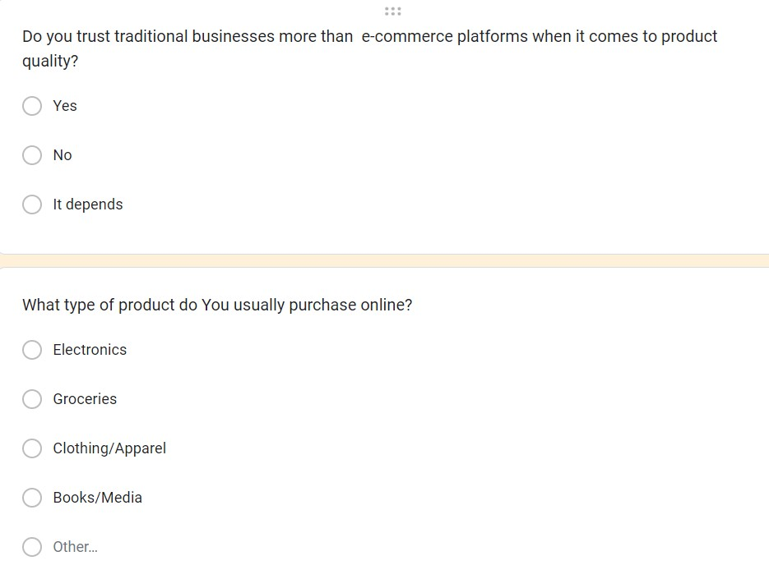

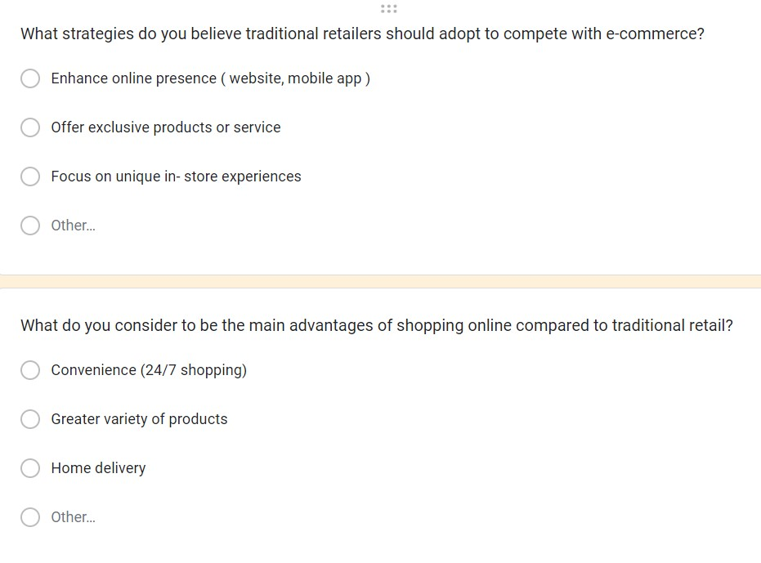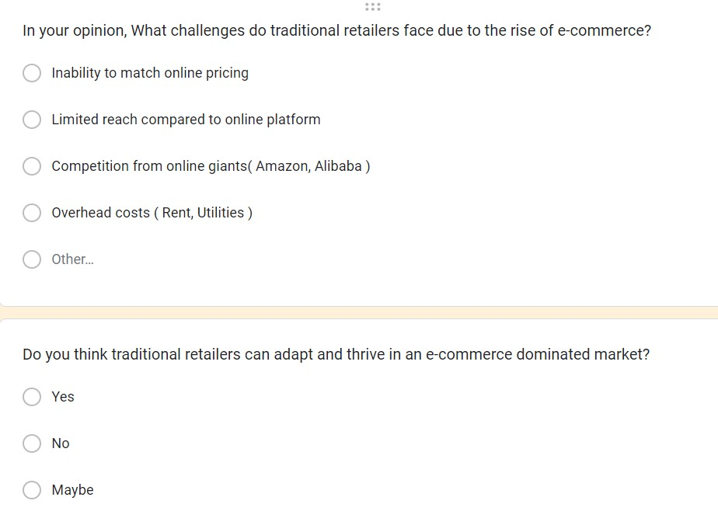

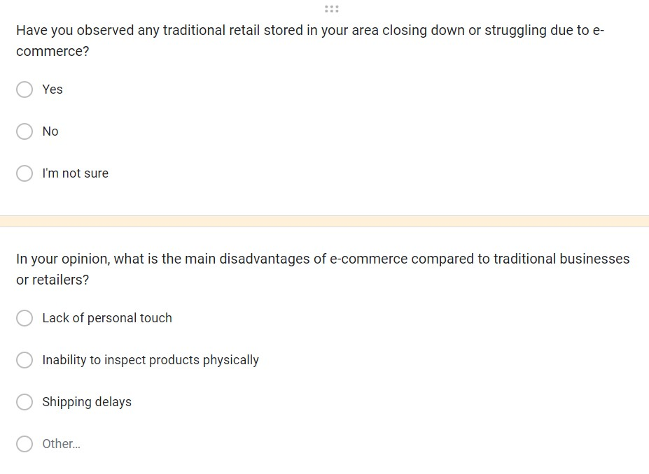

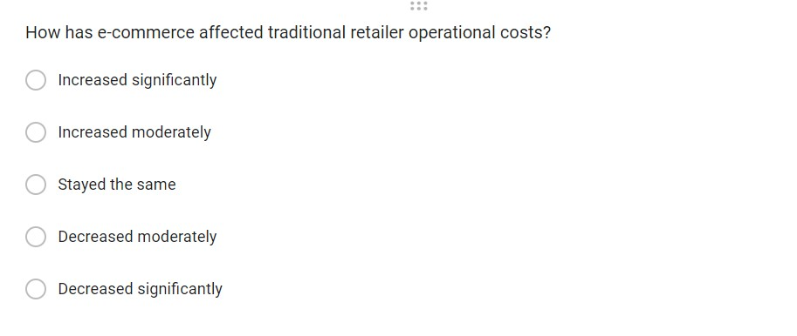

## Bibliography

<https://medium.com/@maazahmedbale9/the-rise-of-e-commerce-and-its-impact-on-traditional-retail-8d91d2cd4201>

<https://www.nielsen.com/sk/sk/insights/news/2018/online-shoppingfashion-first.html>

Sachenko, A. (2019). Electronic commerce systems. Retrieved March 22, 2019, from <http://www.scribd.com/doc/396840/Electronic-Commerce-Systems>

https://www.geeksforgeeks.org/impact-of-e-commerce-on-traditional-retail-business/

<https://chat.openai.com/>

<https://en.wikipedia.org/wiki/Literature_review>

<https://scholar.google.com/>

https://www.researchgate.net/publication/376387670_THE_IMPACT_OF_E-COMMERCE_ON_TRADITIONAL_RETAIL_A_COMPREHENSIVE_ANALYSIS_OF_ECONOMIC_SOCIAL_AND_POLICY_DIMENSIONS

<https://www.jetir.org/papers/JETIRCE06039.pdf>

…………………………………………………………………………………….