**SOFTWARE REQUIREMENTS**

**SPECIFICATIONS**

**EMPLOYEE MANAGEMENT SYSTEM**

Prepared by:

David Gomo 191761253

Aanchal Upreti 191764145

Tanjila Pranti 191764121

Semba Chisenga 191764134

**Table of Contents**

1. **Introduction**------------------------------------------------------------- 3
   1. Purpose------------------------------------------------------------- 3
   2. Scope---------------------------------------------------------------- 3
2. **Use Case(s**)

2.1 Use Case Diagram

2.2 Use Case Description

3. **Specific Requirements**

3.1 Functionality

3.2 Non-Functional Requirements

3.2.1 Usability

3.2.2 Availability

3.2.3 Reliability

3.2.4 Security

3.2.5 Integrity

3.2.6 Performance

3.2.7 Design Constraints

3.2.8 Portability

4. **User Interfaces**

**1. Introduction**

1.1 Purpose

The main objective of this project is to ease the job of the Human Resources Department of any firm or corporation by designing and developing an employee management system to fill existing gaps in the electronic management of employees.

A flexible and easy to use Employee Management software solution for small and medium sized companies provides modules for personnel information management thereby organization and companies are able to manage the crucial organization asset – people. The combination of these modules into one application assures the perfect platform for aligning Human Resource processes along with the organizational goals. This system brings about an easy way of maintaining the details of employees working in any organization.

It is simple to understand and can be used by anyone who is not even familiar with simple employee’s system. It is user friendly and just asks the user to follow step by step operations by giving easy to follow options. It is fast and can perform many operations for a company.

**1.2 Scope**

The designed system is a standalone software that can be used by Human Resources managers, business owners, finance department and other employees to view, edit and manage employee information. Below is a list of functionalities according to user roles:

1.2.1 USER (EMPLOYEES):

The system will be used by employees in organisations, to view their related information which includes their employee ID number, name, salary, attendance status, supervisor, department, daily tasks or projects, information about promotions and certifications, contract information and names of employees in the same department.

1.2.2 Administrators

Administrators such as Department Heads, Human Resources Managers, Executive Officers, Directors, Project Managers and will be able to view, edit, search and delete employee information based on their clearance.

The administrator will have an advantage of other users as the administrator to do the following:

1. Have the ability to access all the data and will be able to view, edit and search the records of other (employees) user.
2. The administrator can accept/reject leave application through the system. •
3. Project Management: Assign tasks and projects to employees, assign a project team and keep track of the progress.
4. Report generation: The HR dept. will be able to generate timely reports in order to monitor employees and this can be used for performance appraisals. The reports will have all the information of an employee from attendance status, trainings attended, projects done as well as technical skills.
5. Attendance status: The HR dept. will be able to view status of employee’s attendance and hence analyse their performance.

1.2.3 Finance Department

Finance department is given access to all employee records to enable them to access

Attendance records and calculate salaries.

**2 Use Cases**

## 2.1 Use Case Diagram

**\*user information (employee id, employee name, no. of years worked, designation, department, Salary, mobile no.)**

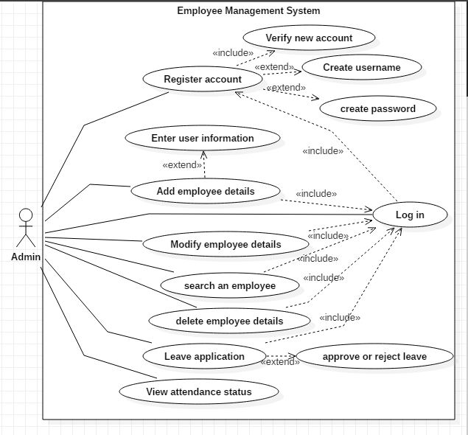

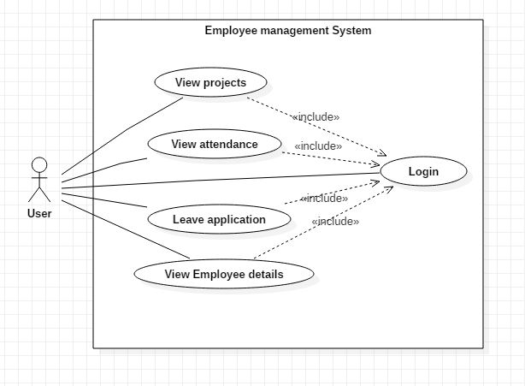

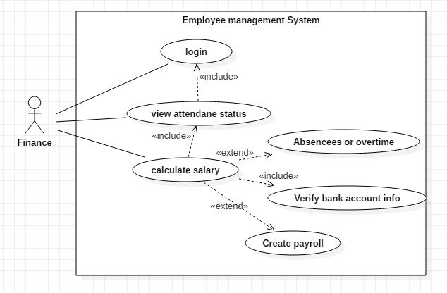

**2.2 Use Case Description**

|  |  |
| --- | --- |
| **Use Case ID:** | UC-1 |
| **Use Case Name:** | Register Account |
| **Actors:** | Admin, User, finance, HR |
| **Description:** | Register account by creating username and password |
| **Trigger:** | Actor selects register account option |
| **Preconditions:** | System displays register account option |
| **Post conditions:** | Successfully created account for an employee |
| **Normal Flow:** | 1. Actor selects register account 2. Actor selects the type of account to be created (USER or ADMIN, HR, Finance) 3. Actor creates username and password according to the type of account. 4. System sends account verification email to the users given email. 5. System displays account created successfully. |
| **Alternative Flows:** | None |
| **Exceptions:** | 1 a. In step 4 of the normal flow, if the user leaves any empty fields  1. System displays a message to fill in all required fields  2. Use Case resumes on step 3 of normal flow    2 a. In step 4 of the normal flow, if the email format is wrong  1. System displays a message to write correct email  2. User provides the correct email  3. Use case resumes to step 4 of normal flow |
| **Includes:** | 1. Create username 2. Create password |
| **Assumptions:** | None |
| **Notes and Issues:** | None |

|  |  |
| --- | --- |
| **Use Case ID:** | UC-2 |
| **Use Case Name:** | Login |
| **Actors:** | Admin, User, Recruiter, Finance |
| **Description:** | Actor would like to sign in to its account to perform desired activities |
| **Trigger:** | Actor clicks on Sign In option |
| **Preconditions:** | Actor has registered to the system |
| **Post conditions:** | Actor has logged into system successfully |
| **Normal Flow:** | 1. Actor launches application  2. User provides username and password according to the account type  3. User selects login  4. User has successfully logged in |
| **Alternative Flows:** | None |
| **Exceptions:** | 1 a. In step 3 of the normal flow, if the user enters wrong username, password  1. System displays a message to provide right credentials  2. Use Case resumes on step 4 of normal flow |
| **Includes:** | None |
| **Assumptions:** | User has already created an account with our system |
| **Notes and Issues:** | None |

|  |  |
| --- | --- |
| **Use Case ID:** | UC-3 |
| **Use Case Name:** | Verify new account |
| **Actors:** | User, Admin, Finance, Recruiter |
| **Description:** | Actor would like to verify its new account to make sure its active |
| **Trigger:** | Actor has registered to our application |
| **Preconditions:** | Actor has logged in successfully |
| **Post conditions:** | 1. Actor views the auto-generated email on its registered account  2. Actor selects the verification link  3. Actor provides verification credentials  4. Actor has successfully verified its account |
| **Normal Flow:** | 1 a. In step 3 of the normal flow, if the user enters wrong verification credentials, password  1. System displays a message to provide right credentials  2. Use Case resumes on step 4 of normal flow |
| **Alternative Flows:** | None |
| **Exceptions:** | None |
| **Includes:** | None |
| **Assumptions:** | Actor has already signed up on our system |
| **Notes and Issues:** | None |

|  |  |
| --- | --- |
| **Use Case ID:** | UC-4 |
| **Use Case Name:** | Add employee details |
| **Actors:** | Admin |
| **Description:** | Admin adds the details of an employee to the system. |
| **Trigger:** | Admin selects add employee details option from the menu |
| **Preconditions:** | Admin logs in to the system |
| **Post conditions:** | Admin successfully adds details of an employee into the system |
| **Normal Flow:** | 1. Admin logs into the system  2. Admin selects add employee details from menu  3. Admin adds details of an employee i.e. Emp id, Name, Salary, No. of Years worked, Designation, Department etc.  4. System saves the details.  5. Admin selects the exit option. |
| **Alternative Flows:** | None |
| **Exceptions:** | 1 a. In step 3 of the normal flow, if the admin leaves any empty fields  1. System displays a message to fill in all required fields  2. Use Case resumes on step 3 of normal flow |
| **Includes:** | None |
| **Assumptions:** | Admin has successfully logged into the system |
| **Notes and Issues:** | None |

|  |  |
| --- | --- |
| **Use Case ID:** | UC-5 |
| **Use Case Name:** | Update employee details |
| **Actors:** | Admin |
| **Description:** | User will be able to update employee profile to keep its account updated with its current credentials |
| **Trigger:** | Admin selects update employee details option from the menu |
| **Preconditions:** | Admin logs in to the system |
| **Post conditions:** | Admin successfully updates details of an employee into the system |
| **Normal Flow:** | 1. Admin logs into the system  2. Admin selects updates employee details from menu  3. Admin update details of employee i.e. Emp id, Name, Salary,Years worked, Designation, Department etc. according to the need.  4. System saves the details.  5. Admin selects the exit option. |
| **Alternative Flows:** | None |
| **Exceptions:** | 1 a.In step 3 of the normal flow, if the admin leaves any empty fields  b. System displays a message to fill in all required fields  2. Use Case resumes on step 3 of normal flow |
| **Includes:** | None |
| **Assumptions:** | Admin has successfully logged into the system |
| **Notes and Issues:** | None |

|  |  |
| --- | --- |
| **Use Case ID:** | UC-6 |
| **Use Case Name:** | Search an employee |
| **Actors:** | Admin |
| **Description:** | Admin will be able to search employee details by entering employee id to be searched |
| **Trigger:** | Admin selects search employee details option from the menu |
| **Preconditions:** | Admin logs in to the system |
| **Post conditions:** | Admin successfully get details of an employee to be searched. |
| **Normal Flow:** | 1. Admin logs into the system  2. Admin selects search employee details from menu  3. Admin enters the employee id to be searched.  4. Admin get details of an employee i.e. Emp id, Name, Salary, No. of Years worked, Designation, Department etc. according to the need.  5. Admin selects the exit option. |
| **Alternative Flows:** | None |
| **Exceptions:** | 1 a. In step 3 of the normal flow, if the admin provides mismatching emp id  1. System displays a message to mismatched user credentials  2. Use Case resumes on step 2 of normal flow |
| **Includes:** | None |
| **Assumptions:** | Admin has successfully logged into the system and provides valid emp id. |
| **Notes and Issues:** | None |

|  |  |
| --- | --- |
| **Use Case ID:** | UC-7 |
| **Use Case Name:** | Delete employee details |
| **Actors:** | Admin |
| **Description:** | Admin will be able to delete employee details for the employees not working in company anymore. |
| **Trigger:** | Admin selects delete employee details option from the menu |
| **Preconditions:** | Admin logs in to the system |
| **Post conditions:** | Admin successfully deletes details of an employee from the system. |
| **Normal Flow:** | 1. Admin logs into the system  2. Admin selects delete employee details from menu  3. Admin deletes details of an employee i.e. Emp id, Name, Salary, No. of Years worked, Designation, Department etc.  5. Admin selects the exit option. |
| **Alternative Flows:** | None |
| **Exceptions:** | 1 a. In step 3 of the flow, if admin provides mismatching emp id  1. System displays a message to mismatched user credentials  2. Use Case resumes on step 2 of normal flow |
| **Includes:** | None |
| **Assumptions:** | Admin has successfully logged in and provides valid emp id. |
| **Notes and Issues:** | None |

|  |  |
| --- | --- |
| **Use Case ID:** | UC-8 |
| **Use Case Name:** | Leave application |
| **Actors:** | Admin, user |
| **Description:** | User will be able to apply for leave and admin to approve or reject leave |
| **Trigger:** | Actors selects leave application option from the menu |
| **Preconditions:** | Actors logs in to the system |
| **Post conditions:** | User successfully apply for leave and admin successfully approve or reject leave. |
| **Normal Flow:** | 1. Actor logs into the system  2. Actor selects leave application option from menu  3. User apply for leave and admin approves or reject leave.  5. Actor selects the exit option. |
| **Alternative Flows:** | None |
| **Exceptions:** | 1 a. In step 3 of the normal flow, if the user leaves any empty fields  1. System displays a message to fill in all required fields  2. Use Case resumes on step 3 of normal flow |
| **Includes:** | 1. User applies for leave. 2. Admin approves or rejects leaves. |
| **Assumptions:** | Actor has successfully logged into the system. |
| **Notes and Issues:** | None |

|  |  |
| --- | --- |
| **Use Case ID:** | UC-9 |
| **Use Case Name:** | View attendance status |
| **Actors:** | Admin, user, finance |
| **Description:** | Actors will be able to view attendance status. |
| **Trigger:** | Actors selects view attendance status option from the menu |
| **Preconditions:** | Actors logs in to the system |
| **Post conditions:** | Actors successfully get information about employee attendance records. |
| **Normal Flow:** | 1. Actor logs into the system  2. Actor selects view application option from menu.  3. Actor selects the exit option. |
| **Alternative Flows:** | None |
| **Exceptions:** | None |
| **Includes:** | 1 a. In step 2 of the normal flow, finance calculates the salary according to the attendance status.  2. Use Case resumes on step 2 of normal flow |
| **Assumptions:** | Actor has successfully logged into the system. |
| **Notes and Issues:** | None |

|  |  |
| --- | --- |
| **Use Case ID:** | UC-10 |
| **Use Case Name:** | Calculate salary |
| **Actors:** | Finance |
| **Description:** | Finance dept. will be able to calculate salary according to the attendance status |
| **Trigger:** | Actor selects calculate salary option from the menu |
| **Preconditions:** | Actor views attendance status |
| **Post conditions:** | Finance successfully calculates salary of employees after viewing attendance status. |
| **Normal Flow:** | 1. Actor logs into the system  2. Actor selects calculate salary option from menu  3. Actor gets info of attendance status and calculates salary.  5. Actor selects the exit option. |
| **Alternative Flows:** | None |
| **Exceptions:** | None |
| **Includes:** | Finance dept. views attendance status |
| **Assumptions:** | Actor has successfully logged into the system. |
| **Notes and Issues:** | None |

|  |  |
| --- | --- |
| **Use Case ID:** | UC-11 |
| **Use Case Name:** | Verify bank account info |
| **Actors:** | Finance |
| **Description:** | Actor would like to verify bank account info with employee id. |
| **Trigger:** | Actor has registered to our application |
| **Preconditions:** | Actor has logged in successfully |
| **Post conditions:** | 1. Actor select views employee’s details option  2. Actor compare bank account info with employee id  3. Actor successfully verifies employees bank account and id. |
| **Normal Flow:** | 1 a. In step 2 of the normal flow, if the actor enters wrong verification credentials, bank account and emp id  1. System displays a message to provide right credentials  2. Use Case resumes on step 2 of normal flow |
| **Alternative Flows:** | None |
| **Exceptions:** | None |
| **Includes:** | None |
| **Assumptions:** | Actor has already signed up on our system |
| **Notes and Issues:** | None |

|  |  |
| --- | --- |
| **Use Case ID:** | UC-12 |
| **Use Case Name:** | View projects |
| **Actors:** | User, admin |
| **Description:** | Actor would like to view projects details. |
| **Trigger:** | Actor has registered to our application |
| **Preconditions:** | Actor has logged in successfully |
| **Post conditions:** | 1. Actor select views project’s details option  2. Actor successfully get info on project details and can check their progress. |
| **Normal Flow:** | 1 a. In step 2 of the normal flow,  1. System displays a chat box to communicate with team mates and admin.  2. Use Case resumes on step 2 of normal flow |
| **Alternative Flows:** | None |
| **Exceptions:** | None |
| **Includes:** | Send messages |
| **Assumptions:** | Actor has already signed up on our system |
| **Notes and Issues:** | None |

1. **Specific Requirements**

Below are the functional requirements for our system

**3.1 Functional Requirements**

Functional Requirement One

|  |  |
| --- | --- |
| Identifier | FR-1 |
| Title | Registration |
| Requirement | Employee registers into the system when they commence employment |
| Rationale | Allows organisation to have access to employee profile |
| Restrictions and Risk | User should be an employee of the organisation |
| Dependencies | FR-2, FR-3, FR-4, FR-5 |
| Priority | High |

Functional Requirement Two

|  |  |
| --- | --- |
| Identifier | FR-2 |
| Title | Account type |
| Requirement | User selects account type during registration |
| Rationale | To allow user to select whether they are system administrator or they are general employee |
| Restrictions and Risk | User should be an employee of the organisation |
| Dependencies | FR-2, FR-3, FR-4, FR-5 |
| Priority | High |

Functional Requirement Three

|  |  |
| --- | --- |
| Identifier | FR-3 |
| Title | Provide Account Information |
| Requirement | User provides their information in accordance with the account type |
| Rationale | To collect necessary information about user that can be used within the system |
| Restrictions and Risk | User should be an employee of the organisation  Information provided should be entirely correct for safety of other system users |
| Dependencies | FR-2, FR-4, FR-5 |
| Priority | High |

Functional Requirement Four

|  |  |
| --- | --- |
| Identifier | FR-4 |
| Title | Validate User Information |
| Requirement | System should be able to confirm that the provided user information is valid |
| Rationale | To ensure that all information entered is correct |
| Restrictions and Risk | None |
| Dependencies | FR-2, FR-3, |
| Priority | High |

Functional Requirement Five

|  |  |
| --- | --- |
| Identifier | FR-5 |
| Title | User Login |
| Requirement | User needs to enter login information in order to enter into the system |
| Rationale | To allow registered users to use the system |
| Restrictions and Risk | Login information should be correct |
| Dependencies | FR-2, FR-3, FR-4 |
| Priority | High |

Functional Requirement Six

|  |  |
| --- | --- |
| Identifier | FR-6 |
| Title | View Personal Information |
| Requirement | User needs to login to view their related employee information |
| Rationale | To allow registered users to view their personal information |
| Restrictions and Risk | Can only be used after login |
| Dependencies | FR-2, FR-3, FR-4, FR-5 |
| Priority | High |

Functional Requirement Seven

|  |  |
| --- | --- |
| Identifier | FR-7 |
| Title | View Employee Information |
| Requirement | Administrators can view all the recorded employee information |
| Rationale | To allow registered administrators to know information about employees |
| Restrictions and Risk | Can be used only by administrator accounts |
| Dependencies | FR-2, FR-3, FR-4, FR-5 |
| Priority | High |

Functional Requirement Eight

|  |  |
| --- | --- |
| Identifier | FR-8 |
| Title | Edit Employee Information |
| Requirement | Administrators can update the recorded employee information |
| Rationale | To allow registered administrators to update database |
| Restrictions and Risk | Can be used only by administrator accounts |
| Dependencies | FR-2, FR-3, FR-4, FR-5 |
| Priority | High |

Functional Requirement Nine

|  |  |
| --- | --- |
| Identifier | FR-9 |
| Title | Email Verification |
| Requirement | System sends an automated email to user |
| Rationale | To verify user identity |
| Restrictions and Risk | Email address has to be the same as one in database |
| Dependencies | FR-1, FR-3 |
| Priority | High |

Functional Requirement Ten

|  |  |
| --- | --- |
| Identifier | FR-10 |
| Title | Department Search |
| Requirement | System provides access to all employees to names of their colleagues in the same department |
| Rationale | Allow workers in the same department to view who they are working with and who they report to |
| Restrictions and Risk | Access restricted to same department |
| Dependencies | FR-1,RR-2,FR3 |
| Priority | High |

Functional Requirement Eleven

|  |  |
| --- | --- |
| Identifier | FR-11 |
| Title | Task Assignment |
| Requirement | System provides for head of departments to assign tasks to employees |
| Rationale | Allow employees and employers to communicate about tasks quickly |
| Restrictions and Risk | Employer, department heads |
| Dependencies | Fr-5 |
| Priority | High |

Functional Requirement Twelve

|  |  |
| --- | --- |
| Identifier | FR-12 |
| Title | View Projects |
| Requirement | System provides access to employees to view projects and tasks assigned by the employer |
| Rationale | Allow employees and employers to communicate about tasks quickly |
| Restrictions and Risk |  |
| Dependencies | Fr-5 |
| Priority | High |

Functional Requirement Thirteen

|  |  |
| --- | --- |
| Identifier | FR-13 |
| Title | Add New Employee |
| Requirement | System provides a way for employers to add new employees to their database |
| Rationale | Allow for the creation of new employee accounts after employee has been added to database |
| Restrictions and Risk | Administrator access |
| Dependencies | FR-1,RR-2,FR3 |
| Priority | High |

Functional Requirement Fourteen

|  |  |
| --- | --- |
| Identifier | FR-14 |
| Title | Delete Employee |
| Requirement | System provides access for employers and heads of departments to delete employees |
| Rationale | To allow for the removal of accounts belonging to employees who have left the organisation |
| Restrictions and Risk | Administrator access |
| Dependencies | FR-5 |
| Priority | High |

Functional Requirement Fifteen

|  |  |
| --- | --- |
| Identifier | FR-15 |
| Title | Leave Application |
| Requirement | The employee has to submit a request for leave through the system |
| Rationale | To allow records of leaves requested to be recorded in the system |
| Restrictions and Risk | User hasn’t used up leave days |
| Dependencies | FR-5 |
| Priority | High |

Functional Requirement Sixteen

|  |  |
| --- | --- |
| Identifier | FR-16 |
| Title | Approve/Reject Leave |
| Requirement | The head of department approves or rejects the application for leave |
| Rationale | To allow the employer to grant or deny a leave application in the system |
| Restrictions and Risk | User Has to be employer |
| Dependencies | FR-5 |
| Priority | High |

Functional Requirement Seventeen

|  |  |
| --- | --- |
| Identifier | FR-17 |
| Title | View Attendance Status |
| Requirement | Human Resources Department and administrators can access user attendance records |
| Rationale | Allow employers to be aware and to use user attendance records as they see fit |
| Restrictions and Risk | Administrator, employer and heads of departments have access |
| Dependencies | FR-5 |
| Priority | High |

Functional Requirement Eighteen

|  |  |
| --- | --- |
| Identifier | FR-18 |
| Title | Calculate absences/overtime |
| Requirement | System calculates absences and overtime by comparing the amount of time attended against the amount of required time |
| Rationale | Allow employers to be aware and to use user attendance records as they see fit |
| Restrictions and Risk | Administrator, employer and heads of departments have access |
| Dependencies | FR-5 |
| Priority | High |

Functional Requirement Nineteen

|  |  |
| --- | --- |
| Identifier | FR-19 |
| Title | Calculate Salary |
| Requirement | The finance department calculates employee salary based on attendance record of user |
| Rationale | To allow for accurate calculation of salary through recorded attendance |
| Restrictions and Risk | Employee may not have recorded all their attendance  Employee has to be eligible for salary |
| Dependencies | FR-5 |
| Priority | High |

Functional Requirement Twenty

|  |  |
| --- | --- |
| Identifier | FR-20 |
| Title | Verify Bank Account Information |
| Requirement | System verifies employee bank account information automatically by carrying out comparison between employee records and the listed bank accounts |
| Rationale | To ensure the safe and secure deposit of salaries to employees |
| Restrictions and Risk | Automatic process, no human intervention  If employee changes bank account, they have to personally report to the employer so that their records are updated before payroll is produced |
| Dependencies | FR-5 |
| Priority | High |

Functional Requirement Twenty-One

|  |  |
| --- | --- |
| Identifier | FR-21 |
| Title | Create Payroll |
| Requirement | System creates payroll based on employee records |
| Rationale | Allow employers to view and print out a periodical payroll with ease |
| Restrictions and Risk | Employer access only |
| Dependencies | FR-5,FR-19,FR20 |
| Priority | High |

**Non – Functional Requirements**

3.2.1 Usability

|  |  |  |
| --- | --- | --- |
| Identifier | NFR-1 | |
| Title | Usability | |
| Requirements | US-1 | Convenience for admin (HR), user(employee), and finance department to keep records of employees |
| Us-2 | Application will have user friendly self-explanatory interface |
| US-3 | It will take few hours of usage to get completely understand the functionality of the Application. |

3.2.2 Availability

|  |  |  |
| --- | --- | --- |
| Identifier | NFR-2 | |
| Title | Availability | |
| Requirements | US-1 | Only to the Company’s stakeholder i.e. Admin, user and finance |
| Us-2 | Available if the user has registered an account on the system. |

3.2.3 Reliability

|  |  |  |
| --- | --- | --- |
| Identifier | NFR-3 | |
| Title | Reliability | |
| Requirements | RE-1 | Reliable for keeping and maintaining employee’s record. |
| RE-2 | Accessible only if the user has registered an account on the system. |

3.2.4 Security

|  |  |  |
| --- | --- | --- |
| Identifier | NFR-4 | |
| Title | Security | |
| Requirements | SE-1 | Only authorized stakeholder can access the system |
| SE-2 | Encrypted with unique username and password for each stakeholder. |
| SE-3 | Only admin and finance can access the critical information of employee. |

3.2.5 Integrity

|  |  |  |
| --- | --- | --- |
| Identifier | NFR-5 | |
| Title | Integrity | |
| Requirements | IN-1 | System shall protect against the unauthorized data changes and deletion. |
| IN-2 | System shall update a record completely or not at all to guard against partially filled data inconsistency |
| SE-3 | Only admin and finance can access the critical information of employee. |

3.2.6 Performance

|  |  |  |
| --- | --- | --- |
| Identifier | NFR-6 | |
| Title | Performance | |
| Requirements | PR-1 | Tested and Approved |
| PR-2 | Meets stakeholders’ requirements |

3.2.7 Design Constraints

|  |  |  |
| --- | --- | --- |
| Identifier | NFR-7 | |
| Title | Design Constraints | |
| Requirements | DC-1 | GUI |
| DC2 | C++ compilation |
| DC-3 | UML drawings |

3.2.8 Supportability

|  |  |  |
| --- | --- | --- |
| Identifier | NFR-8 | |
| Title | Supportability | |
| Requirements | SA-1 | The system shall operate on company’s local network. |

1. **Interfaces**

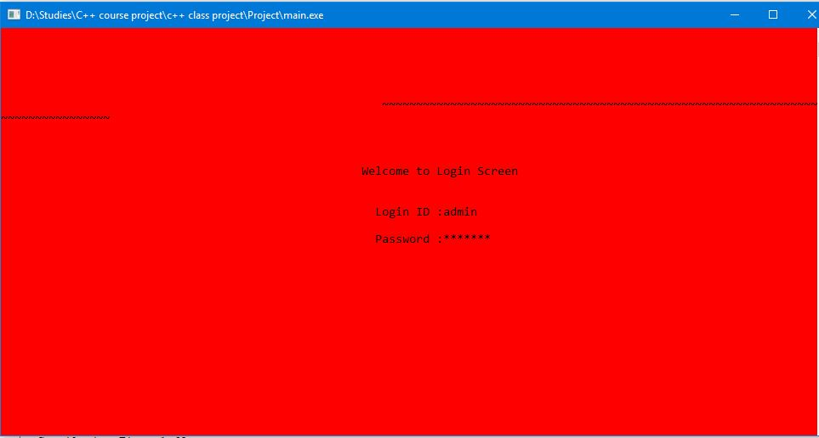

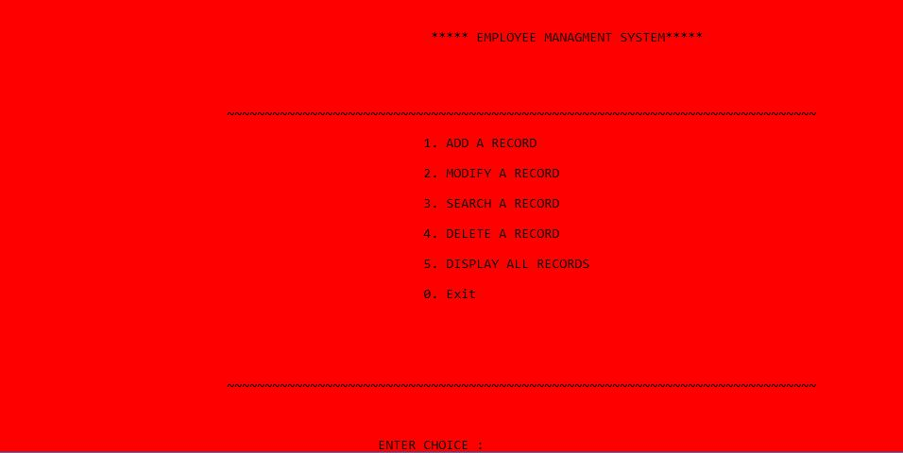

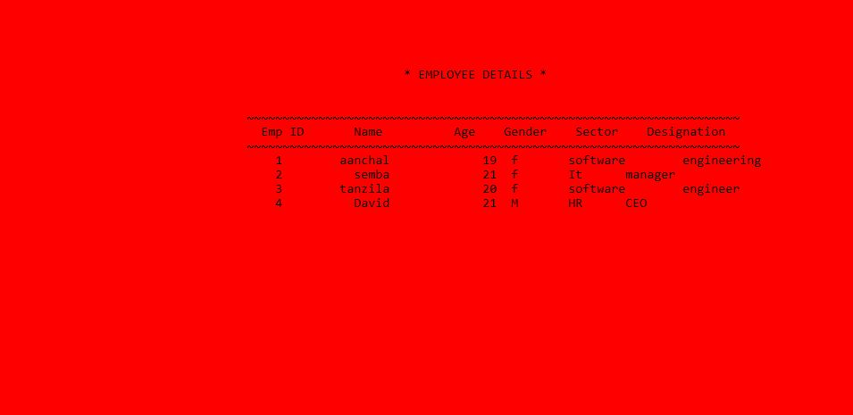

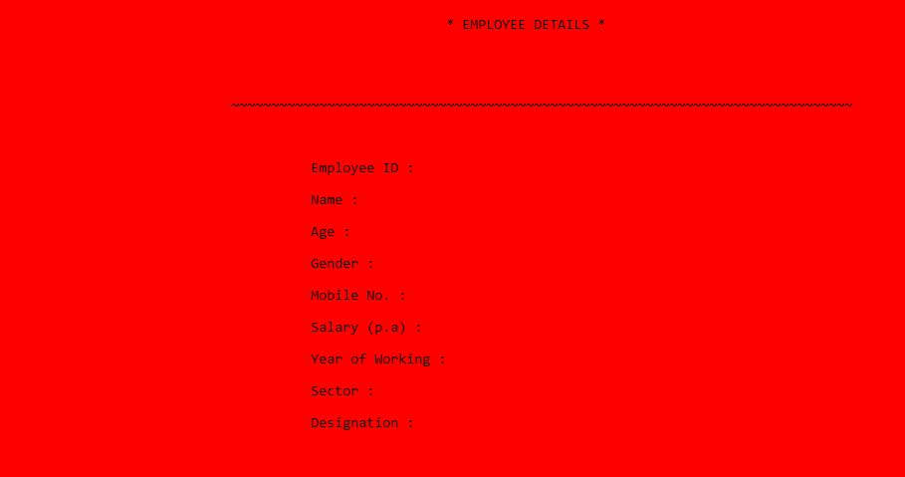

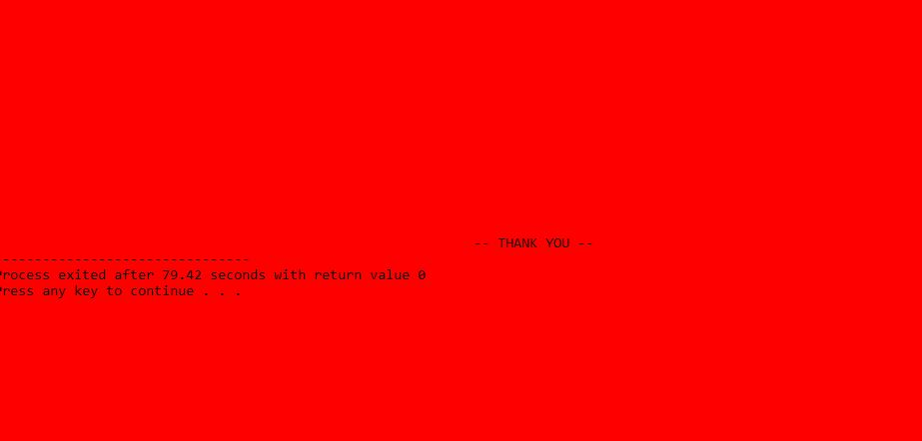

Work iteration

|  |  |  |
| --- | --- | --- |
| **Name** | **Work** | **Duration** |
| **Aanchal Upreti** | Intro, Use case diagram, UC-1, UC-2, UC-3, Table 1 and 2, Usability Availability, Conclusion | Week 9th to Mid-Week 11th |
| **David** | Scope, UC- 4, UC-5, Table 3 and 4 Reliability, Security, Conclusion | Week 9th to Mid-Week 11 |
| **Tanjila** | UC-6, UC-7, Table 5, Integrity, Performance | Week 9th to Mid-Week 11th |
| **Semba** | UC-8, Table 6 and 7, Design Constraints, Supportability | Week 9th to Mid-Week 11th |

**Note:** Everyone worked for the code to one’s capability.

User Interface is abstracted from the DevC++ Compiler after the code was compiled and Run.