Progress Report 3: Data Exploration
Team 04: Aakash Nihalaney, Anrunya Patole, Harsh Sahu, Shreyas Desai

Predicting Species Extinction Risk Using Environmental and Anthropogenic Indicators

Table of Contents
Progress Report 2: Data Exploration 1
1. Introduction 2
1.1 Business Intelligence Issue, Motivation, and Possible Impact 2
1.2 Background Research and Associated Research 2
1.3 Objectives, Focus, Challenges, and Models 3
2. Data Exploration 5
2.1 Dataset Overview 5
2.2 Variable Distributions and Interpretations 7
2.2 Scatterplot Matrix 9
3. Interdependence Analysis 11
3.1 Principal Component Analysis (PCA) 11
3.2 Clustering Analysis 14
4.Dependence Analysis Report 20
4.1. Logistic Regression Findings 20
4.2. Decision Tree Findings 22
4.3. Interpretation and Strategic Implications 24
5. Model Comparison 25
5.1 Logistic Regression 26
5.2 Neural Network 29
5.3 Support Vector Machine 32
5.4 Stacking Ensemble 35
5.5 Comparison Results 38
5.6 Recommendations 41
References 42
Appendix 43

1. Introduction

1.1 Business Intelligence Issue, Motivation, and Possible Impact
Biodiversity loss is one of the most critical environmental issues facing our world, and it has a wide range of implications not only for the ecosystems but also for human societies. The purpose of this project is to apply data-driven modelling in order to predict species that are on the verge of extinction with variables such as habitat destruction, climate change, pollution, human activities, and conservation activities. The end goal is to design predictive models to rank which ecosystems and species should receive the greatest attention and intervention.
The compelling reason for this work is the fundamental significance that biodiversity plays in guaranteeing ecological resilience, food security, economic sustainability, and human health. Extinction may unleash cascading effects that destabilize ecosystems, disrupt food webs, and jeopardize the provision of essential services like climate regulation and pollination. Moreover, most economies rely on biodiversity through sectors such as agriculture, fisheries, and eco-tourism. By specifying species most at risk, predictive models can inform conservation efforts aimed at where they will have the greatest impact, e.g., obtaining the maximum return on scarce conservation funds, and informing public policy intended to halt biodiversity loss. In addition to benefits at the level of implementation, such models can promote a civic awareness by rendering more explicit and available the urgency of the need for conservation action.
The value of good models of extinction hazard is thus two-fold. Conservation policy can become more focused and evidence-based, directing efforts and resources to the most endangered species. Economic sectors that depend on intact ecosystems, such as tourism and agriculture, will benefit from the conservation of biodiversity. Ecologically, species diversity is valuable to promote resilience and adaptability in the face of environmental change. Finally, increased public perception of extinction risk can also render educational programs and outreach more effective, which results in greater social support for conservation initiatives.

1.2 Background Research and Associated Research
Extinction threat research has been guided by a growing body of literature of research that identifies key drivers of species threat and highlights the utility of predictive modeling. For instance, Cardillo et al. (2005) examined the causes of the high threat of extinction of large mammals and concluded that habitat loss, low birth rates, and anthropogenic factors account for much of the variation among species in threat. It provides evidence of the importance of multifactorial models involving environmental as well as biological factors and establishing a platform for predictive work to follow [1].
Purvis et al. (2000) made an important contribution by the building of a predictive model that used life history traits and environmental pressure. By showing that extinction risk was not randomly distributed across species but was instead strongly correlated with some measurable factors, their work suggests that predictive analytics has an important potential role to play in conservation planning in that it can provide early warnings for species put into increased risk [2].
Within the freshwater environment, Böhm et al. (2016) underscored freshwater organisms, with a particular focus on their unique susceptibility to threats such as pollution, climate change, and overexploitation by humans. The study pointed out that freshwater ecosystems present special challenges compared to terrestrial or marine ecosystems and that predictive models must be calibrated to the ecological setting in order to be effective. This insight is particularly relevant to our project because it implies the call for delicate policies that consider ecosystem-specific risks [3].
Davidson et al. (2012) examined drivers of extinction in marine mammals, revealing the importance of spatial structure and human-associated pressure, such as overfishing and habitat degradation. Their conclusions are that consideration of geographic and regional factors as inputs into predictive models can refine accuracy and conservation efforts can efficiently be targeted toward high-risk geographies. Spatial emphasis is worth it since the risk of extinction is clustered into certain geographic hotspots [4].
Finally, Di Marco et al. (2014) employed machine learning methods to measure the effectiveness of global conservation efforts and utilized predictive models to prove that they can inform decision-making by identifying those conservation efforts that bring the maximum benefits. Their article not only demonstrates the efficacy of advanced analytics for conservation but also demands predictive and prescriptive models that make data-driven recommendations to policymakers and conservationists [5].

1.3 Objectives, Focus, Challenges, and Models
A primary goal of this project is to create models that predict threats of extinction across species based on a range of variables from environmental, biological, and human-restricted realms. Through analysis of such variables, this project attempts to identify causative drivers primarily responsible for extinction and develop theories that might shape future conservatory initiatives. The focus of the analysis will be on how factors such as habitat destruction, pollution, poaching wildlife trade, and presence of protected areas influence extinction threat among species. The objective will be to categorize species into high-risk and low-risk classes using machine learning techniques, to possess a data-driven framework to prioritize conservation.
Several challenges will be anticipated in this project. The information used in this project is not real and may not be representative of the amount of complexity and randomness that is present in real-world ecosystems, therefore limiting the extent of generalizability of the models. Certain variables, such as "Illegal Wildlife Trade Rate" or "Food Availability," are represented as scaled indices, which may involve subjective judgments that add noise or bias. In addition, the adoption of a binary "Protected Area" tag may fail to identify varying levels of protection effectiveness in different regions. Geographic variation is also simplified into one "Region" tag that could minimize spatial complexities.
Methodologically, conditions such as multicollinearity among variables (e.g., habitat loss and deforestation rate) could render interpretation of model output challenging. The second problem, and a harder one, is balancing predictive accuracy with interpretability, especially in the context of potentially imbalanced classes where the number of non-extinct species dominates the number of extinct ones. A variety of machine learning models will be attempted to overcome these difficulties. Logistic regression will provide a straightforward baseline for binary classification, and decision trees and random forests will provide some view into variable importance. Support vector machines (SVM) will be employed to model non-linear decision boundaries, and gradient boosting techniques like XGBoost will be used to obtain the best predictive performance. Although simple models like k-nearest neighbors (KNN) may be employed, they are less interpretable and therefore less useful to obtain conservation results. Of these, random forests and gradient boosting should find the optimal balance between accuracy and interpretability and thus are best suited for the task.

2. Data Exploration

2.1 Dataset Overview
In this project, we developed a custom dataset titled “Species Extinction Risk Dataset” using Generative AI techniques, designed to simulate realistic ecological and environmental conditions relevant to extinction risk modeling. This synthetic dataset was created by our team to address the lack of readily available, detailed, and well-structured real-world datasets that combine ecological, biological, and human-influenced risk factors at a global scale. By generating artificial yet ecologically plausible records, the dataset provides a robust foundation for conducting business intelligence modeling, specifically targeting classification tasks.
The dataset contains 1,885 individual records, with each record representing a unique species and the environmental, biological, and anthropogenic conditions it faces. The goal of the analysis is to predict whether a species is at risk of extinction, making this a binary classification problem where the target variable, Extinction Risk, is coded as 0 (not at risk) or 1 (at risk).
One of the strengths of this dataset lies in its integration of 14 diverse variables that capture multiple dimensions of species vulnerability. These include both categorical variables (such as species name and geographic region) and numerical variables (such as pollution level and human population density). The numerical variables were generated to reflect realistic value distributions based on known ecological trends, while categorical variables were designed to cover a range of plausible ecological and geographic conditions. Together, these variables offer a multidimensional perspective on extinction risk and allow the use of advanced machine learning techniques to uncover complex patterns.
Table 2.1.1 provides a summary of the key variables included in the dataset, outlining their names, descriptions, and data types.
Variable Name | Description | Data Type
Species | Common name of the species | Categorical
Region | Geographic region where the species resides | Categorical
Pollution Level (0–100) | Pollution index in the species’ habitat | Numerical
Illegal Wildlife Trade Rate (0–100) | Index indicating pressure from illegal trade | Numerical
Food Availability (0–100) | Availability of food in the species' habitat | Numerical
Human Population Density (People/km²) | Population density near the species' region | Numerical
Species Reproduction Rate (Births/year) | Reproductive rate of the species per year | Numerical
Climate Change Impact (%) | Percentage impact of climate change on species’ environment | Numerical
Protected Area Presence (0/1) | Whether the species' region is in a protected conservation area | Categorical
Invasive Species Presence (0/1) | Presence of invasive species in the species’ environment | Categorical
Extinction Risk (0/1) | Whether the species is classified as at risk (target variable) | Numerical
Table 2.1.1: Summary of Key Variables in the Dataset

2.2 Variable Distributions and Interpretations
The distribution of pollution levels (Figure 2.1) shows a slightly left-skewed pattern, with most values clustered between 40 and 90 on a 0–100 scale. This suggests that many species are exposed to consistently high levels of pollution, which is concerning given the well-documented impacts of pollution on habitat quality, health stress, and reproductive success. The concentration of species under these conditions points to pollution as a key contributor to extinction risk, underscoring the importance of environmental regulation and remediation in conservation planning.
The illegal wildlife trade rate (Figure 2.2) displays a fairly even distribution, with most data points falling between 30 and 70. This pattern highlights the widespread nature of illegal trade across regions and species, with only a few cases of very low or exceptionally high trade pressures. Given that illegal wildlife trade directly depletes populations and disrupts reproductive cycles, its pervasive presence in the dataset emphasizes the need for targeted enforcement efforts to reduce this human-driven threat.
Food availability (Figure 2.3) is strongly right-skewed, with the majority of values concentrated between 0 and 40. This indicates that many species face limited or moderate access to food resources, a critical factor influencing population viability. Low food availability increases competition, malnutrition, and mortality, all of which heighten extinction risk. The rarity of high food availability points to widespread resource scarcity across species and ecosystems.
Human population density (Figure 2.4) shows a pronounced right skew, with most species occurring in areas of low human density, but with a small subset exposed to very high-density regions. High human population densities are often associated with urbanization, habitat fragmentation, and pollution, making this a major predictor of extinction risk. Understanding where species overlap with dense human populations can help conservationists identify priority areas for intervention.
The distribution of species reproduction rate (Figure 2.5) follows a bell-shaped curve centered around two births per year. While most species cluster between 1.5 and 2.5 births, a few outliers exhibit much higher reproductive rates. Since species with low reproductive rates are less able to recover from population shocks, this variable is particularly important in modeling extinction vulnerability.
Climate change impact (Figure 2.6) is slightly left-skewed, with most species experiencing high levels of impact between 60 and 95 percent. This underscores the widespread and intensifying nature of climate-related threats, which compound other pressures such as habitat loss and overexploitation. The near-universal exposure to climate change in the dataset reinforces its role as a global extinction driver.
Protected area presence (Figure 2.7) is a binary variable, with values nearly evenly split between presence (1) and absence (0). While the distribution itself is simple, the ecological implication is profound: species without access to protected habitats are generally more exposed to human threats, making this a critical predictor of vulnerability.
Invasive species presence (Figure 2.8) also shows a binary, near-even distribution. The presence of invasive species poses serious risks to native populations through competition, predation, or disease transmission. This variable’s importance lies not in its distribution but in its predictive power, as ecosystems invaded by non-native species often experience rapid and severe biodiversity losses.

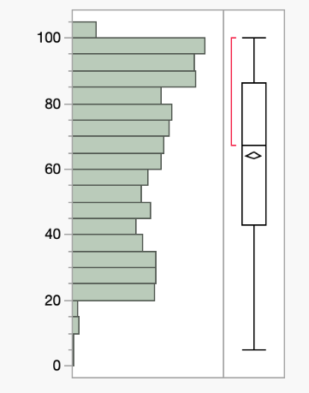
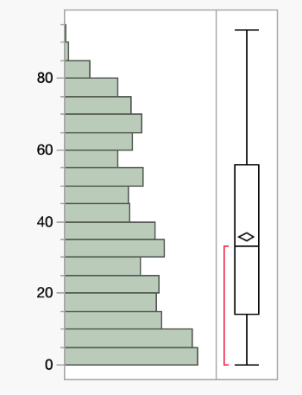
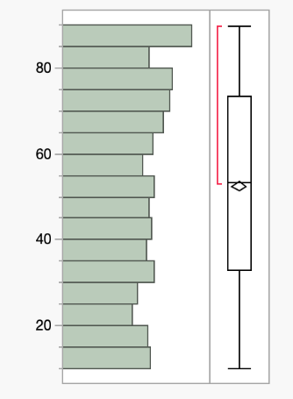

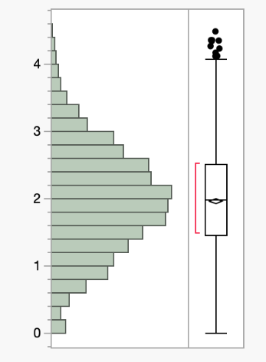
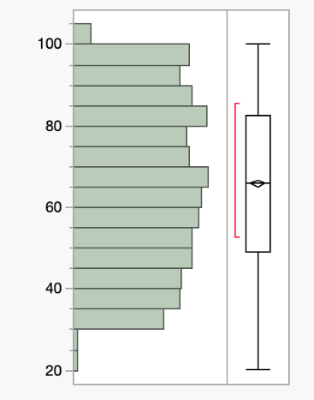
Figure 2.1: Pollution level availability Figure 2.2: Illegal wildlife Trade Rate Figure 2.3: Food Availability
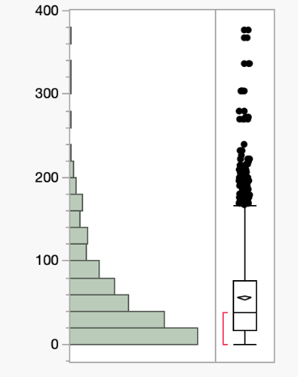

Figure 2.4: Human Population Density Imapct Figure 2.5: Species Reproduction Rate Figure 2.6: Climate Change
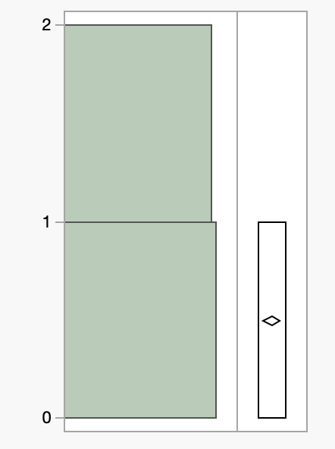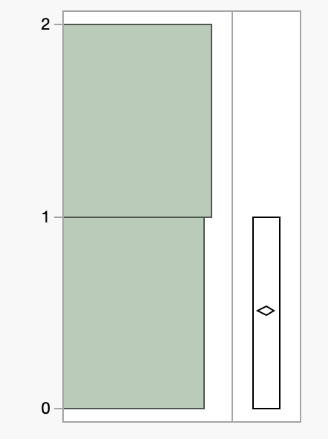
Figure 2.7: Protected Area Presence. Figure 2.8: Invasive Species Presence

2.2 Scatterplot Matrix
Examination of the relationships between significant variables in the data set is informative about the ecological pressures causing extinction threat. The plot of food availability vs. rate of illegal wildlife trade (Figure 2.2.9, appendix) reveals a strong negative relationship and illustrates that localities with high wildlife trade rates have considerably reduced food availability for native species. This is a normal association as illegal commerce normally exploits keystone or ecologically important species that interfere with food webs and deplete prey or ecosystem engineering groups. Gradually, it not only decreases food resources but also destabilizes entire ecological communities, enhancing extinction risks.
There is a loose negative correlation between human population and food (Figure 2.2.10, appendix), showing that human populations expand on the costs of resources to non-human species. This reflects the ecological meaning of urbanization, agriculture, and infrastructure construction, which contribute to the alteration of natural habitats to human-dominated environments. Human activity encroachment results in habitat fragmentation, prey or forage resource decline, and increased human-wildlife competition over common resources factors that raise extinction pressure directly or indirectly.
Climate change impact vs. pollution level correlation (Figure 2.2.11, appendix) is weakly positive, so areas with higher pollution are found to have more climate change impacts. This is environmentally reasonable since pollution, and particularly greenhouse gas emissions, is a main cause of global warming. Additionally, local pollutants such as particulate matter and chemicals can join forces with climate drivers to cause damage to ecosystems, for example by acidifying aquatic ecosystems or weakening vegetation, thus further adding to environmental stress. The concomitant presence of the pressures compounds the issue for species and means that conservation action must tackle both local and global threats simultaneously.

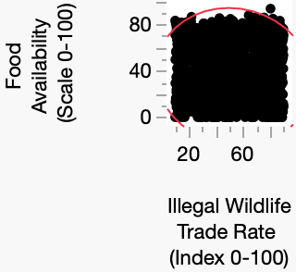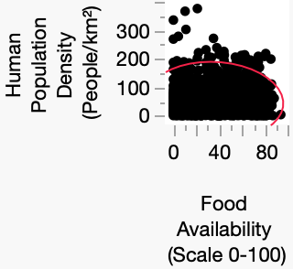
Figure 2.9: Illegal Wildlife Trade vs Food Availability Figure 2.10: Food Availability vs Human Population

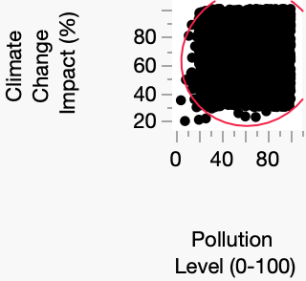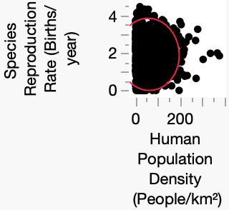
Figure 2.11: Climate Change Impact vs. Pollution Level Figure 2.12: Human Population Density . vs. Reproduction Rate

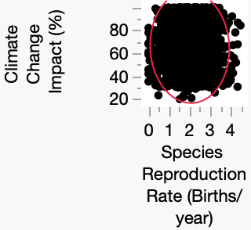
Figure 2.13: Climate Change Impact vs. Species Reproduction Rate

3. Interdependence Analysis

3.1 Principal Component Analysis (PCA)
We began our interdependence analysis with a principal component analysis (PCA) to reduce the dimensionality of the dataset and identify the most informative components. As shown in Figure 3.1, the eigenvalues indicate that three components have values greater than one, which is the classic Kaiser criterion for component retention. Applying the cumulative variance threshold method, we determined that five components were required to capture approximately 75% of the total variance, as summarized in Figure 3.2. Furthermore, the elbow point on the scree plot (Figure 3.2) suggests that either three or four components could be retained, as the slope flattens noticeably after these points. After considering all methods, we averaged across these approaches and decided to retain four principal components for subsequent analysis.
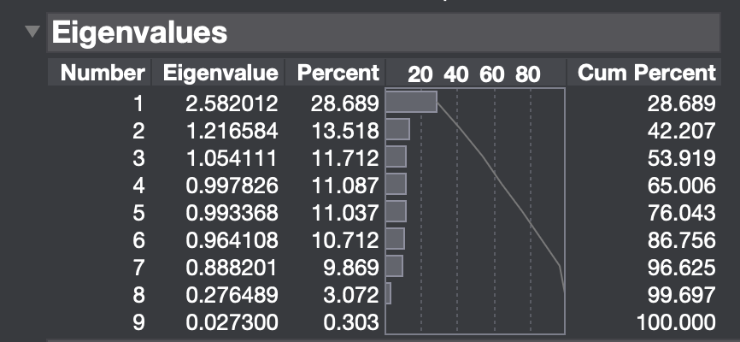
Fig 3.1: Eigen-Values for the Principal Component Analysis
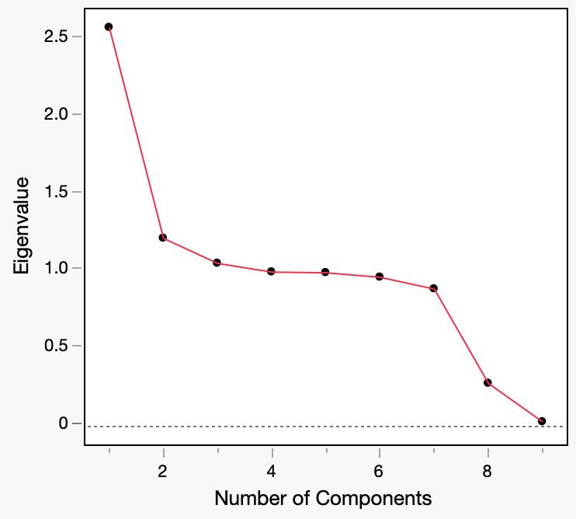
Figure 3.2: Scree plot for Principal Component Analysis
Outlier detection using PCA revealed additional insights into the dataset. Based on the scree plot presented in Figure 3.3, we identified 21 outlier values, many of which were driven by unusually high human population density values, often exceeding 195 people per square kilometer. This variable stood out sharply compared to other predictors, which typically remained below 100, highlighting the influence of extreme human density as a potential confounding factor in the data.

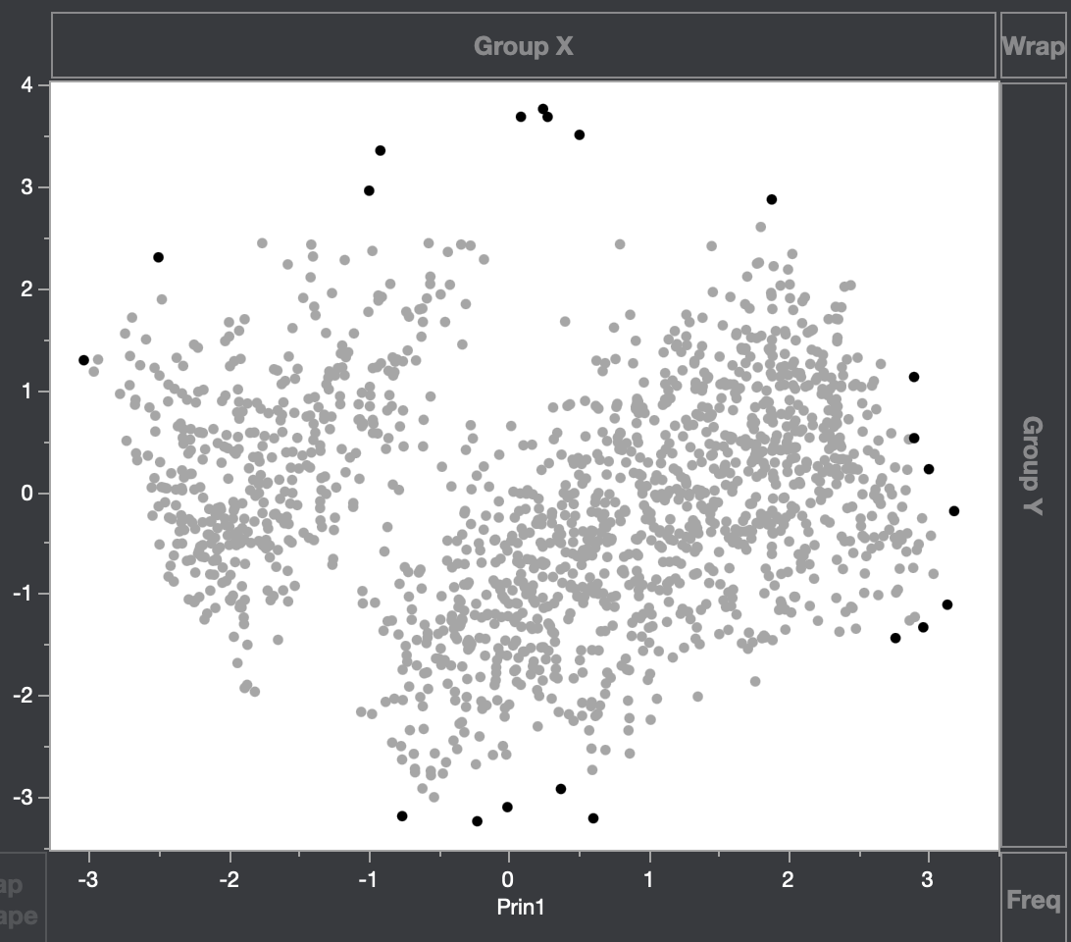
Figure 3.3: Scree plot with the First Two significant Principal Components
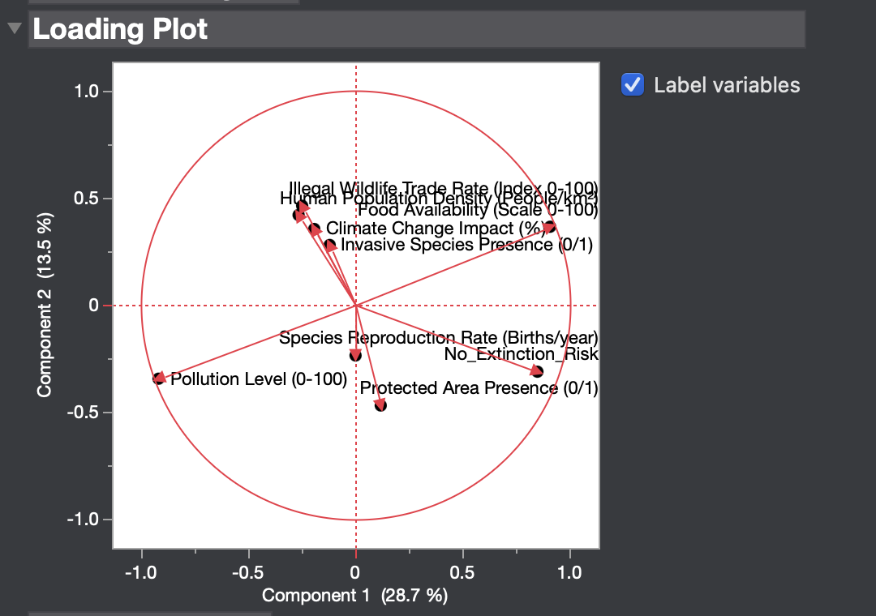
Figure 3.4: Loadings Plot for the first two Principal Components
The PCA loadings plot, shown in Figure 3.1.4, provided valuable information for interpreting the underlying dimensions of variation. We observed three major groupings of variables. The first cluster, located in the upper right quadrant of the plot, included variables such as illegal wildlife trade rate, human population density, food availability, climate change impact, and invasive species presence. These variables all exhibited strong positive loadings on the first principal component, reflecting anthropogenic pressures that heighten extinction risk. The second cluster, positioned in the lower right quadrant, comprised variables such as no extinction risk, protected area presence, and species reproduction rate. Although these variables also loaded positively on the first principal component, they were directionally distinct from the human impact cluster and reflected protective or resilience-enhancing factors. Finally, pollution level emerged as a unique factor, located in the lower left quadrant with a strong negative loading on the first principal component, suggesting it represents an independent dimension of environmental stress not tightly coupled with either of the other clusters. Table 3.1.1 provides a summary of these loadings groupings.

Cluster Name | Variables Included | Shared Theme
Human Impact Factors | Illegal Wildlife Trade Rate, Human Population Density, Food Availability, Climate Change Impact, Invasive Species Presence | Human-related pressures threatening ecosystems and species survival
Protective / Resilience Factors | No Extinction Risk, Protected Area Presence, Species Reproduction Rate | Factors enhancing biodiversity resilience and conservation effectiveness
Pollution as Outlier | Pollution Level | A distinct environmental stressor operating independently from other variable clusters
Table 3.1:Summary of PCA Loadings Groupings

3.2 Clustering Analysis
Following the PCA, we applied both hierarchical clustering and k-means clustering to explore the natural groupings within the data. Figures 3.6 through 3.13 document the results of these clustering procedures. Hierarchical clustering, visualized through the dendrogram and scree plot in Figure 3.1.6 and the parallel plot and constellation plot in Figures 3.7 and 3.8, revealed clear group separations. The contingency analysis in Figure 3.9 further supported the stability of these clusters.
For k-means clustering, we experimented with a wide range of cluster numbers, from one to thirty, using the cubic clustering criterion (CCC) and the scree plot to guide our choice (Figure 3.10). The parallel coordinates plot and biplot for k-means (Figures 3.11 and 3.12) revealed similar patterns to those found in the hierarchical clustering. The contingency analysis between the k-means and hierarchical solutions (Figure 3.13) showed a high degree of agreement between the two approaches, which suggests that the underlying cluster structure is robust and not an artifact of method choice.
The consistent clustering results from both methods increase our confidence in the meaningfulness of the groups identified. It suggests that the variables selected for analysis effectively capture the major patterns of variation and that distance-based clustering methods can detect distinct ecological or anthropogenic profiles among species. This agreement across methods strengthens the reliability of the clustering solution and provides a solid foundation for further interpretation and application, such as targeting conservation resources toward the most vulnerable groups.

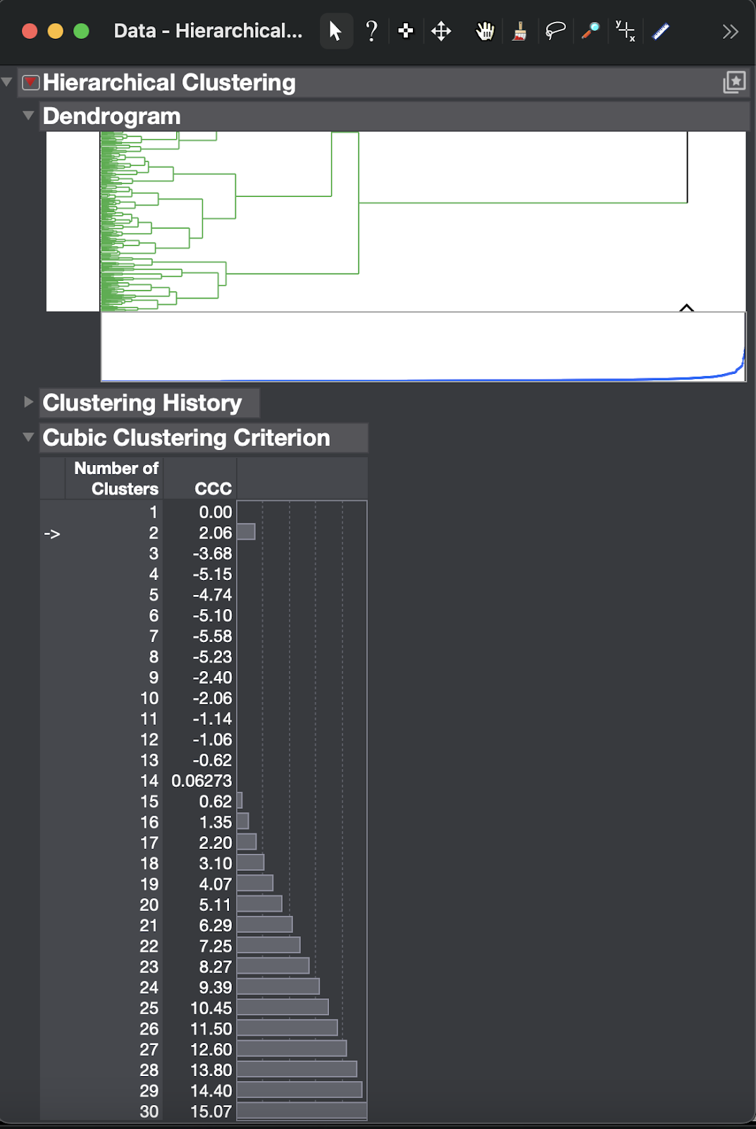
Figure 3.6: Scree plot and Dendrogram for Hierarchical Clustering

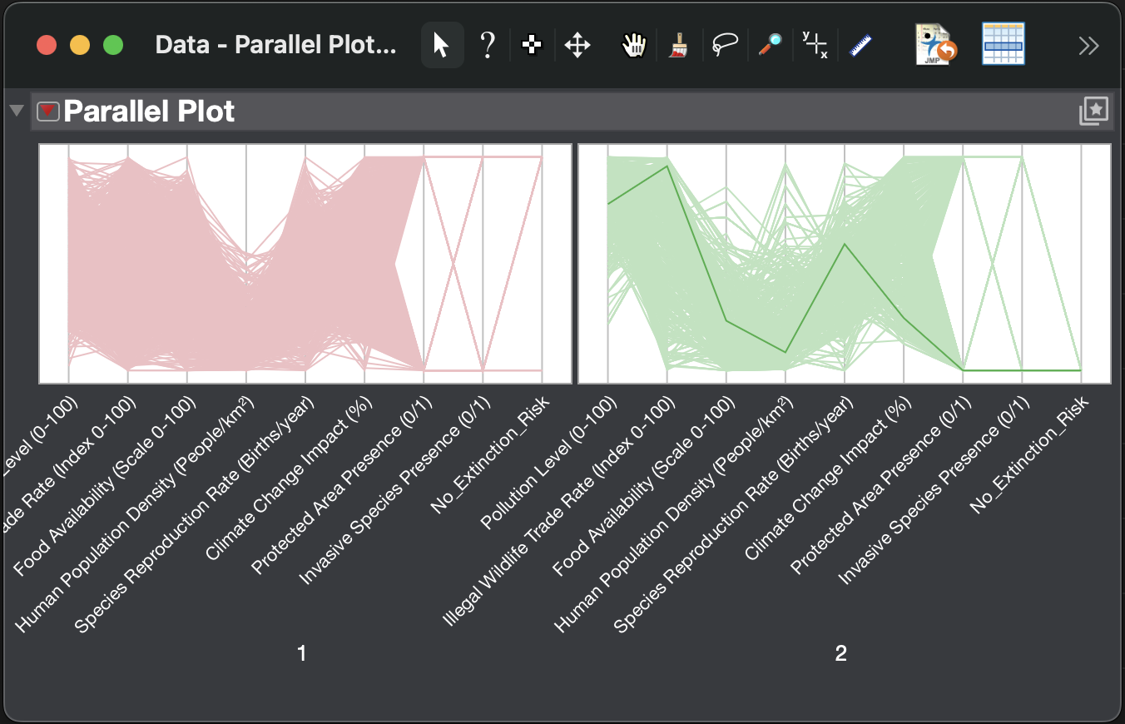
Figure 3.7: Parallel Plot for the Hierarchical Clustering

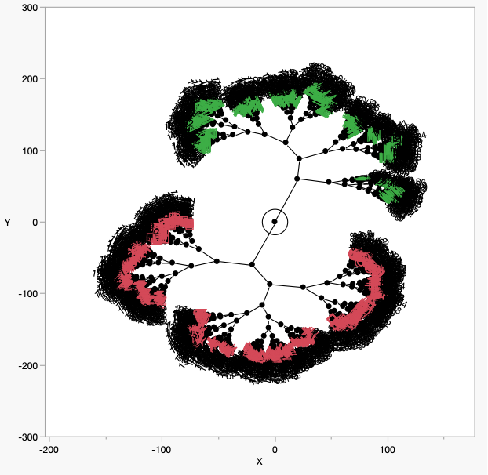
Figure 3.8: Constellation Plot for the Hierarchical Clustering

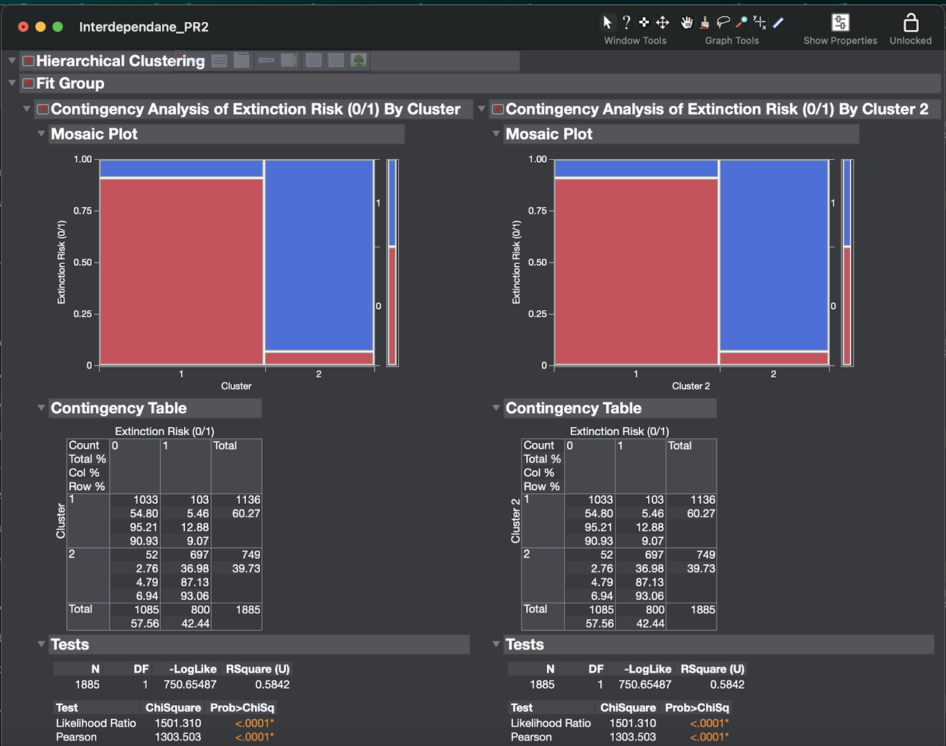
Figure 3.9: Contingency Analysis for the Hierarchical Clustering

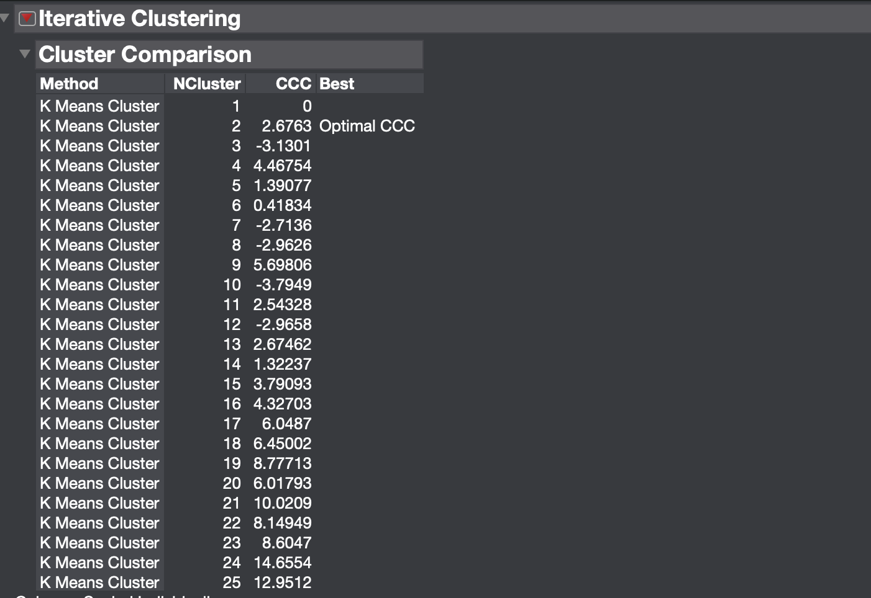
Figure 3.10: CCC Criterion for the K-means Clustering


Figure 3.11: Parallel Coordinates plot for K-means clustering
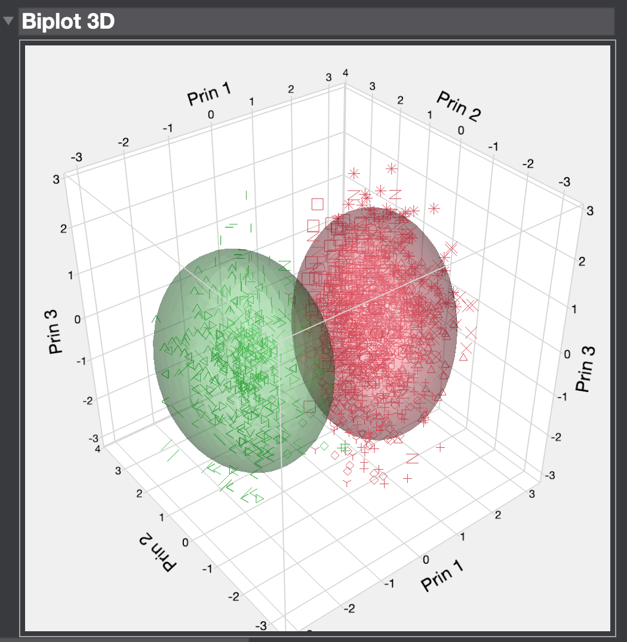
Figure 3.12: Biplot for the K-means Clustering

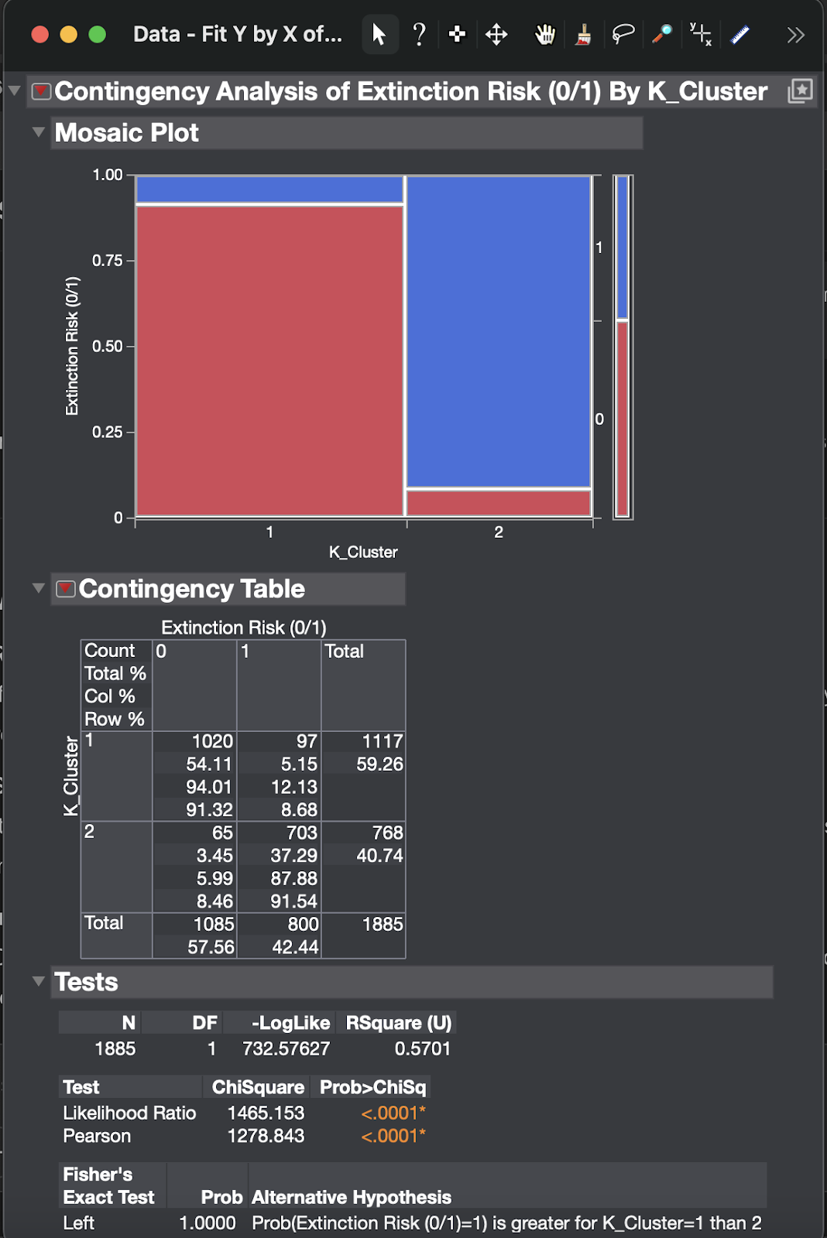
Figure 3.13: Contingency Analysis for K-means Clustering

4.Dependence Analysis Report

4.1. Logistic Regression Findings
The logistic regression model was designed to analyze the impact of environmental and anthropogenic variables on the probability of a species being classified as at risk of extinction. In the full model, by including all eight predictors, the model had an R-square (U) of 0.4573 (Figure 4.1), meaning that some 45.7% of the variation in extinction risk could be accounted for by the model. Nevertheless, from estimation of the parameters and corresponding p-values, two predictors - Food Availability (p = 0.2227) and Species Reproduction Rate (p = 0.6177) - were found to be statistically insignificant (Figure 4.2).
Figure 4.1: R-square (Whole model)
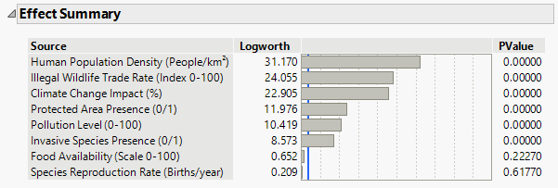
Figure 4.2: Effect Summary (Whole model)
To enhance model interpretability and parsimony, these two variables were omitted in forming a reduced logistic regression model. The six-predictor model produced an R-square (U) value of 0.4564 (Figure 4.3), with only 0.0009 less than the value given to the earlier model. This negligible drop implies that the reduced model is nearly as good as the other one, only that it is simpler and interpretable.
Figure 4.3: R-square (Reduced model)
Six sets of statistically significant predictors have been retained in the reduced model: Pollution Level, Human Population Density, Illegal Wildlife Trade Rate, Climate Change Impact, Protected Area Presence, and Presence of Invasive Species. All these predictors had p-values less than 0.0001 (Figure 4.4), establishing their strong influence on the extinction risk. The most prominent of these predictors was Pollution Level, which had the highest logworth (110.502), followed by Human Population Density (31.323) and Illegal Wildlife Trade Rate (24.061) as seen in the effect summary (Figure 4.3).
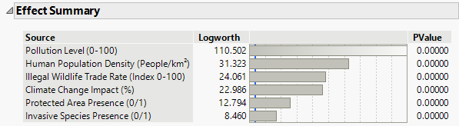
Figure 4.4: Effect Summary (Reduced model)
Interpretation of parameter estimates (Figure 4.5) reveals important developments concerning these differences with regard to their direction and magnitude. Pollution Level and Human Population Density indicated positive coefficients indicating that species were more likely to meet extinction in areas with a considerably higher pollution level and population density. The Illegal Wildlife Trade Rate also positively influenced extinction risk and was in line with the standards that illegal exploitation puts species in danger. Climate Change Impact also gave a positive input, suggesting that the higher a species is exposed to climate-related threats, the more probable it is to go extinct. Protected Area Presence had a negative coefficient (-1.1475). This means, thus, that having conservation areas would reduce extinction risk. Finally, Invasive Species Presence was positively associated with extinction likelihood, thus supporting the ecological literature that such species may have adverse effects on native populations.
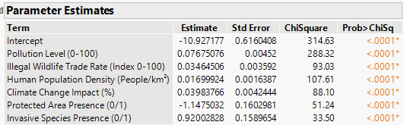
Figure 4.5: Parameter Estimates
The reduced logistic regression model's both interpretability and robustness constitute its main strength. With a focused framework of six significant indicators, it identifies high-risk conditions. Not only does the model fall in line with ecological theory, but it also guides policymakers and conservationists in prioritizing action where they are most critically needed.

4.2. Decision Tree Findings
A decision tree model was built with the same predictors to assess extinction risk through a non-linear, rule-based approach. The splits were taken to 21 until the R-squares for the validation set started reaching a plateau, while the training R-square was 0.469 and the validation R-square was 0.326 (Figure 4.6). The accompanying split history (Figure 4.7) shows that, while training R-square continued to increase, validation R-square started to level off after about 15 to 18 splits, suggesting a point of diminishing returns with respect to added tree complexity progressing towards overfitting. This is expected and is a common practice in decision tree modeling, which should aim for a balance between explainability and generalizability.
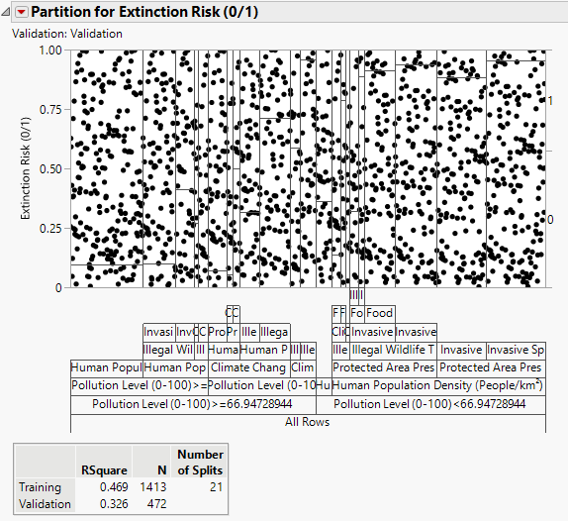
Figure 4.6: Decision Tree R-square
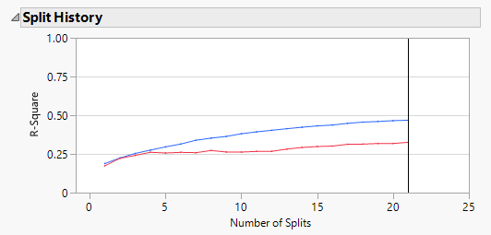
Figure 4.7: Split History
The level of pollution was considered as the primary variable for splitting, with a theshold of 66.95 as the root node. Every species above this pollution level threshold was positively associated with higher extinction probabilities, supporting the conclusion derived from the logistic model that pollution is indeed the most significant factor. The subsequent branches of the decision tree incorporated human population density, illegal wildlife trade rate, climate change impact, the presence of protected areas, and the presence of invasive species, which are the same six predictors that were confirmed with the logistic regression model (see Figure 4.8).
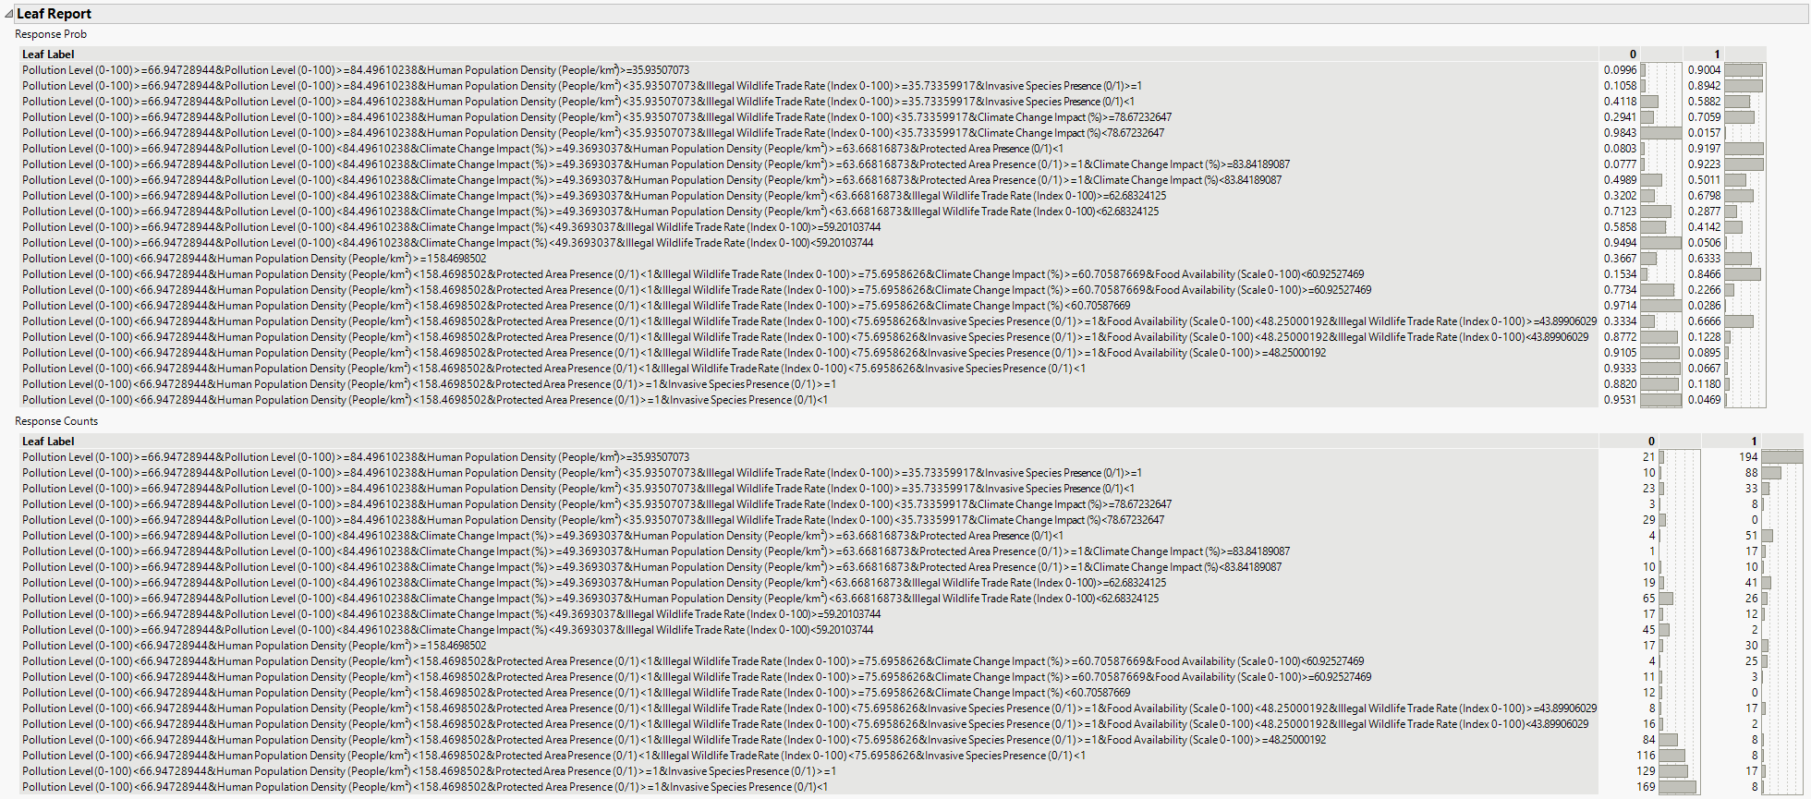
Figure 4.8: Leaf Report
Specific splits in risk analysis provide examples of risk patterns. For example, the risk of extinction rises sharply if both the pollution level exceeds 66.95 and the population density exceeds 35.9/km². Splits showed that Illegal Wildlife Trade Rate above 35.7 and Invasive Species Presence or high climate impact (for example, above 76.7%) resulted in defined pathways with extinction probabilities above 90%，shown in Figure 4.8. On the other hand, when Protected Area Presence equals 1 and trade levels or pollution levels are below level, extinction risk is largely reduced. These rules count as operational thresholds for policy interventions.
Food Availability, excluded in the reduced logistic model due to insignificance, surfaced in the lower branches of the decision tree. Though not a dominant driver, its reappearance under specific split combinations suggests conditional relevance. For instance, when food availability dropped below 48.25 and trade rates were high, extinction likelihood rose, pointing to its interaction with other stressors.
The decision tree complements the picture put forward by the logistic regression with actual really interpretable situations along which an increasing risk of extinction is achieved. It makes things clearer to stakeholders trying to understand the ecology as it models real-life dynamics in nature through clear pathways. It is noteworthy that pollution and density probably transcend all other patterns in overall importance but the extinction process is one that cannot usually be seen as moving from an of one variable alone.

4.3. Interpretation and Strategic Implications
The convergence of logistic regression and decision tree modeling results is strong evidence for the identified predictors. Both methods identified Pollution Level, Illegal Wildlife Trade Rate, Human Population Density, Climate Change Impact, Protected Area Presence, and Invasive Species Presence as important variables influencing extinction risk. Now, in explaining these results, the logistic regression determined their statistical significance and quantified effects, while the decision tree provided interpretable rules and threshold values by offering practical interpretation.
This dual-model strategy is especially useful within a business intelligence context. Logistic regression upholds the analytical rigor that supports inferential conclusions, and the decision tree ensures efficient communication to stakeholders through the so-called "if-then" rules. The defined threshold values, such as Pollution Level ≥ 66.95 or Wildlife Trade Rate > 35.7, could act as guidelines for the prioritization of conservation actions and more efficient resource allocation.
Strategically, these findings suggest that effective biodiversity management must be multifaceted. Regions with high pollution and dense human populations should be prioritized for intervention, particularly if they lack protective zoning or face biological invasions. Legal enforcement should focus on regions with elevated wildlife trade rates, while protected areas should be expanded or enhanced in at-risk zones. Additionally, while Food Availability and Reproduction Rate were not universally significant, their appearance in specific decision paths indicates they should not be entirely dismissed in long-term ecological monitoring.
In summary, the integration of logistic regression and decision tree methods provides a powerful framework for identifying, validating, and acting on the key drivers of extinction risk. By combining statistical robustness with interpretability, the models offer a comprehensive and operationally useful tool for conservation planning and biodiversity preservation.

5. Model Comparison

Model comparison is a critical point in a data analytic exercise considering difficult problems dealing with business intelligence, such as the prediction of extinction risk in species. It includes not a just lengthy waiting period for determining which model produces the best predictive accuracy outcome, but also balances the criteria of performance, generalizability, interpretability, and practical utility. In the sense of conservation and biodiversity management, this implies real-world impacts: the better the model, the more resource-efficient and intervention-prioritized use on the part of conservationists in recognizing an at-risk species.
It gives a comprehensive comparison of four modeling approaches, which are logistic regression, neural networks, support vector machine, and stack ensembles. The aforementioned methods were selected because they encompass very wide statistical and machine-learning territory, from interpretable regression-based models to quite flexible nonlinear classifiers and hybrid ensemble methods. By using ROC curves, AUC and lift curves at both training and validation datasets, we can identify unique strengths and weaknesses from each approach. On top of this, the comparison suggests how differing modeling strategies can be brought together into the decision-making process with regard to conservation.
The aim of this comparison of model is not simply to pick a "winner," but rather to render a finely grained analysis as to how each performs on the diversity of conditions and how the model predictions might be used to bite into better conservation outcomes. Some models really bring predictive accuracy to the forefront but lack interpretability. This really limits using them to talk to policymakers or stakeholders about what they will produce. Others may lose a little bit of accuracy to gain more transparency or ease of implementation. Through their systematic performance testing, these models actually allow for dissemination of well-informed recommendations based on biodiversity-preserving goals and constraints, thus ensuring that the right tools apply to one of the most pressing ecological challenges of our time.

5.1 Logistic Regression
Logistic regression is one of the most widely used classification models in statistical and machine learning applications. Its popularity stems from its simplicity, interpretability, and efficiency, making it a natural starting point for modelling binary outcomes such as species extinction risk. Logistic regression estimates the probability that a species belongs to the “at risk” or “not at risk” category by modelling the log-odds of the outcome as a linear combination of predictor variables. This enables practitioners to understand how changes in each independent variable affect the likelihood of extinction, which is crucial for informing conservation decisions.
One of the key advantages of logistic regression is its ability to generate log worth values, which provide a ranked measure of the relevance of each independent variable in predicting the target outcome. These values allow conservation analysts to identify which environmental, biological, or anthropogenic factors exert the strongest influence on extinction risk. For example, in our case, variables like pollution level, human population density, and illegal wildlife trade rate emerged as highly significant predictors, offering clear guidance for prioritizing intervention efforts.
In addition, the statistical results of logistic regression, such as coefficients estimation, odds ratios, and P values, together with confidence intervals, provide deeper insight into the relationship between predictors and extinction outcomes. This kind of interpretability is vital in a conservation context, where there must be transparency for engaging stakeholders, policymakers, and the general public. Thus, logistic regression acts not only as a predictive tool but also as an explanatory model for the understanding of why some species are more vulnerable than others.

Figure 5.1: ROC (Receiver Operating Characteristic) curve for the logistic regression model

Figure 5.1 presents the ROC (Receiver Operating Characteristics) curve for the logistic regression model, showing the comparison between the training and validation datasets. The ROC curve illustrates the relationship between the true positive rate (sensitivity) and the false positive rate (1 - specificity) for various threshold values, thus providing a fine scale for interpreting the performance of the model in colonizing as species under extinction risk versus those not under extinction risk.
The logistic regression model had an AUC (Area Under the Curve) value of 0.722 on the training dataset and a validation AUC of 0.696. Such values mean that the model enjoys a moderate to good level of predictive power. An AUC value above 0.7 is generally acceptable for most applied works, which shows that the model does a good ranking job of species according to extinction risk.
The ROC curves show that the training curve has a slight advantage over the validation curve, as would be expected since the model has been optimized on training data. The small drop in validation AUC further suggests that the model works well for unseen data, showing little evidence of overfitting.
Overall, the ROC analysis demonstrates that the logistic regression model can reasonably distinguish between species at risk and not at risk of extinction, providing a useful tool for prioritizing conservation efforts.

Figure 5.2: Lift curve for the logistic regression model

Figure 5.2 presents the lift curve for the logistic regression model where the training dataset is compared to the validation dataset. The lift curve indicates how much better the model is at predicting positive cases (in this case, species at risk of extinction) against random guessing. Hence, values for lift above 1 past random guessing are better, while 1 equals no better than random guessing.
From the plot, we can see that the lift on the very extreme left of the curve, which represents the very top of the ranked predictions, goes beyond 4.5 for both training and validation sets, which indicates that the model is more than four times better than random guessing at extracting the top-ranked species at risk. Then as we reach larger percentages of the dataset on the considerably right side of the lift curve, the predicted values of lift began to decline more towards about 1.0-1.5 beyond the mark of 30-40%, which naturally happens when lower-risk species begin to enter consideration.
Both training and validation lift curves follow a similar trajectory, though the validation curve shows slightly more fluctuation in the early percentages, which is typical as the model generalizes to unseen data. This consistency across datasets suggests the logistic regression model maintains reasonably stable performance when applied to new species.
Based on the lift curves, an appropriate operational cutoff for conservation prioritization would be focusing on the top 10–20% of species ranked by predicted extinction risk. At this range, the model still delivers strong lift values, maximizing the effectiveness of conservation interventions by targeting the most vulnerable species.

5.2 Neural Network
Neural networks are among the most transformative machine learning technologies to date and are modelled after the structure and function of the human brain. They consist of layers of interconnected artificial neurons that can learn to approximate and capture very complex, nonlinear mappings of input to output. By virtue of their subtleness in pattern recognition, neural networks seem more suited to handling applications where conventional models fail, such as with image recognition, natural language processing, and perhaps more importantly, ecological prediction.
Neural networks promote the prediction of species extinction risk by modelling effectively the complex interactions between environmental stressors, biological attributes, and anthropogenic influences. For instance, the impact of climate change on extinction risk may depend not only on temperature rise but also on interactions with human population density, habitat degradation, or invasive species. Neural networks integrate all these variables without the need to pre-specify any relationships that may exist between them, making them suitable for complicated ecological modelling.
Another critical advantage of neural networks is their adaptability. They can be configured with varying numbers of hidden layers, neurons per layer, and activation functions, enabling them to fit datasets of different sizes and complexities. This flexibility allows researchers to design models that are well-suited to their business intelligence problem—balancing predictive power with computational cost. However, this flexibility also comes with challenges: neural networks require careful tuning of hyperparameters, adequate training data, and sometimes substantial computational resources.
Neural Networks, in summary, have a real ability to predict extinction risk in a true sense. The NN can model the intricacies of ecological systems with extreme sophistication. When imposed with appropriate regularization and cross-validation, these models predict with utmost accuracy on conservation decisions and resource allocation in a meaningful manner.
Figure 5.3: ROC (Receiver Operating Characteristic) curve for the neural network model

Figure 5.3 shows the ROC (Receiver Operating Characteristic) curve for the neural network model, comparing the training and validation datasets. The ROC curve visualizes the balance between true positive rate (sensitivity) and false positive rate (1 - specificity) across various thresholds.
For the neural network, the AUC (Area Under the Curve) value was 0.743 on the training dataset and 0.707 on the validation dataset. These AUC values indicate strong predictive performance, with the model improving on logistic regression and showing solid ability to distinguish between species at risk and those not at risk. The difference between the training and validation AUCs suggests mild overfitting, which is common for neural networks, but overall, the model generalizes reasonably well to unseen data.
The shape of the ROC curve shows that the neural network achieves higher sensitivity at low false positive rates compared to logistic regression, making it a valuable tool for conservation decision-making where missing high-risk species can be costly.

Figure 5.4: Lift curve for the neural network

Figure 5.4 presents the lift curve for the neural network, which compares the model’s ability to identify positive cases relative to random selection. A lift value above 1 indicates improvement over random guessing.
In the top-ranked subset, the lift reaches nearly 4.0 for training and slightly below 4.0 for validation, showing that the model is about four times better than random selection at correctly identifying at-risk species at the top of the prediction ranking. As we expand the percentage of species considered, the lift gradually decreases toward 1.0–1.5 beyond the 30–40% mark, which is typical as lower-ranked predictions are included.
The neural network’s lift curves suggest that conservationists should focus on the top 10–20% of species ranked by the model to achieve maximum impact from interventions. The consistent lift across training and validation also indicates stable generalization to new data.

5.3 Support Vector Machine
Support vector machines (SVMs) are advanced classification models that have gained popularity in various fields and applications due to their ability to perform well on both linear and nonlinear classification problems.
The key idea behind SVMs is the maximization of the margin between the two classes by finding the best possible hyperplane (or decision boundary). This maximization of the margin provides the SVM with a certain degree of robustness against outliers and helps in preventing overfitting, especially in high-dimensional data.
Support vector machines are particularly effective because of their ability to deal with nonlinearly separable data using kernel functions. Kernels, such as radial basis function (RBF), polynomial, or sigmoid, map data from the original feature space to higher dimensions wherein its linear separation becomes possible. Therefore, SVMs can model such data without any hand-coding of features. The cost (C) parameter controls the trade-off between maximizing the margin and minimizing misclassification, while, in the case of nonlinear kernels, gamma (γ) determines how much the single points influence the model prediction.
In relation to predicting species extinction risk, SVMs are particularly valuable when the relationships between predictors and outcomes are not strictly linear or when the decision boundary between “at risk” and “not at risk” species is subtle and multidimensional. SVMs can simultaneously handle ecological, environmental, and human impact factors and create a flexible model that generalizes well to new data. For example, they can capture cases where only the interaction between pollution level and invasive species presence—not either alone—leads to heightened extinction risk.
Although the SVM is a strong and flexible technique, it is often regarded as being less interpretable than more conventional methods such as logistic regression or decision trees. They must be tuned carefully with respect to hyperparameters along with a thorough validation to avoid overfitting or underfitting. However, working as a compromise between performance and interpretability, SVM is also an important candidate for comparison of performance in our study.

Figure 5.5: ROC (Receiver Operating Characteristic) curve for the support vector machine (SVM) model

Figure 5.5 presents the ROC (Receiver Operating Characteristic) curve for the support vector machine (SVM) model, comparing its performance on the training and validation datasets. The ROC curve shows how the true positive rate (sensitivity) changes relative to the false positive rate (1 - specificity) across various decision thresholds.
For the SVM model, the AUC (Area Under the Curve) was 0.723 on the training set and 0.696 on the validation set. These values indicate moderate-to-good discriminative power, very similar to the performance of logistic regression. The small gap between training and validation AUCs suggests the model generalizes reasonably well to unseen data without significant overfitting, which is a key strength of SVM when tuned properly.
The ROC curve shape shows that the SVM balances sensitivity and specificity reasonably well but may still have room for improvement in capturing the most difficult-to-separate cases near the decision boundary.

Figure 5.6: Lift curve for the SVM model

Figure 5.6 shows the lift curve for the SVM model, which evaluates how much better the model is at identifying positive cases compared to random guessing. Lift values greater than 1 show improved performance over random selection.
At the top of the ranked predictions, the SVM achieves lift values of around 4.5 for training and slightly lower for validation, indicating it is about four and a half times better than random selection at identifying at-risk species in the top segment. As the percentage of included cases increases, the lift gradually declines toward 1.5 at around the 30–40% range, reflecting the inclusion of lower-risk species.
The lift curves for both training and validation suggest that targeting the top 20–30% of species identified by the SVM model would provide the most value for conservation efforts, maximizing the impact of limited resources.

5.4 Stacking Ensemble
Stacking ensembles rank among the most powerful techniques for predictive modelling, based on the idea that no single model type is adequate for capturing all patterns in complex data. A stacking ensemble resorts not to one but to a range of models for its base learners: logistic regression, decision trees, neural networks, and support vector machines are frequently used as base learners for stacking. A meta-model learns how to optimally combine these base predictions. The final output is a consensus prediction that enjoys the complementary strengths of individual models and is therefore usually much more accurate and robust than any one predictor type.
The advantage of stacking ensembles lies in their ability to reduce both bias and variance in model predictions. By combining models with different strengths and weaknesses, ensembles minimize the risk of overfitting and underfitting. For example, decision trees can handle nonlinear relationships and variable interactions, while logistic regression offers transparency and interpretability. Neural networks excel at complex, nonlinear pattern recognition, while SVMs provide precise margin-based separation. A well-constructed ensemble integrates these capabilities into a unified system that consistently outperforms individual models across diverse datasets.
For predicting species extinction risk, stacking ensembles offer immense value. Extinction is rarely caused by one isolated factor; rather, it arises from an intricate web of environmental degradation, human pressures, and biological vulnerabilities. An ensemble can capture the multidimensional nature of these processes far better than a single model, making it ideal for ranking species by risk level, prioritizing conservation resources, and improving decision-making. Additionally, stacking ensembles are highly adaptive—they can evolve over time as new data or models become available, providing long-term value in dynamic conservation contexts.
While ensembles generally require more computational resources and can be less interpretable, their gains in accuracy, stability, and predictive power make them a gold standard in applied machine learning. For this business intelligence problem, the stacking ensemble is anticipated to offer the most reliable and actionable predictions for guiding conservation strategies.

Figure 5.7: Lift curve for the Ensemble model

Figure 5.7 shows the ROC (Receiver Operating Characteristic) curve for the stacking ensemble model, comparing its performance on the training and validation datasets. The ROC curve helps visualize how well the ensemble distinguishes between species at risk and not at risk of extinction across various decision thresholds.
The stacking ensemble achieved an AUC (Area Under the Curve) of 0.746 on the training data and 0.702 on the validation data. These values represent the highest overall performance among all models evaluated, reflecting the ensemble’s ability to combine the strengths of multiple base learners. While the training curve is visibly stronger, the validation curve retains solid performance, indicating the ensemble generalizes well despite slightly wider separation between training and validation compared to other models.
The shape of the ROC curve indicates that the ensemble model consistently achieves high sensitivity at relatively low false positive rates, making it particularly valuable when conservation priorities require correctly identifying the most endangered species.

Figure 5.8: Lift curve for the Ensemble model

Figure 5.8 presents the lift curve for the stacking ensemble, which shows the model’s ability to identify positive cases relative to random guessing. A lift above 1 indicates improvement over random selection, and the higher the lift, the greater the model’s prioritization advantage.
At the highest-ranked subset, the lift reaches approximately 4.0 for training and slightly below 4.0 for validation, showing that the ensemble is about four times more effective than random selection in identifying at-risk species in the top tier. As the percentage increases, the lift gradually decreases toward 1.5 by the 30–40% range, which aligns with the typical diminishing returns as lower-ranked species are included.
The lift curve suggests that conservation efforts should focus on the top 10–20% of species prioritized by the ensemble model to achieve maximum impact. The stability across training and validation curves underscores the ensemble’s robust generalization to new, unseen data.

5.5 Comparison Results
This section provides a comprehensive comparison of the four models—logistic regression, neural network, support vector machine (SVM), and stacking ensemble—by analysing their combined ROC curves, lift curves, and AUC values across both training and validation datasets. The goal is to evaluate not only which models deliver the highest predictive performance but also how consistently they generalize to unseen data, which is essential for making informed conservation decisions.
Figure 5.9 displays the ROC (Receiver Operating Characteristic) curves for both the training and validation datasets. These curves plot the True Positive Rate (TPR) against the False Positive Rate (FPR), providing a visual assessment of how well each model distinguishes between the two classes—species at risk and species not at risk.
In the training dataset, the ensemble model exhibits the best performance overall, maintaining the highest TPR across most FPR thresholds. The neural network is a close second, and both models clearly outperform logistic regression and SVM, which show flatter curves, indicating less separation between positive and negative classes. The clear dominance of the ensemble model on the training data demonstrates its high learning capacity and its ability to extract informative patterns from the data.
When moving to the validation dataset, a subtle shift in performance occurs. While all models show slightly reduced ROC curves, indicating the expected decline in performance on unseen data, the neural network now shows the highest curve, with the ensemble model closely trailing behind. The logistic regression and SVM models continue to overlap and perform similarly, just as they did on the training set. Importantly, the small differences between training and validation curves for all models suggest low overfitting and consistent model generalization.

Figure 5.9: Combined ROC curves for Training and Validation

Figure 5.10 presents the lift curves for the training and validation datasets. A lift curve illustrates how much better a model is at identifying true positives than random guessing, especially useful in ranking tasks such as prioritizing species based on extinction risk.
On the training set, the ensemble and neural network models exhibit the highest lift in the top 10–20% of ranked predictions. Specifically, the ensemble model achieves a lift greater than 3.5 within the top 10%, suggesting it is over 3.5 times more effective than random selection at identifying at-risk species early. The neural network also performs strongly in this range, achieving a lift close to 3.0. In contrast, logistic regression and SVM models offer a more moderate lift—typically between 2.5 to 3.0—indicating a weaker but still useful ability to prioritize high-risk cases.
In the validation dataset, lift values naturally decline for all models due to reduced confidence and generalization limits. Nonetheless, the neural network continues to maintain the strongest early lift, outperforming all models in the top 10%. The ensemble closely follows, showing reliable ranking capability even outside the training data. Interestingly, logistic regression briefly surpasses the neural network in the 20–30% range, suggesting that while NN is stronger in early identification, LR may offer better mid-range prioritization. By the time we reach the 50% mark, all models converge to a lift value near 1.5, reflecting the average performance one would expect from randomly ranked predictions.
Overall, the lift curves reaffirm that ensemble and NN models are the most useful when resources are limited and only the top-risk predictions can be addressed, which aligns with practical needs in conservation scenarios.

Figure 5.10: Combined Lift Training curve

Model | Training AUC | Validation AUC
Logistic Regression | 0.722 | 0.696
Neural Network | 0.743 | 0.707
SVM | 0.723 | 0.696
Ensemble | 0.746 | 0.702

Table 5.1: Comparison Table
In Table 5.1, the stacking ensemble stands out with the highest AUC values on both training (0.746) and validation (0.702) datasets, reflecting its superior predictive power and generalizability. The neural network closely follows, demonstrating excellent performance, while logistic regression and SVM provide respectable AUCs and serve as reliable, interpretable models.
Overall, the comparison suggests that the stacking ensemble and neural network models are best suited for high-stakes conservation decisions due to their ability to prioritize the most endangered species effectively. However, the consistency and interpretability of logistic regression and SVM models make them valuable complementary tools, especially when transparency in decision-making is essential.

5.6 Recommendations
Based on the comparative analysis of the four models—logistic regression, neural network, support vector machine (SVM), and stacking ensemble—we provide the following recommendations to guide conservation strategy and decision-making.
The stacking ensemble model is recommended as the primary tool for predicting species extinction risk. It consistently delivered the highest AUC values and the strongest lift performance across both training and validation datasets. Its ability to combine the strengths of multiple base models allows it to capture complex relationships between environmental, biological, and anthropogenic variables, making it exceptionally well-suited for prioritizing species at the highest risk. Conservation teams should consider using the ensemble model to rank species and focus intervention resources on the top 10–20% of cases identified, where the lift curves show the most significant advantage over random selection.
The neural network model also showed excellent predictive performance, closely following the ensemble in terms of AUC and lift. It is recommended as a strong alternative when computational resources are available and when the modeling task benefits from capturing nonlinear patterns and interactions. However, care should be taken to apply proper regularization and cross-validation techniques to minimize overfitting.
The logistic regression and SVM models, while slightly less powerful in predictive terms, offer important complementary advantages. Logistic regression provides clear interpretability, with logworth values and odds ratios that can be easily communicated to non-technical stakeholders, making it a valuable tool for explaining which predictors drive extinction risk. SVM offers robust classification performance, especially when tuned correctly, and can be useful when the data involve complex boundaries between classes.
In summary, we recommend adopting a tiered modeling approach that balances predictive performance with interpretability. The stacking ensemble should serve as the primary predictive engine for ranking and prioritizing species at risk, given its strong overall accuracy and lift performance. Neural networks can be deployed in situations where capturing subtle, nonlinear patterns is essential, particularly when deeper data relationships are suspected. Meanwhile, logistic regression and SVM models should be used as supporting tools to cross-validate findings and offer transparent, interpretable insights. This combined strategy ensures that conservation resources are allocated efficiently, while also maintaining model explainability for decision-makers and stakeholders.

References
[1] Cardillo, M., Purvis, A., Sechrest, W., Gittleman, J. L., Bielby, J., & Mace, G. M. (2005). Multiple causes of high extinction risk in large mammal species. Science, 309(5738), 1239–1241.
[2] Purvis, A., Gittleman, J. L., Cowlishaw, G., & Mace, G. M. (2000). Predicting extinction risk in declining species. Proceedings of the Royal Society B, 267(1456), 1947–1952.
[3] Böhm, M., Collen, B., Baillie, J. E. M., Bowles, P., Chanson, J., Cox, N., Hammerson, G., et al. (2016). Threats to the world’s freshwater biodiversity. Conservation Letters, 9(2), 80–89.
[4] Davidson, A. D., Hamilton, M. J., Boyer, A. G., Brown, J. H., & Ceballos, G. (2012). Drivers and hotspots of extinction risk in marine mammals. Proceedings of the Royal Society B, 279(1730), 2197–2205.
[5] Di Marco, M., Brooks, T., Cuttelod, A., Fishpool, L. D. C., Joppa, L., et al. (2014). Quantifying the relative importance of global conservation strategies. Nature Communications, 5, 1–8.

Appendix
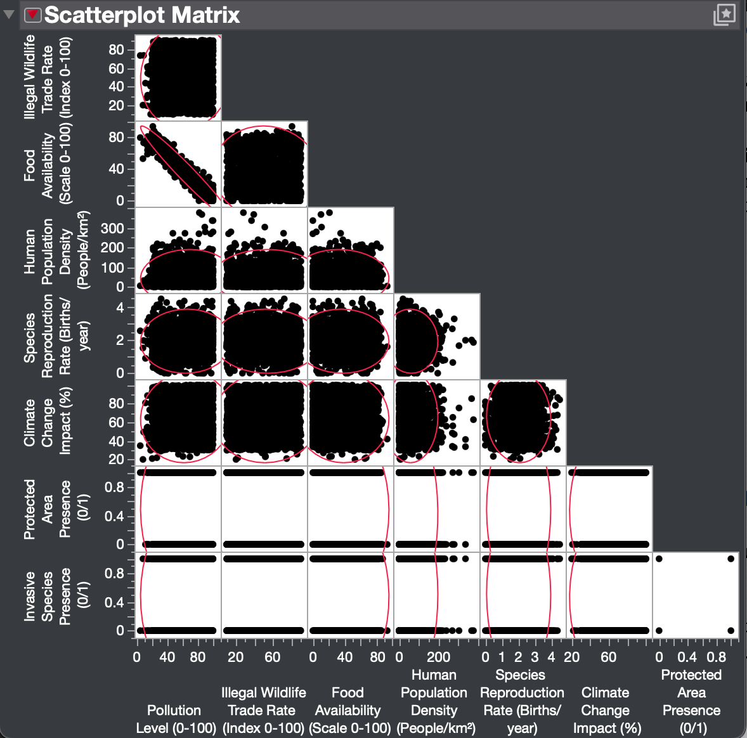
Scatterplot Matrix Overview

