––

**Vernadette Alvarico**

**Flores subdivision brangay 7, Lucena City, Quezon**

**Contact #** 09508619816

## **Tertiary Education :** **ABE International Business College**

Quezon Ave, Lucena City, Quezon

2019- 2022

ABM (Senior High)

## **Secondary Education : Quezon National High School**

Ibabang iyam lucena city

2015 - 2019

## **Primary Education : Lucena east 6 elementary school**

Brgy. 8 Lucena City

2009 - 2015

**Buffchick Buffalo Wings**

**All around crew (Cashier,Kitchen)**

2021-2022

**Sm supermarket**

**(cashier)**

**2022-2023**

**Aldrin Molera**

**CEO, Buffchick Buffalo Wings**

09275041545

**RODERICK QUIMBAO**

**BRGY KAGAWAD**

**Vernadette alvarico**

Applicant

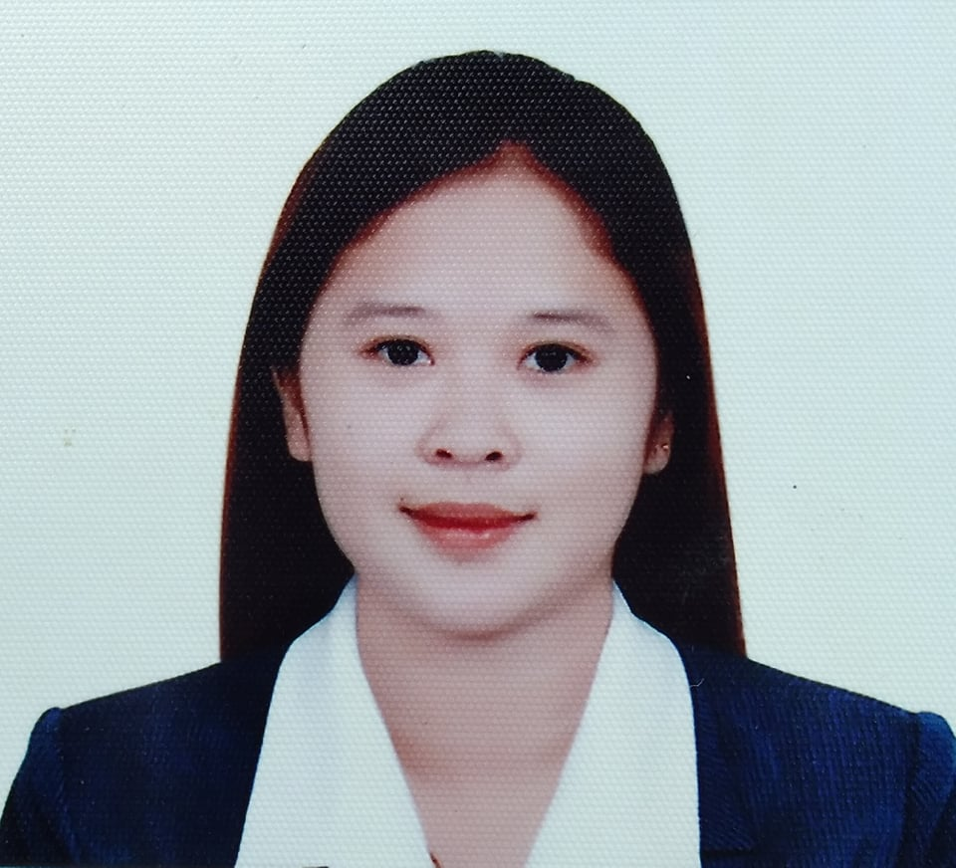

To untilized my acquired knowledge, skills and experience in the field that I’m applying for,with my outmost effort gaining more professional growth and vision of improvement for the job.

**Date of Birth :** February 14 2002

**Place of Birth :** Lucena City, Quezon

**Age :** 20 yrs.old

**Gender :** Female

**Nationality :** Filipino

**Religion :** Roman Catholic

**Civil Status :** Single

**Height :** 5’6

**Weight :** 55 kgs.

**Language :** English/Tagalog

* Computer Literate
* Hard working and Reliable
* Responsible
* Punctual and efficient
* Fast learner and Flexible

**PERSONAL SKILLS**

**OBJECTIVES**

**PERSONAL DATA**

**CHARACTER REFERENCES**

**WORK EXPERIENCE**

**EDUCATIONAL ATTAINMENT**