

SPCM - LAB

6th Sem

**Submitted To: Submitted By:**

**Dr. Hitesh Kumar Sharma Rajat Kamboj**

**School of Computer Science R2142220140**

**500105058**

**Batch 1-NH**

Writing Terraform Scripts to perform the following task 2 ec2 Instances, VPN and S3 **main.tf**

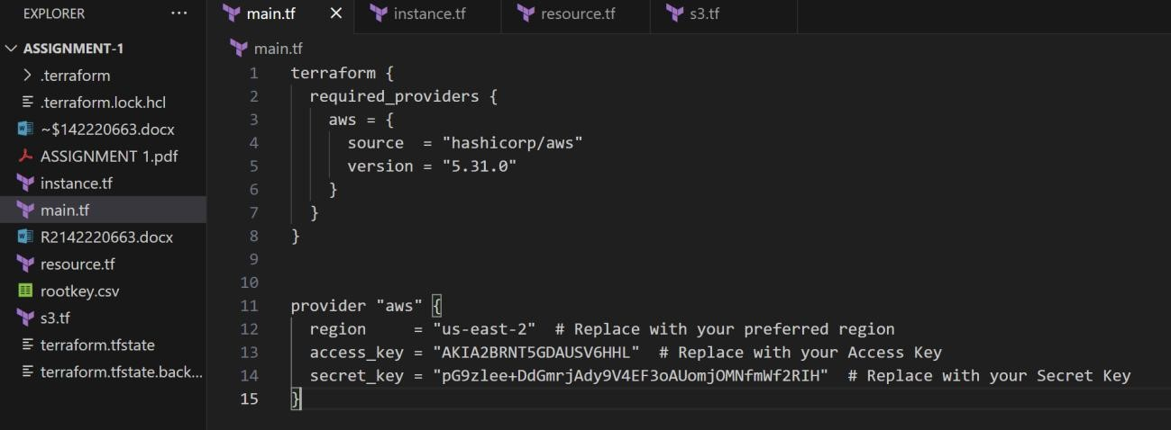

Running **terraform init**

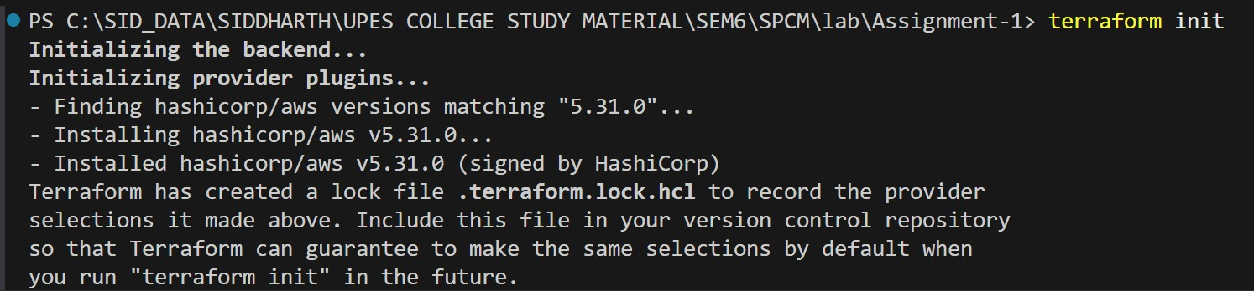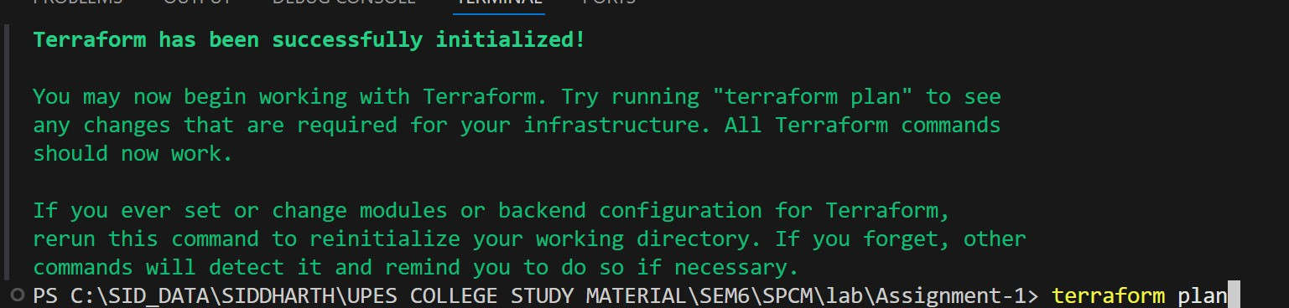

Terraform init to initialize the terraform folder which will have the aws provider plugin installed **instance.tf**

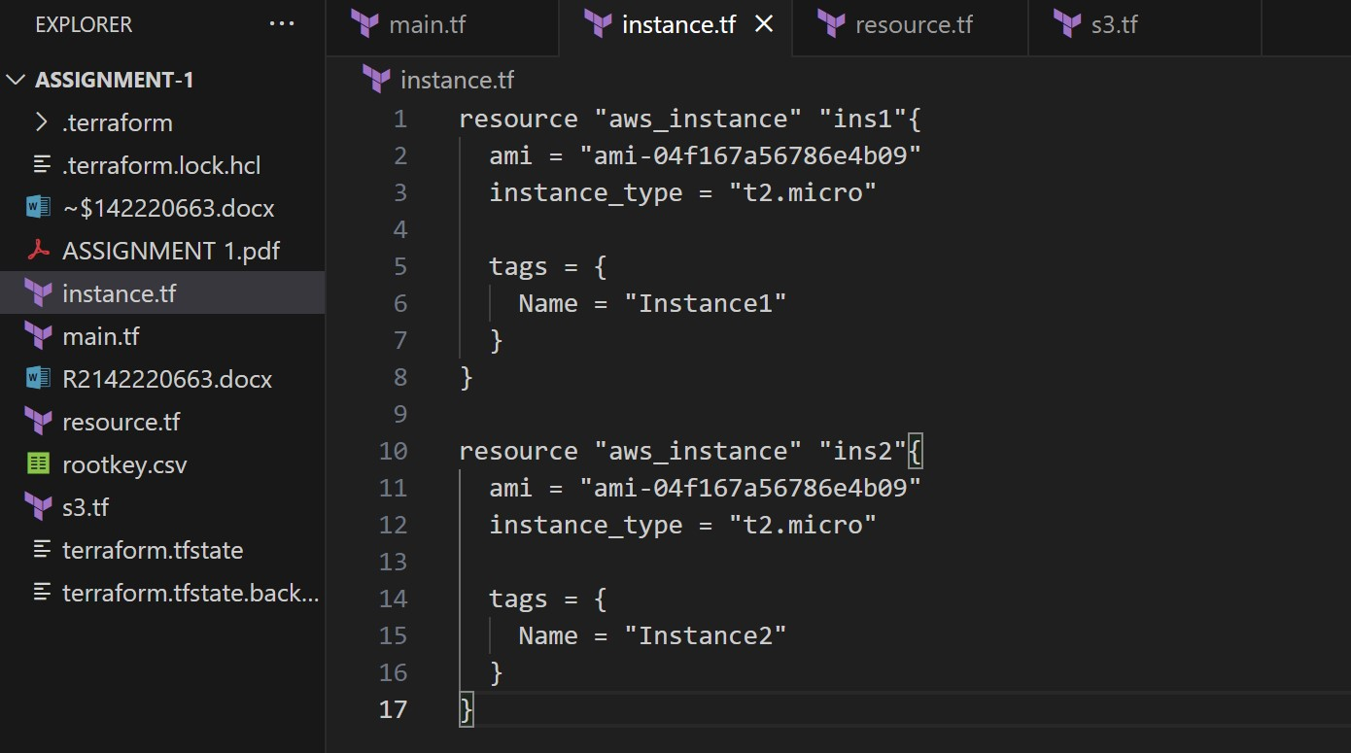

This file holds the iac code to make 2 instances - t2-micro ec2 machines

**resource.tf**

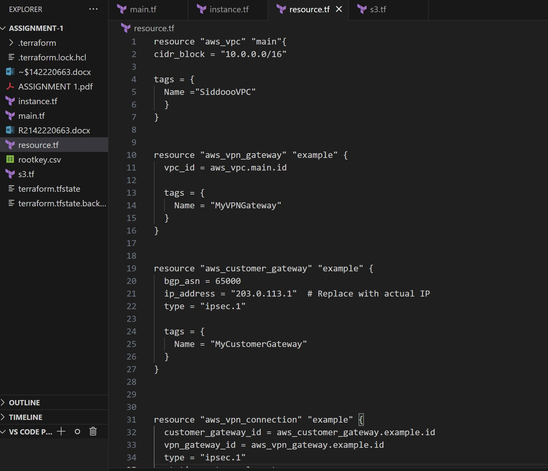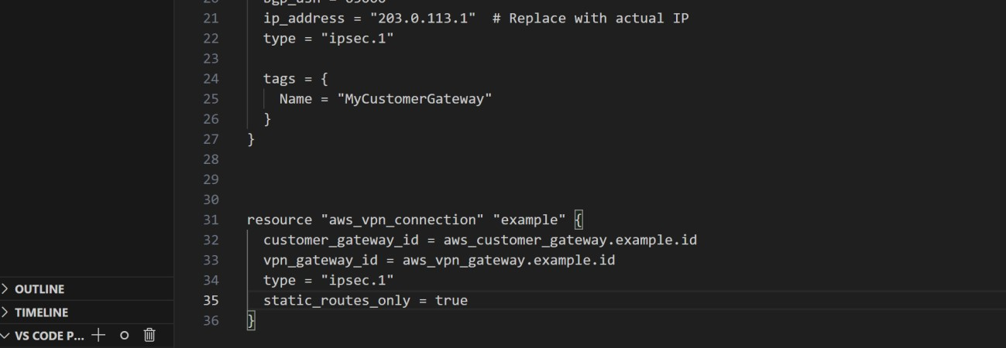

This resource.tf hold the iac code to create vpc , the customer gateway and the vpn connection. **s3.tf**

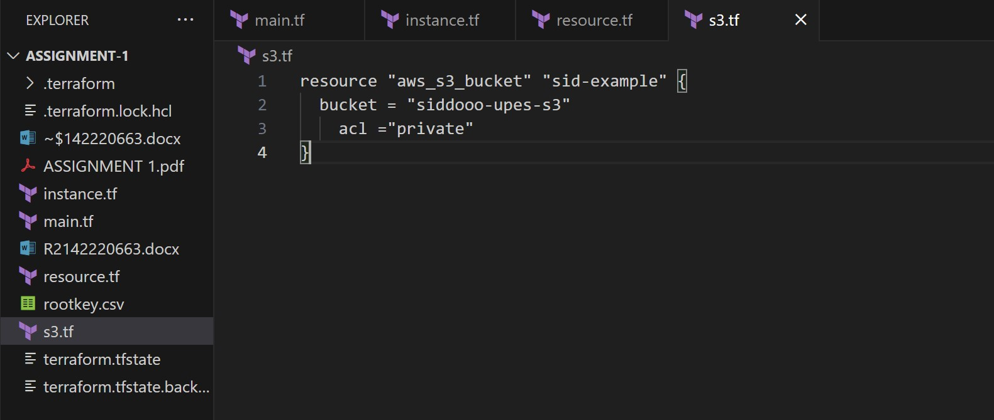

The s3.tf hold the code to create a s3 bucket which has a unique name

Outputs: **terraform plan**

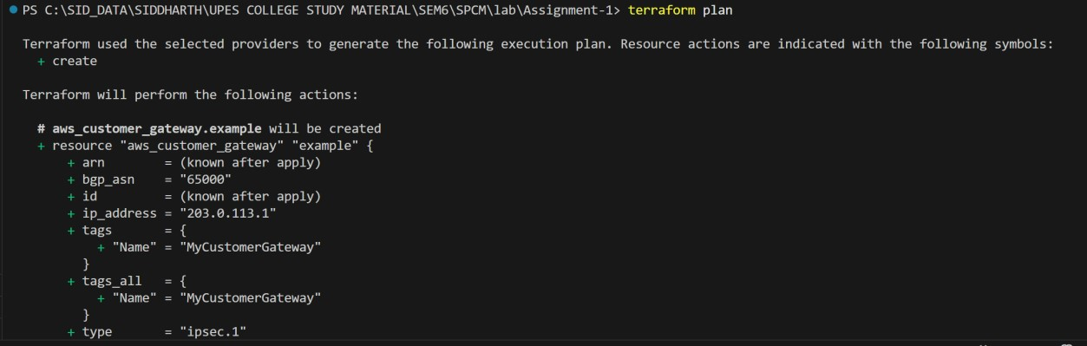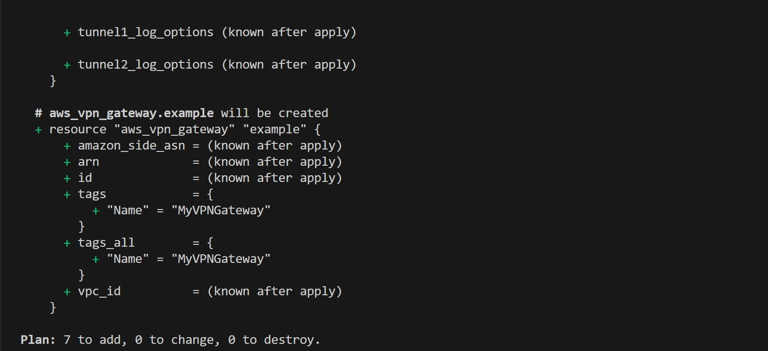

**Terraform apply**

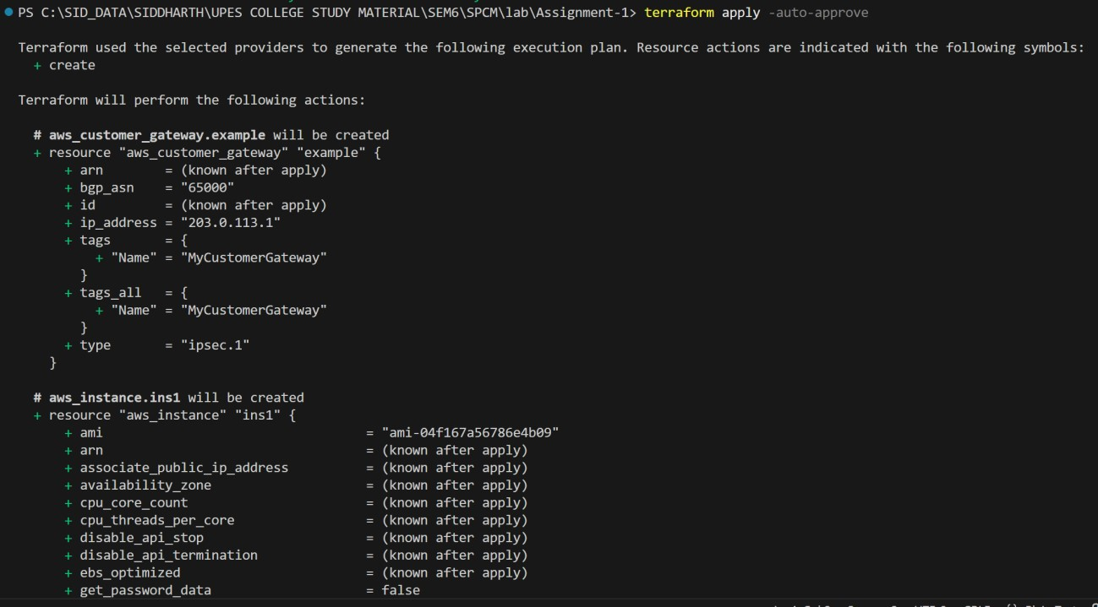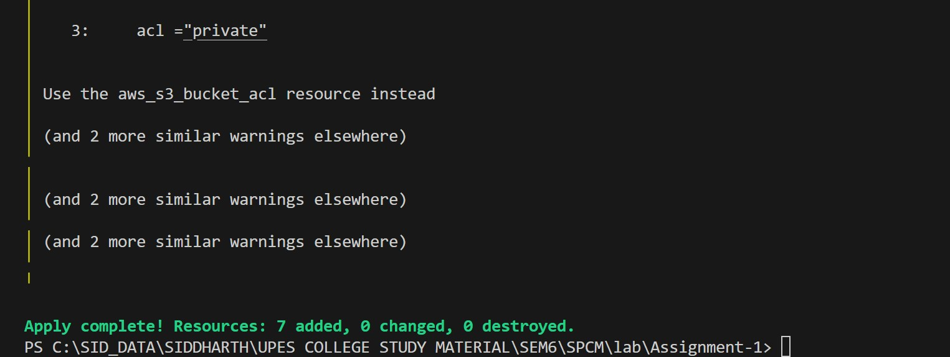

**Customer Gateway**

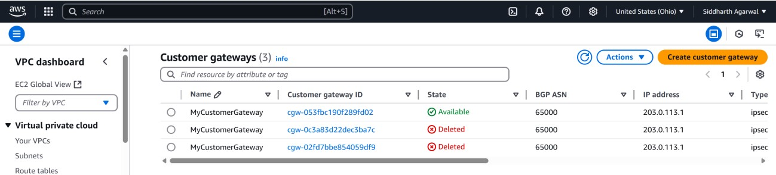

**VPC**

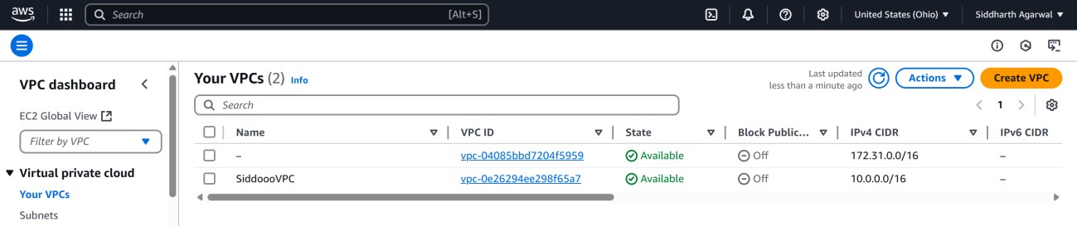

**S3**

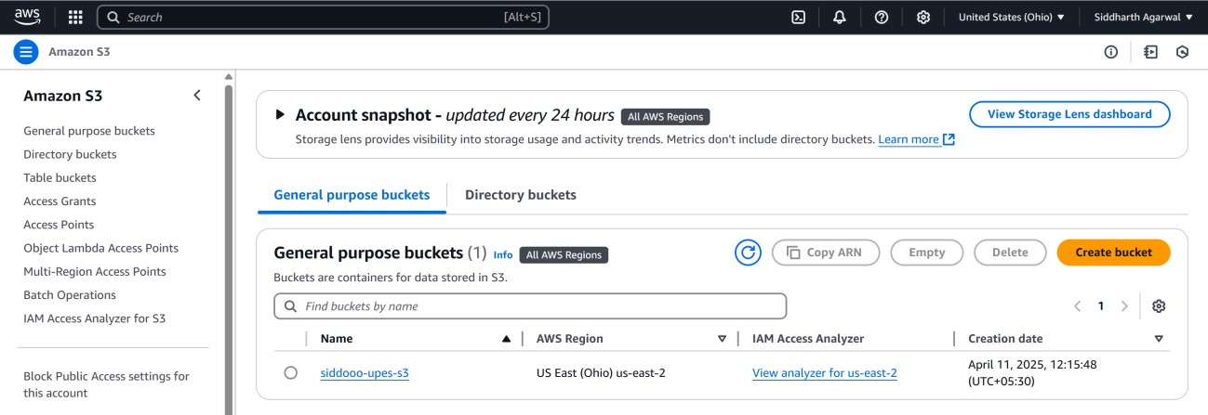

**Instances**

