

**ASSIGNMENT 1**

**Write Terraform script to do perform following tasks on AWS cloud Platform**

**Name – Khushi Chauhan**

**Sap id – 500105956**

**Batch – DevOps(B1)**

**Submitted to – Prof. Hitesh Sharma**

Step 1: Create two T2 Micro EC2 Instances.

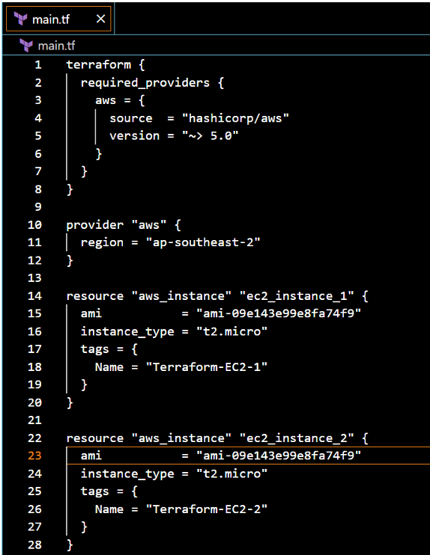

Step2: Create a VPN on AWS

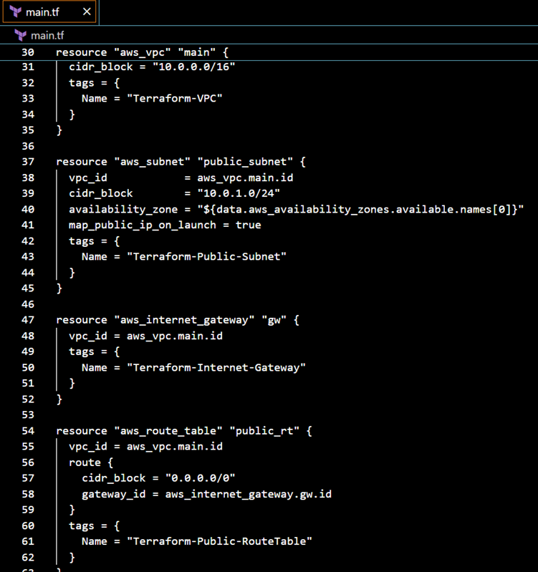

Step 3: Create a S3 Bucket

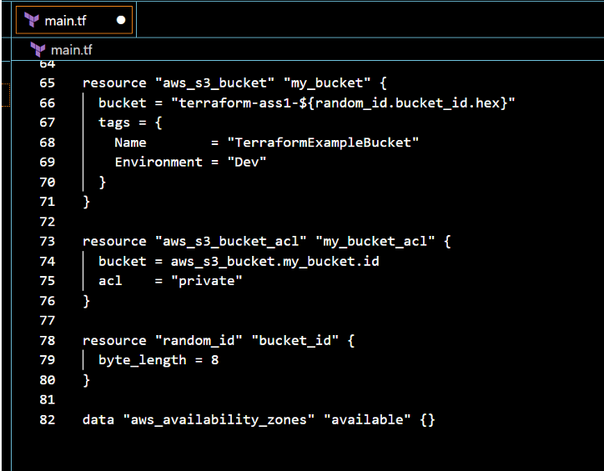

Step 4: Write the code for step 1,2 and 3 in a IaC terraform file and run terraform commands to execute these steps.

terraform {

required_providers {

aws = {

source = "hashicorp/aws"

version = "~> 5.0"

}

}

}

provider "aws" {

region = "ap-southeast-2"

}

data "aws_availability_zones" "available" {}

resource "random_id" "bucket_id" {

byte_length = 8

}

# VPC

resource "aws_vpc" "main" {

cidr_block = "10.0.0.0/16"

tags = {

Name = "Terraform-VPC"

}

}

# Subnet

resource "aws_subnet" "public_subnet" {

vpc_id = aws_vpc.main.id

cidr_block = "10.0.1.0/24"

availability_zone = data.aws_availability_zones.available.names[0]

map_public_ip_on_launch = true

tags = {

Name = "Terraform-Public-Subnet"

}

}

# Internet Gateway

resource "aws_internet_gateway" "gw" {

vpc_id = aws_vpc.main.id

tags = {

Name = "Terraform-Internet-Gateway"

}

}

# Route Table

resource "aws_route_table" "public_rt" {

vpc_id = aws_vpc.main.id

route {

cidr_block = "0.0.0.0/0"

gateway_id = aws_internet_gateway.gw.id

}

tags = {

Name = "Terraform-Public-RouteTable"

}

}

# EC2 Instances

resource "aws_instance" "ec2_instance_1" {

ami = "ami-09e143e99e8fa74f9"

instance_type = "t2.micro"

tags = {

Name = "Terraform-EC2-1"

}

}

resource "aws_instance" "ec2_instance_2" {

ami = "ami-09e143e99e8fa74f9"

instance_type = "t2.micro"

tags = {

Name = "Terraform-EC2-2"

}

}

# S3 Bucket

resource "aws_s3_bucket" "my_bucket" {

bucket = "terraform-ass1-${random_id.bucket_id.hex}"

tags = {

Name = "TerraformExampleBucket"

Environment = "Dev"

}

}

# S3 Bucket ACL

resource "aws_s3_bucket_acl" "my_bucket_acl" {

bucket = aws_s3_bucket.my_bucket.id

acl = "private"

}

Terraform init:

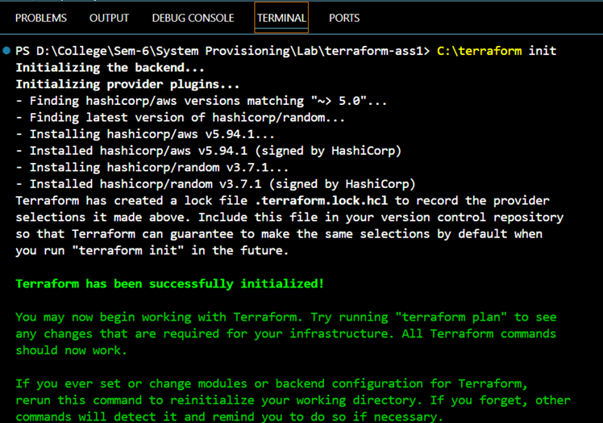

Terraform plan:

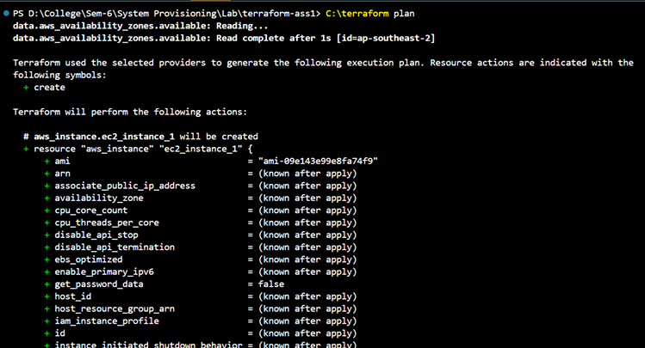

Terraform plan:

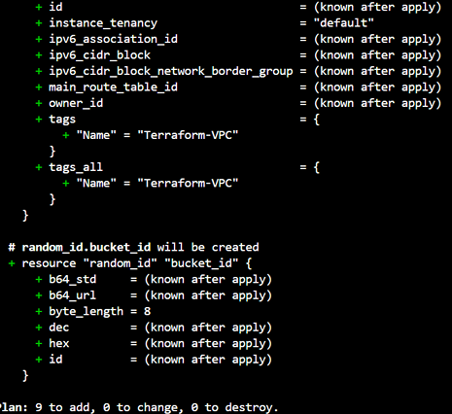

Terraform apply:

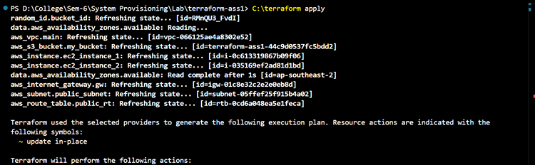

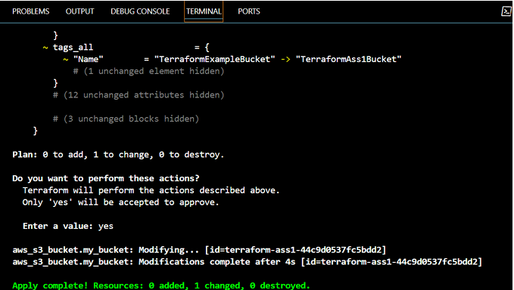

AWS Console Output: Instance-

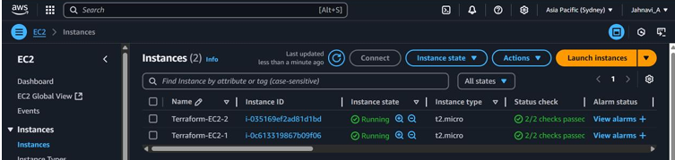

VPN-

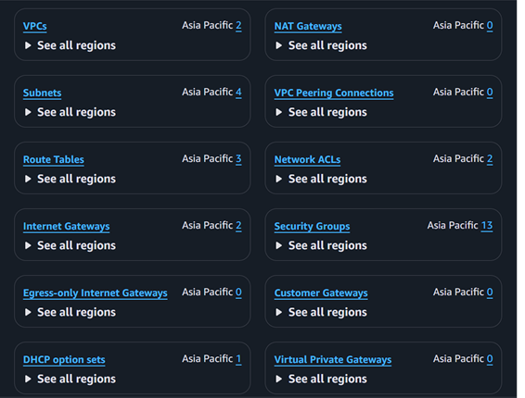

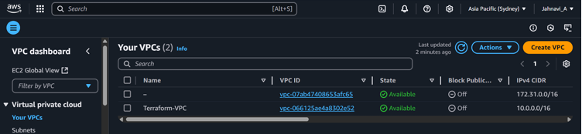

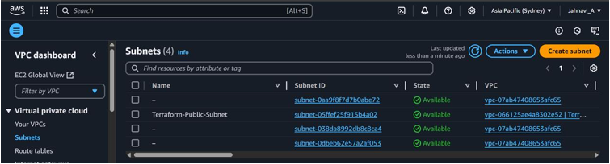

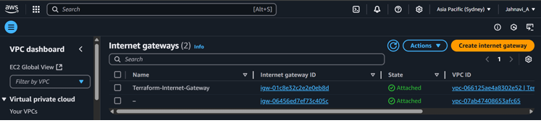

S3 Bucket-

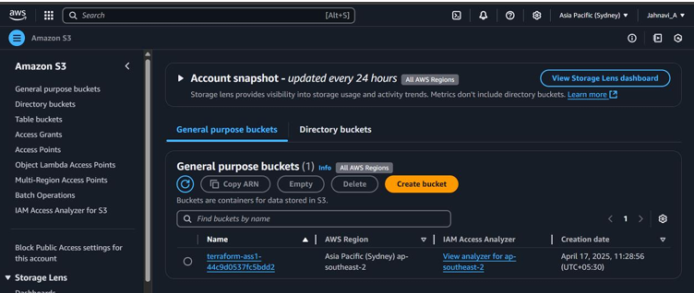

Terraform destroy:

