

SPCM - LAB

6th Sem

**Submitted To: Submitted By:**

**Dr. Hitesh Kumar Sharma Kavya Singh**

**School of Computer Science R2142220538**

**500106891**

**Batch 1-NH**

Writing Terraform Scripts to perform the following task 2 ec2 Instances, VPN and S3

main.tf

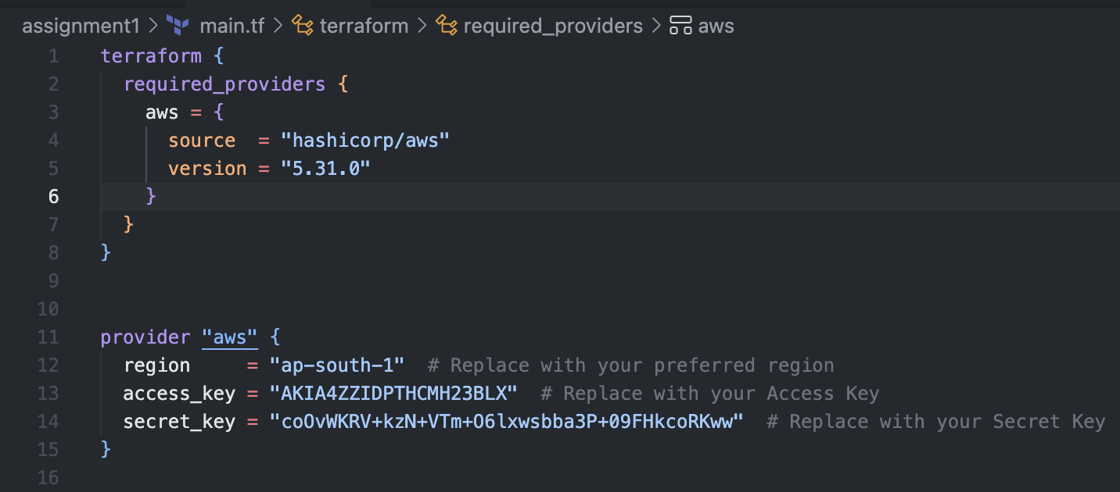

Running terraform init

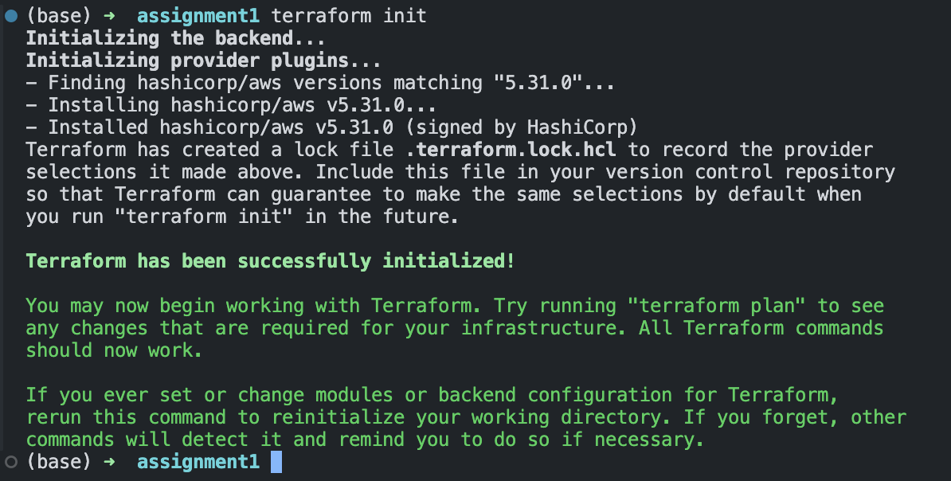

Terraform init to initialize the terraform folder which will have the aws provider plugin installed

instance.tf 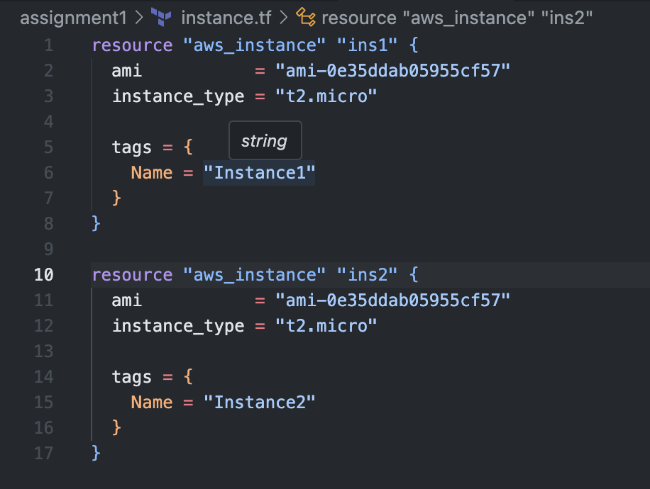

This file holds the iac code to make 2 instances - t2-micro ec2 machines

resource.tf

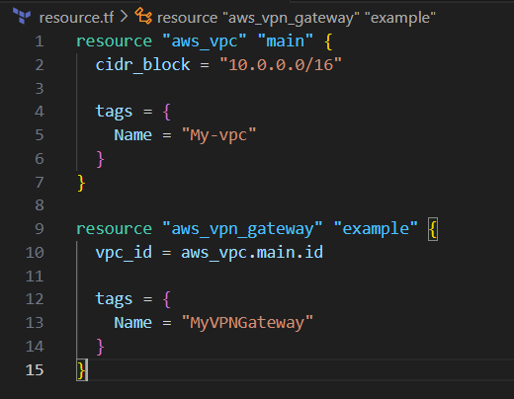

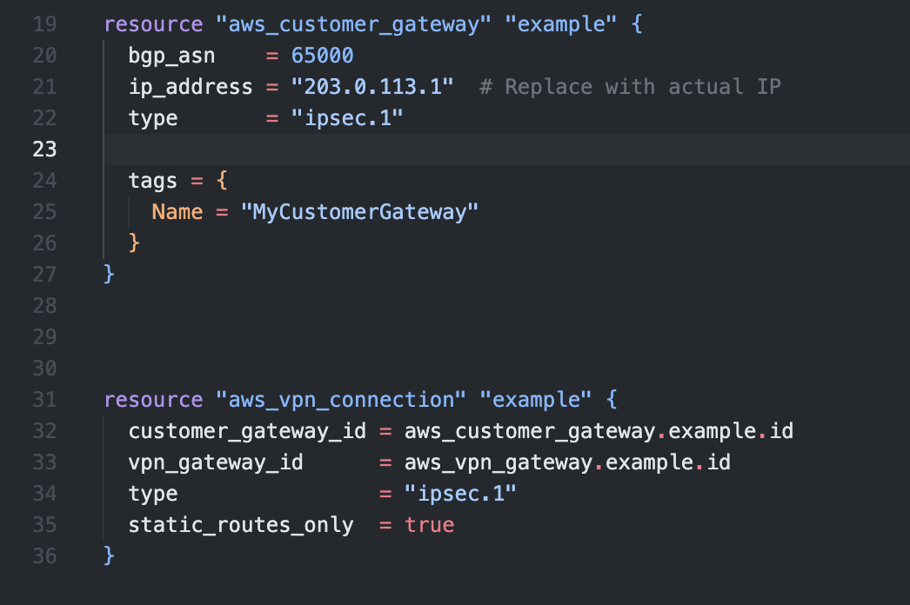

This resource.tf hold the iac code to create vpc , the customer gateway and the vpn connection.

s3.tf

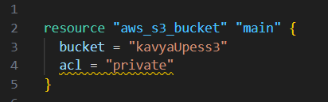

The s3.tf hold the code to create a s3 bucket which has a unique name

Outputs:

terraform plan

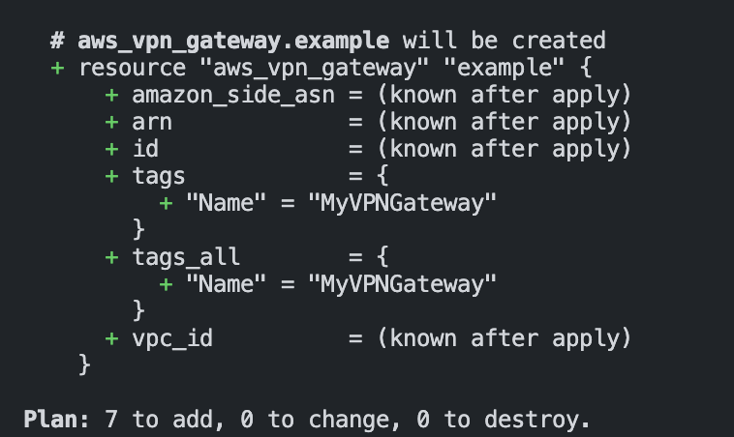

Terraform apply 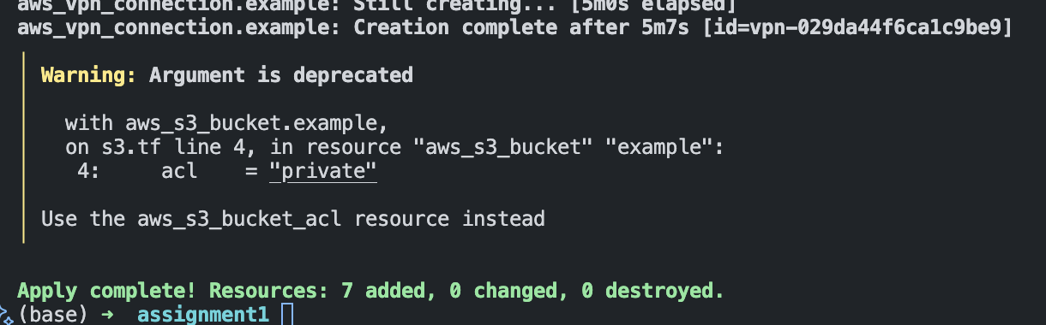

Customer Gateway

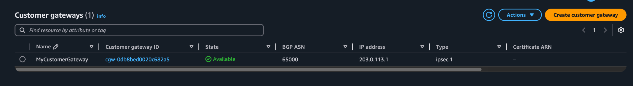

Vpc

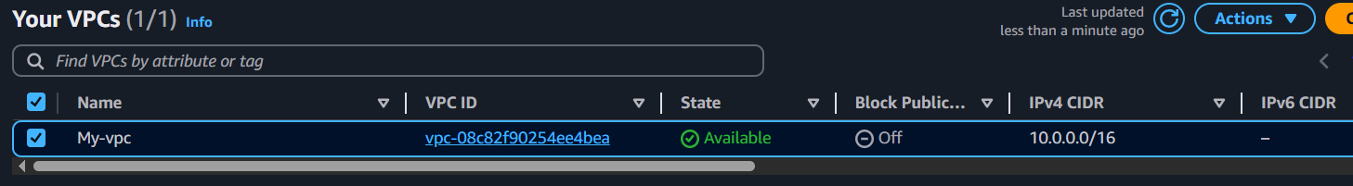

S3

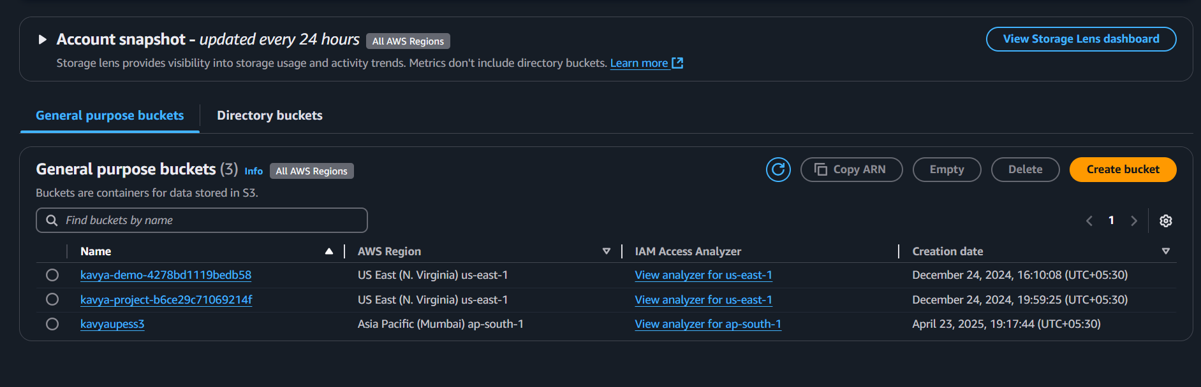

Instances

