**School of Computer Science**

**UNIVERSITY OF PETROLEUM AND ENERGY STUDIES**

**DEHRADUN, UTTARAKHAND**



**System Provisioning and Configuration Management**

**Lab File (2022-2026)**

# **6th Semester**

|  |  |
| --- | --- |
| *Submitted To:*  ***Dr. Hitesh Kumar Sharma*** | *Submitted By:*  *Madhav Madan*  *(500105699)*  *B Tech CSE*  *DevOps[6th Semester]*  *R2142220265*  *Batch - 1* |

**EXPERIMENT 6**

**Lab Exercise: Terraform Variables Objective:**

Learn how to define and use variables in Terraform configuration.

**Prerequisites:**

* Install Terraform on your machine.

**Steps:**

1. **Create a Terraform Directory:**

* Create a new directory for your Terraform project.

**mkdir terraform-variables**

**cd terraform-variables**

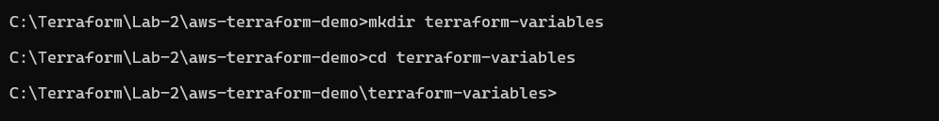

1. **Create a Terraform Configuration File:**

* Create a file named main.tf within your project directory.

**# main.tf**

resource "aws_instance" "myinstance-1" {

    ami = var.myami

    instance_type = var.my_instance_type

    count = var.mycount

    tags = {

      Name= "My Instance"

    }

}

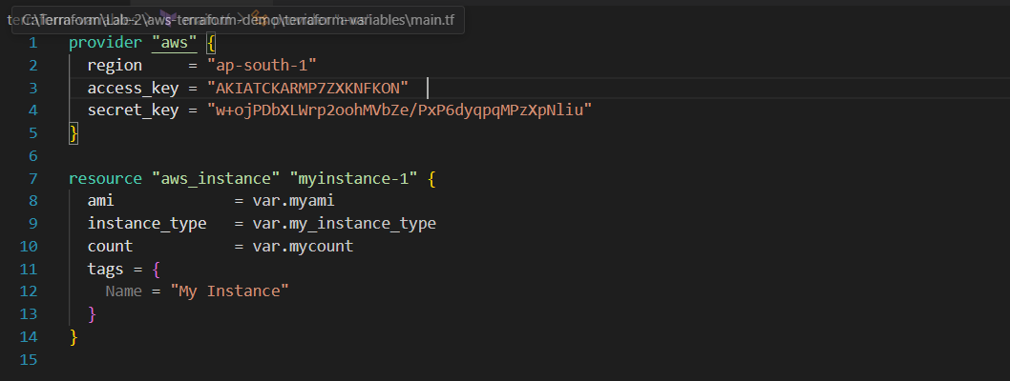

1. **Define Variables:**

* Open a new file named variables.tf. Define variables for region, ami, and instance_type.

**# variables.tf**

variable "myami" {



  type = string



  default = "ami-08718895af4dfa033"

}

variable "mycount" {

  type = number

  default = 5

}



variable "my_instance_type" {

    type = string

    default = "t2.micro"

}

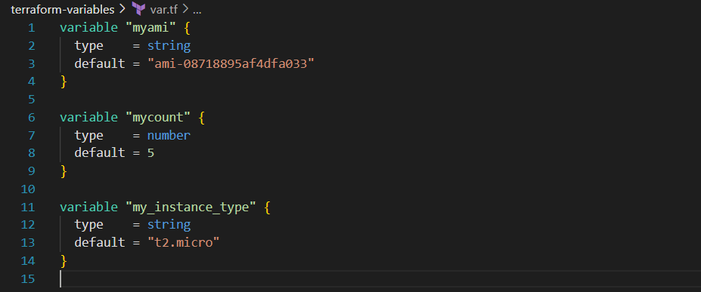

1. **Initialize and Apply:**

* Run the following Terraform commands to initialize and apply the configuration.

**terraform init**

**terraform plan**

**terraform apply -auto-approve**

Observe how the region changes based on the variable override.

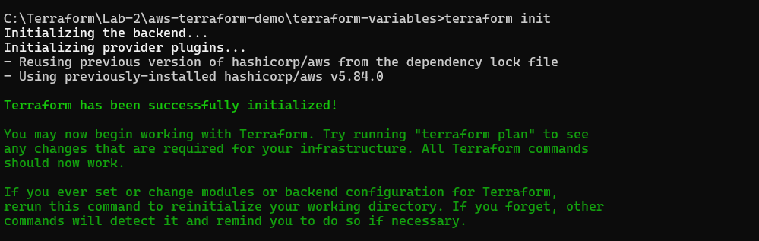

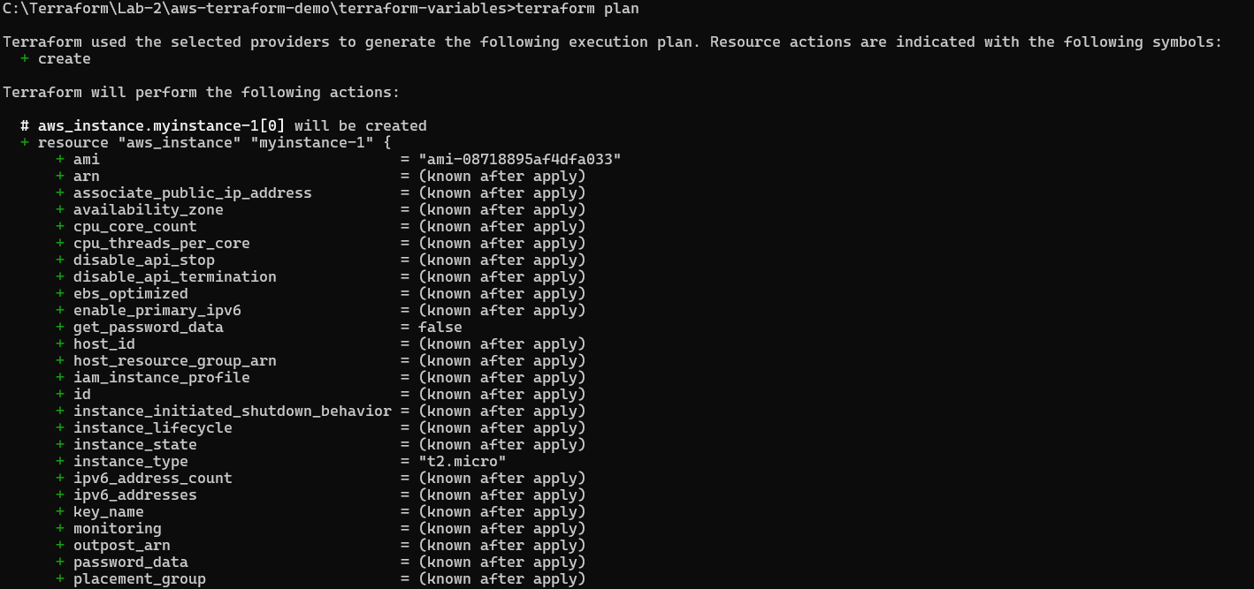

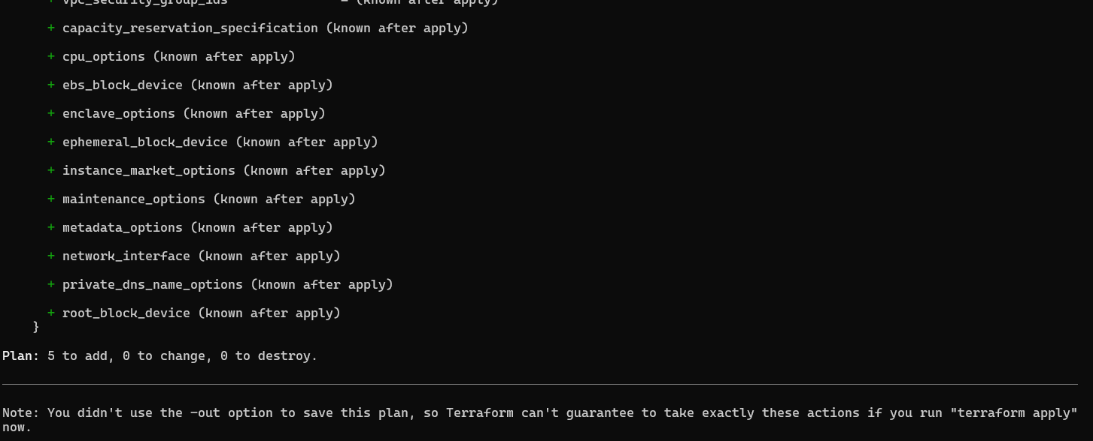

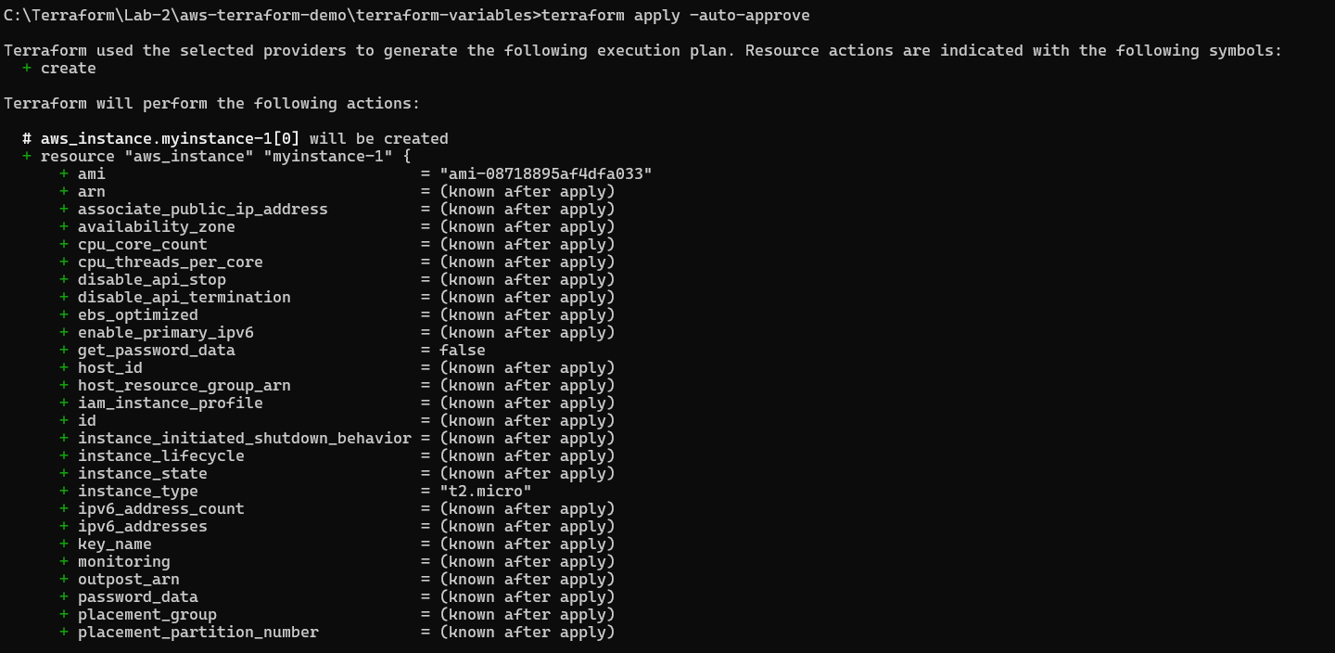 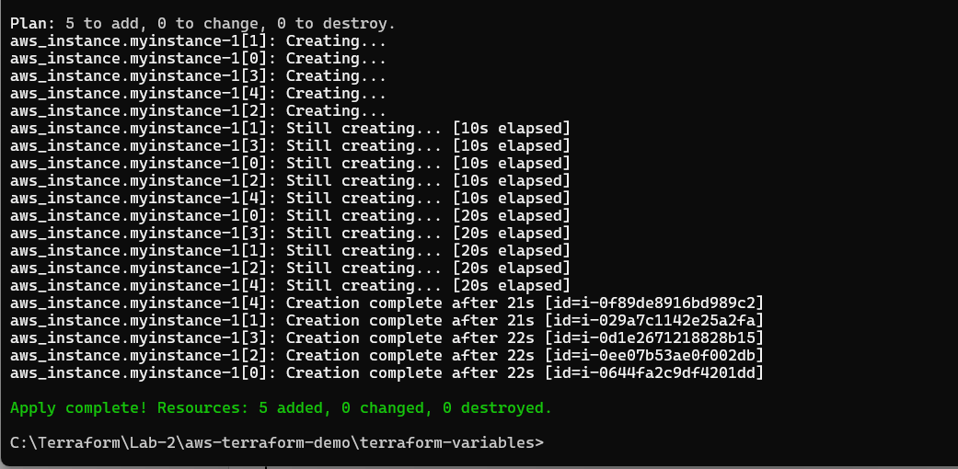 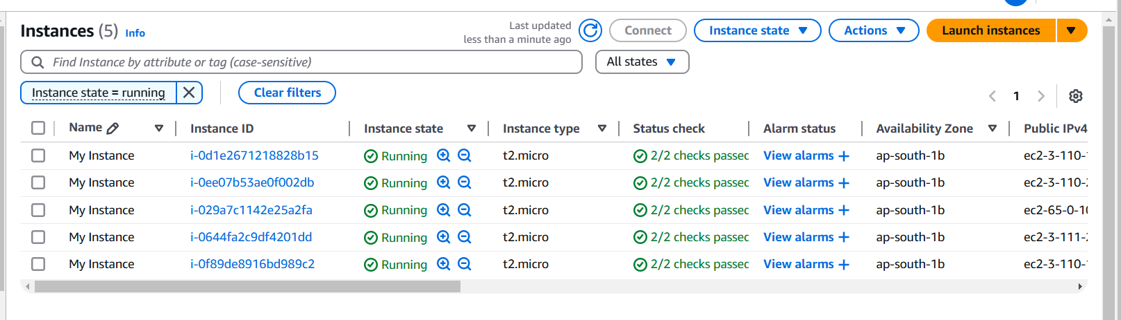

1. **Clean Up:**

After testing, you can clean up resources.

**terraform destroy**

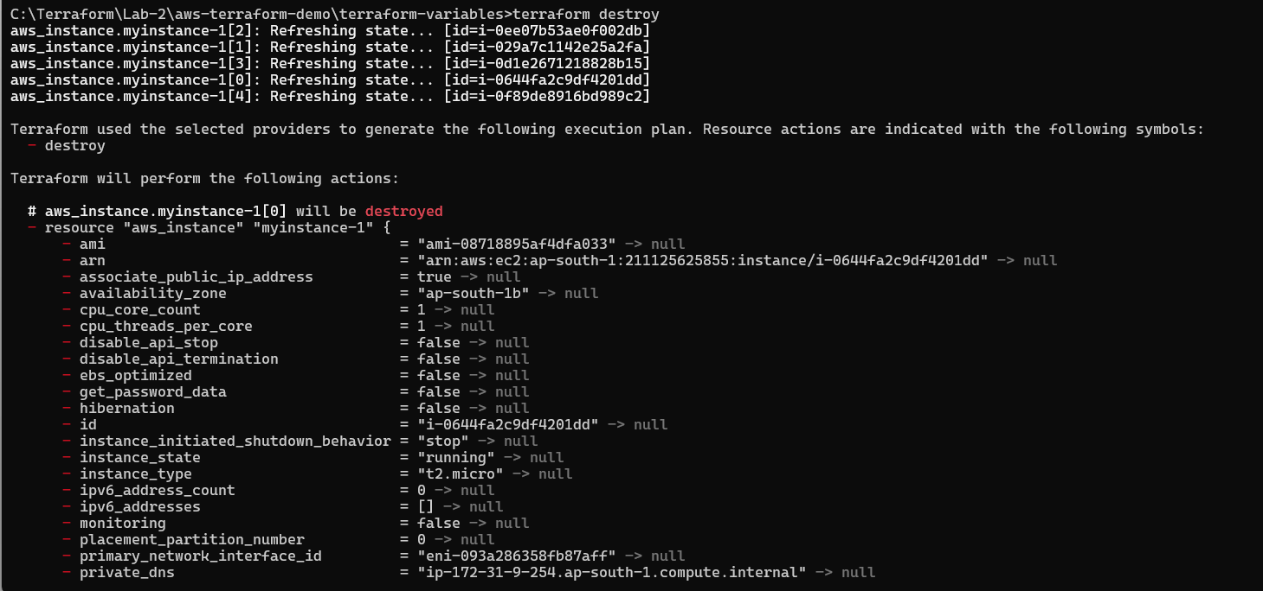 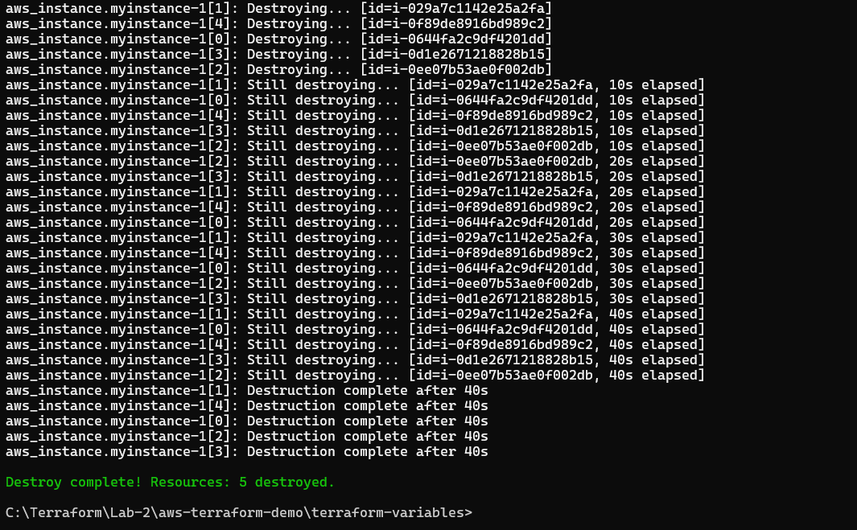

Confirm the destruction by typing yes.

1. **Conclusion:**

This lab exercise introduces you to Terraform variables and demonstrates how to use them in your configurations. Experiment with different variable values and overrides to understand their impact on the