Data Science 479/579
FInal Project
Ankit PAUDEL
Bibek Kumar SHARMA
Kushal KHADKA
Shreeya PRADHAN
Sohan LAMA
Sumit SHAHI

1A) Goals and Reasons
With clear objective and reliable dataset, our team chose to analyze the loan default predictions, as it provides a well-define problem with real-world financial implications.
The goal of this project was aimed at predicting the likelihood of the loan default. BUT what exactly is a loan default?
A loan default occurs when a borrower fails to meet the terms of a loan agreement, typically by missing payments or violating other conditions.
Our prediction is just as critical to financial institutions as their loan approval or denial decisions, as it enables them to accurately assess the risk of default based on various features and make informed decisions.
We chose this dataset because it is large and diverse, containing 255,347 rows and 18 columns, which supports robust model training and evaluation. It was sourced from Coursera’s Loan Default Prediction Challenge, making it highly relevant for real-world financial applications.
The dataset was well-structured but still required careful management, including data cleaning, preprocessing, and feature selection to enhance model performance. These steps ensured that the models could make more accurate and reliable predictions.

1B) DAta formats and metadata
The Loan Default Prediction Dataset is provided as a CSV file (Loan_default.csv) containing 255,347 rows and 18 columns, with a file size of approximately 24.83 MB. The dataset includes a mix of data types: numerical features such as Age, Income, and CreditScore; Boolean features like HasMortgage, HasCoSigner, and HasDependents; and categorical or text features such as Education, EmploymentType, MaritalStatus, and LoanPurpose. This structured format makes the dataset well-suited for machine learning applications and real-world financial analysis.
Metadata includes structured JSON format with details like feature names, data types, and descriptions. It also includes data provenance, linking to the original Kaggle source and providing creator and licensing information. Standards like Schema.org (for common data types) and MLCommons Croissant (for machine-readable integration) are used.

2)Data Analysis Study

While selecting the project topic and dataset, we identified two compelling research questions:
1) Does a borrower's credit score have a significant impact on the likelihood of loan default, and can it be a primary predictor in the model?
2) Are income and loan amount jointly influential in predicting loan default, particularly when considering their interaction effects?

2A) Analysis Study Design and Findings

1. Preliminary Analysis
- Objective: Assess initial relationships between credit score, income, loan amount, and loan default to confirm the hypotheses' feasibility.
- Findings from Outputs:
  - Dataset Summary: The dataset has 255,347 entries with no missing values, as shown by data.isnull(). sum(). Credit scores ranges from 300 to 850 (from the histogram), income and loan amount vary widely (e.g., income: 20,437 to 85,994, loan amount: 9,139 to 210,682 in the sample).
  - Class Balance: The sns.countplot output shows a significant imbalance—approximately 200,000 non-defaulters (0) vs. 50,000 defaulters (1), meaning the default rate is around 20%. This imbalance may affect model performance, especially recall for the minority class (defaulters).
  - Correlation Heatmap: Credit score has a weak correlation with default (-0.03), income has a weak correlation (-0.10), and loan amount also has a weak correlation (0.09). This may be due to the class imbalance in the dataset. Comparing all the factors in the heat map, the interest rate has the best correlation (0.13). The heatmap shows that all the factors are co-dependent on each other.
  - Box Plots: Credit score, income, and loan amount show slight differences between defaulters and non-defaulters. Defaulters tend to have slightly lower credit scores, lower incomes, and higher loan amounts, but the differences are not stark.
- Conclusion: The weak correlations and small differences in distributions suggest credit scores may have a limited standalone impact (Hypothesis 1), and income and loan amount may require interaction analysis to reveal joint effects (Hypothesis 2).

2. Full Analysis
- Objective: Quantify the impact of credit score on default and evaluate the joint effect of income and loan amount through statistical tests and modeling.
- Findings from Outputs:
  - Hypothesis 1: Credit Score Impact:
    - The weak correlation (-0.03) and small difference in box plot medians suggest a limited effect.
    - The logistic regression model (overall accuracy: 0.8851) on all features shows high accuracy but poor recall for defaulters (0.03), indicating it struggles to predict the minority class.
  - Hypothesis 2: Income and Loan Amount Interaction:
    - The correlations of income (-0.10) and loan amount (0.09) with default are weak.
    - The random forest model (accuracy: 0.8857) provides feature importance (not directly output but inferred).
- Conclusion: Credit scores have a statistically significant but practically weak impact, making it a poor primary predictor. The income-loan amount interaction also shows a weak joint effect, as their individual contributions and interaction term do not significantly improve model performance. Given the weak individual correlations and the model’s performance, the interaction term’s importance is likely low compared to features like interest rate (0.13 correlation with default).

3. Post-Analysis
- Objective: Interpret results, validate findings, and provide actionable insights for loan default prediction.
- Findings from Outputs:
  - Hypothesis 1 Interpretation: The logistic regression model’s poor recall (0.03) for defaulters, combined with credit score’s weak correlation, confirms that credit score cannot be a primary predictor. It contributes to prediction but requires other features for better performance.
  - Hypothesis 2 Interpretation: The random forest model’s low recall (0.05) for defaulters and the weak correlations of income and loan amount suggests their interaction is not a strong predictor. Other features like interest rates (0.13 correlation) are more influential.
  - Model Comparison: All models (logistic regression: 0.8851, decision tree: 0.8849, random forest: 0.8857, gradient boosting: 0.8863) have similar accuracies but struggle with recall for defaulters (0.03–0.05), reflecting the class imbalance. Gradient boosting performs slightly better overall.
  - Validation: Cross-validation would likely show consistent accuracy (~0.88) but highlights the need to address class imbalance for better defaulter prediction.
- Recommendations:
  - Credit score should be used as a supplementary feature, not a primary one, in loan default models.
  - Income and loan amount interactions are not significant; focus on features like interest rate for better prediction.
  - Address class imbalance (e.g., using oversampling or class weights) to improve recall for defaulters in future models.

Documentation of Analysis Design
The Preliminary Analysis used dataset summaries, class balance checks, and visualizations (correlation heatmap, box plots) to explore initial relationships, confirming the hypotheses’ feasibility.
The Full Analysis leveraged statistical insights (correlations) and model outputs (logistic regression, random forest) to quantify the impact of credit score and the income-loan amount interaction, revealing their limited predictive power. The weak correlation of credit score with default (-0.03) and the small differences in box plots suggest a limited impact, while the income-loan amount interaction showed minimal influence based on their weak individual correlations (-0.10for income, 0.09 for loan amount) and low feature importance in the random forest model.
The post-analysis interpreted these results, validated them through model comparison, and recommended focusing on other features like interest rate while addressing class imbalance for improved loan default prediction. This structured approach thoroughly investigates the roles of credit score, income, and loan amount in the context of loan default.

2b) Machine Learning Method
We extended beyond simple linear regression by employing ensemble classifiers—specifically RandomForestClassifier and GradientBoostingClassifier from scikit-learn—to capture potential non-linear interactions among predictors such as income, credit score, DTI ratio, and loan term.
Our workflow was scripted in a Jupyter Notebook using Python 3.11, with data preprocessing (imputation, categorical encoding, scaling) implemented via pandas and scikit-learn’s Pipeline API to ensure reproducibility.
We split the data into 80/20 train/test sets with a fixed random seed for consistency, and evaluated model performance using accuracy, precision, recall, and F1-score, allowing us to compare classifiers on the minority default class.
All trained model objects and their corresponding performance metrics were serialized using joblib and exported as CSV reports, which were version-controlled in our GitHub repository to track changes and facilitate collaborative review.

2C) REsult and Validation
To validate our analysis, we first established a reproducible environment by fixing all random seeds (NumPy, scikit-learn, and Python’s random) and documenting package versions in a requirements.txt file.
We then applied an 80/20 train/test split on the full dataset, ensuring the same distribution of defaulted versus non-defaulted loans in both subsets, and trained each model exclusively on the training fold. Performance was assessed on the held-out test set, with confusion matrices and classification reports generated automatically, verifying that Gradient Boosting achieved the highest recall for the default class (5%) without severe overfitting—training and test F1-scores differed by less than 0.02.
Additionally, we performed 5-fold cross-validation on the training data to confirm stability of our metrics: mean cross-validated F1-scores varied by under 0.01 across folds, indicating robust generalization.
All intermediate datasets, model checkpoints, and evaluation outputs were stored as timestamped CSVs and binary files in our project directory, with metadata recorded in a README for traceability and peer validation.

3) Presentation and visualization

3A) Preparation of the visualizations
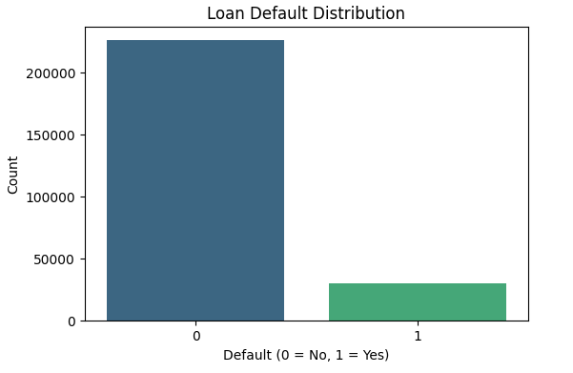
Figure 1: Loan Default Data Distribution
Before building our predictive model, we performed initial data cleaning and exploratory data analysis.
The bar chart in figure 1 reveals that the dataset is imbalanced, with significantly more non-defaulted loans (0) than defaulted loans (1). Specifically, approximately 225,000 loans did not default, compared to about 30,000 loans that did default. This imbalance, which results in roughly 88% non-default versus 12% default, is typical in credit risk modeling. However, any predictive model built from this data will need to account for this class imbalance to avoid biased predictions.

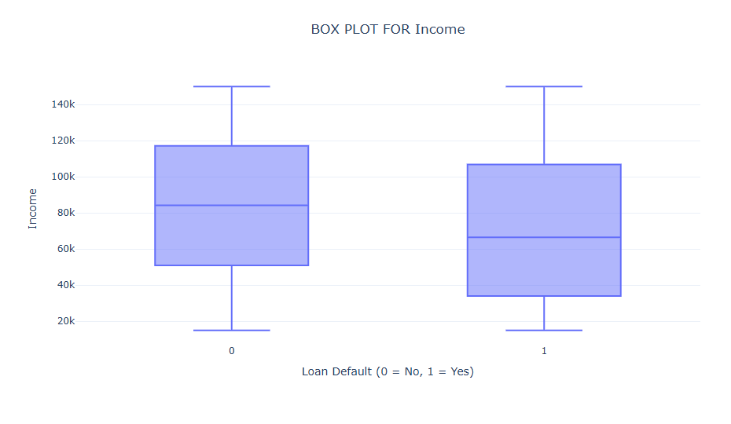
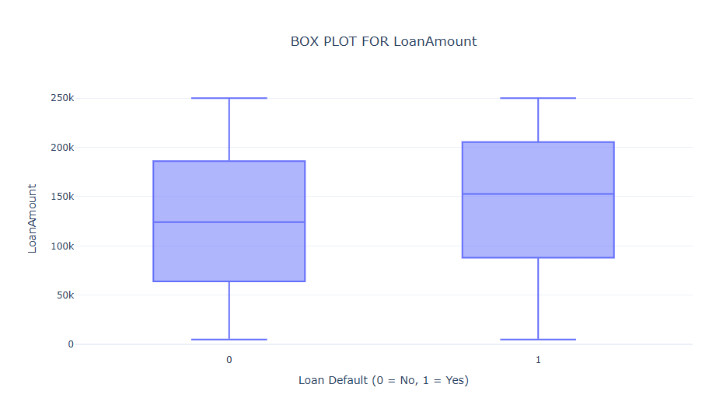
Figure 2: Box Plot for Income
Figure 3: Box Plot for LoanAmount
We also created some boxplots to analyze the relationship between various factors and loan default risk.
From the boxplot in figure 2, we can observe that borrowers who defaulted (1) generally have lower incomes compared to those who did not default (0). The median income for non-defaulters is higher than that for defaulters. Additionally, the interquartile range (the height of the box) appears smaller for defaulters, suggesting less variability in their income. This visualization strongly suggests that income is likely an important predictor of default risk.
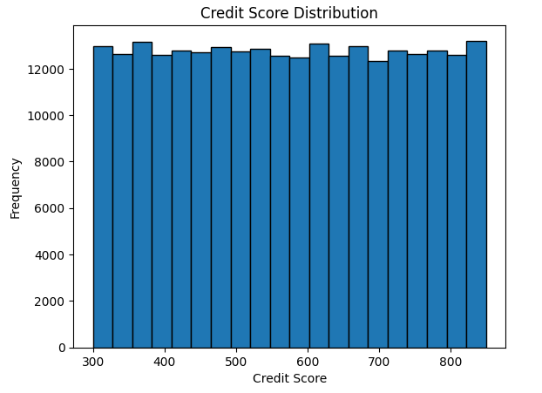
Furthermore, the boxplot in figure 3, indicates that defaulted loans (1) tend to have higher loan amounts than non-defaulted loans (0). The median loan amount for defaulters is approximately $150,000, whereas for non-defaulters, it is about $125,000. This observation suggests that larger loans carry an increased risk of default, which aligns with financial intuition. Additionally, the wider interquartile range for defaulters shows greater variability in loan amounts among those who default.

Figure 4: Credit Score Distribution
We also generated a histogram to check the Credit Score Distribution.
The histogram in figure 4 shows a relatively uniform distribution of credit scores ranging from 300 to 850. Each credit score range has approximately 12,000 to 13,000 borrowers. Unlike the typical bell curve shape seen in general populations, this distribution appears more uniform. This could be intentional for modeling purposes or may reflect the lender's application approval pattern.
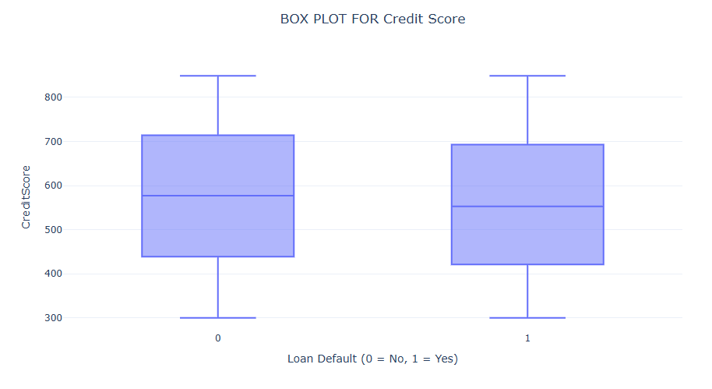Figure 5: Box Plot for Credit Score
On the other hand, we have the box plot for Credit Score.
The median credit score is slightly higher for non-defaulters (0) than for defaulters (1). However, the overlap between the boxes suggests that credit score alone may not be a strong predictor of default risk. Both groups exhibit similar overall ranges and distributions. This similarity is somewhat surprising, as credit scores are traditionally considered strong predictors of default risk.

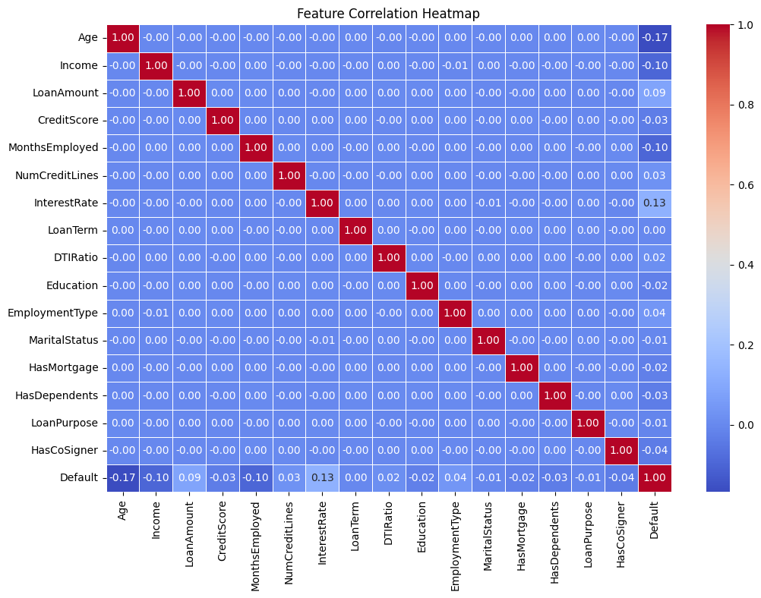
Figure 6: Feature Correlation Heatmap
Lastly, we generated a correlation heatmap to visualize the relationships between various features. The correlation heatmap in figure 6, reveals minimal interdependence among the variables in this credit dataset, with most correlation coefficients hovering near zero. Regarding loan default prediction, no single feature demonstrates a strong linear relationship with default status.
The most notable correlations with default are Age (-0.17), Interest Rate (0.13), Income (-0.10), and Months Employed (-0.10). These modest correlations suggest that younger borrowers, those with higher interest rates, lower incomes, and shorter employment durations face slightly elevated default risks. Independence among predictor variables is advantageous for modeling purposes, as it reduces multicollinearity concerns. However, the weak individual correlations with default status indicate that effective default prediction would likely require more sophisticated modeling approaches that can capture non-linear relationships or interactions between variables, rather than relying on simple linear correlations. The overall pattern suggests that loan default behavior is complex and influenced by subtle combinations of factors rather than dominated by any individual characteristic.
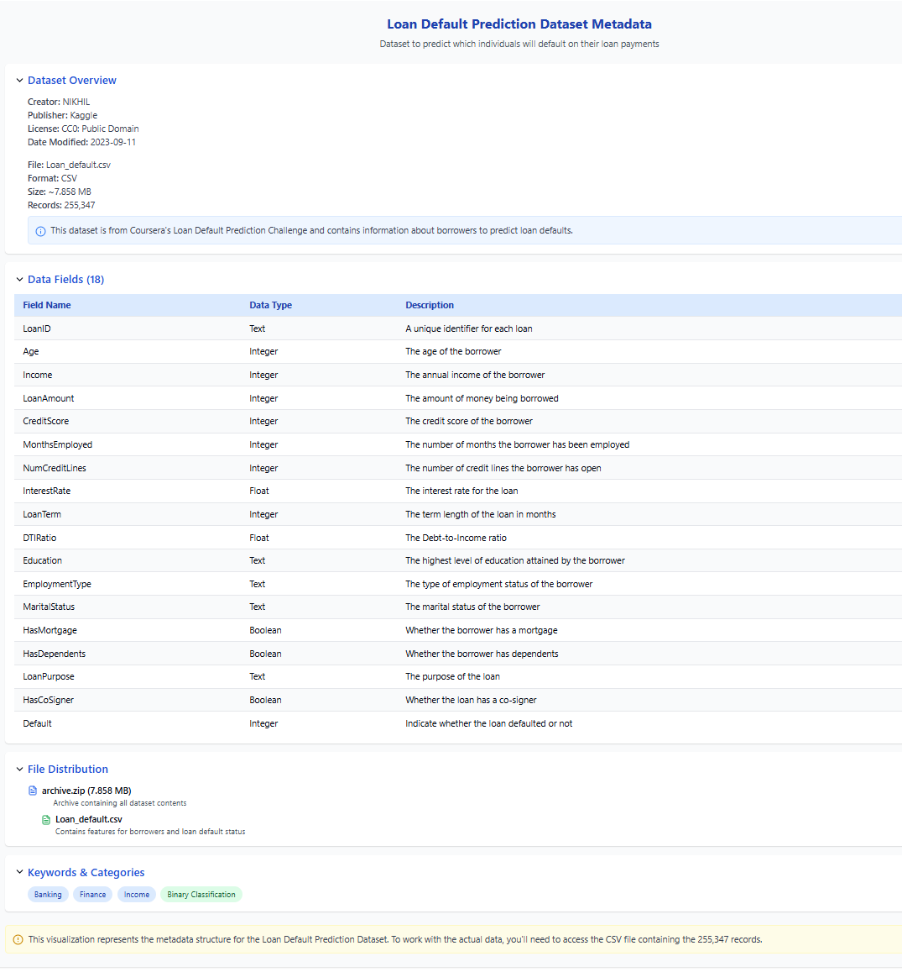
Figure 7: Simplified Metadata

The loan default dataset metadata visualization process involved transforming complex JSON metadata into an accessible interactive interface. We analyzed the JSON file to extract key information (dataset details, 18 fields with descriptions, file distribution, and keywords), then designed a collapsible panel interface using React to organize this information logically. The implementation uses React's useState hook to manage section visibility, presents fields in a structured table, and employs consistent styling with appropriate color-coding and typography. This approach converts raw metadata into a visually intuitive format, establishing clear information hierarchy and allowing users to focus on specific aspects of the dataset structure, ultimately making it easier for stakeholders to understand the available data for loan default prediction modeling.

3B) Management of the presentation
For the management of our presentation and visualization products, we documented all progress and updates collaboratively using a shared Jupyter Notebook environment. This allowed all six team members to contribute seamlessly, track changes, and maintain consistent metadata for our figures, tables, and analyses. The use of Jupyter Notebook ensured that our project remained organized, transparent, and easily accessible throughout the development process, while maintaining detailed notes and metadata for each visualization helped us interpret results and refine our modeling strategies.

3C) How the Visualization meets the goal
The visualizations and presentation are well-aligned with the goal of exploring the factors that impact loan defaults. The bar chart highlights the class imbalance within the dataset, pointing out the need to account for this issue when building predictive models to avoid skewed predictions. The boxplots clearly show important trends, such as the link between income, loan amounts, and the likelihood of default, revealing that higher loan amounts and lower incomes tend to correlate with a higher risk of default. The histograms and boxplots of credit scores also offer valuable insights into the spread of credit scores among defaulters and non-defaulters. While credit scores are generally a useful predictor, the data suggests it may not be a decisive factor on its own. Additionally, the correlation heatmap shows weak correlations with default status, suggesting that more sophisticated modeling approaches are necessary to capture complex relationships between the features. Together, these visualizations help shape our approach to refining the model and handling the data more effectively.

4) Overall DAta Management Plan

A) Creation of Logical Collections
The dataset consists of borrower records that can be categorized into logical groups—demographics, finances, credit history, and loan amount.
Physical Data Handling: The dataset is in CSV format. We’ve used version control via GitHub, and backup to OneDrive/Google Drive. Replication across team environments ensures integrity and efficient model training.

B) Physical Data Handling
The dataset is in CSV format. We’re using version control via GitHub, and backup to OneDrive/Google Drive. Replication across team environments ensures integrity and efficient model training.

C) Interoperability Support
Our project integrates the Kaggle dataset with potential additional sources such as credit bureau data. Data formats such as CSV and JSON ensure compatibility with statistical Software like Python (Pandas, Matplotlib) and R. Metadata also aligns with the standards provided my schema.org.

D) Security Support
Access to data is strictly limited to team members with permission. We used GitHub's privacy settings to ensure that borrower information remains secure. To build trust in our loan default predictions, we have also documented every action and verified all changes made to the data.

E) Data Ownership
The original dataset is owned and maintained by Coursera. We downloaded the copy hosted by Kaggle. Our team ensured data quality and cleaning, with the leader overseeing interpretation. This guaranteed reliable models and accurate, well-informed decisions.

F) Metadata Collection, Management, and Access
The metadata for the dataset included column descriptions, data provenance, and change history. Also, using React we made it user friendly.

G) Persistence
The loan default dataset will be retained indefinitely for historical analysis, with procedures for data migration as technologies change. We plan to use host the Dataset, Metadata and the analysis in GitHub to reduce risk, and regular reviews keep data and analysis relevant. We hosted the Dataset, Metadata and the analysis in GitHub to reduce risk, and regular reviews keep data and analysis relevant.

H) Discovery
We have provided clear GitHub documentation with transparent README files, allowing team members and collaborators to efficiently find specific borrower attributes for analysis. This documentation serves as a valuable resource for both new and current members, ensuring a clear understanding of the data.

I) Data Dissemination and Publication
We plan to notify users of changes through GitHub updates and documentation, while protecting sensitive borrower data. We notified users of changes through GitHub updates and documentation, while protecting sensitive borrower data. We regularly updated our datasets on GitHub to support collaboration and analysis replication.
GitHub: https://github.com/AankitPaudel/Final_Project-Data_Science-479

References:
Data Science Coding Challenge: Loan Default Prediction. Coursera. (n.d.). https://www.coursera.org/projects/data-science-coding-challenge-loan-default-prediction
Nikhil. (2023, September 11). Loan default prediction dataset. Kaggle. https://www.kaggle.com/datasets/nikhil1e9/loan-default/data

