**Final Year Project**

**F23-053-D**

**FYP Team**

**Ahmad Nasim 18I-0465**

**Muhammad Salman Iqbal 18I-0607**

**Muhmmad Arbaz Ishfaq 20I-0521**

**Supervised By**

**Dr. Asif Muhmmad Malik**

**FAST School of Computing**

**National University of Computer and Emerging Sciences**

**Islamabad, Pakistan**

**2023**

**Abstract:**

FamilyVISTA is an innovative web application designed to revolutionize the way families connect, preserve their legacies, and create lasting memories. This project document provides a comprehensive overview of FamilyVISTA, including its objectives, features, constraints, stakeholders, and software requirements.

**Student’s Submission:**

**Anti-Plagiarism Declaration**

This is to declare that the above FYP report produced under the:

Title: Family VISTA

is the sole contribution of the author(s) and no part hereof has been reproduced on as it is

basis (cut and paste) which can be considered as Plagiarism. All referenced parts have

been used to argue the idea and have been cited properly. I/We will be responsible and

liable for any consequence if violation of this declaration is determined.

Date: ___15/10/2023

Student 1

Name: __Ahmad Nasim

Signature: Ahmad___

Student 2

Name: _Salman Iqbal

Signature: Salman__

Student 3

Name: ____Muhammad Arbaz Ishfaq__

Signature: Arbaz_

Supervisor (Faculty)

Name: ____Dr Asif Muhammad Malik_____

Signature:___________________

_____________________________________________________________________

**Title: Mid Evaluation Report (FamilyVISTA)**

# **Authors’ Declaration**

We declare that this document is entirely our work. All the sources that have been used for research and the quotations are fully and properly acknowledged.

# **Acknowledgements**

We also acknowledge our FYP committee for being a source of critical analysis for our work and motivating us to do better. We acknowledge the sincere efforts of our supervisor, Dr. Asif Muhammad Malik, for giving us his precious time and supporting us. His guidance has helped us a lot in the project. We would like to acknowledge the work of our group members as this project would not have been possible without their efforts.

**Executive Summary:**

FamilyVISTA is an ambitious project aiming to redefine how families connect, preserve their legacies, and share memories. The project will encompass an array of features to provide a holistic family experience. It addresses the need for secure and customizable family connections, taking inspiration from both genealogy and social networking platforms.

**Table of Contents**

**Abstract** i

**Students’ Submission** ii

**Authors’ Declaration** iv

**Acknowledgements** iv

**Executive Summary** v

**1. Introduction** 1

**2. Literature Review** 2

***2.1 Summary*** 2

***2.2 Critical Analysis*** 3

**3. Project Vision** 4

**3.2 Business Opportunity** 4

**3.3 Objectives** 4

**3.4 Project Scope** 4

**3.5 Project Constraints** 5

**3.6 Stakeholders Description** 6

**4. Software Requirements** 9

**4.1 List of Features** 9

**4.2 Functional Requirements** 9

**4.4 Non-Functional Requirements** 9

**5. Iterations**

**5.1 Iteration 1**

**5.2 Iteration 2**

**5.3 Iteration 3**

**5.4 Iteration 4**

**6. Implementation Details** 13

**6.1 Use Case Diagram** 13

**6.2 High-Level Use Cases** 13

**6.3 Extended Use Cases** 14

**6.4 System Sequence Diagrams** 19

**6.5 System Architecture Diagram** 23

**6.6 Class Diagram** 26

**7. Refrences** 52

**1.Introduction**

This document provides an in-depth overview of the FamilyVISTA project, which is envisioned as a unique web application that transcends the conventional family tree builders. The application aspires to enable users to construct intricate family trees with personalized profiles and a range of engaging features to connect and share with their family members.

**2.Literature Review**

***2.1 Summary:***

FamilyVISTA is a one-of-a-kind web and mobile application that offers a rich set of features to help users create interactive family trees, personalized profiles, time capsule messages, geographically mapped family histories, suggested connections, news feeds, collaborative memory albums, real-time notifications, storytelling hubs, family cookbooks, and more. It empowers users to engage with their family's past and present in a uniquely personalized way while ensuring data privacy.

**1. Learnings from Genealogy Platforms:**

Reference: Carrick, C. (2004). Genealogy and the Promotion of Community: A Historical Perspective. The Public Historian, 26(4), 47-58.

Explanation: Carrick's work provides historical insights into the promotion of community through genealogy. It can help FamilyVISTA learn from the successes of genealogy platforms in terms of user engagement and community building. By referencing this article, you can extract lessons on feature sets, user retention, and monetization strategies that have worked in the genealogy domain.

**2.Best Practices from Social Networks:**

Reference: Ellison, N. B., Steinfield, C., & Lampe, C. (2007). The Benefits of Facebook "Friends": Social Capital and College Students' Use of Online Social Network Sites. Journal of Computer-Mediated Communication, 12(4), 1143-1168.

Explanation: This reference explores the benefits of social networking and the concept of "social capital." It can inform FamilyVISTA about best practices in maintaining user engagement and privacy in social network platforms. By referencing this study, you can gain insights into user behavior and interaction patterns that can be applied to FamilyVISTA's design.

**3.Privacy in Online Platforms:**

Reference: Acquisti, A., & Gross, R. (2006). Imagined Communities: Awareness, Information Sharing, and Privacy on Facebook. In Privacy Enhancing Technologies (pp. 36-58).

Explanation: Acquisti and Gross's work investigates privacy on online platforms, particularly on Facebook. It can be used to understand the principles and practices of ensuring user privacy and data protection. By referencing this paper, you can learn from real-world cases of privacy breaches and develop strategies to avoid similar pitfalls in FamilyVISTA.

**4.User Personalization:**

Reference: Adomavicius, G., & Tuzhilin, A. (2005). Toward the Next Generation of Recommender Systems: A Survey of the State-of-the-Art and Possible Extensions. IEEE Transactions on Knowledge and Data Engineering, 17(6), 734-749.

Explanation: Adomavicius and Tuzhilin's survey on recommender systems is valuable for understanding how personalization algorithms work. It offers insights into how platforms like Netflix and Amazon use these algorithms to engage users. By referencing this paper, you can explore how FamilyVISTA can implement personalization to enhance the user experience.

**5.Lessons from Collaborative Platforms:**

Reference: Osterwalder, A., & Pigneur, Y. (2010). Business Model Generation: A Handbook for Visionaries, Game Changers, and Challengers. John Wiley & Sons.

Explanation: Osterwalder and Pigneur's work provides insights into business model generation. It can be used to analyze how collaborative platforms like Google Docs and Dropbox facilitate real-time collaboration and document sharing. By referencing this book, you can translate these lessons into the design and functionality of FamilyVISTA’s collaborative memory albums and storytelling hubs.

By incorporating these references into the critical analysis and literature review specific to the FamilyVISTA project, we can ensure that the project is well-informed and equipped with valuable insights to address challenges, make informed decisions, and create a successful and user-friendly platform.

***2.2.Critical Analysis:***

**1. Data Privacy and Security:**

Reference: Whitman, M. E., & Mattord, H. J. (2018). Principles of Information Security. Cengage Learning.

Explanation: This reference provides insights into the principles and practices of information security. It can be used to assess the measures in place to ensure data privacy and security in FamilyVISTA. The book covers topics such as encryption, access controls, and data protection regulations, offering a comprehensive understanding of how to safeguard user data effectively.

**2.User Engagement:**

Reference: Deterding, S., Dixon, D., Khaled, R., & Nacke, L. (2011). From Game Design Elements to Gamefulness: Defining "Gamification". In Proceedings of the 15th International Academic MindTrek Conference: Envisioning Future Media Environments .

Explanation: This reference focuses on gamification and how it can enhance user engagement. It provides valuable insights into designing user-centric features that make interactions enjoyable and encourage participation. For FamilyVISTA, it offers a framework for implementing gamified elements in the platform to keep users engaged in building their family histories and using its features.

**3.Competitive Analysis:**

Reference: Porter, M. E. (2008). Competitive Strategy: Techniques for Analyzing Industries and Competitors. Simon and Schuster.

Explanation: Porter's work on competitive strategy is essential for assessing FamilyVISTA's competitive advantage. It helps in evaluating the strengths and weaknesses of existing family tree builders and social networking platforms. By using this reference, you can identify differentiation strategies and develop a unique value proposition for FamilyVISTA.

**4.Technical Feasibility:**

Reference: Pressman, R. S. (2014). Software Engineering: A Practitioner's Approach. McGraw-Hill Education.

Explanation: This reference delves into software engineering and project feasibility. It can be used to evaluate the technical feasibility of implementing FamilyVISTA's feature set. It provides insights into resource allocation, development methodology, and potential challenges, ensuring that the chosen technology stack aligns with scalability and development timelines.

**5. Scalability:**

Reference: Tanenbaum, A. S., & van Steen, M. (2006). Distributed Systems: Principles and Paradigms. Prentice-Hall.

Explanation: The scalability reference focuses on the principles of distributed systems. It is valuable for assessing FamilyVISTA's ability to handle a growing user base. By referring to this source, you can better understand the system architecture, database scalability, and server infrastructure needed to accommodate an expanding user community effectively.

**3.Project Vision**

The vision of FamilyVISTA is to become the ultimate platform for families to connect, preserve their legacies, and create lasting memories. It seeks to empower users by providing tools and features to strengthen family bonds and facilitate storytelling, collaboration, and engagement across generations.

***3.1.Business Opportunity:***  
The business opportunity for Family Vista is to provide a platform for families to connect, preserve their legacies, and create lasting memories. This is a growing market, as more and more families are looking for ways to stay connected in a digital world. Family Vista can differentiate itself from other family-focused platforms by providing a comprehensive set of features that are easy to use and affordable.

***3.2. Objectives:***The objectives of Family Vista are to:

* Provide a platform for families to connect, preserve their legacies, and create lasting memories.
* Empower users by providing tools and features to strengthen family bonds and facilitate storytelling, collaboration, and engagement across generations.
* Be the ultimate platform for families, with a comprehensive set of features that are easy to use and affordable.

***3.3. Project Scope:***

The scope of the Family Vista project includes the development of the following features:

* A central hub for families to share photos, videos, stories, and other memories.
* A family tree builder and genealogical research tools.
* A collaboration platform for families to work on projects together, such as planning events or creating photo albums.
* A communication platform for families to stay in touch with each other, such as through instant messaging, video chat, and email.
* A variety of other features to help families connect and preserve their legacies, such as a family calendar, a recipe box, and a journal.

***3.4.Project Constraints:***

The following constraints will apply to the Family Vista project:

* Budget: The project must be completed within a specified budget.
* Timeline: The project must be completed within a specified timeline.
* Resources: The project must be completed with the resources that are available.
* Technology: The project must be developed using the technologies that are available and supported by the team.

In addition to the above constraints, the Family Vista team must also consider the following factors:

* User experience: The platform must be easy to use and navigate for users of all ages and technical abilities.
* Security and privacy: The platform must protect the privacy of users' data.
* Scalability: The platform must be scalable to support a large number of users.

***3.5.Stakeholders Description:***

**Users:** The primary stakeholders, individuals, and families who use the platform.

**Developers:** The technical team responsible for the design and implementation of the platform.

**4.Software Requirements**

***4.1. List Of Features:***

* Interactive Family Tree Builder
* Personalized Profiles (Custom Avatars)
* Time Capsule messages
* Geo-graphing Mapping
* Suggested people
* Searching
* News feed and interaction
* Collaborative Memory Albums
* Real-time Notifications
* Story-telling HUB (Textually and Oraly)
* Collaborative family cookbook
* Time Traveler Mode
* Custom family traditions
* Family Tree Printing
* Privacy Empowerment

***4.2. Functional Requirements:***

**Front-end Development:** HTML, CSS, JavaScript, and a responsive design framework.

**Back-end Development:** A server-side scripting language, a database system, and a web framework.

**Mapping:** Geographical information system (GIS) tools for geo-mapping.

**User Accounts:** Authentication and authorization systems.

**Mobile Application:** Development for Android and iOS platforms.

***4.3.Non-Functional Requirements:***

**Data Storage:** For user profiles, family tree data, and media content.

**Security:** Encryption, access controls, and compliance with data protection regulations.

**Notifications:** Real-time communication and messaging services.

**Collaboration Features:** Document collaboration and real-time messaging tools.

**Testing and Quality Assurance:** Tools for testing and debugging.

**Hosting and Deployment:** A reliable web hosting service.

**5.Iterations**

***5.1. Iteration1:***

* User Interface
* Personalized Profiles
* Mid Report
* Poster Designing

***5.2.Iteration2:***

* Story Telling
* Real-Time Notifications
* Backend

***5.3. Iteration3:***

* Geographic Mapping
* Searching
* Time Capsule
* News Feed
* Time Traveler

***5.4. Iteration4:***

* Suggested People
* Mobile App Remaining Features
* Testing & improvement
* Final Documentation

**6.Implementation Details**

***6.1.Use Case Diagram:***

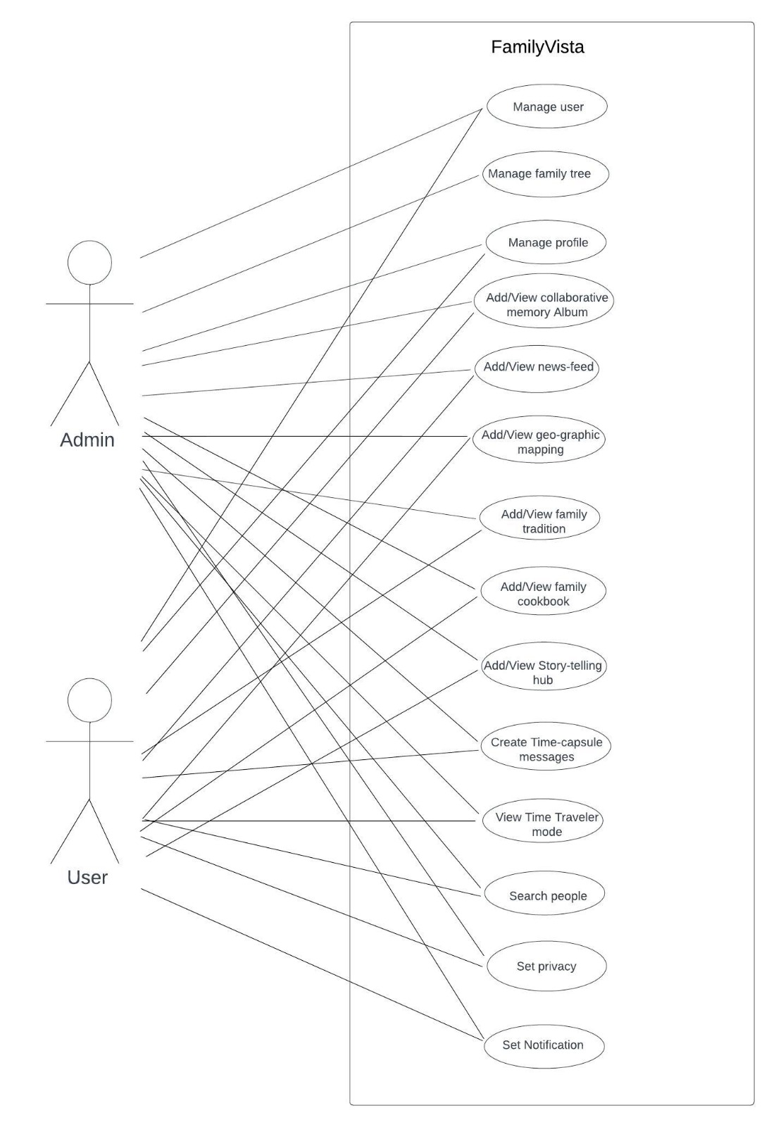

***6.2.High Level Use Cases:***

**Manage user**

|  |  |
| --- | --- |
| **Use Case** | Manage user |
| **Actors** | User, Admin |
| **Type** | Primary, essential |
| **Description** | The user can create, edit, and manage their user account. They can update personal information and preferences. The system ensures user account management is secure and user-friendly. |

**Manage family tree**

|  |  |
| --- | --- |
| **Use Case** | Register Account |
| **Actors** | Admin |
| **Type** | Primary, offstage |
| **Description** | Users can create, edit, and manage their family trees. They can add, edit, or remove family members and specify relationships. The system ensures family tree management is intuitive and collaborative. |

**Manage Profile**

|  |  |
| --- | --- |
| **Use Case** | manage profile |
| **Actors** | User, Admin |
| **Type** | Primary, essential |
| **Description** | Users can customize their profiles, set privacy controls, and add personalized avatars. The system ensures profiles are visually engaging and respect user privacy. |

**View/Add Time Traveler Mode**

|  |  |
| --- | --- |
| **Use Case** | View/Add Time Traveler Mode |
| **Actors** | User, System |
| **Type** | Primary, essential |
| **Description** | A registered user clicks on Time Traveler Mode, which provides a historical overview of their family tree and related events. The system presents the user with a chronological journey. |

**View/Add Collaborative Memory Album**

|  |  |
| --- | --- |
| **Use Case** | View/Add Collaborative Memory Album |
| **Actors** | User, Family Members, System |
| **Type** | Primary, onstage |
| **Description** | Users can view and add collaborative memory albums, uploading photos, videos, and descriptions to preserve family memories. The system ensures easy sharing and preservation of memories. |

**View/Add news feed**

|  |  |
| --- | --- |
| **Use Case** | View/Add News Feed |
| **Actors** | User, Family Members, System |
| **Type** | Primary, onstage |
| **Description** | Users can view and add content to a family news feed to share updates and stories. The system ensures real-time communication and engagement. |

**View/Add geo-graphic mapping**

|  |  |
| --- | --- |
| **Use Case** | View/Add geo-graphic mapping |
| **Actors** | User, Family Members, System |
| **Type** | Primary, onstage |
| **Description** | Users can explore geo-graphic mapping to visualize family locations and histories. The system ensures an interactive and informative mapping experience. |

**View/Add family traditions**

|  |  |
| --- | --- |
| **Use Case** | View/Add family traditions |
| **Actor** | User, Family Members, System |
| **Type** | Primary, onstage |
| **Description** | Users can view and add family traditions, rituals, and customs to celebrate their cultural heritage. The system ensures the traditions are well-documented and passed on. |

**View/Add family cookbook**

|  |  |
| --- | --- |
| **Use Case** | View/Add family cookbook |
| **Actors** | User, Family Members, System |
| **Type** | Primary, onstage |
| **Description** | Users can view and add family recipes and create a collaborative family cookbook. The system ensures easy recipe sharing and preservation. |

**View/Add story-telling hub**

|  |  |
| --- | --- |
| **Use Case** | View/Add story-telling hub |
| **Actors** | User, Family Members, System |
| **Type** | Primary, onstage |
| **Description** | Users can engage in text and oral storytelling to pass down family stories and history. The system provides a platform for sharing and preserving family narratives. |

**Create Time Capsule Messages**

|  |  |
| --- | --- |
| **Use Case** | Create Time Capsule Messages |
| **Actors** | User, System |
| **Type** | Primary, essential |
| **Description** | A registered user composes and stores time capsule messages or notes to be revealed at a future date or event. The system saves the messages securely. |

**Search People**

|  |  |
| --- | --- |
| **Use Case** | Search People |
| **Actors** | User, System |
| **Type** | Primary, essential |
| **Description** | A registered user initiates a search to find specific family members within their family tree or members outside the tree. The system displays search results. |

**Record stories**

|  |  |
| --- | --- |
| **Use Case** | Record stories |
| **Actors** | User, System |
| **Type** | Primary, essential |
| **Description** | A registered user creates and records family stories or anecdotes within their family tree. The system saves and displays these stories in the story telling hub. |

**Set Privacy**

|  |  |
| --- | --- |
| **Use Case** | Set Privacy |
| **Actors** | User, System |
| **Type** | Primary, essential |
| **Description** | A registered user configures privacy settings for their profile and family tree, specifying who can access and view their information. The system enforces the chosen privacy settings. |

**Set Notifications**

|  |  |
| --- | --- |
| **Use Case** | Set Notifications |
| **Actors** | User, System |
| **Type** | Primary, essential |
| **Description** | A registered user receives real-time notifications for various activities, including updates, messages, and interactions within their family network. The system sends notifications as per user preferences. |

***6.2.Extended Use Cases:***

**Manage user**

|  |  |  |
| --- | --- | --- |
| **Use Case Name** | Manage user | |
| **Scope** | FamilyVista | |
| **Level** | User's goal | |
| **Level** | User, Admin | |
| **Stakeholders and Interests** | User, Admin | |
| **Preconditions** | User is connected to the internet and has a registered account. | |
| **Success Guarantee** | The user will be able to successfully manage their user account. | |
| **Main Success Scenario** | User Actions  1: The user accesses the "Manage User" section. 3: The user selects an action (e.g., edit name, contact number, password, email) and provides the necessary details. | System Response  2: The system displays the user's account details with options to edit information.  4: The system updates the user's account information. |
| **Extensions** | If the user encounters an error while making changes, an error message is displayed, and the system provides guidance for resolution. | |

**Manage family tree**

|  |  |  |
| --- | --- | --- |
| **Use Case Name** | Manage family tree | |
| **Scope** | FamilyVista | |
| **Level** | User's goal | |
| **Primary Actor** | Admin | |
| **Stakeholders and Interests** | User, Admin | |
| **Preconditions** | User is connected to the internet and has a registered account. | |
| **Success Guarantee** | The user will be able to successfully manage their family tree. | |
| **Main Success Scenario** | User Actions  1: The user navigates to the "Manage Family Tree" section.  3: The user selects an action (add, edit, or remove) and provides necessary details. | System Response  2: The system displays the user's family tree with options to add, edit, or remove family members.  4: 4: The system updates the family tree accordingly. |
| **Extensions** | If the user encounters an error while making changes, an error message is displayed, and the system provides guidance for resolution. | |

**Manage profile**

|  |  |  |
| --- | --- | --- |
| **Use Case Name** | Manage profile | |
| **Scope** | FamilyVista | |
| **Level** | User's goal | |
| **Primary Actor** | User,Admin | |
| **Stakeholders and Interests** | User,Admin | |
| **Preconditions** | User is connected to the internet and has a registered account. | |
| **Success Guarantee** | The user will be able to successfully manage their profile. | |
| **Main Success Scenario** | User Actions  1: The user accesses the "Manage Profile" section. 3: The user selects an action (customize or set privacy) and makes the desired changes. | System Response  2: The system displays the user's profile with options to customize and set privacy controls.  4: The system updates the profile settings and ensures the changes are reflected. |

**Set Privacy**

|  |  |  |
| --- | --- | --- |
| **Use Case Name** | Set Privacy | |
| **Scope** | FamilyVista | |
| **Level** | User's goal | |
| **Primary Actor** | User,Admin | |
| **Stakeholders and Interests** | User,Admin | |
| **Preconditions** | User is connected to the internet, has a registered account, and has a personalized profile. | |
| **Success Guarantee** | The user will successfully configure privacy settings. | |
| **Main Success Scenario** | User Actions  1: The user logs in to their FamilyVista account.  3: The user accesses their account settings and selects the "Set Privacy" option.  4: The user configures privacy settings, specifying who can access and view their profile and family tree.  6: The user saves their privacy settings.  7: The system provides a confirmation message to the user regarding the updated privacy settings. | System Response  2: The system allows the user to customize their privacy settings, including defining who can see specific information.  5: The system validates and applies the configured privacy settings. |

**View Time Traveler Mode**

|  |  |  |
| --- | --- | --- |
| **Use Case Name** | View Time Traveler Mode | |
| **Scope** | FamilyVista | |
| **Level** | User's goal | |
| **Primary Actor** | User,Admin | |
| **Stakeholders and Interests** | User, Family Members | |
| **Preconditions** | User is connected to the internet, has a registered account, and has created or accessed a family tree. | |
| **Success Guarantee** | The user will successfully enter Time Traveler Mode and explore the family's historical journey. | |
| **Main Success Scenario** | User Actions  1: The user logs in to their FamilyVista account.  3: The user navigates to the family tree.  4: The user selects the "Time Traveler Mode" option.  6: The user can explore the family's history, view historical events, and access stories and media from different time periods. | System Response  2: The system initiates Time Traveler Mode, presenting a chronological journey of the family tree's history.  5: The system provides an immersive and chronological experience, allowing the user to explore the family's history and historical data within the family tree. |

.

**Search People**

|  |  |  |
| --- | --- | --- |
| **Use Case Name** | Search People | |
| **Scope** | FamilyVista | |
| **Level** | User's goal | |
| **Primary Actor** | User | |
| **Stakeholders and Interests** | User, Family Members | |
| **Preconditions** | User is connected to the internet, has a registered account, and has access to their family tree. | |
| **Success Guarantee** | The user will successfully search for and locate specific family members within their family tree. | |
| **Main Success Scenario** | User Actions  1: The user logs in to their FamilyVista account.  3: The user navigates to the family tree.  4: The user selects the "Search People" option.  6: The user enters the family member's name or details and initiates the search. | System Response  2: The system provides a search bar and prompts the user to enter the name or other details of the family member they want to find.  5: The system performs the search and displays the search results, allowing the user to locate the specific family member. |

**View/Add Collaborative Memory Album**

|  |  |  |
| --- | --- | --- |
| **Use Case Name** | View/Add Collaborative Memory Album | |
| **Scope** | FamilyVista | |
| **Level** | User's goal | |
| **Primary Actor** | User | |
| **Stakeholders and Interests** | User, Family Members | |
| **Preconditions** | User is connected to the internet, has a registered account, and has created a family tree. | |
| **Success Guarantee** | The user will successfully view & add collaborative memory albums to relive and share family memories. | |
| **Main Success Scenario** | User Actions  1: The user accesses the "Collaborative Memory Albums" section.  3: The user selects an album to view or adds a new album, uploading photos, videos, and descriptions. | System Response  2: The system displays memory albums with options to view and add new albums.  4: The system updates memory albums accordingly. |

**View/Add News Feed**

|  |  |  |
| --- | --- | --- |
| **Use Case Name** | View/Add News Feed | |
| **Scope** | FamilyVista | |
| **Level** | User's goal | |
| **Primary Actor** | User | |
| **Stakeholders and Interests** | User, Family Members | |
| **Preconditions** | User is connected to the internet, has a registered account, and has access to their family tree. | |
| **Success Guarantee** | The user will successfully view the news feed to stay updated on family activities and events. | |
| **Main Success Scenario** | User Actions  1: The user accesses the "News Feed" section. 3: The user selects content to view or adds new content, such as updates and stories. | System Response  2: The system displays the family news feed with options to view and add content.  4: The system updates the news feed with the new content. |

**View/Add Geo-graphic Mapping**

|  |  |  |
| --- | --- | --- |
| **Use Case Name** | View Geo-graphic Mapping | |
| **Scope** | FamilyVista | |
| **Level** | User's goal | |
| **Primary Actor** | User | |
| **Stakeholders and Interests** | User, Family Members | |
| **Preconditions** | User is connected to the internet, has a registered account, and has access to their family tree. | |
| **Success Guarantee** | The user will successfully view geo-graphic mapping to explore the family's historical and geographical connections. | |
| **Main Success Scenario** | User Actions  1: The user accesses the "Geo-graphic Mapping" section.  3: The user selects information to view or adds new geographic details. | System Response  2: The system displays the family's geographic history with options to view and add geographical information.  4: The system updates the geographic mapping with the new data. |

**View/Add Family Traditions**

|  |  |  |
| --- | --- | --- |
| **Use Case Name** | View Family Traditions | |
| **Scope** | FamilyVista | |
| **Level** | User's goal | |
| **Primary Actor** | User | |
| **Stakeholders and Interests** | User, Family Members | |
| **Preconditions** | User is connected to the internet, has a registered account, and has access to their family tree. | |
| **Success Guarantee** | The user will successfully view family traditions to learn about and appreciate the cultural heritage of the family. | |
| **Main Success Scenario** | User Actions  1: The user accesses the "Family Traditions" section.  3: The user selects traditions to view or adds new traditions, describing rituals, customs, and celebrations. | System Response  2: The system displays family traditions with options to view and add new traditions.  4: The system updates the family traditions with the new information. |

**View/Add Family Cookbook**

|  |  |  |
| --- | --- | --- |
| **Use Case Name** | View/Add Family Cookbook | |
| **Scope** | FamilyVista | |
| **Level** | User's goal | |
| **Primary Actor** | User | |
| **Stakeholders and Interests** | User, Family Members | |
| **Preconditions** | User is connected to the internet, has a registered account, and has access to their family tree. | |
| **Success Guarantee** | The user will successfully view the family cookbook to access and appreciate culinary traditions and recipes. | |
| **Main Success Scenario** | User Actions  1: The user logs in to their FamConnect account.  2: The user navigates to their family tree.  3: The user selects the "Family Cookbook" option.  5: The user explores recipes and culinary traditions. | System Response  4: The system displays existing recipes, including ingredients and instructions, along with associated family members. |

**View/Add Story-telling Hub**

|  |  |  |
| --- | --- | --- |
| **Use Case Name** | View/Add Story-telling Hub | |
| **Scope** | FamilyVista | |
| **Level** | User's goal | |
| **Primary Actor** | User | |
| **Stakeholders and Interests** | User, Family Members | |
| **Preconditions** | User is connected to the internet, has a registered account, and has access to their family tree. | |
| **Success Guarantee** | The user will successfully view stories in the story-telling hub. | |
| **Main Success Scenario** | User Actions  1: The user logs in to their FamilyVista account.  3: The user navigates to their family tree.  5: The user selects the "Story-telling Hub" option.  6: The user views existing stories. | System Response  2: The system displays existing stories . |

**Create Time Capsule Messages**

|  |  |  |
| --- | --- | --- |
| **Use Case Name** | Create Time Capsule Messages | |
| **Scope** | FamilyVista | |
| **Level** | User's goal | |
| **Primary Actor** | User | |
| **Stakeholders and Interests** | User, Future Family Members | |
| **Preconditions** | User is connected to the internet, has a registered account, and has access to their family tree. | |
| **Success Guarantee** | The user will successfully create time capsule messages to be opened by future family members. | |
| **Main Success Scenario** | User Actions  1: The user logs in to their FamilyVista account.  3: The user navigates to their family tree.  4: The user selects the "Create Time Capsule Messages" option.  6: The user creates time capsule messages with content and schedules delivery to specific family members on future dates.  7: The system stores the messages securely and will deliver them as scheduled. | System Response  2: The system prompts the user to compose messages, choose recipients, and set future delivery dates.  5: The system validates and schedules the time capsule messages. |

**Set Notifications**

|  |  |  |
| --- | --- | --- |
| **Use Case Name** | Set Notifications | |
| **Scope** | FamilyVista | |
| **Level** | User's goal | |
| **Primary Actor** | User | |
| **Stakeholders and Interests** | User | |
| **Preconditions** | User is connected to the internet and has a registered account. | |
| **Success Guarantee** | The user will successfully receive and manage notifications related to their family tree and account. | |
| **Main Success Scenario** | User Actions  1: The user logs in to their FamilyVista account.  3: The system periodically checks for and delivers notifications to the user.  4: The user views and manages notifications, marking them as read or taking relevant actions.  6: The user stays informed and connected with their family and account. | System Response  2: The system provides notifications for events such as family updates, messages, or scheduled time capsule messages.  5: The system tracks notification status and responses. |

***6.4.System Sequence diagrams:***

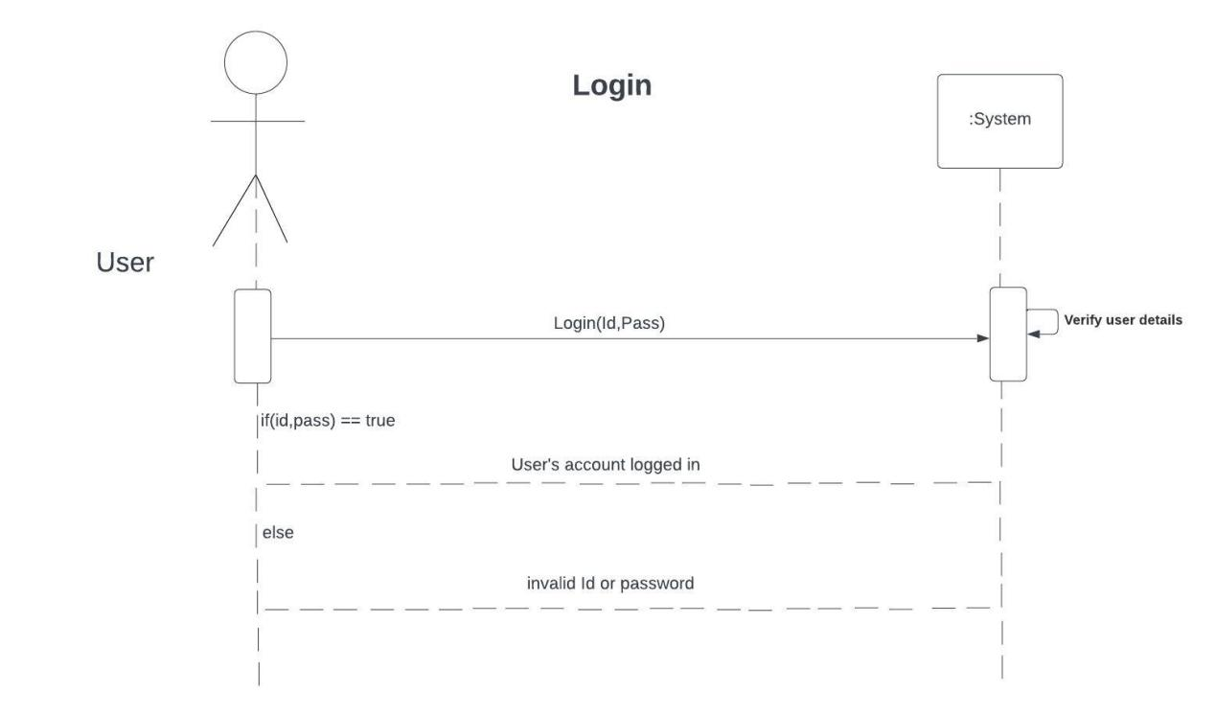

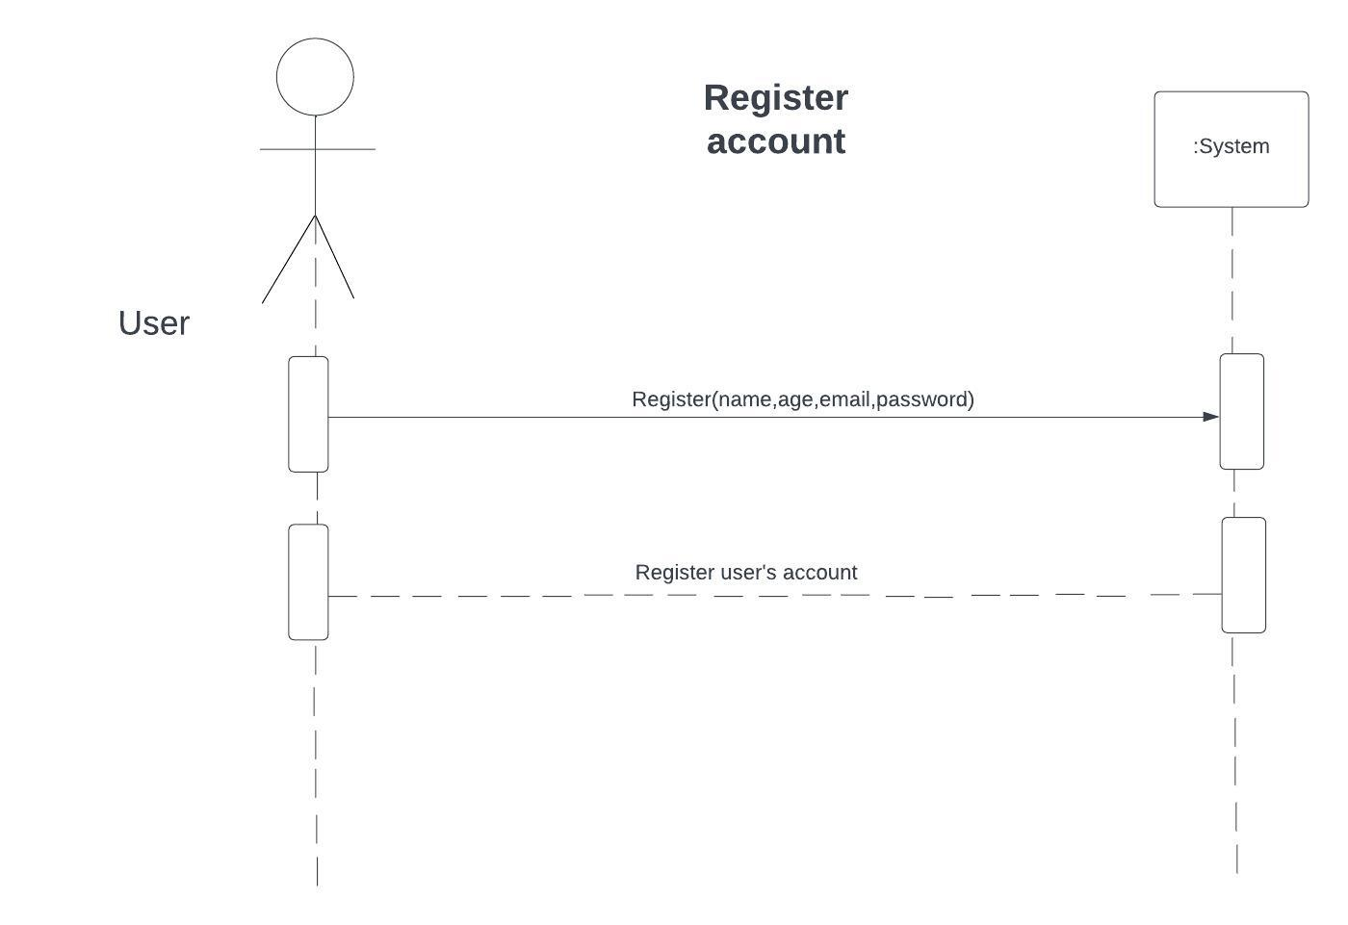

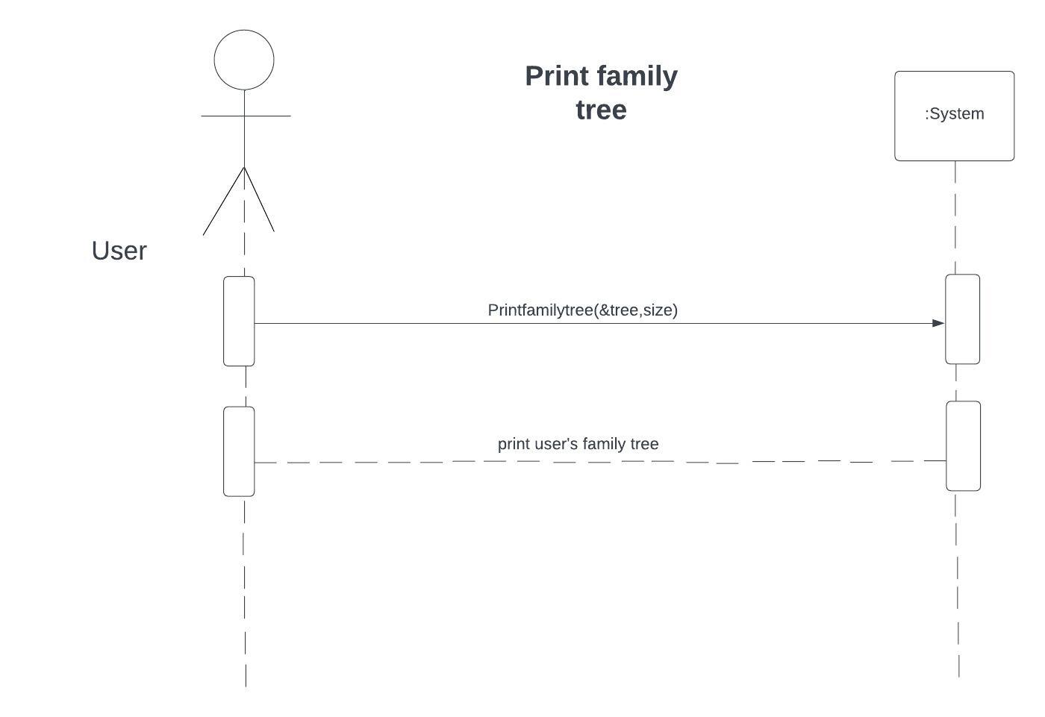

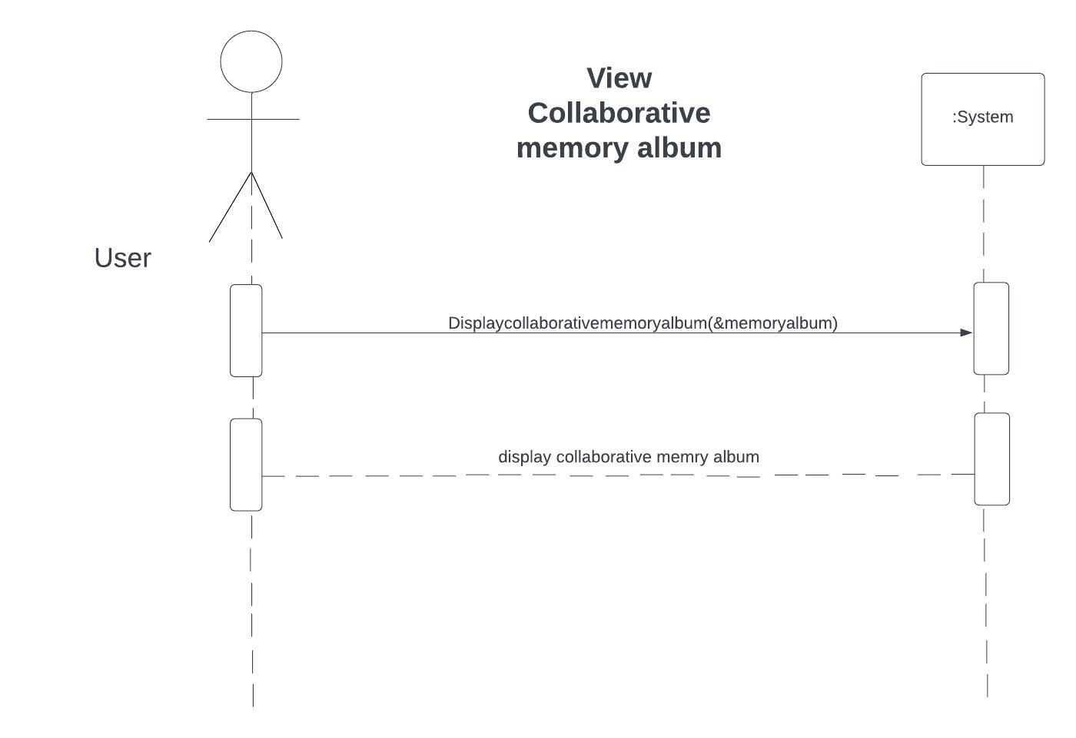

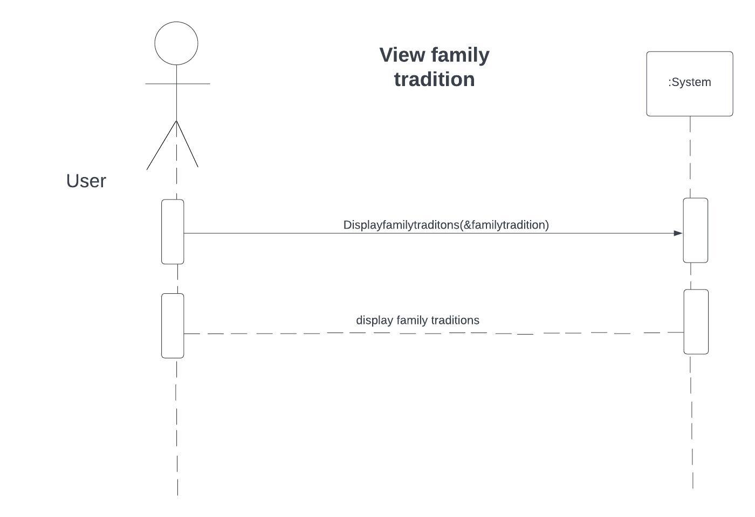

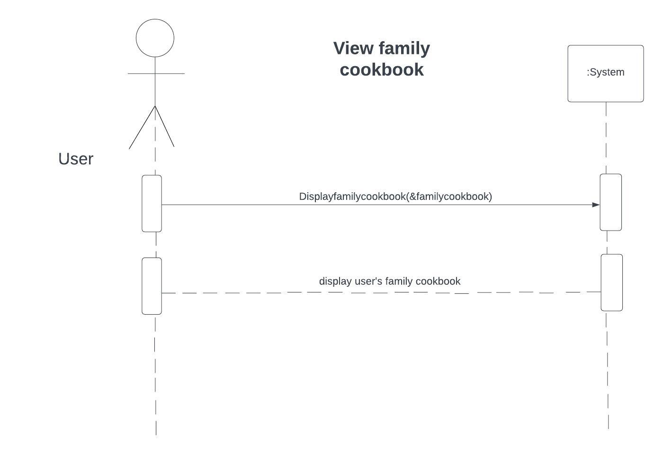

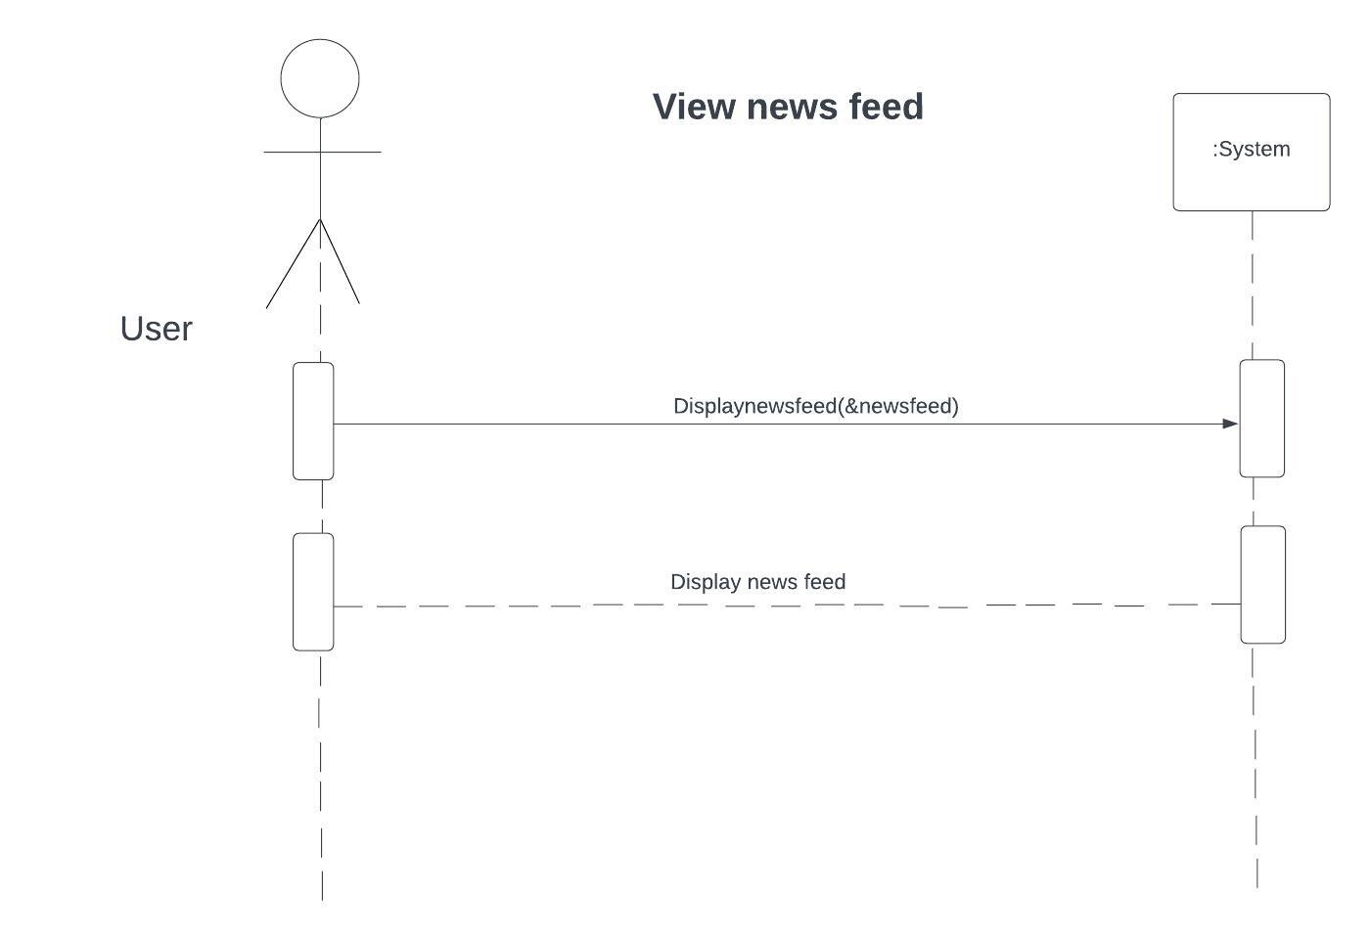

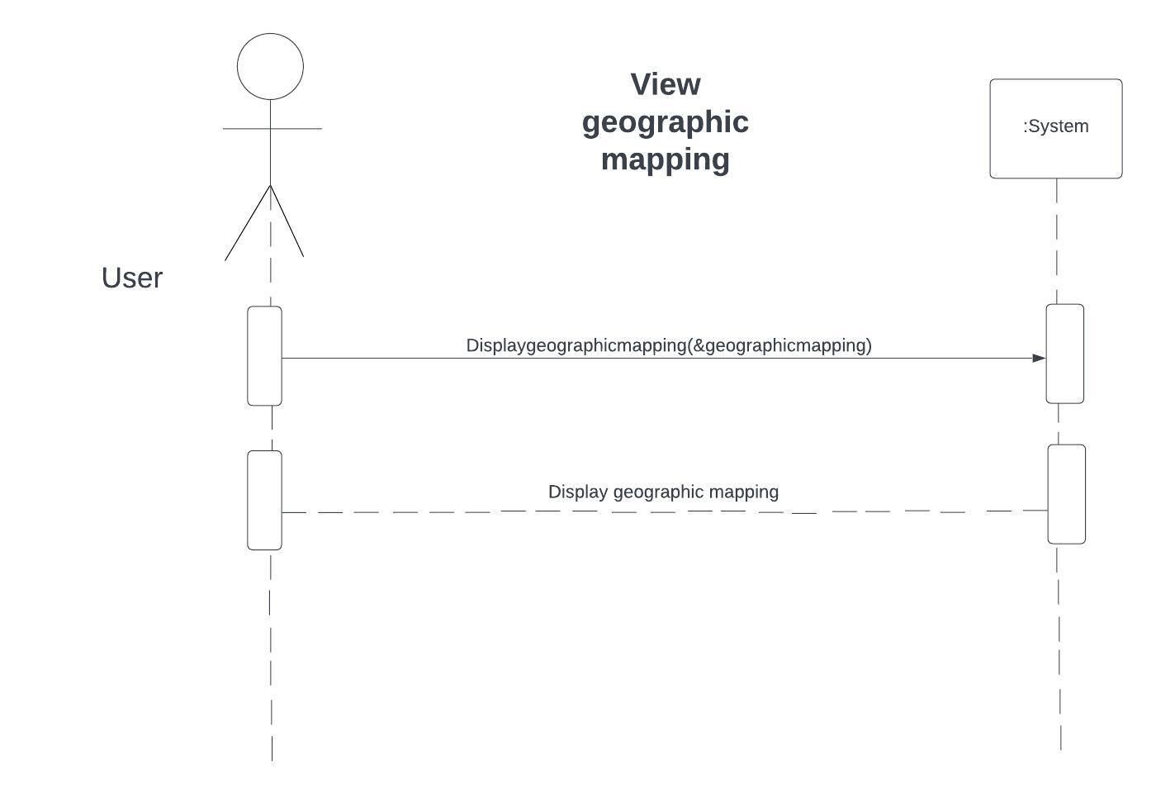

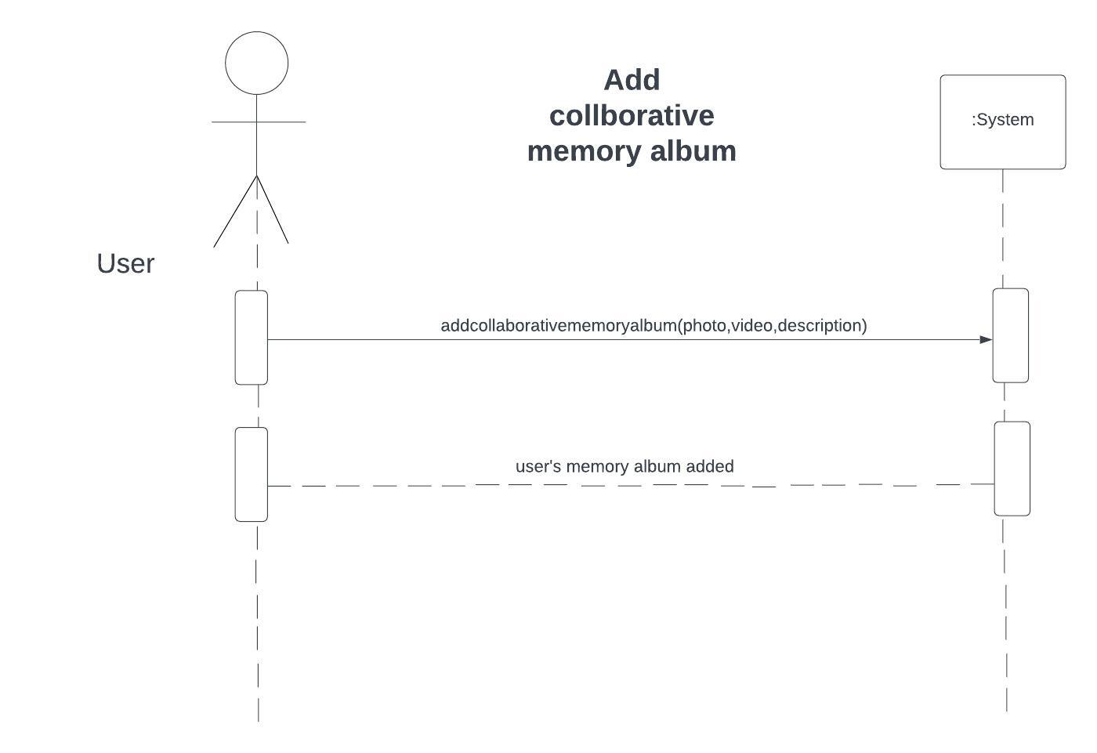

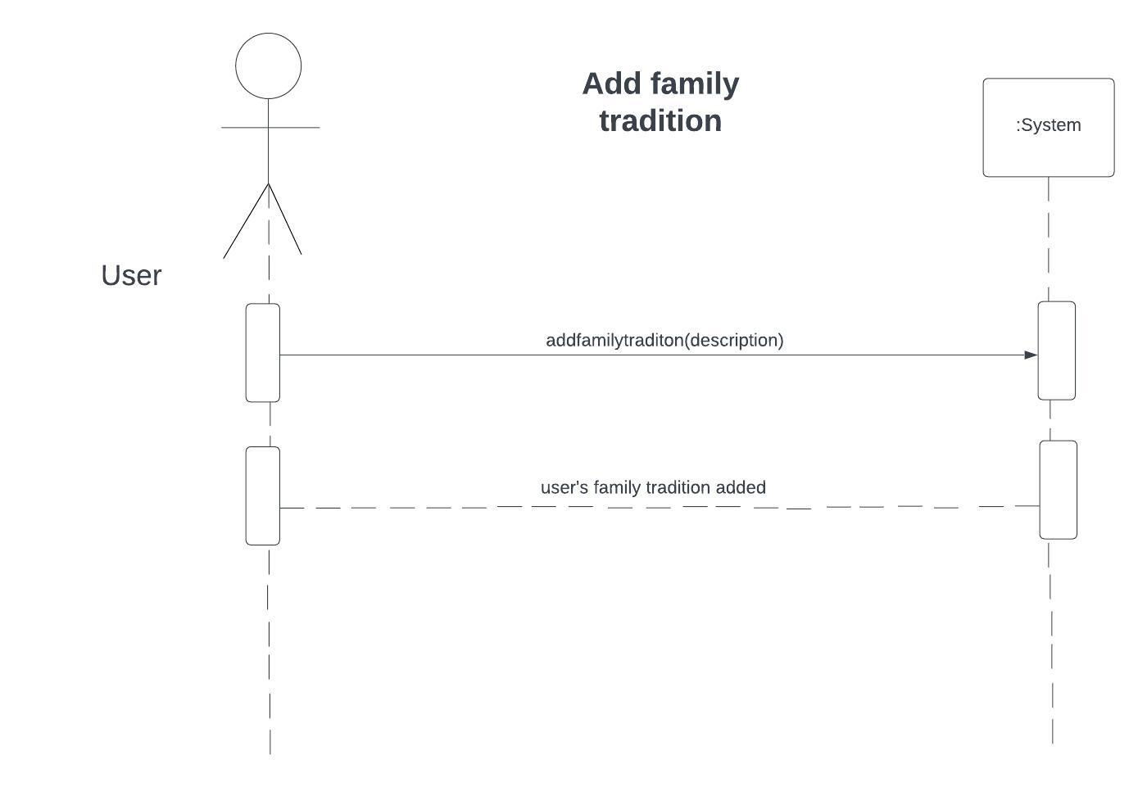

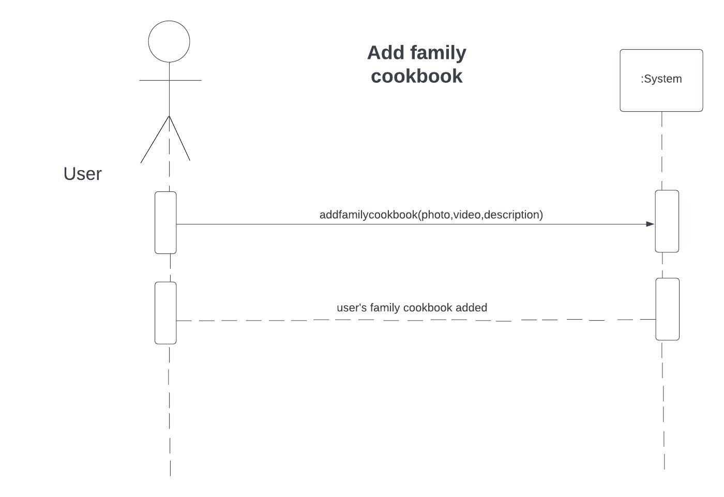

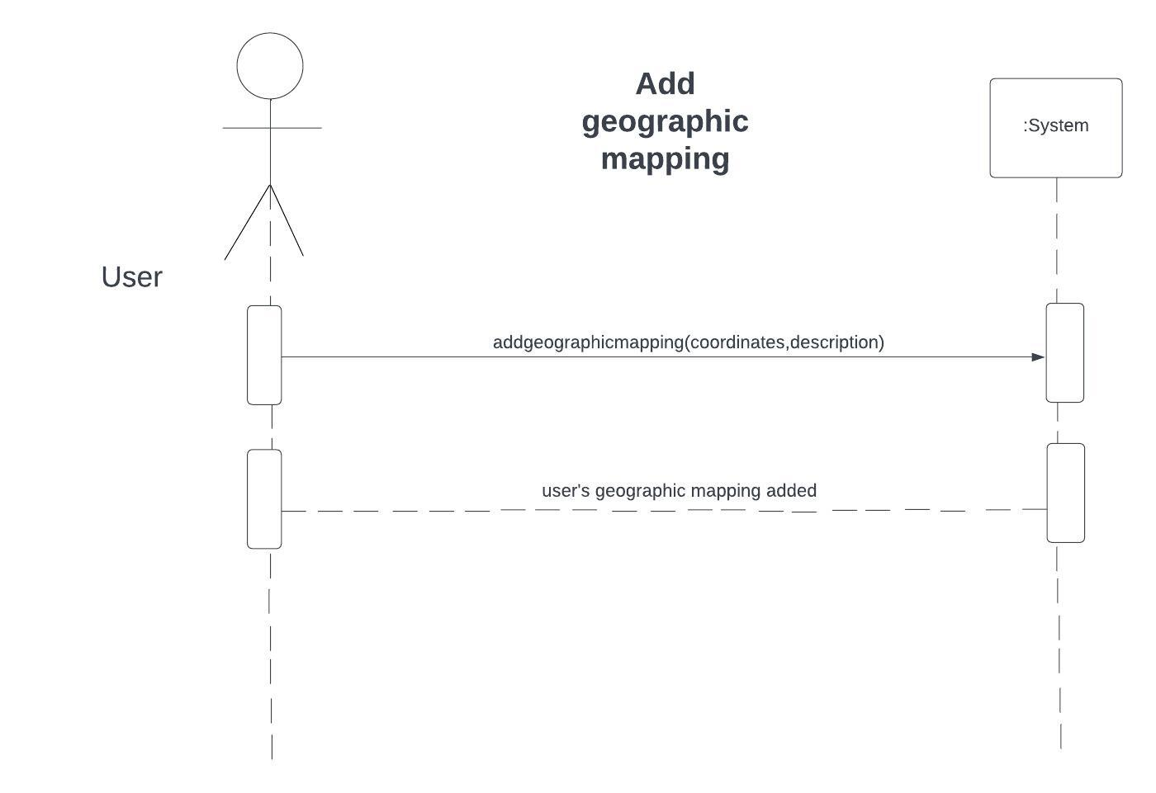

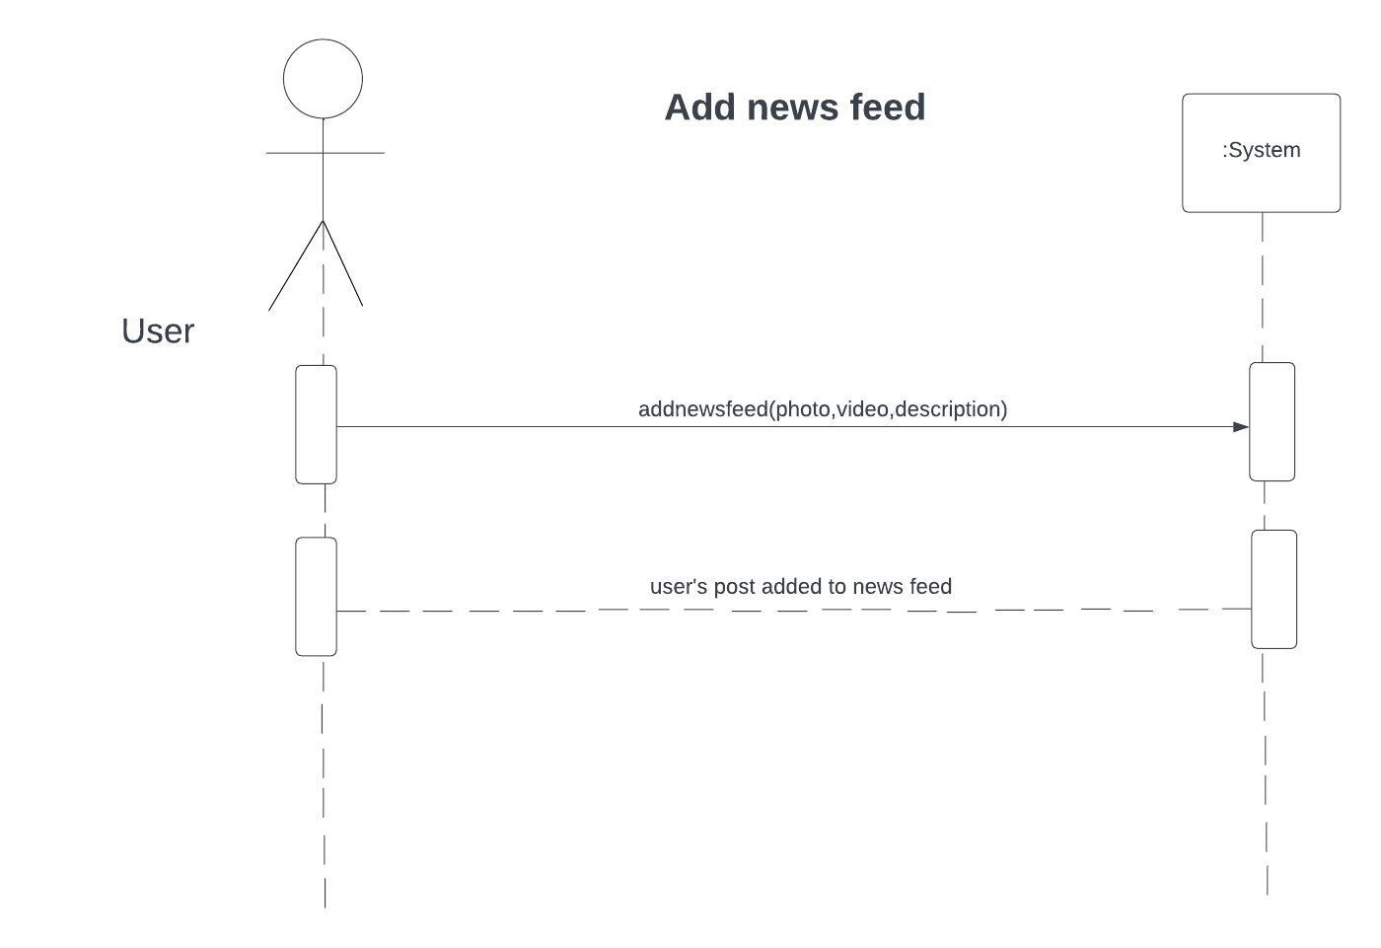

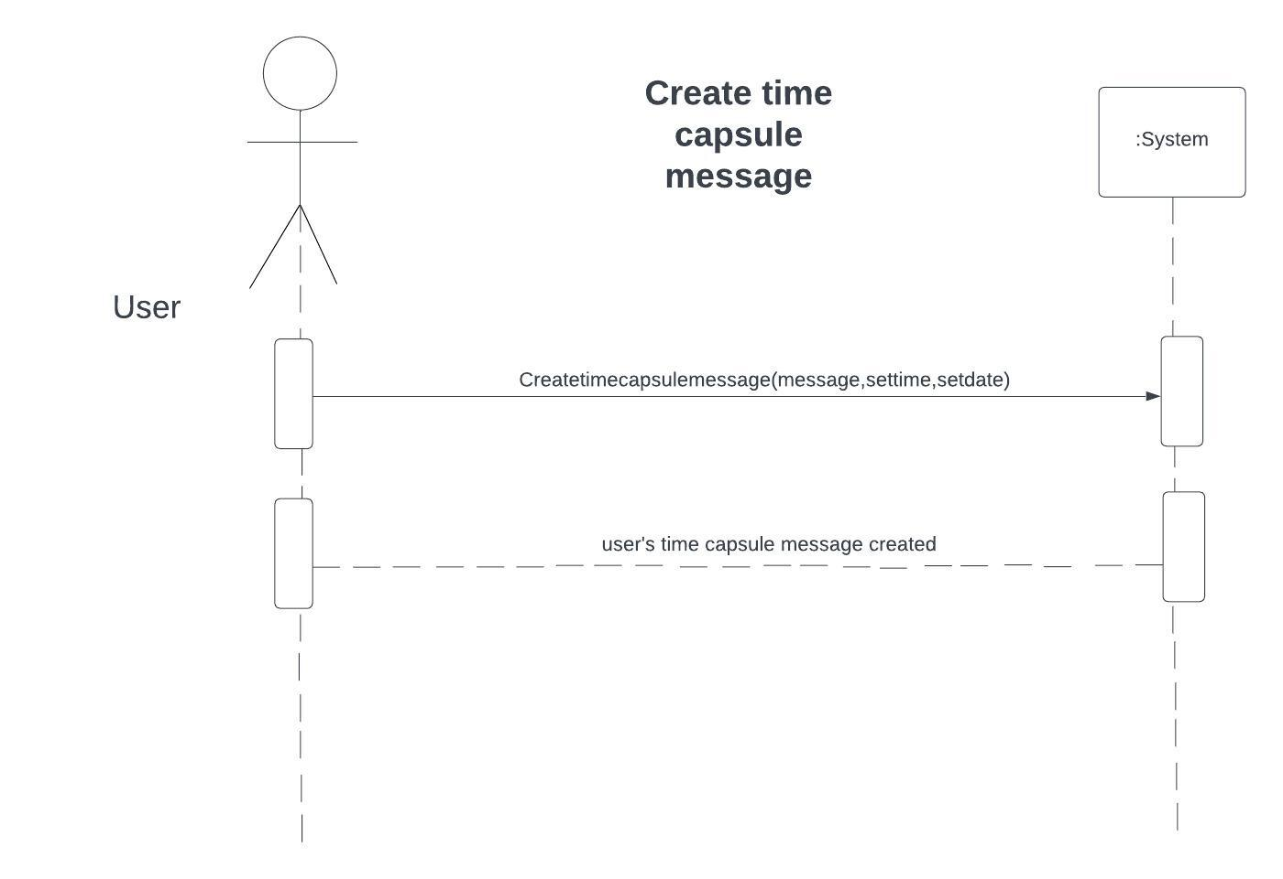

***6.5. System Architecture Diagram:***

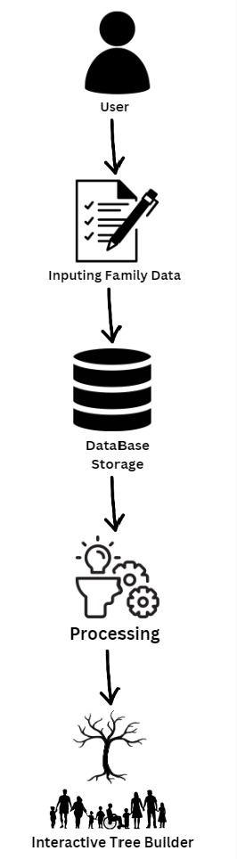

***6.6. Class Diagram:***

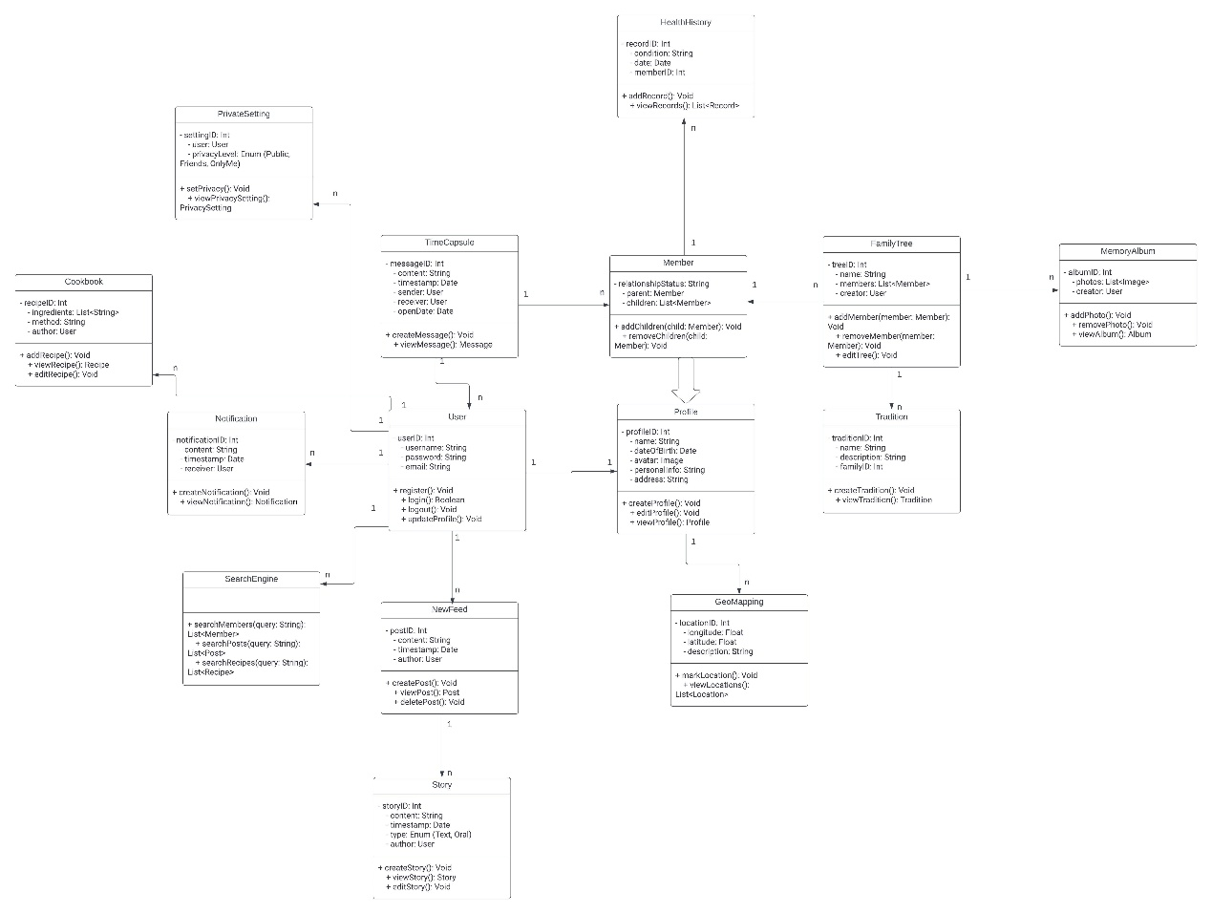

**7. References**

* Carrick, C. (2004). Genealogy and the Promotion of Community: A Historical Perspective. The Public Historian, 26(4), 47-58.
* Ellison, N. B., Steinfield, C., & Lampe, C. (2007). The Benefits of Facebook "Friends": Social Capital and College Students' Use of Online Social Network Sites. Journal of Computer-Mediated Communication, 12(4), 1143-1168.
* Acquisti, A., & Gross, R. (2006). Imagined Communities: Awareness, Information Sharing, and Privacy on Facebook. In Privacy Enhancing Technologies (pp. 36-58).
* Adomavicius, G., & Tuzhilin, A. (2005). Toward the Next Generation of Recommender Systems: A Survey of the State-of-the-Art and Possible Extensions. IEEE Transactions on Knowledge and Data Engineering, 17(6), 734-749.
* Osterwalder, A., & Pigneur, Y. (2010). Business Model Generation: A Handbook for Visionaries, Game Changers, and Challengers. John Wiley & Sons.