🎬 MOVIE RECOMMENDATION SYSTEM
Using Breadth-First Search (BFS) & Depth-First Search (DFS)
Project Report

Name: Anushka Sahu
Registration No.: 25BAI11314
Program: B.Tech CSE (AI/ML)
Session: 2025 – 2026
Subject: Fundamentals of AIML

---

## 1. Introduction

The Movie Recommender System is a Python-based console application that shows how graph traversal algorithms like Breadth-First Search (BFS) and Depth-First Search (DFS) can be used in a real-life scenario.

In this system, movies are treated as nodes in a graph, and connections (edges) are formed when movies share similar genres. When a user selects a movie, the system explores this graph to find related movies and displays them in order of their ratings.

The main aim of this project is to show how basic algorithms from data structures can be applied to build something practical like a recommendation system, while keeping the design simple and easy to understand.

---

## 2. Objectives

The main objectives of this project are:

1. To represent movies as a graph where genres act as connections between them
2. To use BFS for finding a wide range of related movies within a limited distance
3. To use DFS for exploring deeply connected movies, especially within a chosen genre
4. To include additional features like genre-based search and top-rated movies
5. To present results in a clean and easy-to-read console format

---

## 3. Dataset

The system uses a fixed dataset of 15 well-known movies stored in the program itself. Each movie includes the following details:

* Title
* Genres
* IMDb rating
* Director
* Year of release

This small but diverse dataset covers multiple genres such as Drama, Action, Sci-Fi, Thriller, Romance, Crime, and Horror.

---

## 4. System Architecture

The program is divided into simple functions, each handling a specific task:

* **build_genre_graph(movie_db)**
Creates a mapping where each genre points to all movies that belong to it. This forms the base structure for traversal.

* **bfs_recommendations(start, movie_db, max_hops)**
Uses BFS to explore nearby movies level by level. It finds movies within a certain number of hops and sorts them by rating.

* **dfs_recommendations(start, movie_db, preferred_genre, ...)**
Uses DFS to explore one path deeply. If a preferred genre is given, it prioritizes that path first.

* **search_by_genre(genre, movie_db)**
Returns all movies that match a given genre, sorted by rating.

* **top_rated(movie_db, n)**
Displays the top N highest-rated movies.

* **Display functions**
Format and print movie details in a readable way.

---

## 5. Algorithm Analysis

### 5.1 Breadth-First Search (BFS)

BFS explores the graph step by step using a queue. It starts from the selected movie and first visits all directly connected movies before moving further.

This ensures that the recommendations are closely related to the chosen movie.

* Time Complexity: O(V + E)
* Best Use: When the user wants a variety of related movies

---

### 5.2 Depth-First Search (DFS)

DFS explores one path deeply before moving to another. It uses recursion and can prioritize a specific genre if provided.

This allows the system to suggest movies that are more focused within a particular category.

* Time Complexity: O(V + E)
* Best Use: When the user wants more specific or niche recommendations

---

## 6. Menu Options and Outputs

The program provides six menu options for interaction.

### BFS Recommendations

The user selects a movie and sets a hop limit. The system returns nearby movies sorted by rating.

### DFS Recommendations

The user selects a movie and can optionally choose a preferred genre. The system explores that genre more deeply before checking others.

### Search by Genre

The user enters a genre, and the system lists all matching movies sorted by rating.

### Top-Rated Movies

Displays the highest-rated movies based on user input (e.g., top 5).

### List All Movies

Shows all available movies in alphabetical order.

### Exit

Ends the program.

---

## 7. Key Features

* Movies are connected using a graph structure based on genres
* Supports both BFS and DFS for different recommendation styles
* Allows users to guide results using a preferred genre
* Displays recommendations sorted by rating
* Includes extra features like genre search and top-rated movies

---

## 8. Limitations and Future Scope

### Current Limitations

* The dataset is fixed and cannot be updated dynamically
* DFS rebuilds the graph repeatedly, which is not efficient
* Movie names must be entered exactly (case-sensitive)

### Future Improvements

* Connect with APIs like TMDB or OMDb for real-time data
* Build a graphical or web-based interface
* Add user-based recommendations (collaborative filtering)
* Optimize DFS by reusing the graph instead of rebuilding it

---

##9.OUTPUT

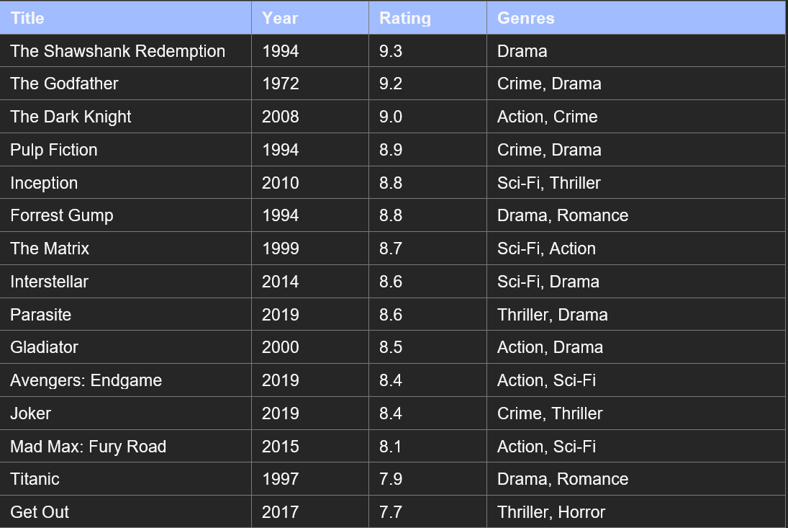

--

## 10. Conclusion

This project shows how basic graph algorithms like BFS and DFS can be used to build a useful application like a movie recommendation system.

BFS helps in finding a wide range of related movies, while DFS focuses on exploring deeper connections within a specific genre. Together, they provide a flexible and effective way to recommend movies.

Overall, the project highlights the importance of data structures and algorithms in solving real-world problems in a simple and understandable way.

