HERITAGE VISION:A novel CNN classification model for Archeological Heritage Monuments in India
Aanya Maria∗, Dilin Maria∗, Sangeetha Chandran†,
∗Student,St. Teresa’s College Ernakulam
‡Research Scholar,CUSAT

Abstract—India with its magnificent and deep-rooted culture can, not only, pride of its rich cultural heritage but also, is home to many historic national monuments. Safeguarding and sustaining these structures is crucial in understanding history and enhancing the sense of cultural belonging. This research paper, named HeritageVision, seeks to provide effective deep learning architectures and image processing methods to enable accurate recognition and categorization of the selected classes of indian heritage monuments. The system also contributes to the dataset preservation process by allowing for more in depth classification and also acts as an encyclopedia for the historians and the tourists for future research. Using a unique dataset, which contained images of selected Indian heritage monuments, we developed and trained a novel model of Convolutional Neural Network (CNN) and its architecture such as ResNet, AlexNet to classify and distinguish these monuments with regards to their geometry ,shape and history. Experimental results show a greater accuracy, indicating the significance of deep learning techniques on the preservation of heritage sites of archeaological importance in india. This study achieved the results of 83.37% of validation accuracy for ResNet, 86% for AlexNet and 93.44% for basic Cnn model respectively
Index Terms—Keywords: Convolutional Neural Network (CNN) ,Residual Neural Network (ResNet) , AlexNet, Cultural Heritage, Feature extraction, Image Processing.
- INTRODUCTION
The heritage of Indian monuments is the well-rooted cul- tural heritage of the Indian nation that carries the cloak of centuries of tradition, craftsmanship, and value tracing back to the dawn of time in the realms of ancient civilizations, religions, and art forms. The Taj Mahal, Sanchi Stupa, or temples at Konark- each one presents a reflection of extraor- dinary architecture and innovation which can speak of the stories of the respective eras they were built in. These sites do not only glimpse across the variety of Indian culture but also act as historical records through inscriptions and reliefs that preserve valuable insights into what has happened in the past, traditions, and lifestyles. Beyond their cultural and historical importance, lies the contribution these sites make to India’s economy, specifically through tourism with local communi- ties’ benefit and substantial employment opportunities. These monuments are outdoor classrooms where artists, historians, and students have easy access to available resources where they can learn about the design and artistry of antiquity that would really animate India’s heritage among the youth.[15] It is, therefore, through these monuments that preservation is
found in sustaining cultural continuity as they make genera- tions to come connect with this country’s past, which further cements cultural identity in this globalized world. Besides, sustainable tourism for conservation attempts ecological and socio-economic balance for the quest of preservation and de- velopments. Preservation and promotion of these monuments and artifacts call for classification and analysis for promotion of research and education. Recently, DL algorithms have attracted massive attention due to their wide application in the classification and analysis of cultural heritage objects.[11] DL algorithms are a subgroup of machine learning. They can automatically learn very complex, hierarchical representations of data by processing large amounts of it. These capabilities make DL especially suitable for classifying cultural heritage objects based on attributes such as style, material, and age and for analysis that might be reflecting patterns and relation- ships between the different artifacts. Several Deep Learning architectures are used to recognize monuments and ensure good performance. Our method employs rich visual features drawn out from satellite images in order to automatically discover and classify monuments. We apply CNNs to heritage recognition. For this purpose, they can learn complex patterns and representations in large volumes of data; thus, they suit themselves to handle diverse and intricate visual characteristics of any heritage site. In this paper, we have elaborated on the different architectures of CNNs, including basic CNN, AlexNet and ResNet .
Convolutional Neural Networks (CNNs) is the very first class of deep models applied in image analysis as it automat- ically forms spatial hierarchies within visual data. The CNN works based on a number of convolutional layers representing edges, textures, and shapes followed by a number of pooling layers that reduce the dimensionality such that efficient fea- tures are captured in images. Among so many architectures of CNN, AlexNet and ResNet were among the first architectures to achieve state-of-the-art results in image classification.[2]
AlexNetwas a breakthrough CNN architecture in 2012, enabling the possibility of having deeper networks with sev- eral convolutional and pooling layers-demonstrating the great power of deep learning on large-scale image datasets. This enabled the use of ReLU activations and dropout layers, which further enhance performance by preventing overfitting; hence, AlexNet has been influential in the progress of computer

vision..[5]

ResNet (Residual Network)
There probably is going to be much benefit in the cate- gorization of cultural heritage artefacts from models that use CNNs and various architectures. The methodology adopted makes the effective use of data from different sources with the establishment of temporal relations and contextual details hence making it especially suitable for the set objectives. Finally, the main purpose behind our project has been the em- phasis on the digital preservation and continuation of cultural heritage information.[4] We present the following sections to give an explanation of our research findings acquired from this model, and further outline the methodology applied in our study. In 2015 it was proposed by the model ResNet which tried to overcome the problems connected with training very deep networks with ”residual connections”. It allows the network to skip layers, and for further learning complex fea- tures, stacks numerous layers, avoiding vanishing gradients.[3] Its good work in complex recognition tasks in images, like classification, and analysis objects cultural heritage, is mainly explained by this model’s ability to successfully train excep- tionally deep networks with high accuracy.
There probably is going to be much benefit in the cate- gorization of cultural heritage artefacts from models that use CNNs and various architectures. The methodology adopted makes the effective use of data from different sources with the establishment of temporal relations and contextual details hence making it especially suitable for the set objectives. Finally, the main purpose behind our project has been the em- phasis on the digital preservation and continuation of cultural heritage information.[4] We present the following sections to give an explanation of our research findings acquired from this model, and further outline the methodology applied in our study.
- LITERATURE REVIEW

Image Classification using CNN
[1]A new area of interest in the work of data analysts is aggregation of heritage images. One of the most time- consuming areas related to the heritage images is the growing volume of images. This research paper addresses the aforementioned challenges by classifying the subjects within the studied images through the application of Convolutional Neural Networks. The current images categorization enriches the dataset of images as well and helps in searching for monuments simultaneously, so this enhances study and analysis of cultural heritage. Pre-trained convolutional neural networks such as GoogLeNet, ResNet18, and ResNet50 are recommended in classifying images related to the cultural heritage of the dataset. This work demonstrates a deep learning approach meant for the classification of digital documentation, mainly utilizing images that are colored.[14] It makes use of a convolutional neural network (CNN) in an effective extraction of features and relevant information from images to classify them. Ultimately, the research does recommend the use of a Gabor filter for extracting
features coupled with a support vector machine for automatic architectural style recognition.

Deep Learning Technique
[16] This paper aims to protect the monuments and, at the same time, allow local people and tourists to visit them for educational purposes. The dataset is prepared by combining images taken from Google and photographs. The extracted images have allowed the model to extract features using Local Binary Patterns and Mean Standard Deviation. A model was designed using deep learning techniques like CNN.[12] The project started by uploading satellite images. These images were further analyzed to determine if a monument could be declared heritage. Further, the model also issues an accurate judgment with regard to the image identified and the visual representation of the monument is provided along with its relevant details. Monuments have proven to be rich sources of historical as well as political knowledge. In a way, they breathe to life our past. They are of immense importance in proving history and are useful in tourism also.

Monument Recognition
[6]The Heritage Identification of Monuments initiative is to develop a framework for automating the identification and the classification of historical locations. A principal focus of the project is the protection and preservation of the wonderful variety of cultural and historical heritage found throughout the world. This work utilizes one of the most advanced techniques in the scope of deep learning, such as Convolutional Neural Networks (CNNs), to learn features and representations of the several monuments from a very huge set of images.[8] It also enabled the creation of a mobile application in which users could upload images of monuments and retrieve information on their history and cultural importance. The Heritage Identification of Monuments initiative aims to enhance the preservation and sharing of worldwide cultural and historical heritage. Recent developments in computer vision methodologies have recently started contributing a lot in the analysis of monuments, and the particular applications that involve such classification into one of these categories. Though landmark recognition is a subdomain that has been well researched within the computer vision field, identifying monuments is yet challenging. Identification of monuments becomes highly complex in a multicultural country like India. Many fields, like history, conservation, tourism, and education, would surely gain if automatic monument designation were possible.

- METHODOLOGY
- Data Collection and Preparation
Images of the following Indian monuments were obtained from online archives, museum collections, and field expedi- tions: Sanchi Stupa, Taj Mahal, Rani Ki Vav, Hampi, and Sun Temple. Data augmentation techniques in the form of random cropping, flipping, and rotation have been applied to make the

Cite | Title | Authors | Techniques Used | Results | Dataset Size | Year
[9] | Detecting surface defects  of heritage buildings based on deep learning | Xiaoli Fu and Niwat  Angkawisittpan | CNN, YOLOv5, Swin Transformer | mIoU of 90.96 and  mAcc of 95.78 | 720-Train,  180-Test | 2024
[10] | Survey Study: Monument  Recognition using Artifi- cial Intelligence | MA Hassan, A Hamdy, M  Nasr | VGG16, KNN, ResNet, DenseNet | AI techniques recog-  nized the monuments with high accuracy | 4708 | 2023
[13] | Heritage identification of  monument using deep learning | Dr S Murugesan, Dr  N Ramshankar, Hiba Mariam, Kalapoorani P, Kalpika K | MobileNet V1, MobileNet V2 | MobileNet  V1 acc=97.0%,  MobileNet  V2 acc=93.3% | 1466-Train,  367-Test | 2023
[19] | A Hybrid Deep Learn-  ing Approach for Multi- Classification of Heritage Monuments Using a Real- Phase Image Dataset | Vinay Kukreja, Rishabh  Sharma, Satvik Vats | Hybrid CNN and LSTM model | Monuments have  accuracy of 92.37%, four classes of Indian monuments have accuracy of 95.89% | - | 2023
[7] | The Classification of Cul-  tural Heritage Buildings in Athens | Konstantina Siountri and  Christos-Nikolaos Anag- nostopoulos | YOLO | Average Precision  (mAP) metric  measures model’s  accuracy on validation data | 6500 images | 2023
[20] | Machine Learning for  Cultural Heritage: A Survey | Marco Fiorucci et al. | Convolutional Neural Networks,  PCA, K-means Clustering | Precision, recall, F1  score, AUC-ROC, MSE, MAE | 100 or 1000  images | 2020
TABLE I: Comparison of Techniques for Cultural Heritage and Monument Analysis

model more robust and to expand the dataset to approximately 10,000 images per monument. Preprocessing steps included conversion to grayscale, normalization, resizing, and random selection of images. The dataset was then split 80:20 into training and testing subsets.
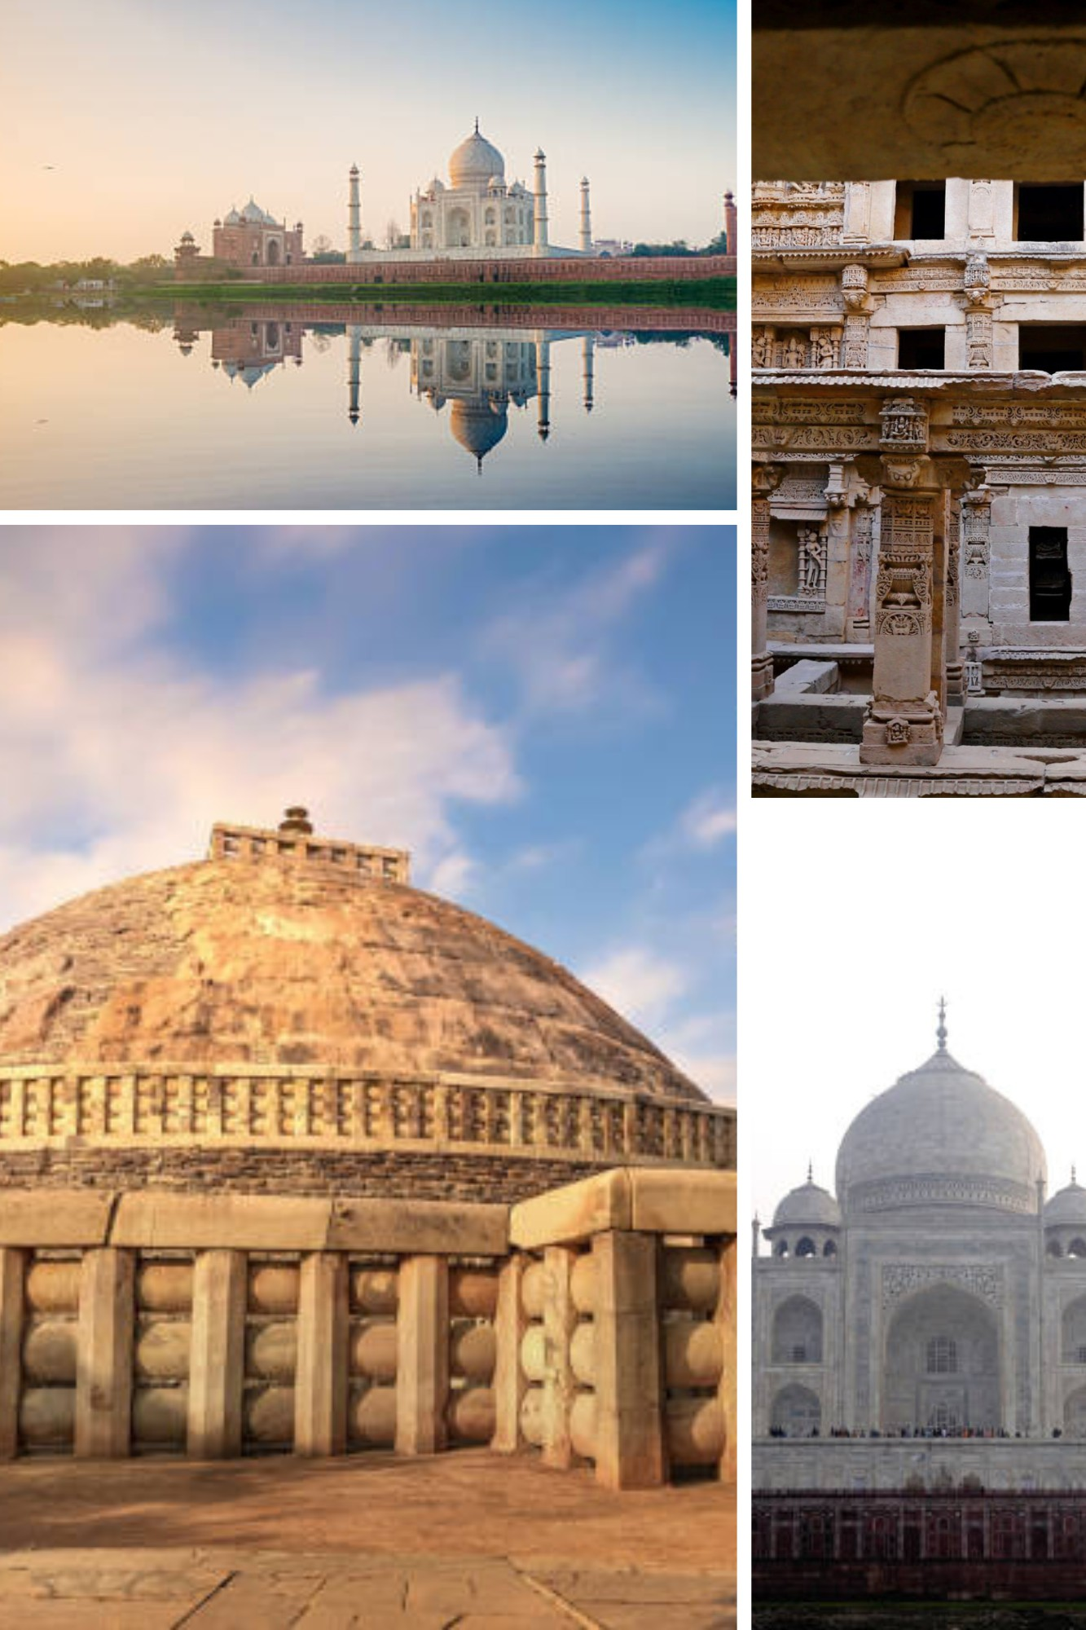
Fig. 1: Sample collection

- Feature Extraction
Deep Convolutional Neural Networks (CNNs), such as ResNet and AlexNet, were used to perform feature extraction. The convolution layers used in such architectures are sensitive to the texture and pattern of monuments. In addition to this, a MSD was applied using deep features extracted from the CNNs to account for the statistical properties of intensity.[17]
- Architectural Network
Model architecture involve an integration of ResNet, AlexNet, and a simple CNN which will be used in classifying the Indian monuments. ResNet is designed in such a manner that through use of skip connections, it helps in avoiding vanishing gradients, which facilitates learning in deeper lay- ers. AlexNet is a feature extractor. The aligning convolution layers with max-pooling capture many levels of features.[?] It contains an efficient CNN for extracting vital features of images that are classified using fully connected layers, and the output layer is softmax, which demonstrates probabilistic results. The skills of the transfer learning techniques help improve adaptation models toward an Indian monument and therefore upgrade classification performance. It combines three methods-those advanced capabilities of ResNet, speed of AlexNet, and some effects of a simple CNN-achieving very good results for monument classification.
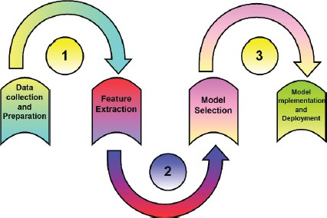
Fig. 2: Proposed Methodology

- RESULT AND ANALYSIS
The dataset includes images of 6 monuments with 10,000 images per class. A training set consisting of 8,000 photos and a testing set consisting of 2,000 images were both created from

the dataset. Experiments are conducted using Google Colab Notebook on a high-performance system.
To evaluate the performance of three models for the identification and classification of Indian monuments: sim- ple CNN, AlexNet, and ResNet-based CNN. It is trained with hyperparameters that are 10 epochs, the learning rate is 0.001, and the batch size is 128. The testing Models were evaluated as follows: training accuracy(Trn.Acc), test ac- curacy(Test.Acc), validation accuracy(Val.Acc), precision(Pr), recall(Rl), F1 score(Fo), and test loss(Test.Loss). The best test accuracy of 84.44% with precision of 86% and with test loss at 53.65% came from the AlexNet model. However, the test accuracy of ResNet was lower at 83.17% while it came with the lowest test loss at 33.19% with better generalization and stability. The CNN model has the highest validation accuracy that is at 93.44% while test accuracy for AlexNet is the highest at 83.49%. Ranking the Indian monuments with high test accuracy and precision and recall, AlexNet exhibits an extremely robust one, in reality, such as for mobile applications. The ResNet model with little test loss, there is a possibility of performing better with more epochs or more training data.[18] In terms of efficiency, AlexNet is effective and efficient in terms of completing the task at hand. In brief, AlexNet is the best model since it attains excellent test accuracy and precision. In case one finds a scope for improvement in ResNet, that could be considered a future candidate for research.
TABLE II: Comparison of Model Performance

Model | Train Acc. | Test Acc. | Val. Acc. | Precision | Recall | F1 Score | Test Loss
CNN Model | 0.8359 | 0.8349 | 0.9344 | 0.9125 | 0.8364 | 0.8668 | 0.4706
AlexNet Model | 0.8454 | 0.8444 | 0.86 | 0.86 | 0.85 | 0.84 | 0.5365
ResNet Model | 0.8435 | 0.8317 | 0.8337 | 0.8451 | 0.8386 | 0.8352 | 0.3319

100
93.44
83.59
83.49

80
Accuracy (%)

60

40

20

0
Train Acc. Test Acc. Val. Acc.
Metrics
Fig. 3: CNN Model Training, Test, and Validation Accuracy

- CONCLUSION
We successfully developed a system for identifying and also recognizing the Indian Monuments . In this work, models
like CNN, ResNet and AlexNet were used for the monument images classification and a comparative study was carried out. The total dataset contained 10,000 images of heritage objects. This dataset was preprocessed and divided into 80% for training and 20% testing. The models trained as well as tested. The best performing model AlexNet achieved test accuracy of 84.44% with precision of 86% indicating its applicability for monument classification. The test accuracy of the ResNet model was relatively lower at 83.17%, but it provided the best generalization with the least test loss of 33.19%. From there, it is assumed that there is a possibility of improvement with further more tuning. The CNN model had the best validation accuracy (93.44%), however, the test result of this model was not as good as the result of AlexNet. This research demonstrates how computer vision and machine learning techniques can facilitate the process of Indian mon- uments classification and promises more on conserving and enhancing the significance of such historical structures.
REFERENCES
- Mohammed Hamzah Abed, Muntasir Al-Asfoor, and Zahir M Hussain. Architectural heritage images classification using deep learning with cnn. 2020.
- Emmanouil Alexakis, Ekaterini T Delegou, Philip Mavrepis, Antonis Rifios, Dimosthenis Kyriazis, and Antonia Moropoulou. A novel application of deep learning approach over irt images for the automated detection of rising damp on historical masonries. Case Studies in Construction Materials, 20:e02889, 2024.
- Emmanouil Alexakis, Kyriakos Lampropoulos, Nikolaos Doulamis, Anastasios Doulamis, and Antonia Moropoulou. Deep learning approach for the identification of structural layers in historic monuments from ground penetrating radar images. Scientific Culture, 8(2), 2022.
- Mark Altaweel, Adel Khelifi, Zehao Li, Andrea Squitieri, Tasnim Basmaji, and Mohammed Ghazal. Automated archaeological feature detection using deep learning on optical uav imagery: Preliminary results. Remote Sensing, 14(3):553, 2022.
- Ariele Caˆmara, Ana de Almeida, David Cac¸ador, and Joao Oliveira. Automated methods for image detection of cultural heritage: Overviews and perspectives. Archaeological Prospection, 30(2):153–169, 2023.
- Atharva Ravindra Chonkar, Shubham Rajesh Giri, Shubham Deepak Shirsat, Ganesh Gopal Reddy Guntaka, and Surekha Khot. Heritage identification of monuments. 2023.
- Marco Fiorucci, Marina Khoroshiltseva, Massimiliano Pontil, Arianna Traviglia, Alessio Del Bue, and Stuart James. Machine learning for cultural heritage: A survey. Pattern Recognition Letters, 133:102–108, 2020.
- Xiaoli Fu and Niwat Angkawisittpan. Detecting surface defects of heritage buildings based on deep learning. Journal of Intelligent Systems, 33(1):20230048, 2024.
- Mennat Allah Hassan, Alaa Hamdy, and Mona Nasr. Survey study: Monument recognition using artificial intelligence. FCI-H Informatics Bulletin, 5(2):1–6, 2023.
- Sowjanya Jindam, Jaimini Keerthan Mannem, Meena Nenavath, and Vineela Munigala. Heritage identification of monuments using deep learning techniques. Indian Journal of Image Processing and Recogni- tion (IJIPR), 3(4):1–7, 2023.
- Jayanth JT et al. Deep learning applications for identifying and detecting heritage sites. In 2024 International Conference on Inventive Computation Technologies (ICICT), pages 1112–1119. IEEE, 2024.
- Alexandra Karamitrou, Fraser Sturt, Petros Bogiatzis, and David Beresford-Jones. Towards the use of artificial intelligence deep learning networks for detection of archaeological sites. Surface Topography: Metrology and Properties, 10(4):044001, 2022.
- Vinay Kukreja, Rishabh Sharma, and Satvik Vats. A hybrid deep learning approach for multi-classification of heritage monuments using a real-phase image dataset. In 2023 5th International Conference on Inventive Research in Computing Applications (ICIRCA), pages 29–32. IEEE, 2023.

- MP Pavan Kumar, B Poornima, HS Nagendraswamy, C Manjunath, BE Rangaswamy, M Varsha, and HP Vinutha. Image abstraction framework as a pre-processing technique for accurate classification of archaeological monuments using machine learning approaches. SN Comput. Sci., 3(1):87, 2022.
- Mayank Mishra and Paulo B Lourenc¸o. Artificial intelligence-assisted visual inspection for cultural heritage: State-of-the-art review. Journal of Cultural Heritage, 66:536–550, 2024.
- S Murugesan, N Ramshankar, H Hiba Mariam, P Kalapoorani, and K Kalpika. Heritage identification of monuments using deep learning techniques. Journal of Data Acquisition and Processing, 38(3):1927, 2023.
- Valerio Palma. Towards deep learning for architecture: A monument recognition mobile app. The International Archives of the Photogram- metry, Remote Sensing and Spatial Information Sciences, 42:551–556, 2019.
- Valerio Palma. Towards deep learning for architecture: A monument recognition mobile app. The International Archives of the Photogram- metry, Remote Sensing and Spatial Information Sciences, 42:551–556, 2019.
- Konstantina Siountri and Christos-Nikolaos Anagnostopoulos. The classification of cultural heritage buildings in athens using deep learning techniques. Heritage, 6(4):3673–3705, 2023.
- K Zhang, S Teruggi, F Fassi, et al. Machine learning methods for unesco chinese heritage: Complexity and comparisons. International Archives of the Photogrammetry, Remote Sensing and Spatial Information Sciences, 46(2):543–550, 2022.

