**Amazon Smbhav Hackathon 2024: Ideation Phase Submission Template**

**Welcome, Innovators!**

Thank you for participating in the Amazon Smbhav Hackathon 2024 Challenge! This template will guide you through the submission process for the ideation phase. Remember, your ideas have the power to transform the future of small and medium businesses. Let's get started!

**Instructions:**

* Please fill out all sections as completely as possible
* Section 1-3 once submitted would need to be carry forwarded as-is if your idea is selected for the next phase.
* Be clear and concise in your responses.
* If a section doesn't apply to your idea, simply write "N/A".
* Feel free to be creative and think big - we're excited to see your innovative ideas!

**1. Team Details**

**Team Name: aanyasharma2408_ddc1**

**Team Members:**

1. AANYA SHARMA
2. GAURANSH GOEL
3. SPARSH CHADHA

**2. Theme Details**

**Theme Name:** 4 : Develop sustainable solutions for the E- commerce industry

**Theme Benefits:**

The benefits of developing sustainable solutions for the e-commerce industry are manifold. It reduces environmental impact by minimizing waste, emissions, and energy consumption, contributing to a greener future. Sustainable practices also drive cost efficiency, as optimized packaging and logistics can lower operational costs. Additionally, businesses gain a competitive edge by appealing to eco-conscious consumers, enhancing brand image and building consumer trust. Regulatory compliance is another key benefit, as sustainable solutions ensure businesses meet evolving environmental regulations. Lastly, adopting green practices fosters innovation and technological advancements, providing scalability for long-term success.

**3. Idea and Approach Details**

**Solution Overview:**

**EcoSmart Hub Network (ESHN):**The EcoSmart Hub Network (ESHN) is a sustainable logistics solution aimed at minimizing EcoShip’s environmental footprint through a modular, decentralized network of Localized Circular Packaging Hubs (LCPH). These hubs reduce resource consumption and emissions by maintaining a continuous loop of reusable, right-sized packaging within regional demand zones. ESHN integrates data-driven, predictive analytics, IoT tracking, and AI optimization to minimize waste and maximize packaging efficiency across the supply chain, enhancing EcoShip’s logistics operations while providing clear environmental benefits.

**Core Objectives:**

1. **Eliminate Packaging Waste:**Through reusable packaging and regional hubs, ESHN reduces the reliance on single-use materials, lowering the need for new packaging production and minimizing waste generation.
2. **Reduce Carbon Emissions with Localized Delivery:**By maintaining packaging stocks locally and using an electric-powered EcoFleet for last-mile deliveries, ESHN decreases transportation emissions, keeping operations eco-friendly and reducing carbon footprints across all shipment stages.
3. **Optimize Packaging Inventory:**AI-powered forecasting and IoT-tracked packaging ensure a balanced supply of right-sized, recyclable materials, reducing overstocking and maintaining sustainable inventory levels.
4. **Increase Transparency and Compliance with Blockchain:**Blockchain technology records each packaging cycle, ensuring transparent and verifiable data for environmental reporting, compliance with sustainability goals, and enhancing EcoShip’s brand reputation.

**Solution Components**

**Localized Circular Packaging Hubs (LCPH):**These hubs are strategically positioned in high-demand urban areas, storing, refurbishing, and redistributing reusable packaging to decrease single-use material needs and streamline logistics. Each hub minimizes waste by keeping packaging in a continuous cycle, significantly reducing both environmental impact and operational costs.

**Intelligent Packaging Inventory System (IPIS):**By leveraging machine learning and IoT, IPIS monitors inventory levels and predicts demand fluctuations, ensuring that each hub has optimal stock levels. This minimizes packaging overproduction and lowers material wastage, aligning EcoShip’s packaging supply with sustainable best practices.

**EcoFleet for Low-Emission Deliveries:**Each hub operates an electric-powered fleet dedicated to short-range, last-mile deliveries. This fleet reduces the carbon impact of traditional fossil-fuel vehicles while providing efficient delivery services. Localized routes minimize travel distances and optimize fleet usage, contributing to a substantial reduction in EcoShip’s emissions profile.

**Blockchain-Enhanced Transparency:**Blockchain technology underpins packaging lifecycles, tracking packaging usage, returns, and refurbishments. This adds a layer of transparency to sustainability reporting, builds consumer trust, and allows EcoShip to certify its packaging as eco-friendly, enhancing brand reputation and customer satisfaction.

**Sustainability Insights for Sellers:**ESHN provides sellers with data-driven insights into packaging trends and sustainability metrics, enabling them to make informed decisions regarding material usage and package design. This feedback loop allows sellers to actively contribute to sustainability goals, aligning their practices with EcoShip’s eco-focused logistics model.

**Technical Stack:**

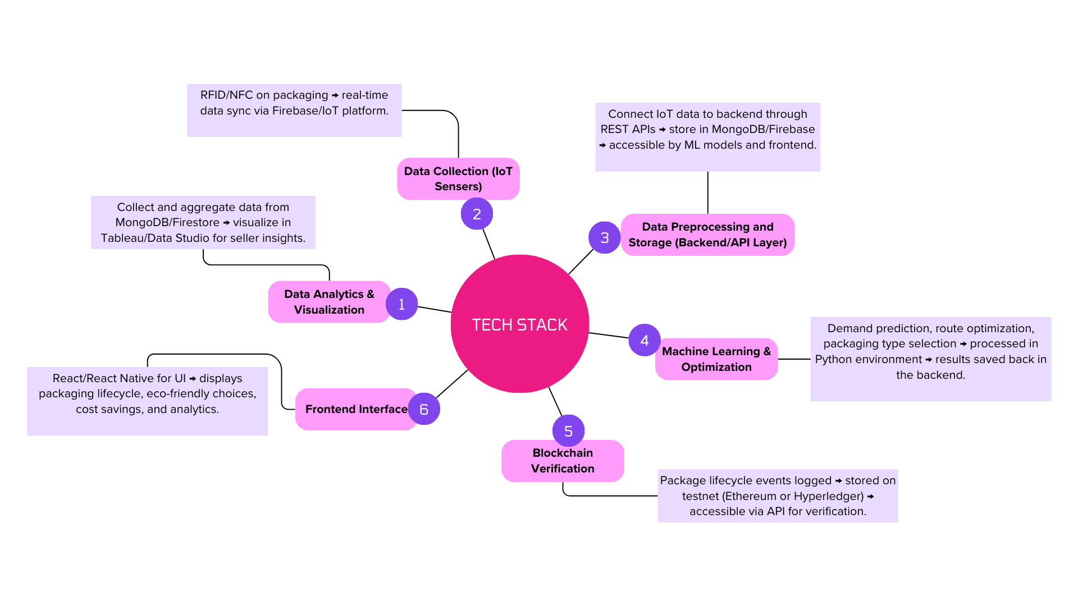

**Decision Rationale:**

**Problem Identification**  
To address the growing concerns around packaging waste in e-commerce, it became evident that a more efficient and sustainable approach was necessary. Sellers often face challenges in balancing product safety with environmental considerations, leading to inefficient packaging that contributes to significant waste and unnecessary shipping costs.

**Data-Driven Solution**  
By analyzing existing industry trends, it was clear that while companies like Amazon have taken steps to reduce packaging waste, the problem persists at the seller level. Most sellers lack the tools or data to make informed packaging decisions that align with sustainability goals. Furthermore, there is a lack of automation in current packaging solutions, leaving much of the process manual and inefficient.

**Feasibility & Scalability**  
Given the complexity and scale of the issue, several potential solutions were explored. Providing manual guidelines could assist in reducing waste, but this approach lacks scalability and would require constant updates as new products and materials are introduced.  
Building a machine learning-driven packaging optimization platform, on the other hand, presents a data-centric, scalable solution. This approach could offer real-time, automated insights to sellers, helping them optimize packaging based on product characteristics and environmental impact.

**Automating the Process**  
After careful evaluation, the machine learning-driven solution emerged as the most viable option. This approach would empower sellers to make data-driven decisions, reducing waste without sacrificing product protection. The system’s scalability would allow it to cater to a wide range of products and sellers, making it an adaptable long-term solution for the entire e-commerce ecosystem.  
The implementation phase focuses on creating a platform that integrates seamlessly into sellers' workflows, providing packaging recommendations based on the dimensions, weight, and fragility of each product. The front-end, built using React.js, ensures a user-friendly experience, while Node.js and MongoDB power the backend, handling real-time recommendations and storage. Firebase handles authentication and instant updates, ensuring a smooth user experience.

**Sustainability & Long-Term Impact**  
Continuous monitoring of the system allows us to track improvements in packaging efficiency, sustainability, and cost-effectiveness. By analyzing the collected data, we can fine-tune the recommendations to ensure optimal results. Furthermore, feedback from sellers is integrated into the platform, creating a dynamic and evolving solution that adapts to changing market and environmental conditions.

Through this iterative process, the solution will not only address the current inefficiencies in packaging but also foster a culture of sustainability, driving long-term benefits for both sellers and the environment.

**Innovation Highlights:**

1. **AI-Powered Eco-Friendly Packaging:** Leverages AI to optimize packaging materials based on product specifics, minimizing waste and using recyclable, biodegradable options.
2. **Route and Delivery Optimization**: AI-driven routes that reduce fuel consumption and emissions by adjusting delivery paths in real-time, incorporating factors like traffic and weather.
3. **Carbon Footprint Dashboard**: Real-time tracking of carbon emissions, allowing clients to monitor and offset their environmental impact through integrated offset programs.
4. **Circular Logistics Network**: A system for reusing materials (crates, pallets, etc.), tracked with RFID, reducing waste and promoting a circular economy.
5. **Green Fleet Integration**: Dynamic allocation of electric vehicles, drones, and e-bikes for deliveries, optimizing fuel use and reducing emissions, with renewable energy charging for sustainability.

**Feasibility and User-Friendliness:**

1. **Feasibility:**
   * **Cost-Efficiency**: Leveraging AI and machine learning to optimize packaging and delivery reduces operational costs by minimizing waste and enhancing resource use. This approach has a high ROI in the long run due to reduced carbon offset fees and improved fuel efficiency.
   * **Scalability**: The system is designed to scale seamlessly across regions, with the ability to adapt to various logistics needs and integrate into existing infrastructure..
   * Integration: Easily integrates with current e-commerce platforms and logistics systems, requiring minimal modification to existing workflows. APIs and middleware support integration with third-party vendors and suppliers.
2. **User-Friendliness**:
   * Intuitive Interface: The dashboard provides real-time visibility into logistics, emissions data, and packaging optimization, all presented in an easy-to-understand format. Users can quickly adjust preferences, track sustainability metrics, and access actionable insights.
   * Minimal Learning Curve: The system is designed to be user-centric, with simple controls and automated features that reduce complexity. Training resources and customer support ensure smooth adoption for logistics teams and e-commerce sellers.

**Customizable Features**: Sellers can tailor the solution to their specific needs, from packaging options to delivery routes. The platform adapts to varying business sizes and scales, offering flexibility for small businesses and large enterprises alike.

**Success Metrics:**

1. **Reduction in Packaging Waste**
   * Target: 30% reduction in packaging waste
   * Current: 0% (baseline, to be measured after implementation)
   * Metric Representation: Pie chart showing the reduction in packaging waste (30% goal, 70% baseline)
2. **Carbon Footprint Reduction**
   * Target: 20% reduction in CO2 emissions from logistics
   * Current: 0% (baseline)
   * Metric Representation: Bar chart or line graph showing the ongoing reduction of carbon emissions with time
3. **Improved Delivery Efficiency**
   * Target: 15% increase in delivery efficiency (time and fuel consumption)
   * Current: 0% (baseline)
   * Metric Representation: Line graph showing a gradual increase in delivery efficiency (measuring fuel savings and delivery time improvements)
4. **Customer Satisfaction and Retention**
   * Target: 25% increase in customer retention
   * Current: 0% (baseline)
   * Metric Representation: Bar chart showing the increase in customer satisfaction (tracked by customer feedback and retention rates)
5. **Scalability and Adoption**
   * Target: 50% adoption rate by sellers
   * Current: 0% (baseline)
   * Metric Representation: Pie chart or line graph showing the growth in the number of sellers adopting the platform
6. **Return on Investment (ROI)**
   * Target: Achieve ROI within two years
   * Current: 0% (baseline)
   * Metric Representation: Line graph or bar chart showing the ROI growth, comparing costs saved vs. investments made
7. **Methodology/Architecture Diagram**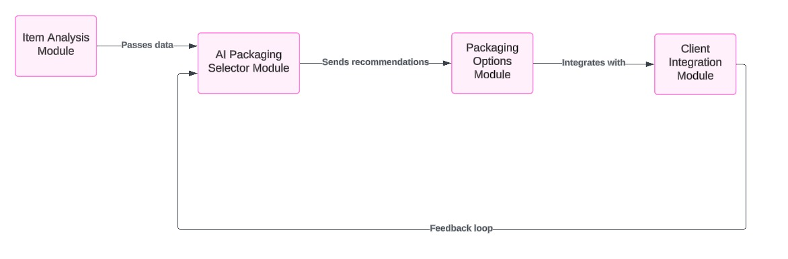

https://lucid.app/lucidchart/0f954424-a157-4f8b-9fe5-5c0f2fd1639a/edit?viewport_loc=-637%2C647%2C3069%2C1595%2C0_0&invitationId=inv_a09a5ea1-12ec-45ff-8195-3bd72c141d43

**Submission Checklist:**

**⇒** All team details are filled out

**⇒** Theme details and benefits are clearly explained

**⇒** Idea and approach details are comprehensive

**⇒** Architecture diagram(s) are included

**⇒** All sections are completed to the best of your ability

Thank you for your submission! Your innovative ideas have the potential to make a significant impact on SMBs across India. We look forward to reviewing your proposal and wish you the best of luck in the challenge!