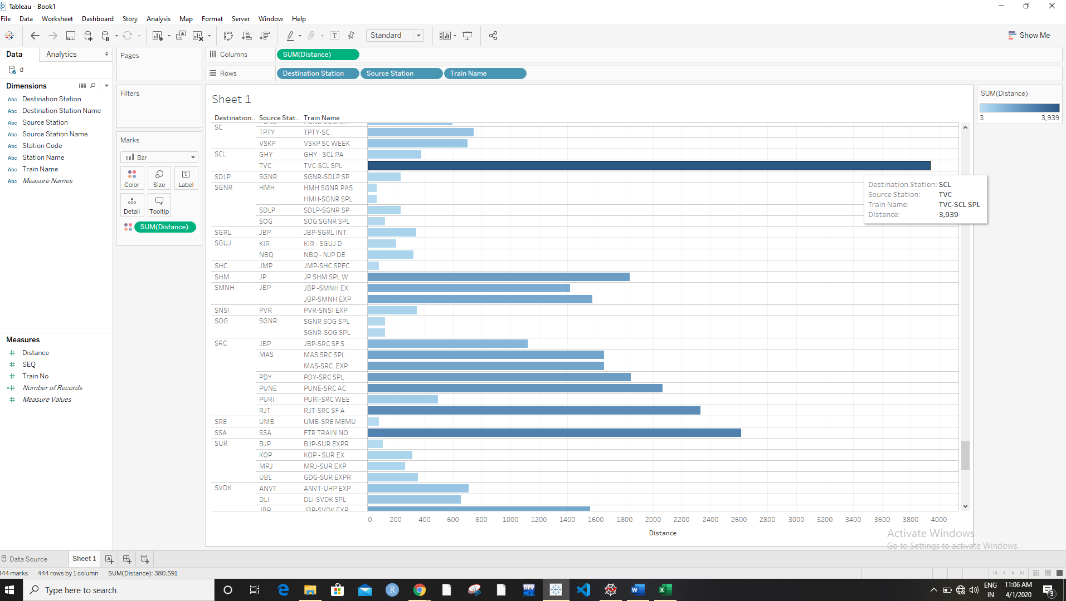

Max distance is 3939 from Trivandrum to Silchar

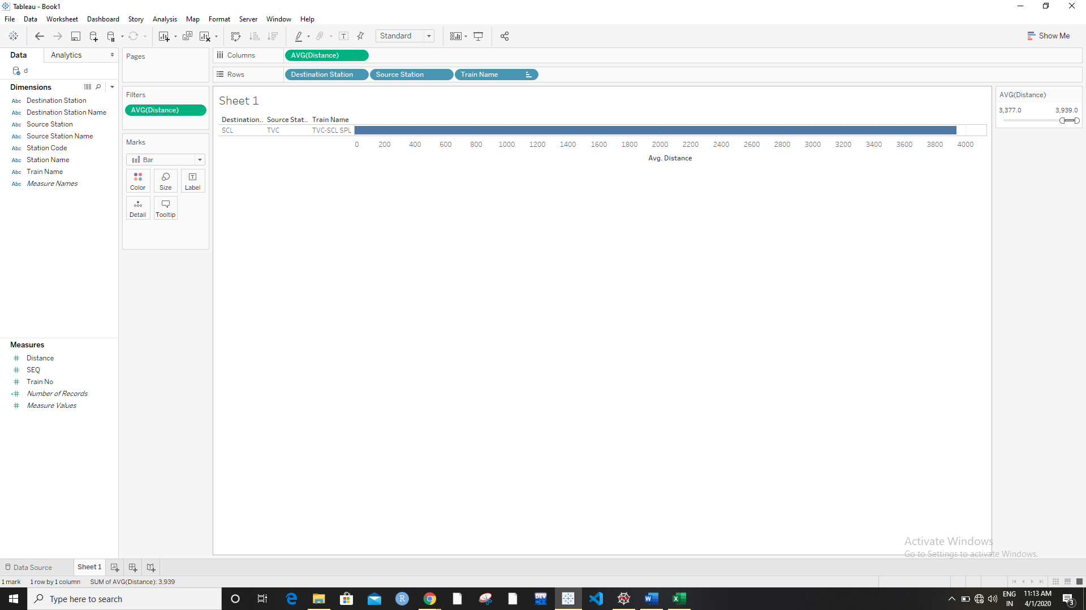

Maximum avg distance is between Silchar and Trivandrum

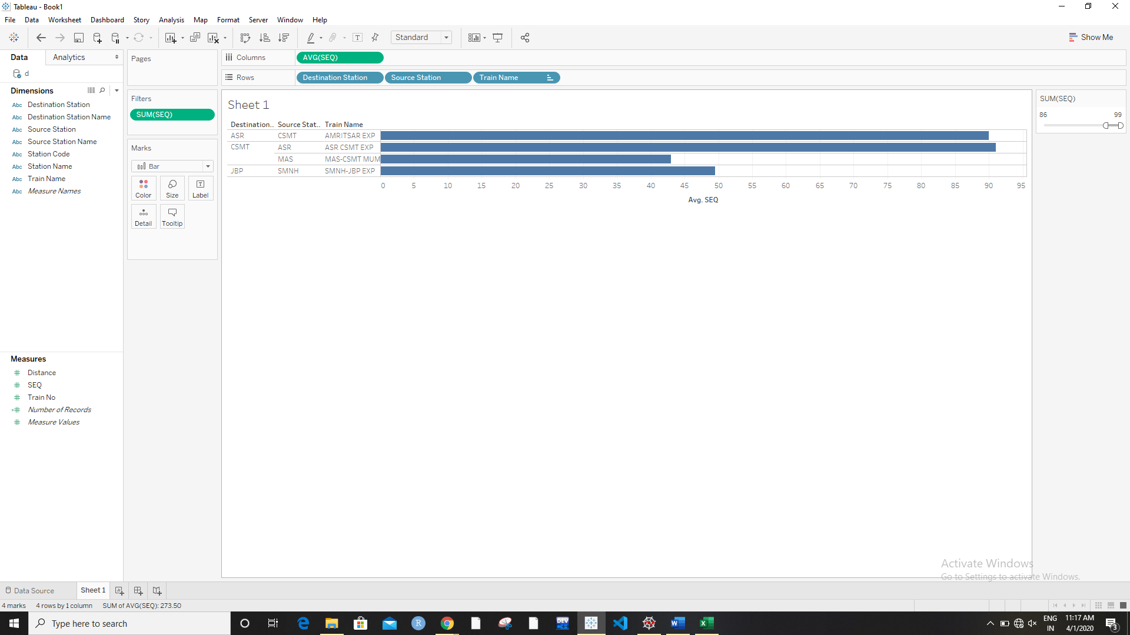

Avg no of trains passing between Amritsar and CST-mumbai

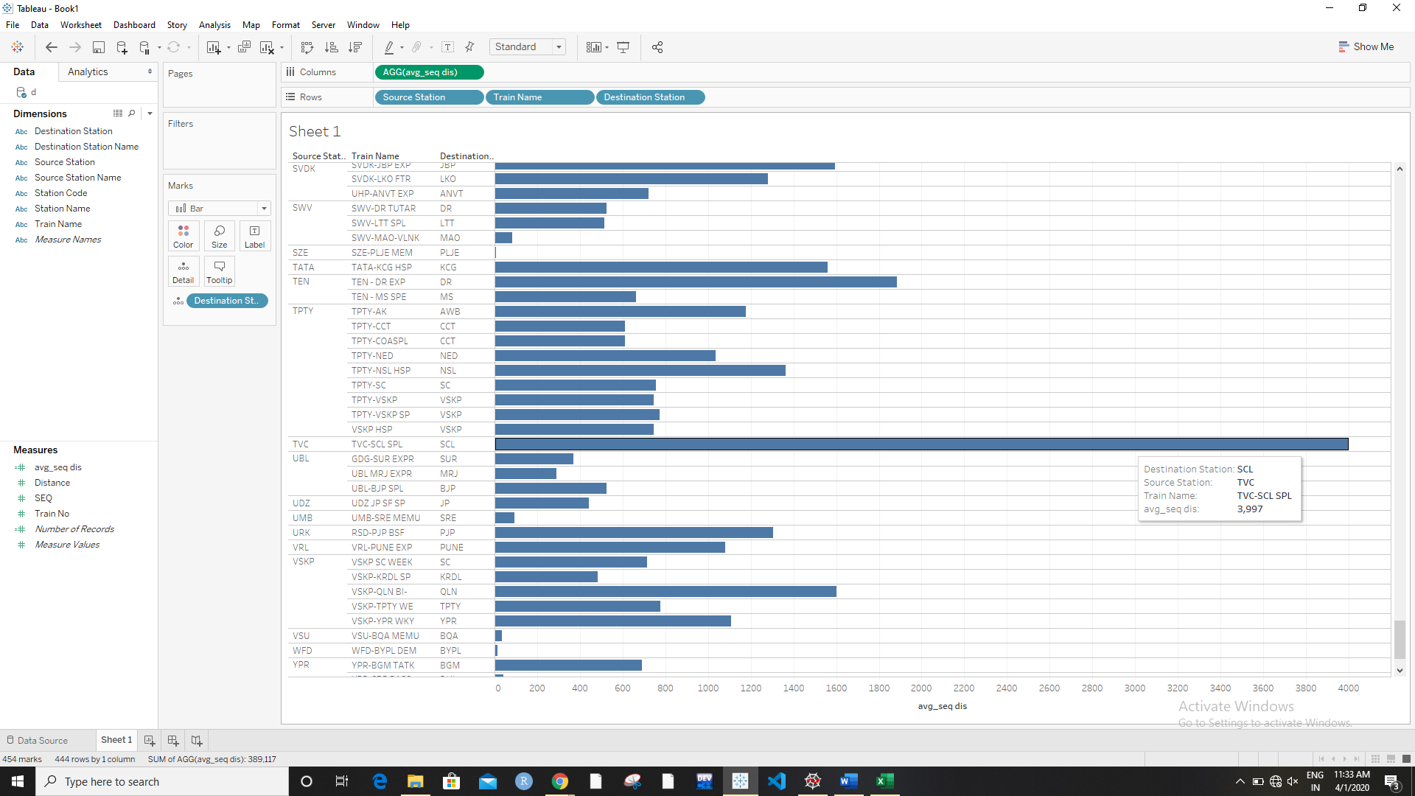

This shows that average sequence distance is 3997 from Trivandrum to Silchar

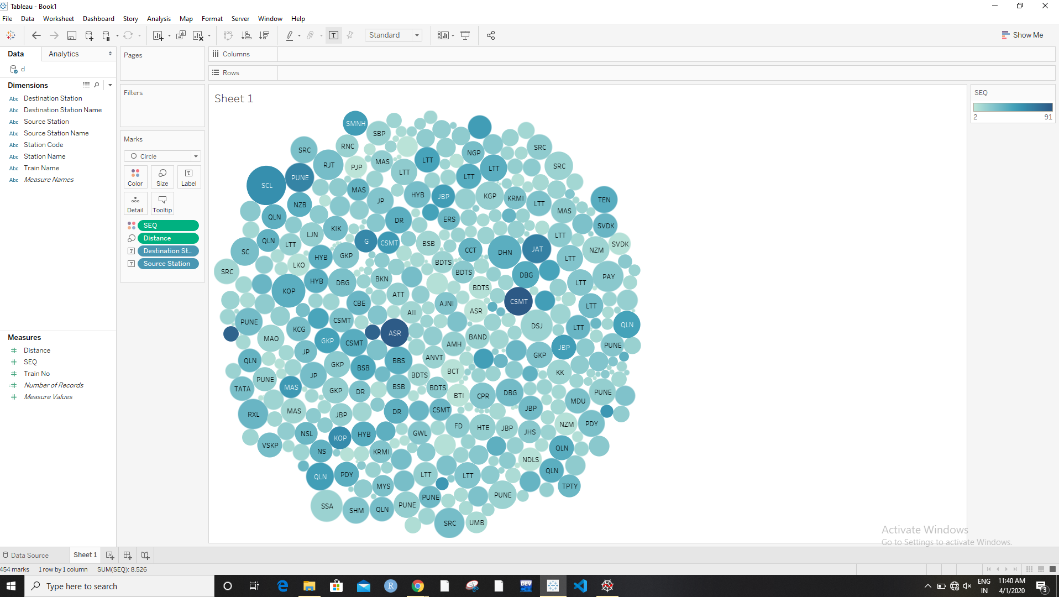

Max dis is from Trivandrum to silchar whereas maximum trains passing are from Amritsar to CST-Mumbai

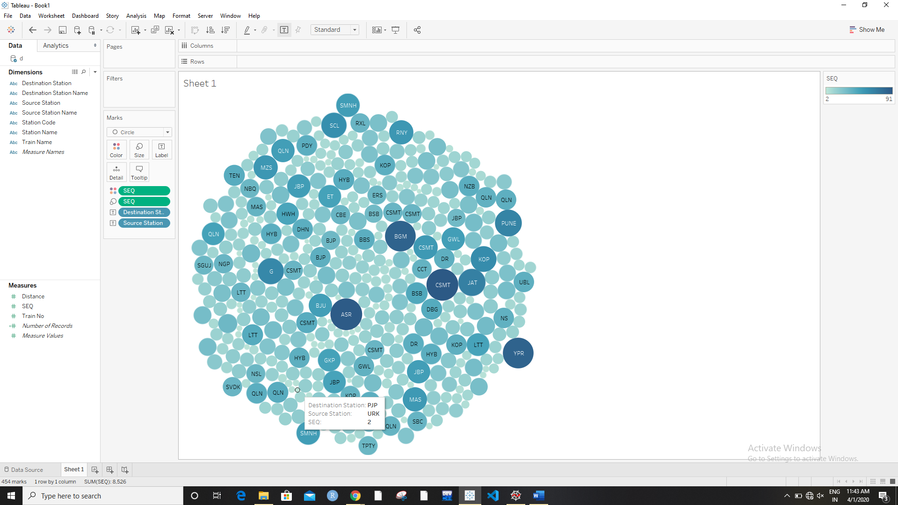

Least no of trains passing are from Urkura to Panjipara