ALERT INTELLIGENCE ENGINE
Data Science Audit & Unsupervised / Self-Supervised ML Feasibility Report
Prepared from the client-provided Alerts_Samples.xlsx and the existing Alert Automation Project Design.
Date: 11 August 2026

Source | Records | Purpose
CustomerViolation | 2,397 | Customer / onboarding / ongoing name alerts
TransactionNameViolation | 2,000 | Transaction-party name screening alerts
Rule | 2,244 | Transaction monitoring / rule alerts
Total | 6,641 | Current proof-of-concept sample
Confidential - Technical Feasibility & PoC Design

1. Executive Summary
The client's problem should be treated as an ML-based Alert Intelligence problem rather than a single binary classification problem. The supplied workbook contains 6,641 historical alert records across three different alert families: customer name alerts, transaction name alerts, and transaction rule alerts.
The current sample does not provide a trustworthy set of confirmed true-match labels. Operational statuses such as Released and UPS cannot safely be converted into TRUE/FALSE training labels because the compliance comments show that many UPS cases were also described as false positives. Therefore, a supervised classifier should not be the first production model.
The recommended architecture is unsupervised-first and self-supervised where the data naturally provides relationships. It learns representations of entities and transaction behaviour, models normal historical patterns, scores novelty/anomaly, and produces a review recommendation. Future confirmed compliance outcomes are retained as feedback and can later support supervised calibration without replacing the unsupervised layer.
No LLM, paid AI API, or per-alert model API is required. The core engine can run on client infrastructure using Python, scikit-learn/PyTorch, FastAPI, PostgreSQL, Redis where needed, and model/version monitoring.

Executive Decision
Decision | Recommendation
Can the current data support a PoC? | Yes
Can it support a trustworthy binary true-match classifier today? | No
Should anomaly detection be the initial learning strategy? | Yes
Should all three alert types use one model? | No
Should RapidFuzz/phonetic scores drive decisions? | No, not under the no-heuristics requirement
Is an LLM required? | No
Can the system improve when more unlabeled data arrives? | Yes, through continual unsupervised/self-supervised learning
Should future confirmed outcomes be used? | Yes, for validation and later supervised calibration

2. Problem Definition
The client has consolidated alerts into three operational sources:
- Customer Name Alerts - generated from registered Customers.
- Transaction Name Alerts - generated from Transactions during screening.
- Transaction Rule Alerts - generated from Transactions by transaction-monitoring rules.
These are not identical ML problems. Customer and transaction name alerts primarily concern entity/watchlist relationship assessment. Rule alerts primarily concern transaction and customer behavioural abnormality. The solution therefore uses one common engine with separate ML pipelines.

2.1 What the engine should answer
- How unusual is this alert compared with the historical population?
- How unusual is the alert relative to this customer's own historical behaviour?
- How unusual is the entity/watchlist relationship compared with historical entity patterns?
- Which alerts are sufficiently similar to historically normal patterns to be candidates for lower-touch handling?
- Which alerts are novel or materially different and therefore require compliance review?

2.2 What the engine should not claim from the current sample
- It should not claim that Released means confirmed false positive.
- It should not claim that UPS means confirmed true match.
- It should not claim that an anomaly score is a probability of sanctions guilt.
- It should not claim autonomous production release accuracy before confirmed outcome labels and prospective validation exist.

3. Workbook Data Audit
Sheet | Rows | Columns | Exact duplicates | Primary ML role
CustomerViolation | 2,397 | 23 | 8 | Entity / customer name intelligence
TransactionNameViolation | 2,000 | 25 | 537 | Entity / transaction-party name intelligence
Rule | 2,244 | 24 | 0 | Transaction behaviour / rule intelligence
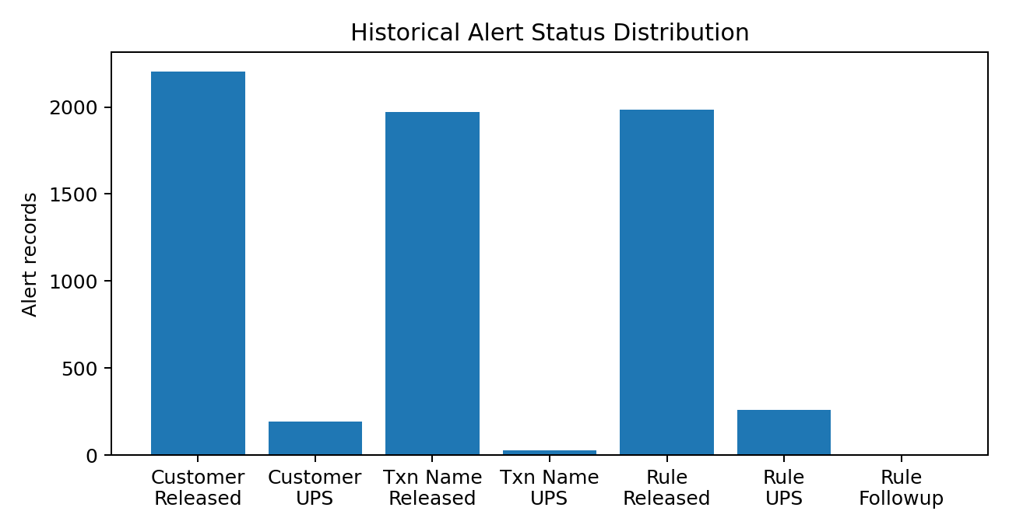
Figure 1. Historical operational status distribution. Status is not treated as ground truth.

3.1 CustomerViolation
Measure | Finding
Records | 2,397
UINs | 1,232 unique
Customer types | INDIVIDUAL 2,089; CORPORATE 308
Alert types | OnBoarding 1,342; OnGoing 904; Delta 151
Screening lists | 11 distinct
Alerted Party | MemberName 2,151; RepresentativeName 246
Status | Released 2,204; UPS 193
Exact duplicates | 8
Alerted Party DOB missing | 1.8%
Hit DOB missing | 30.2%
POB missing | 100% for alerted party and hit
Additional information missing | 100%

3.2 TransactionNameViolation
Measure | Finding
Records | 2,000
Unique UINs | 373
Unique transaction references | 402
Exact duplicate rows | 537
Status | Released 1,970; UPS 28; blank 2
Alerted Party | BeneficiaryName 1,493; ByOrder 223; SenderName 201; BeneficiaryBankName 83
Alerted Party DOB missing | 78.8%
Hit DOB missing | 62.2%
POB missing | 100% for alerted party and hit
Additional information missing | 100%
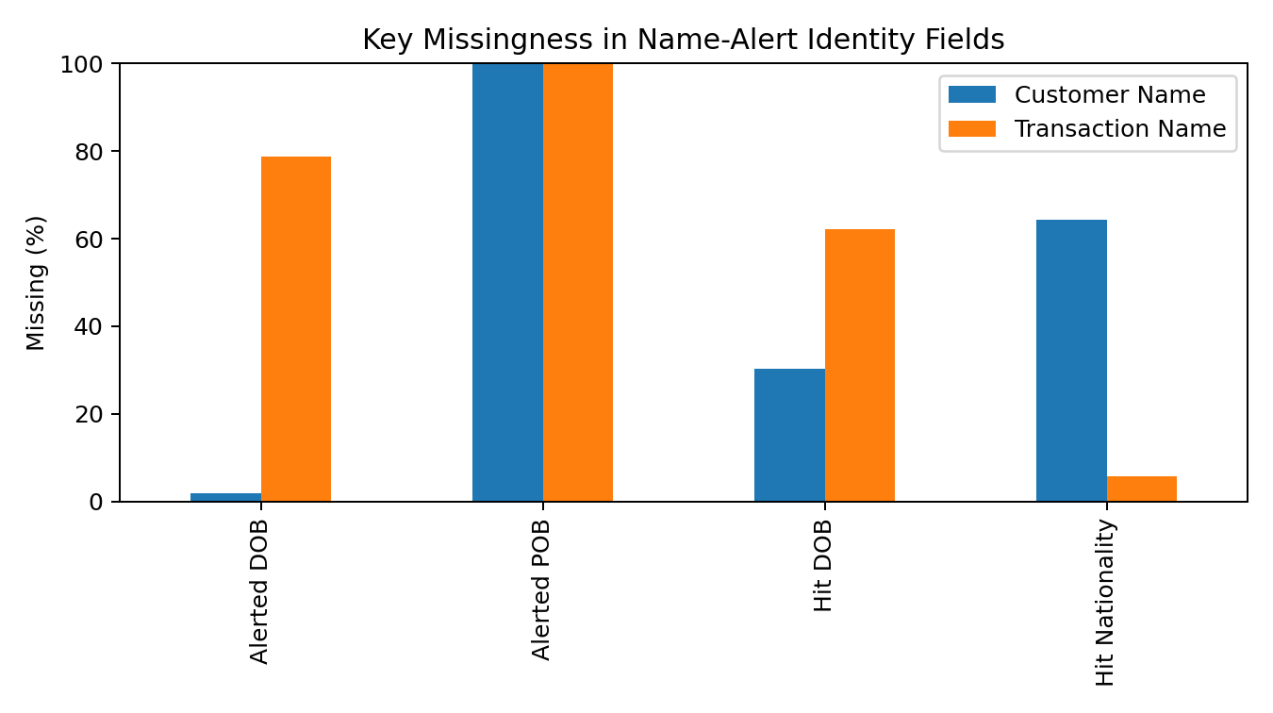
Figure 2. Key missingness in identity fields. POB is unavailable in the current sample.

3.3 Rule
Measure | Finding
Records | 2,244
Unique customers | 1,106
Unique transaction references | 1,619
Rule types | 1 Rule Type value: AML
Rule names | 18
Status | Released 1,983; UPS 260; Followup 1
Beneficiary ID missing | 97.1%
Beneficiary name missing | 22.9%
Beneficiary relationship missing | 22.9%
Currency name missing | 16.9%
Purpose missing | 14.8%
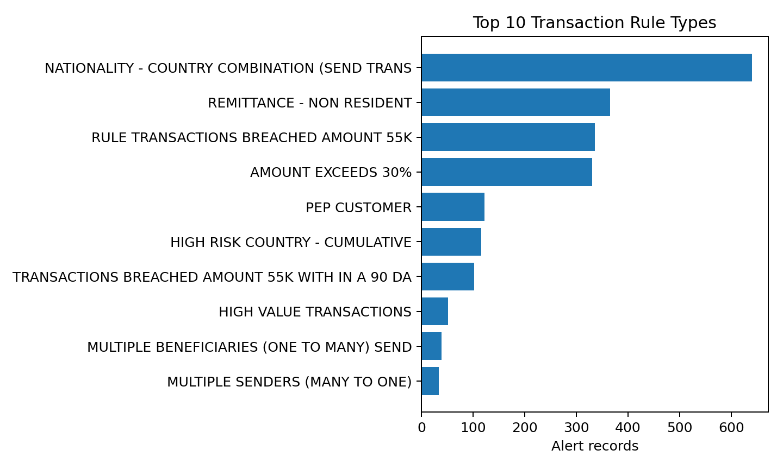
Figure 3. Top transaction rule types in the current sample.

4. Data Quality Findings

4.1 Missing fields
- POB is 100% missing in both name-alert sheets. The first model must not depend on POB.
- Hit nationality is only partially available in CustomerViolation and is substantially better populated in TransactionNameViolation.
- Beneficiary ID is 97.1% missing in Rule, so it cannot be a primary feature in the initial model.
- The Rule dataset has no clean structured transaction amount field. Amounts appear in comments for some alerts. This is unsuitable as the primary production feature and should be replaced by the source transaction amount field.

4.2 Duplicate and repeated-entity structure
- TransactionNameViolation contains 537 exact duplicate rows. These must be deduplicated or handled explicitly before training.
- CustomerViolation contains 1,232 unique UINs across 2,397 rows, so repeated customer history is available.
- TransactionNameViolation contains 373 unique UINs and 402 transaction references across 2,000 rows.
- Rule contains 1,106 unique customers and 1,619 transaction references across 2,244 rows.
- The same customer/transaction may appear in multiple alert records, so random row-level train/test splitting would create leakage.

4.3 Temporal integrity
Dataset | Check | Rows | Share
TransactionNameViolation | Alert generated earlier than transaction date | 1605 | 80.2%
Rule | Scan date earlier than transaction date | 328 | 14.6%
CustomerViolation | Closure date earlier than alert generation | 3 | 0.1%
These timestamp relationships must be clarified with the client before using temporal features. They may reflect business processing semantics, source-system timestamps, or data-quality issues. The PoC should not silently correct them.

5. Label and Outcome Audit
The most important finding is that the workbook is not a clean supervised learning dataset. The operational status fields do not reliably represent the desired ML target.
Dataset | Released | UPS | Other | Comment contains 'false positive'
CustomerViolation | 2,204 | 193 | - | 2,155 / 2,397 (89.9%)
TransactionNameViolation | 1,970 | 28 | 2 blank | 1,881 / 2,000 (94.0%)
Rule | 1,983 | 260 | 1 Followup | 74 / 2,244 (3.3%)
The presence of 'false positive' language in many UPS records is direct evidence that UPS cannot safely be mapped to a positive class. Therefore the initial system must use UNKNOWN/RESOLVED/CONFIRMED outcome semantics instead of manufacturing binary labels.

5.1 Recommended outcome taxonomy
Internal outcome | Meaning | Use initially
UNKNOWN | No trustworthy outcome established | Do not use as supervised target
HISTORICALLY_RELEASED | Operationally released | Useful for historical context, not proof of false positive
CONFIRMED_FALSE_POSITIVE | Explicitly confirmed by reliable evidence | Candidate supervised negative label
CONFIRMED_TRUE_MATCH | Confirmed genuine match | Candidate supervised positive label
ESCALATED / FOLLOW_UP | Requires additional review | Keep separate from positive/negative

6. Unsupervised / Self-Supervised Problem Formulation
The recommended initial formulation is novelty and anomaly detection. The engine learns the distribution of historical entity relationships and transaction behaviour without requiring a complete TRUE/FALSE label set.

6.1 Entity intelligence objective
Alerted entity + watchlist entity + historical entity context
|
v
Learned entity representation
|
+----------+----------+
| |
v v
Global population Customer-specific
baseline baseline
| |
+----------+----------+
|
v
Novelty / anomaly
assessment
Customer Name Alerts and Transaction Name Alerts share the entity-intelligence problem, but their transaction context differs. A shared representation layer can be used while retaining alert-type context.

6.2 Transaction intelligence objective
Customer + transaction + rule context + historical behaviour
|
v
Learned transaction representation
|
+----------+----------+
| |
v v
Global transaction Customer-specific
baseline baseline
| |
+----------+----------+
|
v
Anomaly score
The Rule dataset should therefore use a separate transaction intelligence pipeline rather than the same model used for name/watchlist entity resolution.

6.3 Why self-supervised learning is useful
- Repeated UIN/customer identifiers provide natural relationships between historical records.
- Repeated transaction references provide natural transaction-group structure.
- Historical rule types provide context for learning rule-specific transaction distributions.
- The model can learn representations from these relationships without treating operational status as ground truth.
- This makes the architecture suitable even if future production data remains mostly unlabeled.

7. Feature and Representation Design

7.1 Entity features
Feature group | Current availability | Design
Name | Strong | Learned character/token representation; no hardcoded decision weights
DOB | Partial | Encode when present; missingness is explicit
POB | Unavailable | Exclude from current model; add when source data becomes available
Nationality | Moderate/strong depending on sheet | Normalized categorical representation
Screening match % | Available | Use as a model feature, not a hardcoded threshold
Screening list | Available | Categorical/context feature
Alerted party type | Available | Context feature
Customer type | Available | Context feature
Historical customer alerts | Available | Aggregate/customer representation

7.2 Transaction features
Feature group | Current sample | Production recommendation
Transaction type | Available | Use
Transaction amount | Not cleanly structured in Rule | Obtain structured source field
Currency | Partially available | Use normalized currency
Beneficiary | Partially available | Use when present
Purpose | Partially available | Use when present
Country | Present in some contextual fields/comments | Prefer structured source fields
Historical transaction behaviour | Partially inferable | Obtain full transaction history
Rule type/name | Strong | Use as context; do not replace rule logic with ML
Post-review comments | Available | Training/outcome analysis only; never live input

8. Target ML Architecture
ALERT INTELLIGENCE ENGINE
|
Alert Intake API
|
Normalization Layer
|
+-----------------+-----------------+
| |
ENTITY PIPELINE TRANSACTION PIPELINE
| |
Customer + Transaction Name Rule Alerts
| |
v v
Self-supervised entity Self-supervised /
representation learned transaction
| representation
v v
Global anomaly model Global anomaly model
| |
Customer-specific baseline Customer baseline
| |
+-----------------+-----------------+
|
Decision Support
|
+------------+------------+
| |
Lower novelty High novelty
| |
Candidate handling Compliance review
| |
+------------+------------+
|
Outcome / Feedback
|
Model versioning
|
Future supervised layer

8.1 No-LLM implementation stack
Layer | Recommended technology | Cost model
API | Python + FastAPI | Open-source
Data processing | Pandas + NumPy | Open-source
ML | scikit-learn + PyTorch | Open-source
Feature/representation storage | PostgreSQL | Open-source / client-hosted
Vector/search layer if needed | PostgreSQL extensions or open-source search | Client-hosted
Cache | Redis, only if required | Open-source / client-hosted
Model registry | MLflow or equivalent | Open-source / client-hosted
Deployment | Docker | Open-source / client-hosted
Monitoring | Application + ML metrics | Client-hosted

9. PoC Experiment Plan
The PoC should prove capability rather than manufacture a supervised accuracy claim. The experiment must be reproducible, leakage-controlled, and based only on information available at alert time.

Experiment A - Data normalization
- Standardize missing values and data types.
- Normalize country/nationality representations such as IN-INDIA versus INDIA.
- Normalize names for representation generation without using the normalized string as a deterministic decision.
- Remove exact duplicates from the training population and retain duplicate counts as a data-quality metric.
- Create entity, customer, transaction and rule identifiers for grouped validation.

Experiment B - Entity representation
- Build a baseline character/token representation for names and contextual categorical fields.
- Add DOB and nationality only where present, with explicit missingness indicators.
- Use repeated UIN/entity relationships for self-supervised representation learning where appropriate.
- Generate an embedding/feature representation for each alerted entity-watchlist relationship.
- Compare global and customer-specific novelty.

Experiment C - Entity anomaly detection
- Benchmark Isolation Forest and at least one neural/representation-based anomaly method.
- Do not use Alert Status, Maker Comment, Maker Name or closure information as live features.
- Evaluate score stability across customer groups, watchlist lists, branches and time periods.
- Inspect the highest-novelty and lowest-novelty historical alerts manually.
- Compare anomaly rankings with historical operational outcomes only as an exploratory analysis, not as ground-truth accuracy.

Experiment D - Transaction/rule representation
- Create structured transaction features from fields available before review.
- Build customer-level behavioural aggregates using only prior transactions when performing prospective validation.
- Represent rule type as context rather than assuming every rule has the same distribution.
- Benchmark anomaly methods separately by rule family where sample size permits.
- Inspect high-novelty transactions and determine whether the reason is data quality, a legitimate rare pattern, or a potentially meaningful compliance signal.

Experiment E - Prospective validation simulation
- Order records chronologically where timestamps are semantically valid.
- Train on an earlier period and score a later period.
- Prevent the same customer or transaction from leaking between train and evaluation populations where the experiment requires unseen entities.
- Run a second experiment where the same customer is allowed but only prior customer history is available, representing a realistic repeat-customer scenario.
- Report both scenarios separately.

10. Validation Framework
Validation objective | Method | Why
Unseen customers | Group split by customer/UIN | Tests generalization to new entities
Repeat customers | Time-forward split within customer history | Tests realistic ongoing monitoring
Transaction generalization | Group by transaction reference | Prevents duplicated transaction leakage
Future behaviour | Time-based holdout | Approximates production deployment
Rule stability | Per-rule evaluation | Prevents dominant rules hiding weak rules
Data drift | Period-over-period distribution checks | Detects changing customer/rule populations

10.1 Metrics for an unsupervised PoC
- Alert ranking quality during manual review of top-n novel alerts.
- Novelty concentration by rule, watchlist, branch and customer segment.
- Stability of anomaly rankings across time windows.
- Percentage of historical alerts represented by low-novelty clusters.
- Cluster/representation consistency for repeated customers and repeated transactions.
- Manual compliance review rate reduction in a shadow-mode simulation.
- False-negative analysis once trustworthy confirmed outcomes become available.
Do not use overall accuracy as the primary PoC metric. In an unlabeled anomaly-detection problem, accuracy is not defined without a trustworthy target. A supervised precision/recall/AUC report should be introduced only after confirmed outcomes exist.

11. Client Demonstration Plan
The client demonstration should prove the following sequence:
- Load the supplied XLSX into the engine.
- Show the three alert families and their normalized schemas.
- Show data-quality findings transparently, including missing POB and duplicate transaction alerts.
- Train the initial unsupervised/self-supervised representations.
- Show the historical baseline learned by the model.
- Submit a previously unseen historical alert to the scoring API.
- Display its anomaly/novelty assessment and historical context.
- Show similar/nearby historical representation groups without using an LLM.
- Show why the alert is recommended for lower-touch handling or compliance review.
- Repeat the demonstration for a transaction rule alert.
- Show the feedback record that would be stored after a compliance decision.

11.1 What the demo should NOT claim
- Do not claim that the current sample proves true-match detection.
- Do not claim that anomaly score equals probability of guilt or false positive.
- Do not claim autonomous release is production-safe from this workbook alone.
- Do not hide the lack of confirmed labels; present it as an explicit design condition.

12. Production Learning Strategy
TODAY
Unlabeled / weakly labeled historical alerts
|
v
Self-supervised representations
|
v
Unsupervised anomaly detection
|
v
ML-assisted review
FUTURE
New production alerts
|
v
ML recommendation
|
v
Compliance outcome
|
v
Validated feedback dataset
|
v
Supervised calibration layer
|
v
Controlled automation
The future supervised layer should be additive. The unsupervised representation and anomaly layer remains useful for detecting novel patterns, emerging behaviour and data populations not represented in the labelled training set.

13. Production Controls
Control | Requirement
Model versioning | Every score must record model version and feature/schema version.
Auditability | Persist alert ID, inputs used, score, recommendation, model version and final compliance outcome.
Feature leakage prevention | Only pre-decision fields may enter live inference.
Threshold governance | Any operational routing threshold must be calibrated and approved; not hardcoded from a sample guess.
Shadow mode | Initial production deployment should observe ML recommendations without autonomous release.
Drift monitoring | Monitor feature and score distributions over time.
Retraining | Scheduled retraining with data-quality checks and model comparison before promotion.
Rollback | Maintain previous approved model version.
Security | Run on client-controlled infrastructure; no third-party LLM/API required.

14. Additional Production Data Required
The current XLSX is sufficient for a PoC, but the production engine should consume structured source-system data. The following fields should be requested where available:
- Full customer master/profile fields and stable customer identifiers.
- Structured transaction amount and currency.
- Sender and beneficiary country.
- Customer risk rating and relevant KYC profile attributes.
- Historical transaction history for behavioural baselines.
- Beneficiary identifiers and relationship history.
- Structured rule-trigger information.
- Confirmed compliance outcomes and outcome timestamps.
- Watchlist/screening source identifiers and available entity attributes.
- Clear timestamp semantics and timezone definitions.

15. Risks and Mitigations
Risk | Impact | Mitigation
No confirmed true-match labels | Cannot honestly train binary classifier | Unsupervised/self-supervised first; collect confirmed outcomes
UPS misinterpreted as positive | Wrong model target | Treat UPS as operational/unknown unless independently confirmed
Comments used as features | Severe leakage | Comments only for outcome analysis/training-label validation
Duplicate transaction alerts | Inflated evaluation | Deduplicate and group-split
Timestamp semantics unclear | Invalid temporal validation | Confirm business meaning before time-based features
POB absent | Model cannot learn POB signal | Exclude until source provides it
Rule amounts only in comments | Weak transaction model | Obtain structured transaction amount
Rare rules | Overfitting | Shared representation; specialize only when sample size supports it
Anomaly interpreted as guilt | Unsafe compliance decision | Position as novelty/review signal; validate with compliance outcomes

16. Recommended Implementation Plan
Phase | Duration | Primary outcome
Phase 0 - Data Science Audit | 1-2 weeks | Validated schema, leakage rules, outcome taxonomy, PoC dataset
Phase 1 - Unsupervised PoC | 2-3 weeks | Entity + transaction anomaly models and reproducible evaluation
Phase 2 - Shadow API | 2-3 weeks | FastAPI scoring, audit storage, review dashboard, no autonomous release
Phase 3 - Production Integration | 3-5 weeks | Client source integration, monitoring, model registry and controlled rollout
Phase 4 - Feedback Learning | Ongoing | Confirmed outcomes, model retraining and future supervised calibration

17. PoC Acceptance Criteria
- All three workbook sheets can be ingested and normalized without manual row editing.
- Exact duplicates are identified and handled deterministically.
- No post-review fields are used in live model inference.
- Entity and transaction pipelines are separately evaluated.
- Customer-grouped and time-forward validation runs reproducibly.
- The system produces a ranked anomaly/novelty list for each alert family.
- The system can show historical context for repeated customers/transactions.
- Model scores are reproducible for a fixed model and feature version.
- The PoC produces an auditable score record.
- The report clearly separates exploratory anomaly findings from confirmed supervised performance.

18. Final Recommendation
Proceed with an unsupervised-first Alert Intelligence Engine. Do not treat the current workbook as a binary classification dataset.
The strongest technical proposition is a no-LLM, client-hosted ML system that learns entity and transaction representations, models global and customer-specific historical behaviour, detects novelty/anomaly, and provides an auditable review recommendation. As confirmed compliance outcomes accumulate, a supervised calibration layer can be added without replacing the unsupervised foundation.
This approach fits the client's current data, remains useful if future production data continues to be weakly labelled, and creates a credible path from PoC to controlled automation.

Appendix A - Current Rule Distribution
Rule Name | Records | Share
23 - NATIONALITY - COUNTRY COMBINATION (SEND TRANS | 640 | 28.5%
42 - REMITTANCE - NON RESIDENT | 365 | 16.3%
53 - RULE TRANSACTIONS BREACHED AMOUNT 55K | 336 | 15.0%
107 - AMOUNT EXCEEDS 30% | 331 | 14.8%
91 - PEP CUSTOMER | 122 | 5.4%
56 - HIGH RISK COUNTRY - CUMULATIVE | 116 | 5.2%
84 - TRANSACTIONS BREACHED AMOUNT 55K WITH IN A 90 DAYS | 102 | 4.5%
4 - HIGH VALUE TRANSACTIONS | 52 | 2.3%
96 - MULTIPLE BENEFICIARIES (ONE TO MANY) SEND | 39 | 1.7%
44 - MULTIPLE SENDERS (MANY TO ONE) | 34 | 1.5%
97 - SPLITTING OF TRANSACTIONS | 33 | 1.5%
127 - SEND TO HIGH RISK COUNTRY | 24 | 1.1%
20 - HIGH VALUE TRANSACTIONS - CUMULATIVE | 15 | 0.7%
100 - MANY CUSTOMERS RECEIVING FUNDS FROM A COMMON SENDER | 11 | 0.5%
104 - NEW CLIENT HIGH VALUE TRANSACTION | 10 | 0.4%
101 - MULTIPLE CURRENCIES | 7 | 0.3%
88 - RECEIVE FROM HIGH RISK COUNTRY | 4 | 0.2%
114 - EXCHANGE HOUSE TRANSACTIONS COMPARISON | 3 | 0.1%

Appendix B - Key Data-Science Rules
- Never manufacture true/false labels from operational status without validated business semantics.
- Never use maker/checker comments as live inference features when they are created after alert review.
- Never perform random row-level splits on repeated customers or transactions.
- Never rely on a field that is 100% missing in the current sample.
- Never convert anomaly score directly into a compliance probability without calibration data.
- Every production score must be tied to model version, feature version and input schema version.
- All automated handling must be introduced only after prospective shadow-mode validation and compliance approval.

End of Report

