# Introduction

The task

# System Design

## Deployment Diagram

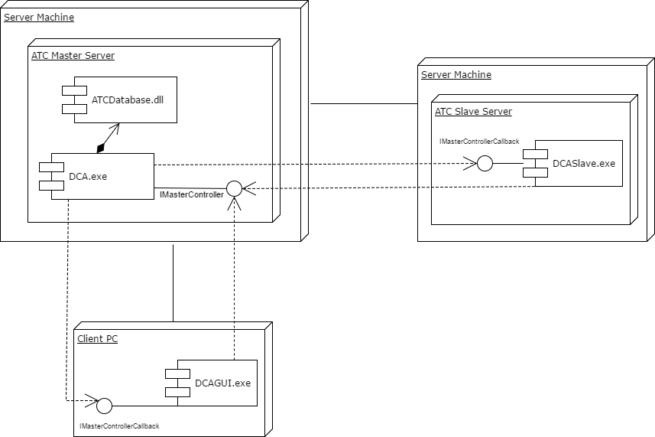

## UML Class Diagram

## Sequence Diagram

### Slave Start-up and allocation

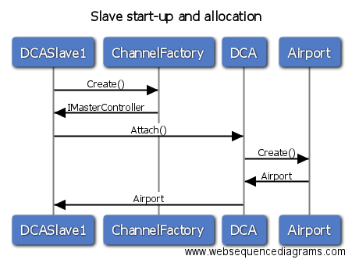

### DCA Web Listing

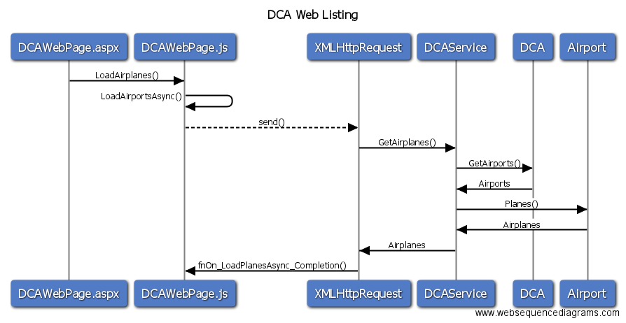

### WPF Sim Step

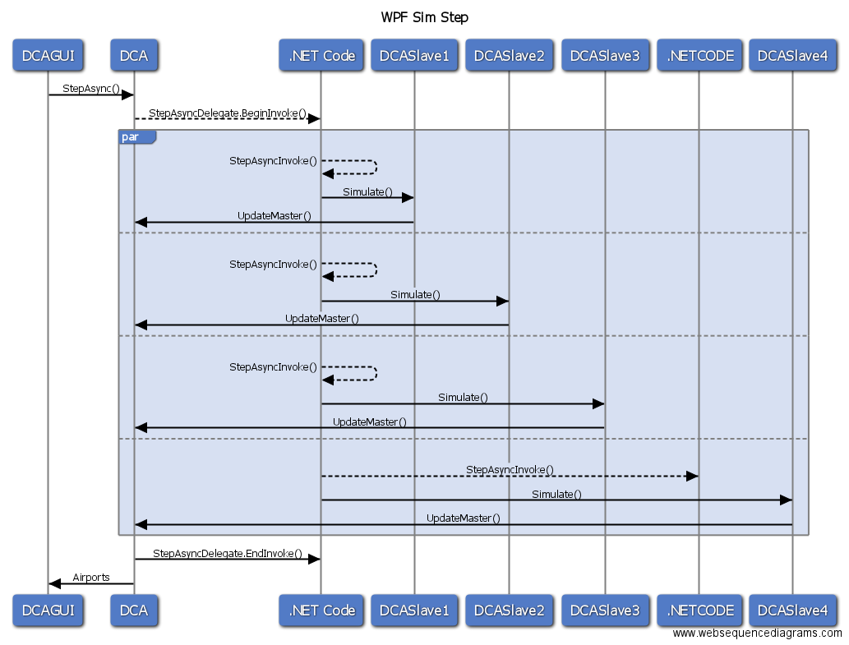

## Design Essay

### Network Efficiency / bandwidth usage

### GUI Responsiveness

### Design and implementation elegance / simplicity

### Design effects of having data classes without significant processing

### Issues in design due to restrictions on object passing

### Effective use of distributed resources (e.g., split of processing load)

### Memory usage on servers and clients

### Any other design aspects.