Aaradhana “Anya” Bharill

John Hamilton

Zachary Schafer

Daniel Verlaque

IA 471

February 19, 2018

Near-misses and Near-hits

**Motivation/Background** **2**

**Methods** **3**

Data Collection Platform 3

Experiment Setup 3

Formulas and Tools 5

**Discussions and Analysis** **7**

Discussion of raw results 7

Linear regression analysis 8

**Additional considerations** **10**

**Conclusion** **10**

**References** **11**

**Team member contributions** **12**

## Motivation/Background

Our paper models how observers reason about outcomes by looking at emotional cues, and what emotions observers expect to see given certain outcomes, based on Ong et al.’s paper, *Near-misses sting even when they are uncontrollable*. In this paper, the authors put forward the hypothesis that “near misses” (such as missing a plane by only two minutes) will cause a person to be more upset than they would be in the case of a “far miss” (such as missing a plane by two hours), even if they had no control over the situation. In the case of missing a plane, this makes sense because the person could have presumably changed the outcome to make the plane on time. However, Ong et al. claim that this is the case even if the subjects have no control over the ‘distance’ of the miss, such as with a gambling wheel or another randomized scenario in which the subject cannot control the outcome at all.

For this project, we focused on the Ong et al. model of ‘near misses’ as they pertain to subjects’ predictions of agents' emotions. The original paper focused on values that ranged from near-miss (0) to middle (0.5) The project expands on this model by testing near-hits, which are scenarios in which somebody got a higher value but was very close to the boundary with a lower value. The main objective was to run an experiment that included three scenario types (near-miss, middle, and the new near-hits type) and to see if we could find any trends between the three. Namely, Ong et al.'s paper has established that near-misses differ from middle hits; we would like to run an experiment that implements and expands their model to see how both of these scenarios compare to near-hits in situations in which participants had no control over the outcomes.

## Methods

### Data Collection Platform

We used Google Forms to collect our data. We wanted to gather data online in a non-monitored way because of time constraints, so we decided to use an online survey tool. We needed a platform which had support for randomized questions, and did not cost any money, which Google Forms met. Another well-known option for internet forms we considered was SurveyMonkey but randomized question order is a premium features which requires paying $30 a month, which was not within our project budget of $0. We also looked into a variety of other platforms, but they all either did not have the required features or were out of budget.

We also considered using PsychoPy to create our model. There are several benefits to using PsychoPy, such as support for displaying questions in a random order, being able to easily export test results to CSV data format for simple parsing, and support for creating a full-screen application to easily test many participants in a lab-style environment. Ultimately we chose not to use PsychoPy because it could not be easily run as a web application and would have required on-site, in-person testing. This would slow down our data collection, and since we had a limited amount of time in which we could collect data, we felt that this would outweigh any benefits.

### Experiment Setup

The participants were shown an image of a gambling wheel (Fig 1A), which was rotated at varying angles and had an arrow indicating the final value. Participants were told that another player had spun the wheel and achieved the portrayed outcome, and they were asked to give values for the emotions they expected said player to feel. The emotions they were asked to quantify were happiness, anger, surprise, and disappointment, and participants gave values by selecting checkboxes in an online form (Fig. 1B).

|  |  |
| --- | --- |
| *Fig. 1A: Gambling wheel* | *Fig. 1B: Sample Likert scales for the online survey* |

Participants were shown a total of nine scenarios. The scenarios were split into three groups ('scenario types'): **near-miss** (where the wheel's arrow landed near a boundary and *missed* the 'better' value), **middle** (the middle of a slice), and **near-hit** (near a boundary, on the side of the higher value). The nine scenarios are shown in the table below (Fig. 2), grouped by the slice on which the arrow landed.

|  |  |  |
| --- | --- | --- |
| **$25 slice** | **$60 slice** | **$100 slice** |
| Near $100 boundary | Near $25 boundary | Near $60 boundary |
| Middle | Middle | Middle |
| Near $60 boundary | Near $100 boundary | Near $25 boundary |

*Fig. 2: The nine scenarios for the experiment, colored by experiment type*

A graphic was generated for each of these nine scenarios, and each scenario had one question associated with it in the online survey. To make sure that the order in which that the participants viewed the situations did not affect their final results, we randomized the order in which the situations were displayed to the participant.

The only issue we had with Google Forms was that on certain screens, the last column of checkboxes (for the value 9) was cut off and the user would have to scroll to see and select it. To help minimize the effects of this, we added a pre-screening question after the instructions (which explicitly stated that the highest value available was 9) and a post-screening question at the end of the survey asking what the highest available value was. If a participant did not select 9 for both questions, we would remove their answers from the response pool on the basis that they might not have known about all the available options.

### Formulas and Tools

We used Jupyter notebook to recreate the model in Python and plug in the data which we acquired from the experiment (the data having been cleaned and formatted using Pandas). Since the equation is a multiple linear regression model, we can quantitatively judge the extent to which the ‘distance’ affects the expected emotional outcome.

We used the following formula to calculate the near miss value for a particular trial:

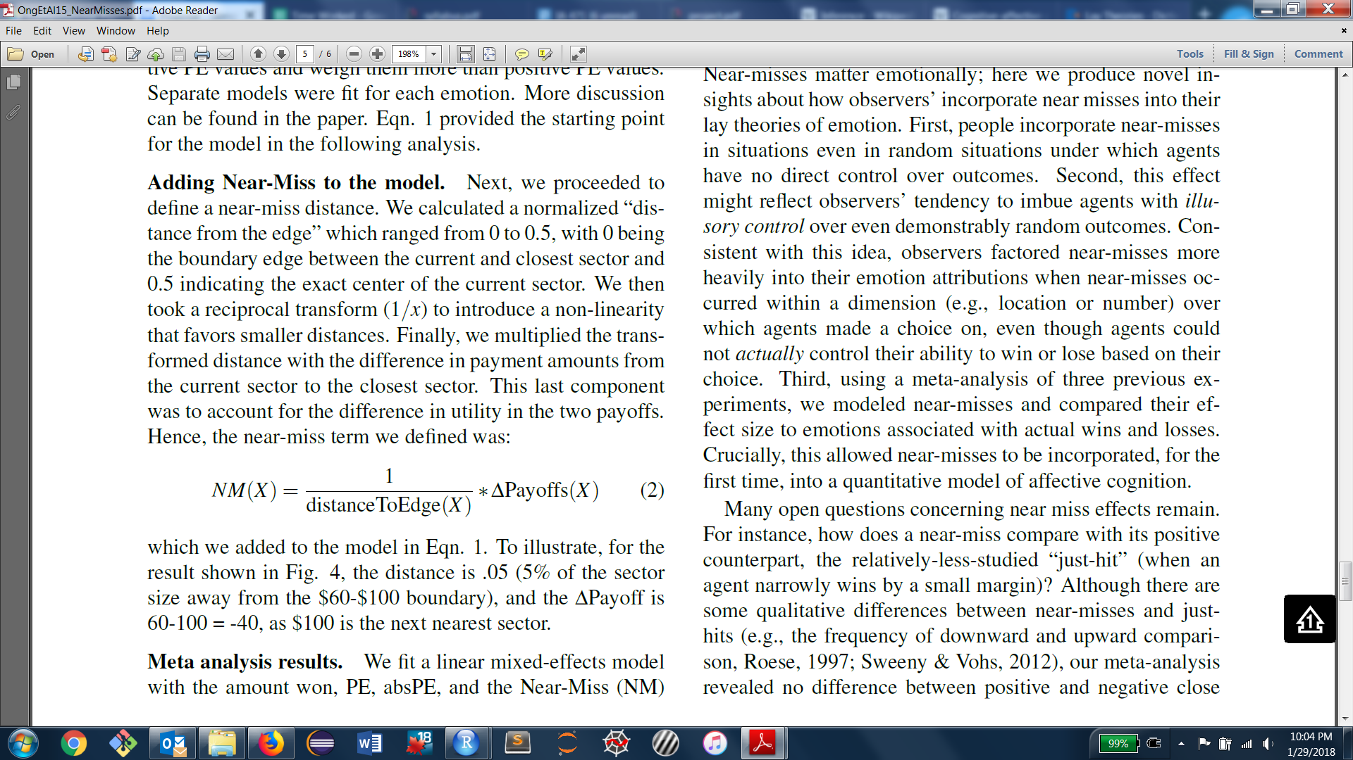

We used the following formula to calculate and compare our obtained coefficient values with the original model, and see how good our model fit was for our obtained data:



Results

We received 21 responses, two of which were removed from consideration because the participants did not answer the pre-screening question correctly (see *Methods: Experiment setup* above). Results were downloaded from Google Forms as a CSV, and then imported into a Jupyter notebook for filtering and analysis. The averaged results of the 19 remaining responses for all nine scenarios are shown below (Fig. 3) on a 1-9 scale:

|  |  |
| --- | --- |
| *Fig. 3A: Near-miss results* | *Fig. 3B: Middle results* |
| *Fig. 3C: Near-hit results* | |  |  | | --- | --- | |  | Disappointment | | Happiness | | Sadness | | Surprise |   *Fig. 3D: Legend for 3A-C* |

## Discussions and Analysis

### Discussion of raw results

In general, it seemed that a greater payoff difference led to a stronger expected emotional response. For example, 25-near-100 had higher sadness and disappointment (and lower happiness) than 25-near-60, with 60-near-100 in the middle of the two. However, this was not the case when participants won the highest possible amount of money; 100-near-25 and 100-near-60 were nearly identical for all emotions, despite the relative winnings of the former being nearly double those of the latter. The middle scenarios had the most variation between scenarios, followed by near-miss and near-hit scenarios. This may be because the middle scenarios were the only group that represented all three slices, whereas near-miss had two $25 slices and near-hit had two $100 slices; a wheel with more than one 'middle' value (values which had both higher and lower neighbors) might have yielded more variable results. We also averaged the results per scenario type and then grouped them by type and by emotion to produce Fig. 4A and Fig. 4B.

|  |  |
| --- | --- |
| *Fig. 4A: Likert scale values (y) for emotions, averaged and grouped by scenario type (x)* | *Fig. 4B: Average Likert scale values (y) for emotions, averaged by scenario type and grouped by emotion (x)* |

When grouping by emotion, it was clear that near-hits had the highest average happiness values, followed by 'middle' scenarios, followed by near misses. The trend was accordingly reversed for the 'negative' emotions (sadness and disappointment). Grouping by scenario type, we can see that near-hit has the largest difference between positive and negative emotions. For middle-result scenarios, the the two are closer, but people were still happy on average to receive money (though this was not actually the case for the middle-25 scenario, per Fig. 3B).

### Linear regression analysis

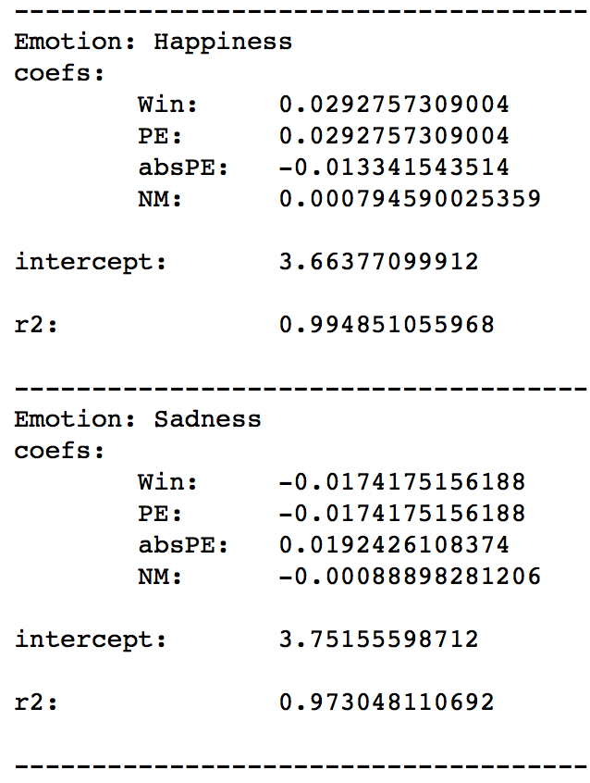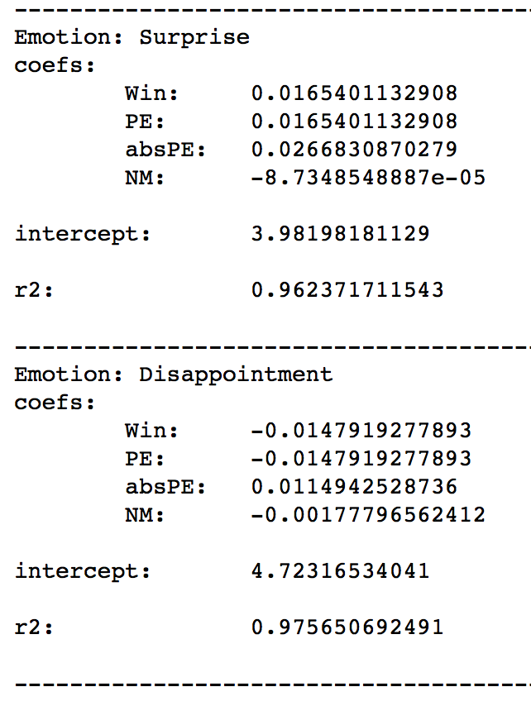

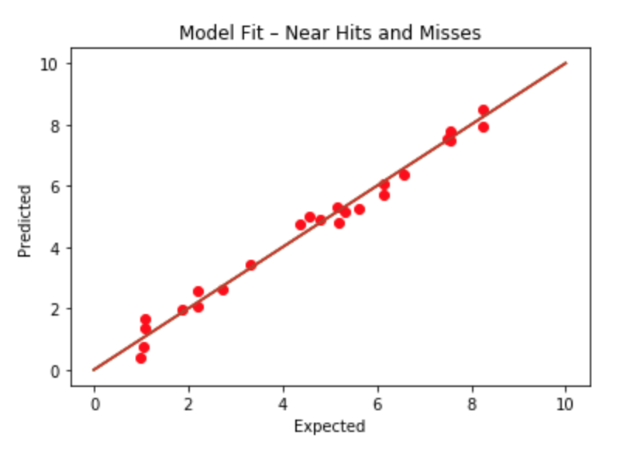

*Fig. 5: Model fit obtained for near hits and near misses*

We will consider two aspects of how well our model performed. First how well do the coefficients that we fit match the data that we found from our experiments. The second is how well the model can be used as a predictive model to predict human results which have not been observed before.

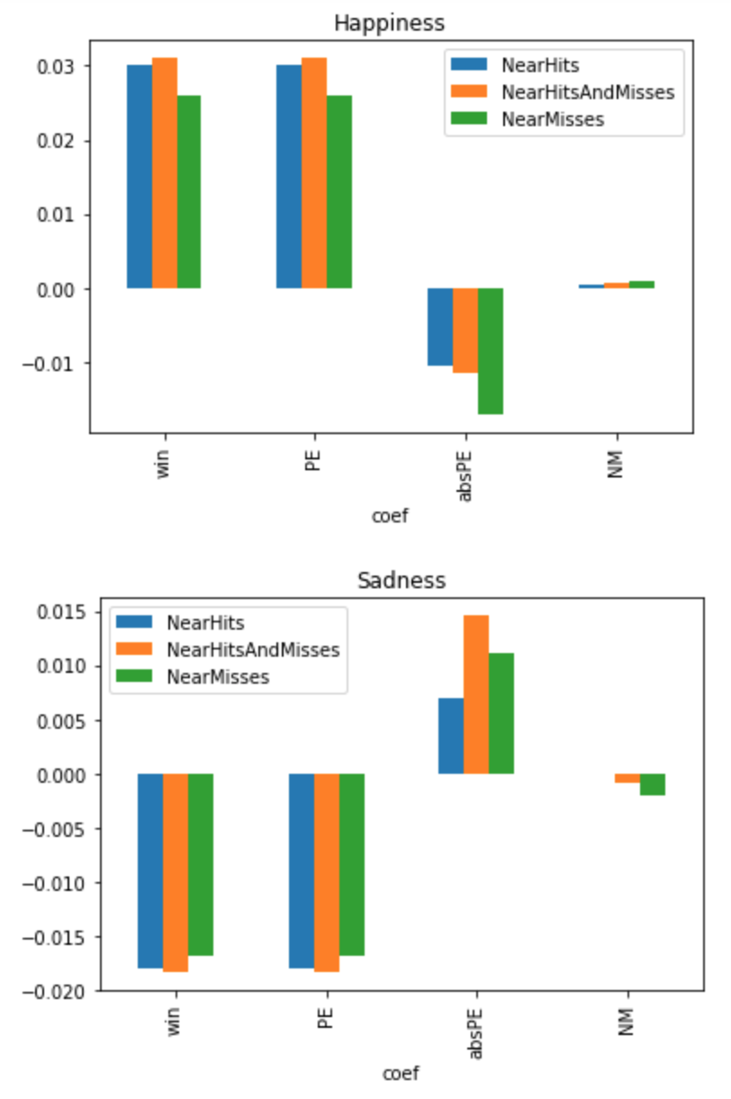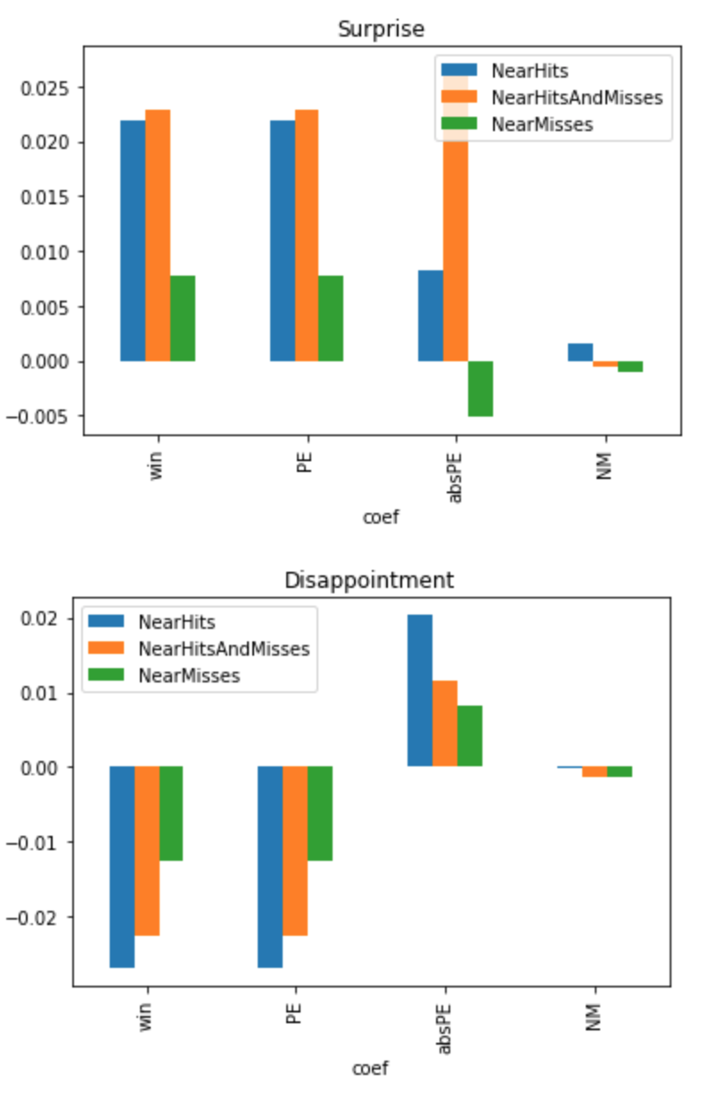

*Fig. 6: Coefficient values obtained for the regression variables for each emotion*

Figure 5 shows the calculated model coefficients using the data we collected. Under the coefficients in that figure, the R squared value is displayed, which indicates how well the model’s predictions capture the data. We observe very high R squared values which indicates that our model parameters were able to represent the data. Towards the end of this analysis section we will return to the explanation of the very high R squared values.

When the obtained linear regression model for near misses and near hits combined is compared with the model for only near misses and only near hits, it is evident in the higher R-squared values that there is a difference in emotions in near miss and near hit cases. We demonstrated how our model can be used to fix data from our experiments. We show that there is a high R squared correlation value between our model fit and experimental results, which indicates that the variables in our model can appropriately fit the data.

## Additional considerations

One thing worth noting is that participants were not told if the player had paid money to spin the wheel, and so it was never clear if the player was actually losing money when they landed on the $25 slice. This might have been good to specify, since the responses might have changed as a result. We also received some feedback that the pre-screening question was worded confusingly, and there may have been some 'false positives' that unnecessarily removed valid data.

## Conclusion

We found that near-hits do have an effect on expected emotions. Whereas near-misses caused people to be less happy about their winnings, near-hits had the reverse effect, and people were happier about the outcome than they would be with a middle result.

## References

Ong, D. C., Zaki, J., & Goodman, N. D. (2015). Affective cognition: Exploring lay theories of emotion. *Cognition*, *143*, 141-162.

Ong, D., Goodman, N. D., & Zaki, J. (2015). Near-misses sting even when they are uncontrollable. In *CogSci*.

## Team member contributions

|  |  |
| --- | --- |
| Aaradhana “Anya” Bharill | Worked on the wheel. Helped with the regression code. Went through the new paper and understood the formulas. Worked on the paper. Contributed many ideas. |
| John Hamilton | Did most of the statistical analysis on the data (Jupyter Notebook included in appendix for reference) and contributed ideas to most of the sections pertaining to statistical analysis. Constructed the wheel that is being used in the survey |
| Zachary Schafer | Helped create jupyter notebook for importing data results as csv. Helped perform statistical analysis on the results of our model.  Contributed to large portions of paper (particularly methods and analysis) |
| Daniel Verlaque | Created Google Forms survey  Generated some graphs  Contributed to large portions of paper (spread over all sections; wrote up most of the graph analyses and methods) |