# DBMS PROJECT REPORT

EFFORTS BY-

Aaradhy Sharma 2210110100

Unnat Sharma 2210110634

Dhruv Mishra 2210110674

Jasmehar Singh 2210110719

# ACKNOWELEDGMENT

We would firstly like to thank Ms. Sonia Khetarpaul for providing us with the opportunity to present our project and providing us with further assistance and guidance, because of her we were able to practically understand the subject matter Ms. Sonia Khetarpaul deserves our gratitude for allowing us to showcase our project and offering invaluable support and direction. Her guidance enabled us to gain a practical comprehension of the topic at hand.

# PROJECT OVERVIEW

The mechanism created to monitor and explore events organized by various entities is designed to serve as a comprehensive platform for individuals to stay informed and engaged with opportunities for personal and professional development. By leveraging this system, users can access a wide range of events such as workshops, seminars, and gatherings hosted by Private/Government agencies and Colleges.

This platform aims to facilitate networking opportunities and foster a community of like-minded individuals who are eager to learn and grow in their respective fields. By providing timely updates on upcoming events, the system enables users to proactively participate in activities that align with their interests and goals.

Platforms like the one showcased in the example link ([https://www.unstop.com](https://www.unstop.com/)) play a crucial role in empowering individuals to expand their knowledge, skills, and professional network. Through easy access to event information and registration processes, users can take advantage of diverse learning opportunities and connect with experts and peers in their areas of interest. Ultimately, this mechanism contributes to the overall personal and professional growth of individuals by offering a centralized hub for discovering and engaging with valuable events and resources.

# FEATURES

We have applied the following concepts of DBMS in our project.

1. We have done **Data Modelling using ER(Entity Relationship)**model using various types of attributes.
2. We have developed an **EER(Enhanced Entity Relational)** model using the ER model by creating multiple disjoint entities.
3. We have converted our **EER model to Relational Model** and done the mapping accordingly.
4. We have used MySQL, an Open-source **RDBMS(Relational Data-Base Management System)** to store our data in a structured format with the help of SQL queries.
5. We have applied **DML (data manipulation language) triggers** in our SQL too
6. We have also **Normalised** the tables (the database and backend of our app does not have the normalised tables as we were not taught that topic by then, and the basic structure of our app was already done by the time we got familiarised to the topic of **Normalisation** which you can check through our log, and now changing all the tables would have pushed us back by a month in our progress so we have shown the normalisation later in the report)

# EER-> RELATIONAL MODEL

Designing a database with an Entity-Relationship (ER) model involves carefully analysing the relationships between entities to ensure efficient database schema. Taking our EER model into consideration, we checked the cardinality of the for each case first, based on that, we created separate table for the required relation type**.** eg in Many-Many cases we created a separate table for the relation between the two entities and included the foreign key from both the entities in our relation/junction table. This allows us to properly capture the complex relationships between our entities. We have also created separate table for multi-valued attributes. By doing so, we ensure that our database design remains free from redundancy.

# RELATIONAL MODEL-> DATABASE

Moving on, we converted our relational model into a database using MySQL. After setting up the database, we used DDL statements to set up our tables. Referencing our relational model, we specified the primary key, foreign key, and required attributes for each table. We then established relationships between the tables using constraints. After normalization, we inserted the required data into our tables. We were then able to obtain a similar Relational model from our digital database. Once we converted our relational model into a MySQL database, we set up our tables using commands that define their structure.

# CONSTRAINTS

These are the constraints we have considered before making the database: -

**Domain constraint**-Making sure that the value entered is correct.

**Primary Key constraint** – Used for uniquely identifying each data.

**Foreign key constraint-** Used for establishing a unique identifying attribute common between two or more tables. Make sures that values in a column of one table match the values in another table's primary key.

# TRIGGERS AN CURSORS

The Triggers are special stored procedures that are automatically executed or fired when certain events occur on a particular table or view in a database and cursors are used to retrieve and manipulate data row by row. Mainly we have used “Before” DML (Data Manipulation language) triggers in our database which are used for setting/inserting values in the table after entry of data. The Cursors are used for fetching, processing and displaying the data provided and performing complex data analysis such as altering certain tables depending upon the entries.

# TIMELINE & Contribution Log

## Contribution Log:

# Log-1 : Date: 16 January 2024

Project created in Github.

Updated Log file.

User: Aaradhy

# Log-2 : Date 23 January 2024

Topic possibility discussed : Arcade Shop inventory subsystem.

Updated Log file.

User: Aaradhy,Dhruv,Unnat

# Log-3 : Date 24 January 2024

Topic changed to making a system similar to unstop website where hackathon, competitions etc are tracked and offered.

Updated Log file.

User: Aaradhy,Dhruv,Unnat

# Log-4 : Date 25 January 2024

Topic discussed thoroughly and finalised as the one discussed above.

Updated Log file.

User: Aaradhy,Dhruv,Unnatt

# Log-5 : Date 31 January 2024

We started making entities and entity models for the users, organisers etc..

Updated Log file.

User: Aaradhy,Unnat

# Log-6 : Date 2 February 2024

Completed with the Entity Relationship Model (ER Model) for the project.

Updated Log file.

User: Aaradhy,Dhruv,Unnat

# Log-7 : Date 4 February 2024

Completed with converting the Entity Relationship Model into an Enchanced Entity Relationship (EER ) model and listing down all the entities.

Updated Log file.

User: Aaradhy,Dhruv,Unnat

# Log-8 : Date 4 February 2024

Completed with converting the EER Model that we made above into a Relational Schema.

Updated Log file.

User: Aaradhy,Dhruv,Unnat

# Log-9 : Date 4 February 2024

Submitted the EER Model along with the Relational Schema on the portal on Blackboard.

Updated Log file.

User: Dhruv,Unnat

# Log-9.2 : Date 4 February 2024

New team member added: Jasmehar

# Log-10 : Date 16 February 2024

Digitally started to recreate the ER Model to enchance it and make it easier to code.

User: Dhruv & Jasmehar

# Log-11 : Date 28 February 2024

Finished creating the EER Model digitally.

Users: Dhruv & Jasmehar.

# Log-12 : Date 16 March 2024

Finished creating the EER,Relational Model Digitally.

Users:Aaradhy,Dhruv,Unnat,Jasmehar

# Log-13 : Date 16 March 2024

Started converting the Relational model into a mySQL database using SQL queries.

User: Aaradhy

# Log-14 : Date 17 March 2024

Finished converting the relational model into a mySQL database which was exported and verified among the rest of the team members.

User: Aaradhy, Unnat

# Log-15 : Date 17 March 2024

Started creating the backend using axios and node.js, express and linking it to the SQL database.

User: Aaradhy

# Log-16 : Date 17 March 2024

Started working on the frontend framework using vite react vanilla javascript and Tailwind CSS.

User: Aaradhy

# Log-17 : Date 17 March 2024

Implemented CORS connection facility in the backend server and got the backend server running locally on http://localhost:8080/

User: Aaradhy

# Log-18 : Date 18 March 2024

Finished with the frontend UI design & linked the backend framework to the frontend framework.

User: Aaradhy

# Log-19 : Date 18 March 2024

Finished adding some functionality as well as implemented a simple admin level hardcoded login form in the webapplication.

User: Aaradhy

# Log-20 : Date 19 March 2024

Given the first project evaluation to the Assigned TA.

User: Aaradhy,Dhruv,Unnat,Jasmehar

# Log-21 : Date 19 March 2024

Added various crud procedures to the database. https://github.com/Aaradhy-Sharma/dbms-project-1/blob/main/Screenshot%202024-03-19%20at%2019.10.13.png

User: Aaradhy

# Log-22 : Date 21 March 2024

Looking for various options to implement user and admin level access separately for the dbms.

User: Aaradhy, Jasmehar

# Log-23 : Date 23 March 2024

Started working on making different access modes for user and admin level access. Kept as783 as an admin level authorization and dm409 as a user level.

User: Aaradhy

# Log-24 : Date 27 March 2024

Started refining the database to support normalisation forms etc...

User: Aaradhy

# Log-25 : Date 11 April 2024

Finished with separate admin and user level views. Kept as783 as an admin level authorization and dm409 as a user level.

- Added support for dark and awesomify mode

User: Aaradhy

# Log-26 : Date 11 April 2024

Added normal and dbnormal() function and procedure respectively to the database. normal() is used to check the current highest normalisation form of a table taken as input(tablename) and dbnormal() takes db name (proj) in our case as input and then proceeds to call normal() for all the tables present in the database.

User: Aaradhy

# Log-27 : Date 12 April 2024

Tried fixing the error of undefined values being sent to the backend in response to crud/edit operations being performed in the frontend. I have been unsuccessful in trying to find a fix for the same despite spending multiple hours on the same. The same is left for the other team members to try and resolve in the remainder time.   
  
User: Aaradhy

## Detailed Timeline

:16th January-25th January: The Ideation phase of the project

* We considered all the possible topics for our project
* We stumbled upon the idea of making a grocery database because our domain was limited to SNU, but then when we were allowed to take other options outside of SNU into consideration we dropped our current plan
* We finally decided to make a system like “**Unstop”** website where hackathon, competitions etc are tracked and offered.

31st January-4th February: Development of EER model and Relational Schema

* Began with the development of our ER model. We started making entities and entity models for the users, organisers etc.
* Converted our existing ER model to EER model and listed down all the entities
* Completed with converting the EER Model that we made above into a Relational Schema.

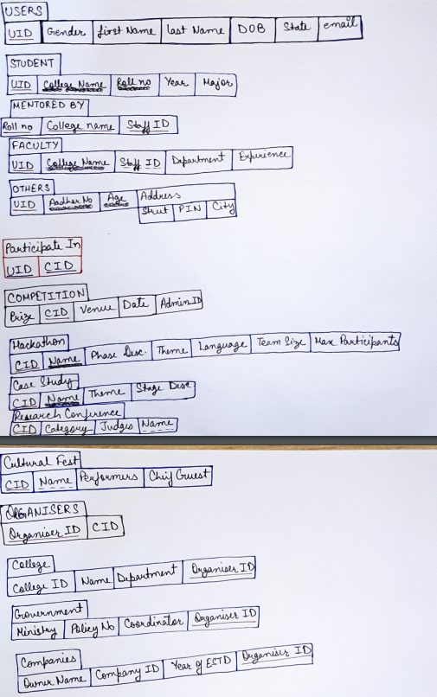 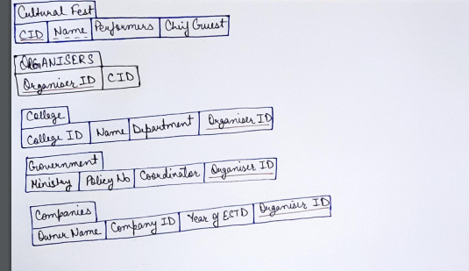

16th February-16th March: Updates and digitalization of EER model and Relational model.

* Looked for a digital tool to represent the EER model and ended up finding draw.io for the task.
* Recreated the EER model in draw.io
* Did proper analysis of the EER model and made the necessary changes in it.
* Based on the updated EER model we made a new relational model as there was a significant update in the amount of knowledge we had regarding the same.
* The link for the Digital EER(GitHub Repository) is present in the end.

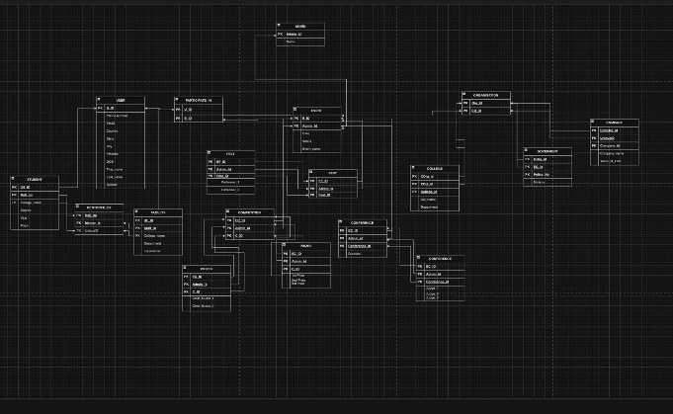

16th March-17th March: Database creation.

* Using the updated relational model ,mySQL Database was created
* Finished converting the relational model into a mySQL database which was exported and verified among the rest of the team members.

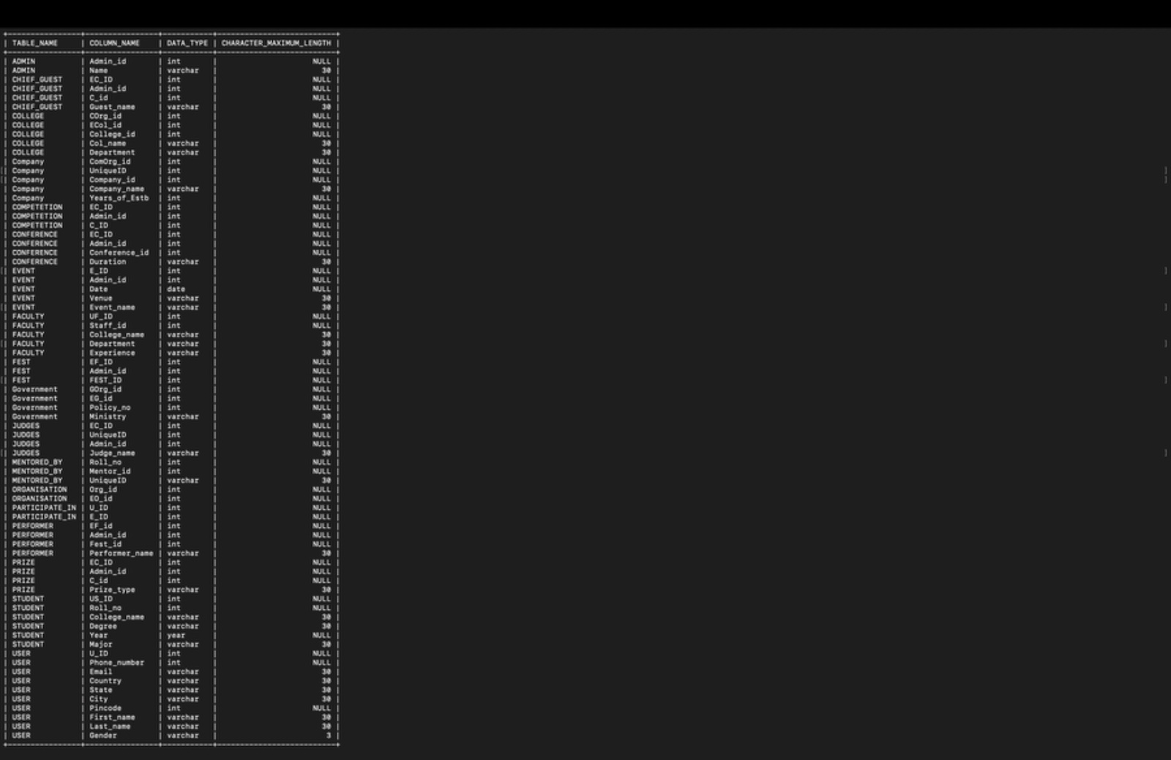

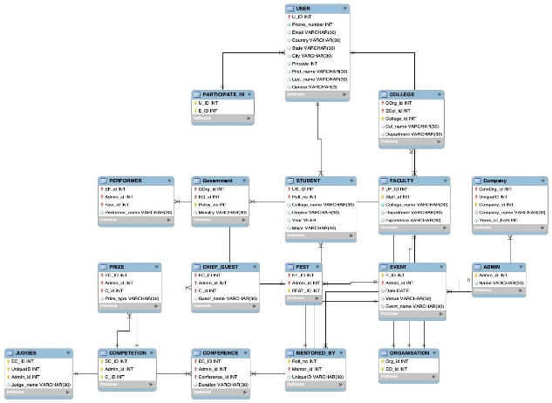

17th March-18th March: Back-end and Front-end.

* Began working on the back-end using axios and node.js
* Began working on the front-end using Vanilla Javascript and Tailwind CSS
* Implemented CORS connection facility in the backend server and got the backend server running locally on <http://localhost:8080/>
* Finished adding some functionality as well as implemented a simple admin level hardcoded login form in the web application.

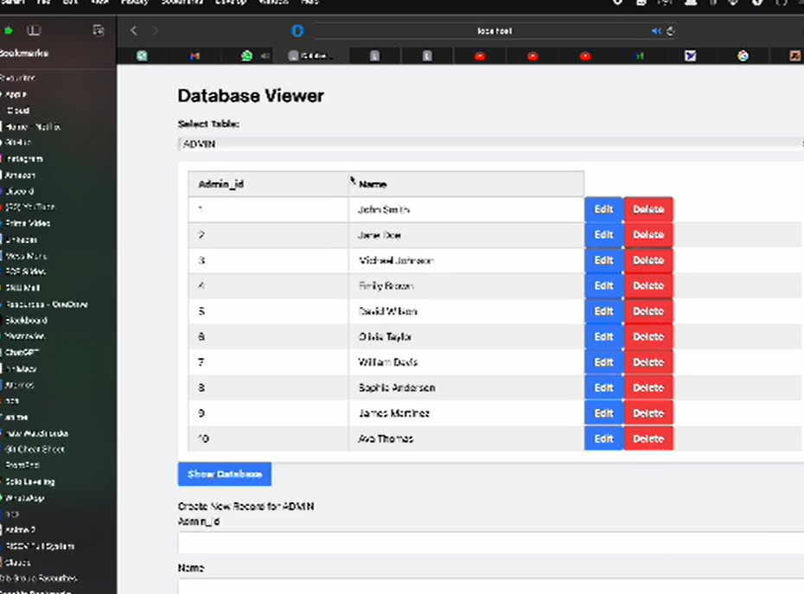

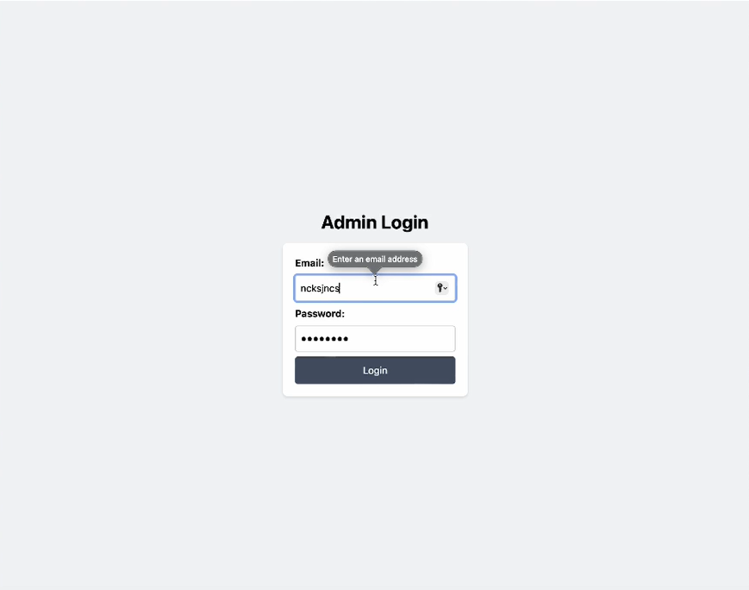

19th March: Project Evaluation

* Got our project evaluated by our TA (Tejansh Sir) and got necessary inputs for the project including the need to add triggers and cursors while taking into consideration the application of our project

21st -25th March: Trigger implementation and User & Admin level views

* On the valuable advice of Tejansh Sir we started adding Triggers
* Implemented DML triggers in our project to make it more efficient
* Worked on User and admin level views

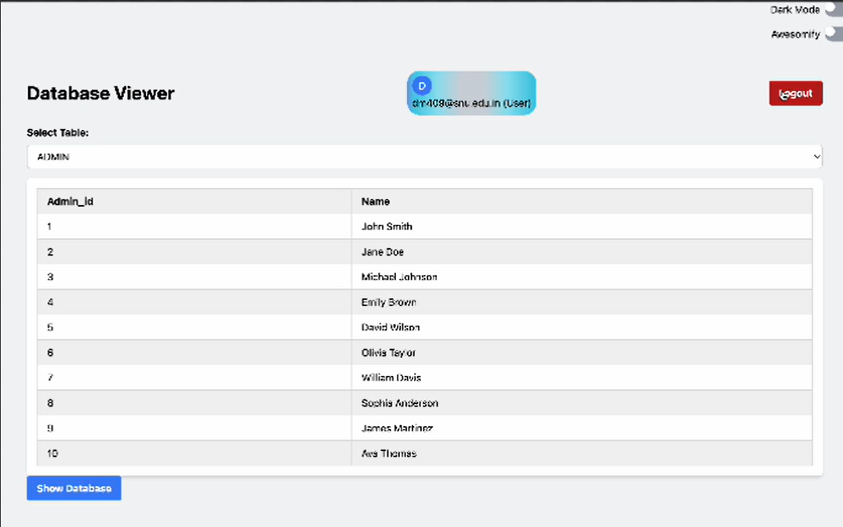

27th March-11th April: Normalisation

* Started studying about the normalisation process and its implementation.
* Used normal function to find out about the highest normal form.
* Tried Relational decomposition of the tables present in the database. However, we were unable to do so due to time constraints but we did them on paper to replace the old table with the new ones in the near future.

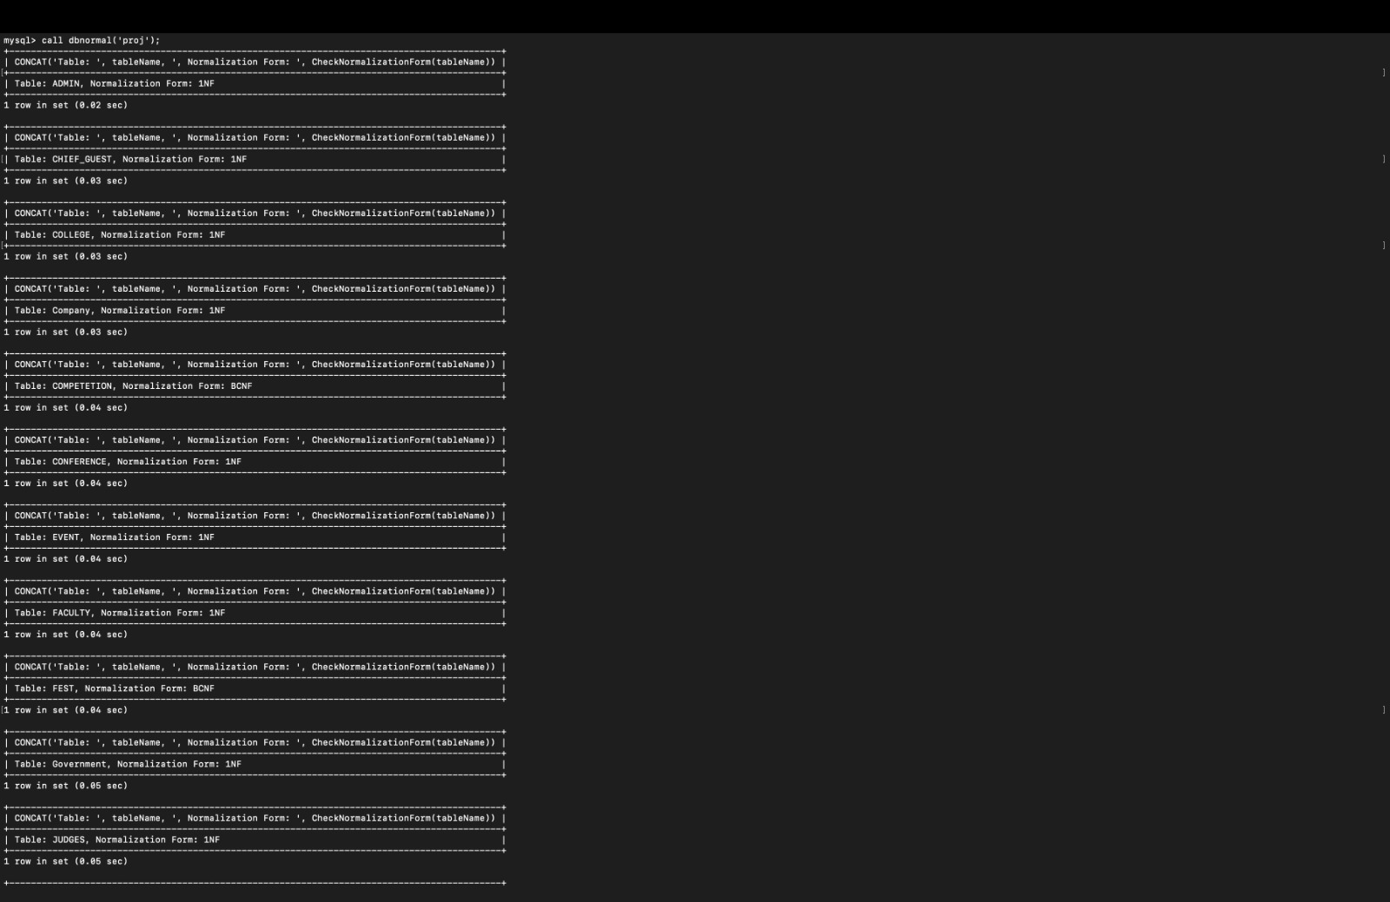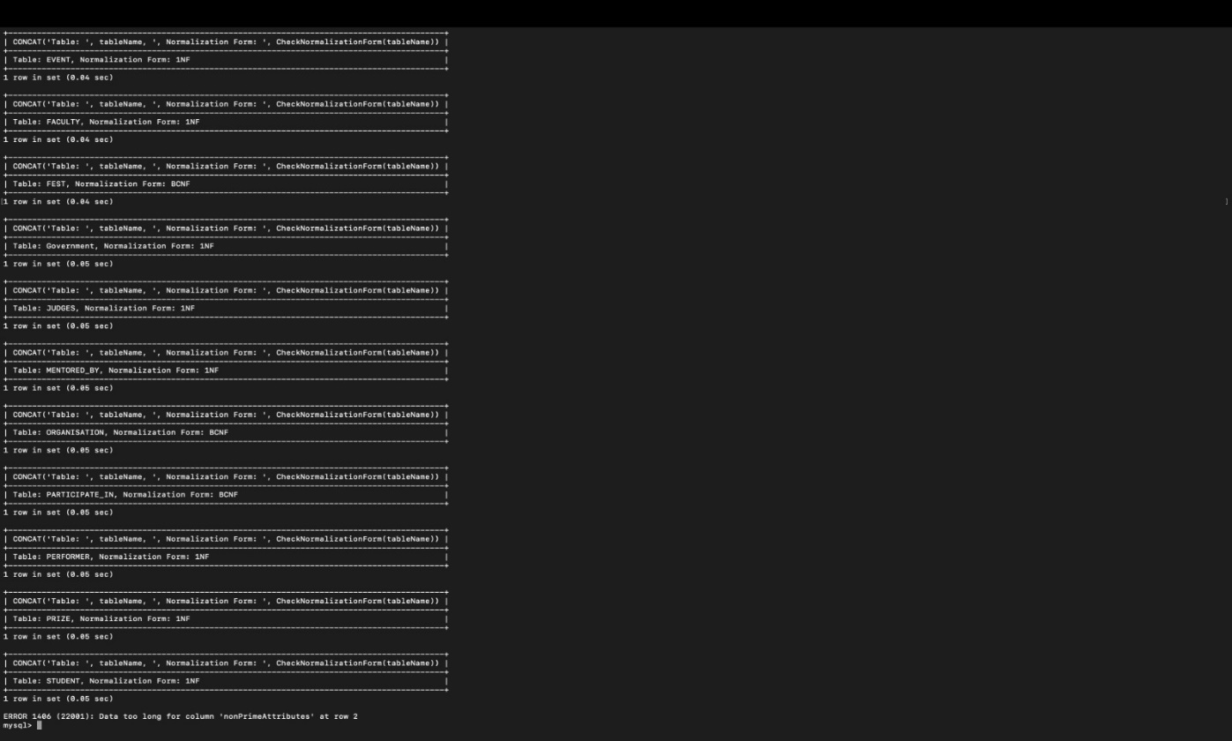

# REFERNCES & LINKS

* <https://github.com/Aaradhy-Sharma/dbms-project-1/blob/main/timeline-log.md>
* [https://app.diagrams.net/#HAaradhy-Sharma%2Fdbms-project-1%2Fmain%2Fer-model.drawio#%7B%22pageId%22%3A%22R2lEEEUBdFMjLlhIrx00%22%7D](https://app.diagrams.net/#HAaradhy-Sharma%2Fdbms-project-1%2Fmain%2Fer-model.drawio)
* <https://unstop.com>
* <https://vyaparapp.in>