Git Bash Commands

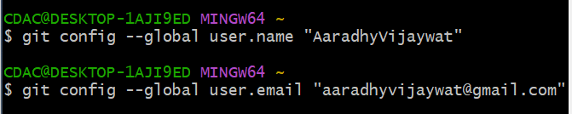To configure git – git config

Create a folder in your local and open the git bash from there

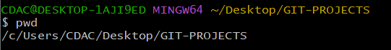

Clone a repo from github

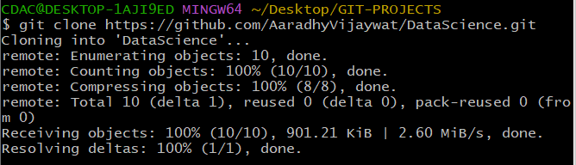

GIT-PROJECT IS MY LOCAL FOLDER

AND GIT-PROJECT/DataScience is my GIT LOCAL FOLDER

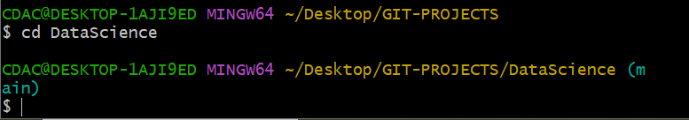

Create a txt file

Git Status – Status of Present working directory

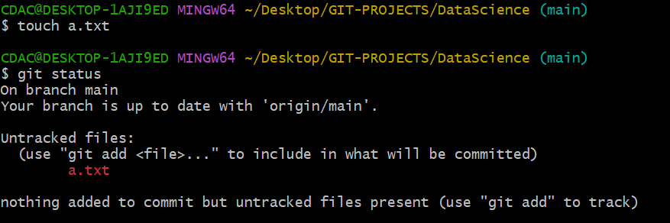

add file to the staging area

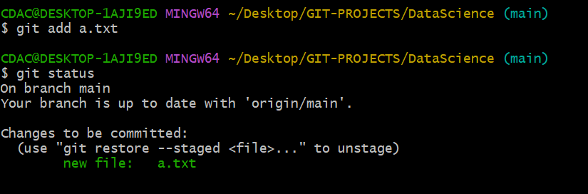

Commit the Changes

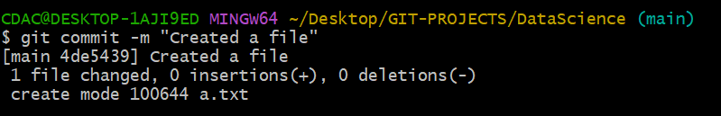

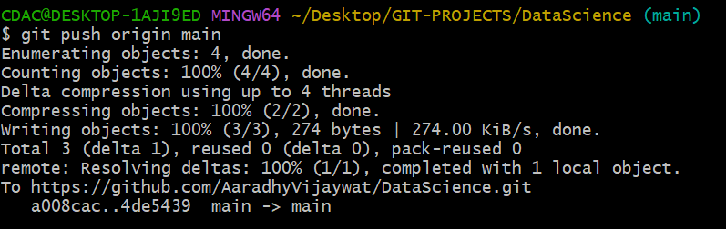Push – Updating changes from the local(git) towards remote(github)

On local

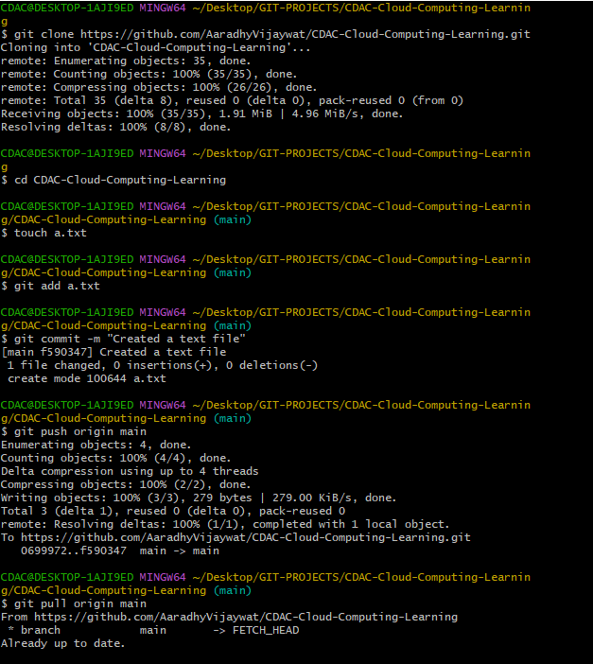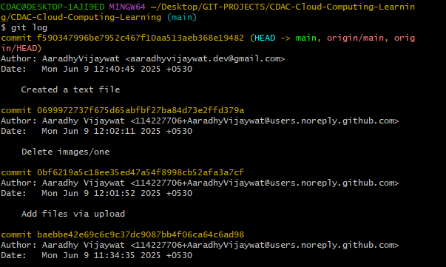

git revert commit_id

commit a change and roll back the commit

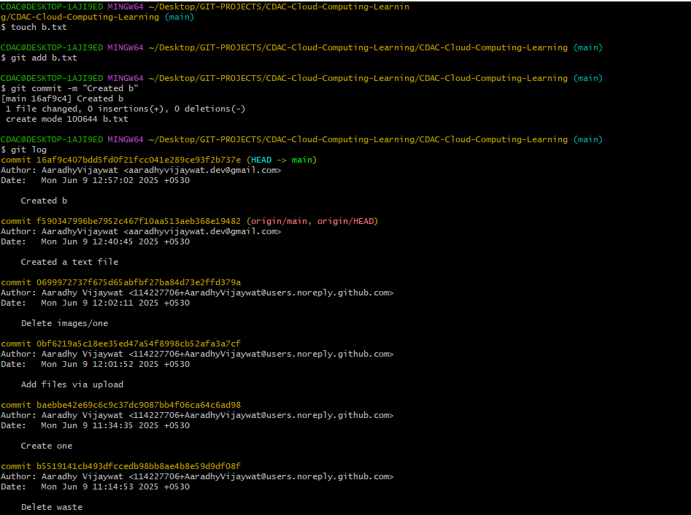

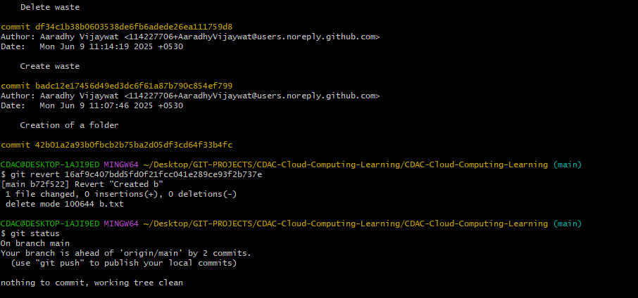

Day 2’

How can we make a git local folder using a local folder using a local folder

* Created a new folder named as Project1
* now open the git bash on the Project1
* and give following commands
  1. $ git init
  2. $ touch one.txt
  3. $ vi one.txt
  4. $ cat one.txt - This is a Sample text file
  5. $ git add .
  6. $ git commit -m "Created a sample text file"
  7. $ git branch -M main
  8. $ git remote add origin https://github.com/AaradhyVijaywat/Project1.git
  9. $ git remote -v
  10. $ git push origin main

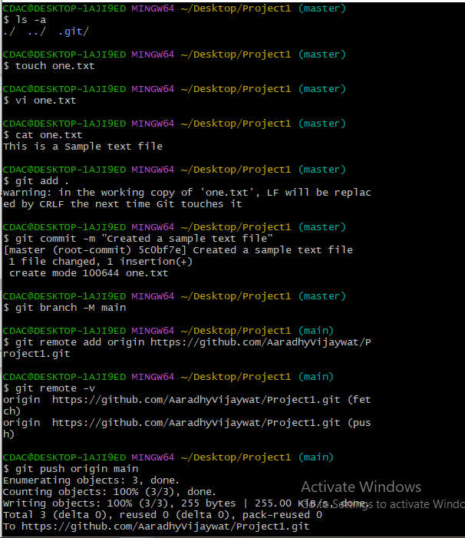

In Case the remote head origin is already exists before establising the connection then we need to 1st merge the unrelated history either using the pull command or merge commands

$ git pull origin main –allow-unrelated-histories

