Git Bash Commands

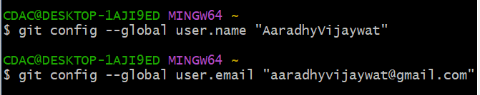
To configure git – git config

Create a folder in your local and open the git bash from there

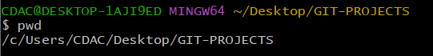

Clone a repo from github

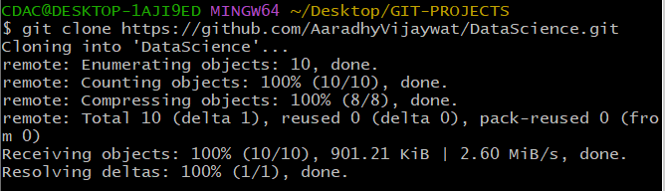

GIT-PROJECT IS MY LOCAL FOLDER

AND GIT-PROJECT/DataScience is my GIT LOCAL FOLDER
