📱 MOBILE SALES
PERFORMANCE REPORT

Analysis Period: October 2021 – October 2024
Coverage: 19,150 units • 3,835 transactions • 19 cities • 5 brands
Source: Mobile Sales Power BI Dashboard & transaction-level sales data
Prepared: September 14, 2026

Executive Summary
₹769.2M  Total Sales | 19,150  Units Sold | 3,835  Transactions | ₹40,114  Avg. Price/Unit

Between October 2021 and October 2024, mobile sales across the tracked network generated ₹769.2 million in revenue from 19,150 units sold across 3,835 transactions, at an average selling price of ₹40,114 per unit. Performance is broadly balanced across the five brands tracked (Apple, Samsung, OnePlus, Vivo and Xiaomi), while revenue is heavily concentrated in two cities — Delhi and Mumbai — which together account for 43% of total sales.
Customer sentiment is positive overall (average rating 3.69/5, with 61% of transactions rated "Good"), though nearly 1 in 5 transactions (22%) received a "Poor" rating — a segment worth investigating further. The sections below break down performance by brand, model, city, payment method and time period, using the underlying dashboard and transaction data, and close with a set of actionable recommendations.

Dashboard Snapshot
The Power BI dashboard below consolidates the full dataset (all models, payment methods and brands) and anchors the analysis that follows.
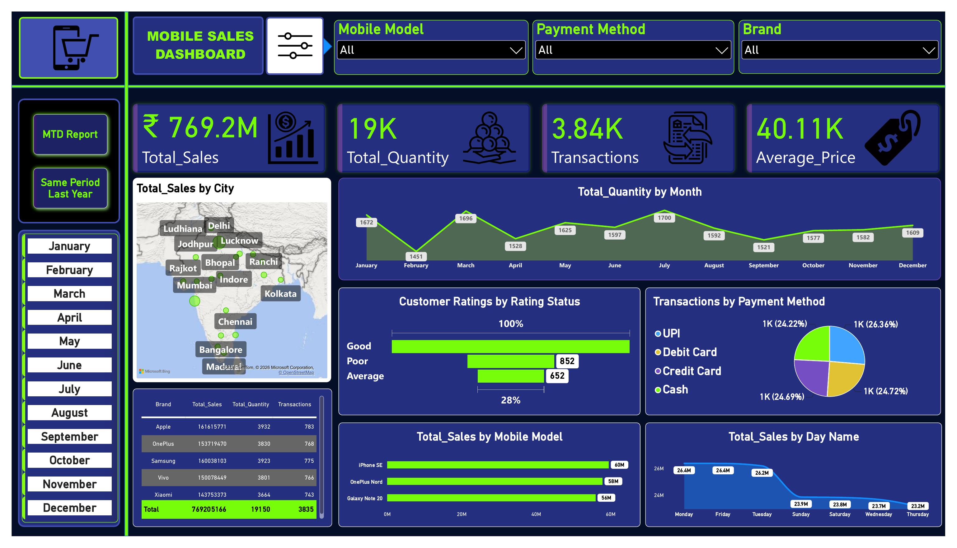
Figure 1 — Mobile Sales Dashboard: overview of sales, quantity, transactions, geography, seasonality, ratings, payment mix and top models.

Sales Performance by Brand
Apple narrowly leads on total revenue, but the top four brands are separated by less than 6% of total sales — this is a competitive, non-dominated market rather than one led by a single brand.
Brand | Total Sales (₹) | Units Sold | Transactions | Avg. Order Value (₹) | Avg. Rating
Apple | 161,615,771 | 3,932 | 783 | 206,406 | 3.71
Samsung | 160,038,103 | 3,923 | 775 | 206,501 | 3.70
OnePlus | 153,719,470 | 3,830 | 768 | 200,156 | 3.68
Vivo | 150,078,449 | 3,801 | 766 | 195,925 | 3.65
Xiaomi | 143,753,373 | 3,664 | 743 | 193,477 | 3.72

- Apple and Samsung command the highest average order values (~₹206K), consistent with their premium positioning.
- Xiaomi has the lowest sales and volume, yet the highest average customer rating (3.72) — satisfaction is not the constraint on its growth.
- Vivo sits mid-table on revenue but has the second-lowest average rating (3.65), a combination worth monitoring.

Top-Performing Models
At the model level, the iPhone SE is the single best-selling model by revenue, narrowly ahead of the OnePlus Nord and Galaxy Note 20 — all three feature on the dashboard's model chart.
Mobile Model | Total Sales (₹) | Units Sold | Transactions
iPhone SE | 59,572,004 | 1,430 | 280
OnePlus Nord | 57,888,591 | 1,409 | 273
Galaxy Note 20 | 56,005,282 | 1,382 | 266
Vivo Y51 | 54,837,667 | 1,429 | 283
Galaxy S21 | 53,270,714 | 1,305 | 260
iPhone 11 | 51,520,221 | 1,263 | 265

Geographic Performance
Sales are heavily concentrated: Delhi and Mumbai together generate 43% of total revenue from just 2 of the 19 cities in the dataset. The remaining 17 cities each contribute between 3.0% and 4.0% of sales — a long, fairly even tail.
City | Total Sales (₹) | Share of Total | Transactions
Delhi | 203,883,500 | 26.5% | 1,008
Mumbai | 127,191,300 | 16.5% | 654
Ranchi | 31,018,770 | 4.0% | 153
Chennai | 30,759,530 | 4.0% | 125
Rajkot | 27,326,700 | 3.6% | 126
Jodhpur | 27,172,940 | 3.5% | 127
Other 13 cities (combined) | 321,852,000 | 41.9% | 1,642

- Delhi alone accounts for over a quarter of national revenue and more than a quarter of all transactions — it is the single most important market to protect and grow.
- No secondary city has broken out from the mid-tier pack (Ranchi through Jodhpur cluster within 1 percentage point of each other), suggesting expansion investment could target any of several comparable markets.

Payment Method Trends
Transaction volume is almost evenly split across the four payment methods, with UPI slightly ahead. Debit Card transactions, however, carry the highest average order value.
Payment Method | Total Sales (₹) | Transactions | Share of Txns | Avg. Order Value (₹)
UPI | 201,673,800 | 1,011 | 26.4% | 199,479
Debit Card | 195,738,800 | 948 | 24.7% | 206,476
Credit Card | 186,698,500 | 947 | 24.7% | 197,147
Cash | 185,094,000 | 929 | 24.2% | 199,240

Seasonal & Weekly Patterns
Monthly sales show a repeating peak-trough pattern: January, March, May and July each generate ₹68–70M, while February and September consistently dip to ₹57–59M — roughly a 17% swing between the strongest and weakest months.
Month | Total Sales (₹) | Units Sold
January | 68,281,301 | 1,672
February | 58,769,665 | 1,451
March | 68,971,956 | 1,696
April | 62,464,153 | 1,528
May | 68,119,488 | 1,625
June | 61,816,232 | 1,597
July | 69,644,083 | 1,700
August | 61,564,989 | 1,592
September | 56,899,972 | 1,521
October | 64,740,720 | 1,577
November | 63,752,242 | 1,582
December | 64,180,187 | 1,609

By day of week, Saturday (₹114.6M) and Monday (₹113.5M) are the strongest, while Wednesday (₹104.9M) is the weakest — but the spread across all seven days is under 10%, so weekday effects are secondary to the monthly cycle.

Customer Satisfaction
Overall sentiment is positive: the average customer rating is 3.69 out of 5, and 61% of all transactions were rated "Good" (4–5 stars).
Rating Band | Transactions | Share of Total
Good (4–5 stars) | 2,331 | 60.8%
Average (3 stars) | 652 | 17.0%
Poor (1–2 stars) | 852 | 22.2%

The 22% "Poor" segment (852 transactions) is the main watch item — it is larger than the "Average" band and represents nearly 1 in 5 customers reporting a negative experience.

Year-over-Year Context
The dataset spans four calendar years, but only 2022 and 2023 are complete years — 2021 contains Oct–Dec only, and 2024 contains Jan–Oct only. Direct year totals should be read with that in mind rather than as like-for-like annual growth.
Year | Total Sales (₹) | Units Sold | Transactions | Coverage
2021 | 58,815,520 | 1,471 | 296 | Oct–Dec only (partial)
2022 | 261,989,800 | 6,434 | 1,281 | Full year
2023 | 253,314,200 | 6,364 | 1,285 | Full year
2024 | 195,085,400 | 4,881 | 973 | Jan–Oct only (partial)

The dashboard's own "Same Period Last Year" view (below) is built to control for this by comparing matching quarters/months rather than raw annual totals, and is the more reliable lens for trend-reading.
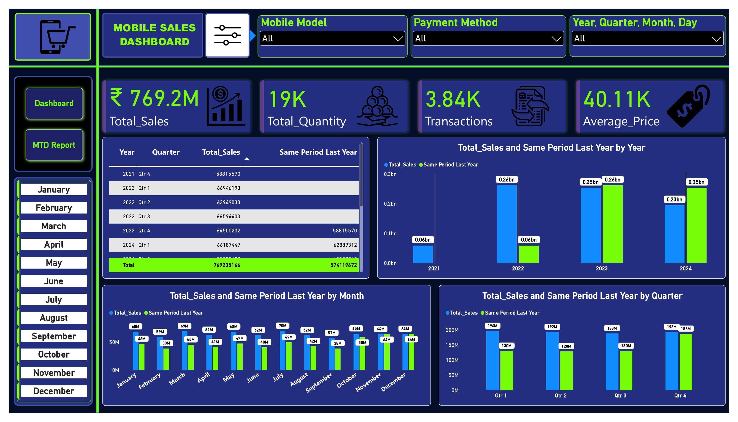
Figure 2 — Total Sales vs. Same Period Last Year, by year, month and quarter.
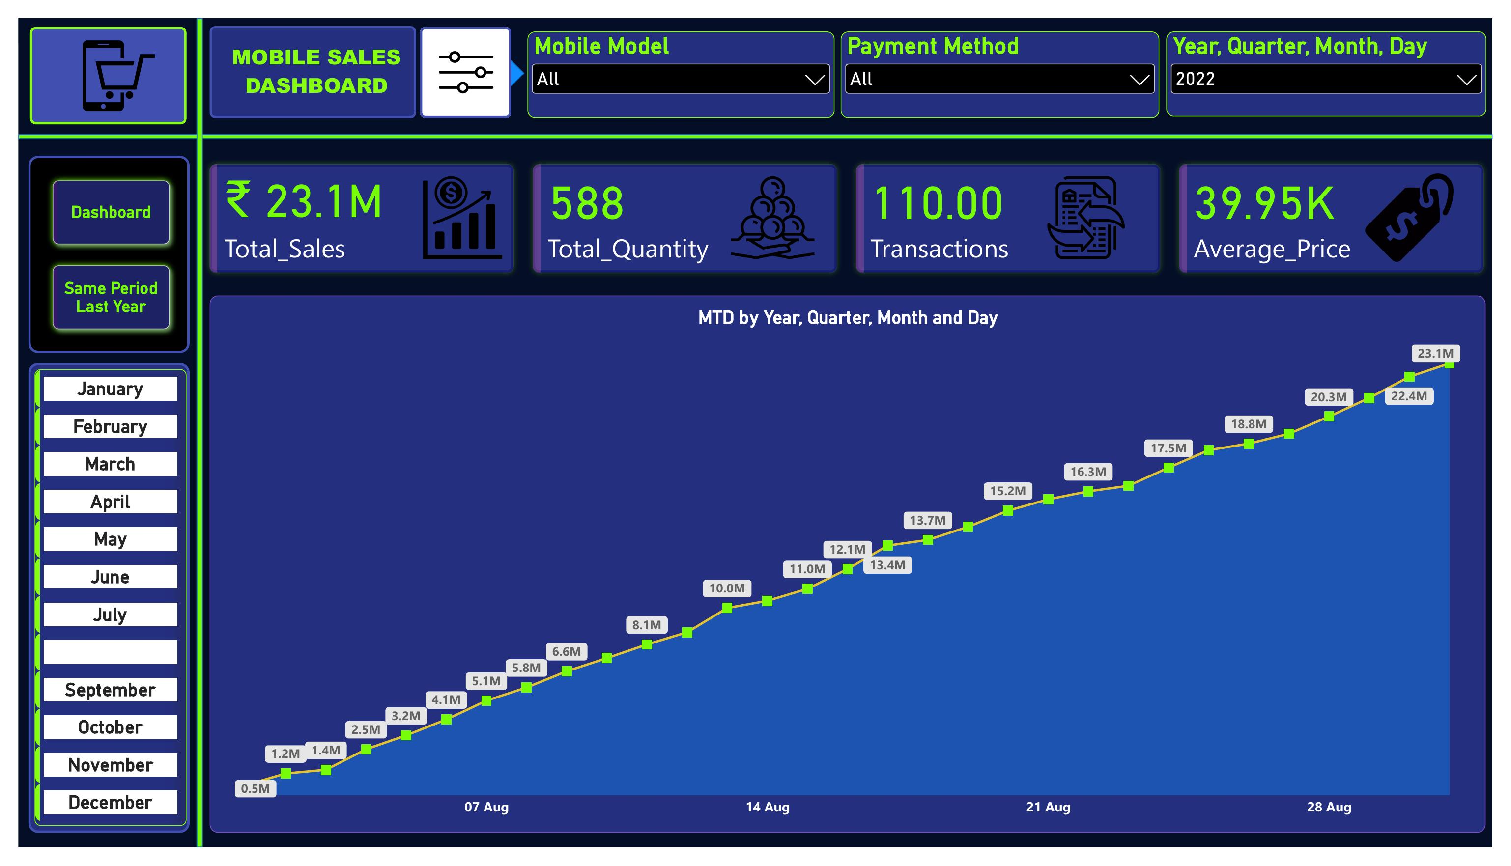
Figure 3 — Month-to-Date report view, used for in-period tracking against the current month's pace.

Data Quality Note
The "Day Name" field in the source data mixes abbreviated and full-text values for the same day (e.g. "Sat" and "Saturday" both appear). These were consolidated before the weekly analysis above; the same cleanup is recommended at the source so the live dashboard's day-of-week visuals aren't silently splitting each day into two categories.

Recommendations
Based on the patterns above, the following actions are recommended, roughly in priority order:

1 | Protect and grow the Delhi–Mumbai core  These two cities drive 43% of revenue. Prioritize inventory availability, delivery SLAs and after-sales support here, since any disruption has an outsized revenue impact.

2 | Run a focused expansion pilot in one mid-tier city  Ranchi, Chennai, Rajkot and Jodhpur are essentially tied (3.5–4.0% share each). Pick one for a concentrated marketing/distribution push and use it as a test case before rolling out to the rest of the mid-tier cluster.

3 | Investigate the 22% "Poor" rating segment  Break the 852 poor-rated transactions down by brand, model, city and payment method to find a root cause (product issue, delivery experience, or a specific outlet), and prioritize fixes before scaling volume further.

4 | Use UPI's transaction lead, but protect Debit Card's higher basket size  UPI drives the most transactions but Debit Card has the highest average order value (₹206K). Test UPI-linked instant discounts to grow volume, paired with EMI/financing offers on Debit/Credit to keep basket sizes up.

5 | Plan inventory and promotions around the Feb/Sep dips  Both months are consistently ~15–18% below the surrounding months. Align promotional calendars or restocking cycles to smooth this pattern, and confirm whether it correlates with a known seasonal or fiscal-cycle effect.

6 | Re-examine Xiaomi's go-to-market  Xiaomi has the highest average customer rating (3.72) but the lowest revenue and volume of the five brands. Since satisfaction isn't the bottleneck, review pricing, distribution reach and marketing spend for a likely quick win.

7 | Standardize source data fields  Fix the mixed abbreviated/full-text "Day Name" values at the point of entry (or in ETL) so weekday reporting in the live dashboard doesn't understate any single day by splitting it across two labels.

