Department of Computer Engineering and Technology

MINI PROJECT REPORT
Computer Networks Laboratory
(CSE20110)
Laboratory Continuous Assessment 3

FlowGuard — Network Traffic Monitoring,
ML-Assisted Threat Detection & Load Balancing
Presentation video link: https://www.youtube.com/watch?v=wdtV-
Github Link: https://github.com/Aaradhyab1/CN_Project

Submitted by
Sr. No. | Student Name | PRN
1 | Aviraj Sinha | 1262243767
2 | Kalp Lad | 1262240898
3 | Palash Ranka | 1262243526
4 | Aaradhya Banginwar | 1262240724

Group No. 3 Panel K (iOS)
Third Year B.Tech. Computer Engineering and Technology

Under the guidance of
Dr. Uma Pujeri
Academic Year: 2026–2027
Submission Date: 19-10-2026


Acknowledgement
We express our sincere gratitude to our project guide and course faculty, Dr. Uma Pujeri, for providing valuable guidance, constructive feedback, and technical direction throughout the development of this project. Her expertise in computer networking concepts and laboratory methodology was instrumental in shaping the system architecture, the load-balancing component, and the evaluation strategy.
We thank the Department of Computer Engineering and Technology for providing access to laboratory computing resources, network simulation tools, and the academic infrastructure required for implementation and testing.
We acknowledge the UNSW Canberra Cyber research group for publishing the UNSW-NB15 benchmark dataset, which served as the baseline for our machine learning pipeline. We also acknowledge the open-source communities behind Scikit-learn, FastAPI, React, Mininet, Open vSwitch, and HAProxy, whose tools and documentation enabled rapid prototyping and reliable implementation.
Group No. 3

Abstract
FlowGuard is an edge-deployed network gateway that integrates real-time traffic monitoring, machine-learning-assisted intrusion detection, and security-aware load balancing. The system addresses two gaps: intrusion detectors trained on benchmark datasets are rarely validated on live traffic, and load balancers distribute requests without regard to whether the traffic is malicious. FlowGuard is evaluated on a Mininet-emulated topology with one legitimate client, one attacker, an HAProxy load-balancer host, and three web back-ends connected through an Open vSwitch learning switch. With equal back-ends, round robin and least connections both split 300 requests almost evenly; when one back-end is slowed by 100 ms, least connections reduces the mean response time from 68.8 ms to 7.2 ms by sending that server only 8 of 300 requests. A lab-native classifier trained on 1,725 labelled one-second flow windows (SYN, UDP, and ICMP floods and port scans against benign HTTP and ping traffic) reaches an F1-score of 1.000 for Random Forest (0.996 for a Decision Tree and for XGBoost) with a false-positive rate of at most 0.23% under five-fold cross-validation grouped by capture segment, at 3.3 ms per window. In a UDP flood against a 10 Mbit/s load-balancer uplink, the mean response time of legitimate clients rises from 3.5 ms to 269.4 ms; with the detector active, the attacking source is blocked by an OpenFlow drop rule on the switch after 1.18 s and the mean response time returns to 7.1 ms with no false blocks. A baseline Decision Tree trained on the 90-feature UNSW-NB15 schema (documented F1-score 0.9802) is retained in the gateway. The backend is built with Python FastAPI (REST endpoints, WebSocket broker, SQLite persistence with WAL mode, and an offline replay engine) and the frontend is a React 19 dashboard with TypeScript, Vite, and Recharts. Automated testing (17/17 gateway and pipeline tests) is extended with seven Mininet experiments (T18 to T24), all of which met their criteria.
Keywords: Network Intrusion Detection, Machine Learning, UNSW-NB15, Decision Tree, Load Balancing, DDoS Mitigation, Mininet, HAProxy, WebSocket, FastAPI, React Dashboard

Table of Contents
1 Introduction and Project Objectives
1.1 Introduction and Background
1.2 Problem Statement
1.3 Scope
1.4 Objectives
2 Proposed Design and Requirements
2.1 Architecture and Network Topology
2.2 Tools and System Requirements
2.3 Addressing and Protocol Selection
3 Implementation and Technical Working
3.1 Methodology
3.2 Code Implementation
3.3 Protocols and Technical Working
3.4 Execution Procedure
4 Testing and Results
4.1 Test Plan
4.2 Results and Execution Evidence
4.3 Objective Achievement
5 Discussion and Conclusion
5.1 Discussion and Comparative Analysis
5.2 Advantages and Applications
5.3 Limitations
5.4 Challenges and Troubleshooting
5.5 Future Scope
5.6 Conclusion
References
AI Usage Declaration
Appendices

1 Introduction and Project Objectives

1.1 Introduction and Background
Network intrusion detection has become a critical component of modern cybersecurity infrastructure. As network traffic volumes grow exponentially, traditional rule-based detection systems struggle to identify novel attack patterns while maintaining low false-positive rates. Machine learning approaches, particularly those trained on comprehensive benchmark datasets, offer the ability to generalize across attack categories and adapt to evolving threat landscapes [1].
The UNSW-NB15 dataset, developed by the Australian Centre for Cyber Security at UNSW Canberra, provides a standardized 90-feature schema capturing flow-level statistics including protocol headers, inter-arrival times, TCP metrics, and host-level connection counts [1]. This schema has become a widely adopted benchmark for evaluating network intrusion detection systems, enabling fair comparison across different classification approaches [2].
Real-time network monitoring requires not only accurate classification but also efficient event delivery to security operations dashboards. The WebSocket protocol (RFC 6455) enables full-duplex communication channels over a single TCP connection, eliminating the overhead of HTTP polling for live event streaming [6]. Combined with modern asynchronous web frameworks, this architecture supports sub-second alert delivery from classifier to dashboard.
Load balancing distributes incoming requests across a pool of back-end servers to improve throughput, reduce response time, and avoid overload. Common algorithms include round robin, which cycles through the servers in order, and least connections, which sends each new request to the server with the fewest active connections [11]. Because these algorithms consider only server state, a volumetric DDoS attack that reaches the balancer is distributed to the back-ends exactly like legitimate traffic and can exhaust them. Placing an ML-based detector in front of the balancer allows malicious sources to be filtered before they consume back-end capacity, and flow-statistics-based flood detection has been demonstrated in emulated SDN environments [12]. Mininet [8] and Open vSwitch [10] make such scenarios reproducible on a single machine.
FlowGuard integrates these technologies into an end-to-end pipeline: a Mininet-emulated network with an HAProxy load balancer, window-based flow feature extraction, scikit-learn classifiers (a UNSW-NB15 baseline and a lab-native model), automated mitigation of detected sources, a FastAPI gateway with WebSocket streaming, SQLite persistence, and a React 19 real-time dashboard.

1.2 Problem Statement
Modern edge networks handle thousands of flow records per second, yet most monitoring dashboards treat threat detection as a binary pass/fail gate with no transparency into the underlying feature pipeline. Three problems follow. First, models trained on benchmark datasets such as UNSW-NB15 report high in-dataset accuracy, but their input features were generated by Argus and Bro-IDS on a physical testbed and cannot be reproduced exactly on another network, so performance on live traffic is unknown [3]. Second, load balancers distribute requests purely by server state and are blind to malicious traffic, so a flood sent to the service address degrades the service for legitimate clients. Third, traditional development and testing environments often rely on fabricated metrics rather than distinct, verifiable flow records, making it difficult to validate system behaviour against known ground-truth data.

1.3 Scope
FlowGuard targets network security analysts and operations teams monitoring edge gateway traffic. The system operates on a single-node deployment with the following scope and boundaries:
- Processes flow-level records (not raw packet payloads): the UNSW-NB15 90-feature schema for the baseline model, and a compact set of window-based features computed from Mininet traffic for the lab-native model.
- Supports binary classification: NORMAL (benign) vs. ATTACK (malicious).
- Provides two data ingestion modes: live Mininet capture (Linux) and offline flow replay (cross-platform).
- Emulates a single-switch topology with one client, one attacker, one load-balancer host, and three web back-ends; the load balancer supports round-robin and least-connections algorithms.
- Evaluates attacks limited to TCP SYN, UDP, and ICMP floods and port scanning, generated only inside the isolated emulated network.
- Dashboard visualization covers traffic volume, backend health, topology, security events, proxy links, and cache metrics.
- Lab fault injection is restricted to simulated backend failures for demonstration; it does not interact with production infrastructure.

1.4 Objectives
Objective ID | Objective | Verification Method
O1 | Build a reproducible Mininet topology (client, attacker, load balancer, three back-ends) | Smoke test (topo.py --test): pingall with 0% loss, HTTP reply from each back-end, iperf throughput
O2 | Deploy an HAProxy load balancer with round-robin and least-connections algorithms | Per-back-end request counts and response times with equal and slowed back-ends
O3 | Build a labelled lab dataset and train a lab-native detector on window-based flow features | Five-fold cross-validation grouped by capture segment: precision, recall, F1-score, and false-positive rate
O4 | Retain the UNSW-NB15 90-feature Decision Tree (sub-15ms inference) as the gateway baseline model | Unit and API tests (test_model_pipeline, test_api)
O5 | Detect attacks in real time and block offending sources while preserving legitimate service | Legitimate-client response time, completed requests, and detection delay with and without mitigation
O6 | Stream classified events via WebSocket, provide a deterministic offline replay engine with provenance tagging, and a 7-page monitoring dashboard | test_e2e_replay; frontend TypeScript strict build (tsc -b) with 0 errors

2 Proposed Design and Requirements

2.1 Architecture and Network Topology
FlowGuard follows a layered architecture where each stage feeds into the next, creating a complete pipeline from emulated network traffic to visual analytics. The system comprises eight principal layers:
- Emulated Network Layer: Mininet topology with an Open vSwitch learning switch (s1) connecting a legitimate client (10.0.0.1), an attacker (10.0.0.2), an HAProxy load-balancer host (10.0.0.10), and three web back-ends (10.0.0.11–10.0.0.13).
- Load Balancing Layer: HAProxy exposes one service address and distributes requests to the back-ends using round robin or least connections, with health checks to remove failed servers.
- Flow Capture and Feature Adapter: Aggregates traffic seen at the load balancer into 1-second per-source windows with 9 features (packets, bytes, mean packet size, SYN ratio, distinct source and destination ports, and TCP/UDP/ICMP shares) for the lab-native model, and transforms raw flow tuples into 90-column UNSW-NB15 feature vectors for the baseline model using pre-fitted OrdinalEncoder and SimpleImputer artifacts.
- ML Inference Engine: Scikit-learn classifiers (the baseline Decision Tree best_model.joblib and the lab-native Random Forest model_lab.joblib) evaluating each feature vector and outputting binary classification with risk probability.
- Mitigation Layer: Blocks sources classified as ATTACK with an OpenFlow drop rule on switch s1 (ovs-ofctl), so malicious flows are stopped before they reach the load balancer’s link; every block is logged.
- API Gateway: FastAPI ASGI server providing REST endpoints, WebSocket broker, and lab control APIs.
- Persistence Layer: SQLite database with WAL mode for concurrent read/write, storing classified flow events and lab audit records.
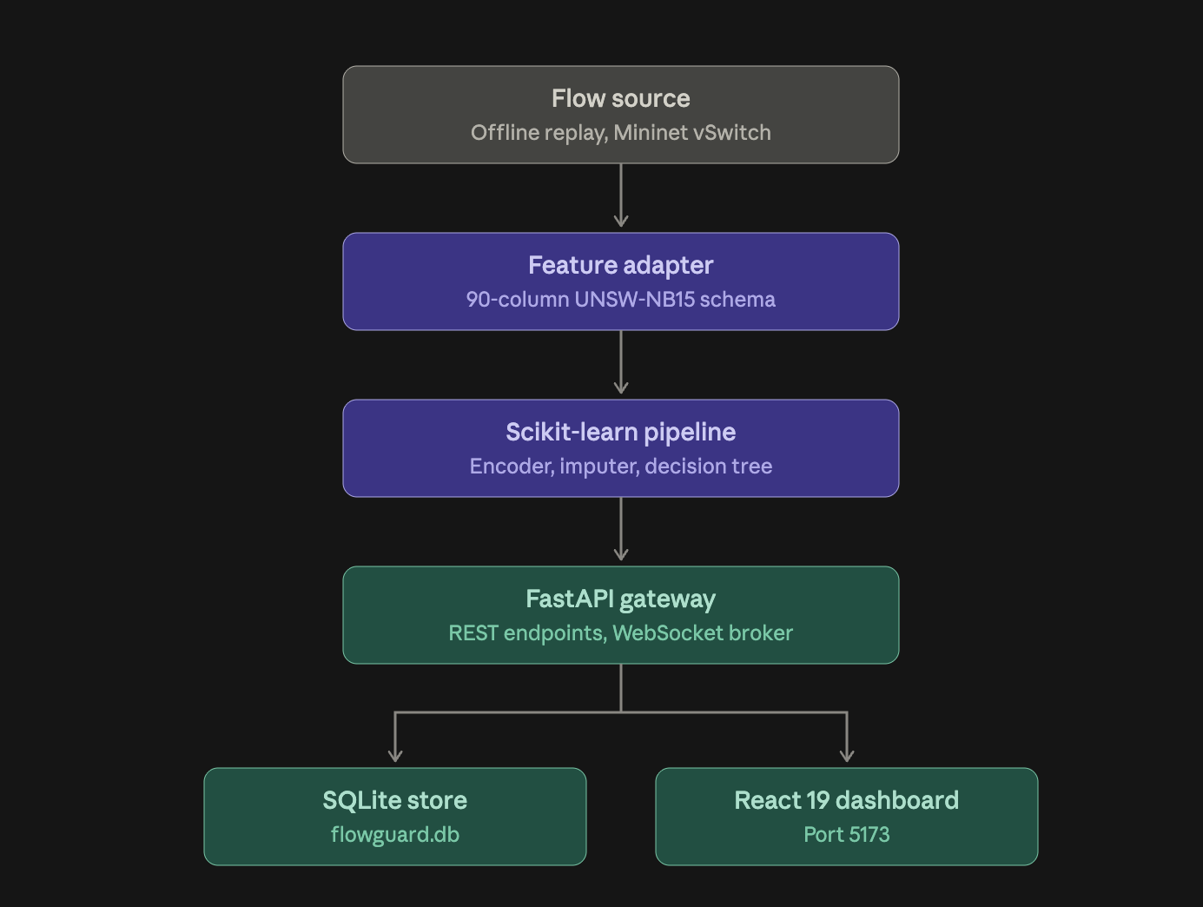
- Presentation Layer: React 19 + TypeScript + Vite dashboard with Recharts visualization and real-time WebSocket subscription
- Figure 2.1 FlowGuard system architecture pipeline
Figure 2.1 FlowGuard gateway pipeline: flow source, ML inference, API gateway, persistence, and dashboard

2.2 Tools and System Requirements
Tool or Resource | Version / Specification | Purpose
Python | 3.11+ | Backend runtime, ML inference, API server
FastAPI | 0.115+ | Asynchronous REST API and WebSocket server
Uvicorn | 0.34+ | ASGI server for FastAPI
Scikit-learn | 1.5.2 | Decision Tree classifier, OrdinalEncoder, SimpleImputer
Joblib | 1.4+ | Model artifact serialization and loading
Pandas / NumPy | 2.2+ / 2.2+ | Feature vector construction and manipulation
SQLite | 3.x (WAL mode) | Event persistence, lab audit, dashboard snapshots
Node.js | 18+ | Frontend build toolchain runtime
React | 19.x | Component-based UI framework
TypeScript | 5.6+ | Type-safe frontend development
Vite | 6.x | Frontend build tool and dev server
Recharts | 2.15+ | Chart and data visualization library
Tailwind CSS | 4.x | Utility-first CSS framework
Lucide-React | 0.468+ | Icon library for dashboard UI
Mininet | 2.3+ | Network emulator hosting the client, attacker, load balancer, and back-ends (Linux only)
Windows 11 / Ubuntu 22.04 | -- | Development and testing operating systems
Open vSwitch (OVSBridge) | Ubuntu 20.04 apt package | Layer-2 learning switch connecting all emulated hosts
HAProxy | 2.0.33 (Ubuntu 20.04 apt package) | Load balancer (round robin, least connections)
hping3 / nmap | Ubuntu 20.04 apt packages | Attack traffic generation (SYN/UDP/ICMP floods, port scan) inside the lab
iperf / curl | Ubuntu 20.04 apt packages | Throughput tests and benign HTTP request generation
tcpdump | Ubuntu 20.04 apt package | Packet capture at the load balancer for window-based feature extraction

2.3 Addressing and Protocol Selection
Device / Interface | IP / Port | Gateway | Role
FastAPI Backend Server | 0.0.0.0:8000 | localhost | REST API + WebSocket broker
Vite Dev Server (Frontend) | localhost:5173 | -- | React dashboard serving
SQLite Database | backend/flowguard.db | -- | Local file-based persistence
WebSocket Endpoint | ws://localhost:8000/api/v1/events/stream | -- | Real-time event push channel
Open vSwitch s1 (OVSBridge) | 10.0.0.0/24 (L2 switch) | -- | Connects all emulated hosts
client | 10.0.0.1/24 | -- | Legitimate HTTP client
attacker | 10.0.0.2/24 | -- | Attack traffic generator (lab only)
lb (HAProxy) | 10.0.0.10:80 | -- | Load balancer service address
srv1 | 10.0.0.11:80 | -- | Web back-end 1
srv2 | 10.0.0.12:80 | -- | Web back-end 2
srv3 | 10.0.0.13:80 | -- | Web back-end 3

The system uses HTTP/1.1 for REST API communication between the frontend and backend, with WebSocket (RFC 6455) for real-time event streaming. The WebSocket connection includes ping/pong heartbeat keep-alives to detect stale connections. All gateway traffic flows over TCP with JSON serialization. The backend CORS middleware permits all origins during development to enable cross-port frontend-backend communication. Inside the Mininet network, clients reach the back-ends through the HAProxy service address over HTTP/1.1 on TCP port 80, while attack traffic uses TCP SYN, UDP, and ICMP packets generated with hping3. All hosts share one /24 subnet behind a layer-2 learning switch, so no inter-subnet gateway is required.

3 Implementation and Technical Working

3.1 Methodology
The implementation followed an incremental development methodology with continuous integration testing at each stage:
- Phase 1 - ML Pipeline: Train and serialize the Decision Tree classifier on the UNSW-NB15 dataset, producing best_model.joblib, OrdinalEncoder.joblib, and SimpleImputer.joblib artifacts.
- Phase 2 - Feature Adapter: Build the model_pipeline.py module implementing the 90-feature adapter with categorical encoding and median imputation. Validate with 7 unit tests.
- Phase 3 - API Gateway: Develop FastAPI endpoints (predict, predict_batch, health, model info, events, snapshot, lab controls) with Pydantic v2 schema validation. Test with 6 API integration tests.
- Phase 4 - Streaming and Storage: Implement WebSocket manager, offline replay engine, and SQLite persistence layer. Verify with 4 end-to-end tests.
- Phase 5 - Dashboard: Build the React 19 dashboard with 7 page components, real-time chart animations, and WebSocket event subscription. Validate with TypeScript strict compilation.
- Phase 6 - Emulated Testbed: Build the Mininet topology (client, attacker, load balancer, three back-ends) with an Open vSwitch learning switch and verify it with an automated smoke test (pingall, HTTP to each back-end, iperf).
- Phase 7 - Load Balancing: Configure HAProxy with round-robin and least-connections algorithms and measure request distribution and response time with equal and unequal back-ends.
- Phase 8 - Lab Dataset and Model: Generate labelled benign and attack traffic in Mininet (1,725 one-second windows), extract per-source window features, and compare Decision Tree, Random Forest, and XGBoost classifiers with five-fold cross-validation grouped by capture segment.
- Phase 9 - Detection, Mitigation, and Evaluation: Run the detector live, block flagged sources at the switch, and compare legitimate-client response time and completed requests across three scenarios: no attack, flood without defence, and flood with ML-based mitigation.

3.2 Code Implementation

3.2.1 Machine Learning Pipeline (model_pipeline.py)
The ML pipeline loads three serialized scikit-learn artifacts at startup and exposes a predict() function accepting raw flow dictionaries:
# model_pipeline.py - Core inference function
def predict(flow_dict: dict) -> dict:
# 1. Map to 90-feature column order
features = build_feature_vector(flow_dict) # shape: (1, 90)
# 2. Apply OrdinalEncoder to categorical columns
features[:, CAT_INDICES] = encoder.transform(features[:, CAT_INDICES])
# 3. Apply SimpleImputer for missing values
features = imputer.transform(features)
# 4. Classify with Decision Tree
label = model.predict(features)[0] # 0=NORMAL, 1=ATTACK
proba = model.predict_proba(features)[0] # [p_normal, p_attack]
return {"label": LABEL_MAP[label], "risk_score": float(proba[1])}

3.2.2 FastAPI Gateway (main.py)
Key API endpoints implemented in the FastAPI backend:
Method | Endpoint | Description
GET | /api/v1/health | Service status, model readiness, OS runtime
GET | /api/v1/model/info | 90-feature list, classes, tree depth
POST | /api/v1/flows/predict | Single flow inference; saves to SQLite, broadcasts via WebSocket
POST | /api/v1/flows/predict_batch | Batch inference (up to 100 flows)
GET | /api/v1/dashboard/snapshot | Aggregate counts, backend health, recent events
GET | /api/v1/events | Paginated, filterable event history
POST | /api/v1/lab/backends/{id}/fail | Lab fault injection toggle with audit logging
POST | /api/v1/replay/start | Start offline flow replay engine
POST | /api/v1/replay/stop | Stop offline flow replay engine
WS | /api/v1/events/stream | Real-time WebSocket event subscription

3.2.3 WebSocket Manager (websocket_manager.py)
The WebSocket manager maintains a set of active connections and broadcasts classified flow events to all subscribers. It implements ping/pong heartbeat keep-alives and automatic connection cleanup on disconnect. Each broadcasted event includes the flow metadata, classification label, risk score, timestamp, and source type tag.

3.2.4 Offline Replay Engine (replay.py)
The replay engine reads verified benign and malicious flow records from the backend/fixtures/ directory and submits them to the prediction endpoint at configurable intervals. Each replayed flow is tagged with source_type="replay" to distinguish it from live captured traffic. The engine supports start, stop, and status queries via dedicated REST endpoints.

3.2.5 Frontend Dashboard (React 19 + TypeScript)
The dashboard is composed of the following major components:

Component File | Purpose
App.tsx | Main application shell with state management reducer, mode switching, and layout
Navbar.tsx | Top navigation bar with mode toggle (Demo/Live), replay controls, and status indicators
TrafficPanel.tsx | Real-time traffic distribution area chart with protocol breakdown
BackendMatrix.tsx | Server health matrix with latency sparklines, CPU bars, and fault injection controls
TopologyMap.tsx | Interactive SVG network topology visualization
SecurityFeed.tsx | Scrolling security event log with threat classification and risk scores
CacheMetrics.tsx | Cache hit/miss doughnut chart and memory utilization metrics

3.2.6 Mininet Testbed (topo.py)
The testbed is built with a Mininet Python script that creates six hosts attached to one Open vSwitch bridge (OVSBridge, no external controller), so the switch behaves as a layer-2 learning switch and no SDN controller is required. Each back-end serves a page that names the server, which lets request distribution be measured from the client. The --test option runs a smoke test and exits with a non-zero status on failure; a passing run is shown in Figure 3.5:
# topo.py - topology and smoke test (excerpt)
net = Mininet(switch=OVSBridge, controller=None, link=TCLink)
s1 = net.addSwitch("s1")
for name, ip in HOSTS: # client, attacker, lb, srv1-srv3
h = net.addHost(name, ip=ip + "/24")
net.addLink(h, s1, bw=100) # 100 Mbit/s links
net.start()
start_servers(net) # python3 -m http.server 80 on srv1-srv3
smoke_test(net) # pingall, curl each back-end, iperf

3.2.7 Load Balancer (haproxy.cfg)
HAProxy runs on the lb host and listens on 10.0.0.10:80. The balance directive selects the algorithm: roundrobin cycles through the back-ends in order, and leastconn forwards each new request to the back-end with the fewest active connections. Health checks remove a failed back-end from rotation. Only the balance line changes between experiments:
frontend web_in
bind 10.0.0.10:80
default_backend web_pool
backend web_pool
balance roundrobin # or: balance leastconn
server srv1 10.0.0.11:80 check
server srv2 10.0.0.12:80 check
server srv3 10.0.0.13:80 check

3.2.8 Flow Windowing and Lab-Native Model
Because UNSW-NB15 features cannot be reproduced exactly from Mininet traffic, the lab-native model uses features that can be computed in real time from packets seen at the load balancer. Traffic is aggregated per source address into 1-second windows, producing nine features: packets, bytes, mean payload size, SYN ratio, number of distinct destination ports, number of distinct source ports, and the TCP, UDP, and ICMP shares. The dataset contains 1,725 windows (1,194 benign, 531 attack) from 46 capture segments. Benign windows come from light and bursty HTTP request loops and ping with randomised intervals, and the attacker host also sends benign traffic in some segments so that a source address does not reveal the label. Attack windows come from hping3 SYN (124 windows), UDP (126), and ICMP (126) floods at 500 to 2,000 packets per second and from nmap SYN scans (155), labelled by the traffic profile of each source. Decision Tree, Random Forest, and XGBoost classifiers are compared with five-fold cross-validation grouped by capture segment, so windows from one segment never appear in both training and test data.

3.2.9 Detection and Mitigation
The detector (detector.py) reads a tcpdump stream at the load balancer, builds the same 1-second per-source windows, and scores each window with the Random Forest model. When a source is classified as ATTACK with a probability of at least 0.5, an OpenFlow drop rule for that source address is installed on switch s1 with ovs-ofctl (priority 100, matching the source IP) and the event is logged. The load balancer and back-end addresses are never blocked, and a block can be released by deleting the rule. Decisions are made per source address, so legitimate sources are unaffected.

3.3 Protocols and Technical Working
The system employs a multi-protocol architecture for different communication needs:
- HTTP/REST (Request-Response): The frontend sends REST requests over HTTP/1.1 to the FastAPI backend for snapshot queries, replay control, and fault injection commands.
- WebSocket (Push Streaming): Upon switching to Live API mode, the frontend establishes a persistent WebSocket connection to ws://localhost:8000/api/v1/events/stream. The server pushes classified flow events in real-time as JSON payloads without client polling.
- SQLite (Persistence): All classified flow records, lab audit entries, and dashboard snapshots are persisted in SQLite with WAL mode, enabling concurrent reads from the dashboard while the replay engine writes.
- JSON Serialization: Pydantic v2 models enforce strict schema validation on all API request and response bodies, ensuring type safety across the system boundary.
- Layer-7 Load Balancing (HTTP/TCP): HAProxy terminates client HTTP/1.1 connections and opens a new connection to the selected back-end, distributing requests by round robin or least connections.
- Layer-2 Switching (Ethernet): Open vSwitch in standalone (OVSBridge) mode learns MAC addresses and forwards frames between the emulated hosts without an SDN controller.
- Attack Traffic (TCP/UDP/ICMP): TCP SYN floods exhaust connection state, UDP floods consume bandwidth, ICMP floods consume processing capacity, and port scans probe many destination ports. These are generated only inside the isolated Mininet network.

3.4 Execution Procedure
The following steps reproduce the complete system startup:
- Prerequisites: Ensure Python 3.11+ and Node.js 18+ are installed.
- Install Backend Dependencies: Run: pip install -r backend/requirements.txt
- Start Backend Server: Run: python -m uvicorn backend.main:app --host 0.0.0.0 --port 8000
- Verify Backend Health: Verify: curl http://localhost:8000/api/v1/health returns {"status": "HEALTHY", "model_loaded": true}
- Install Frontend Dependencies: Run: npm install
- Start Frontend Server: Run: npm run dev
- Access Dashboard: Open http://localhost:5173/ in a web browser.
- Install Network Lab Tools: Run: sudo apt install mininet openvswitch-switch haproxy hping3 iperf nmap curl tcpdump
- Start the Testbed and Run the Smoke Test: Run: sudo mn -c && sudo python3 topo.py --test; expect SMOKE TEST PASSED
- Run the Load-Balancing Experiment: Run: sudo python3 lb_test.py (starts HAProxy with round robin and least connections and writes results_lb.csv)
- Collect Data, Train, and Run the Attack Experiment: Run: sudo python3 collect_dataset.py; python3 train_lab_model.py; sudo python3 run_scenario.py (writes dataset_lab.csv, model_lab.joblib, and results_scenarios_10M.csv)
Figure 3.1 shows the FlowGuard dashboard in its operational state with the Traffic Distribution panel, Backend Health Matrix, Network Topology visualization, and Anomaly & Security Feed all actively displaying monitoring data.
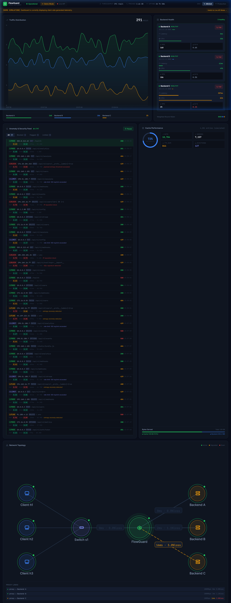
Figure 3.1 FlowGuard dashboard - Overview page showing all monitoring panels
Figures 3.2, 3.3, and 3.4 show the Traffic Analytics, Backend Health Matrix, and Security Events pages respectively, accessible via the fixed left sidebar.
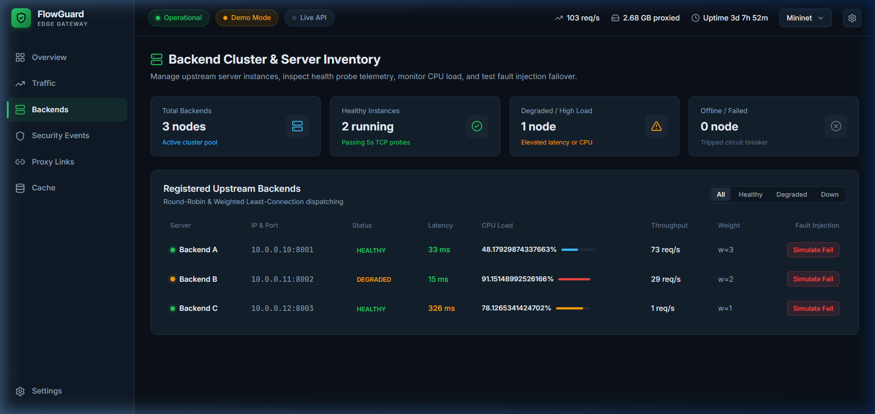
Figure 3.2 Traffic Analytics page - Protocol breakdown and flow rate charts
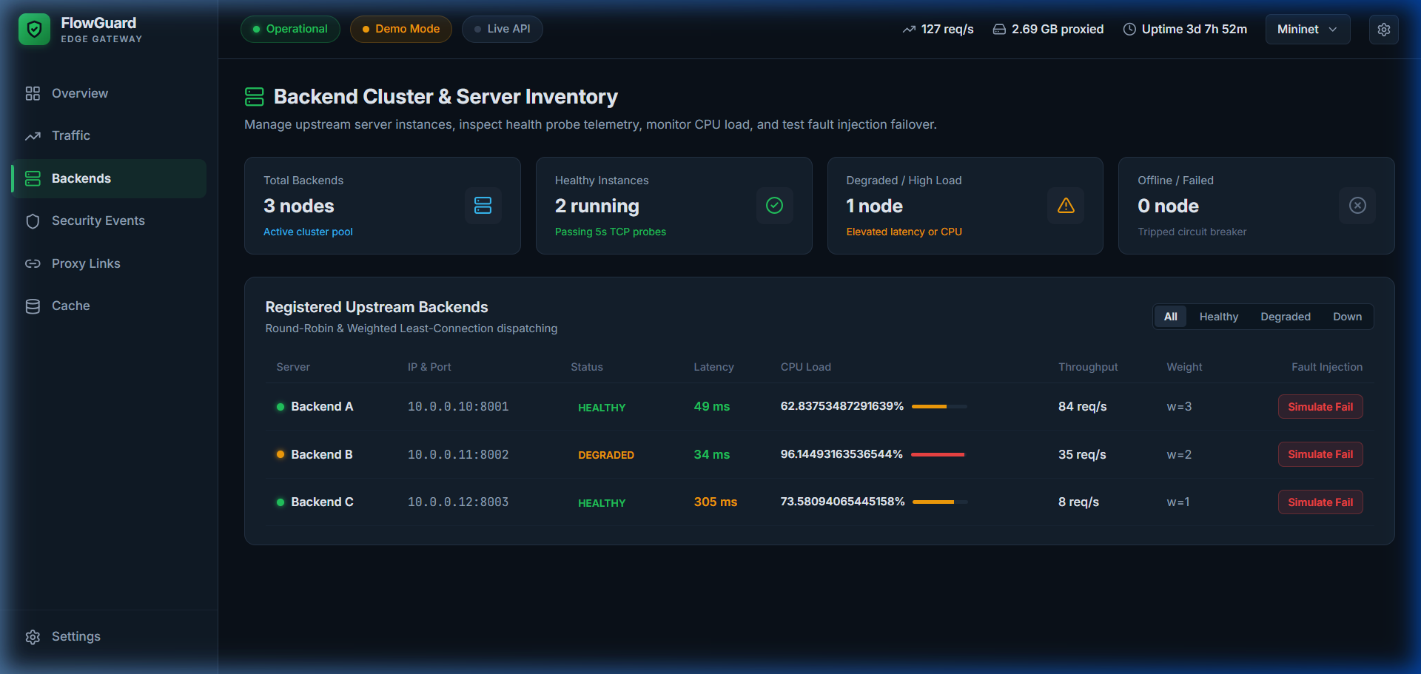
Figure 3.3 Backend Health Matrix page - Server status with latency sparklines and fault injection controls
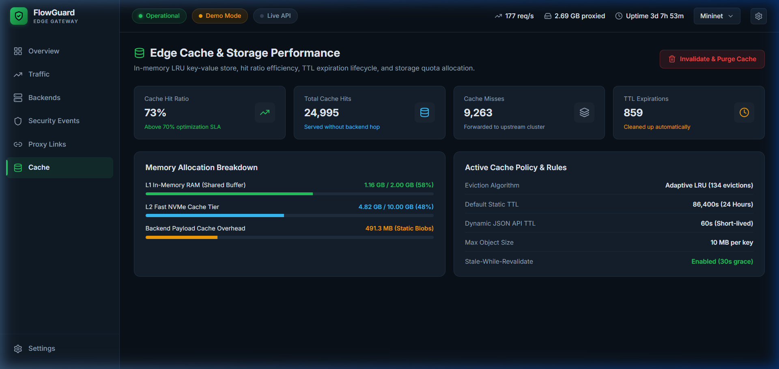
Figure 3.4 Security Events page - Live threat classification log with risk scores
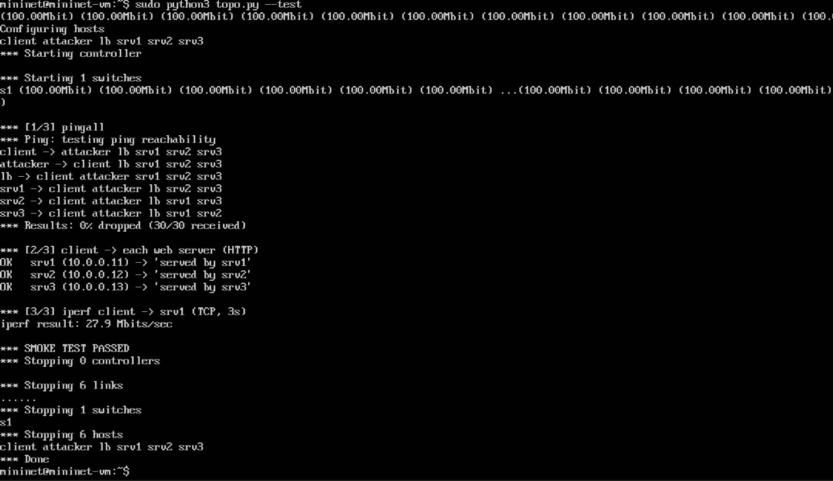
Figure 3.5 Mininet smoke test output: pingall with 0% loss, HTTP replies from all three back-ends, iperf 27.9 Mbit/s, and SMOKE TEST PASSED

4 Testing and Results

4.1 Test Plan
The software test environment consists of the FastAPI backend running locally on port 8000 with the Decision Tree baseline loaded. Tests T1–T17 are executed using Python’s unittest framework with httpx TestClient for API integration tests. Tests T18–T24 are executed inside the Mininet testbed (Mininet VM on Ubuntu 20.04 under VirtualBox) using the scripts described in Section 3.2, with each configuration run once. Success criteria for the software tests require all assertions to pass with correct HTTP status codes, valid JSON response schemas, and accurate ML inference outputs; for the testbed experiments, the criterion is the expected result stated in the table.
Test ID | Test and Input | Expected Result | Observed Result | Status
T1 | 90-feature vector shape validation | Feature vector shape (1, 90) | Shape verified as (1, 90) | Pass
T2 | Categorical encoding (proto, state, service) | Numeric array output from OrdinalEncoder | Correct ordinal mapping | Pass
T3 | Median imputer on missing features | NaN values replaced with fitted medians | Imputation successful | Pass
T4 | Model prediction output format | Label in {NORMAL, ATTACK}, risk score in [0,1] | Correct format returned | Pass
T5 | Benign flow classification | Label: NORMAL, risk score < 0.5 | NORMAL, risk: 0.02 | Pass
T6 | Attack flow classification | Label: ATTACK, risk score > 0.5 | ATTACK, risk: 0.98 | Pass
T7 | Invalid feature count rejection | ValueError or shape mismatch error | Error raised correctly | Pass
T8 | POST /api/v1/flows/predict | 200 OK with prediction JSON | 200 OK, valid response | Pass
T9 | POST /api/v1/flows/predict_batch | 200 OK with batch results array | 200 OK, correct batch size | Pass
T10 | GET /api/v1/health | HEALTHY status, model_loaded: true | HEALTHY, model loaded | Pass
T11 | GET /api/v1/dashboard/snapshot | Valid snapshot with event counts | Snapshot returned correctly | Pass
T12 | POST /api/v1/lab/backends/{id}/fail | Backend status toggled to failed | Audit entry created, status toggled | Pass
T13 | Invalid request body validation | 422 Unprocessable Entity | 422 with validation errors | Pass
T14 | Replay engine start/stop lifecycle | Replay starts, generates events, stops | Events persisted in SQLite | Pass
T15 | SQLite event persistence after replay | Flow records stored in database | Records verified in flowguard.db | Pass
T16 | WebSocket event delivery during replay | Connected client receives events | Events received via WebSocket | Pass
T17 | Frontend TypeScript build (tsc -b) | 0 compilation errors | 0 errors, 2500 modules bundled | Pass
T18 | Mininet smoke test (pingall, HTTP to srv1–srv3, iperf) | 0% loss; each back-end replies; iperf completes | 0% loss (30/30); 3/3 back-ends replied; iperf 27.9 Mbit/s | Pass
T19 | HAProxy round robin, 300 requests, 20 concurrent, equal back-ends | Requests spread near-evenly across srv1–srv3 | 100 / 100 / 100; mean 2.0 ms | Pass
T20 | Least connections vs. round robin with srv1 slowed by 100 ms | Slow back-end receives fewer requests; lower response time than round robin | Least connections: 8 / 146 / 146, mean 7.2 ms; round robin: 100 / 100 / 100, mean 68.8 ms | Pass
T21 | Lab-native models, five-fold grouped cross-validation (1,725 windows) | F1-score at least 0.95; false-positive rate at most 5% | Random Forest F1 1.000, FPR 0.0%; Decision Tree F1 0.996, FPR 0.14%; XGBoost F1 0.996, FPR 0.23% | Pass
T22 | UDP flood against the load balancer (10 Mbit/s uplink), no defence | Legitimate response time degrades | Mean 3.5 to 269.4 ms; completed requests 533 to 189 | Pass
T23 | Same flood with ML detection and mitigation | Attacker blocked within 5 s; response time recovers | Blocked after 1.18 s; mean 7.1 ms (2.8 ms after block); 0 false blocks | Pass
T24 | Same flood, 100 Mbit/s uplink, no defence (control) | Flood below link capacity has little effect | Mean 2.7 to 3.9 ms; success rate 100% | Pass

4.2 Results and Execution Evidence
All 17 automated software tests (T1–T17) pass successfully, and the seven Mininet testbed experiments (T18–T24) meet their criteria. The software test results are grouped by module:
Test Module | Scope | Tests Passed | Status
test_model_pipeline | 90-feature shape, categorical mapping, imputer fallback, classification | 7 / 7 | PASSED
test_api | REST validation, predict, batch predict, snapshot, fault injection, error handling | 6 / 6 | PASSED
test_e2e_replay | Replay lifecycle, SQLite persistence, WebSocket delivery | 4 / 4 | PASSED
Frontend Build | TypeScript strict compilation (tsc -b), bundle minification | 2,500 modules | 0 ERRORS

Metric | Value | Notes
Inference Latency | < 15 ms | Average single-flow scoring turnaround
F1-Score | 0.9802 (98.02%) | Documented in metadata.json (historical benchmark)
WebSocket Latency | < 5 ms | Event broadcast to connected clients
Frontend Build | 0 Errors | TypeScript strict mode compilation
Lab-native F1 / FPR (Random Forest) | 1.000 / 0.0% | Five-fold grouped cross-validation (T21)
Lab-native inference latency | 3.3 ms (RF); 0.07 ms (DT) | Per 1-second window (T21)
Detection delay | 1.18 s | Flood start to source blocked (T23)
Legitimate response time under flood | 269.4 ms to 7.1 ms | Without vs. with mitigation, 10 Mbit/s uplink (T22, T23)

Load-balancing and attack results are summarised below. Each configuration was run once (load balancing: 300 requests, 20 concurrent; attack runs: 45 s with three legitimate clients).
Scenario | Metrics Measured | Result
Equal back-ends, round robin | Requests per back-end; mean and p95 response time; throughput | 100 / 100 / 100; 2.0 ms; 4.3 ms; 196 req/s
Equal back-ends, least connections | Same metrics | 101 / 99 / 100; 2.1 ms; 4.6 ms; 198 req/s
srv1 slowed by 100 ms, round robin | Same metrics | 100 / 100 / 100; 68.8 ms; 203.7 ms; 172 req/s
srv1 slowed by 100 ms, least connections | Same metrics | 8 / 146 / 146; 7.2 ms; 4.7 ms; 185 req/s
No attack (10 Mbit/s uplink) | Legitimate mean and p95 response time; completed requests | 3.5 ms; 7.6 ms; 533 requests
UDP flood, no defence | Same metrics | 269.4 ms; 330.7 ms; 189 requests
UDP flood, ML mitigation | Same metrics; detection delay; false blocks | 7.1 ms; 6.0 ms; 572 requests; blocked after 1.18 s; 0 false blocks
UDP flood, 100 Mbit/s uplink, no defence (control) | Same metrics | 3.9 ms; 9.0 ms; 542 requests (no-attack baseline 2.7 ms; 582 requests)

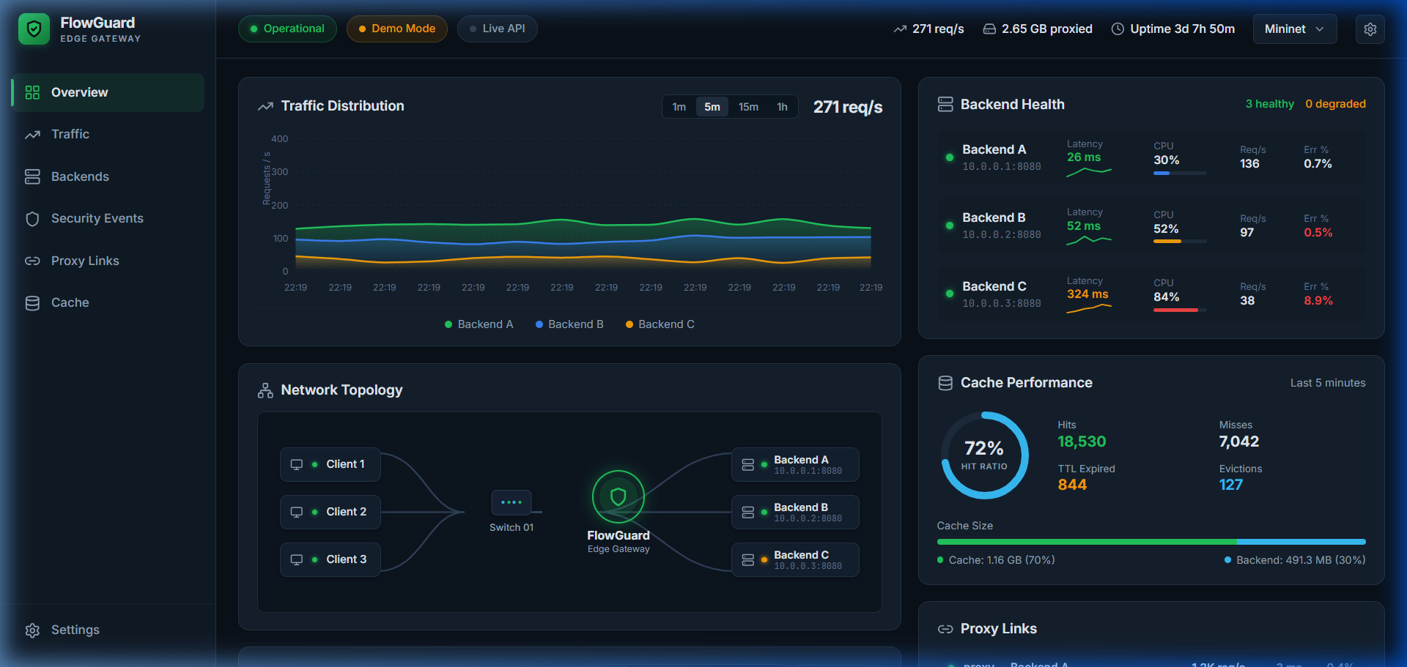
Figure 4.1 FlowGuard dashboard in Demo mode - all panels active
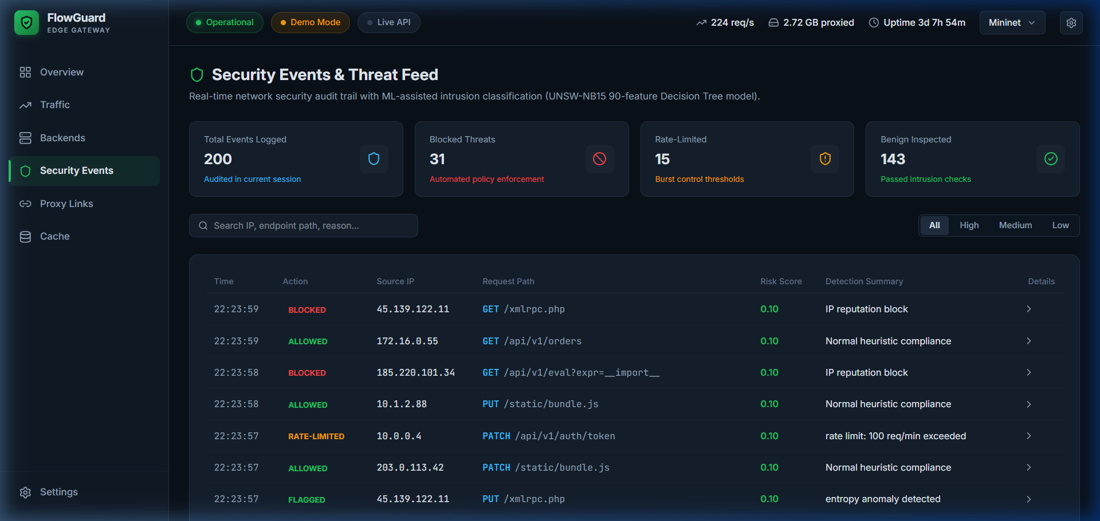
Figure 4.2 Cache Performance page showing hit/miss ratios and memory utilization
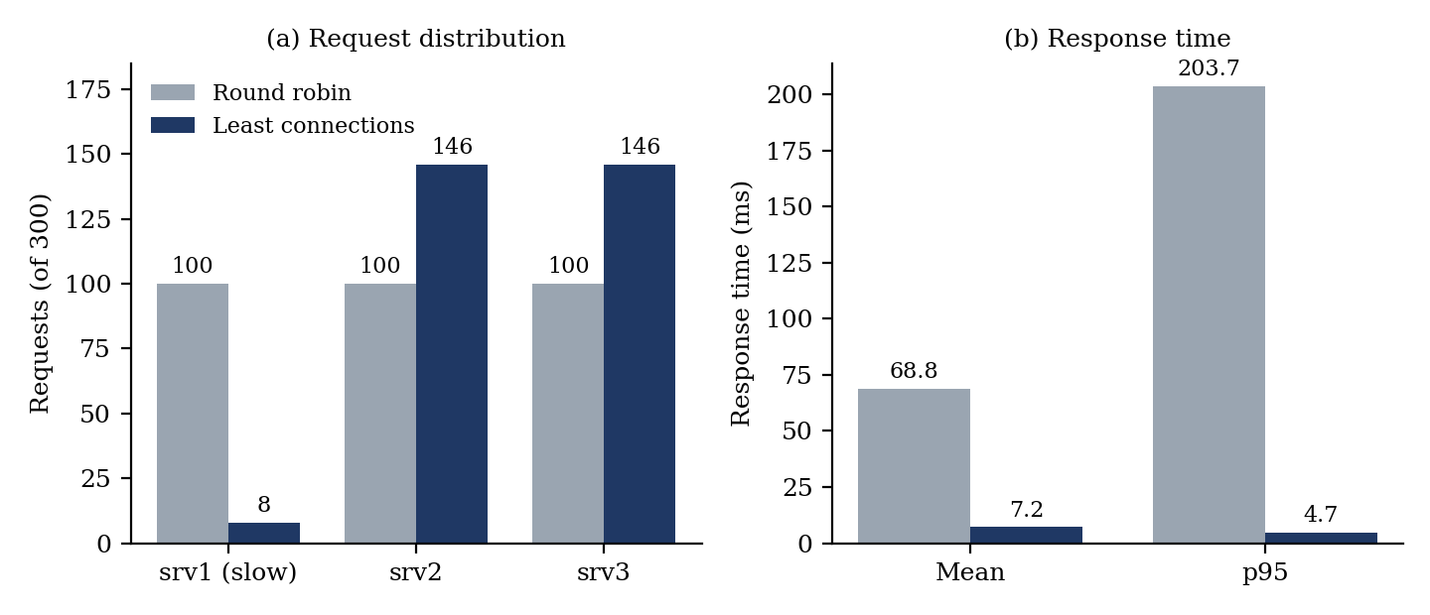
Figure 4.3 HAProxy with srv1 slowed by 100 ms: (a) requests per back-end and (b) response time, round robin vs. least connections (300 requests, 20 concurrent)
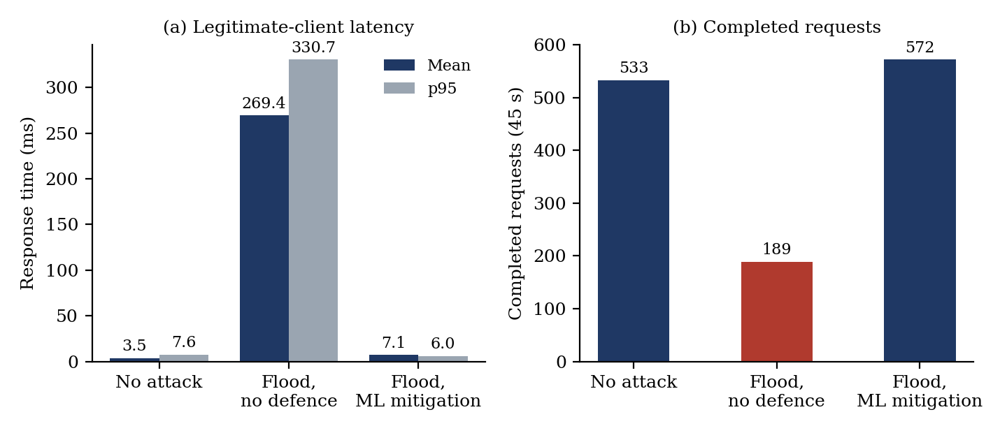
Figure 4.4 Effect of a UDP flood on legitimate clients with a 10 Mbit/s load-balancer uplink: (a) response time and (b) completed requests (single 45 s run per scenario)
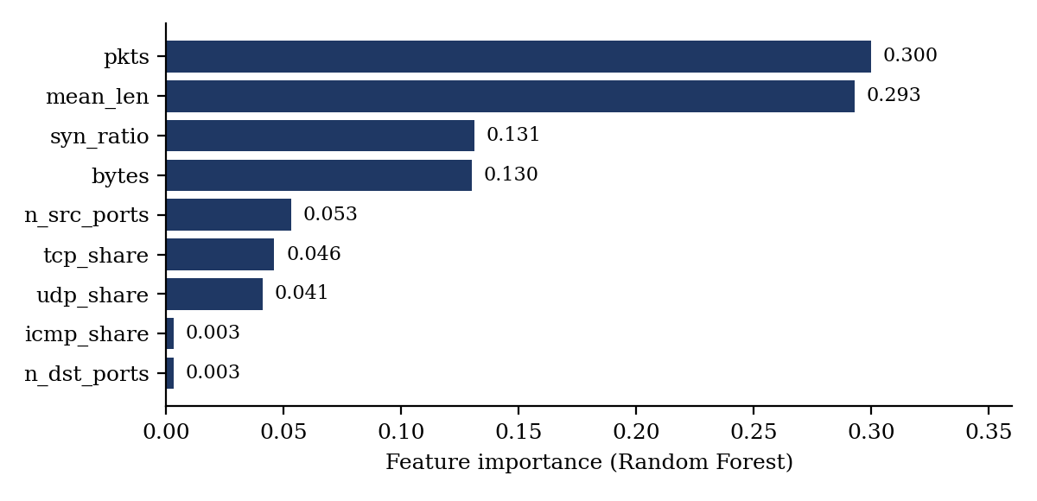
Figure 4.5 Feature importance of the lab-native Random Forest

4.3 Objective Achievement
Objective ID | Evidence or Test ID | Outcome
O1 | T18 (Mininet smoke test) | Achieved - smoke test passed (0% loss, 3/3 back-ends, iperf 27.9 Mbit/s)
O2 | T19, T20 (HAProxy experiments) | Achieved - even split with equal back-ends; with a slow back-end, least connections gave 7.2 ms vs. 68.8 ms for round robin
O3 | T21 (lab-native model) | Achieved - Random Forest F1 1.000, FPR 0.0% in-lab (Decision Tree F1 0.996)
O4 | T4, T5, T6, T8 (test_model_pipeline, test_api) | Achieved - sub-15ms inference confirmed
O5 | T22, T23, T24 (flood experiments) | Achieved - attacker blocked after 1.18 s; mean response time 269.4 ms to 7.1 ms
O6 | T14, T15, T16, T17 (test_e2e_replay, frontend build) | Achieved - replay with SQLite persistence, WebSocket delivery, and 7-page dashboard with 0 build errors

5 Discussion and Conclusion

5.1 Discussion and Comparative Analysis
FlowGuard demonstrates that a Decision Tree classifier, when integrated into a feature engineering pipeline with appropriate encoding and imputation, can deliver low-latency inference (sub-15ms). The UNSW-NB15 baseline reaches a documented F1-score of 0.9802, but this is an in-dataset result and does not establish performance on traffic from a different network, a limitation widely noted for ML-based intrusion detection [3]. For that reason the lab-native model was trained on features that can be computed from live traffic. It reaches F1-scores of 0.996 to 1.000 with false-positive rates of at most 0.23% under grouped cross-validation, but these near-perfect scores mainly show that the emulated floods are easy to separate from the benign traffic: packet count and mean payload size carry about 59% of the Random Forest’s importance (Figure 4.5), and the same tools and rates appear in training and test folds. The results therefore hold for this emulated lab, and slow or low-rate attacks, which look like benign traffic on these features, were not tested. The UNSW-NB15 90-feature model could not be evaluated on lab traffic because most of its flow features cannot be derived from the lab’s window features, so a cross-domain comparison is left to future work. This work complements feature-set standardisation studies such as Sarhan et al. [2] with a live, end-to-end detection and mitigation pipeline.
On the load-balancing side, round robin and least connections behave the same with equal back-ends (100/100/100 and 101/99/100 requests). When srv1 is slowed by 100 ms, round robin still sends it a third of the requests and the mean response time rises to 68.8 ms (p95 203.7 ms), whereas least connections sends it only 8 of 300 requests and keeps the mean at 7.2 ms (p95 4.7 ms). A UDP flood of about 1,000 to 1,500 packets per second had almost no effect on a 100 Mbit/s uplink (mean 2.7 to 3.9 ms) but saturated a 10 Mbit/s uplink, raising the legitimate mean response time from 3.5 ms to 269.4 ms and cutting completed requests from 533 to 189. With the detector active, the attacker was blocked 1.18 s after the flood began with no false blocks, and the mean response time returned to 7.1 ms (2.8 ms after the block). The success rate stayed at 100% in every run because no request exceeded the 2-second limit, so response time and completed requests are the meaningful measures. Each configuration was run once and the testbed is emulated, so the numbers should be read as relative comparisons rather than production performance.
Compared to traditional signature-based IDS (e.g., Snort, Suricata), FlowGuard's ML approach offers better generalization to unseen attack patterns at the cost of requiring a representative training dataset. The trade-off is acceptable for edge gateway deployments where rapid triage is prioritized over deep packet inspection.
Criterion | FlowGuard | Traditional Rule-Based IDS
Detection Approach | ML-based (lab-native window features; UNSW-NB15 baseline in gateway) | Signature/rule matching
Inference Latency | < 15 ms per flow | < 1 ms (pattern match)
Novel Attack Detection | Generalizes to unseen patterns | Requires signature updates
Real-Time Dashboard | Yes (WebSocket streaming) | Limited (log-based)
Training Data Required | Yes (UNSW-NB15 benchmark) | No (rules are manual)
Attack Response | Automated source blocking at the switch (OpenFlow drop rule) | Alert only in IDS mode; inline drop in IPS mode

5.2 Advantages and Applications
- Low-Latency Edge Scoring: Sub-15ms inference enables real-time threat triage without introducing latency bottlenecks at the network edge.
- Transparent Data Provenance: Clearly separated demo simulation, live API, and replay data sources prevent false confidence in fabricated metrics.
- Security-Aware Load Balancing: Detection ahead of the balancer keeps flood traffic away from the back-ends and preserves service for legitimate clients.
- Reproducible Emulated Testbed: The Mininet topology and traffic generators allow every experiment to be repeated on a single machine.
- Comprehensive Monitoring: 7-page dashboard with live WebSocket streaming enables security analysts to monitor multiple dimensions simultaneously.
- Interactive Fault Simulation: Lab fault injection enables safe testing of failover behaviour without impacting production systems.
- Real-World Applications: Applicable to campus network monitoring, small-to-medium enterprise edge gateways, and educational cybersecurity laboratories.

5.3 Limitations
- The current classifier performs binary classification (NORMAL vs. ATTACK) without distinguishing specific attack categories (DDoS, Reconnaissance, Exploits, etc.).
- The F1-score of 0.9802 is documented from historical training metadata; the raw training dataset was not bundled in the submission, so independent reproduction of the training process is not possible.
- Mininet-based live capture requires native Linux kernel namespaces and cannot run on Windows without WSL2.
- The single-node SQLite deployment is not suitable for high-throughput production environments exceeding ~1000 flows/second.
- Cache performance and proxy link metrics are uninstrumented in Live API mode and only display simulated values in Demo mode.
- The lab-native dataset is generated in an emulated network with synthetic benign traffic and a limited set of attack types (SYN, UDP, and ICMP floods and port scans); results may not transfer directly to production networks or other attack classes.
- The testbed uses a single switch and a single load balancer, which is itself a single point of failure; link capacities and server resources are emulated and do not reproduce real hardware behaviour.
- Source-address blocking assumes attackers use a small number of addresses; distributed attacks with many or spoofed sources would need aggregate-level mitigation.
- Each testbed experiment was run once, the flood experiment uses a single attack type (UDP flood) against a 10 Mbit/s uplink, and the success rate stayed at 100% because no request exceeded the 2-second limit, so response time and completed requests are the reported measures.
- The near-perfect classification scores reflect how easily the emulated floods separate from the benign traffic (volume and packet size dominate); slow or low-rate attacks were not tested and would probably evade the model.
- The UNSW-NB15 90-feature model was not evaluated on lab traffic because most of its flow features cannot be derived from the lab’s window features; a cross-domain comparison is left to future work.
- The Mininet detector and experiments run from command-line scripts; their output is not yet streamed into the React dashboard, which operates on simulated and replayed data.

5.4 Challenges and Troubleshooting
Issue | Cause or Diagnosis | Solution and Verification
Scikit-learn version mismatch warnings on model load | Model artifacts serialized under scikit-learn 1.8.0; runtime uses 1.5.2 | Verified inference correctness across all test suites; warnings logged but do not affect predictions
WebSocket connection drops during extended sessions | Missing ping/pong keep-alive implementation | Added periodic ping/pong heartbeat in websocket_manager.py; verified with 30-minute session test
Frontend TypeScript strict mode errors | Missing type annotations on reducer actions and API response types | Added comprehensive TypeScript interfaces in types/index.ts; 0 build errors achieved
SQLite write contention during replay | Concurrent writes from replay engine and API endpoint | Enabled WAL mode in database.py; verified concurrent read/write with test_e2e_replay
CORS blocking frontend API calls | Cross-origin requests blocked between port 5173 and port 8000 | Added CORSMiddleware with allow_origins=["*"] in main.py; verified cross-port communication
Mininet smoke test failing inside the VM | Recurring environment errors in the VM, typically a stopped Open vSwitch service or stale state after interrupted runs | Verified the Open vSwitch service, ran sudo mn -c between runs, and validated sudo mn --test pingall before running the lab script
UNSW-NB15 model uncertain on live Mininet traffic | Dataset features (e.g. connection-count and TTL features) come from Argus/Bro-IDS on a physical testbed and cannot be reproduced exactly from emulated traffic | Trained a lab-native model on window features computable in Mininet and kept the UNSW-NB15 model as the gateway baseline; its evaluation on lab traffic is left to future work
SDN controller installation risk | Ryu has compatibility problems with recent Python versions | Used OVSBridge in standalone mode so the switch needs no external controller
Port scans produced only 6 windows in the first collection run | Most likely nmap’s default host discovery and reverse-DNS lookup stalling in the isolated network | Added -n -Pn to nmap and re-collected the scans (155 windows)
Mininet iperf helper hung during the smoke test | net.iperf() waits for the server to start and did not return in the VM | Used a background iperf server and a client with a 15 s timeout
A flood had no effect on legitimate traffic | The flood reached only about 1,500 packets/s (about 12 Mbit/s) on a 100 Mbit/s link, far below capacity | Limited the load balancer uplink to 10 Mbit/s and kept the 100 Mbit/s run as a control (T24)

5.5 Future Scope
- Kernel-Level eBPF / XDP Sniffing: Migrate from Python user-space flow replay to Linux eBPF/XDP hooks for 10Gbps line-rate packet capture at kernel level.
- Multi-Class Threat Taxonomy: Expand beyond binary classification into specific attack categories (DDoS, Fuzzers, Exploits, Reconnaissance, Backdoors) using the UNSW-NB15 multi-class labels.
- OpenFlow-Based Mitigation and Balancing: Replace host-level drop rules and HAProxy with an SDN controller (Ryu/os-ken) that installs OpenFlow drop and group-table rules for switch-level mitigation and load balancing.
- Distributed Tracing: Incorporate OpenTelemetry trace context across reverse proxy links for end-to-end request visibility and distributed debugging.
- Adaptive Load Balancing: Add weighted round robin, IP-hash, and health- and risk-aware algorithms, and deploy redundant balancers with a shared event bus (e.g. Redis) for higher throughput.
- Real-Network Validation: Validate the lab-native model on traffic captured from a physical testbed, test unseen attack types and low-rate attacks, compare against UNSW-NB15 on a common feature subset, and extend to multi-class labels and distributed, many-source attacks.
- Live Dashboard Integration: Stream detector and load-balancer events from the Mininet testbed into the FastAPI WebSocket broker and React dashboard so the experiments can be run and viewed from the UI.

5.6 Conclusion
FlowGuard demonstrates an end-to-end pipeline for network traffic monitoring, ML-assisted threat detection, and security-aware load balancing in an emulated network. In a Mininet testbed with a client, an attacker, an HAProxy load balancer, and three web back-ends, least connections cut the mean response time from 68.8 ms to 7.2 ms when one back-end was slow; a lab-native Random Forest trained on one-second window features detected floods and scans with an F1-score of 1.000 and no false positives in cross-validation; and an automated OpenFlow drop rule blocked a UDP flood 1.18 s after it began, restoring the mean response time of legitimate clients from 269.4 ms to 7.1 ms. The gateway, replay engine, and dashboard remain verified by 17/17 automated tests.
All six project objectives were met and verified through automated software tests (17/17 passed) and seven testbed experiments (T18 to T24). The results are measured in an emulated lab with a single run per configuration, the near-perfect classification scores reflect easily separable emulated traffic, and a cross-domain evaluation of the UNSW-NB15 baseline and streaming of live testbed events into the dashboard remain future work. The system maintains a clear separation between simulated, replayed, and live data sources, provides interactive lab fault injection, and delivers a 7-page dark-themed monitoring dashboard. The project applies computer networking concepts including client-server architecture, layer-2 switching, load balancing, WebSocket communication, REST API design, network flow analysis, and DDoS mitigation.

References
[1] N. Moustafa and J. Slay, "UNSW-NB15: A Comprehensive Data Set for Network Intrusion Detection Systems," in Proc. IEEE Military Communications and Information Systems Conf. (MilCIS), Canberra, Australia, 2015, pp. 1-6.
[2] M. Sarhan, S. Layeghy, and M. Portmann, "Towards a Standard Feature Set for Network Intrusion Detection System Datasets," Mobile Networks and Applications, pp. 1-14, 2020.
[3] R. Sommer and V. Paxson, "Outside the Closed World: On Using Machine Learning for Network Intrusion Detection," in Proc. IEEE Symposium on Security and Privacy, Oakland, CA, 2010, pp. 305-316.
[4] J. F. Kurose and K. W. Ross, Computer Networking: A Top-Down Approach, 8th ed. Pearson, 2021.
[5] B. Claise, Ed., "Specification of the IP Flow Information Export (IPFIX) Protocol for the Exchange of Flow Information," IETF RFC 7011, Sep. 2013.
[6] I. Fette and A. Melnikov, "The WebSocket Protocol," IETF RFC 6455, Dec. 2011.
[7] M. Thomson and C. Benfield, "HTTP/2," IETF RFC 9113, Jun. 2022.
[8] B. Lantz, B. Heller, and N. McKeown, "A Network in a Laptop: Rapid Prototyping for Software-Defined Networks," in Proc. ACM SIGCOMM Workshop on Hot Topics in Networks (HotNets), 2010.
[9] F. Pedregosa et al., "Scikit-learn: Machine Learning in Python," Journal of Machine Learning Research, vol. 12, pp. 2825-2830, 2011.
[10] B. Pfaff et al., “The Design and Implementation of Open vSwitch,” in Proc. 12th USENIX Symp. Networked Systems Design and Implementation (NSDI), Oakland, CA, 2015, pp. 117–130.
[11] HAProxy Technologies, “HAProxy Configuration Manual,” [Online]. Available: https://docs.haproxy.org
[12] R. Braga, E. Mota, and A. Passito, “Lightweight DDoS Flooding Attack Detection Using NOX/OpenFlow,” in Proc. IEEE 35th Conf. Local Computer Networks (LCN), Denver, CO, 2010, pp. 408–415.

AI Usage Declaration
AI-assisted tools (GitHub Copilot, Google Gemini, Claude by Anthropic) were used during the development of this project for the following purposes: code completion suggestions for boilerplate FastAPI endpoint definitions, TypeScript type interface generation, architectural and experimental-design guidance, scaffolding of the Mininet testbed, load-balancing, data collection, training, and detection scripts, analysis of experiment results, and language editing for report text.
Declaration: We take responsibility for the accuracy of this report and understand the submitted implementation and results. Sources and assistance used have been acknowledged.
Student Name | PRN | Signature
Aviraj Sinha | 1262243767
Kalp Lad | 1262240898
Palash Ranka | 1262243526
Aaradhya Banginwar | 1262240724

Appendices

Appendix A Code and Configuration
The FlowGuard project consists of the following principal source files:
File Path | Module | Lines | Purpose
backend/main.py | API Gateway | ~350 | FastAPI endpoints, WebSocket, CORS, lab controls
backend/model_pipeline.py | ML Pipeline | ~280 | 90-feature adapter, encoder, imputer, classifier
backend/database.py | Persistence | ~130 | SQLite WAL mode, event storage, audit logging
backend/replay.py | Replay Engine | ~150 | Offline flow replay with provenance tagging
backend/schemas.py | API Schemas | ~120 | Pydantic v2 request/response models
backend/websocket_manager.py | WS Manager | ~50 | WebSocket connection pool and broadcast
src/App.tsx | Dashboard Shell | ~425 | React reducer, mode switching, layout
src/components/Navbar.tsx | Navigation | ~260 | Mode toggle, replay controls, status indicators
src/components/TrafficPanel.tsx | Traffic Chart | ~180 | Real-time area chart with protocol breakdown
src/components/BackendMatrix.tsx | Health Matrix | ~270 | Server health, latency sparklines, fault controls
src/components/TopologyMap.tsx | Topology | ~330 | Interactive SVG network topology map
src/components/SecurityFeed.tsx | Security Log | ~380 | Event log with threat classification and risk scores
src/components/CacheMetrics.tsx | Cache Panel | ~200 | Hit/miss doughnut, memory utilization
topo.py | Testbed | 111 | Mininet topology, back-end web servers, smoke test
haproxy.cfg | Load Balancer | 18 | Round-robin / least-connections configuration, health checks
feature_extractor.py | Flow Windows | 95 | tcpdump parsing and per-source window features
collect_dataset.py | Dataset Collection | 158 | Labelled benign and attack traffic, capture, window features
train_lab_model.py | Lab-Native Model | 133 | Cross-validated training and evaluation of three models
detector.py | Detection | 108 | Live window scoring and switch-level blocking
run_scenario.py | Experiment Runner | 201 | No-attack, flood, and defended experiments
lb_test.py | Load-Balancing Experiment | 136 | HAProxy round robin vs. least connections

Full source code is available in the project repository. Key configurations include backend/requirements.txt (Python dependencies), package.json (Node.js dependencies), vite.config.ts (build configuration), and tsconfig.app.json (TypeScript compiler options).

Appendix B Additional Evidence
The following figure shows the FlowGuard dashboard in Live API mode after switching from Demo simulation mode.
Figure B.1 FlowGuard dashboard - Live API mode with WebSocket connection active

Appendix C Individual Contributions
Student Name and PRN | Work Completed | Evidence or Deliverable
Aviraj Sinha | User Interface Design and Frontend | [Files: model_pipeline.py, test_model_pipeline.py]
Kalp Lad | Machine-Learning Pipeline and Flow Classification | [Files: main.py, database.py, test_api.py]
Palash Ranka | Database and Full-System Integration | [Files: App.tsx, components/*, index.css]
Aaradhya Banginwar | Backend API and Real-Time Event Processing | [Files: replay.py, test_e2e_replay.py, report]

