DTS-ZSC Coordination Dashboard: UI Guide

This guide explains what every part of the dashboard means, why it is present, and how to read the interface while a warehouse coordination episode is running.

The screenshots below were captured from the current application using the Greedy heuristic, the average human-partner profile, 2 orders, and a 1 AI + 1 human team. They illustrate the interface rather than a claim about PPO performance. The comparison and research panels use saved evaluation data and do not change when the live policy selector changes.

1. Dashboard at a glance

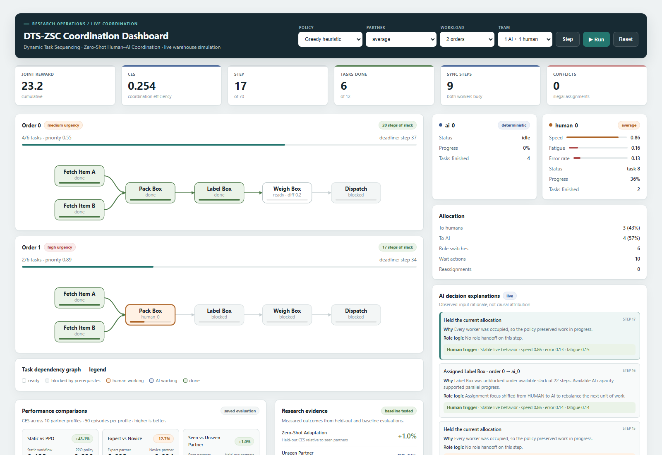

Running desktop state. The live episode occupies the left side; worker state and decision context stay visible in the right rail. The lower panels contain saved evaluation evidence.

The page is organized into five levels:

1. Scenario controls define the policy, partner, workload, and team.
2. Episode metrics summarize the current run.
3. Order workflow cards show what work is ready, active, blocked, or complete.
4. Worker and explanation panels show who is doing the work and the context behind coordinator decisions.
5. Evaluation panels put the live demonstration in the context of repeatable research results.

This hierarchy is intentional: the most frequently used controls and live state are at the top, detailed operational context is beside the workflow, and slower-changing research evidence is below it.

2. Header and scenario controls

The dark header visually separates experiment configuration from simulation results. Every selector has a permanent label so its meaning remains visible after a value is chosen.

Element What it means Why it is in the UI
Policy Chooses the coordinator: PPO, Greedy, Static, or Random. Makes learned and baseline behavior observable under the same type of scenario.
Partner Chooses a simulated human behavior profile. Profiles are grouped as seen during training or held-out. Lets a researcher inspect adaptation to different human speeds, fatigue, and error patterns.
Workload Selects one, two, or three orders. Changes task volume and deadline pressure without changing the page structure.
Team Selects 1 AI + 1 human, 1 AI + 2 humans, or 2 AI + 2 humans. Exposes coordination behavior at different team sizes.
Step Advances the environment by one decision tick. Supports slow, inspectable debugging and demonstrations.
Run / Pause Automatically advances the environment or pauses it at the current step. Supports continuous playback without removing manual control.
Reset Starts a new episode using the selected configuration. Applies selector changes and returns the simulation to a known initial state.

Policy meanings

Policy Behavior
PPO agent (learned) Uses the trained reinforcement-learning policy when a compatible checkpoint is available.
Greedy heuristic Ranks ready tasks by urgency and dependency value, then selects the free worker with the best estimated completion time from observable signals.
Static workflow Follows a fixed task order and round-robin assignment. It does not adapt to the current partner.
Random baseline Selects uniformly from currently legal actions and represents a lower-bound baseline.

All policies receive the same legality mask. Illegal actions therefore fall back to waiting rather than giving one policy an unfair conflict penalty.

Button states

• The primary Run button uses teal because it starts the main action.
• Step is quieter because it is a secondary, deliberate action.
• Reset is outlined to distinguish restarting from advancing.
• Step and Run become visibly disabled when an episode finishes or reaches its step limit. A disabled button is unavailable, not missing.

3. Live episode metrics

The six cards under the header provide a single-row health check on large screens and reflow into smaller grids on narrow screens.

Metric Definition How to read it
Joint reward Cumulative environment reward earned by the team in the current episode. Higher is generally better, but use CES for a normalized coordination comparison.
CES Coordination Efficiency Score calculated from task completion, speed, synchronization, on-time orders, and conflicts. Higher is better. The implemented theoretical range is -0.10 to 0.90.
Step Current simulation step out of the maximum allowed steps. Shows how much of the episode time budget has been consumed.
Tasks done Completed tasks out of all tasks across all orders. Direct measure of work completed. Each order contains six tasks.
Sync steps Steps during which at least two workers were busy. Indicates parallel human-AI activity rather than sequential work.
Conflicts Illegal assignment attempts recorded by the environment. Lower is better. The action mask normally keeps this at zero.

The CES formula is:

CES = 0.35 x completion rate
+ 0.20 x speed score
+ 0.15 x synchronization score
+ 0.20 x on-time order rate
- 0.10 x conflict rate

CES is shown as an em dash before the first step because there is not yet meaningful episode activity to score.

4. Order cards and completion line

Each order card is a compact operational view of one six-task order.

Order header

Element Meaning
Order number Stable identifier for the order.
Urgency tag Human-readable category derived from the order priority. Red indicates high urgency; amber indicates medium urgency.
x/6 tasks Number of completed tasks in this order.
Priority Numeric weight used by policies and the environment to represent importance.
Slack / complete tag Remaining time before the deadline, or a completed state.
Deadline Step by which the order should be completed.

The long line is task completion, not deadline progress

The line directly below x/6 tasks fills from left to right as tasks complete:

• 0/6 = 0% filled
• 3/6 = 50% filled
• 6/6 = 100% filled

Teal means active progress, green means the order is complete, and red means the order is still unfinished after its deadline. The deadline text on the right is a reference value; it is not a second bar and does not fill in the opposite direction.

This separation prevents two different concepts from being mixed: completion answers much work is finished? while deadline/slack answers much time remains?

. Task dependency graph

Every order follows this dependency sequence:

Pick Item ------\
> Pack Box -> Label Box -> Weigh Box -> Dispatch
Fetch Box ------/

Pick Item and Fetch Box can begin independently. Packing becomes available only after both are complete; the remaining tasks then unlock in sequence. Arrows make these prerequisites explicit, and an arrow turns green after its upstream dependency has been satisfied.

Task-node states

Appearance Meaning Why this color is used
White with neutral outline Ready to be assigned. High contrast without implying ownership.
Pale grey Blocked by prerequisites. Visually recedes until it becomes actionable.
Ochre / amber A human is working on the task. Matches the human identity color used in worker cards.
Indigo An AI worker is working on the task. Matches the AI identity color used throughout the page.
Pale green Task is complete. Consistent success/completion signal.

The small label inside a node shows its current state: ready, blocked, the assigned worker name, starting, or done. The thin inner line at the bottom of a node is that task's own execution progress; it is different from the full-order completion line above the graph.

The fetch nodes are the same visual scale as the downstream tasks. On small screens, the graph keeps a readable minimum width and can be scrolled horizontally instead of shrinking the labels until they become unreadable.

6. Worker cards

Worker cards answer two questions: who is available? and what is their current operating condition?

AI worker

• Indigo dot identifies AI consistently with indigo task nodes.
• Status reports idle or active task state.
• Progress reports completion of the AI worker's current task.
• Tasks finished is the worker's completed-task count.
• The profile badge indicates deterministic AI operation in the live demonstration.

Human worker

• Ochre dot identifies a human consistently with ochre task nodes.
• Speed is the observed normalized working pace; 1.00 is baseline speed or faster.
• Fatigue is a normalized value from 0 to 1.
• Error rate is the recently observed error frequency.
• Status, Progress, and Tasks finished have the same meanings as on the AI card.
• A red zero-shot tag means this partner profile was held out from training.

The horizontal tracks make human behavior signals scannable without requiring readers to compare several decimal values mentally. The numeric values remain visible for exact interpretation.

7. Allocation summary

The allocation card summarizes coordination behavior over the current episode.

Field Meaning
To humans Accepted assignments sent to human workers, with their share of all accepted assignments.
To AI Accepted assignments sent to AI workers, with their share.
Role switches Changes between human and AI assignment types across accepted decisions.
Wait actions Decisions in which no new task was assigned. Waiting can be correct when all workers are occupied or no task is unblocked.
Reassignments In-progress tasks moved to another worker. Because takeover forfeits existing progress, a high count can indicate disruptive coordination churn.

The allocation summary is descriptive, not a target quota. A 50/50 split is not automatically better than an adaptive split suited to the active partner and workload.

8. AI decision explanations

The explanation panel translates each coordinator action into operational language. Newest decisions appear first, and each record includes its simulation step.

Each explanation contains:

• Decision hat the coordinator did, such as assigning a task, changing its holder, or maintaining the current allocation.
• Why elevant task availability, timing, or worker availability at that step.
• Role logic hy the selected worker type or unchanged ownership made operational sense.
• Human trigger bserved human speed, error, fatigue, or delayed-response signals relevant to the decision context.

The panel says input rationale, not causal attributionntentionally. It explains a decision using inputs available to the coordinator; it does not claim to expose the PPO network's private internal chain of thought or prove that one input alone caused the action.

Green trigger strips indicate stable observed human behavior. Amber draws attention to fatigue, errors, or delayed responses that may affect assignment suitability.

9. Performance comparisons

The comparison panel contains saved evaluation results, not the single live episode. It reports CES across 10 partner profiles and 50 episodes per profile so the user does not mistake one animation for statistical evidence.

Comparison What it answers
Static vs PPO Does the learned coordinator improve on a fixed, non-adaptive workflow?
Expert vs Novice How does PPO performance change between a fast/expert and a slower/novice partner?
Seen vs Unseen Partner How well does PPO transfer to held-out partner profiles without retraining?

Each card shows both CES values as comparable bars. The percentage badge reports the right-hand result relative to the left-hand result. Positive and negative signs therefore describe direction, not automatically good or bad; for example, a novice score below an expert score is expected to display a negative difference.

10. Research evidence

The research evidence panel turns the evaluated results into five thesis-level outcomes.

Evidence item Definition
Zero-Shot Adaptation Held-out-partner CES relative to seen-partner CES.
Unseen Partner Solve rate across the held-out-partner episodes, without retraining.
Coordination Improvement Overall PPO CES relative to the static baseline.
Idle Time Reduction Change in the fully idle step rate versus Static, measured across 500 episodes per policy. A negative displayed change means fewer idle steps.
Conflict Reduction Change in disruptive in-progress task takeovers versus Random. Illegal conflicts remained zero for all legality-masked policies, so the card states this caveat explicitly.

The values come from results/evaluation.json and results/research_evidence.json. The saved evaluation and baseline tested tags distinguish measured artifacts from live simulation state.

11. Completed episode

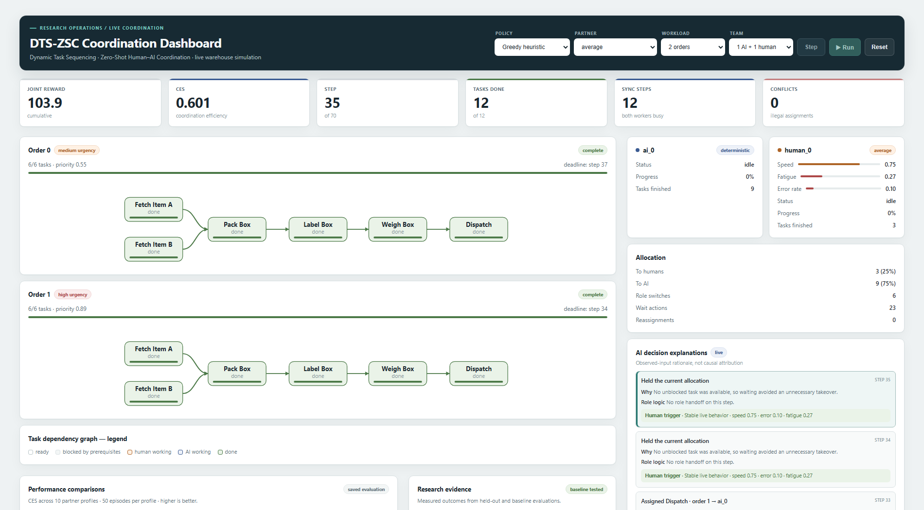

Completed desktop state. Order bars and workflow nodes are green, while Step and Run are disabled because no further simulation action is available.

At successful completion:

• Every order shows a green complete tag.
• Every order-completion line is filled fully in green.
• Every graph node is in the done state.
• Step and Run are disabled.
• The bottom status message summarizes completion step, CES, and reward.

If the maximum step count is reached first, the status uses the failure/risk treatment and reports how many tasks and orders were completed before truncation.

12. Responsive behavior

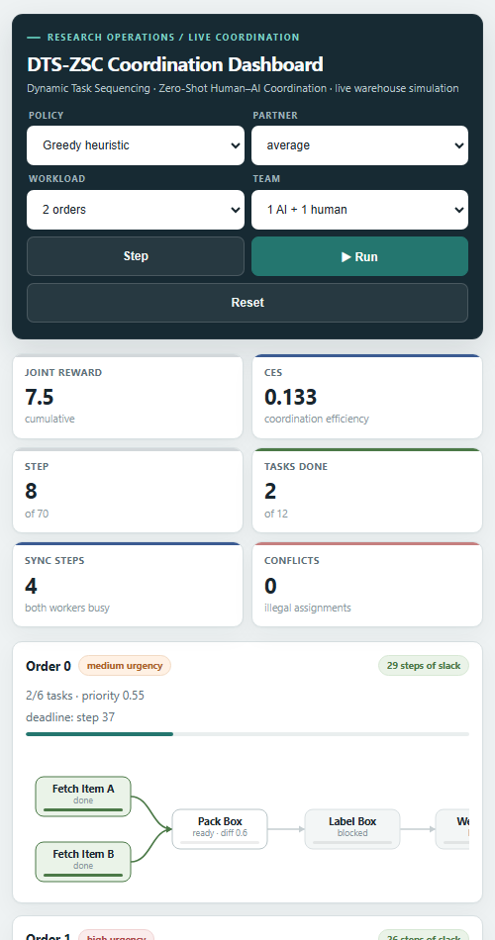

Mobile state. Controls and metrics reflow into compact grids, panels stack vertically, and the dependency graph remains readable through horizontal scrolling.

The same content is preserved at all supported widths:

• On wide desktop screens, order workflows use the main column and worker/explanation panels form a right rail.
• On medium screens, the right rail moves below the simulation instead of compressing text.
• On phones, controls and metric cards use two-column grids and secondary sections stack into one column.
• Dependency graphs retain legible nodes and use horizontal scrolling when the screen is narrower than the workflow.
• Buttons remain full-height touch targets and labels stay visible.

This is a full-width layout with a small page gutter rather than a narrow fixed-width canvas. It uses CSS Grid for page regions and Flexbox where content needs to wrap naturally.

13. Color and visual-language reference

Color family Meaning
Dark slate / navy Application identity and experiment controls.
Teal Primary action and live completion progress.
Indigo AI identity and AI-owned work.
Ochre / amber Human identity, human-owned work, or attention.
Green Completed, successful, or stable state.
Red High urgency, zero-shot warning, missed deadline, conflict, or failure.
Grey Blocked, disabled, or secondary information.

Color is reinforced by text, labels, percentages, and status words so it is never the only way to understand a state.

14. Data boundaries and interpretation

• Live panels etrics, order cards, workers, allocation, explanations, and status escribe the current episode only.
• Saved evaluation panels omparisons and research evidence ummarize repeated evaluation runs from result files.
• An attractive live run is a demonstration, not proof of general performance; use the evaluation panels for research claims.
• Decision explanations are contextual summaries of observable inputs, not causal model introspection.
• Conflict counts and takeover counts are distinct: a takeover may be legal but still disruptive.

15. Running the dashboard

From the repository root:

python app.py

Then open http://localhost:5000 (http://localhost:5000). Select a scenario, press Reset to apply it, and use Step for inspection or Run for continuous playback.

The dashboard is self-contained: its component styles, responsive rules, icons, and workflow graphics are defined within the application rather than loaded from an external UI framework or image service.

