E-Commerce Sales Analysis

1. Project Overview

This project analyzes e-commerce transactions to understand sales performance, customer behavior, product performance, and business opportunities.
Tools Used:
- PostgreSQL
- Python
- Pandas
- Matplotlib
- Seaborn

2. Dataset Overview
The original dataset contained 541,909 transactions.
After data cleaning:
- Rows: 397,884
- Customers: 4,338
- Countries: 37

3. Data Cleaning
Steps performed:
- Removed missing CustomerID values
- Removed duplicates
- Created Total Price column
- Extracted Year_Month column
- Extracted Day_Time column

4. Revenue Analysis

Total Revenue
£8.91 Million

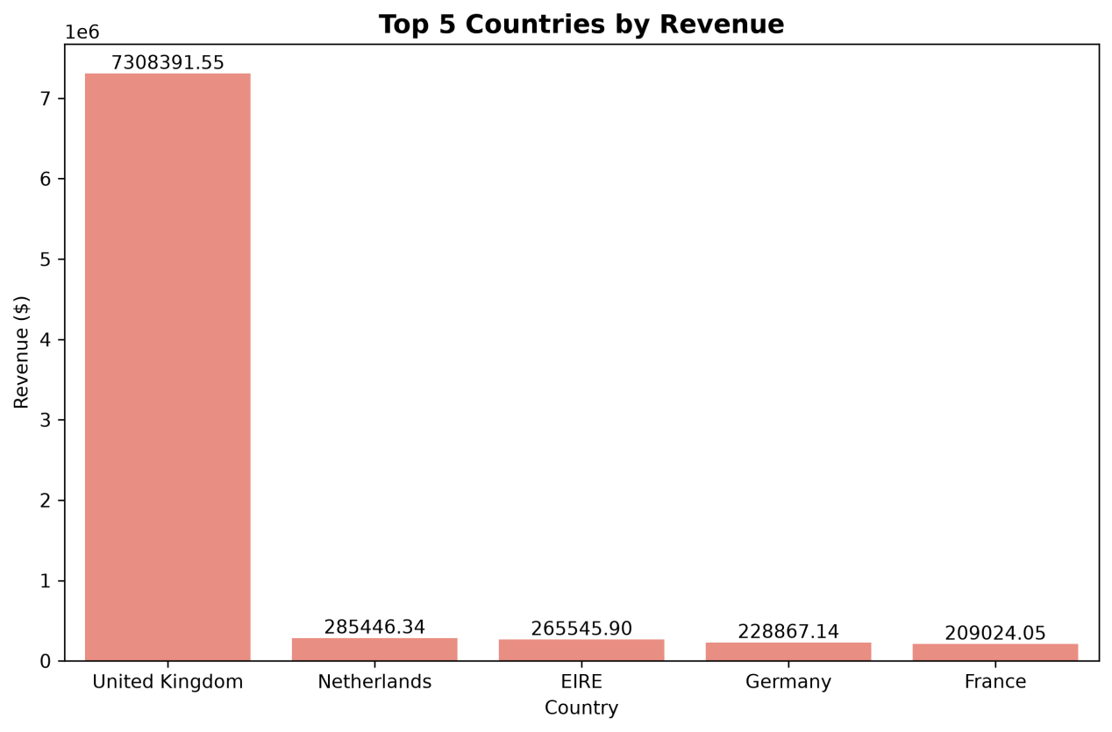
Revenue by Country
Finding
United Kingdom generated the highest revenue.
Business Insight
The company depends heavily on the UK market. Expanding internationally may reduce risk and increase growth opportunities.

5. Product Analysis
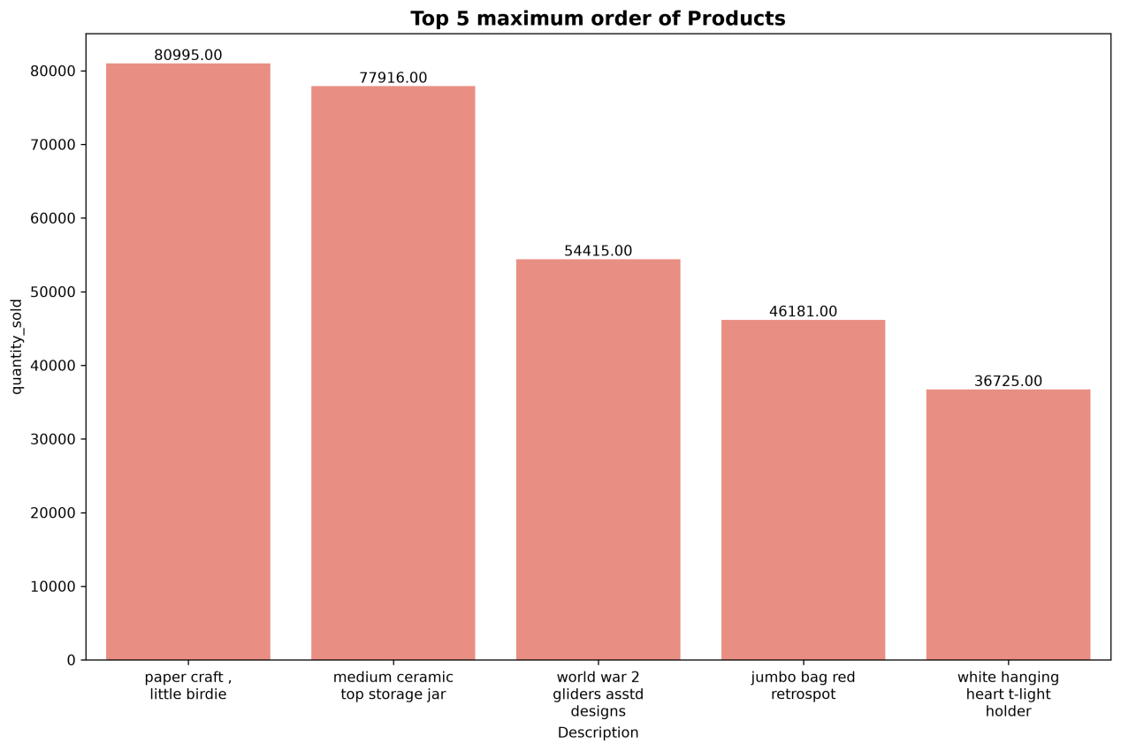
Finding
Paper Craft, Little Birdie generated the highest revenue.
Business Insight
The company should prioritize inventory and marketing efforts for high-performing products.

6. Recommendations
- Increase inventory for top-selling products.
- Expand marketing outside the UK.
- Focus customer retention on high-value customers.
- Monitor sales trends monthly.
- Investigate product returns and customer satisfaction.

7. Conclusion
The analysis identified major revenue drivers, top-performing products, and key markets. The UK contributes most of the revenue, while a small number of products generate a large share of sales.

