Evaluating ANN and Matrix-Product-State Signals
in a FinRL PPO Agent
Aarav Nagar
July 2026
Abstract
This study examines whether a quantum-inspired matrix-product-state (MPS) model provides a more useful trading signal than a conventional artificial neural network (ANN). The two models were matched in parameter count and trained on the same inputs and next-day return target. Their predictions were added separately to the state of a FinRL Proximal Policy Optimization (PPO) agent. The MPS produced slightly lower prediction error and higher directional accuracy, but the ANN-based agent achieved a higher mean out-of-sample Sharpe ratio (0.735 compared with 0.694). MPS trailed ANN in all three paired seeds, and a block-bootstrap confidence interval for the annualized return difference included zero. Under this setup, the MPS signal did not improve trading performance.

1. Research Question
My earlier project compared quantum-inspired neural networks with hybrid ensemble ANNs for stock-market prediction. One question remained: if one model predicts returns slightly better, will a trading agent actually make better decisions when transaction costs and changing market conditions are included?
Following Professor Xiao-Yang Liu's suggestion, I tested the prediction models as state signals inside a FinRL benchmark. The experiment asks whether an MPS signal improves out-of-sample trading performance when the data, parameter count, PPO configuration, costs, and random seeds are held constant.

2. Experimental Design

2.1 Data and time split
The experiment used 15 stocks from the processed Nasdaq dataset associated with the FinRL Contest 2025 workflow: AAPL, AMD, AMGN, AMZN, COST, FANG, GILD, HON, INTC, MSFT, NFLX, NVDA, PEP, SBUX, and XEL.
The ANN and MPS models were fit on 2013-2017 data and validated on 2018. PPO was trained on 2013-2018 and evaluated out of sample on 2019-2023. No test-period return target was used to fit either prediction model or PPO policy. The data were checksum-pinned, and the environment used FinRL commit 2334a5fe6d30629157f13c3b0319e1637e15e123.

2.2 Prediction models
Both models used the same 13 market features and predicted the same standardized next-day return. The ANN used fully connected layers of 13-16-8-1. The MPS used a trigonometric local feature map and bond dimension 4. Each model contained exactly 369 trainable parameters. The MPS was simulated on classical hardware; no qubits were used.

2.3 PPO state construction
Table 1. State construction for the three PPO conditions
Condition | State supplied to PPO | Dimension
Base FinRL | Cash, prices, holdings, and 10 indicators per stock | 181
ANN signal | Base state plus one frozen ANN prediction per stock | 196
MPS signal | Base state plus one frozen MPS prediction per stock | 196

The base state contained one cash value, 15 prices, 15 holdings, and 10 indicators for each stock. For the signal conditions, a 15-value prediction vector was appended as one additional indicator block.
Base: 1 + 15 + 15 + (10 x 15) = 181 values
Signal: 1 + 15 + 15 + (11 x 15) = 196 values
The prediction model was frozen during PPO training, so the ANN and MPS agents differed only in the final 15 state values.

2.4 Trading setup
Each PPO condition used the same two-layer 64-unit policy and value network, 5,000 environment steps, three optimization epochs per update, and seeds 0, 1, and 2. The starting portfolio was $1,000,000. A 0.10% transaction cost was applied to every executed buy and sell. Daily turnover was defined as gross executed notional divided by beginning-of-step portfolio value.
The backtest did not model bid-ask spread, slippage, market impact, taxes, liquidity limits, or borrow costs.

3. Results

3.1 Prediction results
The MPS achieved slightly lower mean-squared error and slightly higher directional accuracy. Its information coefficient was slightly negative, however, so the prediction evidence was mixed.
Table 2. Out-of-sample prediction results, 2019-2023
Model | Parameters | MSE | Directional accuracy | Information coefficient
ANN | 369 | 1.5101 | 50.25% | +0.0119
MPS | 369 | 1.5034 | 51.06% | -0.0060

3.2 Trading results
The small improvement in two prediction metrics did not carry over to the PPO backtest.
Table 3. Mean out-of-sample portfolio results
Condition | Total return | Sharpe | Maximum drawdown | Turnover | Total cost
Base FinRL | 73.24% | 0.559 | -40.46% | 26.43% | $1,375.38
ANN signal | 104.66% | 0.735 | -27.55% | 27.32% | $1,429.65
MPS signal | 94.27% | 0.694 | -26.79% | 24.14% | $1,253.61
Equal-weight | 218.25% | 1.115 | -28.54% | 20.06% | $1,000.00

The PPO values are means across three seeds. MPS produced a lower Sharpe than ANN in every paired run: 0.759 compared with 0.790 for seed 0, 0.726 compared with 0.812 for seed 1, and 0.596 compared with 0.602 for seed 2. MPS traded less and had a slightly smaller mean drawdown, but it also produced lower return and risk-adjusted performance.
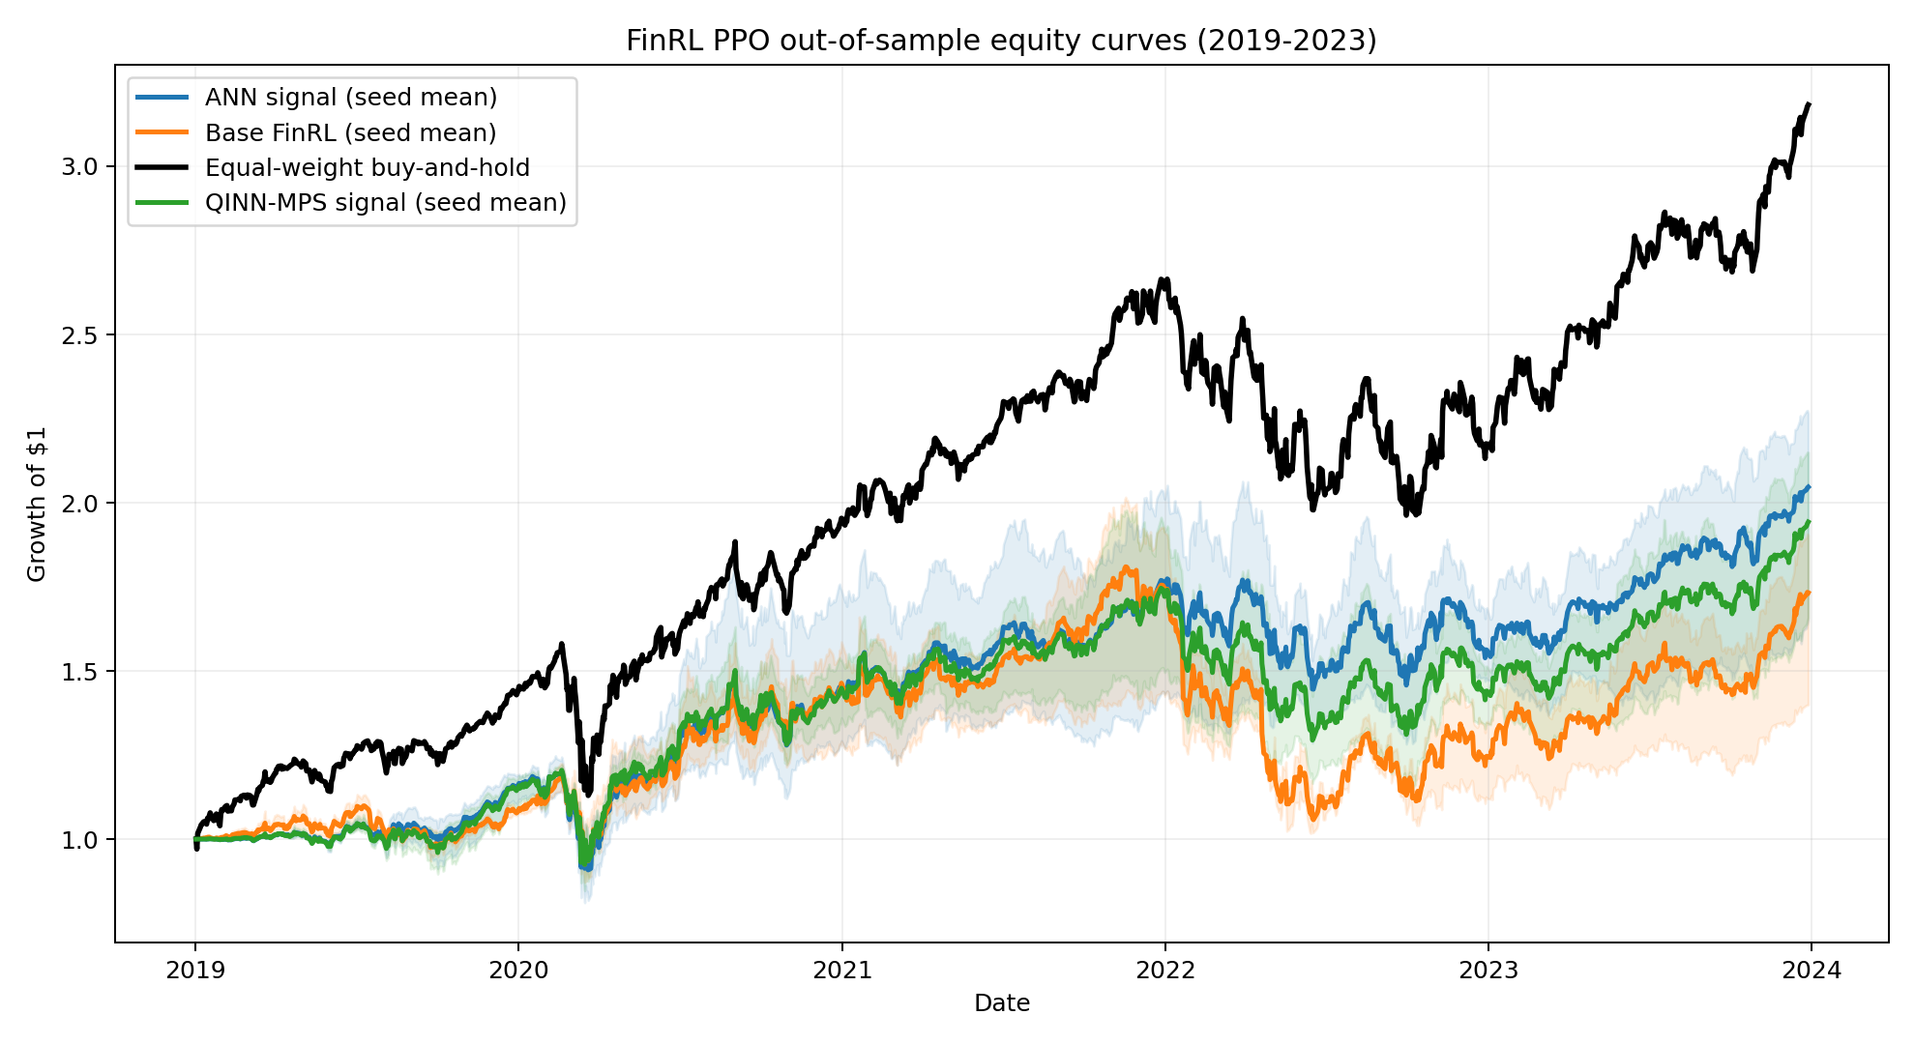
Figure 1. Mean out-of-sample equity curves. Shaded regions show variation across PPO seeds.

3.3 Uncertainty and performance across years
Daily returns were averaged across seeds and evaluated with a moving 20-trading-day block bootstrap using 2,000 samples. The annualized return difference, MPS minus ANN, was -0.92 percentage points. The 95% interval was -4.63 to +2.63 percentage points, and the bootstrap probability that MPS exceeded ANN was 31.05%. Because the interval includes zero, the experiment does not establish a reliable difference between the two signal agents.
The results also varied across calendar years. MPS outperformed ANN in 2020 and 2023, while ANN outperformed MPS in 2019, 2021, and 2022. Neither signal agent beat the equal-weight benchmark over the full test period.

4. Discussion
Under this dataset, time split, parameter budget, PPO configuration, and set of random seeds, the MPS signal did not improve trading performance relative to the ANN signal.
The prediction and trading results should be considered separately. The MPS had slightly better MSE and directional accuracy, but the ANN agent produced a higher Sharpe ratio in each paired PPO run. A trading agent responds to a sequence of noisy predictions together with its portfolio state, costs, and earlier actions; a small improvement in one-step prediction is therefore not enough by itself to guarantee a better policy.
None of the PPO agents beat the equal-weight buy-and-hold portfolio over this Nasdaq-heavy test period. The study therefore does not claim market-beating performance.

5. Limitations and Next Step
The study used a single historical split, three PPO seeds, one MPS bond dimension, and a 5,000-step PPO training budget. The 15-stock universe is small and not sector-neutral. Trading activity also became very low later in the test period, suggesting that some policies settled into nearly static positions.
Before testing a tensor-network policy architecture, I would strengthen this baseline with more random seeds, a longer PPO training budget, and rolling or expanding-window retraining. A policy-level comparison would then be easier to interpret.

6. Reproducibility
The repository contains the experiment pipeline, integrity tests, daily equity curves, per-seed metrics, calendar-year results, bootstrap output, and a run manifest with the dataset checksum, FinRL commit, configuration, and known limitations.
Repository: https://github.com/Aarav-Nagar/QINN-FinRL-Evaluation

References
1. Biamonte, J., et al. “Quantum Machine Learning.” Nature, vol. 549, 2017, pp. 195-202.
2. Liu, X.-Y., and Y. Fang. “Quantum Tensor Networks for Variational Reinforcement Learning.” NeurIPS 2020 Quantum Tensor Networks in Machine Learning Workshop.
3. NeurIPS 2020 Quantum Tensor Networks in Machine Learning Workshop. https://tensorworkshop.github.io/NeurIPS2020/accepted_papers.html
4. NeurIPS 2021 Quantum Tensor Networks in Machine Learning Workshop. https://tensorworkshop.github.io/NeurIPS2021/accepted_papers.html
5. FinRL Contest 2025. “Task 1: FinRL-DeepSeek for Stock Trading.” https://finrl-contest.readthedocs.io/en/latest/finrl2025/task1.html
6. AI4Finance Foundation. FinRL. Commit 2334a5fe6d30629157f13c3b0319e1637e15e123.

