ANN vs. Quantum-Inspired MPS Signals
A reproducible evaluation inside a FinRL PPO trading agent
Author: Aarav Nagar
Evaluation: Out-of-sample 2019-2023
Prepared: July 24, 2026
Scope: Classical tensor-network simulation; no quantum hardware
Main finding: The MPS predictor had slightly better prediction error and directional accuracy, but its PPO agent did not outperform the matched ANN agent.

Executive summary
Professor Xiao-Yang Liu suggested testing whether a quantum-inspired representation improves sequential decisions when injected into FinRL. I compared Base FinRL, ANN-signal, and QINN-MPS-signal PPO agents under identical dates, assets, costs, policy settings, and seeds.
- Mean Sharpe: ANN 0.735, QINN-MPS 0.694, Base FinRL 0.559.
- MPS trailed ANN in all three paired seeds; the paired annualized return difference was -0.92 percentage points.
- A 20-day block bootstrap 95% interval was [-4.63, +2.63] percentage points, so the difference is not statistically established.
- Mean annualized turnover was 27.32% for ANN and 24.14% for MPS; all transaction costs reconcile to executed notional at 0.10%.

1. Research question and protocol
Research question: Does a parameter-matched quantum-inspired MPS prediction signal improve FinRL trading performance or robustness relative to an ANN signal?

Conditions
Condition | State supplied to PPO | Dimension
Base FinRL | Cash, prices, holdings, 10 indicators/asset | 181
ANN signal | Base state + one frozen ANN signal/asset | 196
QINN-MPS signal | Base state + one frozen MPS signal/asset | 196

Chronology and controls
- 2013-2017: fit the ANN and MPS encoders.
- 2018: encoder validation and early stopping.
- 2013-2018: PPO policy training.
- 2019-2023: locked out-of-sample evaluation.
The same 15 stocks, 13 encoder inputs, next-day return target, optimizer family, 0.10% buy/sell cost, PPO network, 5,000-step budget, and seeds 0, 1, and 2 were used in every comparison.

Parameter-matched encoders
The ANN uses a 13-16-8-1 tanh network. The MPS uses a trigonometric local feature map and bond dimension 4. Each contains exactly 369 trainable parameters. The MPS runs classically and does not imply quantum advantage.

Exact signal entry
Base state = 1 cash + 15 prices + 15 holdings + (10 indicators x 15 assets) = 181 values.
Signal state = base state + one standardized, clipped, frozen encoder prediction per asset = 196 values. The 15 predictions are appended as the final per-asset indicator block; the encoder is not updated by PPO.

2. Prediction and portfolio results

Prediction metrics on untouched 2019-2023 targets
Encoder | Parameters | MSE | MAE | Direction | IC
ANN | 369 | 1.5101 | 0.7994 | 50.25% | +0.0119
QINN-MPS | 369 | 1.5034 | 0.7967 | 51.06% | -0.0060

MPS had slightly lower error and higher directional accuracy, while its information coefficient was slightly negative. Predictive evidence was mixed before the trading comparison.

Mean portfolio results
Condition | Return | Sharpe | Max DD | Turnover | Cost
Base FinRL | 73.24% | 0.559 | -40.46% | 26.43% | $1,375
ANN signal | 104.66% | 0.735 | -27.55% | 27.32% | $1,430
QINN-MPS signal | 94.27% | 0.694 | -26.79% | 24.14% | $1,254
Equal-weight | 218.25% | 1.115 | -28.54% | 20.06% | $1,000

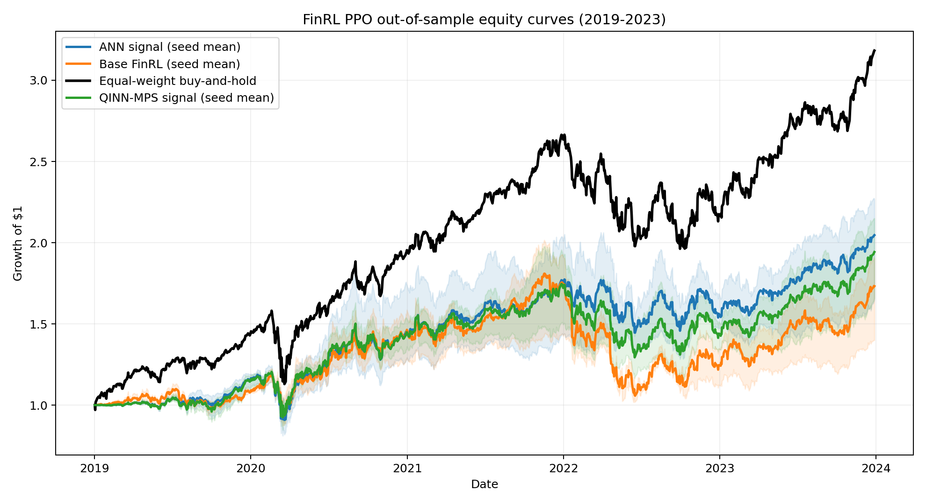
Figure 1. Out-of-sample equity curves; shading spans PPO seeds.

3. Seeds, uncertainty, turnover, and costs

Seed-level Sharpe
Seed | Base | ANN | MPS | MPS - ANN
0 | 0.436 | 0.790 | 0.759 | -0.032
1 | 0.633 | 0.812 | 0.726 | -0.086
2 | 0.608 | 0.602 | 0.596 | -0.006

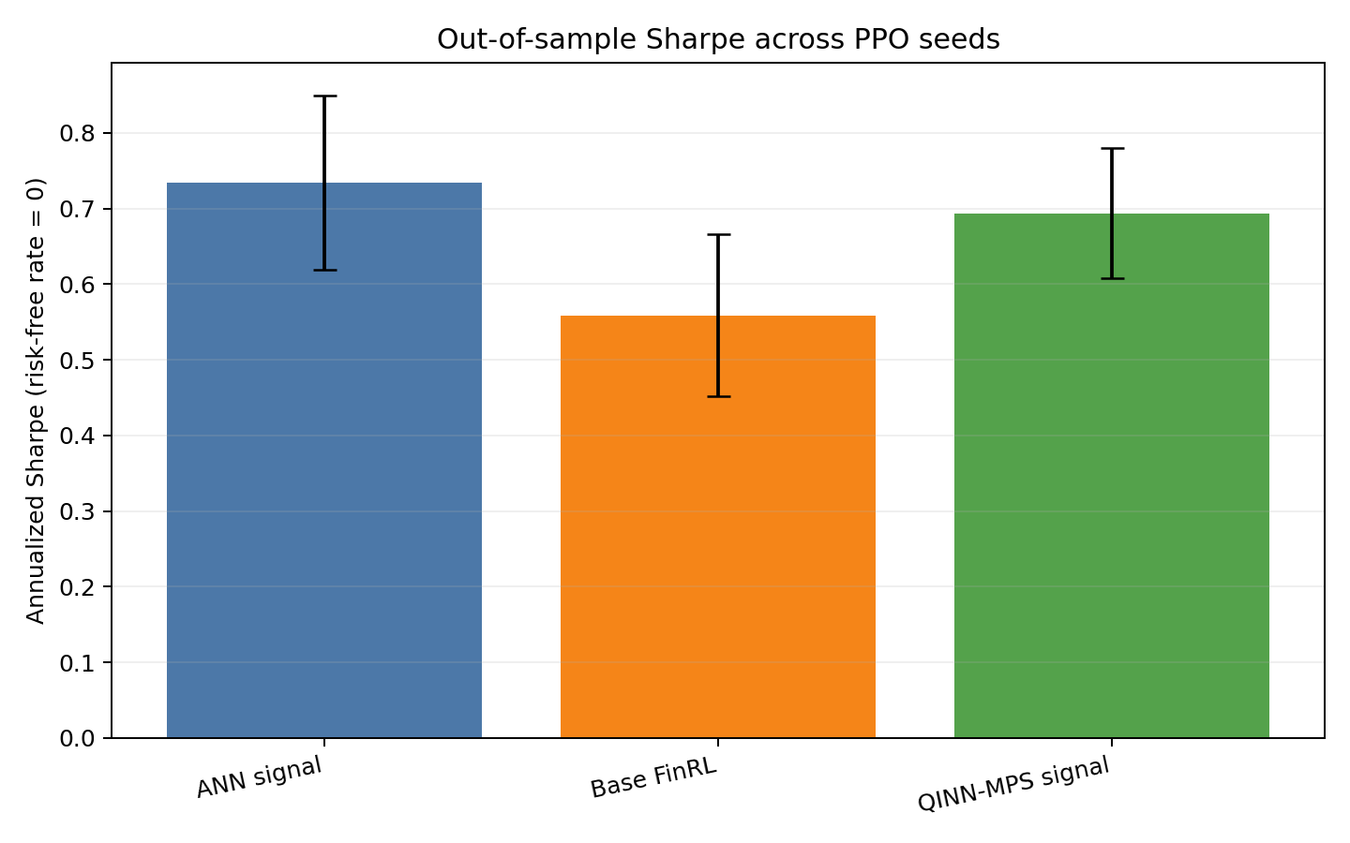
Figure 2. Mean Sharpe and seed-to-seed standard deviation.

Paired uncertainty
A moving 20-day block bootstrap with 2,000 samples estimated the annualized MPS-minus-ANN mean-return difference at -0.92%, with a 95% interval of [-4.63%, 2.63%]. The interval includes zero.

Turnover and transaction costs
Daily gross turnover equals executed share notional divided by beginning-of-step portfolio value. Mean annualized turnover was 27.32% for ANN, 24.14% for MPS, and 26.43% for Base FinRL.
At a fixed 0.10% buy/sell fee, five-year mean costs were $1,429.65 for ANN, $1,253.61 for MPS, and $1,375.38 for Base FinRL. Every cost total reconciles exactly to gross executed notional x 0.001.

4. Market-period robustness
Year | Base | ANN | MPS | Equal-weight
2019 | 8.00% | 15.69% | 14.85% | 43.52%
2020 | 35.48% | 25.85% | 26.28% | 36.13%
2021 | 18.36% | 20.48% | 18.70% | 34.88%
2022 | -27.71% | -9.24% | -15.79% | -17.47%
2023 | 38.40% | 30.72% | 34.55% | 46.34%

Calendar years were used to avoid selecting favorable regimes after observing results. MPS beat ANN in 2020 and 2023; ANN beat MPS in 2019, 2021, and 2022. No stable MPS advantage appears.
Trading was concentrated early. Mean annualized turnover fell from about 103% for ANN and 100% for MPS in 2019 to below 1% for both by 2023. Longer PPO training and rolling retraining should test whether later policies became excessively static.

Interpretation
Supported conclusion: For this dataset, parameter budget, PPO configuration, three seeds, and historical split, a quantum-inspired MPS signal did not improve FinRL trading performance over an equally sized ANN signal.

The result does not generalize to all tensor networks. It demonstrates the prediction-decision gap: MPS slightly improved some prediction metrics, but ANN produced higher Sharpe in every paired trading seed.

Limitations
- One chronological split and a 15-stock Nasdaq subset.
- Three seeds and a scoped 5,000-step PPO training budget.
- Classical MPS simulation; no quantum hardware or quantum advantage claim.
- Fixed 0.10% fee but no spread, slippage, impact, taxes, or borrow costs.
- Calendar years do not replace rolling or expanding-window evaluation.

5. Recommended ATL/FinRL continuation
The strongest next step is to strengthen the evaluation before adding a tensor-network policy head.
- Increase PPO training to at least 50,000 steps and use 10 or more seeds.
- Add rolling or expanding-window retraining.
- Predeclare and compare several MPS bond dimensions.
- Add exposure, concentration, slippage, and crisis-window diagnostics.
- Then compare a tensor-network policy head against this external-signal design.

Reproducibility package
- run_experiment.py - complete data, encoder, PPO, and evaluation pipeline.
- test_experiment.py - six focused integrity tests.
- results/ppo_backtest_metrics.csv - per-seed full-period metrics.
- results/equity_curves.csv - daily returns, notional, turnover, and costs.
- results/annual_period_metrics.csv - calendar-year metrics by seed.
- results/condition_seed_summary.csv - exploratory seed confidence intervals.
- results/ann_vs_mps_block_bootstrap.csv - paired uncertainty analysis.
- results/run_manifest.json - pinned source, checksums, protocol, and definitions.

References
- Biamonte, J. et al. Quantum Machine Learning. Nature 549, 195-202 (2017). https://www.nature.com/articles/nature23474
- Liu, X.-Y. and Fang, Y. Quantum Tensor Networks for Variational Reinforcement Learning. NeurIPS 2020 Quantum Tensor Networks Workshop.
- NeurIPS 2020 and 2021 Quantum Tensor Networks in Machine Learning Workshop accepted-paper pages. https://tensorworkshop.github.io/
- FinRL Contest 2025 Task 1: FinRL-DeepSeek for Stock Trading. https://finrl-contest.readthedocs.io/en/latest/finrl2025/task1.html
- Wang, K. et al. FinRL Contests: Benchmarking Data-driven Financial Reinforcement Learning Agents. arXiv:2504.02281 (2025).

