**1.0 Scope of the Project**

This software system will be an online portal for students of a university and HR officials of different companies. Students register with the system to apply for jobs, participate in discussions etc. The company officials interact with the portal to register a new company, to post new jobs (by creating new groups or job web pages), start discussion threads, give permission to students to participate in discussions etc. This system will be designed to benefit the students mostly. They can search for a job and apply for it, all in one place! They need not browse through each company’s website to apply for a job.

Also, this system’s design will allow a company official to manage and communicate with a group of students and get them to apply for the job. The official creates a new page/group (represents a job) whenever there is a requirement for the position. The software will facilitate communication between company officials and the students via e-mail and text. The relational database contains the list of companies, jobs and the details of the students applying.

**2.0 Technology**

|  |  |
| --- | --- |
| Operating System: | Windows 7 |
| IDE: | Microsoft Visual Studio Express-Web 2012, Eclipse IDE |
| Framework: | .NET 4.0/4.5 Framework |
| Application Architecture: | MVC Architecture |
| Web Services: | REST |
| Web Technologies: | jQuery, JavaScript, jQuery Mobile, HTML |
| Database: | Relational, MS-SQL compact |
| Server: | IIS Express 8.0 |
| Additional Software: | Microsoft Web Matrix (Windows Phone Emulator) Android SDK (Android Phone Emulator) |

Screenshots:

Screenshots:

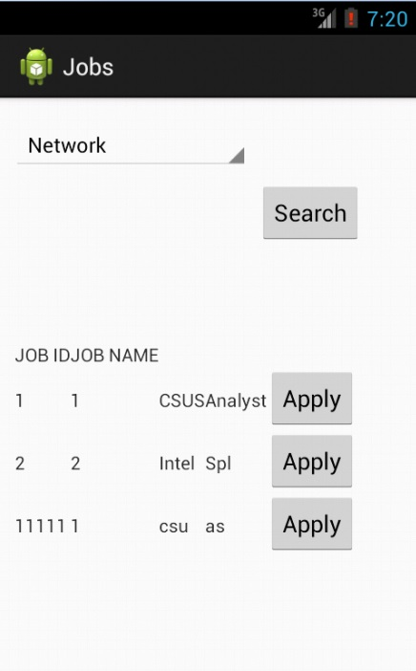

Image 2:

