SOFTWARE REQUIREMENTS SPECIFICATION (SRS)
MovieMatch
A Hybrid Movie Recommendation System using Machine Learning (SVD, KNN) and Generative AI (Google Gemini)
Student Name(s) | Aarav Gupta | Roll Number(s) | 2400320100006
Branch / Department | CSE | College Name | ABES ENGINEERING COLLEGE
Project Guide | Ms. Anshika Chaudhary | Academic Year | 2026-27

1. Abstract
MovieMatch is a hybrid movie recommendation web application that combines classical machine learning with Generative AI. Users often struggle to choose from thousands of titles, and traditional recommenders return only ranked lists without explanation or mood awareness. MovieMatch uses SVD (matrix factorization), KNN (item-based, Pearson baseline) and a baseline model, trained on MovieLens (610 users, 9,742 movies, 100,836 ratings), for personalised Top Picks. Google Gemini 2.5 Flash (via OpenRouter) enhances the results through three features: a dynamic fallback for movies missing from the dataset, AI-generated synopses and a mood-based re-ranker. The system follows a three-tier architecture: a Streamlit frontend, a FastAPI backend with Pydantic validation, and an SQLite database managed through SQLAlchemy in 3NF. Pre-trained models are stored as Pickle files and used by the backend to serve predictions. It is aimed at movie viewers and casual streamers who want quick, trustworthy suggestions. The expected outcome is a modular application that gives accurate, explainable and mood-aware recommendations and reduces the time users spend deciding what to watch.

2. Problem Statement
Choosing a movie from a huge catalogue causes choice paralysis. Rating-based recommenders return only a ranked list: they cannot explain their picks, cannot adapt to the user's mood, and fail for movies that are absent from the training data. MovieMatch solves this by pairing ML-based ranking with Gemini-powered, context-aware suggestions.

3. Objectives
- Build personalised recommendations using SVD, item-based KNN (Pearson baseline) and a baseline model.
- Integrate Gemini for synopses, mood re-ranking and a dynamic fallback for unknown movies.
- Use a modular Streamlit / FastAPI / SQL architecture with a validated REST API.
- Store users, movies, ratings and watchlists in a normalised (3NF) database.
- Provide a simple interface that reduces the time needed to pick a movie.

4. Proposed Solution
How it works: each action in the Streamlit UI (e.g., Top Picks) calls a FastAPI endpoint; the backend reads the database, runs the SVD/KNN models and calls Gemini when needed, then returns JSON that is shown as movie cards. Users: movie viewers and casual streamers. Benefits: faster decisions, explainable and mood-aware picks, and results even for unknown movies.

5. Scope of the Project
Implemented: Top Picks (SVD, KNN, Baseline), similar movies, three Gemini features, ratings and watchlist, validated REST API, 3NF database and Streamlit interface. Outside scope: real-time retraining, password login, mobile app, video streaming, social features and deep learning.

6. Functional Requirements
ID | Functional Requirement
FR-01 | The user shall be able to request personalised Top Picks, ranked by the SVD, KNN or Baseline model they choose.
FR-02 | The user shall be able to open a movie and view six similar movies based on overlapping genres.
FR-03 | The system shall store users, movies, ratings and watchlist entries in a relational database.
FR-04 | The system shall use Gemini as a dynamic fallback when a movie is not found in the dataset.
FR-05 | The system shall generate an AI synopsis for recommended movies.
FR-06 | The user shall be able to log in with a username, rate movies (1–5 stars) and keep a Plan to Watch list.
FR-07 | The user shall be able to enter a mood, and the system shall re-rank the Top Picks accordingly.
FR-08 | The backend shall validate every request with Pydantic and return a clear error (HTTP 422) for invalid input.
FR-09 | The frontend shall keep the user's selections and results during a session (st.session_state).

7. Non-Functional Requirements
Performance: models load once at start-up; Gemini is called only when needed; endpoints reply in under 3 s.
Security: inputs are validated (ratings limited to 1–5), the ORM uses parameterised queries, API keys stay in the backend.
Usability: one-click navigation (Home, Discover, My List, Top Picks), a mood box and readable movie cards.
Reliability: the fallback returns a response even for unknown movies; AI-call failures are handled gracefully.
Scalability: separate frontend, backend and database tiers; SQLAlchemy allows moving from SQLite to PostgreSQL.
Compatibility: runs in any modern browser; no client-side installation; SQLite needs no separate server.

8. Technology Stack
Language | Python 3.14+ | Frontend | Streamlit 1.64 (st.session_state)
Backend | FastAPI 0.141, Pydantic 2.13, Dependency Inj. | Database | SQLite via SQLAlchemy 2.1 ORM
ML Models | scikit-surprise 1.1.5 (SVD, KNN, Baseline) | Generative AI | Gemini 2.5 Flash via OpenRouter API

9. System Architecture
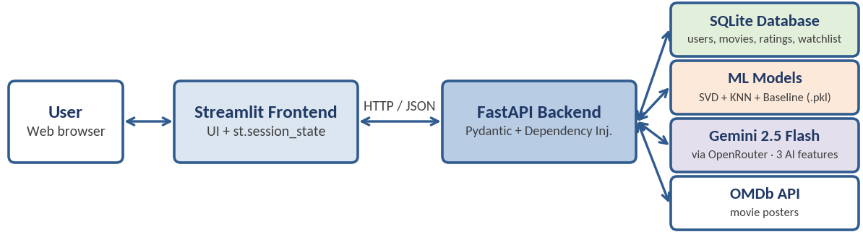
Figure 1: Three-tier architecture – Streamlit frontend, FastAPI backend, SQLite database / ML models / Gemini / OMDb API

10. System Design
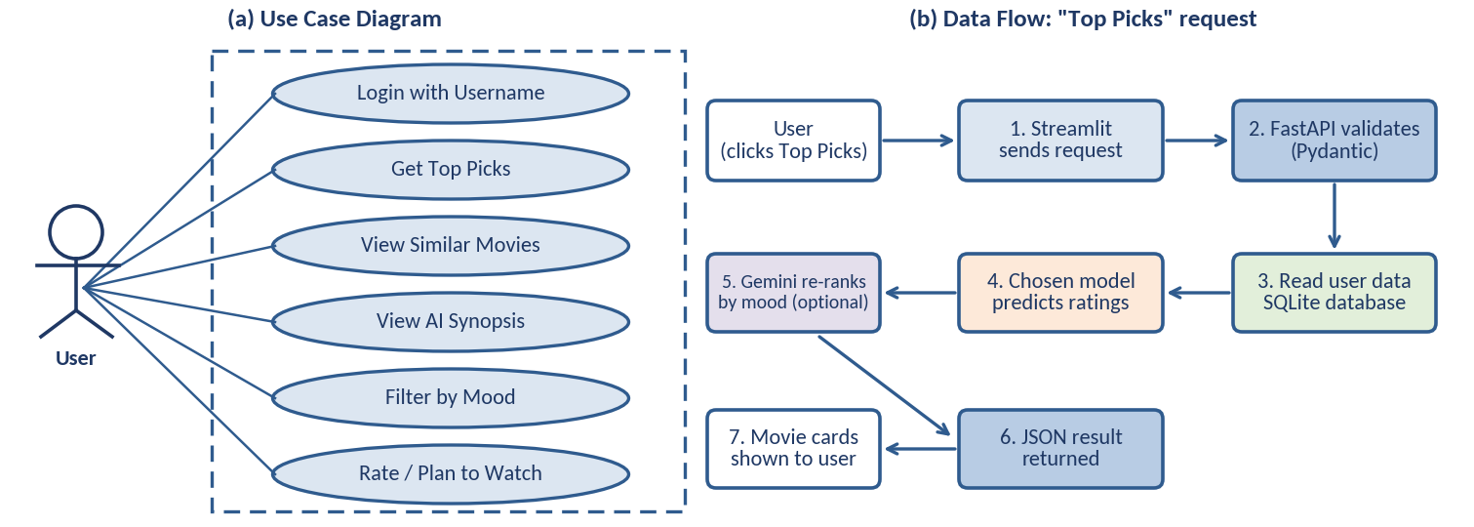
Figure 2: (a) Use case diagram and (b) data flow for a “Top Picks” request

11. Module Description
Module | Functions
1. Frontend (Streamlit) | Login, Home, Discover, My List, Top Picks pages; send API requests; keep session state.
2. Backend API (FastAPI) | Expose endpoints; validate input (Pydantic); manage DB sessions (dependency injection); coordinate ML and Gemini.
3. Data Management | SQLAlchemy models and queries for users, movies, ratings and watchlist.
4. Recommendation Engine | SVD, KNN and Baseline models for Top Picks (Pickle files); genre overlap for similar movies.
5. Gemini AI | Dynamic fallback, synopsis generation and mood re-ranker using structured prompts.

12. Database Design
The schema follows 3NF: no repeated data; tables are linked through user_id and movie_id (SQLAlchemy ORM). | 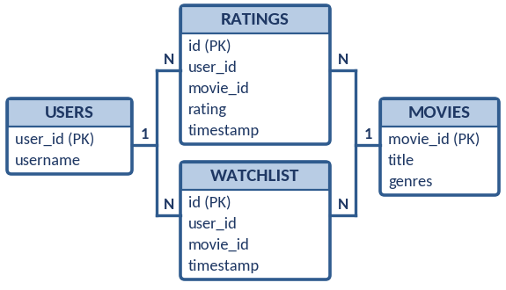  Figure 3: ER diagram
  Table | Key Fields | Purpose
  users | user_id (PK), username (unique) | Stores user identity.
  movies | movie_id (PK), title, genres | Movie catalogue used by the models.
  ratings | id (PK), user_id, movie_id, rating, timestamp | User ratings (1–5); training data.
  watchlist | id (PK), user_id, movie_id, timestamp | Plan to Watch list.

13. Testing
Test ID | Test Case | Expected Result |  | Status
TC01 | Click Top Picks for a user | Personalised, ranked Top Picks are displayed |  | Pass
TC02 | Open a movie for similar titles | Six genre-based similar movies are displayed |  | Pass
TC03 | Search a movie not in the dataset | Gemini fallback returns movie details; no crash |  | Pass
TC04 | Choose a mood (e.g., Cozy) | Recommendations are re-ranked to match the mood |  | Pass
TC05 | Request an AI synopsis | A short synopsis is displayed for the movie |  | Pass
TC06 | Send an invalid API request | Validation error (HTTP 422) is returned |  | Pass
Results: all 15 automated pytest tests pass. Model scores on MovieLens – SVD: RMSE 0.879, MAE 0.673, NDCG 0.956; KNN: 0.852, 0.648, 0.963; Baseline: 0.873, 0.671, 0.959.
14. Limitations  - Gemini features need internet access and depend on API availability, latency and quota.  - Models are trained offline; new ratings are not reflected until retraining.  - New users with no rating history receive less accurate personalised results.  - AI-generated text (e.g., synopses) can occasionally be inaccurate.  - SQLite and username-only login limit scale and security. |  |  | 15. Future Scope  - Automated nightly ML retraining pipeline.  - Neural Collaborative Filtering (deep learning).  - Cloud deployment with a managed PostgreSQL database.  - Caching of Gemini responses to cut latency and cost.  - Mobile application and secure password-based accounts.  - AI Director: Gemini-curated personalised picks.

16. References
- Y. Koren, R. Bell and C. Volinsky, “Matrix Factorization Techniques for Recommender Systems,” IEEE Computer, vol. 42, no. 8, 2009.
- F. Ricci, L. Rokach and B. Shapira (Eds.), Recommender Systems Handbook, Springer.
- F. M. Harper and J. A. Konstan, “The MovieLens Datasets: History and Context,” ACM TiiS, vol. 5, no. 4, 2015.
- N. Hug, “Surprise: A Python library for recommender systems,” JOSS, vol. 5, no. 52, 2020.
- FastAPI – https://fastapi.tiangolo.com | Streamlit – https://docs.streamlit.io
- SQLAlchemy – https://docs.sqlalchemy.org | Pydantic – https://docs.pydantic.dev
- Gemini API – ai.google.dev/gemini-api/docs | OpenRouter – openrouter.ai/docs | OMDb – omdbapi.com

Appendix: Algorithm Evaluation Results
Algorithm | test_rmse | test_mae | Precision | Recall | NDCG
KNNBaseline (pearson_baseline | 0.8527 | 0.6482 | 0.8312 | 0.4132 | 0.9631
CoClustering | 0.9522 | 0.7333 | 0.7826 | 0.381 | 0.9557
BaselineOnly | 0.8735 | 0.6718 | 0.8074 | 0.4004 | 0.9591
KNNWithZScore | 0.8992 | 0.6786 | 0.7948 | 0.3915 | 0.9542
KNNWithMeans | 0.9 | 0.6837 | 0.801 | 0.3871 | 0.9527
KNNBaseline | 0.8763 | 0.666 | 0.7964 | 0.4159 | 0.9562
NMF | 0.9291 | 0.7095 | 0.7793 | 0.3807 | 0.9549
SlopeOne | 0.9056 | 0.6877 | 0.8075 | 0.3965 | 0.9555
SVDpp | 0.8691 | 0.6641 | 0.8178 | 0.3979 | 0.9603
SVD | 0.8794 | 0.6739 | 0.8033 | 0.3855 | 0.9566
KNNBasic | 0.9508 | 0.7267 | 0.7839 | 0.4215 | 0.9587
Analysis Summary:
• The best algorithm by RMSE was KNNBaseline (pearson_baseline with an RMSE of 0.8527.
• The best algorithm by NDCG was KNNBaseline (pearson_baseline with an NDCG score of 0.9631.

