
FACULTY OF TECHNOLOGY AND ENGINEERING
DEVANG PATEL INSTITUTE OF ADVANCE TECHNOLOGY
AND RESEARCH

DEPARTMENT OF COMPUTER ENGINEERING

A.Y 2026 – 27 Semester – 3

LAB MANUAL

CSUC201 Fundamentals of Data Structures and Algorithms

Practical 4: Singly Linked List: Dynamic Insertion, Deletion, and Traversal

Practical Aim: To implement core singly linked list operations and develop the ability to manipulate dynamic sequences through real-world problem scenarios.

Problem 1:
A hospital manages a queue of patient tokens. New critical patients must be added to the front, routine patients are added to the end, and occasionally a patient with a priority number must be inserted at a specific position in the queue. Given a sequence of such operations, implement all three insertion types and print the final queue after each operation.
Problem 2:
The hospital also needs to remove a patient token from the queue when a patient leaves, print all remaining tokens from last to first for an end-of-day audit, and display the full queue from front to back at any point. Implement deletion by value, reverse printing, and forward traversal on the same queue from Problem 4.1a.

For Code:
https://github.com/Aarav280907/FDSA_A2_SHP/blob/52c56a4fb953b7da8ac51e7665fedf897dd9bc90/PRACTICAL-4/practical4_1.cpp

Output :
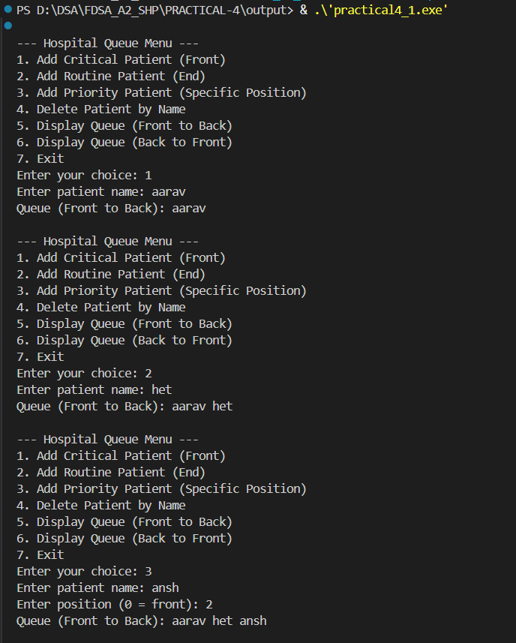
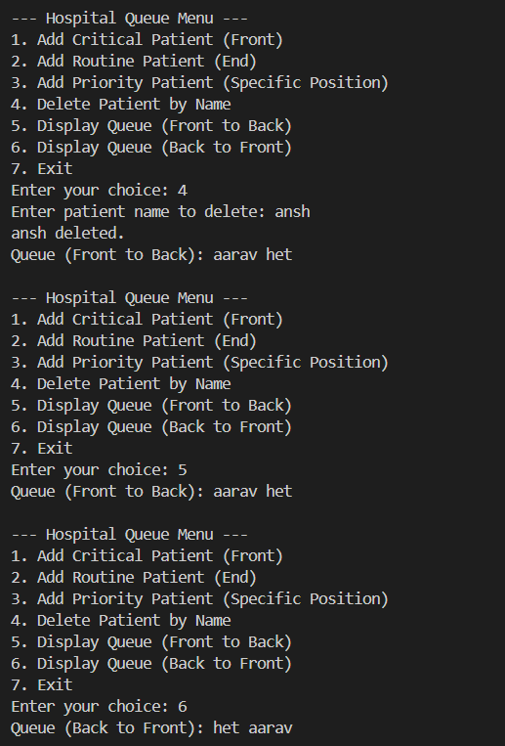

KEY QUESTIONS:

Problem 1:Inserting at a position beyond the current length of the list is an invalid operation. Should your solution silently insert at the end, report an error, or do something else entirely? Justify your choice and explain what assumption about the caller your choice makes.
Problem 2: If the node to be deleted is the only node in the list, how many pointers need to change and what must they be set to? How is this case structurally different from deleting a node in the middle?

ANSWERS:
ANS-1:Inserting a node at a position beyond the current length of the list should be treated as an invalid operation and an error should be reported. The program should not silently insert the node at the end because that would change the meaning of the requested position.
For example, if the list has 5 nodes and the user asks to insert at position 8, position 8 does not exist. The program should display an error such as "Invalid position" and leave the list unchanged.
ANS-2: If the node is the only node in the list, only the head pointer changes and is set to NULL; unlike deleting a middle node, there is no previous or next node whose link needs to be changed.

