MINIBANK

- GITHUB REPOSITORY :

- SOURCE CODE :

MODEL / BANKINFO.JAVA :
package model;

/** PR-1: record used as the application header. */
public record BankInfo(String name, String branch) {
}

MODEL / MENUOPTION.JAVA :
package model;

/** PR-1 / PR-14: actions MiniBank offers. */
public enum MenuOption {
OPEN_ACCOUNT, DEPOSIT, WITHDRAW, TRANSFER, STATEMENT, LIST_ACCOUNTS, RUN_BATCH, REPORT, EXIT
}

MODEL / CUSTOMER.JAVA :
package model;

import model.annotation.Id;

import java.io.Serializable;

public class Customer implements Cloneable, Serializable {
private static final long serialVersionUID = 1L;

private String name;
private String email;
private String mobile;
@Id
private final String customerId;
private Address address;

private static long customerCounter = 100;

private static String generateCustomerId() {
customerCounter++;
return "CUST" + customerCounter;
}

public Customer(String name, String email, String mobile, Address address) {
this.name = name;
this.email = email;
this.mobile = mobile;
this.address = address;
this.customerId = generateCustomerId();
}

/** PR-3: public static nested class. */
public static class Address implements Serializable {
private static final long serialVersionUID = 1L;

private String line;
private String city;
private String pincode;

public Address(String line, String city, String pincode) {
this.line = line;
this.city = city;
this.pincode = pincode;
}

public String getLine() { return line; }
public String getCity() { return city; }
public String getPincode() { return pincode; }

@Override
public String toString() {
return line + ", " + city + " - " + pincode;
}
}

public String getName() { return name; }
public String getEmail() { return email; }
public String getMobile() { return mobile; }
public String getCustomerId() { return customerId; }
public Address getAddress() { return address; }

@Override
public Customer clone() {
try {
Customer copy = (Customer) super.clone();
if (address != null) {
copy.address = new Address(address.getLine(), address.getCity(), address.getPincode());
}
return copy;
} catch (CloneNotSupportedException e) {
throw new AssertionError(e);
}
}

@Override
public String toString() {
return "Customer[" + customerId + ", name=" + name + ", email=" + email
+ ", mobile=" + mobile + ", address=" + address + "]";
}
}

MODEL / TRANSACTABLE.JAVA :
package model;

import exception.InsufficientFundsException;
import exception.InvalidAmountException;

public interface Transactable {
void deposit(long amount) throws InvalidAmountException;

boolean withdraw(long amount) throws InsufficientFundsException, InvalidAmountException;
}

MODEL / INTERESTBEARING.JAVA :
package model;

public interface InterestBearing {
double interestRate();

long getBalance();

default double yearlyInterest() {
return Math.max(0, getBalance()) * interestRate() / 100.0;
}
}

MODEL / WITHDRAWRULE.JAVA :
package model;

@FunctionalInterface
public interface WithdrawRule {
boolean allow(Account account, long amount);
}

MODEL / PREMIUM.JAVA :
package model;

/** Marker interface (no methods) - tags premium account types. */
public interface Premium {
}

MODEL / ACCOUNT.JAVA :
package model;

import exception.AccountNotFoundException;
import exception.BankException;
import exception.InsufficientFundsException;
import exception.InvalidAmountException;
import model.annotation.Id;
import model.annotation.MaxLength;
import model.annotation.Positive;

import java.io.Serializable;
import java.util.Objects;

public abstract class Account implements Transactable, InterestBearing, Serializable, Comparable<Account> {

private static final long serialVersionUID = 1L;

@Id
private final String accountNumber;
@MaxLength(20)
private String ownerName;
@Positive
private long balance; // changes only via deposit() / withdraw()
private boolean active;

private static long accountCounter = 0;

/** PR-14: after saved accounts are loaded, numbering continues after the highest one. */
public static synchronized void continueNumberingFrom(long highest) {
if (highest > accountCounter) {
accountCounter = highest;
}
}

private static synchronized String generateAccountNumber() {
accountCounter++;
return String.format("AC%04d", accountCounter);
}

public Account(String ownerName, long openingBalance) {
this.accountNumber = generateAccountNumber();
this.ownerName = ownerName;
this.balance = openingBalance;
this.active = true;
}

public Account(String ownerName) {
this(ownerName, 0);
}

// ---- PR-8: exceptions instead of boolean flags ----
@Override
public synchronized void deposit(long amount) throws InvalidAmountException {
if (amount <= 0) {
throw new InvalidAmountException(amount);
}
balance += amount;
}

@Override
public synchronized boolean withdraw(long amount) throws InsufficientFundsException, InvalidAmountException {
if (amount <= 0) {
throw new InvalidAmountException(amount);
}
if (!canWithdraw(amount)) {
throw new InsufficientFundsException(amount - availableToWithdraw());
}
balance -= amount;
return true;
}

/** Moves money to another account; rolls back if the credit side fails. */
public void transfer(Account to, long amount) throws BankException {
if (to == null) {
throw new AccountNotFoundException("null");
}
boolean debited = false;
try {
withdraw(amount);
debited = true;
to.deposit(amount);
System.out.println("Transferred Rs." + amount + " from " + accountNumber + " to " + to.accountNumber);
} catch (BankException e) {
if (debited) {
balance += amount; // rollback the debit
}
System.out.println("Transfer failed: " + e.getMessage());
throw e; // rethrow to the caller
} finally {
System.out.println("Transfer attempt finished (" + accountNumber + " -> " + to.accountNumber + ").");
}
}

public String getAccountNumber() { return accountNumber; }

public String getOwnerName() { return ownerName; }

@Override
public long getBalance() { return balance; }

public boolean isActive() { return active; }

/** How much can currently be taken out; used to compute the shortfall. */
protected long availableToWithdraw() {
return balance;
}

@Override
public String toString() {
return "Account[accountNumber=" + accountNumber
+ ", ownerName=" + ownerName
+ ", balance=Rs." + balance + "]";
}

@Override
public boolean equals(Object o) {
if (this == o) return true;
if (!(o instanceof Account)) return false;
Account other = (Account) o;
return Objects.equals(accountNumber, other.accountNumber);
}

@Override
public int hashCode() {
return Objects.hash(accountNumber);
}

/** PR-12: natural order = by account number. */
@Override
public int compareTo(Account other) {
return accountNumber.compareTo(other.accountNumber);
}

@Override
public abstract double interestRate();

public abstract boolean canWithdraw(long amount);
}

MODEL / SAVINGSACCOUNT.JAVA :
package model;

public class SavingsAccount extends Account {
private static final long serialVersionUID = 1L;
private long minBalance;

public SavingsAccount(String ownerName, long openingBalance, long minBalance) {
super(ownerName, openingBalance);
this.minBalance = minBalance;
}

public long getMinBalance() { return minBalance; }

@Override
public double interestRate() { return 4.0; }

@Override
public boolean canWithdraw(long amount) {
return getBalance() - amount >= minBalance;
}

@Override
protected long availableToWithdraw() {
return Math.max(0, getBalance() - minBalance);
}
}

MODEL / CURRENTACCOUNT.JAVA :
package model;

public class CurrentAccount extends Account {
private static final long serialVersionUID = 1L;
private long overdraftLimit;

public CurrentAccount(String ownerName, long openingBalance, long overdraftLimit) {
super(ownerName, openingBalance);
this.overdraftLimit = overdraftLimit;
}

public long getOverdraftLimit() { return overdraftLimit; }

@Override
public double interestRate() { return 0; }

@Override
public boolean canWithdraw(long amount) {
return getBalance() - amount >= -overdraftLimit;
}

@Override
protected long availableToWithdraw() {
return getBalance() + overdraftLimit;
}
}

MODEL / FIXEDDEPOSITACCOUNT.JAVA :
package model;

public class FixedDepositAccount extends Account implements Premium {
private static final long serialVersionUID = 1L;

public FixedDepositAccount(String ownerName, long openingBalance) {
super(ownerName, openingBalance);
}

@Override
public double interestRate() { return 7.0; }

@Override
public boolean canWithdraw(long amount) {
return false; // deposit is locked
}

@Override
protected long availableToWithdraw() {
return 0;
}
}

MODEL / ANNOTATION / ID.JAVA :
package model.annotation;

import java.lang.annotation.ElementType;
import java.lang.annotation.Retention;
import java.lang.annotation.RetentionPolicy;
import java.lang.annotation.Target;

/** Marker: identifies the record id (used by the generic repository in PR-13). */
@Target(ElementType.FIELD)
@Retention(RetentionPolicy.RUNTIME)
public @interface Id {
}

MODEL / ANNOTATION / MAXLENGTH.JAVA :
package model.annotation;

import java.lang.annotation.ElementType;
import java.lang.annotation.Retention;
import java.lang.annotation.RetentionPolicy;
import java.lang.annotation.Target;

@Target(ElementType.FIELD)
@Retention(RetentionPolicy.RUNTIME)
public @interface MaxLength {
int value();
}

MODEL / ANNOTATION / POSITIVE.JAVA :
package model.annotation;

import java.lang.annotation.ElementType;
import java.lang.annotation.Retention;
import java.lang.annotation.RetentionPolicy;
import java.lang.annotation.Target;

@Target(ElementType.FIELD)
@Retention(RetentionPolicy.RUNTIME)
public @interface Positive {
String message() default "must be > 0";
}

EXCEPTION / ACCOUNTNOTFOUNDEXCEPTION.JAVA :
package exception;

public class AccountNotFoundException extends BankException {
private static final long serialVersionUID = 1L;

public AccountNotFoundException(String accountNumber) {
super("Account not found: " + accountNumber);
}
}

EXCEPTION / BANKEXCEPTION.JAVA :
package exception;

/** Checked base class for every MiniBank failure (PR-8). */
public class BankException extends Exception {
private static final long serialVersionUID = 1L;

public BankException(String message) {
super(message);
}
}

EXCEPTION / INSUFFICIENTFUNDSEXCEPTION.JAVA :
package exception;

public class InsufficientFundsException extends BankException {
private static final long serialVersionUID = 1L;

private final long shortfall;

public InsufficientFundsException(long shortfall) {
super("Insufficient funds. Short by Rs." + shortfall);
this.shortfall = shortfall;
}

public long getShortfall() {
return shortfall;
}
}

EXCEPTION / INVALIDAMOUNTEXCEPTION.JAVA :
package exception;

public class InvalidAmountException extends BankException {
private static final long serialVersionUID = 1L;

public InvalidAmountException(long amount) {
super("Invalid amount: Rs." + amount + " (must be greater than 0)");
}
}

UTIL / ANNOTATIONVALIDATOR.JAVA :
package util;

import model.annotation.MaxLength;
import model.annotation.Positive;

import java.lang.reflect.Field;
import java.util.ArrayList;
import java.util.List;

/** PR-7: validates any object by reading its annotations with reflection. */
public class AnnotationValidator {
private AnnotationValidator() { }

public static String[] validate(Object obj) {
if (obj == null) {
throw new IllegalArgumentException("Object cannot be null.");
}
List<String> errors = new ArrayList<>();

// walk up the hierarchy: SavingsAccount -> Account -> Object
for (Class<?> c = obj.getClass(); c != null && c != Object.class; c = c.getSuperclass()) {
for (Field field : c.getDeclaredFields()) {
field.setAccessible(true);
try {
Object value = field.get(obj);

if (field.isAnnotationPresent(Positive.class)
&& value instanceof Number n && n.longValue() <= 0) {
errors.add(field.getName() + ": " + field.getAnnotation(Positive.class).message());
}
if (field.isAnnotationPresent(MaxLength.class)
&& value instanceof String s) {
int max = field.getAnnotation(MaxLength.class).value();
if (s.length() > max) {
errors.add(field.getName() + ": length must be <= " + max);
}
}
} catch (IllegalAccessException e) {
errors.add(field.getName() + ": cannot be read");
}
}
}
return errors.toArray(new String[0]);
}
}

UTIL / AUDITLOGGER.JAVA :
package util;

/** PR-8: small AutoCloseable used in a try-with-resources example. */
public class AuditLogger implements AutoCloseable {
private final String name;

public AuditLogger(String name) {
this.name = name;
System.out.println("[" + name + "] audit log opened");
}

public void log(String message) {
System.out.println("[" + name + "] " + message);
}

@Override
public void close() {
System.out.println("[" + name + "] audit log closed");
}
}

UTIL / COMMAND.JAVA :
package util;

public record Command(TransactionType type, String accountNumber, long amount) {
}

UTIL / COMMANDPARSER.JAVA :
package util;

public class CommandParser {
private CommandParser() { }

/** Parses a line such as "DEPOSIT AC0001 500". */
public static Command parse(String line) {
if (line == null) {
throw new IllegalArgumentException("Command cannot be null.");
}
String[] parts = line.trim().split("\\s+");
if (parts.length != 3) {
throw new IllegalArgumentException("Expected: <TYPE> <ACCOUNT> <AMOUNT>");
}
try {
TransactionType type = TransactionType.valueOf(parts[0].toUpperCase());
long amount = Long.parseLong(parts[2]);
return new Command(type, parts[1], amount);
} catch (IllegalArgumentException e) { // also covers NumberFormatException
throw new IllegalArgumentException("Invalid command: " + line, e);
}
}
}

UTIL / REPORTGENERATOR.JAVA :
package util;

import java.io.BufferedReader;
import java.io.IOException;
import java.nio.file.DirectoryStream;
import java.nio.file.Files;
import java.nio.file.Path;
import java.nio.file.attribute.BasicFileAttributes;
import java.util.ArrayList;
import java.util.List;

/** PR-11: walks the logs folder and writes an end-of-day summary report. */
public class ReportGenerator {
private ReportGenerator() { }

public static List<String> generate(Path logsDir, Path reportFile) throws IOException {
long totalDeposits = 0;
long totalWithdrawals = 0;
List<String> report = new ArrayList<>();
report.add("===== END OF DAY REPORT =====");

try (DirectoryStream<Path> files = Files.newDirectoryStream(logsDir, "*.log")) {
for (Path file : files) {
BasicFileAttributes attrs = Files.readAttributes(file, BasicFileAttributes.class);
if (attrs.size() == 0) {
continue; // skip empty logs
}
report.add("Log file: " + file.getFileName() + " (" + attrs.size()
+ " bytes, modified " + attrs.lastModifiedTime() + ")");
try (BufferedReader reader = Files.newBufferedReader(file)) {
String line;
while ((line = reader.readLine()) != null) {
String[] parts = line.trim().split("\\s+");
if (parts.length != 3) {
continue;
}
long amount = Long.parseLong(parts[2]);
if (parts[0].equals("DEPOSIT")) {
totalDeposits += amount;
} else if (parts[0].equals("WITHDRAW")) {
totalWithdrawals += amount;
}
}
}
}
}
report.add("Total deposits : Rs." + totalDeposits);
report.add("Total withdrawals : Rs." + totalWithdrawals);
report.add("Net change : Rs." + (totalDeposits - totalWithdrawals));

if (reportFile.getParent() != null) {
Files.createDirectories(reportFile.getParent());
}
Files.write(reportFile, report);
return report;
}
}

UTIL / STATEPERSISTER.JAVA :
package util;

import model.Account;

import java.io.IOException;
import java.io.ObjectInputStream;
import java.io.ObjectOutputStream;
import java.nio.file.Files;
import java.nio.file.Path;

/** PR-11: saves and loads every account with object serialization. */
public class StatePersister {
private StatePersister() { }

public static void save(Account[] accounts, Path file) throws IOException {
if (file.getParent() != null) {
Files.createDirectories(file.getParent());
}
try (ObjectOutputStream out = new ObjectOutputStream(Files.newOutputStream(file))) {
out.writeObject(accounts);
}
}

public static Account[] load(Path file) throws IOException, ClassNotFoundException {
try (ObjectInputStream in = new ObjectInputStream(Files.newInputStream(file))) {
return (Account[]) in.readObject();
}
}
}

UTIL / STATEMENTFORMATTER.JAVA :
package util;

import model.Account;

public class StatementFormatter {
private StatementFormatter() { }

public static String buildStatement(Account account) {
StringBuilder sb = new StringBuilder();
sb.append("======= ACCOUNT STATEMENT =======\n");
sb.append("Account No : ").append(account.getAccountNumber()).append('\n');
sb.append("Owner : ").append(account.getOwnerName()).append('\n');
sb.append("Type : ").append(account.getClass().getSimpleName()).append('\n');
sb.append("Balance : Rs.").append(account.getBalance()).append('\n');
sb.append("Status : ").append(account.isActive() ? "Active" : "Inactive").append('\n');
sb.append("=================================");
return sb.toString();
}
}

UTIL / TRANSACTIONLOG.JAVA :
package util;

import java.io.IOException;
import java.nio.charset.StandardCharsets;
import java.nio.file.Files;
import java.nio.file.Path;
import java.nio.file.StandardOpenOption;

/** PR-11: append-only transaction log, one line per transaction. */
public class TransactionLog {
private TransactionLog() { }

public static synchronized void append(Path file, String line) throws IOException {
if (file.getParent() != null) {
Files.createDirectories(file.getParent());
}
Files.write(file, (line + System.lineSeparator()).getBytes(StandardCharsets.UTF_8),
StandardOpenOption.CREATE, StandardOpenOption.APPEND);
}
}

UTIL / TRANSACTIONTYPE.JAVA :
package util;

public enum TransactionType {
DEPOSIT, WITHDRAW, TRANSFER
}

UTIL / VALIDATOR.JAVA :
package util;

import java.util.regex.Pattern;

public class Validator {
private static final Pattern MOBILE = Pattern.compile("^[6-9]\\d{9}$");
private static final Pattern EMAIL = Pattern.compile("^[A-Za-z0-9._%+-]+@[A-Za-z0-9.-]+\\.[A-Za-z]{2,}$");
private static final Pattern PAN = Pattern.compile("^[A-Z]{5}[0-9]{4}[A-Z]$");
private static final Pattern IFSC = Pattern.compile("^[A-Z]{4}0[A-Z0-9]{6}$");

private Validator() { }

public static boolean isValidMobile(String s) { return s != null && MOBILE.matcher(s).matches(); }
public static boolean isValidEmail(String s) { return s != null && EMAIL.matcher(s).matches(); }
public static boolean isValidPan(String s) { return s != null && PAN.matcher(s).matches(); }
public static boolean isValidIfsc(String s) { return s != null && IFSC.matcher(s).matches(); }
}

REPOSITORY / REPOSITORY.JAVA :
package repository;

import model.annotation.Id;

import java.lang.reflect.Field;
import java.util.ArrayList;
import java.util.HashMap;

/** PR-13: one generic repository for any type; the key is the field marked with @Id. */
public class Repository<T> {
private final HashMap<String, T> store = new HashMap<>();

public T save(T entity) {
store.put(idOf(entity), entity);
return entity;
}

public T findById(String id) {
return store.get(id);
}

public ArrayList<T> findAll() {
return new ArrayList<>(store.values());
}

public boolean delete(String id) {
return store.remove(id) != null;
}

public int count() {
return store.size();
}

@SafeVarargs
public final void saveAll(T... items) {
for (T item : items) {
save(item);
}
}

/** Bounded type parameter: only Integer, Double, Long ... (subclasses of Number) are accepted. */
public static <N extends Number> double average(N[] values) {
double sum = 0;
for (N v : values) {
sum += v.doubleValue();
}
return values.length == 0 ? 0 : sum / values.length;
}

/** Reflection: look for the @Id field in the class and its superclasses. */
private String idOf(T entity) {
for (Class<?> c = entity.getClass(); c != null && c != Object.class; c = c.getSuperclass()) {
for (Field field : c.getDeclaredFields()) {
if (field.isAnnotationPresent(Id.class)) {
try {
field.setAccessible(true);
return String.valueOf(field.get(entity));
} catch (IllegalAccessException e) {
throw new IllegalStateException("Cannot read @Id field " + field.getName(), e);
}
}
}
}
throw new IllegalArgumentException("No @Id field found in " + entity.getClass().getSimpleName());
}
}

SERVICE / ACCOUNTSTORE.JAVA :
package service;

import exception.AccountNotFoundException;
import model.Account;

import java.util.ArrayList;
import java.util.Comparator;
import java.util.HashMap;

/** PR-12: accounts kept in a HashMap keyed by account number, plus a transaction history list. */
public class AccountStore {
private final HashMap<String, Account> accounts = new HashMap<>();
private final ArrayList<String> history = new ArrayList<>();

public void add(Account account) {
accounts.put(account.getAccountNumber(), account);
history.add("ADDED " + account.getAccountNumber() + " (" + account.getOwnerName() + ")");
}

public Account get(String accountNumber) throws AccountNotFoundException {
Account account = accounts.get(accountNumber);
if (account == null) {
throw new AccountNotFoundException(accountNumber);
}
history.add("LOOKUP " + accountNumber);
return account;
}

public ArrayList<Account> getAll() {
return new ArrayList<>(accounts.values());
}

public ArrayList<String> getHistory() {
return history;
}

/** Highest balance first. */
public ArrayList<Account> sortedByBalance() {
ArrayList<Account> list = getAll();
list.sort(Comparator.comparingLong(Account::getBalance).reversed());
return list;
}

/** Supplementary: every account with a balance above the given value. */
public ArrayList<Account> balanceAbove(long limit) {
ArrayList<Account> result = new ArrayList<>();
for (Account a : accounts.values()) {
if (a.getBalance() > limit) {
result.add(a);
}
}
return result;
}
}

SERVICE / ACCOUNTWORKER.JAVA :
package service;

import exception.InvalidAmountException;
import model.Account;

/** PR-9: each worker thread makes many deposits on the same shared account. */
public class AccountWorker implements Runnable {
private final Account account;
private final int times;
private final long amount;

public AccountWorker(Account account, int times, long amount) {
this.account = account;
this.times = times;
this.amount = amount;
}

@Override
public void run() {
System.out.println(Thread.currentThread().getName() + " started");
for (int i = 0; i < times; i++) {
try {
account.deposit(amount);
} catch (InvalidAmountException e) {
System.out.println("Deposit failed: " + e.getMessage());
}
}
System.out.println(Thread.currentThread().getName() + " finished");
}
}

SERVICE / BANKSERVICE.JAVA :
package service;

import exception.AccountNotFoundException;
import exception.BankException;
import model.*;
import repository.Repository;
import util.*;

import java.io.IOException;
import java.io.UncheckedIOException;
import java.nio.file.Files;
import java.nio.file.Path;
import java.util.ArrayList;
import java.util.Collections;
import java.util.List;

/** PR-14: the service layer. It wires the repository, validation and exceptions together. */
public class BankService {
private final Repository<Account> repository = new Repository<>();
private final Path dataDir;

public BankService(Path dataDir) {
this.dataDir = dataDir;
}

private Path accountsFile() { return dataDir.resolve("accounts.dat"); }

private Path logsDir() { return dataDir.resolve("logs"); }

private Path logFile() { return logsDir().resolve("transactions.log"); }

// ---------------------------------------------------------------- operations
public Account openAccount(String type, String owner, String mobile, long opening, long extra) {
if (!Validator.isValidMobile(mobile)) {
throw new IllegalArgumentException("Invalid mobile number: " + mobile);
}
Account account = switch (type.toUpperCase()) {
case "SAVINGS" -> new SavingsAccount(owner, opening, extra);
case "CURRENT" -> new CurrentAccount(owner, opening, extra);
case "FD" -> new FixedDepositAccount(owner, opening);
default -> throw new IllegalArgumentException("Unknown account type: " + type);
};
String[] errors = AnnotationValidator.validate(account);
if (errors.length > 0) {
throw new IllegalArgumentException(String.join("; ", errors));
}
repository.save(account);
return account;
}

public Account find(String accountNumber) throws AccountNotFoundException {
Account account = repository.findById(accountNumber);
if (account == null) {
throw new AccountNotFoundException(accountNumber);
}
return account;
}

public void deposit(String accountNumber, long amount) throws BankException {
find(accountNumber).deposit(amount);
log("DEPOSIT", accountNumber, amount);
}

public void withdraw(String accountNumber, long amount) throws BankException {
find(accountNumber).withdraw(amount);
log("WITHDRAW", accountNumber, amount);
}

public void transfer(String from, String to, long amount) throws BankException {
Account source = find(from);
Account target = find(to);
source.transfer(target, amount);
log("WITHDRAW", from, amount);
log("DEPOSIT", to, amount);
}

public String statement(String accountNumber) throws AccountNotFoundException {
return StatementFormatter.buildStatement(find(accountNumber));
}

public List<Account> listAccounts() {
ArrayList<Account> all = repository.findAll();
Collections.sort(all); // Comparable: by account number
return all;
}

// ---------------------------------------------------------------- batch processing
/** Runs "DEPOSIT AC0001 500"-style commands on a thread pool over a ConcurrentHashMap. */
public List<String> runBatch(List<String> commands) {
TransactionProcessor processor = new TransactionProcessor();
for (Account account : repository.findAll()) {
processor.register(account);
}
List<String> results = Collections.synchronizedList(new ArrayList<>());
for (String line : commands) {
processor.submit(() -> {
try {
Command cmd = CommandParser.parse(line);
Account account = processor.find(cmd.accountNumber());
if (account == null) {
throw new AccountNotFoundException(cmd.accountNumber());
}
switch (cmd.type()) {
case DEPOSIT -> account.deposit(cmd.amount());
case WITHDRAW -> account.withdraw(cmd.amount());
default -> throw new IllegalArgumentException("Batch supports DEPOSIT and WITHDRAW only");
}
TransactionLog.append(logFile(), cmd.type() + " " + cmd.accountNumber() + " " + cmd.amount());
results.add("OK " + line);
} catch (BankException | IllegalArgumentException | IOException e) {
results.add("FAILED " + line + " -> " + e.getMessage());
}
});
}
processor.stop();
return results;
}

// ---------------------------------------------------------------- persistence and report
public void save() throws IOException {
StatePersister.save(repository.findAll().toArray(new Account[0]), accountsFile());
}

/** Loads saved accounts (if any) and returns how many were loaded. */
public int load() throws IOException, ClassNotFoundException {
if (!Files.exists(accountsFile())) {
return 0;
}
Account[] saved = StatePersister.load(accountsFile());
long highest = 0;
for (Account account : saved) {
repository.save(account);
highest = Math.max(highest, Long.parseLong(account.getAccountNumber().substring(2)));
}
Account.continueNumberingFrom(highest);
return saved.length;
}

public List<String> report() throws IOException {
Files.createDirectories(logsDir());
return ReportGenerator.generate(logsDir(), dataDir.resolve("report.txt"));
}

private void log(String type, String accountNumber, long amount) {
try {
TransactionLog.append(logFile(), type + " " + accountNumber + " " + amount);
} catch (IOException e) {
throw new UncheckedIOException(e);
}
}
}

SERVICE / MINIBANK.JAVA :
package service;

import exception.BankException;
import model.*;

import java.io.IOException;
import java.nio.file.Paths;
import java.util.ArrayList;
import java.util.List;
import java.util.Scanner;

public class MiniBank {

public static void main(String[] args) throws IOException, ClassNotFoundException {
Scanner sc = new Scanner(System.in);
BankInfo bank = new BankInfo("MiniBank", "Main Branch");
System.out.println("==========================================");
System.out.println(" " + bank);
System.out.println("==========================================");

BankService service = new BankService(Paths.get("data"));
int loaded = service.load(); // PR-11: load saved accounts on start-up
if (loaded > 0) {
System.out.println("Loaded " + loaded + " saved account(s).");
}

runMenu(sc, bank, service);

service.save(); // PR-11: save on exit
System.out.println("Accounts saved to data/accounts.dat");
sc.close();
}

private static void runMenu(Scanner sc, BankInfo bank, BankService service) {
MenuOption option;
do {
System.out.println("\n--- MAIN MENU ---");
for (MenuOption m : MenuOption.values()) {
System.out.println((m.ordinal() + 1) + ". " + m);
}
System.out.print("Enter choice: ");

if (!sc.hasNextLine()) { // input closed -> behave like EXIT
option = MenuOption.EXIT;
} else {
option = readOption(sc.nextLine());
}
if (option == null) {
System.out.println("Invalid choice. Please enter a number from 1 to " + MenuOption.values().length + ".");
continue;
}

try {
switch (option) {
case OPEN_ACCOUNT -> openAccount(sc, service);
case DEPOSIT -> {
service.deposit(ask(sc, "Account number: "), readLong(sc, "Amount: "));
System.out.println("Deposit successful.");
}
case WITHDRAW -> {
service.withdraw(ask(sc, "Account number: "), readLong(sc, "Amount: "));
System.out.println("Withdrawal successful.");
}
case TRANSFER -> {
service.transfer(ask(sc, "From account: "), ask(sc, "To account: "), readLong(sc, "Amount: "));
System.out.println("Transfer successful.");
}
case STATEMENT -> System.out.println(service.statement(ask(sc, "Account number: ")));
case LIST_ACCOUNTS -> {
for (Account a : service.listAccounts()) {
System.out.println(" " + a.getAccountNumber() + " | " + a.getOwnerName()
+ " | " + a.getClass().getSimpleName() + " | Rs." + a.getBalance());
}
}
case RUN_BATCH -> runBatch(sc, service);
case REPORT -> service.report().forEach(System.out::println);
case EXIT -> System.out.println("Goodbye! Thank you for using " + bank.name() + ".");
}
} catch (BankException | IllegalArgumentException | IOException e) {
System.out.println("Operation failed: " + e.getMessage());
}
} while (option != MenuOption.EXIT);
}

private static void openAccount(Scanner sc, BankService service) {
String type = ask(sc, "Account type (SAVINGS / CURRENT / FD): ");
String owner = ask(sc, "Owner name: ");
String mobile = ask(sc, "Mobile number: ");
long opening = readLong(sc, "Opening balance: ");
long extra = 0;
if (type.equalsIgnoreCase("SAVINGS")) {
extra = readLong(sc, "Minimum balance: ");
} else if (type.equalsIgnoreCase("CURRENT")) {
extra = readLong(sc, "Overdraft limit: ");
}
Account account = service.openAccount(type, owner, mobile, opening, extra);
System.out.println("Account opened: " + account.getAccountNumber());
}

private static void runBatch(Scanner sc, BankService service) {
System.out.println("Enter commands such as DEPOSIT AC0001 500 (blank line to run):");
List<String> commands = new ArrayList<>();
while (true) {
String line = sc.nextLine().trim();
if (line.isEmpty()) {
break;
}
commands.add(line);
}
service.runBatch(commands).forEach(System.out::println);
}

private static String ask(Scanner sc, String prompt) {
System.out.print(prompt);
return sc.nextLine().trim();
}

private static long readLong(Scanner sc, String prompt) {
String text = ask(sc, prompt);
try {
return Long.parseLong(text);
} catch (NumberFormatException e) {
throw new IllegalArgumentException("Not a valid whole number: " + text);
}
}

/** Converts typed text to a MenuOption; returns null for invalid input. */
private static MenuOption readOption(String text) {
try {
int n = Integer.parseInt(text.trim());
MenuOption[] all = MenuOption.values();
if (n >= 1 && n <= all.length) {
return all[n - 1];
}
} catch (NumberFormatException ignored) {
// fall through
}
return null;
}
}

SERVICE / TRANSACTIONBUFFER.JAVA :
package service;

/** PR-10: small shared array buffer; producer and consumer coordinate with wait()/notify(). */
public class TransactionBuffer {
private final String[] items;
private int head = 0;
private int tail = 0;
private int count = 0;

public TransactionBuffer(int capacity) {
this.items = new String[capacity];
}

public synchronized void put(String line) throws InterruptedException {
while (count == items.length) {
wait(); // buffer full: wait for the consumer
}
items[tail] = line;
tail = (tail + 1) % items.length;
count++;
notifyAll();
}

public synchronized String take() throws InterruptedException {
while (count == 0) {
wait(); // buffer empty: wait for the producer
}
String line = items[head];
items[head] = null;
head = (head + 1) % items.length;
count--;
notifyAll();
return line;
}
}

SERVICE / TRANSACTIONPROCESSOR.JAVA :
package service;

import model.Account;

import java.util.concurrent.ConcurrentHashMap;
import java.util.concurrent.ExecutorService;
import java.util.concurrent.Executors;
import java.util.concurrent.TimeUnit;

/** PR-10: runs banking tasks on a managed pool of 4 threads. */
public class TransactionProcessor {
private final ExecutorService pool = Executors.newFixedThreadPool(4);

/** PR-12: thread-safe map of the accounts shared by all pool threads. */
private final ConcurrentHashMap<String, Account> accounts = new ConcurrentHashMap<>();

public void register(Account account) {
accounts.put(account.getAccountNumber(), account);
}

public Account find(String accountNumber) {
return accounts.get(accountNumber);
}

public void submit(Runnable task) {
pool.execute(task);
}

public void stop() {
pool.shutdown();
try {
if (!pool.awaitTermination(30, TimeUnit.SECONDS)) {
pool.shutdownNow();
}
} catch (InterruptedException e) {
pool.shutdownNow();
Thread.currentThread().interrupt();
}
}
}

SERVICE / TRANSFERTASKS.JAVA :
package service;

import exception.BankException;
import model.Account;

/** PR-10: two ways to transfer money between accounts, one of which can deadlock. */
public class TransferTasks {
private TransferTasks() { }

private static void pause() {
try {
Thread.sleep(100);
} catch (InterruptedException e) {
Thread.currentThread().interrupt();
}
}

/** Locks "from" first, then "to": two opposite transfers can deadlock. */
public static void transferUnsafe(Account from, Account to, long amount) throws BankException {
synchronized (from) {
pause();
synchronized (to) {
from.withdraw(amount);
to.deposit(amount);
}
}
}

/** Always locks the account with the smaller accountNumber first: no deadlock. */
public static void transferSafe(Account from, Account to, long amount) throws BankException {
Account first = from.getAccountNumber().compareTo(to.getAccountNumber()) < 0 ? from : to;
Account second = (first == from) ? to : from;
synchronized (first) {
pause();
synchronized (second) {
from.withdraw(amount);
to.deposit(amount);
}
}
}
}

TEST / SERVICE / BANKSERVICETEST.JAVA :
package service;

import exception.InsufficientFundsException;
import model.Account;
import org.junit.jupiter.api.Test;
import org.junit.jupiter.api.io.TempDir;

import java.nio.file.Path;
import java.util.ArrayList;
import java.util.List;

import static org.junit.jupiter.api.Assertions.*;

class BankServiceTest {

@Test
void depositIncreasesTheBalance(@TempDir Path dir) throws Exception {
BankService service = new BankService(dir);
Account a = service.openAccount("SAVINGS", "Asha Patel", "9876543210", 5000, 1000);
service.deposit(a.getAccountNumber(), 2000);
assertEquals(7000, a.getBalance());
}

@Test
void withdrawalOverTheLimitThrowsException(@TempDir Path dir) throws Exception {
BankService service = new BankService(dir);
Account a = service.openAccount("SAVINGS", "Asha Patel", "9876543210", 5000, 1000);
InsufficientFundsException e = assertThrows(InsufficientFundsException.class,
() -> service.withdraw(a.getAccountNumber(), 5000));
assertEquals(1000, e.getShortfall());
assertEquals(5000, a.getBalance()); // balance unchanged
}

@Test
void invalidMobileNumberIsRejected(@TempDir Path dir) {
BankService service = new BankService(dir);
assertThrows(IllegalArgumentException.class,
() -> service.openAccount("SAVINGS", "Asha Patel", "12345", 5000, 1000));
}

@Test
void manyConcurrentDepositsKeepTheBalanceCorrect(@TempDir Path dir) throws Exception {
BankService service = new BankService(dir);
Account a = service.openAccount("SAVINGS", "Asha Patel", "9876543210", 1000, 0);
List<String> commands = new ArrayList<>();
for (int i = 0; i < 2000; i++) {
commands.add("DEPOSIT " + a.getAccountNumber() + " 1");
}
List<String> results = service.runBatch(commands);
assertEquals(2000, results.size());
assertEquals(3000, a.getBalance()); // 1000 + 2000 x 1, nothing lost
}

@Test
void savedStateIsLoadedUnchanged(@TempDir Path dir) throws Exception {
BankService first = new BankService(dir);
Account a = first.openAccount("CURRENT", "Ravi Shah", "9123456780", 2000, 3000);
first.deposit(a.getAccountNumber(), 500);
first.save();

BankService second = new BankService(dir);
assertEquals(1, second.load());
Account reloaded = second.find(a.getAccountNumber());
assertEquals("Ravi Shah", reloaded.getOwnerName());
assertEquals(2500, reloaded.getBalance());
}
}

MANIFEST.TXT :
Main-Class: service.MiniBank

README.MD :
# MiniBank

Console banking application built across the OOP (CEUC203) lab series.

## Features
- Menu: open account, deposit, withdraw, transfer, statement, list accounts, run a batch, end-of-day report
- Account types: Savings (minimum balance), Current (overdraft), Fixed Deposit (locked)
- Validation (regex), custom exceptions, annotation + reflection validator
- Thread-safe accounts, thread-pool batch processing over a `ConcurrentHashMap`
- Saves accounts to `data/accounts.dat` on exit and reloads them on start-up
- Append-only transaction log in `data/logs/` and an NIO based report

## Project layout
```
model/ Account, SavingsAccount, CurrentAccount, FixedDepositAccount, Customer, interfaces, annotations
exception/ BankException and its subclasses
util/ Validator, CommandParser, StatementFormatter, AnnotationValidator, StatePersister, TransactionLog, ReportGenerator
repository/ Repository<T> (generic, key found through @Id)
service/ BankService, AccountStore, TransactionProcessor, MiniBank (main)
test/ JUnit 5 tests
```

## Build and run (JDK 17+)
```
javac -d out model/*.java model/annotation/*.java exception/*.java util/*.java repository/*.java service/*.java
jar cfm minibank.jar manifest.txt -C out .
java -jar minibank.jar
```

## Run the tests (JUnit 5 console launcher)
```
javac -d testout -cp "out;junit-platform-console-standalone.jar" test/service/BankServiceTest.java
java -jar junit-platform-console-standalone.jar execute --class-path "out;testout" --scan-class-path
```
(use `:` instead of `;` on Linux / macOS)

Generated files in `data/` are not committed.

- OUTPUT :

JUnit tests (all pass):
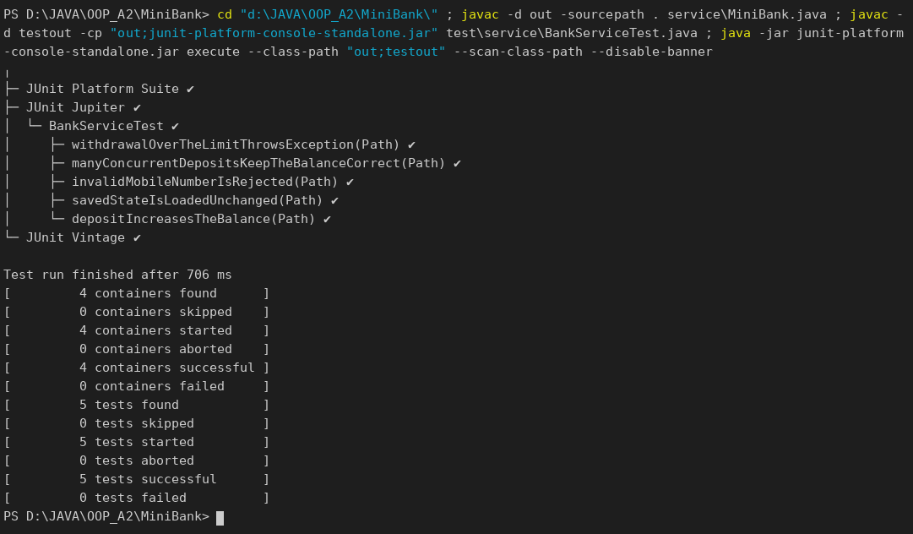

Build the runnable JAR:
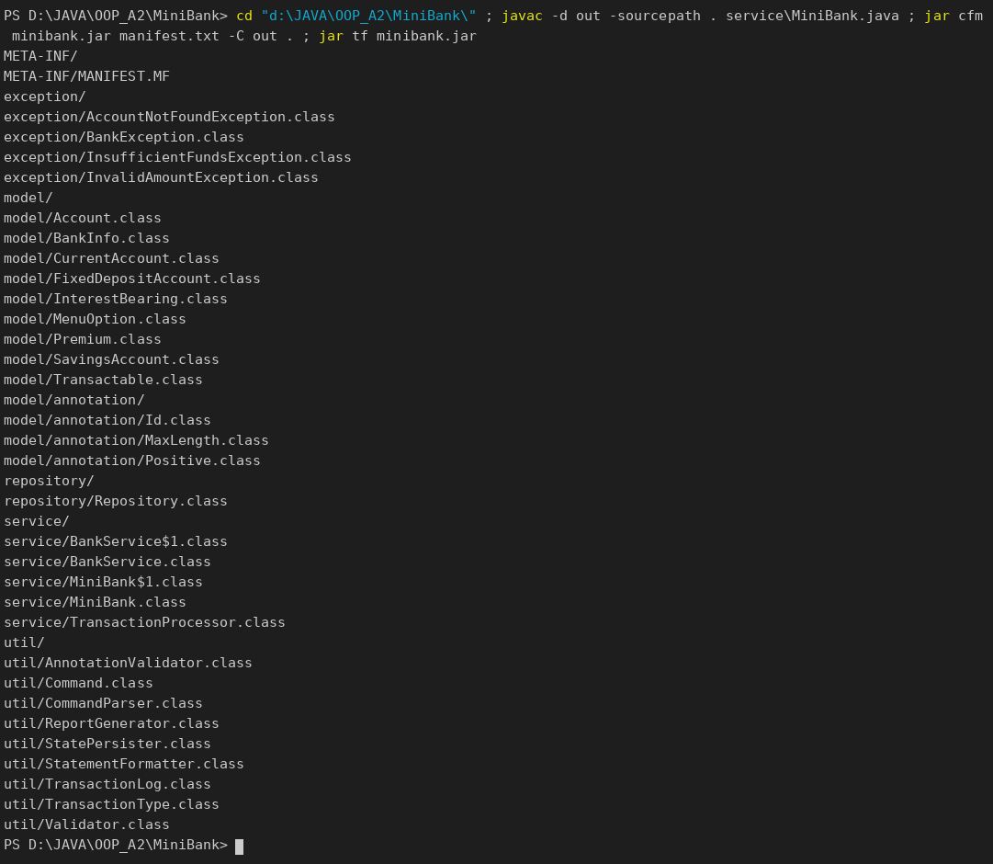

Session 1 – open accounts, deposit, withdraw (fails), transfer, statement, list, batch, report, exit:
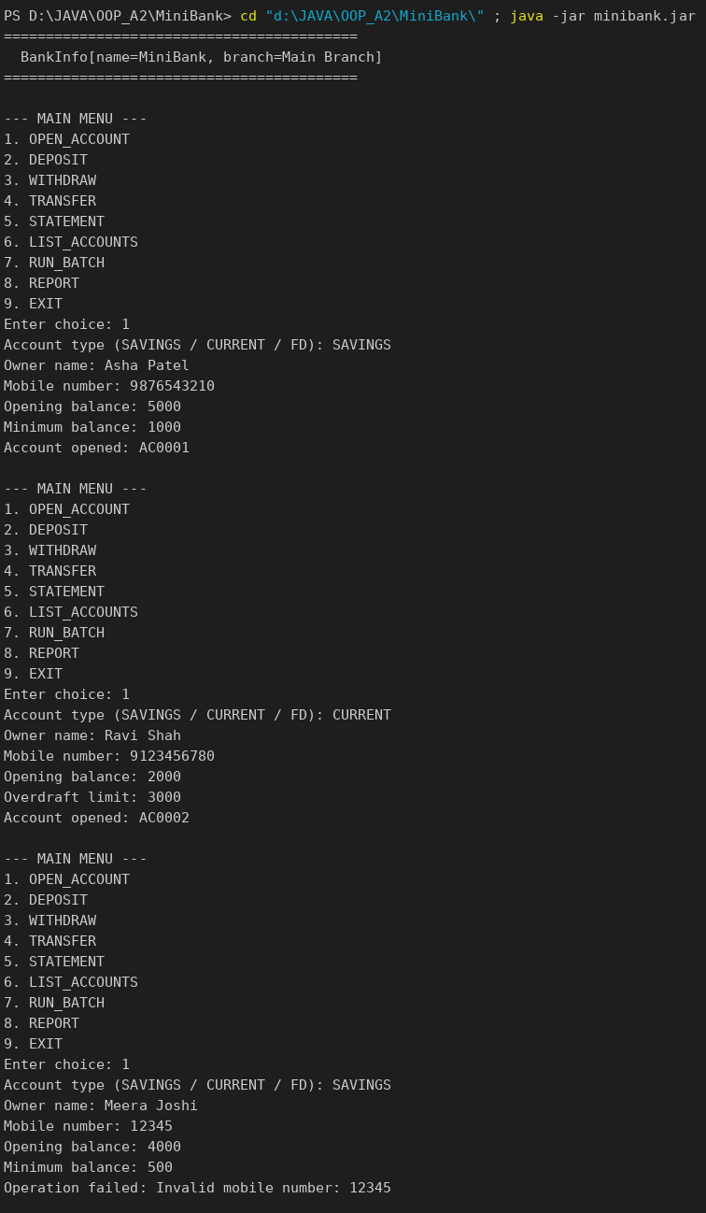
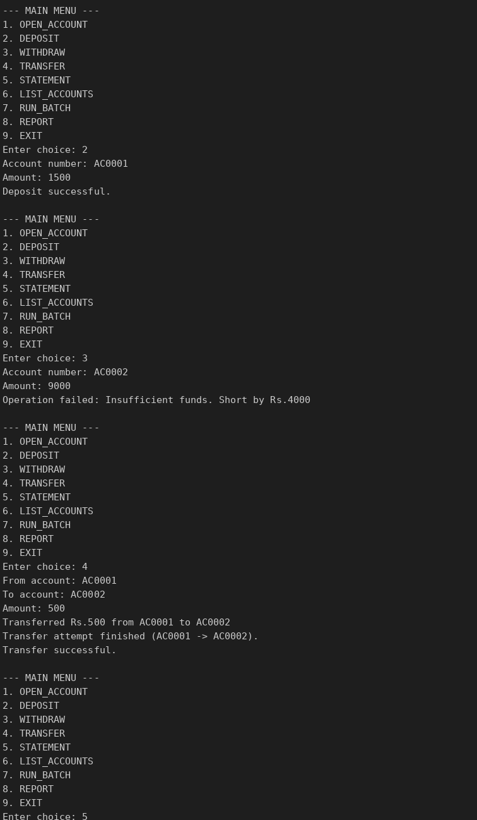
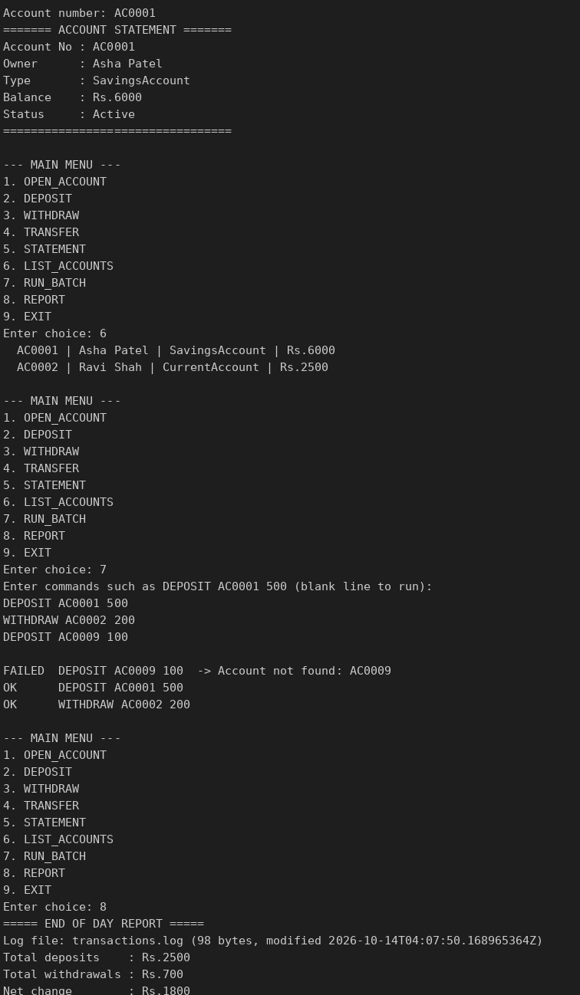
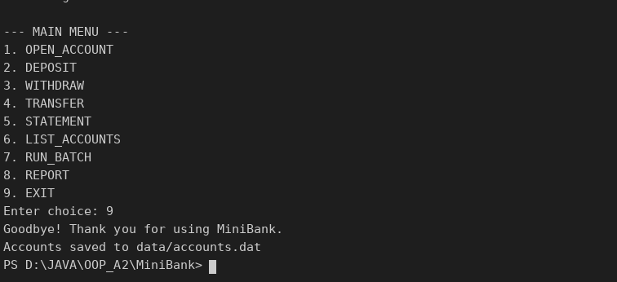

Session 2 – restart: the saved accounts are loaded again:
