PRACTICAL-10

- AIM:

Work these in your lab-NN/ folder before the project: do the first one or two in the lab; the last (For Advanced Learners) is for home.

1. Thread-pool runner
With a fixed pool of 3 (ExecutorService), submit about 10 Runnable tasks that print their id and sleep briefly; shut down and await completion, observing the few threads being reused.

2. Producer–consumer
One thread adds numbers to a small shared buffer and another removes them, coordinated with wait()/notify(); produce and consume a fixed number of items in order with none lost.

3. (For Advanced Learners – home) Deadlock
Reproduce a deadlock between two threads that lock two objects in opposite order, then remove it with a consistent lock order. Choose the scenario yourself.

- SOURCE CODE :

THREADPOOLRUNNER.JAVA :
import java.util.concurrent.ExecutorService;
import java.util.concurrent.Executors;
import java.util.concurrent.TimeUnit;

public class ThreadPoolRunner {
public static void main(String[] args) throws InterruptedException {
ExecutorService pool = Executors.newFixedThreadPool(3);

for (int i = 1; i <= 10; i++) {
final int id = i;
pool.submit(() -> {
System.out.println("Task " + id + " running on " + Thread.currentThread().getName());
try {
Thread.sleep(200);
} catch (InterruptedException e) {
Thread.currentThread().interrupt();
}
});
}

pool.shutdown();
pool.awaitTermination(30, TimeUnit.SECONDS);
System.out.println("All tasks finished. Pool terminated: " + pool.isTerminated());
}
}

- OUTPUT :

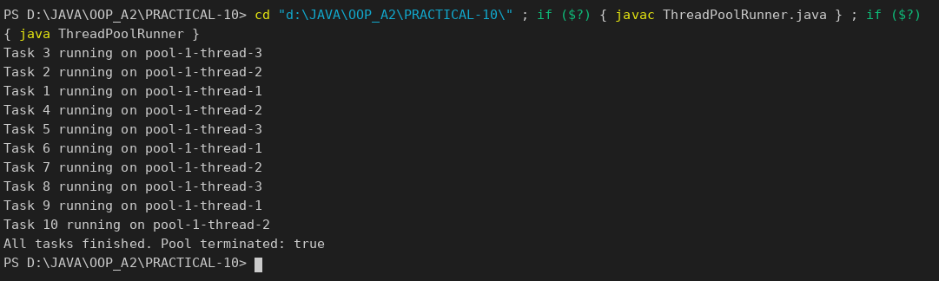

PRODUCERCONSUMER.JAVA :
class Buffer {
private final int[] items = new int[3];
private int head = 0, tail = 0, count = 0;

public synchronized void put(int value) throws InterruptedException {
while (count == items.length) {
wait(); // buffer full: wait for the consumer
}
items[tail] = value;
tail = (tail + 1) % items.length;
count++;
System.out.println("Produced " + value);
notifyAll();
}

public synchronized int take() throws InterruptedException {
while (count == 0) {
wait(); // buffer empty: wait for the producer
}
int value = items[head];
head = (head + 1) % items.length;
count--;
System.out.println(" Consumed " + value);
notifyAll();
return value;
}
}

public class ProducerConsumer {
public static void main(String[] args) throws InterruptedException {
Buffer buffer = new Buffer();
final int TOTAL = 10;

Thread producer = new Thread(() -> {
try {
for (int i = 1; i <= TOTAL; i++) {
buffer.put(i);
}
} catch (InterruptedException e) {
Thread.currentThread().interrupt();
}
}, "Producer");

Thread consumer = new Thread(() -> {
try {
int sum = 0;
for (int i = 1; i <= TOTAL; i++) {
sum += buffer.take();
}
System.out.println("Consumer received all " + TOTAL + " items, sum = " + sum);
} catch (InterruptedException e) {
Thread.currentThread().interrupt();
}
}, "Consumer");

producer.start();
consumer.start();
producer.join();
consumer.join();
}
}

OUTPUT :

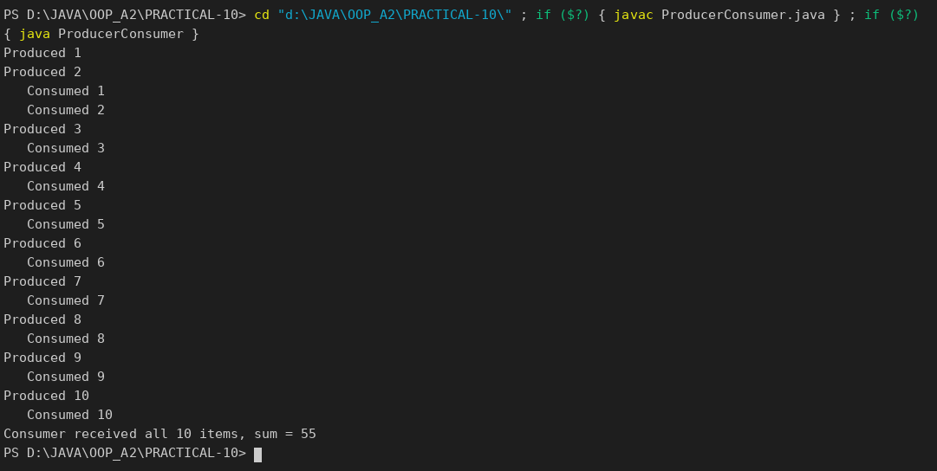

DEADLOCKDEMO.JAVA :
import java.lang.management.ManagementFactory;
import java.lang.management.ThreadMXBean;

public class DeadlockDemo {
static final Object LOCK_A = new Object();
static final Object LOCK_B = new Object();

static void pause() {
try { Thread.sleep(100); } catch (InterruptedException e) { Thread.currentThread().interrupt(); }
}

public static void main(String[] args) throws InterruptedException {
// ---- 1. opposite lock order -> deadlock ----
Thread t1 = new Thread(() -> {
synchronized (LOCK_A) { pause(); synchronized (LOCK_B) { System.out.println("T1 done"); } }
}, "T1");
Thread t2 = new Thread(() -> {
synchronized (LOCK_B) { pause(); synchronized (LOCK_A) { System.out.println("T2 done"); } }
}, "T2");
t1.setDaemon(true); // daemon, so the JVM can still exit while they are stuck
t2.setDaemon(true);
t1.start();
t2.start();
t1.join(2000);
t2.join(2000);

ThreadMXBean mx = ManagementFactory.getThreadMXBean();
long[] stuck = mx.findDeadlockedThreads();
System.out.println("Opposite order : " + (stuck != null ? "DEADLOCK detected, " + stuck.length + " threads blocked" : "no deadlock"));

// ---- 2. same order for everybody -> no deadlock (fresh locks: the old ones are still stuck) ----
final Object lockC = new Object();
final Object lockD = new Object();
Thread f1 = new Thread(() -> {
synchronized (lockC) { pause(); synchronized (lockD) { System.out.println("F1 done"); } }
}, "F1");
Thread f2 = new Thread(() -> {
synchronized (lockC) { pause(); synchronized (lockD) { System.out.println("F2 done"); } }
}, "F2");
f1.start();
f2.start();
f1.join();
f2.join();
System.out.println("Consistent order: both threads finished normally");
}
}

OUTPUT :

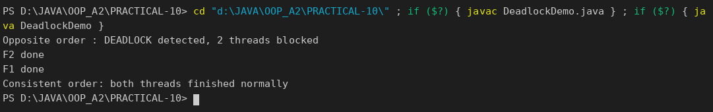

PART-B :

Building on basic threads, this lab gives MiniBank a proper transaction engine. You process a batch of transactions on a managed thread pool, coordinate two threads with wait/notify, and learn to avoid deadlock with consistent lock ordering — the way back-office systems process many transactions safely.
1. Create a class named TransactionProcessor that holds an ExecutorService created with Executors.newFixedThreadPool(4). Add a method submit(Runnable task) that calls execute(), and a method stop() that calls shutdown() and awaitTermination().
2. Create Runnable tasks that each perform a deposit or withdrawal; submit many of them, then stop the processor and wait for completion.
3. Build a simple producer-consumer: one thread adds transactions to a shared array buffer and another thread processes them, using wait() and notify() inside synchronized blocks.
4. Create a deadlock: two threads transfer money A to B and B to A, locking the two accounts in opposite order. Then fix it by always locking the account with the smaller accountNumber first.

SERVICE / TRANSACTIONPROCESSOR.JAVA :
package service;

import java.util.concurrent.ExecutorService;
import java.util.concurrent.Executors;
import java.util.concurrent.TimeUnit;

/** PR-10: runs banking tasks on a managed pool of 4 threads. */
public class TransactionProcessor {
private final ExecutorService pool = Executors.newFixedThreadPool(4);

public void submit(Runnable task) {
pool.execute(task);
}

public void stop() {
pool.shutdown();
try {
if (!pool.awaitTermination(30, TimeUnit.SECONDS)) {
pool.shutdownNow();
}
} catch (InterruptedException e) {
pool.shutdownNow();
Thread.currentThread().interrupt();
}
}
}

SERVICE / TRANSACTIONBUFFER.JAVA :
package service;

/** PR-10: small shared array buffer; producer and consumer coordinate with wait()/notify(). */
public class TransactionBuffer {
private final String[] items;
private int head = 0;
private int tail = 0;
private int count = 0;

public TransactionBuffer(int capacity) {
this.items = new String[capacity];
}

public synchronized void put(String line) throws InterruptedException {
while (count == items.length) {
wait(); // buffer full: wait for the consumer
}
items[tail] = line;
tail = (tail + 1) % items.length;
count++;
notifyAll();
}

public synchronized String take() throws InterruptedException {
while (count == 0) {
wait(); // buffer empty: wait for the producer
}
String line = items[head];
items[head] = null;
head = (head + 1) % items.length;
count--;
notifyAll();
return line;
}
}

SERVICE / TRANSFERTASKS.JAVA :
package service;

import exception.BankException;
import model.Account;

/** PR-10: two ways to transfer money between accounts, one of which can deadlock. */
public class TransferTasks {
private TransferTasks() { }

private static void pause() {
try {
Thread.sleep(100);
} catch (InterruptedException e) {
Thread.currentThread().interrupt();
}
}

/** Locks "from" first, then "to": two opposite transfers can deadlock. */
public static void transferUnsafe(Account from, Account to, long amount) throws BankException {
synchronized (from) {
pause();
synchronized (to) {
from.withdraw(amount);
to.deposit(amount);
}
}
}

/** Always locks the account with the smaller accountNumber first: no deadlock. */
public static void transferSafe(Account from, Account to, long amount) throws BankException {
Account first = from.getAccountNumber().compareTo(to.getAccountNumber()) < 0 ? from : to;
Account second = (first == from) ? to : from;
synchronized (first) {
pause();
synchronized (second) {
from.withdraw(amount);
to.deposit(amount);
}
}
}
}

SERVICE / MINIBANK.JAVA :
package service;

import exception.BankException;
import model.*;
import util.Command;
import util.CommandParser;

import java.lang.management.ManagementFactory;
import java.lang.management.ThreadMXBean;
import java.util.HashMap;
import java.util.Map;

public class MiniBank {

public static void main(String[] args) throws Exception {
BankInfo bank = new BankInfo("MiniBank", "Main Branch");
System.out.println("==========================================");
System.out.println(" " + bank);
System.out.println("==========================================");

demoPr10();
}

// ================= PR-10 =================
private static void demoPr10() throws Exception {
// ---- 1. thread pool: 8 deposits run by 4 pool threads ----
section("PR-10 (1): ExecutorService thread pool");
Account shared = new SavingsAccount("Asha Patel", 0, 0);
TransactionProcessor processor = new TransactionProcessor();
for (int i = 1; i <= 8; i++) {
final int id = i;
processor.submit(() -> {
try {
shared.deposit(100);
System.out.println("Task " + id + " deposited Rs.100 on " + Thread.currentThread().getName());
} catch (BankException e) {
System.out.println("Task " + id + " failed: " + e.getMessage());
}
});
}
processor.stop();
System.out.println("Final balance after 8 tasks = Rs." + shared.getBalance());

// ---- 2. producer-consumer with wait()/notify() ----
section("PR-10 (2): producer-consumer");
Account target = new SavingsAccount("Ravi Shah", 1000, 0);
Map<String, Account> accounts = new HashMap<>();
accounts.put(target.getAccountNumber(), target);
TransactionBuffer buffer = new TransactionBuffer(3);
String no = target.getAccountNumber();
String[] lines = {
"DEPOSIT " + no + " 500", "WITHDRAW " + no + " 200", "DEPOSIT " + no + " 300",
"WITHDRAW " + no + " 100", "DEPOSIT " + no + " 50"
};

Thread producer = new Thread(() -> {
try {
for (String line : lines) {
buffer.put(line);
System.out.println("Produced : " + line);
}
buffer.put("STOP");
} catch (InterruptedException e) {
Thread.currentThread().interrupt();
}
}, "Producer");

Thread consumer = new Thread(() -> {
try {
String line;
while (!(line = buffer.take()).equals("STOP")) {
Command cmd = CommandParser.parse(line);
Account acc = accounts.get(cmd.accountNumber());
if (cmd.type() == util.TransactionType.DEPOSIT) {
acc.deposit(cmd.amount());
} else if (cmd.type() == util.TransactionType.WITHDRAW) {
acc.withdraw(cmd.amount());
}
System.out.println(" Consumed: " + line + " -> balance Rs." + acc.getBalance());
}
} catch (InterruptedException | BankException e) {
System.out.println("Consumer stopped: " + e.getMessage());
}
}, "Consumer");

producer.start();
consumer.start();
producer.join();
consumer.join();
System.out.println("Final balance = Rs." + target.getBalance() + " (expected Rs.1550)");

// ---- 3. deadlock and its fix ----
section("PR-10 (3): deadlock and lock ordering");
Account a = new SavingsAccount("Account A", 5000, 0);
Account b = new SavingsAccount("Account B", 5000, 0);

Thread t1 = new Thread(() -> runTransfer(false, a, b, 1000), "A-to-B");
Thread t2 = new Thread(() -> runTransfer(false, b, a, 500), "B-to-A");
t1.setDaemon(true);
t2.setDaemon(true); // daemon: JVM can still exit if they hang
t1.start();
t2.start();
t1.join(2000);
t2.join(2000);
ThreadMXBean mx = ManagementFactory.getThreadMXBean();
long[] stuck = mx.findDeadlockedThreads();
System.out.println("Opposite lock order : "
+ (stuck != null ? "DEADLOCK - " + stuck.length + " threads are blocked forever" : "finished"));

Account c = new SavingsAccount("Account C", 5000, 0);
Account d = new SavingsAccount("Account D", 5000, 0);
Thread t3 = new Thread(() -> runTransfer(true, c, d, 1000), "C-to-D");
Thread t4 = new Thread(() -> runTransfer(true, d, c, 500), "D-to-C");
t3.start();
t4.start();
t3.join();
t4.join();
System.out.println("Smaller number first: both transfers finished");
System.out.println("C = Rs." + c.getBalance() + ", D = Rs." + d.getBalance() + " (expected 4500 and 5500)");
}

private static void runTransfer(boolean safe, Account from, Account to, long amount) {
try {
if (safe) {
TransferTasks.transferSafe(from, to, amount);
} else {
TransferTasks.transferUnsafe(from, to, amount);
}
} catch (BankException e) {
System.out.println("Transfer failed: " + e.getMessage());
}
}

private static void section(String title) {
System.out.println("\n==========================================");
System.out.println(" " + title);
System.out.println("==========================================");
}
}

OUTPUT:

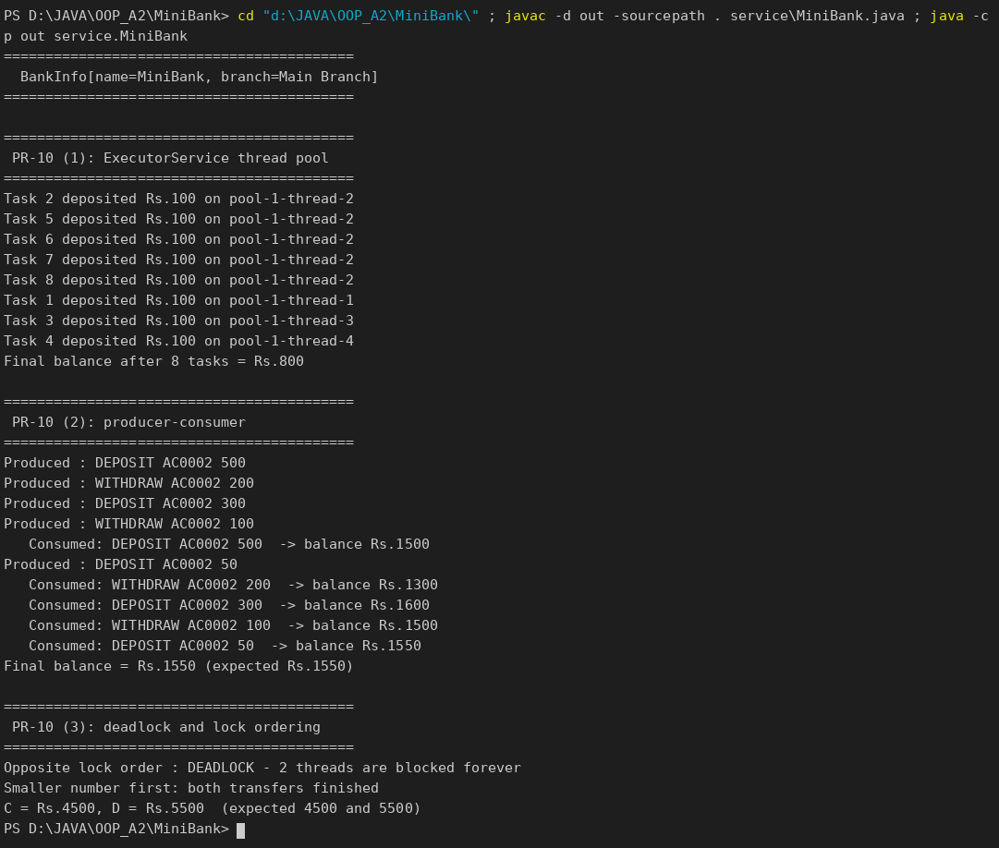

KEY QUESTIONS :
- Why is a thread pool better than creating a new thread per task?
Creating and destroying threads is expensive and too many threads exhaust memory. A pool keeps a fixed number of threads and reuses them for many tasks, which saves time and limits resource use.
- How do wait() and notify() coordinate two threads?
Inside a synchronized block, wait() releases the lock and puts the thread to sleep until the condition changes, and notify()/notifyAll() wakes a waiting thread. The producer waits when the buffer is full and the consumer waits when it is empty.
- What causes a deadlock, and how does consistent lock ordering prevent it?
A deadlock happens when each thread holds one lock and waits for a lock held by the other, so neither can continue. If every thread always takes the locks in the same order (smaller account number first), a circular wait can never form.

