PRACTICAL-11

- AIM:

Work these in your lab-NN/ folder before the project: do the first one or two in the lab; the last (For Advanced Learners) is for home.

1. Save/load
Make a small class Serializable, save an array of its objects to a file with ObjectOutputStream, then read it back into fresh objects and confirm the values survived. Mark one field transient and show it is not saved.

2. Log analyzer
Create a few text files, then use Path/Files to read each line by line and count the total lines and how many contain a keyword across all files; also print each file’s size from its attributes.

3. (For Advanced Learners – home) Folder report
Walk a folder tree with NIO and produce a report of the files it contains (name, size, modified time), writing the summary to a file; decide what to include.

- SOURCE CODE :

SAVELOAD.JAVA :
import java.io.*;

class Player implements Serializable {
private static final long serialVersionUID = 1L;
private String name;
private int score;
private transient String password; // transient: NOT written to the file

public Player(String name, int score, String password) {
this.name = name;
this.score = score;
this.password = password;
}

@Override
public String toString() {
return name + " | score=" + score + " | password=" + password;
}
}

public class SaveLoad {
public static void main(String[] args) throws Exception {
Player[] players = {
new Player("Asha", 120, "secret1"),
new Player("Ravi", 95, "secret2"),
new Player("Meera", 150, "secret3")
};

System.out.println("Before saving:");
for (Player p : players) System.out.println(" " + p);

try (ObjectOutputStream out = new ObjectOutputStream(new FileOutputStream("players.dat"))) {
out.writeObject(players);
}

Player[] loaded;
try (ObjectInputStream in = new ObjectInputStream(new FileInputStream("players.dat"))) {
loaded = (Player[]) in.readObject();
}

System.out.println("After loading from players.dat:");
for (Player p : loaded) System.out.println(" " + p);
}
}

- OUTPUT :

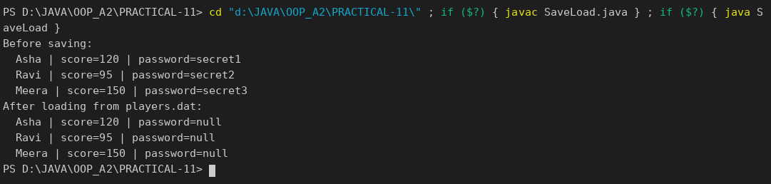

LOGANALYZER.JAVA :
import java.io.IOException;
import java.nio.file.*;
import java.nio.file.attribute.BasicFileAttributes;
import java.util.List;

public class LogAnalyzer {
public static void main(String[] args) throws IOException {
Path dir = Paths.get("logs");
Files.createDirectories(dir);
Files.write(dir.resolve("a.log"), List.of("INFO started", "ERROR disk full", "INFO running"));
Files.write(dir.resolve("b.log"), List.of("ERROR timeout", "ERROR timeout again", "INFO ok"));
Files.write(dir.resolve("c.log"), List.of("INFO all good"));

String keyword = "ERROR";
int totalLines = 0, matches = 0;

try (DirectoryStream<Path> files = Files.newDirectoryStream(dir, "*.log")) {
for (Path file : files) {
List<String> lines = Files.readAllLines(file);
totalLines += lines.size();
for (String line : lines) {
if (line.contains(keyword)) matches++;
}
BasicFileAttributes attrs = Files.readAttributes(file, BasicFileAttributes.class);
System.out.println(file.getFileName() + " -> " + lines.size() + " lines, " + attrs.size() + " bytes");
}
}
System.out.println("Total lines: " + totalLines);
System.out.println("Lines containing \"" + keyword + "\": " + matches);
}
}

OUTPUT :

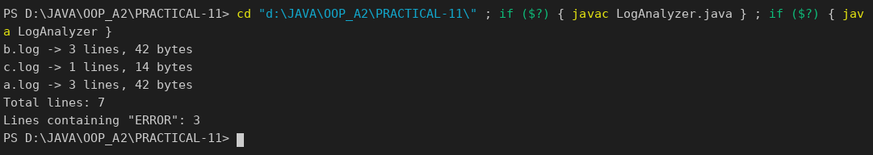

FOLDERREPORT.JAVA :
import java.io.IOException;
import java.nio.file.*;
import java.nio.file.attribute.BasicFileAttributes;
import java.util.ArrayList;
import java.util.List;
import java.util.stream.Stream;

public class FolderReport {
public static void main(String[] args) throws IOException {
Path root = Paths.get("logs"); // run LogAnalyzer first to create it
List<String> report = new ArrayList<>();
report.add("Folder report for: " + root);

long totalBytes = 0;
try (Stream<Path> walk = Files.walk(root)) {
for (Path p : (Iterable<Path>) walk.filter(Files::isRegularFile)::iterator) {
BasicFileAttributes a = Files.readAttributes(p, BasicFileAttributes.class);
totalBytes += a.size();
report.add(p.getFileName() + " | " + a.size() + " bytes | modified " + a.lastModifiedTime());
}
}
report.add("Total size: " + totalBytes + " bytes");

Files.write(Paths.get("folder-report.txt"), report);
report.forEach(System.out::println);
System.out.println("Summary written to folder-report.txt");
}
}

OUTPUT :

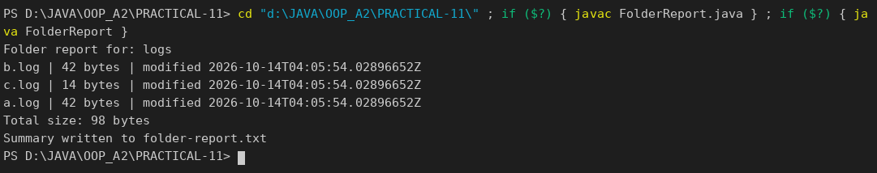

PART-B :

So far MiniBank forgets everything when it closes. In this lab you add the persistence and reporting layer: you make the model Serializable and save/load all accounts to a file, write an append-only transaction log, and then use NIO to walk the logs and produce an end-of-day summary report.
1. Make Account (and its subclasses and Customer) implement Serializable, and add a private static final long serialVersionUID field.
2. Create a class named StatePersister with a public static method void save(Account[] accounts, Path file) that uses ObjectOutputStream inside try-with-resources, and a public static method Account[] load(Path file) that uses ObjectInputStream.
3. Create a class named TransactionLog with a public static method void append(Path file, String line) that uses Files.write(...) with CREATE and APPEND.
4. Create a class named ReportGenerator that walks the logs folder using Files.newDirectoryStream, reads each file line by line with a BufferedReader, and adds up the total deposits and total withdrawals in long variables; also read file details (size, last-modified) using Files.readAttributes, then write the summary to a report file.
5. In main, save the accounts, reload them into a new array and print them to confirm the data survived, then generate and print the report.
(Customer, Customer.Address, SavingsAccount, CurrentAccount and FixedDepositAccount received the same two additions as Account: implements Serializable and serialVersionUID. The generated data folder is not committed.)

MODEL / ACCOUNT.JAVA :
package model;

import exception.AccountNotFoundException;
import exception.BankException;
import exception.InsufficientFundsException;
import exception.InvalidAmountException;
import model.annotation.Id;
import model.annotation.MaxLength;
import model.annotation.Positive;

import java.io.Serializable;
import java.util.Objects;

public abstract class Account implements Transactable, InterestBearing, Serializable {

private static final long serialVersionUID = 1L;

@Id
private final String accountNumber;
@MaxLength(20)
private String ownerName;
@Positive
private long balance; // changes only via deposit() / withdraw()
private boolean active;

private static long accountCounter = 0;

private static String generateAccountNumber() {
accountCounter++;
return String.format("AC%04d", accountCounter);
}

public Account(String ownerName, long openingBalance) {
this.accountNumber = generateAccountNumber();
this.ownerName = ownerName;
this.balance = openingBalance;
this.active = true;
}

public Account(String ownerName) {
this(ownerName, 0);
}

// ---- PR-8: exceptions instead of boolean flags ----
@Override
public synchronized void deposit(long amount) throws InvalidAmountException {
if (amount <= 0) {
throw new InvalidAmountException(amount);
}
balance += amount;
}

@Override
public synchronized boolean withdraw(long amount) throws InsufficientFundsException, InvalidAmountException {
if (amount <= 0) {
throw new InvalidAmountException(amount);
}
if (!canWithdraw(amount)) {
throw new InsufficientFundsException(amount - availableToWithdraw());
}
balance -= amount;
return true;
}

/** Moves money to another account; rolls back if the credit side fails. */
public void transfer(Account to, long amount) throws BankException {
if (to == null) {
throw new AccountNotFoundException("null");
}
boolean debited = false;
try {
withdraw(amount);
debited = true;
to.deposit(amount);
System.out.println("Transferred Rs." + amount + " from " + accountNumber + " to " + to.accountNumber);
} catch (BankException e) {
if (debited) {
balance += amount; // rollback the debit
}
System.out.println("Transfer failed: " + e.getMessage());
throw e; // rethrow to the caller
} finally {
System.out.println("Transfer attempt finished (" + accountNumber + " -> " + to.accountNumber + ").");
}
}

public String getAccountNumber() { return accountNumber; }

public String getOwnerName() { return ownerName; }

@Override
public long getBalance() { return balance; }

public boolean isActive() { return active; }

/** How much can currently be taken out; used to compute the shortfall. */
protected long availableToWithdraw() {
return balance;
}

@Override
public String toString() {
return "Account[accountNumber=" + accountNumber
+ ", ownerName=" + ownerName
+ ", balance=Rs." + balance + "]";
}

@Override
public boolean equals(Object o) {
if (this == o) return true;
if (!(o instanceof Account)) return false;
Account other = (Account) o;
return Objects.equals(accountNumber, other.accountNumber);
}

@Override
public int hashCode() {
return Objects.hash(accountNumber);
}

@Override
public abstract double interestRate();

public abstract boolean canWithdraw(long amount);
}

UTIL / STATEPERSISTER.JAVA :
package util;

import model.Account;

import java.io.IOException;
import java.io.ObjectInputStream;
import java.io.ObjectOutputStream;
import java.nio.file.Files;
import java.nio.file.Path;

/** PR-11: saves and loads every account with object serialization. */
public class StatePersister {
private StatePersister() { }

public static void save(Account[] accounts, Path file) throws IOException {
if (file.getParent() != null) {
Files.createDirectories(file.getParent());
}
try (ObjectOutputStream out = new ObjectOutputStream(Files.newOutputStream(file))) {
out.writeObject(accounts);
}
}

public static Account[] load(Path file) throws IOException, ClassNotFoundException {
try (ObjectInputStream in = new ObjectInputStream(Files.newInputStream(file))) {
return (Account[]) in.readObject();
}
}
}

UTIL / TRANSACTIONLOG.JAVA :
package util;

import java.io.IOException;
import java.nio.charset.StandardCharsets;
import java.nio.file.Files;
import java.nio.file.Path;
import java.nio.file.StandardOpenOption;

/** PR-11: append-only transaction log, one line per transaction. */
public class TransactionLog {
private TransactionLog() { }

public static synchronized void append(Path file, String line) throws IOException {
if (file.getParent() != null) {
Files.createDirectories(file.getParent());
}
Files.write(file, (line + System.lineSeparator()).getBytes(StandardCharsets.UTF_8),
StandardOpenOption.CREATE, StandardOpenOption.APPEND);
}
}

UTIL / REPORTGENERATOR.JAVA :
package util;

import java.io.BufferedReader;
import java.io.IOException;
import java.nio.file.DirectoryStream;
import java.nio.file.Files;
import java.nio.file.Path;
import java.nio.file.attribute.BasicFileAttributes;
import java.util.ArrayList;
import java.util.List;

/** PR-11: walks the logs folder and writes an end-of-day summary report. */
public class ReportGenerator {
private ReportGenerator() { }

public static List<String> generate(Path logsDir, Path reportFile) throws IOException {
long totalDeposits = 0;
long totalWithdrawals = 0;
List<String> report = new ArrayList<>();
report.add("===== END OF DAY REPORT =====");

try (DirectoryStream<Path> files = Files.newDirectoryStream(logsDir, "*.log")) {
for (Path file : files) {
BasicFileAttributes attrs = Files.readAttributes(file, BasicFileAttributes.class);
if (attrs.size() == 0) {
continue; // skip empty logs
}
report.add("Log file: " + file.getFileName() + " (" + attrs.size()
+ " bytes, modified " + attrs.lastModifiedTime() + ")");
try (BufferedReader reader = Files.newBufferedReader(file)) {
String line;
while ((line = reader.readLine()) != null) {
String[] parts = line.trim().split("\\s+");
if (parts.length != 3) {
continue;
}
long amount = Long.parseLong(parts[2]);
if (parts[0].equals("DEPOSIT")) {
totalDeposits += amount;
} else if (parts[0].equals("WITHDRAW")) {
totalWithdrawals += amount;
}
}
}
}
}
report.add("Total deposits : Rs." + totalDeposits);
report.add("Total withdrawals : Rs." + totalWithdrawals);
report.add("Net change : Rs." + (totalDeposits - totalWithdrawals));

if (reportFile.getParent() != null) {
Files.createDirectories(reportFile.getParent());
}
Files.write(reportFile, report);
return report;
}
}

SERVICE / MINIBANK.JAVA :
package service;

import exception.BankException;
import model.*;
import util.ReportGenerator;
import util.StatePersister;
import util.TransactionLog;

import java.io.IOException;
import java.nio.file.Files;
import java.nio.file.Path;
import java.nio.file.Paths;

public class MiniBank {

public static void main(String[] args) throws Exception {
BankInfo bank = new BankInfo("MiniBank", "Main Branch");
System.out.println("==========================================");
System.out.println(" " + bank);
System.out.println("==========================================");

demoPr11();
}

// ================= PR-11 =================
private static void demoPr11() throws IOException, ClassNotFoundException, BankException {
section("PR-11: Serialization, transaction log, NIO report");
Path dataDir = Paths.get("data");
Path accountsFile = dataDir.resolve("accounts.dat");
Path logsDir = dataDir.resolve("logs");

// 1. save the accounts and load them back into a new array
Account[] accounts = {
new SavingsAccount("Asha Patel", 5000, 1000),
new CurrentAccount("Ravi Shah", 2000, 3000),
new FixedDepositAccount("Meera Joshi", 50000)
};
StatePersister.save(accounts, accountsFile);
System.out.println("Saved " + accounts.length + " accounts to " + accountsFile);

Account[] loaded = StatePersister.load(accountsFile);
System.out.println("Loaded back from the file:");
for (Account a : loaded) {
System.out.println(" " + a);
}
System.out.println("Same data after reload: " + loaded[0].equals(accounts[0])
+ ", balance " + loaded[0].getBalance());

// 2. append-only transaction logs (fresh files for this demo run)
Files.createDirectories(logsDir);
Files.deleteIfExists(logsDir.resolve("day1.log"));
Files.deleteIfExists(logsDir.resolve("day2.log"));
TransactionLog.append(logsDir.resolve("day1.log"), "DEPOSIT AC0001 500");
TransactionLog.append(logsDir.resolve("day1.log"), "WITHDRAW AC0002 200");
TransactionLog.append(logsDir.resolve("day1.log"), "DEPOSIT AC0003 1500");
TransactionLog.append(logsDir.resolve("day2.log"), "WITHDRAW AC0001 300");
TransactionLog.append(logsDir.resolve("day2.log"), "DEPOSIT AC0002 700");
System.out.println("\nTransaction logs written to " + logsDir);

// 3. NIO report over every log file
System.out.println();
for (String line : ReportGenerator.generate(logsDir, dataDir.resolve("report.txt"))) {
System.out.println(line);
}
System.out.println("Report saved to " + dataDir.resolve("report.txt"));
}

private static void section(String title) {
System.out.println("\n==========================================");
System.out.println(" " + title);
System.out.println("==========================================");
}
}

OUTPUT:

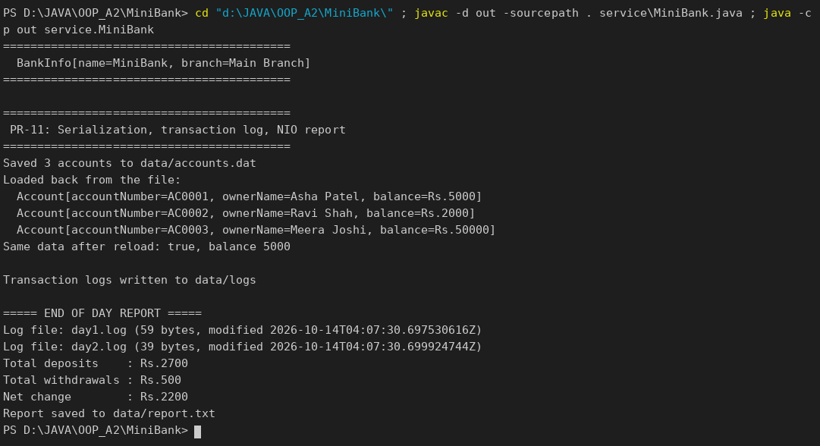

KEY QUESTIONS :
- What does it mean for a class to be Serializable, and why add serialVersionUID?
A Serializable class can be converted to a stream of bytes and rebuilt later, so objects can be saved to a file. serialVersionUID is the version number of the class; Java checks it on loading, so a file saved by an incompatible version is rejected instead of being read wrongly.
- What is the difference between a byte stream and a character stream?
A byte stream (InputStream/OutputStream, ObjectOutputStream) reads and writes raw bytes and is used for binary data such as serialized objects. A character stream (Reader/Writer, BufferedReader) works with text and handles character encoding.
- How does NIO’s Path/Files API differ from the old File class, and how is a directory stream iterated?
Path and Files give a simpler, more complete API with better error reporting (exceptions instead of false), attribute access and helpers such as Files.write and Files.readAllLines. A directory is iterated with try (DirectoryStream<Path> ds = Files.newDirectoryStream(dir, "*.log")) { for (Path p : ds) ... }.

