PRACTICAL-12

- AIM:

Work these in your lab-NN/ folder before the project: do the first one or two in the lab; the last (For Advanced Learners) is for home.

1. Word frequency
Split a paragraph into words, count each in a HashMap, and print the words sorted by frequency (highest first) using a Comparator.

2. Unique visitors
From a list of login names with repeats, use a HashSet to count unique users and a LinkedHashSet to keep first-seen order; print the unique count and the first three distinct names.

3. (For Advanced Learners – home) Leaderboard
Build a leaderboard from player scores held in a Map and print the top-N sorted by score (ties broken by name); choose the data and sorting details.

- SOURCE CODE :

WORDFREQUENCY.JAVA :
import java.util.*;

public class WordFrequency {
public static void main(String[] args) {
String paragraph = "the quick brown fox jumps over the lazy dog the fox runs and the dog sleeps";
Map<String, Integer> freq = new HashMap<>();
for (String word : paragraph.split("\\s+")) {
freq.put(word, freq.getOrDefault(word, 0) + 1);
}

List<Map.Entry<String, Integer>> entries = new ArrayList<>(freq.entrySet());
entries.sort(Comparator.comparing((Map.Entry<String, Integer> e) -> e.getValue()).reversed()
.thenComparing(Map.Entry::getKey));

for (Map.Entry<String, Integer> e : entries) {
System.out.println(e.getKey() + " -> " + e.getValue());
}
}
}

- OUTPUT :

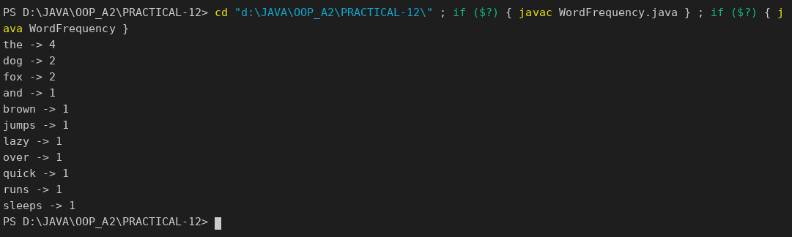

UNIQUEVISITORS.JAVA :
import java.util.*;

public class UniqueVisitors {
public static void main(String[] args) {
String[] logins = {"asha", "ravi", "asha", "meera", "ravi", "john", "asha", "meera"};

Set<String> unique = new HashSet<>(Arrays.asList(logins));
Set<String> firstSeen = new LinkedHashSet<>(Arrays.asList(logins));

System.out.println("Total logins : " + logins.length);
System.out.println("Unique users : " + unique.size());
System.out.print("First three distinct (first-seen order): ");
int shown = 0;
for (String name : firstSeen) {
if (shown++ == 3) break;
System.out.print(name + (shown < 3 ? ", " : ""));
}
System.out.println();
}
}

OUTPUT :

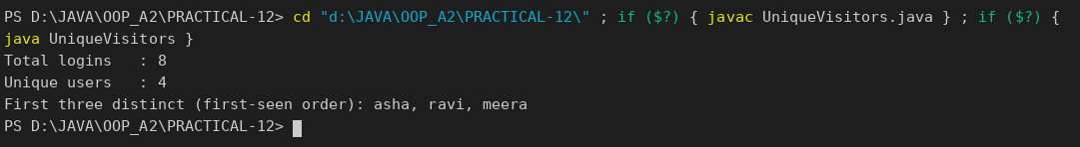

LEADERBOARD.JAVA :
import java.util.*;

public class Leaderboard {
public static void main(String[] args) {
Map<String, Integer> scores = new HashMap<>();
scores.put("Asha", 250);
scores.put("Ravi", 310);
scores.put("Meera", 250);
scores.put("John", 180);
scores.put("Priya", 310);

int topN = 3;
List<Map.Entry<String, Integer>> entries = new ArrayList<>(scores.entrySet());
// highest score first, ties broken by name
entries.sort((a, b) -> {
int byScore = Integer.compare(b.getValue(), a.getValue());
return byScore != 0 ? byScore : a.getKey().compareTo(b.getKey());
});

System.out.println("Top " + topN + " players:");
for (int i = 0; i < topN && i < entries.size(); i++) {
System.out.println((i + 1) + ". " + entries.get(i).getKey() + " - " + entries.get(i).getValue());
}
}
}

OUTPUT :

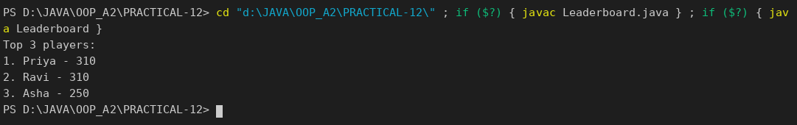

PART-B :

Until now accounts have lived in a plain array, which is hard to search and grow. In this lab you upgrade MiniBank’s storage to the Collections Framework — a HashMap keyed by account number, sorting with a Comparator, and a thread-safe map for concurrent access. This is the Milestone 2 checkpoint.
1. Create a class named AccountStore that keeps accounts in a HashMap<String, Account> using the account number as the key. Add methods add(Account account), get(String accountNumber) and getAll().
2. Keep a transaction history in an ArrayList<String>.
3. Add a method sortedByBalance() that returns an ArrayList<Account> sorted with a Comparator.
4. Make Account implement Comparable<Account> by comparing account numbers in compareTo().
5. In the TransactionProcessor, use a ConcurrentHashMap for the shared accounts so it is thread-safe.
6. In main, add several accounts to the store and print them sorted by balance.

SERVICE / ACCOUNTSTORE.JAVA :
package service;

import exception.AccountNotFoundException;
import model.Account;

import java.util.ArrayList;
import java.util.Comparator;
import java.util.HashMap;

/** PR-12: accounts kept in a HashMap keyed by account number, plus a transaction history list. */
public class AccountStore {
private final HashMap<String, Account> accounts = new HashMap<>();
private final ArrayList<String> history = new ArrayList<>();

public void add(Account account) {
accounts.put(account.getAccountNumber(), account);
history.add("ADDED " + account.getAccountNumber() + " (" + account.getOwnerName() + ")");
}

public Account get(String accountNumber) throws AccountNotFoundException {
Account account = accounts.get(accountNumber);
if (account == null) {
throw new AccountNotFoundException(accountNumber);
}
history.add("LOOKUP " + accountNumber);
return account;
}

public ArrayList<Account> getAll() {
return new ArrayList<>(accounts.values());
}

public ArrayList<String> getHistory() {
return history;
}

/** Highest balance first. */
public ArrayList<Account> sortedByBalance() {
ArrayList<Account> list = getAll();
list.sort(Comparator.comparingLong(Account::getBalance).reversed());
return list;
}

/** Supplementary: every account with a balance above the given value. */
public ArrayList<Account> balanceAbove(long limit) {
ArrayList<Account> result = new ArrayList<>();
for (Account a : accounts.values()) {
if (a.getBalance() > limit) {
result.add(a);
}
}
return result;
}
}

MODEL / ACCOUNT.JAVA (implements Comparable<Account>) :
package model;

import exception.AccountNotFoundException;
import exception.BankException;
import exception.InsufficientFundsException;
import exception.InvalidAmountException;
import model.annotation.Id;
import model.annotation.MaxLength;
import model.annotation.Positive;

import java.io.Serializable;
import java.util.Objects;

public abstract class Account implements Transactable, InterestBearing, Serializable, Comparable<Account> {

private static final long serialVersionUID = 1L;

@Id
private final String accountNumber;
@MaxLength(20)
private String ownerName;
@Positive
private long balance; // changes only via deposit() / withdraw()
private boolean active;

private static long accountCounter = 0;

private static String generateAccountNumber() {
accountCounter++;
return String.format("AC%04d", accountCounter);
}

public Account(String ownerName, long openingBalance) {
this.accountNumber = generateAccountNumber();
this.ownerName = ownerName;
this.balance = openingBalance;
this.active = true;
}

public Account(String ownerName) {
this(ownerName, 0);
}

// ---- PR-8: exceptions instead of boolean flags ----
@Override
public synchronized void deposit(long amount) throws InvalidAmountException {
if (amount <= 0) {
throw new InvalidAmountException(amount);
}
balance += amount;
}

@Override
public synchronized boolean withdraw(long amount) throws InsufficientFundsException, InvalidAmountException {
if (amount <= 0) {
throw new InvalidAmountException(amount);
}
if (!canWithdraw(amount)) {
throw new InsufficientFundsException(amount - availableToWithdraw());
}
balance -= amount;
return true;
}

/** Moves money to another account; rolls back if the credit side fails. */
public void transfer(Account to, long amount) throws BankException {
if (to == null) {
throw new AccountNotFoundException("null");
}
boolean debited = false;
try {
withdraw(amount);
debited = true;
to.deposit(amount);
System.out.println("Transferred Rs." + amount + " from " + accountNumber + " to " + to.accountNumber);
} catch (BankException e) {
if (debited) {
balance += amount; // rollback the debit
}
System.out.println("Transfer failed: " + e.getMessage());
throw e; // rethrow to the caller
} finally {
System.out.println("Transfer attempt finished (" + accountNumber + " -> " + to.accountNumber + ").");
}
}

public String getAccountNumber() { return accountNumber; }

public String getOwnerName() { return ownerName; }

@Override
public long getBalance() { return balance; }

public boolean isActive() { return active; }

/** How much can currently be taken out; used to compute the shortfall. */
protected long availableToWithdraw() {
return balance;
}

@Override
public String toString() {
return "Account[accountNumber=" + accountNumber
+ ", ownerName=" + ownerName
+ ", balance=Rs." + balance + "]";
}

@Override
public boolean equals(Object o) {
if (this == o) return true;
if (!(o instanceof Account)) return false;
Account other = (Account) o;
return Objects.equals(accountNumber, other.accountNumber);
}

@Override
public int hashCode() {
return Objects.hash(accountNumber);
}

/** PR-12: natural order = by account number. */
@Override
public int compareTo(Account other) {
return accountNumber.compareTo(other.accountNumber);
}

@Override
public abstract double interestRate();

public abstract boolean canWithdraw(long amount);
}

SERVICE / TRANSACTIONPROCESSOR.JAVA (ConcurrentHashMap added) :
package service;

import model.Account;

import java.util.concurrent.ConcurrentHashMap;
import java.util.concurrent.ExecutorService;
import java.util.concurrent.Executors;
import java.util.concurrent.TimeUnit;

/** PR-10: runs banking tasks on a managed pool of 4 threads. */
public class TransactionProcessor {
private final ExecutorService pool = Executors.newFixedThreadPool(4);

/** PR-12: thread-safe map of the accounts shared by all pool threads. */
private final ConcurrentHashMap<String, Account> accounts = new ConcurrentHashMap<>();

public void register(Account account) {
accounts.put(account.getAccountNumber(), account);
}

public Account find(String accountNumber) {
return accounts.get(accountNumber);
}

public void submit(Runnable task) {
pool.execute(task);
}

public void stop() {
pool.shutdown();
try {
if (!pool.awaitTermination(30, TimeUnit.SECONDS)) {
pool.shutdownNow();
}
} catch (InterruptedException e) {
pool.shutdownNow();
Thread.currentThread().interrupt();
}
}
}

SERVICE / MINIBANK.JAVA :
package service;

import exception.AccountNotFoundException;
import exception.BankException;
import model.*;

import java.util.ArrayList;
import java.util.Collections;

public class MiniBank {

public static void main(String[] args) throws Exception {
BankInfo bank = new BankInfo("MiniBank", "Main Branch");
System.out.println("==========================================");
System.out.println(" " + bank);
System.out.println("==========================================");

demoPr12();
}

// ================= PR-12 =================
private static void demoPr12() throws BankException {
section("PR-12: Collections framework");
AccountStore store = new AccountStore();
store.add(new SavingsAccount("Asha Patel", 5000, 1000)); // AC0001
store.add(new CurrentAccount("Ravi Shah", 2000, 3000)); // AC0002
store.add(new FixedDepositAccount("Meera Joshi", 9000)); // AC0003

System.out.println("get(\"AC0002\") -> " + store.get("AC0002"));
try {
store.get("AC9999");
} catch (AccountNotFoundException e) {
System.out.println("get(\"AC9999\") -> " + e.getMessage());
}

System.out.println("\nSorted by balance (Comparator, highest first):");
for (Account a : store.sortedByBalance()) {
System.out.println(" " + a.getAccountNumber() + " Rs." + a.getBalance());
}

ArrayList<Account> natural = store.getAll();
Collections.sort(natural); // uses Comparable.compareTo
System.out.print("\nNatural order (Comparable, by account number):");
for (Account a : natural) {
System.out.print(" " + a.getAccountNumber());
}
System.out.println();

System.out.println("Balance above 4000:");
for (Account a : store.balanceAbove(4000)) {
System.out.println(" " + a.getAccountNumber());
}

System.out.println("\nTransaction history (ArrayList<String>):");
for (String h : store.getHistory()) {
System.out.println(" " + h);
}

// thread-safe map inside the TransactionProcessor
TransactionProcessor processor = new TransactionProcessor();
for (Account a : store.getAll()) {
processor.register(a);
}
for (int i = 0; i < 4; i++) {
processor.submit(() -> {
try {
processor.find("AC0001").deposit(250);
} catch (BankException e) {
System.out.println(e.getMessage());
}
});
}
processor.stop();
System.out.println("\nAfter 4 pool deposits of Rs.250 via ConcurrentHashMap: AC0001 = Rs."
+ processor.find("AC0001").getBalance());
}

private static void section(String title) {
System.out.println("\n==========================================");
System.out.println(" " + title);
System.out.println("==========================================");
}
}

OUTPUT:

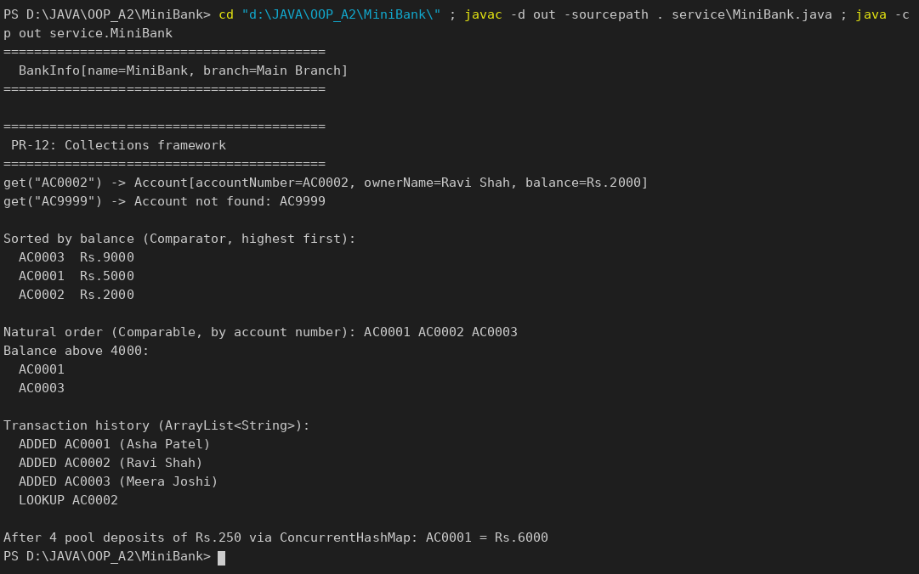

KEY QUESTIONS :
- What is the difference between a List, a Set and a Map?
A List is an ordered collection that allows duplicates and access by index. A Set holds only unique elements. A Map stores key-value pairs with unique keys and looks a value up by its key.
- When do you use a HashMap versus a TreeMap?
HashMap gives the fastest lookup (about constant time) but no order. TreeMap keeps the keys sorted (lookup in log n time), so it is used when sorted order or range operations are needed.
- What is the difference between Comparable and Comparator?
Comparable is implemented by the class itself and defines its single natural order through compareTo() (accounts by number). A Comparator is a separate object that defines any other order, such as balance highest first, without changing the class.

