PRACTICAL-13

- AIM:

Work these in your lab-NN/ folder before the project: do the first one or two in the lab; the last (For Advanced Learners) is for home.

1. Generic containers
A generic Box<T> with get/set and a Pair<A,B>; use them with different types to show type safety without casts, and write a generic method that returns the first element of any array.

2. Bounded stats
A generic method <N extends Number> double average(N[] values) that works for Integer[], Double[] and Long[]; note why it refuses non-Number types.

3. (For Advanced Learners – home) Generic stack
Implement a small generic container of your choice (e.g. a stack) backed by an array, reuse it for two different types, and handle the empty case sensibly.

- SOURCE CODE :

GENERICBOXDEMO.JAVA :
class Box<T> {
private T value;
public Box(T value) { this.value = value; }
public T get() { return value; }
public void set(T value) { this.value = value; }
}

class Pair<A, B> {
private final A first;
private final B second;
public Pair(A first, B second) { this.first = first; this.second = second; }
public A getFirst() { return first; }
public B getSecond() { return second; }
@Override
public String toString() { return "(" + first + ", " + second + ")"; }
}

public class GenericBoxDemo {
static <E> E firstOf(E[] items) {
return items[0];
}

public static void main(String[] args) {
Box<String> name = new Box<>("Riya");
Box<Integer> age = new Box<>(20);
String n = name.get(); // no cast needed
int a = age.get(); // no cast needed
System.out.println("Box<String> : " + n);
System.out.println("Box<Integer> : " + a);

Pair<String, Double> p = new Pair<>("Balance", 5000.50);
System.out.println("Pair : " + p);

System.out.println("firstOf(String[]) : " + firstOf(new String[]{"x", "y", "z"}));
System.out.println("firstOf(Integer[]) : " + firstOf(new Integer[]{10, 20, 30}));
// name.set(42); // would NOT compile: Box<String> only accepts String
}
}

- OUTPUT :

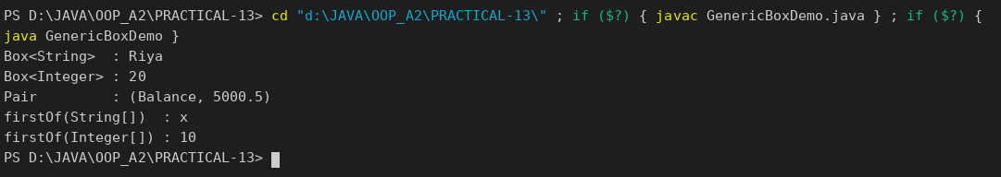

BOUNDEDSTATS.JAVA :
public class BoundedStats {
static <N extends Number> double average(N[] values) {
double sum = 0;
for (N v : values) {
sum += v.doubleValue();
}
return sum / values.length;
}

public static void main(String[] args) {
System.out.println("Integer[] average : " + average(new Integer[]{10, 20, 30}));
System.out.println("Double[] average : " + average(new Double[]{1.5, 2.5, 3.5}));
System.out.println("Long[] average : " + average(new Long[]{100L, 200L, 300L, 400L}));
// average(new String[]{"a", "b"}); // compile error: String is not a Number
}
}

OUTPUT :

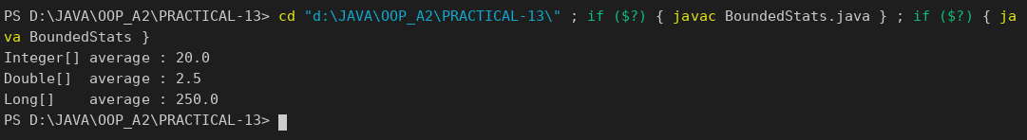

GENERICSTACK.JAVA :
public class GenericStack<T> {
private Object[] data = new Object[2];
private int size = 0;

public void push(T item) {
if (size == data.length) {
Object[] bigger = new Object[data.length * 2];
System.arraycopy(data, 0, bigger, 0, size);
data = bigger;
}
data[size++] = item;
}

@SuppressWarnings("unchecked")
public T pop() {
if (size == 0) {
throw new IllegalStateException("Stack is empty");
}
T item = (T) data[--size];
data[size] = null;
return item;
}

public boolean isEmpty() { return size == 0; }

public static void main(String[] args) {
GenericStack<Integer> numbers = new GenericStack<>();
numbers.push(1); numbers.push(2); numbers.push(3);
System.out.print("Integer stack pops: ");
while (!numbers.isEmpty()) System.out.print(numbers.pop() + " ");
System.out.println();

GenericStack<String> words = new GenericStack<>();
words.push("one"); words.push("two");
System.out.print("String stack pops : ");
while (!words.isEmpty()) System.out.print(words.pop() + " ");
System.out.println();

try {
words.pop();
} catch (IllegalStateException e) {
System.out.println("Empty case handled: " + e.getMessage());
}
}
}

OUTPUT :

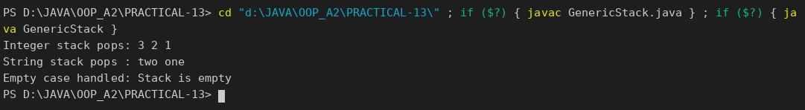

PART-B :

The HashMap store from the previous lab works only for accounts. In this lab you make MiniBank’s storage reusable: one generic Repository<T> that stores any type safely and finds each object’s key through the @Id annotation by reflection — the repository pattern used in real data-access layers. The service layer in Practical 14 will use it.
1. Create a generic class named Repository<T> that holds a HashMap<String, T>. Add methods T save(T entity), T findById(String id), ArrayList<T> findAll() and boolean delete(String id).
2. Inside save(), find the id by reflection: look for the field marked @Id (from Practical 7) and read its value as the map key.
3. Add a method marked @SafeVarargs called saveAll(T... items) that saves several objects at once.
4. Add one generic method with a bounded type parameter, for example static <N extends Number> double average(N[] values).
5. In main, create a Repository<Account>, save several accounts, fetch one by id, and print all of them.
(Supplementary: Customer.customerId was also marked @Id, so the same Repository class stores Customer objects without any change.)

REPOSITORY / REPOSITORY.JAVA :
package repository;

import model.annotation.Id;

import java.lang.reflect.Field;
import java.util.ArrayList;
import java.util.HashMap;

/** PR-13: one generic repository for any type; the key is the field marked with @Id. */
public class Repository<T> {
private final HashMap<String, T> store = new HashMap<>();

public T save(T entity) {
store.put(idOf(entity), entity);
return entity;
}

public T findById(String id) {
return store.get(id);
}

public ArrayList<T> findAll() {
return new ArrayList<>(store.values());
}

public boolean delete(String id) {
return store.remove(id) != null;
}

public int count() {
return store.size();
}

@SafeVarargs
public final void saveAll(T... items) {
for (T item : items) {
save(item);
}
}

/** Bounded type parameter: only Integer, Double, Long ... (subclasses of Number) are accepted. */
public static <N extends Number> double average(N[] values) {
double sum = 0;
for (N v : values) {
sum += v.doubleValue();
}
return values.length == 0 ? 0 : sum / values.length;
}

/** Reflection: look for the @Id field in the class and its superclasses. */
private String idOf(T entity) {
for (Class<?> c = entity.getClass(); c != null && c != Object.class; c = c.getSuperclass()) {
for (Field field : c.getDeclaredFields()) {
if (field.isAnnotationPresent(Id.class)) {
try {
field.setAccessible(true);
return String.valueOf(field.get(entity));
} catch (IllegalAccessException e) {
throw new IllegalStateException("Cannot read @Id field " + field.getName(), e);
}
}
}
}
throw new IllegalArgumentException("No @Id field found in " + entity.getClass().getSimpleName());
}
}

MODEL / CUSTOMER.JAVA (@Id added) :
package model;

import model.annotation.Id;

import java.io.Serializable;

public class Customer implements Cloneable, Serializable {
private static final long serialVersionUID = 1L;

private String name;
private String email;
private String mobile;
@Id
private final String customerId;
private Address address;

private static long customerCounter = 100;

private static String generateCustomerId() {
customerCounter++;
return "CUST" + customerCounter;
}

public Customer(String name, String email, String mobile, Address address) {
this.name = name;
this.email = email;
this.mobile = mobile;
this.address = address;
this.customerId = generateCustomerId();
}

/** PR-3: public static nested class. */
public static class Address implements Serializable {
private static final long serialVersionUID = 1L;

private String line;
private String city;
private String pincode;

public Address(String line, String city, String pincode) {
this.line = line;
this.city = city;
this.pincode = pincode;
}

public String getLine() { return line; }
public String getCity() { return city; }
public String getPincode() { return pincode; }

@Override
public String toString() {
return line + ", " + city + " - " + pincode;
}
}

public String getName() { return name; }
public String getEmail() { return email; }
public String getMobile() { return mobile; }
public String getCustomerId() { return customerId; }
public Address getAddress() { return address; }

@Override
public Customer clone() {
try {
Customer copy = (Customer) super.clone();
if (address != null) {
copy.address = new Address(address.getLine(), address.getCity(), address.getPincode());
}
return copy;
} catch (CloneNotSupportedException e) {
throw new AssertionError(e);
}
}

@Override
public String toString() {
return "Customer[" + customerId + ", name=" + name + ", email=" + email
+ ", mobile=" + mobile + ", address=" + address + "]";
}
}

SERVICE / MINIBANK.JAVA :
package service;

import model.*;
import repository.Repository;

public class MiniBank {

public static void main(String[] args) {
BankInfo bank = new BankInfo("MiniBank", "Main Branch");
System.out.println("==========================================");
System.out.println(" " + bank);
System.out.println("==========================================");

demoPr13();
}

// ================= PR-13 =================
private static void demoPr13() {
section("PR-13: Generic Repository<T> with @Id reflection");
Repository<Account> accounts = new Repository<>();
accounts.save(new SavingsAccount("Asha Patel", 5000, 1000));
accounts.saveAll(
new CurrentAccount("Ravi Shah", 2000, 3000),
new FixedDepositAccount("Meera Joshi", 9000));

System.out.println("findById(\"AC0002\") -> " + accounts.findById("AC0002"));
System.out.println("findById(\"AC9999\") -> " + accounts.findById("AC9999"));
System.out.println("count = " + accounts.count() + ", findAll():");
for (Account a : accounts.findAll()) {
System.out.println(" " + a);
}
System.out.println("delete(\"AC0001\") -> " + accounts.delete("AC0001") + ", count = " + accounts.count());

// the very same class works for Customer, no change needed
Repository<Customer> customers = new Repository<>();
customers.save(new Customer("Asha Patel", "asha@example.com", "9876543210",
new Customer.Address("12 MG Road", "Vadodara", "390001")));
customers.save(new Customer("Ravi Shah", "ravi@example.com", "9123456780",
new Customer.Address("5 Station Road", "Anand", "388001")));
System.out.println("\nRepository<Customer>: count = " + customers.count());
System.out.println("findById(\"CUST102\") -> " + customers.findById("CUST102").getName());

// bounded generic method
System.out.println("\nRepository.average(Integer[]) = " + Repository.average(new Integer[]{10, 20, 30}));
System.out.println("Repository.average(Double[]) = " + Repository.average(new Double[]{1.5, 2.5}));
System.out.println("Repository.average(Long[]) = " + Repository.average(new Long[]{100L, 200L, 300L}));
}

private static void section(String title) {
System.out.println("\n==========================================");
System.out.println(" " + title);
System.out.println("==========================================");
}
}

OUTPUT:

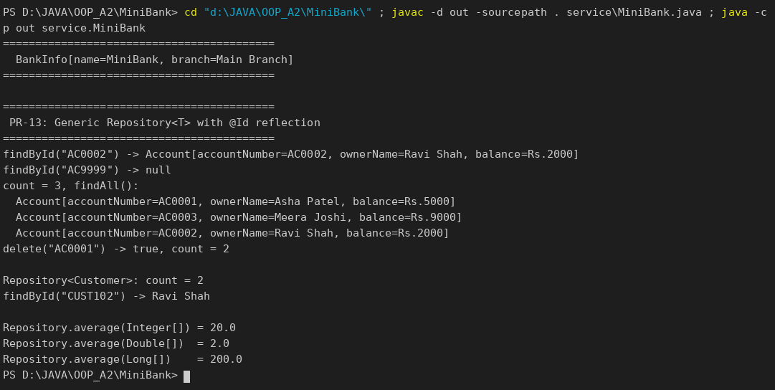

KEY QUESTIONS :
- What problem do generics solve compared with using Object?
With Object every value must be cast when it is read, and a wrong type is found only at run time (ClassCastException). Generics move the check to compile time, so Repository<Account> can only hold Account objects and no casts are needed.
- What is a bounded type parameter, and why is <N extends Number> useful?
A bounded type parameter limits which types may be used. <N extends Number> accepts Integer, Double, Long and so on, so the method can safely call doubleValue(), but it refuses types such as String at compile time.
- What is type erasure?
The compiler checks the generic types and then removes them; at run time Repository<Account> and Repository<Customer> are both just Repository and T becomes Object (or its bound). This is why a generic class cannot use new T() or check instanceof List<String>.

