PRACTICAL-14

- AIM:

Work these in your lab-NN/ folder before the project: do the first one or two in the lab; the last (For Advanced Learners) is for home.

1. Assemble and test
Build a tiny layered app (a model, a service using an ArrayList, and a menu main), then write two or three JUnit @Test methods checking that adding increases the count and an invalid action throws — practice before testing MiniBank.

2. (For Advanced Learners – home) Package, JAR and persistence test
Organise that app into packages, build a runnable JAR, and add a test that saves and reloads its data unchanged.

- SOURCE CODE :

TASK.JAVA :
public record Task(String title) {
}

TASKSERVICE.JAVA :
import java.util.ArrayList;

public class TaskService {
private final ArrayList<Task> tasks = new ArrayList<>();

public void add(String title) {
if (title == null || title.isBlank()) {
throw new IllegalArgumentException("Title must not be blank");
}
tasks.add(new Task(title.trim()));
}

public int count() {
return tasks.size();
}

public ArrayList<Task> all() {
return new ArrayList<>(tasks);
}
}

MAIN.JAVA :
import java.util.Scanner;

public class Main {
public static void main(String[] args) {
TaskService service = new TaskService();
Scanner sc = new Scanner(System.in);
int choice;
do {
System.out.println("\n1. Add task 2. List tasks 3. Exit");
System.out.print("Choice: ");
choice = Integer.parseInt(sc.nextLine().trim());
switch (choice) {
case 1 -> {
System.out.print("Title: ");
try {
service.add(sc.nextLine());
System.out.println("Added. Total tasks: " + service.count());
} catch (IllegalArgumentException e) {
System.out.println("Error: " + e.getMessage());
}
}
case 2 -> service.all().forEach(t -> System.out.println(" - " + t.title()));
case 3 -> System.out.println("Bye!");
default -> System.out.println("Invalid choice");
}
} while (choice != 3);
sc.close();
}
}

- OUTPUT :

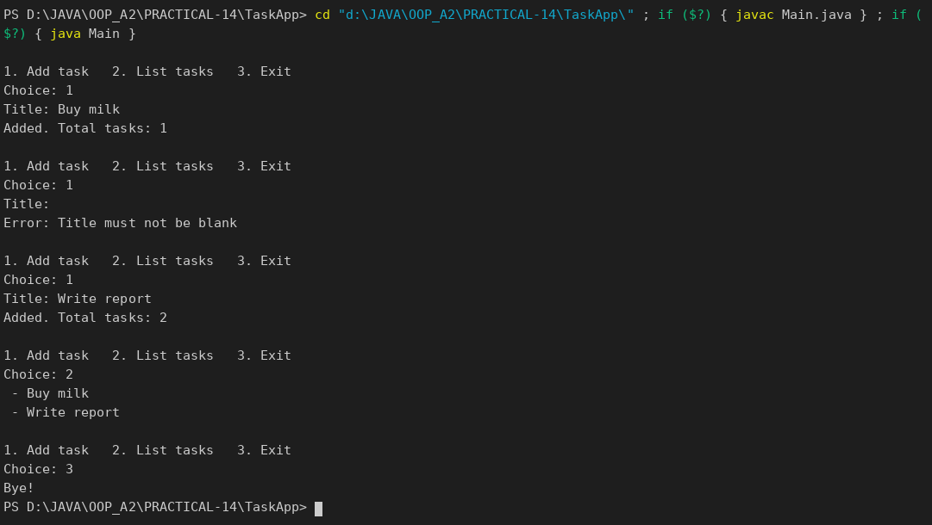

TASKSERVICETEST.JAVA :
import org.junit.jupiter.api.Test;

import static org.junit.jupiter.api.Assertions.*;

class TaskServiceTest {

@Test
void addingATaskIncreasesTheCount() {
TaskService service = new TaskService();
service.add("Buy milk");
service.add("Write report");
assertEquals(2, service.count());
}

@Test
void blankTitleThrowsException() {
TaskService service = new TaskService();
assertThrows(IllegalArgumentException.class, () -> service.add(" "));
assertEquals(0, service.count());
}

@Test
void titleIsTrimmed() {
TaskService service = new TaskService();
service.add(" Pay bills ");
assertEquals("Pay bills", service.all().get(0).title());
}
}

OUTPUT :

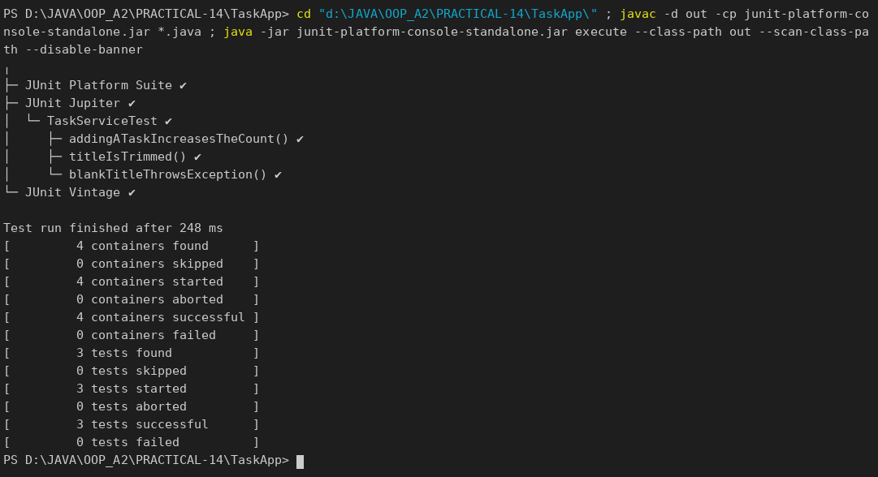

APP / MODEL / TASK.JAVA :
package app.model;

public record Task(String title) {
}

APP / SERVICE / TASKSERVICE.JAVA :
package app.service;

import app.model.Task;

import java.io.IOException;
import java.nio.file.Files;
import java.nio.file.Path;
import java.util.ArrayList;
import java.util.List;

public class TaskService {
private final ArrayList<Task> tasks = new ArrayList<>();

public void add(String title) {
if (title == null || title.isBlank()) {
throw new IllegalArgumentException("Title must not be blank");
}
tasks.add(new Task(title.trim()));
}

public int count() {
return tasks.size();
}

public ArrayList<Task> all() {
return new ArrayList<>(tasks);
}

public void save(Path file) throws IOException {
List<String> lines = new ArrayList<>();
for (Task t : tasks) {
lines.add(t.title());
}
Files.write(file, lines);
}

public void load(Path file) throws IOException {
tasks.clear();
for (String line : Files.readAllLines(file)) {
tasks.add(new Task(line));
}
}
}

APP / MAIN.JAVA :
package app;

import app.service.TaskService;

import java.io.IOException;
import java.nio.file.Files;
import java.nio.file.Path;
import java.nio.file.Paths;

public class Main {
public static void main(String[] args) throws IOException {
Path file = Paths.get("tasks.txt");
TaskService service = new TaskService();
if (Files.exists(file)) {
service.load(file);
System.out.println("Loaded " + service.count() + " task(s) from " + file);
}
service.add("Revise OOP notes");
service.add("Finish lab-14");
service.save(file);
System.out.println("Saved " + service.count() + " task(s) to " + file);
service.all().forEach(t -> System.out.println(" - " + t.title()));
}
}

MANIFEST.TXT :
Main-Class: app.Main

OUTPUT :

Build the JAR:
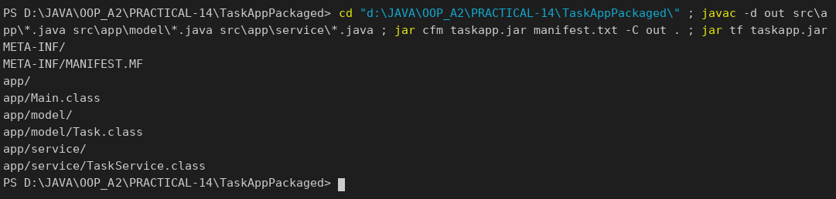

Run 1 (creates tasks.txt):
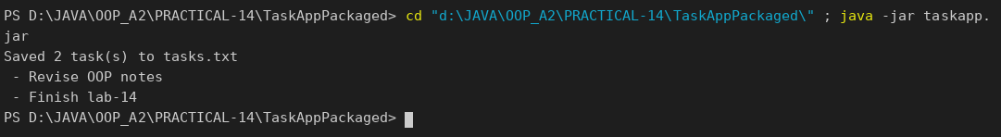

Run 2 (loads the saved tasks first):
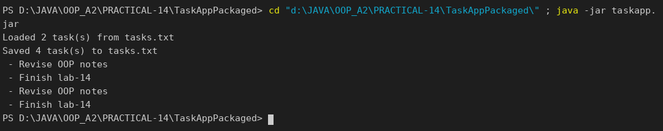

TEST / APP / SERVICE / TASKSERVICETEST.JAVA (includes the save and reload test) :
package app.service;

import org.junit.jupiter.api.Test;
import org.junit.jupiter.api.io.TempDir;

import java.io.IOException;
import java.nio.file.Path;

import static org.junit.jupiter.api.Assertions.*;

class TaskServiceTest {

@Test
void addingATaskIncreasesTheCount() {
TaskService service = new TaskService();
service.add("Buy milk");
assertEquals(1, service.count());
}

@Test
void blankTitleThrowsException() {
assertThrows(IllegalArgumentException.class, () -> new TaskService().add(""));
}

@Test
void saveAndReloadKeepsDataUnchanged(@TempDir Path dir) throws IOException {
TaskService original = new TaskService();
original.add("One");
original.add("Two");
Path file = dir.resolve("tasks.txt");
original.save(file);

TaskService reloaded = new TaskService();
reloaded.load(file);
assertEquals(original.all(), reloaded.all());
}
}

OUTPUT :

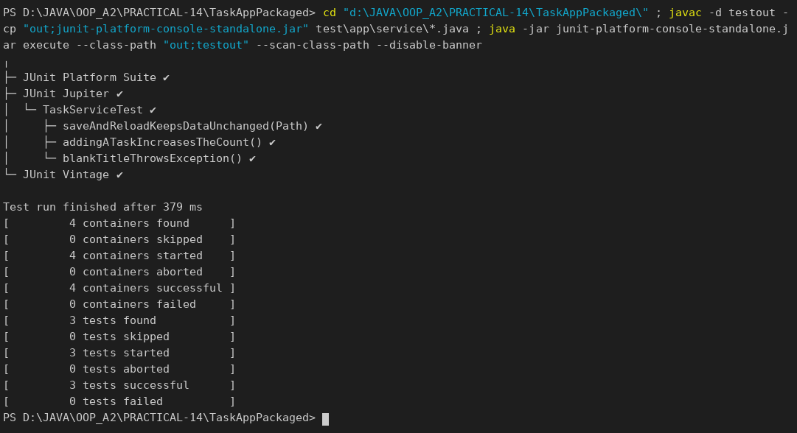

PART-B :

All the parts now exist. In this final capstone lab you assemble MiniBank and finish it to a deliverable standard: a BankService wires the repository, validation and exceptions together and the Practical 1 menu calls real operations; you add safe batch processing and the report; and you test and package the application. This is the Milestone 3 final checkpoint and viva.
1. Create a class named BankService that uses Repository<Account>, the Validator and the exception classes to provide openAccount, deposit, withdraw, transfer, statement and listAccounts.
2. Connect the Practical 1 menu so each option calls the matching BankService method; load saved accounts on start-up (Practical 11) and save them on exit.
3. Use the TransactionProcessor (Practical 10) over the thread-safe store (Practical 12) to process a batch of transactions safely, and add the report (Practical 11) as a menu option.
4. Write a few JUnit tests using @Test: a deposit increases the balance; a withdrawal over the limit throws an exception; many concurrent deposits keep the balance correct.
5. (Optional) Add an @Audit annotation and a reflective logger that records which service method was called.
6. Build the final runnable JAR and complete the README.
(Supplementary: a state save and load test was added. The Account class gained continueNumberingFrom() so that new account numbers continue after the loaded ones, and MenuOption gained STATEMENT, LIST_ACCOUNTS, RUN_BATCH and REPORT.)

SERVICE / BANKSERVICE.JAVA :
package service;

import exception.AccountNotFoundException;
import exception.BankException;
import model.*;
import repository.Repository;
import util.*;

import java.io.IOException;
import java.io.UncheckedIOException;
import java.nio.file.Files;
import java.nio.file.Path;
import java.util.ArrayList;
import java.util.Collections;
import java.util.List;

/** PR-14: the service layer. It wires the repository, validation and exceptions together. */
public class BankService {
private final Repository<Account> repository = new Repository<>();
private final Path dataDir;

public BankService(Path dataDir) {
this.dataDir = dataDir;
}

private Path accountsFile() { return dataDir.resolve("accounts.dat"); }

private Path logsDir() { return dataDir.resolve("logs"); }

private Path logFile() { return logsDir().resolve("transactions.log"); }

// ---------------------------------------------------------------- operations
public Account openAccount(String type, String owner, String mobile, long opening, long extra) {
if (!Validator.isValidMobile(mobile)) {
throw new IllegalArgumentException("Invalid mobile number: " + mobile);
}
Account account = switch (type.toUpperCase()) {
case "SAVINGS" -> new SavingsAccount(owner, opening, extra);
case "CURRENT" -> new CurrentAccount(owner, opening, extra);
case "FD" -> new FixedDepositAccount(owner, opening);
default -> throw new IllegalArgumentException("Unknown account type: " + type);
};
String[] errors = AnnotationValidator.validate(account);
if (errors.length > 0) {
throw new IllegalArgumentException(String.join("; ", errors));
}
repository.save(account);
return account;
}

public Account find(String accountNumber) throws AccountNotFoundException {
Account account = repository.findById(accountNumber);
if (account == null) {
throw new AccountNotFoundException(accountNumber);
}
return account;
}

public void deposit(String accountNumber, long amount) throws BankException {
find(accountNumber).deposit(amount);
log("DEPOSIT", accountNumber, amount);
}

public void withdraw(String accountNumber, long amount) throws BankException {
find(accountNumber).withdraw(amount);
log("WITHDRAW", accountNumber, amount);
}

public void transfer(String from, String to, long amount) throws BankException {
Account source = find(from);
Account target = find(to);
source.transfer(target, amount);
log("WITHDRAW", from, amount);
log("DEPOSIT", to, amount);
}

public String statement(String accountNumber) throws AccountNotFoundException {
return StatementFormatter.buildStatement(find(accountNumber));
}

public List<Account> listAccounts() {
ArrayList<Account> all = repository.findAll();
Collections.sort(all); // Comparable: by account number
return all;
}

// ---------------------------------------------------------------- batch processing
/** Runs "DEPOSIT AC0001 500"-style commands on a thread pool over a ConcurrentHashMap. */
public List<String> runBatch(List<String> commands) {
TransactionProcessor processor = new TransactionProcessor();
for (Account account : repository.findAll()) {
processor.register(account);
}
List<String> results = Collections.synchronizedList(new ArrayList<>());
for (String line : commands) {
processor.submit(() -> {
try {
Command cmd = CommandParser.parse(line);
Account account = processor.find(cmd.accountNumber());
if (account == null) {
throw new AccountNotFoundException(cmd.accountNumber());
}
switch (cmd.type()) {
case DEPOSIT -> account.deposit(cmd.amount());
case WITHDRAW -> account.withdraw(cmd.amount());
default -> throw new IllegalArgumentException("Batch supports DEPOSIT and WITHDRAW only");
}
TransactionLog.append(logFile(), cmd.type() + " " + cmd.accountNumber() + " " + cmd.amount());
results.add("OK " + line);
} catch (BankException | IllegalArgumentException | IOException e) {
results.add("FAILED " + line + " -> " + e.getMessage());
}
});
}
processor.stop();
return results;
}

// ---------------------------------------------------------------- persistence and report
public void save() throws IOException {
StatePersister.save(repository.findAll().toArray(new Account[0]), accountsFile());
}

/** Loads saved accounts (if any) and returns how many were loaded. */
public int load() throws IOException, ClassNotFoundException {
if (!Files.exists(accountsFile())) {
return 0;
}
Account[] saved = StatePersister.load(accountsFile());
long highest = 0;
for (Account account : saved) {
repository.save(account);
highest = Math.max(highest, Long.parseLong(account.getAccountNumber().substring(2)));
}
Account.continueNumberingFrom(highest);
return saved.length;
}

public List<String> report() throws IOException {
Files.createDirectories(logsDir());
return ReportGenerator.generate(logsDir(), dataDir.resolve("report.txt"));
}

private void log(String type, String accountNumber, long amount) {
try {
TransactionLog.append(logFile(), type + " " + accountNumber + " " + amount);
} catch (IOException e) {
throw new UncheckedIOException(e);
}
}
}

SERVICE / MINIBANK.JAVA :
package service;

import exception.BankException;
import model.*;

import java.io.IOException;
import java.nio.file.Paths;
import java.util.ArrayList;
import java.util.List;
import java.util.Scanner;

public class MiniBank {

public static void main(String[] args) throws IOException, ClassNotFoundException {
Scanner sc = new Scanner(System.in);
BankInfo bank = new BankInfo("MiniBank", "Main Branch");
System.out.println("==========================================");
System.out.println(" " + bank);
System.out.println("==========================================");

BankService service = new BankService(Paths.get("data"));
int loaded = service.load(); // PR-11: load saved accounts on start-up
if (loaded > 0) {
System.out.println("Loaded " + loaded + " saved account(s).");
}

runMenu(sc, bank, service);

service.save(); // PR-11: save on exit
System.out.println("Accounts saved to data/accounts.dat");
sc.close();
}

private static void runMenu(Scanner sc, BankInfo bank, BankService service) {
MenuOption option;
do {
System.out.println("\n--- MAIN MENU ---");
for (MenuOption m : MenuOption.values()) {
System.out.println((m.ordinal() + 1) + ". " + m);
}
System.out.print("Enter choice: ");

if (!sc.hasNextLine()) { // input closed -> behave like EXIT
option = MenuOption.EXIT;
} else {
option = readOption(sc.nextLine());
}
if (option == null) {
System.out.println("Invalid choice. Please enter a number from 1 to " + MenuOption.values().length + ".");
continue;
}

try {
switch (option) {
case OPEN_ACCOUNT -> openAccount(sc, service);
case DEPOSIT -> {
service.deposit(ask(sc, "Account number: "), readLong(sc, "Amount: "));
System.out.println("Deposit successful.");
}
case WITHDRAW -> {
service.withdraw(ask(sc, "Account number: "), readLong(sc, "Amount: "));
System.out.println("Withdrawal successful.");
}
case TRANSFER -> {
service.transfer(ask(sc, "From account: "), ask(sc, "To account: "), readLong(sc, "Amount: "));
System.out.println("Transfer successful.");
}
case STATEMENT -> System.out.println(service.statement(ask(sc, "Account number: ")));
case LIST_ACCOUNTS -> {
for (Account a : service.listAccounts()) {
System.out.println(" " + a.getAccountNumber() + " | " + a.getOwnerName()
+ " | " + a.getClass().getSimpleName() + " | Rs." + a.getBalance());
}
}
case RUN_BATCH -> runBatch(sc, service);
case REPORT -> service.report().forEach(System.out::println);
case EXIT -> System.out.println("Goodbye! Thank you for using " + bank.name() + ".");
}
} catch (BankException | IllegalArgumentException | IOException e) {
System.out.println("Operation failed: " + e.getMessage());
}
} while (option != MenuOption.EXIT);
}

private static void openAccount(Scanner sc, BankService service) {
String type = ask(sc, "Account type (SAVINGS / CURRENT / FD): ");
String owner = ask(sc, "Owner name: ");
String mobile = ask(sc, "Mobile number: ");
long opening = readLong(sc, "Opening balance: ");
long extra = 0;
if (type.equalsIgnoreCase("SAVINGS")) {
extra = readLong(sc, "Minimum balance: ");
} else if (type.equalsIgnoreCase("CURRENT")) {
extra = readLong(sc, "Overdraft limit: ");
}
Account account = service.openAccount(type, owner, mobile, opening, extra);
System.out.println("Account opened: " + account.getAccountNumber());
}

private static void runBatch(Scanner sc, BankService service) {
System.out.println("Enter commands such as DEPOSIT AC0001 500 (blank line to run):");
List<String> commands = new ArrayList<>();
while (true) {
String line = sc.nextLine().trim();
if (line.isEmpty()) {
break;
}
commands.add(line);
}
service.runBatch(commands).forEach(System.out::println);
}

private static String ask(Scanner sc, String prompt) {
System.out.print(prompt);
return sc.nextLine().trim();
}

private static long readLong(Scanner sc, String prompt) {
String text = ask(sc, prompt);
try {
return Long.parseLong(text);
} catch (NumberFormatException e) {
throw new IllegalArgumentException("Not a valid whole number: " + text);
}
}

/** Converts typed text to a MenuOption; returns null for invalid input. */
private static MenuOption readOption(String text) {
try {
int n = Integer.parseInt(text.trim());
MenuOption[] all = MenuOption.values();
if (n >= 1 && n <= all.length) {
return all[n - 1];
}
} catch (NumberFormatException ignored) {
// fall through
}
return null;
}
}

MODEL / MENUOPTION.JAVA :
package model;

/** PR-1 / PR-14: actions MiniBank offers. */
public enum MenuOption {
OPEN_ACCOUNT, DEPOSIT, WITHDRAW, TRANSFER, STATEMENT, LIST_ACCOUNTS, RUN_BATCH, REPORT, EXIT
}

MODEL / ACCOUNT.JAVA (continueNumberingFrom added) :
package model;

import exception.AccountNotFoundException;
import exception.BankException;
import exception.InsufficientFundsException;
import exception.InvalidAmountException;
import model.annotation.Id;
import model.annotation.MaxLength;
import model.annotation.Positive;

import java.io.Serializable;
import java.util.Objects;

public abstract class Account implements Transactable, InterestBearing, Serializable, Comparable<Account> {

private static final long serialVersionUID = 1L;

@Id
private final String accountNumber;
@MaxLength(20)
private String ownerName;
@Positive
private long balance; // changes only via deposit() / withdraw()
private boolean active;

private static long accountCounter = 0;

/** PR-14: after saved accounts are loaded, numbering continues after the highest one. */
public static synchronized void continueNumberingFrom(long highest) {
if (highest > accountCounter) {
accountCounter = highest;
}
}

private static synchronized String generateAccountNumber() {
accountCounter++;
return String.format("AC%04d", accountCounter);
}

public Account(String ownerName, long openingBalance) {
this.accountNumber = generateAccountNumber();
this.ownerName = ownerName;
this.balance = openingBalance;
this.active = true;
}

public Account(String ownerName) {
this(ownerName, 0);
}

// ---- PR-8: exceptions instead of boolean flags ----
@Override
public synchronized void deposit(long amount) throws InvalidAmountException {
if (amount <= 0) {
throw new InvalidAmountException(amount);
}
balance += amount;
}

@Override
public synchronized boolean withdraw(long amount) throws InsufficientFundsException, InvalidAmountException {
if (amount <= 0) {
throw new InvalidAmountException(amount);
}
if (!canWithdraw(amount)) {
throw new InsufficientFundsException(amount - availableToWithdraw());
}
balance -= amount;
return true;
}

/** Moves money to another account; rolls back if the credit side fails. */
public void transfer(Account to, long amount) throws BankException {
if (to == null) {
throw new AccountNotFoundException("null");
}
boolean debited = false;
try {
withdraw(amount);
debited = true;
to.deposit(amount);
System.out.println("Transferred Rs." + amount + " from " + accountNumber + " to " + to.accountNumber);
} catch (BankException e) {
if (debited) {
balance += amount; // rollback the debit
}
System.out.println("Transfer failed: " + e.getMessage());
throw e; // rethrow to the caller
} finally {
System.out.println("Transfer attempt finished (" + accountNumber + " -> " + to.accountNumber + ").");
}
}

public String getAccountNumber() { return accountNumber; }

public String getOwnerName() { return ownerName; }

@Override
public long getBalance() { return balance; }

public boolean isActive() { return active; }

/** How much can currently be taken out; used to compute the shortfall. */
protected long availableToWithdraw() {
return balance;
}

@Override
public String toString() {
return "Account[accountNumber=" + accountNumber
+ ", ownerName=" + ownerName
+ ", balance=Rs." + balance + "]";
}

@Override
public boolean equals(Object o) {
if (this == o) return true;
if (!(o instanceof Account)) return false;
Account other = (Account) o;
return Objects.equals(accountNumber, other.accountNumber);
}

@Override
public int hashCode() {
return Objects.hash(accountNumber);
}

/** PR-12: natural order = by account number. */
@Override
public int compareTo(Account other) {
return accountNumber.compareTo(other.accountNumber);
}

@Override
public abstract double interestRate();

public abstract boolean canWithdraw(long amount);
}

TEST / SERVICE / BANKSERVICETEST.JAVA :
package service;

import exception.InsufficientFundsException;
import model.Account;
import org.junit.jupiter.api.Test;
import org.junit.jupiter.api.io.TempDir;

import java.nio.file.Path;
import java.util.ArrayList;
import java.util.List;

import static org.junit.jupiter.api.Assertions.*;

class BankServiceTest {

@Test
void depositIncreasesTheBalance(@TempDir Path dir) throws Exception {
BankService service = new BankService(dir);
Account a = service.openAccount("SAVINGS", "Asha Patel", "9876543210", 5000, 1000);
service.deposit(a.getAccountNumber(), 2000);
assertEquals(7000, a.getBalance());
}

@Test
void withdrawalOverTheLimitThrowsException(@TempDir Path dir) throws Exception {
BankService service = new BankService(dir);
Account a = service.openAccount("SAVINGS", "Asha Patel", "9876543210", 5000, 1000);
InsufficientFundsException e = assertThrows(InsufficientFundsException.class,
() -> service.withdraw(a.getAccountNumber(), 5000));
assertEquals(1000, e.getShortfall());
assertEquals(5000, a.getBalance()); // balance unchanged
}

@Test
void invalidMobileNumberIsRejected(@TempDir Path dir) {
BankService service = new BankService(dir);
assertThrows(IllegalArgumentException.class,
() -> service.openAccount("SAVINGS", "Asha Patel", "12345", 5000, 1000));
}

@Test
void manyConcurrentDepositsKeepTheBalanceCorrect(@TempDir Path dir) throws Exception {
BankService service = new BankService(dir);
Account a = service.openAccount("SAVINGS", "Asha Patel", "9876543210", 1000, 0);
List<String> commands = new ArrayList<>();
for (int i = 0; i < 2000; i++) {
commands.add("DEPOSIT " + a.getAccountNumber() + " 1");
}
List<String> results = service.runBatch(commands);
assertEquals(2000, results.size());
assertEquals(3000, a.getBalance()); // 1000 + 2000 x 1, nothing lost
}

@Test
void savedStateIsLoadedUnchanged(@TempDir Path dir) throws Exception {
BankService first = new BankService(dir);
Account a = first.openAccount("CURRENT", "Ravi Shah", "9123456780", 2000, 3000);
first.deposit(a.getAccountNumber(), 500);
first.save();

BankService second = new BankService(dir);
assertEquals(1, second.load());
Account reloaded = second.find(a.getAccountNumber());
assertEquals("Ravi Shah", reloaded.getOwnerName());
assertEquals(2500, reloaded.getBalance());
}
}

MANIFEST.TXT :
Main-Class: service.MiniBank

README.MD :
# MiniBank

Console banking application built across the OOP (CEUC203) lab series.

## Features
- Menu: open account, deposit, withdraw, transfer, statement, list accounts, run a batch, end-of-day report
- Account types: Savings (minimum balance), Current (overdraft), Fixed Deposit (locked)
- Validation (regex), custom exceptions, annotation + reflection validator
- Thread-safe accounts, thread-pool batch processing over a `ConcurrentHashMap`
- Saves accounts to `data/accounts.dat` on exit and reloads them on start-up
- Append-only transaction log in `data/logs/` and an NIO based report

## Project layout
```
model/ Account, SavingsAccount, CurrentAccount, FixedDepositAccount, Customer, interfaces, annotations
exception/ BankException and its subclasses
util/ Validator, CommandParser, StatementFormatter, AnnotationValidator, StatePersister, TransactionLog, ReportGenerator
repository/ Repository<T> (generic, key found through @Id)
service/ BankService, AccountStore, TransactionProcessor, MiniBank (main)
test/ JUnit 5 tests
```

## Build and run (JDK 17+)
```
javac -d out model/*.java model/annotation/*.java exception/*.java util/*.java repository/*.java service/*.java
jar cfm minibank.jar manifest.txt -C out .
java -jar minibank.jar
```

## Run the tests (JUnit 5 console launcher)
```
javac -d testout -cp "out;junit-platform-console-standalone.jar" test/service/BankServiceTest.java
java -jar junit-platform-console-standalone.jar execute --class-path "out;testout" --scan-class-path
```
(use `:` instead of `;` on Linux / macOS)

Generated files in `data/` are not committed.

OUTPUT:

JUnit tests (all pass):
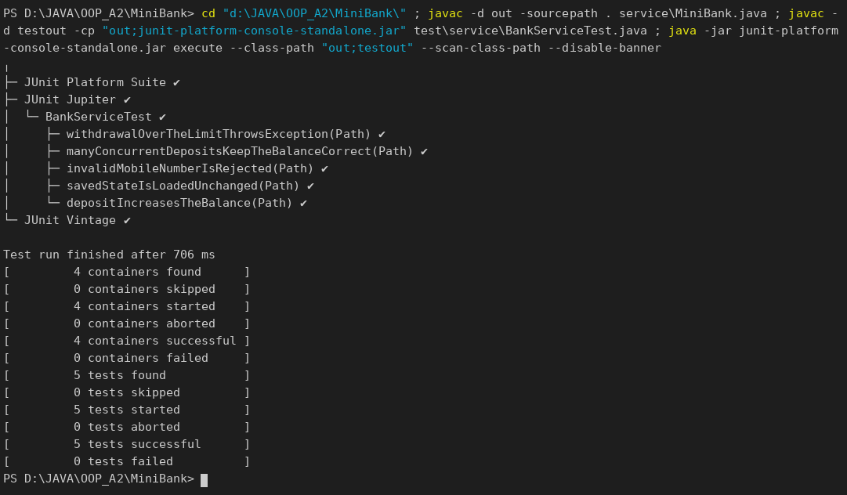

Build the final runnable JAR:
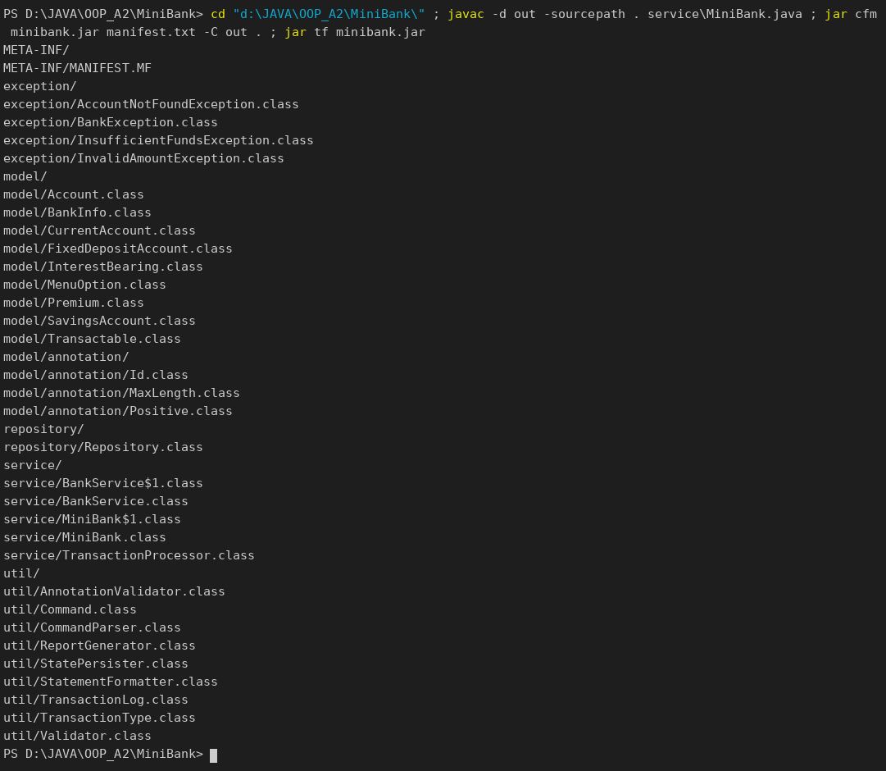

Session 1 – open accounts, deposit, withdraw (fails), transfer, statement, list, batch, report, exit:
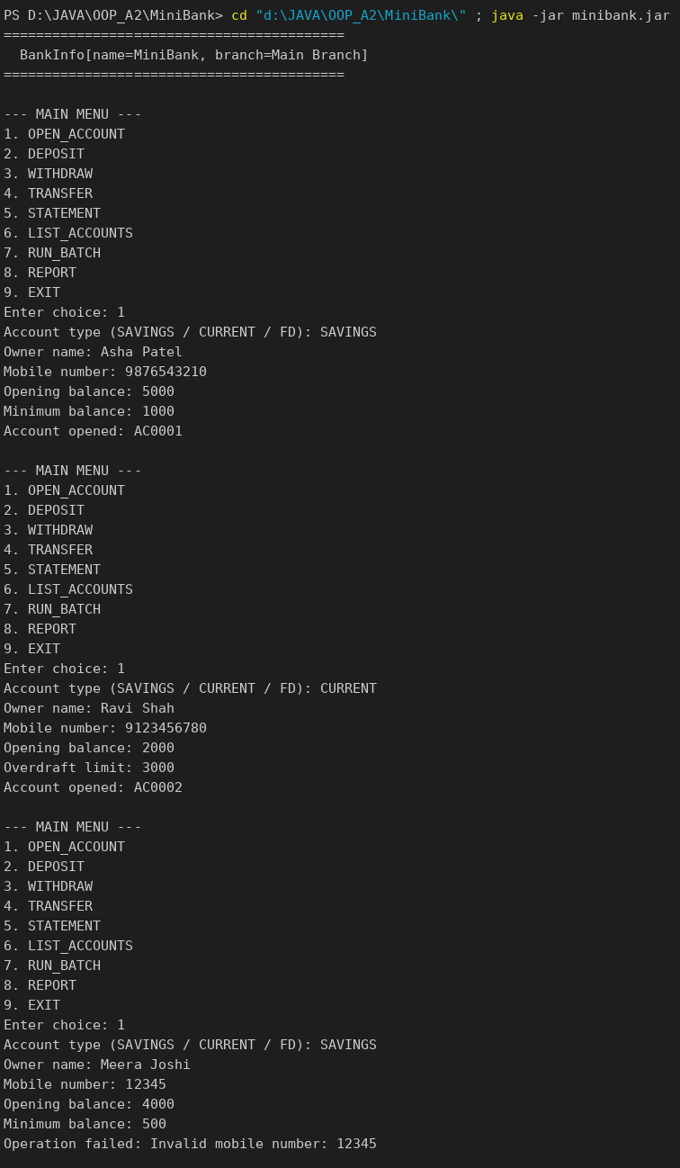
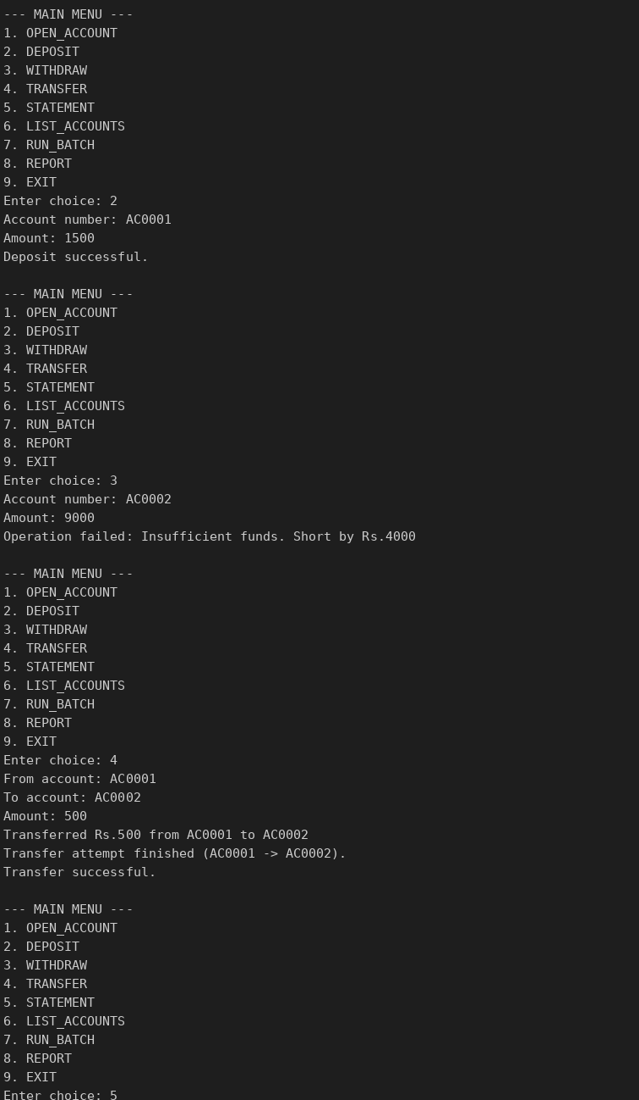
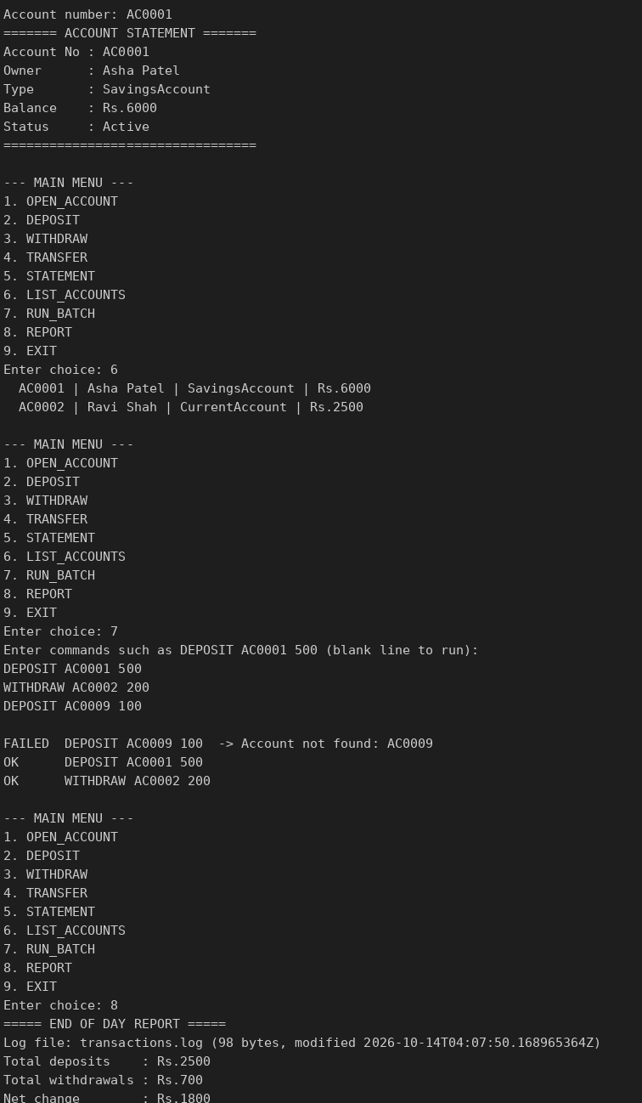
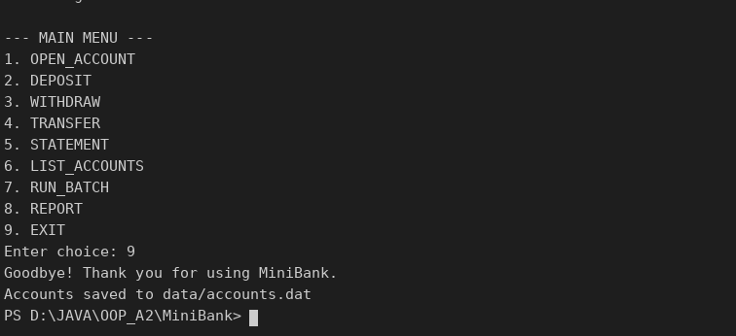

Session 2 – restart: the saved accounts are loaded again:
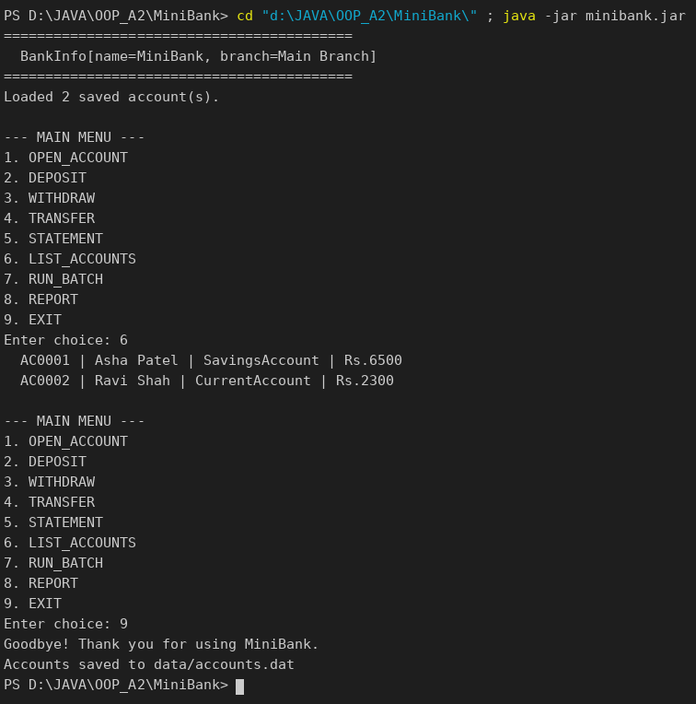

KEY QUESTIONS :
- What is a layered architecture (model, service, user interface), and why is it useful?
The program is split into layers: model (the data and its rules), service (the business operations such as BankService) and user interface (the menu). Each layer only talks to the one below, so a layer can be changed or tested on its own, for example JUnit tests call BankService without any menu.
- How do you assert in JUnit that a method throws an expected exception?
Use assertThrows(ExpectedException.class, () -> method()). It passes only if that exception is thrown and returns the exception object, so the test can also check details such as getShortfall().
- What does packaging the application as a runnable JAR provide?
A single file that contains all the compiled classes and a manifest naming the Main-Class. It can be copied to any machine with Java and started with java -jar minibank.jar, which makes the application easy to deliver.

