PRACTICAL-1

- AIM:

Work these in your lab-NN/ folder before the project: do the first one or two in the lab; the
last (For Advanced Learners) is for home.

1. Vending machine (VendingMachine.java, main in this file)
(a) Define an enum Coin with constants ONE, TWO, FIVE, TEN.
(b) In main, set a snack price of 15 and a running total of 0; create a Scanner.
(c) Loop: read a coin name, use a switch expression to convert the Coin to its value
(ONE→1, TWO→2, FIVE→5, TEN→10), add it to the total, and print the total so
far.
(d) Stop the loop once the total reaches 15 or more.
(e) Print the change to return (total − 15).
Expected output: TEN then FIVE prints “Paid. Change: 0”; TEN then TEN prints
“Paid. Change: 5”.

2. Toll booth (TollBooth.java, main in this file)
(a) Define a record Vehicle(String number, String type).
(b) In main, keep a running toll total and three counters (bike, car, truck).
(c) Loop until the user types “done” for the number: build a Vehicle, use a switch
expression on its type for the toll (bike→20, car→50, truck→150), add to the total,
and increment that type’s counter.
(d) After the loop, print the total toll and the type with the highest count.
Expected output: two cars + one bike → “Total toll: 120”, “Most frequent: car”.

3. (For Advanced Learners – home) Rock-Paper-Scissors-Lizard-Spock (RPSLS.java)
(a) Define an enum Move with ROCK, PAPER, SCISSORS, LIZARD, SPOCK.
(b) Write winner(Move a, Move b) returning 1 if a beats b, -1 if b beats a, 0 for a tie —
use a switch expression listing what each move beats (Scissors cut Paper, Paper
covers Rock, Rock crushes Lizard, Lizard poisons Spock, Spock smashes Scissors,
and the five mirror cases).
(c) In main, play 5 rounds: pick a random computer Move, read the player’s Move, call
winner(), print the round result and keep score.
(d) After 5 rounds, print the overall winner.
Expected output: each round prints both moves and the round winner; ends with a
“You win 3–2” summary.

- SOURCE CODE :

VENDINMACHINE.JAVA :
import java.util.Scanner;
public class VendingMachine {
public static enum Coin {
ONE,TWO,FIVE,TEN
}

public static void main(String[] args) {
System.out.println("Vending Machine");
int snackPrice = 15;
int total = 0;
Scanner sc = new Scanner(System.in);
while (total < snackPrice) {
System.out.print("Enter coin (ONE, TWO, FIVE, TEN): ");
String coinName = sc.nextLine().toUpperCase();
Coin coin = Coin.valueOf(coinName);
int coinValue = switch (coin) {
case ONE -> 1;
case TWO -> 2;
case FIVE -> 5;
case TEN -> 10;
};
total += coinValue;
System.out.println("Total so far: " + total);
}
System.out.println("Paid. Change: " + (total - snackPrice));
sc.close();
}

}

- OUTPUT :

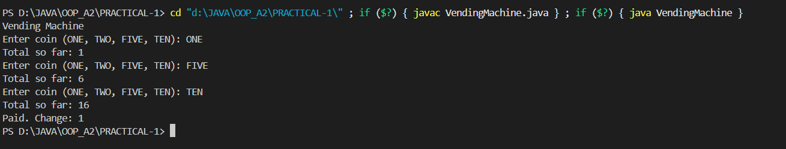

TOLLBOOTH.JAVA :

import java.util.Scanner;
public class TollBooth {
record Vehicle(String number, String type) {};

public static void main(String[] args)
{
Scanner sc = new Scanner(System.in);
int tollAmount = 0;
int bikecount = 0;
int carcount = 0;
int truckcount = 0;
while(true)
{
System.out.println("====== Toll Booth ======");
System.out.println("Enter vehicle number(or 'done' to finish): ");
String number = sc.nextLine();
if(number.equalsIgnoreCase("done")) break;
System.out.println("Enter vehicle type (bike, car, truck): ");
String type = sc.nextLine();

Vehicle v= new Vehicle(number, type);

int toll= switch(v.type().toLowerCase())
{
case "bike"-> 20;
case "car"-> 50;
case "truck"-> 150;
default -> 0;
};
tollAmount += toll;
switch(v.type().toLowerCase())
{
case "bike"-> bikecount++;
case "car"-> carcount++;
case "truck"-> truckcount++;
}
}
System.out.println("====== Toll Summary ======");

System.out.println("Total toll amount: " + tollAmount);
if(bikecount>=carcount && bikecount>=truckcount)
{
System.out.println("Most frequent: Bike");
}
else if(carcount>=bikecount && carcount>=truckcount)
{
System.out.println("Most frequent: Car");
}
else
{
System.out.println("Most frequent: Truck");
}
System.out.println("====== Summary ======");
System.out.println("Total vehicles: " + (bikecount + carcount + truckcount));
System.out.println("Bike count: " + bikecount);
System.out.println("Car count: " + carcount);
System.out.println("Truck count: " + truckcount);
sc.close();

}
}

OUTPUT :

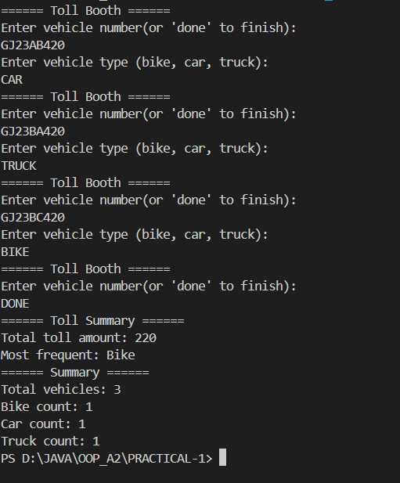

RPSLS.JAVA :
import java.util.Random;
import java.util.Scanner;
public class RPSLS {
enum Move {
ROCK, PAPER, SCISSORS, LIZARD, SPOCK
}
static int winner(Move a, Move b)

{
if (a == b) return 0;
return switch (a)
{
case SCISSORS -> (b == Move.PAPER || b == Move.LIZARD) ? 1 : -1;
case PAPER -> (b == Move.ROCK || b == Move.SPOCK) ? 1 : -1;
case ROCK -> (b == Move.LIZARD || b == Move.SCISSORS) ? 1 : -1;
case LIZARD -> (b == Move.SPOCK || b == Move.PAPER) ? 1 : -1;
case SPOCK -> (b == Move.SCISSORS || b == Move.ROCK) ? 1 : -1;
};

}

public static void main(String[] args) {
Scanner sc = new Scanner(System.in);
Random rand = new Random();
int playerScore = 0, computerScore = 0;
System.out.println("=======Welcome to Rock Paper Scissors Lizard Spock!=======");

for(int round=1;round<=5;round++)
{
System.out.print("Round " + round + ": Enter your move (ROCK, PAPER, SCISSORS, LIZARD, SPOCK): ");
String input = sc.nextLine().toUpperCase();
Move playerMove=Move.valueOf(input);
Move computerMove = Move.values()[rand.nextInt(Move.values().length)];
System.out.print("You: " + playerMove + ", Computer: " + computerMove + ". ");
int result = winner(playerMove, computerMove);
if(result == 1) {
System.out.println("You win this round!");
System.out.println(" ");
playerScore++;
} else if(result == -1) {
System.out.println("Computer wins this round!");
System.out.println(" ");
computerScore++;
} else {
System.out.println("This round is a tie!");
System.out.println(" ");
}
}
System.out.println("=======Game Over!=======");

System.out.println("Final Scores - You: " + playerScore + ", Computer: " + computerScore + ", Ties: " + (5 - playerScore - computerScore));
if(playerScore > computerScore) {
System.out.println("Congratulations! You won the game!");
} else if(playerScore < computerScore) {
System.out.println("Computer wins the game! Better luck next time.");
} else {
System.out.println("The game is a tie!");
}
sc.close();
}
}

OUTPUT :

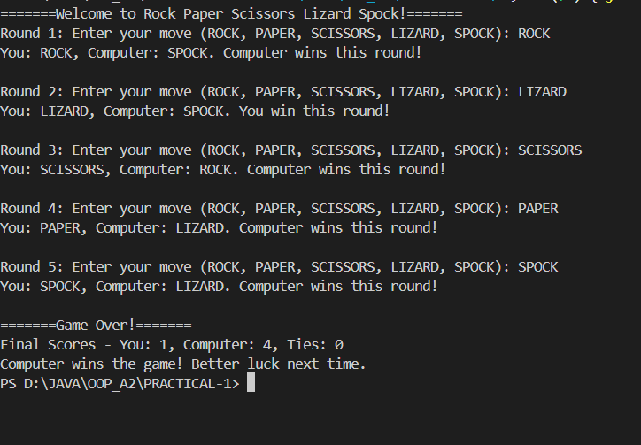

PART-B :
MiniBank is the console banking application you will build across the whole semester. In
this first lab you set up your tools and create the project and its menu shell — the screen the
user navigates. Every later lab attaches one real banking feature behind these menu options.
1. Set up your environment: open the project in GitHub Codespaces (or install JDK 17+ and
an IDE locally), and create a private GitHub repository named oop-minibank-<rollno>;
add the faculty as a collaborator.
2. Create a public class named MiniBank that contains the main method.
3. Define a record named BankInfo with two String fields, name and branch (a record is a
short, read-only class; Java auto-generates its constructor and field accessors). Print one
BankInfo object as the application header.
4. Define an enum named MenuOption with the constants OPEN_ACCOUNT, DEPOSIT,
WITHDRAW, TRANSFER and EXIT — these are the actions MiniBank will offer.
5. Display the numbered menu to the user and read the chosen number with a Scanner.
6. Use a switch expression on the choice to print a short placeholder for that option (for
example, “Deposit — to be implemented in a later lab”). Keep showing the menu in a
loop until the user selects EXIT, then print a goodbye message.

MINIBANK.JAVA :
import java.util.Objects;

public class MiniBank {

record BankInfo(String name, String branch) {}

enum MenuOption {
OPEN_ACCOUNT,
DEPOSIT,
WITHDRAW,
TRANSFER,
EXIT
}

static class Customer implements Cloneable {
private String name;
private String email;
private String mobile;
private final String customerId;
private Address address;

private static long customerCounter = 100;
private static String generateCustomerId() {
customerCounter++;
return "CUST" + customerCounter;
}

public Customer(String name, String email, String mobile, Address address) {
this.name = name;
this.email = email;
this.mobile = mobile;
this.address = address;
this.customerId = generateCustomerId();
}

public static class Address {
private String line;
private String city;
private String pincode;

public Address(String line, String city, String pincode) {
this.line = line;
this.city = city;
this.pincode = pincode;
}

public String getLine() { return line; }
public String getCity() { return city; }
public String getPincode() { return pincode; }

@Override
public String toString() {
return line + ", " + city + " - " + pincode;
}
}

public String getName() { return name; }
public String getEmail() { return email; }
public String getMobile() { return mobile; }
public String getCustomerId() { return customerId; }
public Address getAddress() { return address; }

@Override
public Customer clone() {
try {
Customer copy = (Customer) super.clone();
// Deep copy of Address
copy.address = new Address(address.getLine(), address.getCity(), address.getPincode());
return copy;
} catch (CloneNotSupportedException e) {
throw new AssertionError();
}
}

@Override
public String toString() {
return "Customer[" + customerId + ", " + name + ", " + email + ", " + mobile + ", " + address + "]";
}
}

// --- Account class ---
static class Account {
private final String accountNumber;
private String ownerName;
private long balance;
private boolean active;

private static long accountCounter = 0;

private static String generateAccountNumber() {
accountCounter++;
return String.format("AC%04d", accountCounter);
}

public Account(String ownerName, long openingBalance) {
this.ownerName = ownerName;
this.balance = openingBalance;
this.accountNumber = generateAccountNumber();
this.active = true;
}

public Account(String ownerName) {
this(ownerName, 0);
}

public void deposit(long amount) {
if (amount > 0) balance += amount;
}

public boolean withdraw(long amount) {
if (amount > 0 && balance >= amount) {
balance -= amount;
return true;
}
return false;
}

public String getAccountNumber() { return accountNumber; }
public String getOwnerName() { return ownerName; }
public long getBalance() { return balance; }
public boolean isActive() { return active; }

// Override toString
@Override
public String toString() {
return "Account[" + accountNumber + ", Owner: " + ownerName + ", Balance: Rs." + balance + "]";
}

// Override equals and hashCode
@Override
public boolean equals(Object o) {
if (this == o) return true;
if (!(o instanceof Account)) return false;
Account account = (Account) o;
return Objects.equals(accountNumber, account.accountNumber);
}

@Override
public int hashCode() {
return Objects.hash(accountNumber);
}
}

public static void main(String[] args) {
BankInfo bank = new BankInfo("MiniBank", "Main Branch");
System.out.println("==================================");
System.out.println("Welcome to " + bank.name() + " - " + bank.branch());
System.out.println("==================================");

// Create Customers with Address
Customer.Address addr1 = new Customer.Address("123 Street", "Thasra", "388250");
Customer c1 = new Customer("Alice", "alice@mail.com", "9876543210", addr1);

Customer.Address addr2 = new Customer.Address("456 Road", "Anand", "388001");
Customer c2 = new Customer("Bob", "bob@mail.com", "9123456780", addr2);

// Clone customer
Customer c3 = c1.clone();

// Create Accounts
Account a1 = new Account(c1.getName(), 1000);
Account a2 = new Account(c2.getName(), 500);
Account a3 = new Account(c3.getName());

// Print accounts using toString
System.out.println(a1);
System.out.println(a2);
System.out.println(a3);

// Compare accounts with equals
System.out.println("a1 equals a2? " + a1.equals(a2));
System.out.println("a1 equals a3? " + a1.equals(a3));

// Use instanceof
if (a1 instanceof Account) {
System.out.println("a1 is an Account object");
}
if (c1 instanceof Customer) {
System.out.println("c1 is a Customer object");

}

}

}

OUTPUT:
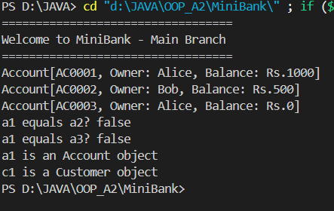

KEY QUESTIONS :
- What is the role of the JVM, and what file does the javac compiler produce?
javac produces .class files containing bytecode, and the JVM runs those files on any system with a compatible JVM installed.
- How does a switch expression differ from a traditional switch statement?6
switch expressions are safer, cleaner, and can be used directly in expressions, while traditional switch statements are more verbose and prone to fall-through errors.
- Why is an enum a good choice for a fixed set of menu options, and a record for read-only data?
An enum is ideal because it represents a fixed set of constants (like START, SETTINGS, EXIT). It ensures type safety, avoids invalid values, and makes the code more readable and maintainable.

