PRACTICAL-2

- AIM:

Work these in your lab-NN/ folder before the project: do the first one or two in the lab; the last (For Advanced Learners) is for home.

1. Smart thermostat (Thermostat.java, main in this file)
(a) Create class Thermostat with private String location, private int temperature, private static final int MIN=16 and MAX=30, and private static int activeCount=0.
(b) Constructor(location, startTemp): store location; set temperature to startTemp if it is within MIN..MAX else 22; increment activeCount.
(c) Constructor(location): chain with this(location, 22).
(d) raise(): if temperature < MAX add 1, else print “Already at maximum (30)”.
(e) lower(): if temperature > MIN subtract 1, else print “Already at minimum (16)”.
(f) Add getTemperature() (no setter) and static getActiveCount().
(g) In main: create two thermostats, call raise() 10 times then lower() 20 times in loops (printing the temperature each time), then print getActiveCount().
Expected output: temperature rises to 30 then “Already at maximum”, falls to 16 then “Already at minimum”, count 2.

2. Cinema show (CinemaShow.java, main in this file)
(a) Create class CinemaShow with private String title, private int seatsAvailable, private final int capacity, and private static int totalBooked=0.
(b) Constructor(title, capacity): set both and seatsAvailable = capacity. Constructor(title): chain with this(title, 100).
(c) book(int n): if n ≤ seatsAvailable, reduce seatsAvailable by n, add n to totalBooked, return true; else return false unchanged.
(d) cancel(int n): increase seatsAvailable by n but never above capacity.
(e) Add getSeatsAvailable() and static getTotalBooked().
(f) In main: run a sequence of book and cancel calls, printing the result and seats after each, then print getTotalBooked().
Expected output: booking more than available prints false and leaves seats unchanged; totalBooked equals the successful bookings.

3. (For Advanced Learners – home) Parking lot (ParkingLot.java)
(a) Create class ParkingLot with private int twoWheelers and fourWheelers, private final int twoCap and fourCap, and private static long revenue=0.
(b) park(String type): for “two”, if twoWheelers < twoCap increment and add 20 to revenue; for “four”, if fourWheelers < fourCap increment and add 40; otherwise print “Full” and reject.
(c) leave(String type): decrement the matching count but never below 0.
(d) In main: simulate a sequence of park/leave events, printing each outcome, then print final occupancy and revenue.
Expected output: parking into a full section is refused; revenue = 20×(two parked) + 40×(four parked).

- SOURCE CODE :

1. SMART THERMOSTAT
THERMOSTAT.JAVA :
public class Thermostat
{

private int temperature;
private String location;

static int MIN=16;
static int MAX=30;

private static int activeCount=0;

public Thermostat(String loaction,int startTemp)
{

this.location=loaction;
if (startTemp>=MIN && startTemp<=MAX) {
this.temperature=startTemp;
}
else
{
this.temperature=22;
}
activeCount++;
}

public Thermostat(String location)
{
this(location, 22);
}

public void raise()
{
if (temperature<MAX) {
temperature++;
} else {
System.out.println("Already at maximum(30)");
}
}
public void lower(){
if (temperature>MIN) {
temperature--;

} else
{
System.out.println("Already at minimum(16)");
}
}
public int getTemperature(){
return temperature;
}
public static int getActiveCount(){
return activeCount;
}
public static void main(String[] args) {
Thermostat t1=new Thermostat("Livinig Room",20);
Thermostat t2=new Thermostat("Bedroom");

for (int i = 0; i < 20; i++) {
t1.raise();
System.out.println("Temperature: "+t1.getTemperature());
}
for (int i =0; i < 10; i++) {
t1.lower();
System.out.println("Temperature: "+t1.getTemperature());
}
System.out.println("Active Thermostat: "+Thermostat.getActiveCount());
}

}

- OUTPUT :

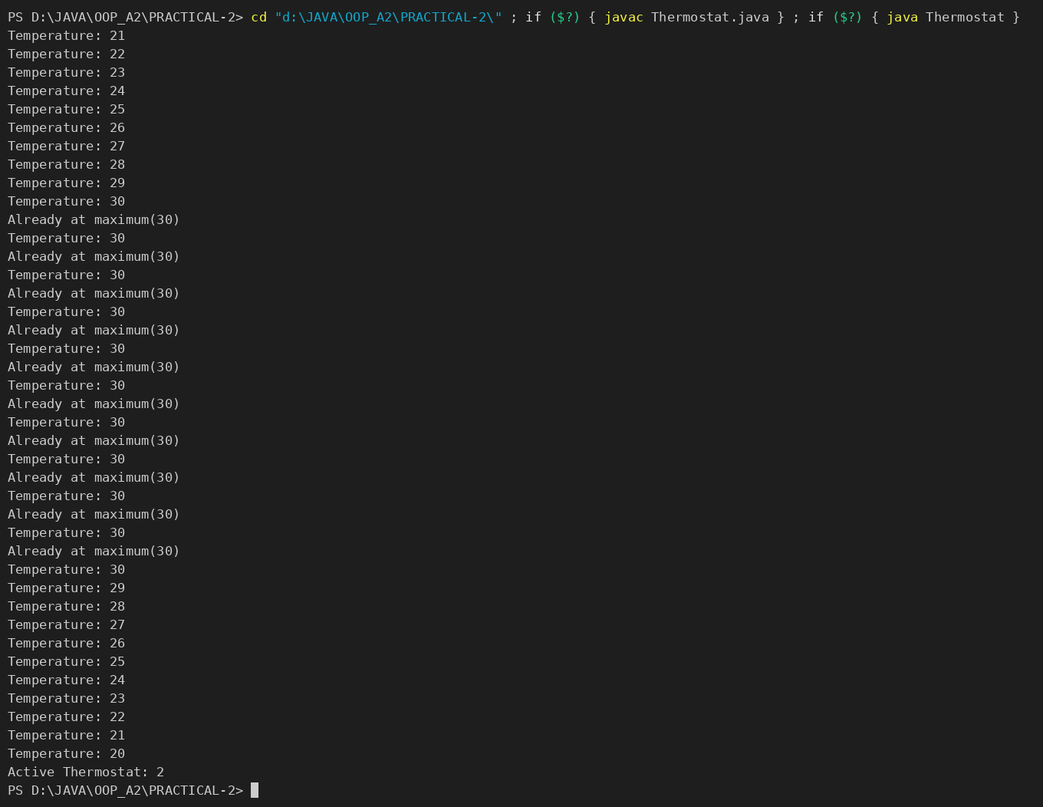

2. CINEMA SHOW
CINEMASHOW.JAVA :
public class CinemaShow{
private String title;
private int seatAvailable;
private final int capacity;
private static int totalBooked=0;

public CinemaShow(String title,int capacity){
this.title=title;
this.capacity=capacity;
this.seatAvailable=capacity;
}

public CinemaShow(String title){
this(title,100);
}

public boolean book(int n){
if(n <= seatAvailable){
seatAvailable-=n;
totalBooked+=n;
return true;
}else{
return false;
}
}

public void cancel(int n){
seatAvailable+=n;
if(seatAvailable>capacity){
seatAvailable=capacity;
}
}

public int getSeatsAvailable(){
return seatAvailable;
}
public static int getTotalBooked(){
return totalBooked;
}

public static void main(String[] args) {

CinemaShow show = new CinemaShow("Avengers", 120);

System.out.println(show.book(30));
System.out.println(show.getSeatsAvailable());
System.out.println("Total Booking: " + CinemaShow.getTotalBooked());

}

}

- OUTPUT :

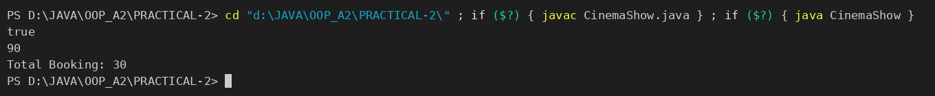

3. PARKING LOT
PARKINGLOT.JAVA :
public class ParkingLot {
private int twoWheelers;
private int fourWheelers;
private final int twoCap;
private final int fourCap;
private static long revenue = 0;

public ParkingLot(int twoCap, int fourCap) {
this.twoCap = twoCap;
this.fourCap = fourCap;
this.twoWheelers = 0;
this.fourWheelers = 0;
}

// (b) park method
public void park(String type) {
if (type.equalsIgnoreCase("two")) {
if (twoWheelers < twoCap) {
twoWheelers++;
revenue += 20;
System.out.println("Two-wheeler parked. Revenue +20");
} else {
System.out.println("Two-wheeler section Full");
}
} else if (type.equalsIgnoreCase("four")) {
if (fourWheelers < fourCap) {
fourWheelers++;
revenue += 40;
System.out.println("Four-wheeler parked. Revenue +40");
} else {
System.out.println("Four-wheeler section Full");
}
} else {
System.out.println("Invalid vehicle type");
}
}

// (c) leave method
public void leave(String type) {
if (type.equalsIgnoreCase("two")) {
if (twoWheelers > 0) {
twoWheelers--;
System.out.println("Two-wheeler left.");
} else {
System.out.println("No two-wheelers to leave.");
}
} else if (type.equalsIgnoreCase("four")) {
if (fourWheelers > 0) {
fourWheelers--;
System.out.println("Four-wheeler left.");
} else {
System.out.println("No four-wheelers to leave.");
}
} else {
System.out.println("Invalid vehicle type");
}
}

public void printStatus() {
System.out.println("Current occupancy: " + twoWheelers + " two-wheelers, " +
fourWheelers + " four-wheelers");
System.out.println("Total revenue: Rs." + revenue);
}

public static void main(String[] args) {
ParkingLot lot = new ParkingLot(2, 2); // capacity: 2 two-wheelers, 2 four-wheelers

// Simulate events
lot.park("two");
lot.park("two");
lot.park("two"); // should be refused
lot.park("four");
lot.park("four");
lot.park("four"); // should be refused

lot.leave("two");
lot.leave("four");
lot.leave("four"); // one extra leave, should say none left

// Final status
lot.printStatus();
}
}

- OUTPUT :

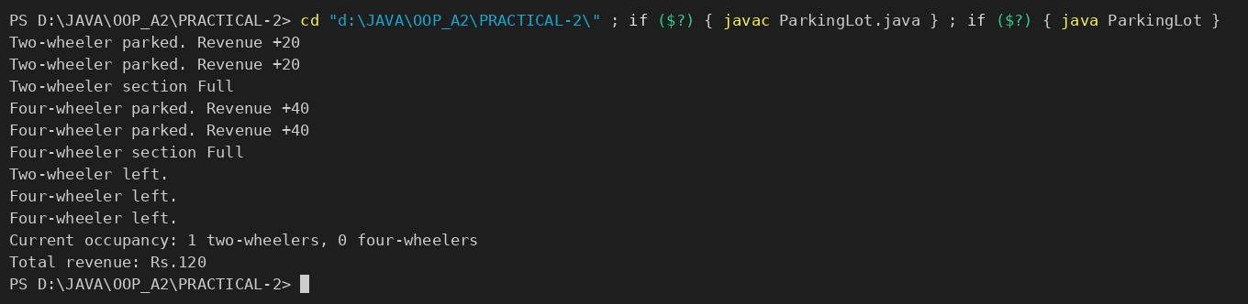

PART-B : MiniBank
In Practical 1 you built the empty menu shell. Now you create the data the bank works on — the Customer and Account classes. Using encapsulation, an account’s balance can change only through deposit() and withdraw(), never directly. These two classes are the foundation every later lab extends.
1. Create a class named Customer with private fields name, email and mobile (all String) and a private final field customerId (String). Use a private static long field customerCounter and a private static method generateCustomerId() to create ids such as “CUST101”. Add a constructor and public getter methods.
2. Create a class named Account with private fields: a final String accountNumber, a String ownerName, a long balance (whole rupees) and a boolean active. Generate accountNumber with a private static counter (for example “AC0001”).
3. Add two constructors to Account: one taking ownerName and an opening balance; one taking only ownerName that calls the first using this(ownerName, 0).
4. Add a public method deposit(long amount) that adds amount to balance. Add a public method withdraw(long amount) that subtracts amount and returns true when the balance is sufficient, otherwise returns false without changing the balance. Add getter methods. Do NOT add a public setter for balance.
5. In main, create three Account objects inside an Account[] array, perform a few deposits and withdrawals, and print each balance.
Note: the MiniBank classes below are shown as they are in the project (MiniBank folder); later labs build on the same classes.
CUSTOMER.JAVA :
package model;

public class Customer implements Cloneable {
private String name;
private String email;
private String mobile;
private final String customerId;
private Address address;

private static long customerCounter = 100;

private static String generateCustomerId() {
customerCounter++;
return "CUST" + customerCounter;
}

public Customer(String name, String email, String mobile, Address address) {
this.name = name;
this.email = email;
this.mobile = mobile;
this.address = address;
this.customerId = generateCustomerId();
}

/** PR-3: public static nested class. */
public static class Address {
private String line;
private String city;
private String pincode;

public Address(String line, String city, String pincode) {
this.line = line;
this.city = city;
this.pincode = pincode;
}

public String getLine() { return line; }
public String getCity() { return city; }
public String getPincode() { return pincode; }

@Override
public String toString() {
return line + ", " + city + " - " + pincode;
}
}

public String getName() { return name; }
public String getEmail() { return email; }
public String getMobile() { return mobile; }
public String getCustomerId() { return customerId; }
public Address getAddress() { return address; }

@Override
public Customer clone() {
try {
Customer copy = (Customer) super.clone();
if (address != null) {
copy.address = new Address(address.getLine(), address.getCity(), address.getPincode());
}
return copy;
} catch (CloneNotSupportedException e) {
throw new AssertionError(e);
}
}

@Override
public String toString() {
return "Customer[" + customerId + ", name=" + name + ", email=" + email
+ ", mobile=" + mobile + ", address=" + address + "]";
}
}

ACCOUNT.JAVA :
package model;

import exception.AccountNotFoundException;
import exception.BankException;
import exception.InsufficientFundsException;
import exception.InvalidAmountException;
import model.annotation.Id;
import model.annotation.MaxLength;
import model.annotation.Positive;

import java.util.Objects;

public abstract class Account implements Transactable, InterestBearing {

@Id
private final String accountNumber;
@MaxLength(20)
private String ownerName;
@Positive
private long balance; // changes only via deposit() / withdraw()
private boolean active;

private static long accountCounter = 0;

private static String generateAccountNumber() {
accountCounter++;
return String.format("AC%04d", accountCounter);
}

public Account(String ownerName, long openingBalance) {
this.accountNumber = generateAccountNumber();
this.ownerName = ownerName;
this.balance = openingBalance;
this.active = true;
}

public Account(String ownerName) {
this(ownerName, 0);
}

// ---- PR-8: exceptions instead of boolean flags ----
// ---- PR-9: deposit / withdraw are synchronized (thread-safe) ----
@Override
public synchronized void deposit(long amount) throws InvalidAmountException {
if (amount <= 0) {
throw new InvalidAmountException(amount);
}
balance += amount;
}

@Override
public synchronized boolean withdraw(long amount) throws InsufficientFundsException, InvalidAmountException {
if (amount <= 0) {
throw new InvalidAmountException(amount);
}
if (!canWithdraw(amount)) {
throw new InsufficientFundsException(amount - availableToWithdraw());
}
balance -= amount;
return true;
}

/** Moves money to another account; rolls back if the credit side fails. */
public void transfer(Account to, long amount) throws BankException {
if (to == null) {
throw new AccountNotFoundException("null");
}
boolean debited = false;
try {
withdraw(amount);
debited = true;
to.deposit(amount);
System.out.println("Transferred Rs." + amount + " from " + accountNumber + " to " + to.accountNumber);
} catch (BankException e) {
if (debited) {
synchronized (this) {
balance += amount; // rollback the debit
}
}
System.out.println("Transfer failed: " + e.getMessage());
throw e; // rethrow to the caller
} finally {
System.out.println("Transfer attempt finished (" + accountNumber + " -> " + to.accountNumber + ").");
}
}

public String getAccountNumber() { return accountNumber; }

public String getOwnerName() { return ownerName; }

@Override
public long getBalance() { return balance; }

public boolean isActive() { return active; }

/** How much can currently be taken out; used to compute the shortfall. */
protected long availableToWithdraw() {
return balance;
}

@Override
public String toString() {
return "Account[accountNumber=" + accountNumber
+ ", ownerName=" + ownerName
+ ", balance=Rs." + balance + "]";
}

@Override
public boolean equals(Object o) {
if (this == o) return true;
if (!(o instanceof Account)) return false;
Account other = (Account) o;
return Objects.equals(accountNumber, other.accountNumber);
}

@Override
public int hashCode() {
return Objects.hash(accountNumber);
}

@Override
public abstract double interestRate();

public abstract boolean canWithdraw(long amount);
}

MINIBANK.JAVA (demoPr2 — called from main) :
private static Account[] demoPr2() {
section("PR-2: Accounts (encapsulation, constructors)");
Account[] accounts = {
new SavingsAccount("Asha Patel", 5000, 1000),
new CurrentAccount("Ravi Shah", 2000, 3000),
new FixedDepositAccount("Meera Joshi", 50000)
};
try {
accounts[0].deposit(1500);
accounts[1].withdraw(4000); // uses overdraft
accounts[2].deposit(10000);
} catch (BankException e) {
System.out.println("Error: " + e.getMessage());
}
for (Account a : accounts) {
System.out.println(a.getAccountNumber() + " balance = Rs." + a.getBalance());
}
return accounts;
}

- OUTPUT :
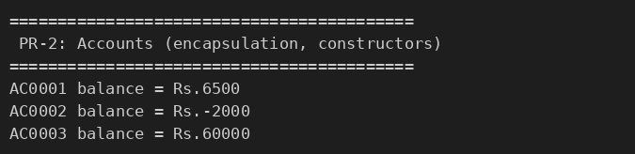

KEY QUESTIONS :

- What is encapsulation, and how do private fields with public getters enforce it?
Encapsulation means bundling the data (fields) and the methods that work on it into one class and hiding the internal state from outside code. In Account the fields are private, so no other class can change balance directly; the public getters only read the values, and the only way to change the balance is through deposit() and withdraw(), which check the amount first. This keeps every account in a valid state.
- Why is accountNumber declared final?
A final field can be assigned only once (in the constructor). The account number is generated from the static counter when the object is created and must never change afterwards, because it is the identity of the account (it is later used by equals(), hashCode() and as a map key). Declaring it final makes the compiler enforce this.
- What is the difference between a static field and an instance field when generating ids?
An instance field belongs to each object, so every object has its own copy. A static field belongs to the class and there is only one copy shared by all objects. For id generation the counter must be static (accountCounter, customerCounter): each constructor call increments the same shared counter, so every new object gets the next unique number (AC0001, AC0002, ...). If the counter were an instance field, every object would start from 0 and get the same id.

