PRACTICAL-3

- AIM:

Work these in your lab-NN/ folder before the project: do the first one or two in the lab; the last (For Advanced Learners) is for home.

1. Distinct points (Point.java + Driver.java with main)
(a) Create class Point with private int x, y and a constructor.
(b) Override toString() to return “(x, y)”.
(c) Override equals(Object) to be true when both x and y match, and hashCode() to agree (e.g. Objects.hash(x, y)).
(d) In Driver.main: build a Point[] with some repeated coordinates.
(e) Count distinct points: for each point, use equals() to check whether it already appeared earlier; count those that did not.
(f) Print “Distinct: N”.
Expected output: 5 points with 2 repeats → “Distinct: 3”.

2. Duplicate card check (Card.java + Driver.java)
(a) Create class Card with private String rank, suit and a constructor.
(b) Override toString() to return rank + “ of ” + suit (e.g. “Queen of Hearts”).
(c) Override equals()/hashCode() by rank + suit.
(d) In Driver.main: add cards to a Card[] one at a time; before adding each, use equals() to check it against the earlier cards.
(e) Print “Duplicate found: <card>” the first time a repeat appears.
Expected output: a second “Ace of Spades” → “Duplicate found: Ace of Spades”.

3. (For Advanced Learners – home) Fractions (Fraction.java + Driver.java)
(a) Create class Fraction with private int num, den.
(b) In the constructor, reduce to lowest terms: compute g = gcd(num, den) and divide both by g.
(c) Override toString() to return num + “/” + den.
(d) Override equals()/hashCode() using the reduced num and den.
(e) In Driver.main: create several equivalent fractions (1/2, 2/4, 3/6) and confirm they are all equal and print the same.
Expected output: new Fraction(2,4) prints “1/2” and equals new Fraction(1,2).

- SOURCE CODE :

1. DISTINCT POINTS
POINT.JAVA :
import java.util.Objects;

public class Point {
private int x, y;

public Point(int x, int y) {
this.x = x;
this.y = y;
}

@Override
public String toString() {
return "(" + x + ", " + y + ")";
}

@Override
public boolean equals(Object o) {
if (this == o) return true;
if (!(o instanceof Point)) return false;
Point p = (Point) o;
return x == p.x && y == p.y;
}

@Override
public int hashCode() {
return Objects.hash(x, y);
}

}

DRIVER.JAVA :
public class Driver {
public static void main(String[] args) {
// Create array with repeated points
Point[] points = {
new Point(1, 2),
new Point(3, 4),
new Point(1, 2), // repeat
new Point(5, 6),
new Point(3, 4), // repeat
};

int distinctCount = 0;

// Check distinct points manually
for (int i = 0; i < points.length; i++) {
boolean seenBefore = false;
for (int j = 0; j < i; j++) {
if (points[i].equals(points[j])) {
seenBefore = true;
break;
}
}
if (!seenBefore) {
distinctCount++;
}
}

System.out.println("Distinct: " + distinctCount);
}
}

- OUTPUT :

2. DUPLICATE CARD CHECK
CARD.JAVA :
import java.util.Objects;

public class Card {
private String rank;
private String suit;

public Card(String rank, String suit) {
this.rank = rank;
this.suit = suit;
}

@Override
public String toString() {
return rank + " of " + suit;
}

@Override
public boolean equals(Object o) {
if (this == o) return true;
if (!(o instanceof Card)) return false;
Card c = (Card) o;
return rank.equals(c.rank) && suit.equals(c.suit);
}

@Override
public int hashCode() {
return Objects.hash(rank, suit);
}
}

DRIVER.JAVA :
public class Driver {
public static void main(String[] args) {
Card[] cards = new Card[5];

// Add cards one at a time
cards[0] = new Card("Ace", "Spades");
cards[1] = new Card("Queen", "Hearts");
cards[2] = new Card("King", "Diamonds");
cards[3] = new Card("Ace", "Spades"); // duplicate
cards[4] = new Card("Jack", "Clubs");

// Check for duplicates as we add
for (int i = 0; i < cards.length; i++) {
for (int j = 0; j < i; j++) {
if (cards[i].equals(cards[j])) {
System.out.println("Duplicate found: " + cards[i]);
// Stop after first duplicate found
return;
}
}
}
}
}

- OUTPUT :

3. FRACTIONS
FRACTION.JAVA :
import java.util.Objects;

public class Fraction {
private int num, den;

public Fraction(int num, int den) {
int g = gcd(num, den);
this.num = num / g;
this.den = den / g;
}

private int gcd(int a, int b) {
return b == 0 ? a : gcd(b, a % b);
}

@Override
public String toString() {
return num + "/" + den;
}

@Override
public boolean equals(Object o) {
if (this == o) return true;
if (!(o instanceof Fraction)) return false;
Fraction f = (Fraction) o;
return num == f.num && den == f.den;
}

@Override
public int hashCode() {
return Objects.hash(num, den);
}
}

DRIVER.JAVA :
public class Driver {
public static void main(String[] args) {
Fraction f1 = new Fraction(1, 2);
Fraction f2 = new Fraction(2, 4);
Fraction f3 = new Fraction(3, 6);

// Print them
System.out.println("f1: " + f1);
System.out.println("f2: " + f2);
System.out.println("f3: " + f3);

// Equality checks
System.out.println("f1 equals f2? " + f1.equals(f2));
System.out.println("f2 equals f3? " + f2.equals(f3));
System.out.println("f1 equals f3? " + f1.equals(f3));
}
}

- OUTPUT :

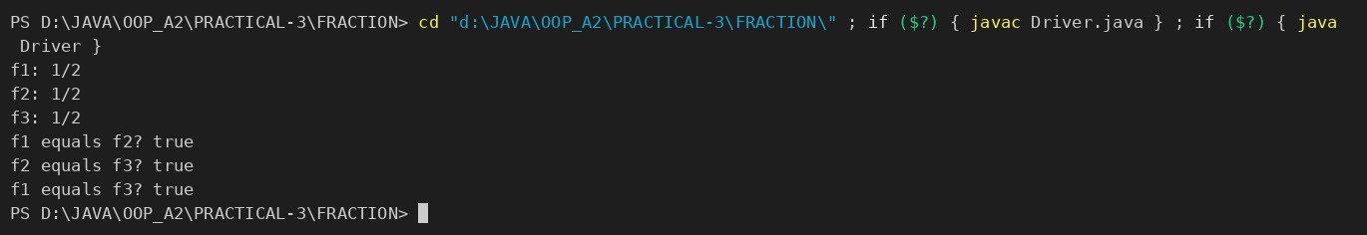

PART-B : MiniBank
In Practical 2 you created the Account and Customer classes. Here you make their objects behave correctly — they print as readable text (toString) and are compared by account number (equals/hashCode) — and you add a nested Address class. Correct equals/hashCode is essential because Practical 12 will store accounts in collections that rely on it.
1. In Account, override the toString() method to return a readable line containing accountNumber, ownerName and balance.
2. In Account, override equals(Object o) and hashCode() so that two accounts are equal when their accountNumber values are equal.
3. In Customer, add a public static nested class named Address with String fields line, city and pincode plus getters; add an Address field to Customer and a getAddress() method.
4. In Customer, add a clone() method (implement Cloneable) that returns a copy of the customer.
5. In main, print accounts using toString(), compare two Account objects with equals(), and use instanceof to check an object’s type.
Note: the MiniBank classes below are shown as they are in the project (MiniBank folder); later labs build on the same classes.
ACCOUNT.JAVA (toString, equals, hashCode) :
public String getAccountNumber() { return accountNumber; }

public String getOwnerName() { return ownerName; }

@Override
public long getBalance() { return balance; }

public boolean isActive() { return active; }

/** How much can currently be taken out; used to compute the shortfall. */
protected long availableToWithdraw() {
return balance;
}

@Override
public String toString() {
return "Account[accountNumber=" + accountNumber
+ ", ownerName=" + ownerName
+ ", balance=Rs." + balance + "]";
}

@Override
public boolean equals(Object o) {
if (this == o) return true;
if (!(o instanceof Account)) return false;
Account other = (Account) o;
return Objects.equals(accountNumber, other.accountNumber);
}

@Override
public int hashCode() {
return Objects.hash(accountNumber);
}

CUSTOMER.JAVA (static nested Address, clone) :
package model;

public class Customer implements Cloneable {
private String name;
private String email;
private String mobile;
private final String customerId;
private Address address;

private static long customerCounter = 100;

private static String generateCustomerId() {
customerCounter++;
return "CUST" + customerCounter;
}

public Customer(String name, String email, String mobile, Address address) {
this.name = name;
this.email = email;
this.mobile = mobile;
this.address = address;
this.customerId = generateCustomerId();
}

/** PR-3: public static nested class. */
public static class Address {
private String line;
private String city;
private String pincode;

public Address(String line, String city, String pincode) {
this.line = line;
this.city = city;
this.pincode = pincode;
}

public String getLine() { return line; }
public String getCity() { return city; }
public String getPincode() { return pincode; }

@Override
public String toString() {
return line + ", " + city + " - " + pincode;
}
}

public String getName() { return name; }
public String getEmail() { return email; }
public String getMobile() { return mobile; }
public String getCustomerId() { return customerId; }
public Address getAddress() { return address; }

@Override
public Customer clone() {
try {
Customer copy = (Customer) super.clone();
if (address != null) {
copy.address = new Address(address.getLine(), address.getCity(), address.getPincode());
}
return copy;
} catch (CloneNotSupportedException e) {
throw new AssertionError(e);
}
}

@Override
public String toString() {
return "Customer[" + customerId + ", name=" + name + ", email=" + email
+ ", mobile=" + mobile + ", address=" + address + "]";
}
}

MINIBANK.JAVA (demoPr3 — called from main) :
private static void demoPr3(Account[] accounts) {
section("PR-3: toString / equals / hashCode / nested Address / clone");
for (Account a : accounts) {
System.out.println(a);
}
System.out.println("accounts[0].equals(accounts[1]) = " + accounts[0].equals(accounts[1]));
System.out.println("accounts[0].equals(accounts[0]) = " + accounts[0].equals(accounts[0]));

Object o = accounts[0];
System.out.println("o instanceof Account = " + (o instanceof Account));
System.out.println("o instanceof CurrentAccount = " + (o instanceof CurrentAccount));

Customer.Address address = new Customer.Address("12 MG Road", "Vadodara", "390001");
Customer c1 = new Customer("Asha Patel", "asha@example.com", "9876543210", address);
Customer c2 = c1.clone();
System.out.println(c1);
System.out.println("Clone is a different object: " + (c1 != c2)
+ ", address copied: " + (c1.getAddress() != c2.getAddress()));
}

- OUTPUT :
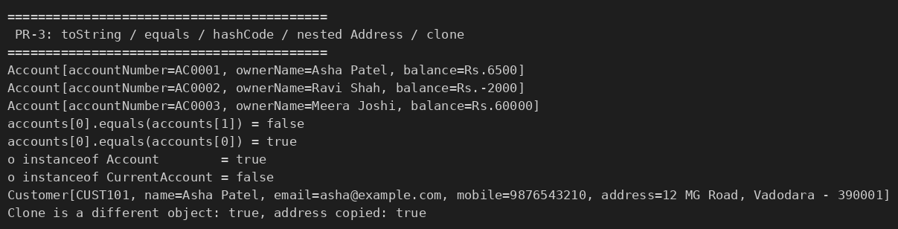

KEY QUESTIONS :

- Why must equals() and hashCode() be overridden together?
The Java contract says that two objects that are equal according to equals() must return the same hashCode(). Hash-based collections (HashMap, HashSet) first use hashCode() to pick a bucket and then equals() to compare. If only equals() is overridden, two equal accounts can get different hash codes, land in different buckets, and the collection will treat them as different objects (duplicates, failed look-ups). So both are overridden using the same field (accountNumber).
- What does the default Object.toString() return, and why override it?
The default Object.toString() returns the class name followed by @ and the hash code in hexadecimal (for example model.SavingsAccount@1b6d3586), which tells nothing about the object. Overriding it lets the object print its real state, e.g. Account[accountNumber=AC0001, ownerName=Asha Patel, balance=Rs.6500], which is useful for output, logging and debugging.
- What is the difference between a static nested class and an inner class?
A static nested class (like Customer.Address) is just a class placed inside another class for grouping; it does not hold a reference to an outer object and can be created without one: new Customer.Address(...). An inner class (non-static) is tied to an instance of the outer class, keeps a hidden reference to it (Outer.this), can use the outer instance’s members directly and can only be created through an outer object: outer.new Inner().

