PRACTICAL-4

- AIM:

Work these in your lab-NN/ folder before the project: do the first one or two in the lab; the last (For Advanced Learners) is for home.

1. Password strength (PasswordChecker.java + Driver.java)
(a) In PasswordChecker, check four rules — length ≥ 8, contains an uppercase letter, contains a digit, contains a special character — using regex (e.g. “.*[A-Z].*”) or String methods.
(b) Write strength(String pw) that counts how many rules pass and returns “Weak” (0–1), “Medium” (2–3) or “Strong” (4).
(c) In Driver.main: test several passwords; for each, print which rules passed and the final label.
Expected output: “abc” → Weak; “Abcd1234!” → Strong.

2. Chat-log filter (ChatFilter.java + Driver.java)
(a) In Driver.main, define a String[] of log lines like “10:05 alice Hello there” (include one malformed line with fewer than 3 parts).
(b) Read a keyword from the user.
(c) For each line, split into time/user/message with split(“ ”, 3); skip lines that do not have 3 parts.
(d) If the message contains the keyword (case-insensitive), increment a counter and append “time user: message” to a StringBuilder.
(e) Print “Matches: N” and the built report.
Expected output: keyword “hello” over 3 lines (1 malformed) → “Matches: 1” and the matching line.

3. (For Advanced Learners – home) Template filler (TemplateFiller.java + Driver.java)
(a) In Driver.main, define a template like “Dear {name}, order {id} ships {date}.” and two parallel arrays: names {“name”, “id”} and values {“Riya”, “A07”} (note {date} is not supplied).
(b) Compile a Pattern for \{(\w+)\} and get a Matcher on the template.
(c) Walk the matches with a StringBuilder: for each {placeholder}, look up its value in the names array and replace with the value, or with “[?]” if not found.
(d) Print the filled template.
Expected output: the unsupplied {date} becomes [?].

- SOURCE CODE :

1. PASSWORD STRENGTH
PASSWORDCHECKER.JAVA :
public class PasswordChecker {
public boolean hasMinimumLength(String password) {
return password.length() >= 8;
}

public boolean hasUppercaseLetter(String password) {
return password.matches(".*[A-Z].*");
}

public boolean hasDigit(String password) {
return password.matches(".*\\d.*");
}

public boolean hasSpecialCharacter(String password) {
return password.matches(".*[^a-zA-Z0-9].*");
}

public String strength(String password) {
int passedRules = 0;
if (hasMinimumLength(password)) passedRules++;
if (hasUppercaseLetter(password)) passedRules++;
if (hasDigit(password)) passedRules++;
if (hasSpecialCharacter(password)) passedRules++;

if (passedRules <= 1) return "Weak";
if (passedRules <= 3) return "Medium";
return "Strong";
}
}

DRIVER.JAVA :
public class Driver {
public static void main(String[] args) {
PasswordChecker checker = new PasswordChecker();
String[] passwords = {"abc", "password", "Password1", "Abcd1234!"};

for (String password : passwords) {
System.out.println("Password: " + password);
System.out.println("Length >= 8: " + checker.hasMinimumLength(password));
System.out.println("Contains uppercase: " + checker.hasUppercaseLetter(password));
System.out.println("Contains digit: " + checker.hasDigit(password));
System.out.println("Contains special character: " + checker.hasSpecialCharacter(password));
System.out.println("Strength: " + checker.strength(password));
System.out.println();
}
}
}

- OUTPUT :

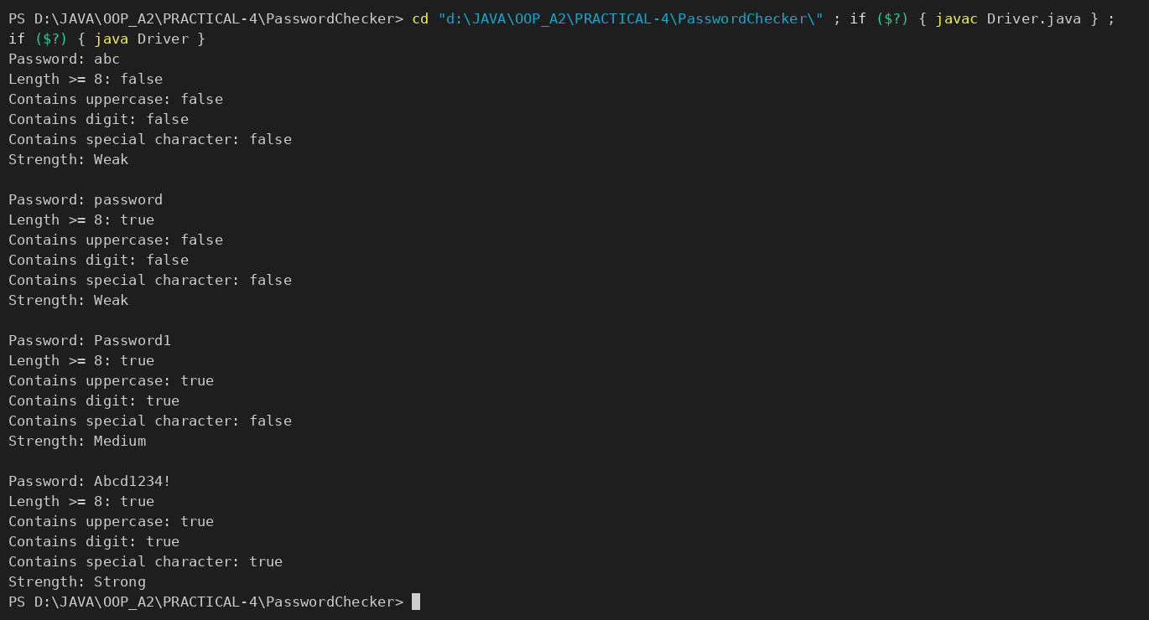

2. CHAT-LOG FILTER
CHATFILTER.JAVA :
public class ChatFilter {
public String filter(String[] lines, String keyword) {
int matches = 0;
StringBuilder report = new StringBuilder();
String searchTerm = keyword.toLowerCase();

for (String line : lines) {
String[] parts = line.split(" ", 3);
if (parts.length < 3) continue;

String message = parts[2];
if (message.toLowerCase().contains(searchTerm)) {
matches++;
report.append(parts[0]).append(" ")
.append(parts[1]).append(": ")
.append(message).append(System.lineSeparator());
}
}

return "Matches: " + matches + System.lineSeparator() + report;
}
}

DRIVER.JAVA :
import java.util.Scanner;

public class Driver {
public static void main(String[] args) {
String[] logs = {
"10:05 alice Hello there",
"10:06 bob I am working",
"malformed line"
};

Scanner scanner = new Scanner(System.in);
System.out.print("Enter keyword: ");
String keyword = scanner.nextLine();

ChatFilter filter = new ChatFilter();
System.out.println(filter.filter(logs, keyword));
}
}

- OUTPUT :

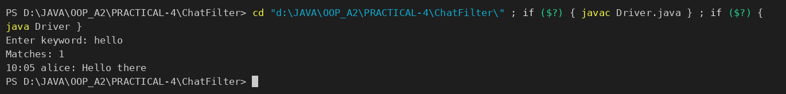

3. TEMPLATE FILLER
TEMPLATEFILLER.JAVA :
import java.util.regex.Matcher;
import java.util.regex.Pattern;

public class TemplateFiller {
private static final Pattern PLACEHOLDER = Pattern.compile("\\{(\\w+)\\}");

public String fill(String template, String[] names, String[] values) {
Matcher matcher = PLACEHOLDER.matcher(template);
StringBuilder filled = new StringBuilder();
int previousEnd = 0;

while (matcher.find()) {
filled.append(template, previousEnd, matcher.start());
filled.append(findValue(matcher.group(1), names, values));
previousEnd = matcher.end();
}
filled.append(template, previousEnd, template.length());
return filled.toString();
}

private String findValue(String name, String[] names, String[] values) {
for (int index = 0; index < names.length; index++) {
if (names[index].equals(name)) return values[index];
}
return "[?]";
}
}

DRIVER.JAVA :
public class Driver {
public static void main(String[] args) {
String template = "Dear {name}, order {id} ships {date}.";
String[] names = {"name", "id"};
String[] values = {"Riya", "A07"};

TemplateFiller filler = new TemplateFiller();
System.out.println(filler.fill(template, names, values));
}
}

- OUTPUT :

PART-B : MiniBank
Your classes exist, but the bank must never trust raw user input. In this lab you build MiniBank’s validation and command-parsing layer — regex checks for mobile, email, PAN and IFSC, and a parser that turns a typed line such as “DEPOSIT AC0001 500” into a Command object. Practical 14 will run every menu action through this layer.
1. Create a class named Validator with public static methods that use compiled regular expressions (Pattern): isValidMobile(String), isValidEmail(String), isValidPan(String) and isValidIfsc(String); each returns a boolean.
2. Define an enum named TransactionType with the constants DEPOSIT, WITHDRAW and TRANSFER. Then define a record named Command with three fields: a TransactionType type, a String accountNumber and a long amount.
3. Create a class named CommandParser with a public static method parse(String line) that splits a line such as “DEPOSIT AC0001 500” with split(), converts the parts, and returns a Command object.
4. Create a class named StatementFormatter with a public static method buildStatement(Account account) that uses a StringBuilder to assemble a multi-line account statement string.
5. In main, test each validator with one correct and one wrong input, then parse a sample command and print its three parts.
Note: the MiniBank classes below are shown as they are in the project (MiniBank folder); later labs build on the same classes.
VALIDATOR.JAVA :
package util;

import java.util.regex.Pattern;

public class Validator {
private static final Pattern MOBILE = Pattern.compile("^[6-9]\\d{9}$");
private static final Pattern EMAIL = Pattern.compile("^[A-Za-z0-9._%+-]+@[A-Za-z0-9.-]+\\.[A-Za-z]{2,}$");
private static final Pattern PAN = Pattern.compile("^[A-Z]{5}[0-9]{4}[A-Z]$");
private static final Pattern IFSC = Pattern.compile("^[A-Z]{4}0[A-Z0-9]{6}$");

private Validator() { }

public static boolean isValidMobile(String s) { return s != null && MOBILE.matcher(s).matches(); }
public static boolean isValidEmail(String s) { return s != null && EMAIL.matcher(s).matches(); }
public static boolean isValidPan(String s) { return s != null && PAN.matcher(s).matches(); }
public static boolean isValidIfsc(String s) { return s != null && IFSC.matcher(s).matches(); }
}

TRANSACTIONTYPE.JAVA :
package util;

public enum TransactionType {
DEPOSIT, WITHDRAW, TRANSFER
}

COMMAND.JAVA :
package util;

public record Command(TransactionType type, String accountNumber, long amount) {
}

COMMANDPARSER.JAVA :
package util;

public class CommandParser {
private CommandParser() { }

/** Parses a line such as "DEPOSIT AC0001 500". */
public static Command parse(String line) {
if (line == null) {
throw new IllegalArgumentException("Command cannot be null.");
}
String[] parts = line.trim().split("\\s+");
if (parts.length != 3) {
throw new IllegalArgumentException("Expected: <TYPE> <ACCOUNT> <AMOUNT>");
}
try {
TransactionType type = TransactionType.valueOf(parts[0].toUpperCase());
long amount = Long.parseLong(parts[2]);
return new Command(type, parts[1], amount);
} catch (IllegalArgumentException e) { // also covers NumberFormatException
throw new IllegalArgumentException("Invalid command: " + line, e);
}
}
}

STATEMENTFORMATTER.JAVA :
package util;

import model.Account;

public class StatementFormatter {
private StatementFormatter() { }

public static String buildStatement(Account account) {
StringBuilder sb = new StringBuilder();
sb.append("======= ACCOUNT STATEMENT =======\n");
sb.append("Account No : ").append(account.getAccountNumber()).append('\n');
sb.append("Owner : ").append(account.getOwnerName()).append('\n');
sb.append("Type : ").append(account.getClass().getSimpleName()).append('\n');
sb.append("Balance : Rs.").append(account.getBalance()).append('\n');
sb.append("Status : ").append(account.isActive() ? "Active" : "Inactive").append('\n');
sb.append("=================================");
return sb.toString();
}
}

MINIBANK.JAVA (demoPr4 — called from main) :
private static void demoPr4(Account account) {
section("PR-4: Validator, CommandParser, StatementFormatter");
System.out.println("Mobile 9876543210 -> " + isValidMobile("9876543210"));
System.out.println("Mobile 12345 -> " + isValidMobile("12345"));
System.out.println("Email a@b.com -> " + Validator.isValidEmail("a@b.com"));
System.out.println("Email a@b -> " + Validator.isValidEmail("a@b"));
System.out.println("PAN ABCDE1234F -> " + Validator.isValidPan("ABCDE1234F"));
System.out.println("PAN abcde1234 -> " + Validator.isValidPan("abcde1234"));
System.out.println("IFSC SBIN0001234 -> " + Validator.isValidIfsc("SBIN0001234"));
System.out.println("IFSC SBIN1001234 -> " + Validator.isValidIfsc("SBIN1001234"));

Command cmd = CommandParser.parse("DEPOSIT AC0001 500");
System.out.println("Parsed: type=" + cmd.type()
+ ", account=" + cmd.accountNumber() + ", amount=" + cmd.amount());
try {
CommandParser.parse("DEPOSIT AC0001 abc");
} catch (IllegalArgumentException e) {
System.out.println("Bad command rejected: " + e.getMessage());
}
System.out.println(StatementFormatter.buildStatement(account));
}

- OUTPUT :
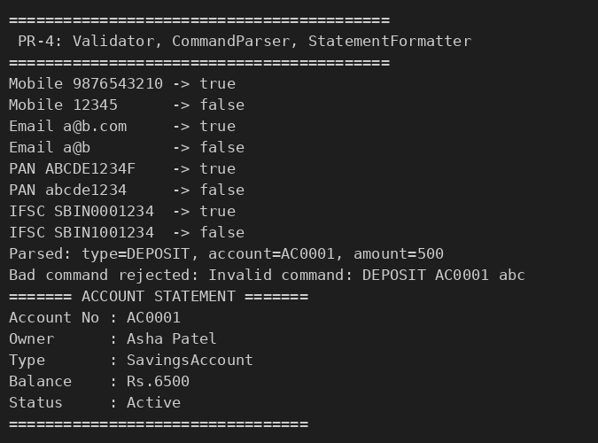

KEY QUESTIONS :

- What is the difference between String, StringBuilder and StringBuffer, and when is each preferred?
String is immutable – every change creates a new object, so it is best for fixed text, keys and constants. StringBuilder is mutable and not synchronized, so it is the fastest way to build or modify text in a single thread (used in StatementFormatter and ChatFilter). StringBuffer is also mutable but its methods are synchronized (thread-safe), so it is slower and preferred only when several threads modify the same buffer.
- What does the regular expression [6-9][0-9]{9} match, and why use anchors?
It matches exactly ten digits where the first digit is 6, 7, 8 or 9 (a valid Indian mobile number). Anchors ^ and $ (or using matches()) force the whole string to fit the pattern. Without them the pattern would also match a part of a longer string, e.g. 98765432101 or abc9876543210xyz, which are not valid mobile numbers.
- Why should input be validated at the boundary before it is used?
Data coming from users or files can be wrong or malicious. Checking it at the boundary (as soon as it enters the program) stops bad values before they corrupt the account data, cause exceptions deep inside the code, or create security problems. It also keeps the rules in one place (Validator, CommandParser), gives clear error messages to the user, and lets the rest of the code assume the data is valid.

