PRACTICAL-5

- AIM:

Work these in your lab-NN/ folder before the project: do the first one or two in the lab; the last (For Advanced Learners) is for home.

1. Shape areas
An abstract Shape with abstract area(); subclasses Circle, Rectangle, Triangle. Put a mix in a Shape[] and loop once to print each area and the running total, tracking the largest — one loop handling every shape through polymorphism.

2. Payroll
An abstract Employee with abstract monthlySalary(); FullTime (fixed), PartTime (hours × rate) and Intern (stipend), each calling super for the shared name/id. Loop a mixed array to print each salary and the total; use instanceof to add a note only for interns.

3. (For Advanced Learners – home) Media late fees
Model a few media types that each compute a late fee differently and total the fees for a returned batch. Design the hierarchy and rules yourself.

- SOURCE CODE :

1. SHAPE AREAS
SHAPE.JAVA (package ShapeAreas) :
package ShapeAreas;

import java.util.Scanner;
abstract class Shape {
abstract double getArea();
static class Circle extends Shape
{
private double radius;

public Circle(double radius)
{
this.radius = radius;
}
@Override
double getArea()
{
return Math.PI * radius * radius;
}
}
static class Rectangle extends Shape
{
private double length;
private double width;

public Rectangle(double length, double width)
{
this.length = length;
this.width = width;
}
@Override
double getArea()
{
return length*width;
}
}
static class Triangle extends Shape
{
private double base;
private double height;

public Triangle(double base,double height)
{
this.base=base;
this.height=height;
}
@Override
double getArea()
{
return 0.5 * base * height;
}
}

public static void main(String[] args) {
Scanner sc = new Scanner(System.in);

System.out.println("Enter the radius of the circle:");
double radius = sc.nextDouble();
Shape circle = new Shape.Circle(radius);

System.out.println("Enter the length and width of the rectangle:");
double length = sc.nextDouble();
double width = sc.nextDouble();
Shape rectangle = new Shape.Rectangle(length, width);

System.out.println("Enter the base and height of the triangle:");
double base = sc.nextDouble();
double height = sc.nextDouble();
Shape triangle = new Shape.Triangle(base, height);

Shape[] shapes = {circle, rectangle, triangle};

double totalArea = 0;
double largestArea = Double.MIN_VALUE;
Shape largestShape = null;

for (Shape s : shapes) {
double area = s.getArea();
System.out.println("Area: " + area);
totalArea += area;

if (area > largestArea) {
largestArea = area;
largestShape = s;
}
}

System.out.println("Total Area of all shapes: " + totalArea);
System.out.println("Largest Area: " + largestArea);
}
}

- OUTPUT :

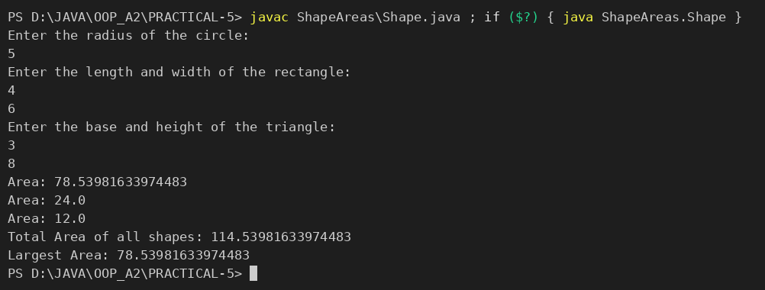

2. PAYROLL
EMPLOYEE.JAVA :
abstract class Employee {
private final String name;
private final int id;

Employee(String name, int id) {
this.name = name;
this.id = id;
}

String getName() {
return name;
}

int getId() {
return id;
}

abstract double monthlySalary();

static class FullTime extends Employee {
private final double salary;

FullTime(String name, int id, double salary) {
super(name, id);
this.salary = salary;
}

@Override
double monthlySalary() {
return salary;
}
}

static class PartTime extends Employee {
private final double hours;
private final double rate;

PartTime(String name, int id, double hours, double rate) {
super(name, id);
this.hours = hours;
this.rate = rate;
}

@Override
double monthlySalary() {
return hours * rate;
}
}

static class Intern extends Employee {
private final double stipend;

Intern(String name, int id, double stipend) {
super(name, id);
this.stipend = stipend;
}

@Override
double monthlySalary() {
return stipend;
}
}
}

DRIVER.JAVA :
public class Driver {
public static void main(String[] args) {
Employee[] employees = {
new Employee.FullTime("Asha", 101, 60000),
new Employee.PartTime("Bilal", 102, 80, 250),
new Employee.Intern("Chen", 103, 12000)
};

double totalSalary = 0;

for (Employee employee : employees) {
double salary = employee.monthlySalary();
totalSalary += salary;

System.out.println(employee.getName() + " (ID: " + employee.getId() + ") salary: " + salary);
if (employee instanceof Employee.Intern) {
System.out.println("Note: this employee is an intern.");
}
}

System.out.println("Total monthly payroll: " + totalSalary);
}
}

- OUTPUT :

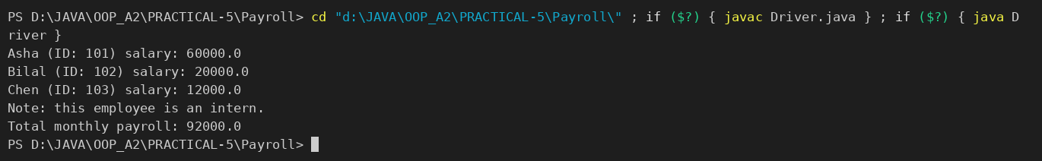

3. MEDIA LATE FEES
MEDIA.JAVA :
abstract class Media {
private final String title;

Media(String title) {
this.title = title;
}

String getTitle() {
return title;
}

abstract double lateFee(int daysLate);

static class Book extends Media {
Book(String title) {
super(title);
}

@Override
double lateFee(int daysLate) {
return daysLate * 0.75;
}
}

static class DVD extends Media {
DVD(String title) {
super(title);
}

@Override
double lateFee(int daysLate) {
return daysLate * 1.50;
}
}

static class VideoGame extends Media {
VideoGame(String title) {
super(title);
}

@Override
double lateFee(int daysLate) {
return daysLate * 2.00;
}
}
}

DRIVER.JAVA :
public class Driver {
public static void main(String[] args) {
Media[] returnedBatch = {
new Media.Book("The Hobbit"),
new Media.DVD("Inception"),
new Media.VideoGame("Racing Pro")
};
int[] daysLate = {2, 4, 3};
double totalFees = 0;

for (int index = 0; index < returnedBatch.length; index++) {
double fee = returnedBatch[index].lateFee(daysLate[index]);
totalFees += fee;
System.out.println(returnedBatch[index].getTitle() + " late fee: " + fee);
}

System.out.println("Total late fees: " + totalFees);
}
}

- OUTPUT :

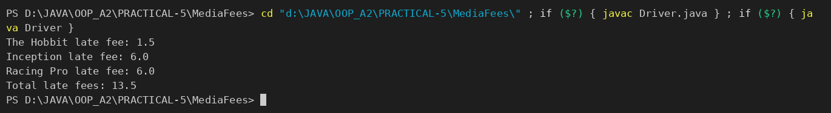

PART-B : MiniBank
A real bank has different account types. Building on the single Account class, this lab makes Account abstract and adds three subclasses — SavingsAccount, CurrentAccount and FixedDepositAccount — each with its own interest and withdrawal rules chosen automatically by polymorphism. This lets the rest of MiniBank treat every account through one common type.
1. Make Account an abstract class. Add two abstract methods: double interestRate() and boolean canWithdraw(long amount).
2. Create a class SavingsAccount that extends Account with a long field minBalance; interestRate() returns 4.0; canWithdraw() returns true only if the balance stays greater than or equal to minBalance.
3. Create a class CurrentAccount that extends Account with a long field overdraftLimit; interestRate() returns 0; canWithdraw() allows the balance to fall to minus overdraftLimit.
4. Create a class FixedDepositAccount that extends Account; interestRate() returns 7.0; canWithdraw() returns false (the deposit is locked).
5. Call super(...) from each subclass constructor to initialise the inherited fields.
6. In main, place objects of the three types in an Account[] array, loop through it and call interestRate() on each (this demonstrates run-time polymorphism); use a pattern instanceof check to handle one type specially.
Note: the MiniBank classes below are shown as they are in the project (MiniBank folder); later labs build on the same classes.
ACCOUNT.JAVA (abstract class, constructors, abstract methods) :
public abstract class Account implements Transactable, InterestBearing {

@Id
private final String accountNumber;
@MaxLength(20)
private String ownerName;
@Positive
private long balance; // changes only via deposit() / withdraw()
private boolean active;

private static long accountCounter = 0;

private static String generateAccountNumber() {
accountCounter++;
return String.format("AC%04d", accountCounter);
}

public Account(String ownerName, long openingBalance) {
this.accountNumber = generateAccountNumber();
this.ownerName = ownerName;
this.balance = openingBalance;
this.active = true;
}

public Account(String ownerName) {
this(ownerName, 0);
}
// ...
@Override
public abstract double interestRate();

public abstract boolean canWithdraw(long amount);
}

SAVINGSACCOUNT.JAVA :
package model;

public class SavingsAccount extends Account {
private long minBalance;

public SavingsAccount(String ownerName, long openingBalance, long minBalance) {
super(ownerName, openingBalance);
this.minBalance = minBalance;
}

public long getMinBalance() { return minBalance; }

@Override
public double interestRate() { return 4.0; }

@Override
public boolean canWithdraw(long amount) {
return getBalance() - amount >= minBalance;
}

@Override
protected long availableToWithdraw() {
return Math.max(0, getBalance() - minBalance);
}
}

CURRENTACCOUNT.JAVA :
package model;

public class CurrentAccount extends Account {
private long overdraftLimit;

public CurrentAccount(String ownerName, long openingBalance, long overdraftLimit) {
super(ownerName, openingBalance);
this.overdraftLimit = overdraftLimit;
}

public long getOverdraftLimit() { return overdraftLimit; }

@Override
public double interestRate() { return 0; }

@Override
public boolean canWithdraw(long amount) {
return getBalance() - amount >= -overdraftLimit;
}

@Override
protected long availableToWithdraw() {
return getBalance() + overdraftLimit;
}
}

FIXEDDEPOSITACCOUNT.JAVA :
package model;

public class FixedDepositAccount extends Account implements Premium {

public FixedDepositAccount(String ownerName, long openingBalance) {
super(ownerName, openingBalance);
}

@Override
public double interestRate() { return 7.0; }

@Override
public boolean canWithdraw(long amount) {
return false; // deposit is locked
}

@Override
protected long availableToWithdraw() {
return 0;
}
}

MINIBANK.JAVA (demoPr5 — called from main) :
private static void demoPr5() {
section("PR-5: Polymorphism and pattern instanceof");
Account[] accounts = {
new SavingsAccount("Asha Patel", 8000, 1000),
new CurrentAccount("Ravi Shah", 3000, 5000),
new FixedDepositAccount("Meera Joshi", 60000)
};
for (Account a : accounts) {
System.out.println(a.getClass().getSimpleName() + " -> interestRate = " + a.interestRate() + "%");
if (a instanceof SavingsAccount s) { // pattern instanceof
System.out.println(" minimum balance = Rs." + s.getMinBalance());
}
}
}

- OUTPUT :
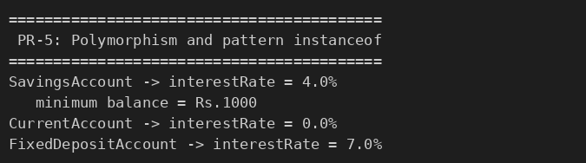

KEY QUESTIONS :

- What is the difference between an abstract class and a concrete class?
A concrete class has an implementation for all its methods and can be instantiated with new. An abstract class is declared with abstract, cannot be instantiated directly, and may contain abstract methods (no body) that every concrete subclass must implement. Account is abstract because “a generic account” does not exist in the bank – only SavingsAccount, CurrentAccount and FixedDepositAccount do – while the shared code (balance, deposit, toString) stays in one place.
- What is dynamic method dispatch (run-time polymorphism)?
It is the mechanism by which the call to an overridden method is resolved at run time from the actual object type, not from the reference type. In Account[] accounts = {new SavingsAccount(...), new CurrentAccount(...), new FixedDepositAccount(...)} the call a.interestRate() runs the version of the object that a really refers to and prints 4.0, 0.0 and 7.0, although every reference is of type Account.
- What does the super keyword do in a subclass constructor?
super(...) calls the constructor of the parent class so that the inherited fields are initialised first; it must be the first statement of the constructor. In SavingsAccount, super(ownerName, openingBalance) makes Account generate the account number and set the owner and balance, after which the subclass sets its own field minBalance. If it is not written, the compiler inserts a call to the parent’s no-argument constructor.

