PRACTICAL-6

- AIM:

Work these in your lab-NN/ folder before the project: do the first one or two in the lab; the last (For Advanced Learners) is for home.

1. Remote control
An interface Switchable with on()/off() and a default toggle(); Fan and Light implement it. Loop over a Switchable[] toggling each. Then add a functional interface that decides, given a device and an hour, whether it may switch on, and supply it once as an anonymous class and once as a lambda.

2. Notification senders
A functional interface Notifier with send(String); make email and SMS senders as lambdas, hold them in an array, and broadcast one message through all. Add a marker interface Urgent and send twice for senders marked urgent.

3. (For Advanced Learners – home) Discount engine
Build a small discount engine where each rule is a lambda the user picks at runtime and applies to a list of prices; organise it into packages and ship it as a runnable JAR.

- SOURCE CODE :

1. REMOTE CONTROL
REMOTECONTROLDEMO.JAVA :
/*Remote control: an interface Switchable with on()/off() and a default toggle(); Fan and
Light implement it. Loop over a Switchable[] toggling each. Then add a functional
interface that decides, given a device and an hour, whether it may switch on, and supply it
once as an anonymous class and once as a lambda. */

// Switchable interface
interface Switchable {
void on();
void off();

default void toggle() {
System.out.println("Toggling...");
on(); // simple default: just call on()
}
}

// Fan implementation
class Fan implements Switchable {
private boolean running = false;

@Override
public void on() {
running = true;
System.out.println("Fan is now ON");
}

@Override
public void off() {
running = false;
System.out.println("Fan is now OFF");
}
}

// Light implementation
class Light implements Switchable {
private boolean lit = false;

@Override
public void on() {
lit = true;
System.out.println("Light is now ON");
}

@Override
public void off() {
lit = false;
System.out.println("Light is now OFF");
}
}

// Functional interface for policy
@FunctionalInterface
interface SwitchPolicy {
boolean maySwitchOn(Switchable device, int hour);
}

// Runner
public class RemoteControlDemo {
public static void main(String[] args) {
Switchable[] devices = { new Fan(), new Light() };

// Loop over devices and toggle each
for (Switchable s : devices) {
s.toggle();
}

// Anonymous class policy: only allow switching on before 6pm
SwitchPolicy dayPolicy = new SwitchPolicy() {
@Override
public boolean maySwitchOn(Switchable device, int hour) {
return hour < 18;
}
};

// Lambda policy: only allow switching on after 6pm
SwitchPolicy nightPolicy = (device, hour) -> hour >= 18;

System.out.println("\nPolicy checks:");
int testHour = 20;
for (Switchable s : devices) {
System.out.println("At " + testHour + "h, "
+ s.getClass().getSimpleName()
+ " may switch on (dayPolicy)? " + dayPolicy.maySwitchOn(s, testHour));
System.out.println("At " + testHour + "h, "
+ s.getClass().getSimpleName()
+ " may switch on (nightPolicy)? " + nightPolicy.maySwitchOn(s, testHour));
}
}
}

- OUTPUT :

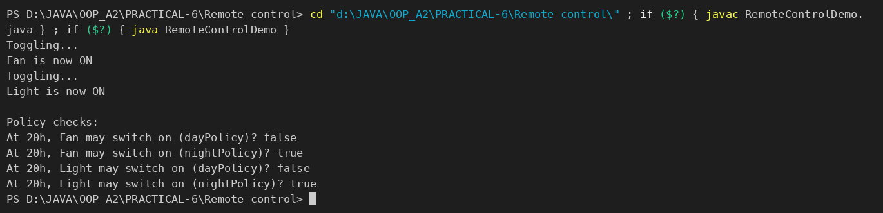

2. NOTIFICATION SENDERS
NOTIFICATIONDEMO.JAVA :
// Functional interface
@FunctionalInterface
interface Notifier {
void send(String message);
}

// Marker interface
interface Urgent { }

// Runner
public class NotificationDemo {
public static void main(String[] args) {
// Email sender (urgent)
Notifier emailSender = (Notifier & Urgent) msg ->
System.out.println("Email: " + msg);

// SMS sender (not urgent)
Notifier smsSender = msg ->
System.out.println("SMS: " + msg);

// Hold them in an array
Notifier[] senders = { emailSender, smsSender };

// Broadcast a message
String message = "System update at 5 PM";

for (Notifier n : senders) {
n.send(message);
// If marked urgent, send twice
if (n instanceof Urgent) {
n.send("[URGENT] " + message);
}
}
}
}

- OUTPUT :

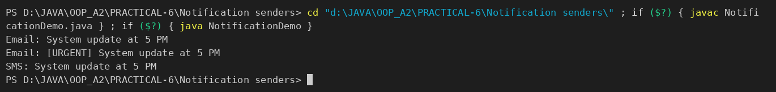

PART-B : MiniBank
With several classes now in place, this lab gives MiniBank a clean structure. You express account capabilities as interfaces, organise the code into model, util and service packages, and build a runnable JAR — the form in which the finished application will actually be delivered and run.
1. Create an interface named Transactable with methods void deposit(long amount) and boolean withdraw(long amount); make Account implement it.
2. Create an interface named InterestBearing with a default method double yearlyInterest() that uses interestRate() and the balance.
3. Create a functional interface named WithdrawRule with a single method boolean allow(Account account, long amount). Use it two ways in main: first with an anonymous class, then with a lambda expression.
4. Create a marker interface named Premium (an interface with no methods).
5. Move all classes into the packages model, util and service (add package statements and fix the import statements). Use one static import.
6. Build a runnable JAR file with a manifest whose Main-Class is the MiniBank class, and run it with the command java -jar.
Note: the MiniBank classes below are shown as they are in the project (MiniBank folder); later labs build on the same classes.
TRANSACTABLE.JAVA :
package model;

import exception.InsufficientFundsException;
import exception.InvalidAmountException;

public interface Transactable {
void deposit(long amount) throws InvalidAmountException;

boolean withdraw(long amount) throws InsufficientFundsException, InvalidAmountException;
}

INTERESTBEARING.JAVA :
package model;

public interface InterestBearing {
double interestRate();

long getBalance();

default double yearlyInterest() {
return Math.max(0, getBalance()) * interestRate() / 100.0;
}
}

WITHDRAWRULE.JAVA :
package model;

@FunctionalInterface
public interface WithdrawRule {
boolean allow(Account account, long amount);
}

PREMIUM.JAVA :
package model;

/** Marker interface (no methods) - tags premium account types. */
public interface Premium {
}

ACCOUNT.JAVA (class declaration — implements both interfaces) :
public abstract class Account implements Transactable, InterestBearing {

FIXEDDEPOSITACCOUNT.JAVA (implements Premium) :
package model;

public class FixedDepositAccount extends Account implements Premium {

public FixedDepositAccount(String ownerName, long openingBalance) {
super(ownerName, openingBalance);
}

@Override
public double interestRate() { return 7.0; }

@Override
public boolean canWithdraw(long amount) {
return false; // deposit is locked
}

@Override
protected long availableToWithdraw() {
return 0;
}
}

PACKAGE STRUCTURE :
MiniBank/
├── manifest.txt
├── model/
│ ├── Account.java, SavingsAccount.java, CurrentAccount.java,
│ │ FixedDepositAccount.java, Customer.java, BankInfo.java,
│ │ MenuOption.java
│ ├── Transactable.java, InterestBearing.java,
│ │ WithdrawRule.java, Premium.java
│ └── annotation/ (Id, Positive, MaxLength)
├── exception/ (BankException and its subclasses)
├── util/ (Validator, Command, CommandParser,
│ StatementFormatter, AnnotationValidator, ...)
└── service/ (MiniBank.java, AccountWorker.java)

MANIFEST.TXT :
Manifest-Version: 1.0
Main-Class: service.MiniBank

MINIBANK.JAVA (static import + demoPr6 — called from main) :
import static util.Validator.isValidMobile; // PR-6: the one static import

private static void demoPr6(Account[] accounts) {
section("PR-6: Interfaces, default method, WithdrawRule, Premium");
for (Account a : accounts) {
System.out.println(a.getAccountNumber() + " yearlyInterest = Rs." + a.yearlyInterest()
+ (a instanceof Premium ? " [Premium]" : ""));
}

WithdrawRule anonymous = new WithdrawRule() {
@Override
public boolean allow(Account account, long amount) {
return account.getBalance() >= amount;
}
};
WithdrawRule lambda = (account, amount) -> amount <= account.getBalance() / 2;

System.out.println("Anonymous rule (balance >= 4000) : " + anonymous.allow(accounts[0], 4000));
System.out.println("Lambda rule (amount <= half) : " + lambda.allow(accounts[0], 4000));
}

- BUILDING THE JAR :
Compile into the out folder, create MiniBank.jar with the manifest, and list the JAR contents.
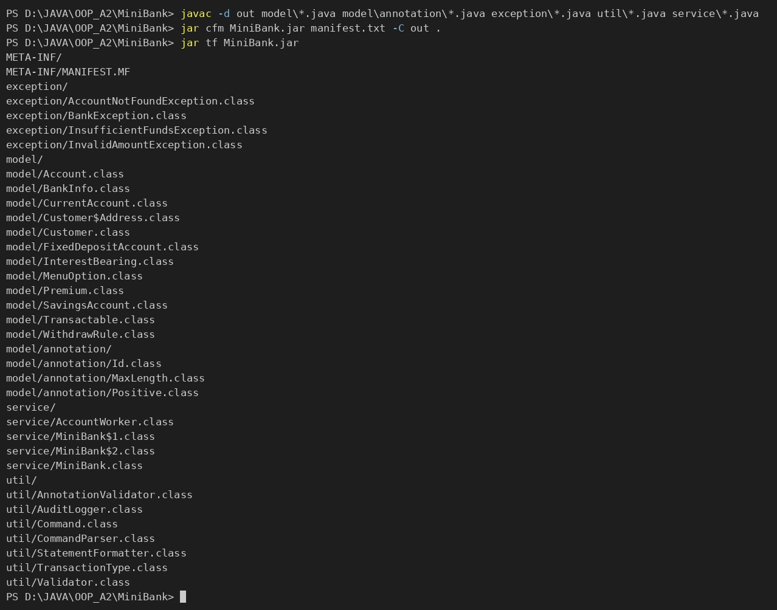

- RUNNING THE JAR :
java -jar MiniBank.jar starts the menu from Practical 1 (the demo output of the later labs follows it).
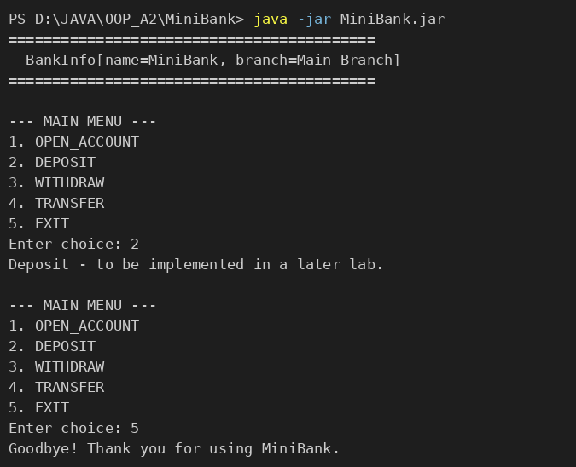

- OUTPUT (PR-6 SECTION) :
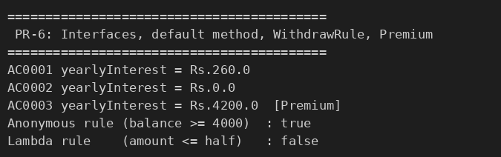

KEY QUESTIONS :

- What is the difference between an interface and an abstract class?
An interface defines a contract: abstract methods (plus default, static and private methods) and constants, but no instance state. A class can implement many interfaces. An abstract class can have fields, constructors and both abstract and concrete methods, but a class can extend only one class. Use an interface for a capability (Transactable, InterestBearing, Premium) and an abstract class for a common base with shared state and code (Account).
- What is a functional interface, and how does a lambda use it?
A functional interface has exactly one abstract method (marked with @FunctionalInterface), e.g. WithdrawRule.allow(Account, long). A lambda expression is a short way to supply the implementation of that single method, so (account, amount) -> amount <= account.getBalance() / 2 is an object of type WithdrawRule; the compiler infers the types from the interface. The same rule written as an anonymous class gives the same result with more code.
- Why is a default method useful in an interface?
A default method has a body inside the interface. It lets you add new behaviour to an interface without breaking the classes that already implement it, and it gives all implementers a ready-made common behaviour that they may override. InterestBearing.yearlyInterest() calculates the yearly interest from interestRate() and getBalance() once, and every account type gets it automatically.

