PRACTICAL-7

- AIM:

Work these in your lab-NN/ folder before the project: do the first one or two in the lab; the last (For Advanced Learners) is for home.

1. Form validator
Define @NotBlank and @MaxLength(int) for fields and annotate a SignupForm. Write a checker that uses reflection to read each field’s annotations and returns the list of validation errors for a given object.

2. Mini test runner
Define a @Run annotation and mark some no-arg methods of a class with it. Use reflection to find and invoke only the @Run methods and report how many ran — the idea behind how JUnit finds @Test methods.

3. (For Advanced Learners – home) Column mapper
Define a @Column(name) annotation and, by reflection, populate an object’s fields from a header row and a data row by matching column names; decide how to handle a missing column.

- SOURCE CODE :

1. FORM VALIDATOR
FORMVALIDATORDEMO.JAVA :
import java.lang.annotation.*;
import java.lang.reflect.*;
import java.util.*;

// --- Custom Annotations ---
@Retention(RetentionPolicy.RUNTIME)
@Target(ElementType.FIELD)
@interface NotBlank { }

@Retention(RetentionPolicy.RUNTIME)
@Target(ElementType.FIELD)
@interface MaxLength {
int value();
}

// --- Form Class ---
class SignupForm {
@NotBlank
@MaxLength(20)
private String username;

@NotBlank
@MaxLength(50)
private String email;

private String bio; // optional, no constraints

public SignupForm(String username, String email, String bio) {
this.username = username;
this.email = email;
this.bio = bio;
}
}

// --- Validator ---
class FormValidator {
public static List<String> validate(Object form) {
List<String> errors = new ArrayList<>();
Class<?> clazz = form.getClass();

for (Field field : clazz.getDeclaredFields()) {
field.setAccessible(true);
try {
Object value = field.get(form);

// Check @NotBlank
if (field.isAnnotationPresent(NotBlank.class)) {
if (value == null || value.toString().trim().isEmpty()) {
errors.add(field.getName() + " must not be blank");
}
}

// Check @MaxLength
if (field.isAnnotationPresent(MaxLength.class) && value != null) {
int max = field.getAnnotation(MaxLength.class).value();
if (value.toString().length() > max) {
errors.add(field.getName() + " must not exceed " + max + " characters");
}
}

} catch (IllegalAccessException e) {
errors.add("Could not access field: " + field.getName());
}
}
return errors;
}
}

// --- Demo Runner ---
public class FormValidatorDemo {
public static void main(String[] args) {
SignupForm form1 = new SignupForm("Alice", "alice@example.com", "Hello!");
SignupForm form2 = new SignupForm("", "averylongemailaddresswhichiswaytoolong@example.com", null);

System.out.println("Form1 errors: " + FormValidator.validate(form1));
System.out.println("Form2 errors: " + FormValidator.validate(form2));
}
}

- OUTPUT :

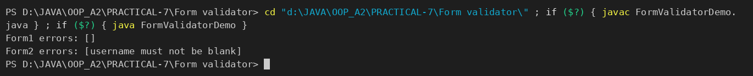

2. MINI TEST RUNNER
MINITESTRUNNER.JAVA :
import java.lang.annotation.*;
import java.lang.reflect.*;

// --- Custom annotation ---
@Retention(RetentionPolicy.RUNTIME)
@Target(ElementType.METHOD)
@interface Run { }

// --- Class with test methods ---
class MyTests {
@Run
public void testOne() {
System.out.println("Running testOne");
}

@Run
public void testTwo() {
System.out.println("Running testTwo");
}

public void helper() {
System.out.println("Helper method (not annotated)");
}
}

// --- Mini runner ---
public class MiniTestRunner {
public static void main(String[] args) throws Exception {
MyTests tests = new MyTests();
int count = 0;

for (Method m : MyTests.class.getDeclaredMethods()) {
if (m.isAnnotationPresent(Run.class) && m.getParameterCount() == 0) {
m.invoke(tests); // invoke only @Run no-arg methods
count++;
}
}

System.out.println("Total @Run methods executed: " + count);
}
}

- OUTPUT :

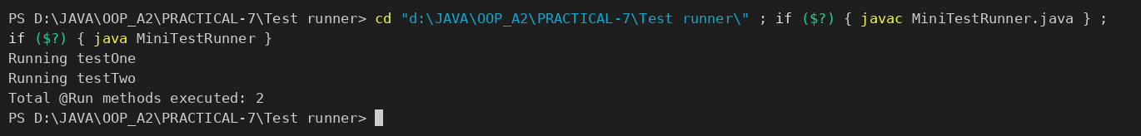

PART-B : MiniBank
Now that you are comfortable with classes and interfaces, you add metadata to MiniBank. You define custom annotations (@Id, @Positive, @MaxLength) and read them at run time with reflection to validate any object automatically — the same idea real frameworks use. The @Id marker will later identify each record in the generic repository you build in Practical 13.
1. Add the @Override annotation above every overridden method written so far (toString, equals, hashCode and the subclass methods). Add @FunctionalInterface above the WithdrawRule interface.
2. In a package named model.annotation, define three custom annotations: @Id (a marker, with @Target(FIELD) and @Retention(RUNTIME)); @Positive with a member String message() default “must be > 0”; and @MaxLength with a member int value().
3. Put @Id on the accountNumber field and @Positive on the balance field of Account.
4. Create a class named AnnotationValidator with a public static method String[] validate(Object obj) that uses reflection — getClass().getDeclaredFields(), field.isAnnotationPresent(...), field.setAccessible(true) and field.get(obj) — to check the @Positive and @MaxLength rules and return the error messages as a String[].
5. In main, create an Account with a negative balance and run AnnotationValidator.validate() to print the error.
Note: the MiniBank classes below are shown as they are in the project (MiniBank folder); later labs build on the same classes.
ID.JAVA :
package model.annotation;

import java.lang.annotation.ElementType;
import java.lang.annotation.Retention;
import java.lang.annotation.RetentionPolicy;
import java.lang.annotation.Target;

/** Marker: identifies the record id (used by the generic repository in PR-13). */
@Target(ElementType.FIELD)
@Retention(RetentionPolicy.RUNTIME)
public @interface Id {
}

POSITIVE.JAVA :
package model.annotation;

import java.lang.annotation.ElementType;
import java.lang.annotation.Retention;
import java.lang.annotation.RetentionPolicy;
import java.lang.annotation.Target;

@Target(ElementType.FIELD)
@Retention(RetentionPolicy.RUNTIME)
public @interface Positive {
String message() default "must be > 0";
}

MAXLENGTH.JAVA :
package model.annotation;

import java.lang.annotation.ElementType;
import java.lang.annotation.Retention;
import java.lang.annotation.RetentionPolicy;
import java.lang.annotation.Target;

@Target(ElementType.FIELD)
@Retention(RetentionPolicy.RUNTIME)
public @interface MaxLength {
int value();
}

ACCOUNT.JAVA (annotated fields, @Override) :
public abstract class Account implements Transactable, InterestBearing {

@Id
private final String accountNumber;
@MaxLength(20)
private String ownerName;
@Positive
private long balance; // changes only via deposit() / withdraw()
private boolean active;

WITHDRAWRULE.JAVA (@FunctionalInterface) :
package model;

@FunctionalInterface
public interface WithdrawRule {
boolean allow(Account account, long amount);
}

ANNOTATIONVALIDATOR.JAVA :
package util;

import model.annotation.MaxLength;
import model.annotation.Positive;

import java.lang.reflect.Field;
import java.util.ArrayList;
import java.util.List;

/** PR-7: validates any object by reading its annotations with reflection. */
public class AnnotationValidator {
private AnnotationValidator() { }

public static String[] validate(Object obj) {
if (obj == null) {
throw new IllegalArgumentException("Object cannot be null.");
}
List<String> errors = new ArrayList<>();

// walk up the hierarchy: SavingsAccount -> Account -> Object
for (Class<?> c = obj.getClass(); c != null && c != Object.class; c = c.getSuperclass()) {
for (Field field : c.getDeclaredFields()) {
field.setAccessible(true);
try {
Object value = field.get(obj);

if (field.isAnnotationPresent(Positive.class)
&& value instanceof Number n && n.longValue() <= 0) {
errors.add(field.getName() + ": " + field.getAnnotation(Positive.class).message());
}
if (field.isAnnotationPresent(MaxLength.class)
&& value instanceof String s) {
int max = field.getAnnotation(MaxLength.class).value();
if (s.length() > max) {
errors.add(field.getName() + ": length must be <= " + max);
}
}
} catch (IllegalAccessException e) {
errors.add(field.getName() + ": cannot be read");
}
}
}
return errors.toArray(new String[0]);
}
}

MINIBANK.JAVA (demoPr7 — called from main) :
private static void demoPr7() {
section("PR-7: Annotations + reflection");
Account bad = new SavingsAccount("A Very Long Owner Name Here", -500, 0);
System.out.println("Validating " + bad);
for (String error : AnnotationValidator.validate(bad)) {
System.out.println(" ERROR -> " + error);
}
Account good = new SavingsAccount("Asha Patel", 2500, 500);
System.out.println("Errors for a valid account: " + AnnotationValidator.validate(good).length);
}

- OUTPUT :
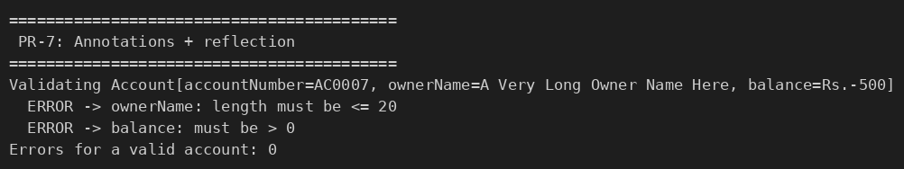

KEY QUESTIONS :

- What are the meta-annotations @Retention and @Target used for?
Meta-annotations are annotations applied to other annotations. @Retention says how long the annotation is kept: SOURCE (only in source code), CLASS (in the .class file) or RUNTIME (available to reflection while the program runs). @Target says where the annotation may be placed (FIELD, METHOD, TYPE, ...). @Id, @Positive and @MaxLength use @Retention(RUNTIME) so the validator can read them, and @Target(FIELD) so they can only be put on fields.
- What is reflection, and what does getDeclaredFields() return?
Reflection is the ability of a program to inspect and use classes, fields, methods and annotations at run time, without knowing them at compile time. getDeclaredFields() returns an array of Field objects for all fields declared in that class (public, protected, package and private) but not the inherited ones, which is why AnnotationValidator also walks up to the superclass Account.
- How do annotations plus reflection let a framework validate any object?
The rules are written as annotations on the fields (@Positive, @MaxLength(20)). A single generic method (AnnotationValidator.validate) uses reflection to list the fields of any object, check isAnnotationPresent(...), read the field value with setAccessible(true) and get(obj), and compare it with the rule. No validation code is written per class – adding a new annotated field is enough, which is how validation frameworks and ORMs work.

