PRACTICAL-8

- AIM:

Work these in your lab-NN/ folder before the project: do the first one or two in the lab; the last (For Advanced Learners) is for home.

1. Guarded calculator
Read two numbers and an operator; throw a custom DivideByZeroException and catch invalid-number input separately, printing a clear message each time; loop until a valid calculation succeeds and use finally to log each attempt.

2. Stock issue
A Warehouse where issue(item, qty) throws a custom checked OutOfStockException carrying the shortfall, and InvalidQuantityException for qty ≤ 0. Process a list of requests, catching and reporting each failure without stopping the run.

3. (For Advanced Learners – home) AutoCloseable resource
Create an AutoCloseable resource and use try-with-resources to prove it always closes — even when an exception is thrown inside the block — and that the original error is the one reported. Decide what to model as the resource.

- SOURCE CODE :

1. GUARDED CALCULATOR
CALC.JAVA :
//Guarded calculator: read two numbers and an operator; throw a custom
//DivideByZeroException and catch invalid-number input separately, printing a clear
//message each time; loop until a valid calculation succeeds and use finally to log each
//attempt.
import java.util.Scanner;

class DivideByZeroException extends Exception {
public DivideByZeroException(String message) {
super(message);
}
}

public class Calc {
public static void main(String[] args) {
Scanner sc = new Scanner(System.in);
boolean success = false;

System.out.println("Welcome to the Guarded Calculator!");

while (!success) {
double num1 = 0, num2 = 0;
char operator = ' ';

try {
System.out.print("Enter the first number: ");
num1 = sc.nextDouble();

System.out.print("Enter the second number: ");
num2 = sc.nextDouble();

System.out.print("Enter the operator (+, -, *, /): ");
operator = sc.next().charAt(0);

switch (operator) {
case '+':
System.out.println("Addition: " + (num1 + num2));
success = true;
break;
case '-':
System.out.println("Subtraction: " + (num1 - num2));
success = true;
break;
case '*':
System.out.println("Multiplication: " + (num1 * num2));
success = true;
break;
case '/':
if (num2 == 0) {
throw new DivideByZeroException("Cannot divide by zero.");
}
System.out.println("Division: " + ((double) num1 / num2));
success = true;
break;
default:
System.out.println("Invalid operator. Please use +, -, *, or /.");
}

} catch (DivideByZeroException e) {
System.out.println("Error: " + e.getMessage());
} catch (java.util.InputMismatchException e) {
System.out.println("Invalid input. Please enter valid numbers.");
sc.nextLine(); // clear the invalid input
} finally {
System.out.println("Calculation attempt logged.");
}
}

sc.close();
System.out.println("Calculation succeeded. Program ends.");
}
}

- OUTPUT :

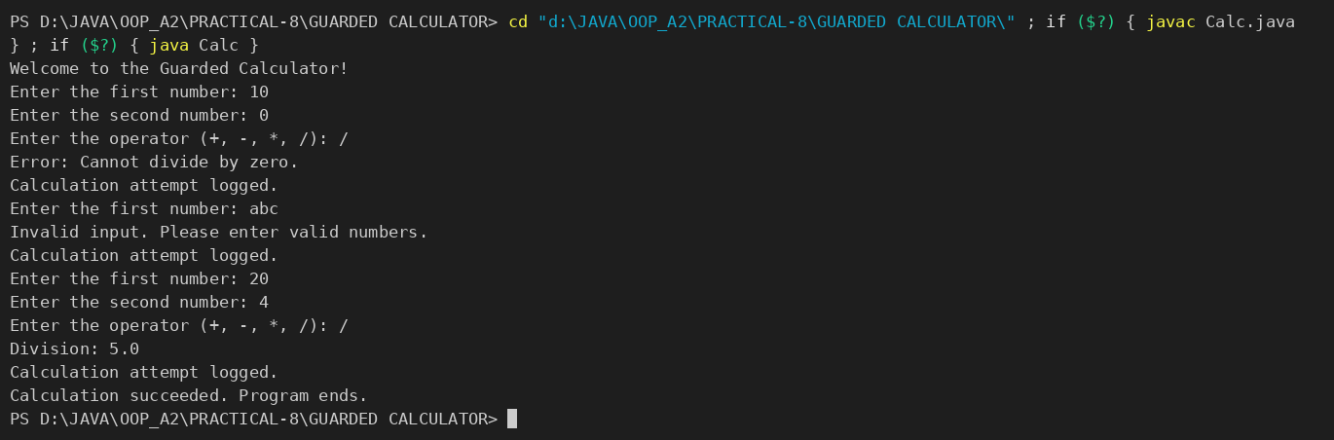

2. STOCK ISSUE (GUARDED WAREHOUSE)
GUARDEDWAREHOUSE.JAVA :
/*Stock issue: a Warehouse where issue(item, qty) throws a custom checked
OutOfStockException carrying the shortfall, and InvalidQuantityException for qty ≤ 0.
Process a list of requests, catching and reporting each failure without stopping the run.*/

import java.util.*;

// Custom exceptions
class OutOfStockException extends Exception {
private final int shortfall;
public OutOfStockException(int shortfall) {
super("Out of stock, shortfall: " + shortfall);
this.shortfall = shortfall;
}
public int getShortfall() { return shortfall; }
}

class InvalidQuantityException extends Exception {
public InvalidQuantityException(int qty) {
super("Invalid quantity: " + qty);
}
}

// Warehouse class
class Warehouse {
private Map<String, Integer> stock = new HashMap<>();
public Warehouse() {
stock.put("Widget", 10);
stock.put("Gadget", 5);
stock.put("Thingamajig", 0);
}

public void issue(String item, int qty) throws OutOfStockException, InvalidQuantityException {
if (qty <= 0) throw new InvalidQuantityException(qty);
int available = stock.getOrDefault(item, 0);
if (available < qty) throw new OutOfStockException(qty - available);
stock.put(item, available - qty);
System.out.println("Issued " + qty + " of " + item);
}
}

// Runner
public class GuardedWarehouse {
public static void main(String[] args) {
Warehouse wh = new Warehouse();
Scanner sc = new Scanner(System.in);
boolean success = false;

System.out.println("Welcome to the Guarded Warehouse!");

while (!success) {
try {
System.out.print("Enter item name(Widget/Gadget/Thingamajig): ");
String item = sc.nextLine().trim();

System.out.print("Enter quantity: ");
int qty = sc.nextInt();
sc.nextLine(); // clear newline

wh.issue(item, qty);
success = true;

} catch (OutOfStockException e) {
System.out.println("Error: " + e.getMessage());
} catch (InvalidQuantityException e) {
System.out.println("Error: " + e.getMessage());
} catch (InputMismatchException e) {
System.out.println("Invalid input. Quantity must be a number.");
sc.nextLine(); // clear invalid input
} finally {
System.out.println("Request attempt logged.");
}
}

sc.close();
System.out.println("Request succeeded. Program ends.");
}
}

- OUTPUT :

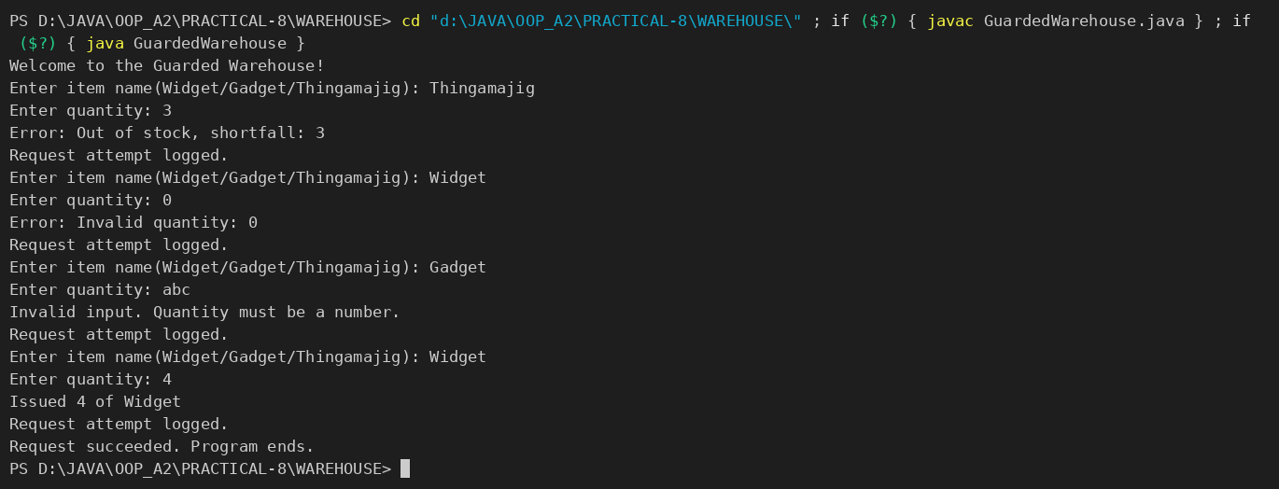

PART-B : MiniBank
Until now a failed withdrawal just returned false. In this lab you make MiniBank fault-tolerant: you replace those flags with a custom exception hierarchy so every failure is explicit and carries information (such as the shortfall). This is the Milestone 1 checkpoint, where the model, validation, annotations and error handling come together.
1. In a package named exception, create a checked base class BankException that extends Exception. Then create InsufficientFundsException, AccountNotFoundException and InvalidAmountException, each extending BankException. Give InsufficientFundsException a long field shortfall.
2. Change withdraw(long amount) to declare throws InsufficientFundsException, InvalidAmountException; throw InsufficientFundsException when the balance is too low and InvalidAmountException when the amount is less than or equal to zero. Make deposit(long amount) throw InvalidAmountException for a non-positive amount.
3. Add a method transfer(Account to, long amount) that uses try, catch and finally and re-throws a BankException when needed.
4. In main, wrap the operations in try-catch blocks and print friendly messages; use a finally block; and show one try-with-resources example using a small AutoCloseable class that you create.
Note: the MiniBank classes below are shown as they are in the project (MiniBank folder); later labs build on the same classes.
BANKEXCEPTION.JAVA :
package exception;

/** Checked base class for every MiniBank failure (PR-8). */
public class BankException extends Exception {
private static final long serialVersionUID = 1L;

public BankException(String message) {
super(message);
}
}

INSUFFICIENTFUNDSEXCEPTION.JAVA :
package exception;

public class InsufficientFundsException extends BankException {
private static final long serialVersionUID = 1L;

private final long shortfall;

public InsufficientFundsException(long shortfall) {
super("Insufficient funds. Short by Rs." + shortfall);
this.shortfall = shortfall;
}

public long getShortfall() {
return shortfall;
}
}

ACCOUNTNOTFOUNDEXCEPTION.JAVA :
package exception;

public class AccountNotFoundException extends BankException {
private static final long serialVersionUID = 1L;

public AccountNotFoundException(String accountNumber) {
super("Account not found: " + accountNumber);
}
}

INVALIDAMOUNTEXCEPTION.JAVA :
package exception;

public class InvalidAmountException extends BankException {
private static final long serialVersionUID = 1L;

public InvalidAmountException(long amount) {
super("Invalid amount: Rs." + amount + " (must be greater than 0)");
}
}

ACCOUNT.JAVA (deposit, withdraw, transfer) :
// ---- PR-8: exceptions instead of boolean flags ----
// ---- PR-9: deposit / withdraw are synchronized (thread-safe) ----
@Override
public synchronized void deposit(long amount) throws InvalidAmountException {
if (amount <= 0) {
throw new InvalidAmountException(amount);
}
balance += amount;
}

@Override
public synchronized boolean withdraw(long amount) throws InsufficientFundsException, InvalidAmountException {
if (amount <= 0) {
throw new InvalidAmountException(amount);
}
if (!canWithdraw(amount)) {
throw new InsufficientFundsException(amount - availableToWithdraw());
}
balance -= amount;
return true;
}

/** Moves money to another account; rolls back if the credit side fails. */
public void transfer(Account to, long amount) throws BankException {
if (to == null) {
throw new AccountNotFoundException("null");
}
boolean debited = false;
try {
withdraw(amount);
debited = true;
to.deposit(amount);
System.out.println("Transferred Rs." + amount + " from " + accountNumber + " to " + to.accountNumber);
} catch (BankException e) {
if (debited) {
synchronized (this) {
balance += amount; // rollback the debit
}
}
System.out.println("Transfer failed: " + e.getMessage());
throw e; // rethrow to the caller
} finally {
System.out.println("Transfer attempt finished (" + accountNumber + " -> " + to.accountNumber + ").");
}
}

AUDITLOGGER.JAVA (AutoCloseable) :
package util;

/** PR-8: small AutoCloseable used in a try-with-resources example. */
public class AuditLogger implements AutoCloseable {
private final String name;

public AuditLogger(String name) {
this.name = name;
System.out.println("[" + name + "] audit log opened");
}

public void log(String message) {
System.out.println("[" + name + "] " + message);
}

@Override
public void close() {
System.out.println("[" + name + "] audit log closed");
}
}

MINIBANK.JAVA (demoPr8 — called from main) :
private static void demoPr8() {
section("PR-8: Custom exceptions");
Account savings = new SavingsAccount("Asha Patel", 5000, 1000);
Account current = new CurrentAccount("Ravi Shah", 1000, 500);
Account fixed = new FixedDepositAccount("Meera Joshi", 20000);

try {
savings.withdraw(4500); // leaves < minBalance
} catch (InsufficientFundsException e) {
System.out.println("Withdraw failed: " + e.getMessage() + " (shortfall = " + e.getShortfall() + ")");
} catch (InvalidAmountException e) {
System.out.println("Withdraw failed: " + e.getMessage());
}

try {
savings.deposit(-100);
} catch (InvalidAmountException e) {
System.out.println("Deposit failed: " + e.getMessage());
}

try {
fixed.withdraw(1); // locked deposit
} catch (BankException e) {
System.out.println("FD withdraw failed: " + e.getMessage());
}

try {
savings.transfer(current, 1500); // succeeds
savings.transfer(current, 5000); // fails
} catch (BankException e) {
System.out.println("Caught in main: " + e.getMessage());
} finally {
System.out.println("Balances -> savings Rs." + savings.getBalance()
+ ", current Rs." + current.getBalance());
}

try {
savings.transfer(null, 100);
} catch (AccountNotFoundException e) {
System.out.println("Caught: " + e.getMessage());
} catch (BankException e) {
System.out.println("Caught: " + e.getMessage());
}

try (AuditLogger logger = new AuditLogger("AUDIT")) {
logger.log("Session summary for " + savings.getAccountNumber());
}
}

- OUTPUT :
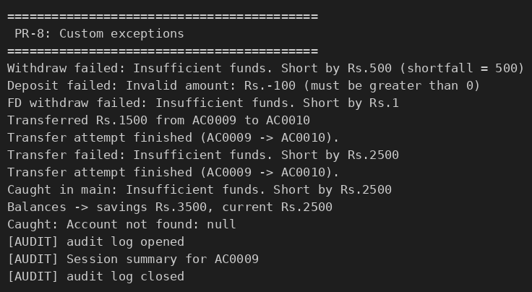

KEY QUESTIONS :

- What is the difference between a checked and an unchecked exception?
A checked exception (a subclass of Exception that is not a RuntimeException, e.g. BankException, IOException) is verified by the compiler: the code must either catch it or declare it with throws. An unchecked exception (subclass of RuntimeException or Error, e.g. NullPointerException, IllegalArgumentException) is not checked at compile time and usually shows a programming error. MiniBank’s exceptions are checked so the caller is forced to handle a failed withdrawal.
- What is the purpose of the finally block, and when does it run?
The finally block holds clean-up or logging code that must run whether or not an exception occurred. It runs after the try (and the matching catch) finishes – normally, after an exception, or even after a return. It does not run only if the JVM stops (for example System.exit()). In transfer() it prints “Transfer attempt finished” for both successful and failed transfers.
- How does try-with-resources guarantee a resource is closed?
A resource declared in try ( ... ) must implement AutoCloseable. The compiler generates code that calls close() automatically when the block ends – normally or because of an exception – in reverse order of creation. If close() also fails, that exception is added as a *suppressed* exception so the original error is still the one reported. AuditLogger prints “audit log closed” without any explicit close() call.

