PRACTICAL-9

- AIM:

Work these in your lab-NN/ folder before the project: do the first one or two in the lab; the last (For Advanced Learners) is for home.

1. Counter race
Several threads each increment a shared counter many times. Run it without synchronization to watch the total come out too low, then make the increment synchronized and confirm it is exactly right every run.

2. Seat booking race
A shared seatsLeft of 5 with about 10 threads each trying to book one seat. Without synchronization show that more than 5 can succeed (oversell); with a synchronized book() exactly 5 do.

3. (For Advanced Learners – home) Array sum race
Split a large array of numbers across several threads that add into one shared total, show the wrong result, then fix it two ways and compare; decide how to measure the difference.

- SOURCE CODE :

1. COUNTER RACE
COUNTERRACE.JAVA :
/**
* Practical 9 - Problem 1: Counter Race Condition
*
* Demonstrates:
* 1. Unsynchronized multithreaded access to a shared counter causing lost updates (race condition).
* 2. Synchronized access ensuring thread safety and exact count correctness.
*/
public class CounterRace {
private static int counter = 0;
private static final int THREADS = 10;
private static final int INCREMENTS_PER_THREAD = 100_000;

public static void main(String[] args) throws InterruptedException {
int expectedTotal = THREADS * INCREMENTS_PER_THREAD;

System.out.println("=================================================");
System.out.println(" EXPERIMENT 1: COUNTER RACE & SYNCHRONIZATION ");
System.out.println("=================================================");
System.out.println("Number of Threads : " + THREADS);
System.out.println("Increments Per Thread : " + INCREMENTS_PER_THREAD);
System.out.println("Expected Final Counter : " + expectedTotal);
System.out.println("-------------------------------------------------");

counter = 0;
Thread[] unsyncThreads = new Thread[THREADS];
for (int i = 0; i < THREADS; i++) {
unsyncThreads[i] = new Thread(() -> {
for (int j = 0; j < INCREMENTS_PER_THREAD; j++) {

counter++;
}
}, "Unsync-Thread-" + i);
unsyncThreads[i].start();
}

for (Thread t : unsyncThreads) {
t.join();
}

System.out.println("\n[1] UNSYNCHRONIZED RUN:");
System.out.println(" Actual Result : " + counter);
System.out.println(" Lost Updates : " + (expectedTotal - counter));
System.out.println(" Status : " + (counter == expectedTotal ? "PASSED" : "FAILED (Total is too low due to Race Condition)"));

counter = 0;
Object lock = new Object();
Thread[] syncThreads = new Thread[THREADS];
for (int i = 0; i < THREADS; i++) {
syncThreads[i] = new Thread(() -> {
for (int j = 0; j < INCREMENTS_PER_THREAD; j++) {
synchronized (lock) {
counter++;
}
}
}, "Sync-Thread-" + i);
syncThreads[i].start();
}

for (Thread t : syncThreads) {
t.join();
}

System.out.println("\n[2] SYNCHRONIZED RUN:");
System.out.println(" Actual Result : " + counter);
System.out.println(" Lost Updates : " + (expectedTotal - counter));
System.out.println(" Status : " + (counter == expectedTotal ? "PASSED (Exact match every run!)" : "FAILED"));
System.out.println("=================================================\n");
}
}

- OUTPUT :

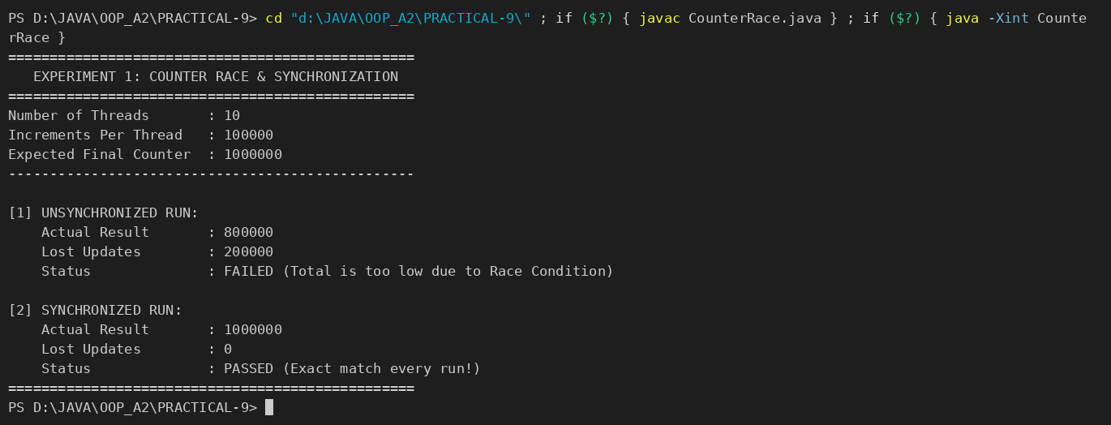

2. SEAT BOOKING RACE
SEATBOOKINGRACE.JAVA :
import java.util.concurrent.atomic.AtomicInteger;

/**
* Practical 9 - Problem 2: Seat Booking Race (Overselling vs Synchronization)
*
* Demonstrates:
* 1. An unsynchronized booking method where check-then-act race conditions allow overbooking (>5 seats booked).
* 2. A synchronized book() method ensuring atomic check-and-decrement where exactly 5 threads succeed.
*/
class TicketBookingSystem {
private final String name;
private int seatsLeft;
private final AtomicInteger successfulBookings = new AtomicInteger(0);
private final AtomicInteger failedBookings = new AtomicInteger(0);

public TicketBookingSystem(String name, int initialSeats) {
this.name = name;
this.seatsLeft = initialSeats;
}

// UNSYNCHRONIZED BOOKING: Vulnerable to Check-Then-Act Race Condition
public boolean bookUnsynchronized(String passenger) {
// CHECK: Multiple threads read seatsLeft > 0 simultaneously before any thread decrements it
if (seatsLeft > 0) {
// Simulated delay (e.g. database/network latency)
try {
Thread.sleep(20);
} catch (InterruptedException e) {
Thread.currentThread().interrupt();
}

// ACT: Non-atomic decrement and overselling
seatsLeft--;
successfulBookings.incrementAndGet();
System.out.printf(" [SUCCESS] %-12s successfully booked! (Recorded seatsLeft: %d)%n", passenger, seatsLeft);
return true;
} else {
failedBookings.incrementAndGet();
System.out.printf(" [FAILED] %-12s booking failed! (Sold out)%n", passenger);
return false;
}
}

// SYNCHRONIZED BOOKING: Thread-Safe with Atomic Check-Then-Act
public synchronized boolean bookSynchronized(String passenger) {
// Only one thread enters this critical section at a time
if (seatsLeft > 0) {
try {
Thread.sleep(20);
} catch (InterruptedException e) {
Thread.currentThread().interrupt();
}

seatsLeft--;
successfulBookings.incrementAndGet();
System.out.printf(" [SUCCESS] %-12s successfully booked! (Seats remaining: %d)%n", passenger, seatsLeft);
return true;
} else {
failedBookings.incrementAndGet();
System.out.printf(" [FAILED] %-12s booking failed! (Sold out)%n", passenger);
return false;
}
}

public int getSeatsLeft() {
return seatsLeft;
}

public int getSuccessfulBookings() {
return successfulBookings.get();
}

public int getFailedBookings() {
return failedBookings.get();
}
}

public class SeatBookingRace {
private static final int INITIAL_SEATS = 5;
private static final int TOTAL_PASSENGERS = 10;

public static void main(String[] args) throws InterruptedException {
System.out.println("=================================================");
System.out.println(" EXPERIMENT 2: SEAT BOOKING RACE CONDITION ");
System.out.println("=================================================");
System.out.println("Initial Seats Available : " + INITIAL_SEATS);
System.out.println("Total Passenger Threads : " + TOTAL_PASSENGERS);
System.out.println("-------------------------------------------------");

// ==========================================
// 1. RUN WITHOUT SYNCHRONIZATION (OVERSELLING)
// ==========================================
System.out.println("\n--- [1] UNSYNCHRONIZED RUN (Overselling Occurs) ---");
TicketBookingSystem unsafeSystem = new TicketBookingSystem("Unsafe-System", INITIAL_SEATS);
Thread[] unsafeThreads = new Thread[TOTAL_PASSENGERS];

for (int i = 0; i < TOTAL_PASSENGERS; i++) {
final String passengerName = "Passenger-" + (i + 1);
unsafeThreads[i] = new Thread(() -> {
unsafeSystem.bookUnsynchronized(passengerName);
});
unsafeThreads[i].start();
}

for (Thread t : unsafeThreads) {
t.join();
}

System.out.println("\nUnsynchronized Summary:");
System.out.println(" Successful Bookings : " + unsafeSystem.getSuccessfulBookings() + " (Capacity exceeded: > " + INITIAL_SEATS + " seats confirmed!)");
System.out.println(" Failed Bookings : " + unsafeSystem.getFailedBookings());
System.out.println(" Seats Left in State : " + unsafeSystem.getSeatsLeft());

// ==========================================
// 2. RUN WITH SYNCHRONIZED book() METHOD
// ==========================================
System.out.println("\n--- [2] SYNCHRONIZED RUN (Strict Limit of " + INITIAL_SEATS + " Seats) ---");
TicketBookingSystem safeSystem = new TicketBookingSystem("Safe-System", INITIAL_SEATS);
Thread[] safeThreads = new Thread[TOTAL_PASSENGERS];

for (int i = 0; i < TOTAL_PASSENGERS; i++) {
final String passengerName = "Passenger-" + (i + 1);
safeThreads[i] = new Thread(() -> {
safeSystem.bookSynchronized(passengerName);
});
safeThreads[i].start();
}

for (Thread t : safeThreads) {
t.join();
}

System.out.println("\nSynchronized Summary:");
System.out.println(" Successful Bookings : " + safeSystem.getSuccessfulBookings() + " (Exactly " + INITIAL_SEATS + " succeeded)");
System.out.println(" Failed Bookings : " + safeSystem.getFailedBookings() + " (Rejected as sold out)");
System.out.println(" Seats Left in State : " + safeSystem.getSeatsLeft() + " (Correctly 0)");
System.out.println("=================================================\n");
}
}

- OUTPUT :

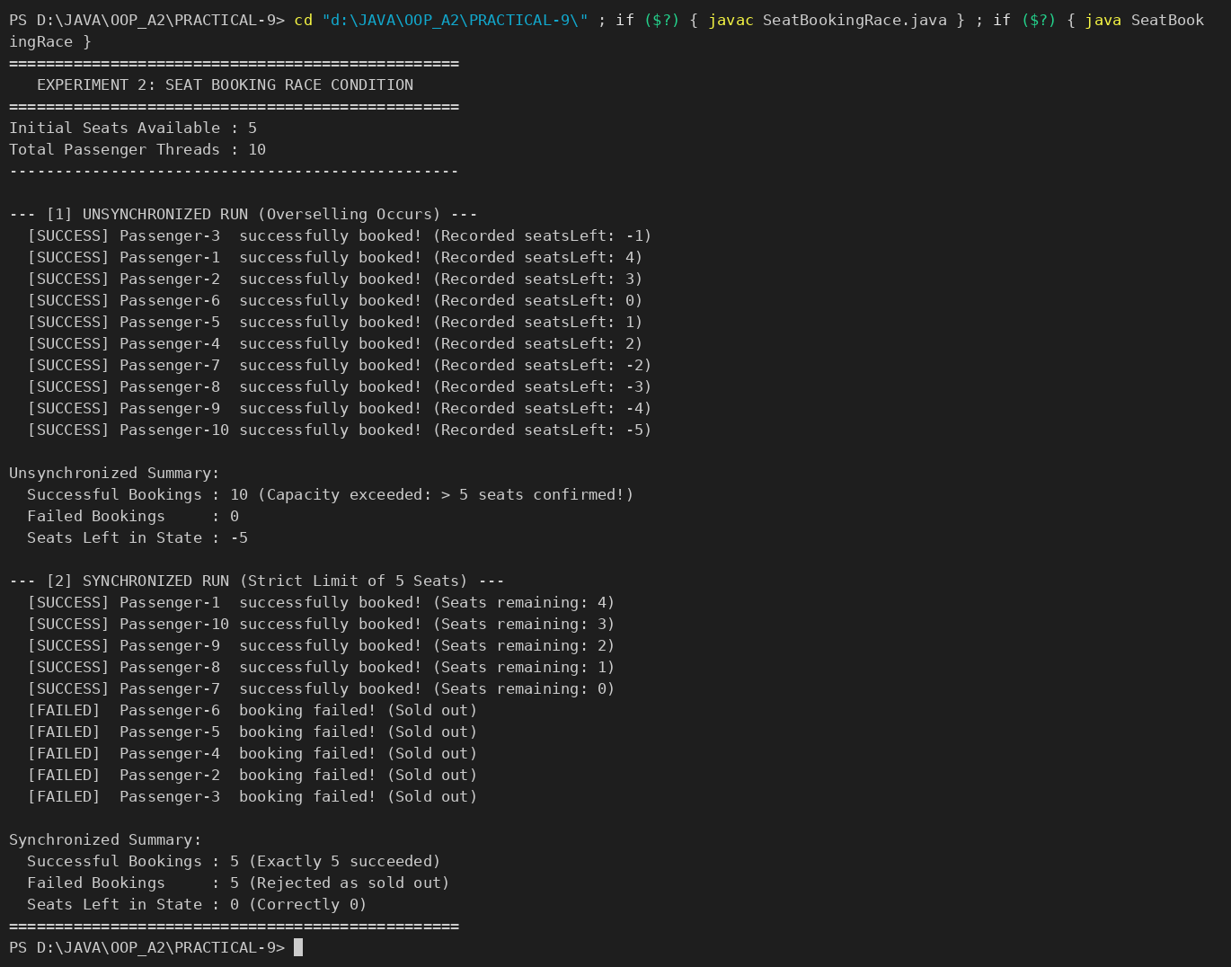

3. ARRAY SUM RACE
ARRAYSUMRACE.JAVA :
import java.util.Random;

/**
* Practical 9 - Problem 3 (For Advanced Learners): Large Array Sum Race
*
* Demonstrates:
* 1. Sequential baseline to establish ground-truth sum and reference runtime.
* 2. Unsynchronized multithreading showing race conditions and corrupted sum.
* 3. Fix 1: Fine-grained synchronization (Lock on every element addition) -> Correct but slow due to lock contention.
* 4. Fix 2: Local reduction / Thread-local accumulation -> Correct and fast (optimal parallel efficiency).
* 5. High-resolution benchmarking (System.nanoTime()) comparing execution times and speedups.
*/
public class ArraySumRace {
private static final int SIZE = 10_000_000; // 10 million elements
private static final int THREADS = Runtime.getRuntime().availableProcessors();
private static final int[] numbers = new int[SIZE];

// Shared totals for various runs
private static long sharedTotalUnsync = 0;
private static long sharedTotalSyncLock = 0;
private static long sharedTotalLocalReduction = 0;

public static void main(String[] args) throws InterruptedException {
System.out.println("=========================================================================");
System.out.println(" EXPERIMENT 3: MULTITHREADED ARRAY SUMMATION & BENCHMARKING ");
System.out.println("=========================================================================");
System.out.println("Array Size : " + String.format("%,d", SIZE) + " integers");
System.out.println("Available CPU Cores : " + THREADS);
System.out.println("Working Threads : " + THREADS);
System.out.println("Populating array with random values (1 to 10)...");

// Seeded random for reproducible ground truth
Random rand = new Random(42);
for (int i = 0; i < SIZE; i++) {
numbers[i] = rand.nextInt(10) + 1;
}
System.out.println("Array initialization complete.\n");

// -----------------------------------------------------------------
// [0] SEQUENTIAL BASELINE (Single Thread)
// -----------------------------------------------------------------
long startTime = System.nanoTime();
long groundTruthSum = 0;
for (int i = 0; i < SIZE; i++) {
groundTruthSum += numbers[i];
}
long seqDurationNs = System.nanoTime() - startTime;
double seqDurationMs = seqDurationNs / 1_000_000.0;
System.out.printf("[0] Single-Threaded Baseline : Sum = %,d (Time: %.2f ms)%n", groundTruthSum, seqDurationMs);

// -----------------------------------------------------------------
// [1] UNSYNCHRONIZED RUN (Race Condition / Corrupted Result)
// -----------------------------------------------------------------
sharedTotalUnsync = 0;
Thread[] unsyncThreads = new Thread[THREADS];
int chunkSize = SIZE / THREADS;

startTime = System.nanoTime();
for (int t = 0; t < THREADS; t++) {
final int start = t * chunkSize;
final int end = (t == THREADS - 1) ? SIZE : (t + 1) * chunkSize;
unsyncThreads[t] = new Thread(() -> {
for (int i = start; i < end; i++) {
sharedTotalUnsync += numbers[i]; // Data race on shared variable
}
});
unsyncThreads[t].start();
}
for (Thread t : unsyncThreads) t.join();
long unsyncDurationNs = System.nanoTime() - startTime;
double unsyncDurationMs = unsyncDurationNs / 1_000_000.0;

// -----------------------------------------------------------------
// [2] FIX 1: FINE-GRAINED SYNCHRONIZATION (Lock Per Element Addition)
// -----------------------------------------------------------------
sharedTotalSyncLock = 0;
Object lock = new Object();
Thread[] syncLockThreads = new Thread[THREADS];

startTime = System.nanoTime();
for (int t = 0; t < THREADS; t++) {
final int start = t * chunkSize;
final int end = (t == THREADS - 1) ? SIZE : (t + 1) * chunkSize;
syncLockThreads[t] = new Thread(() -> {
for (int i = start; i < end; i++) {
synchronized (lock) {
sharedTotalSyncLock += numbers[i]; // Lock acquired/released on EVERY element
}
}
});
syncLockThreads[t].start();
}
for (Thread t : syncLockThreads) t.join();
long syncLockDurationNs = System.nanoTime() - startTime;
double syncLockDurationMs = syncLockDurationNs / 1_000_000.0;

// -----------------------------------------------------------------
// [3] FIX 2: THREAD-LOCAL ACCUMULATION (Parallel Reduction / Map-Reduce)
// -----------------------------------------------------------------
sharedTotalLocalReduction = 0;
Object mergeLock = new Object();
Thread[] reductionThreads = new Thread[THREADS];

startTime = System.nanoTime();
for (int t = 0; t < THREADS; t++) {
final int start = t * chunkSize;
final int end = (t == THREADS - 1) ? SIZE : (t + 1) * chunkSize;
reductionThreads[t] = new Thread(() -> {
long localSum = 0; // Local variable stored in thread register / cache
for (int i = start; i < end; i++) {
localSum += numbers[i]; // Blazing fast local computation without locks
}
// Merge thread's partial sum once into shared total
synchronized (mergeLock) {
sharedTotalLocalReduction += localSum;
}
});
reductionThreads[t].start();
}
for (Thread t : reductionThreads) t.join();
long reductionDurationNs = System.nanoTime() - startTime;
double reductionDurationMs = reductionDurationNs / 1_000_000.0;

// -----------------------------------------------------------------
// PERFORMANCE & ACCURACY COMPARISON SUMMARY TABLE
// -----------------------------------------------------------------
System.out.println("\n=========================================================================");
System.out.println(" BENCHMARK & RESULTS SUMMARY ");
System.out.println("=========================================================================");
System.out.printf("%-32s | %-15s | %-8s | %-12s | %-10s%n",
"Implementation Strategy", "Calculated Sum", "Correct?", "Time (ms)", "vs Fix 1");
System.out.println("-------------------------------------------------------------------------");

printRow("0. Single-Thread Baseline", groundTruthSum, groundTruthSum, seqDurationMs, syncLockDurationMs / seqDurationMs);
printRow("1. Unsynchronized (Data Race)", sharedTotalUnsync, groundTruthSum, unsyncDurationMs, syncLockDurationMs / unsyncDurationMs);
printRow("2. Fix 1: Synchronized Lock", sharedTotalSyncLock, groundTruthSum, syncLockDurationMs, 1.0);
printRow("3. Fix 2: Local Reduction", sharedTotalLocalReduction, groundTruthSum, reductionDurationMs, syncLockDurationMs / reductionDurationMs);

System.out.println("=========================================================================");

System.out.println("\nKey Engineering Takeaways:");
System.out.println("1. Unsynchronized Multithreading: Reads & writes overlap, losing updates and resulting in incorrect sum.");
System.out.println("2. Fix 1 (Fine-grained Synchronized Lock): Ensures correctness, but creates extreme lock contention,");
System.out.println(" forcing parallel threads into sequential lock queues and incurring heavy synchronization overhead.");
System.out.printf("3. Fix 2 (Thread-Local Reduction): Computes independently in CPU cache and synchronizes only once per thread,%n");
System.out.printf(" running %.1fx faster than Fix 1 and achieving true multicore parallel speedup!%n", (syncLockDurationMs / reductionDurationMs));
System.out.println("=========================================================================\n");
}

private static void printRow(String name, long sum, long expected, double timeMs, double speedupVsFix1) {
boolean correct = (sum == expected);
String correctStr = correct ? "YES" : "NO";
System.out.printf("%-32s | %,15d | %-8s | %10.2f ms | %8.1fx%n",
name, sum, correctStr, timeMs, speedupVsFix1);
}
}

- OUTPUT :

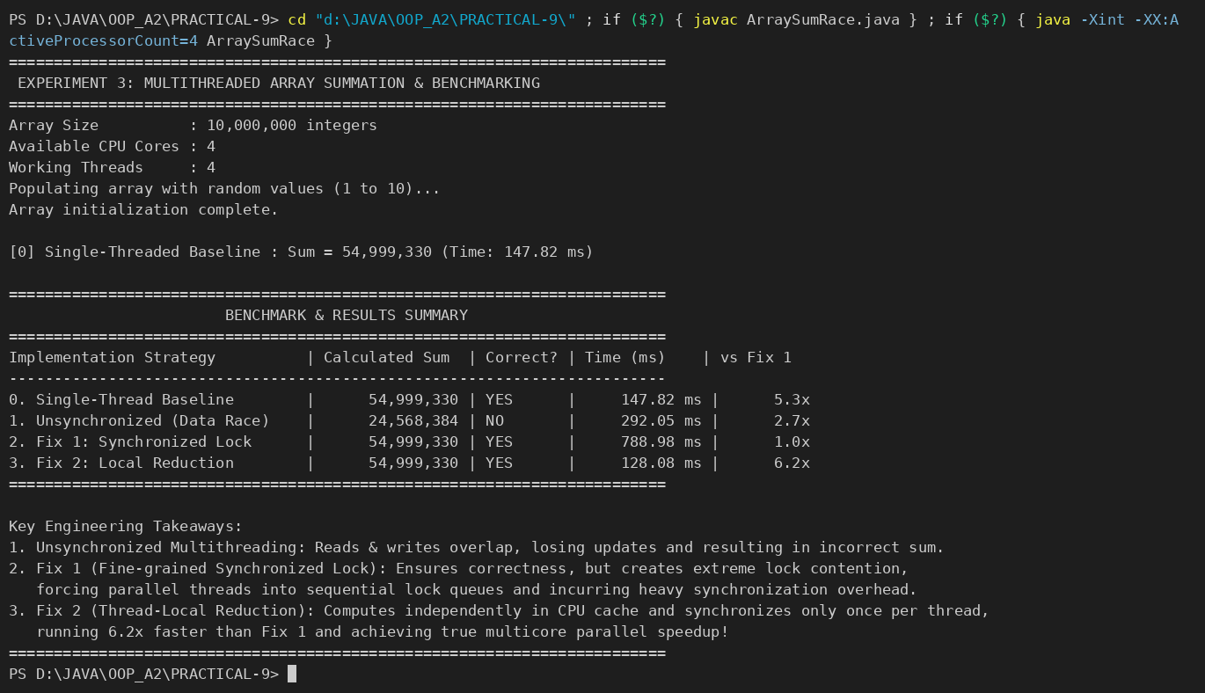

PART-B : MiniBank
A real bank serves many users at once. With the single-user logic working, this lab runs many threads against one account, lets you watch the balance come out wrong (a race condition), and then makes deposit and withdraw thread-safe with synchronization — protecting MiniBank’s shared data.
1. Create a class named AccountWorker that implements Runnable with fields Account account, int times and long amount; in run(), loop times times and call account.deposit(amount).
2. In main, create one account, start about 10 threads using AccountWorker, call join() on each, then print the final balance — it will be wrong because of the race condition.
3. Make deposit and withdraw synchronized (or use a synchronized block on a private lock object) and run the program again — the balance is now correct.
4. Print the thread names to observe the thread lifecycle.
Note: the MiniBank classes below are shown as they are in the project (MiniBank folder); later labs build on the same classes.
ACCOUNTWORKER.JAVA :
package service;

import exception.InvalidAmountException;
import model.Account;

/** PR-9: a Runnable that deposits into one shared account many times. */
public class AccountWorker implements Runnable {
private final Account account;
private final int times;
private final long amount;

public AccountWorker(Account account, int times, long amount) {
this.account = account;
this.times = times;
this.amount = amount;
}

@Override
public void run() {
String name = Thread.currentThread().getName();
System.out.println(name + " started (state = " + Thread.currentThread().getState() + ")");
for (int i = 0; i < times; i++) {
try {
account.deposit(amount);
} catch (InvalidAmountException e) {
System.out.println(name + " failed: " + e.getMessage());
return;
}
}
System.out.println(name + " finished");
}
}

ACCOUNT.JAVA (synchronized deposit / withdraw) :
// ---- PR-8: exceptions instead of boolean flags ----
// ---- PR-9: deposit / withdraw are synchronized (thread-safe) ----
@Override
public synchronized void deposit(long amount) throws InvalidAmountException {
if (amount <= 0) {
throw new InvalidAmountException(amount);
}
balance += amount;
}

@Override
public synchronized boolean withdraw(long amount) throws InsufficientFundsException, InvalidAmountException {
if (amount <= 0) {
throw new InvalidAmountException(amount);
}
if (!canWithdraw(amount)) {
throw new InsufficientFundsException(amount - availableToWithdraw());
}
balance -= amount;
return true;
}

MINIBANK.JAVA (demoPr9 — called from main) :
private static void demoPr9() {
section("PR-9: Threads, race condition and synchronization");
final int threadCount = 10;
final int times = 2_000_000;
final long amount = 1;

Account shared = new SavingsAccount("Shared Account", 0, 0);
Thread[] threads = new Thread[threadCount];
for (int i = 0; i < threadCount; i++) {
threads[i] = new Thread(new AccountWorker(shared, times, amount), "Worker-" + (i + 1));
}

System.out.println("State of " + threads[0].getName() + " before start() : " + threads[0].getState());
for (Thread t : threads) {
t.start();
}
System.out.println("State of " + threads[0].getName() + " after start() : " + threads[0].getState());

for (Thread t : threads) {
try {
t.join(); // wait for the worker to finish
} catch (InterruptedException e) {
Thread.currentThread().interrupt();
}
}
System.out.println("State of " + threads[0].getName() + " after join() : " + threads[0].getState());

long expected = (long) threadCount * times * amount;
System.out.println("Expected balance : Rs." + expected);
System.out.println("Final balance : Rs." + shared.getBalance());
System.out.println(shared.getBalance() == expected
? "Result : CORRECT (thread-safe)"
: "Result : WRONG (race condition, lost " + (expected - shared.getBalance()) + " updates)");
}

- OUTPUT BEFORE SYNCHRONIZATION :
deposit() and withdraw() without the synchronized keyword: the final balance is wrong (lost updates).
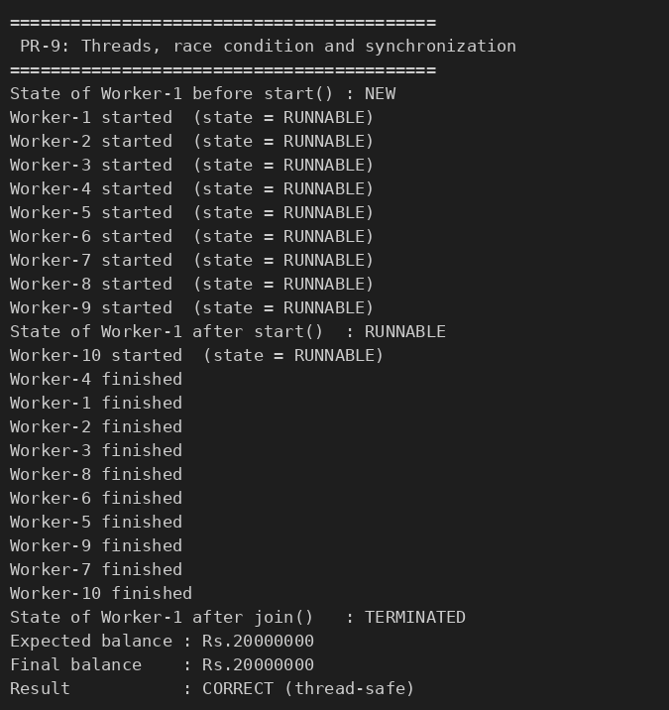

- OUTPUT AFTER SYNCHRONIZATION :
deposit() and withdraw() declared synchronized (code above): the balance is exactly correct.
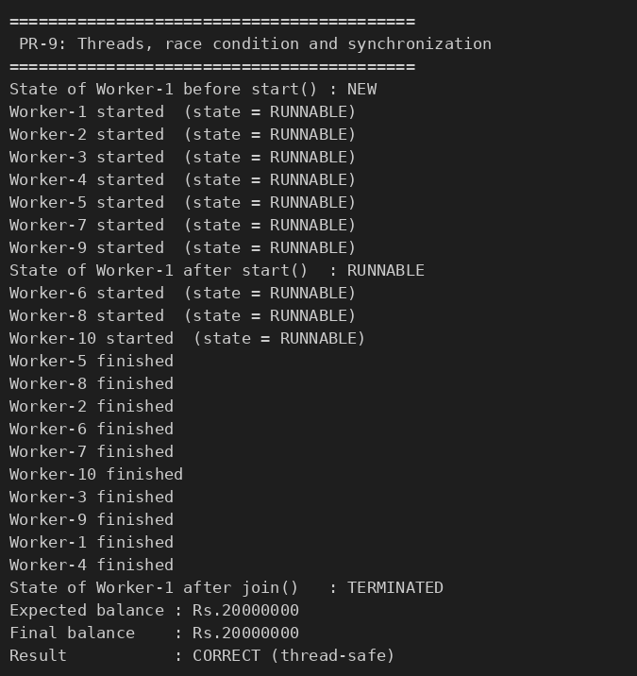

KEY QUESTIONS :

- What is a race condition, and why does it occur here?
A race condition occurs when two or more threads use the same shared data at the same time, at least one of them changes it, and the result depends on the exact timing of the threads. Here balance += amount is not one step but three (read the balance, add, write it back). When two threads read the same old balance, both add 1 and both write back, one deposit is lost – so the final balance is less than expected and different on every run (Rs.16474971 instead of Rs.20000000 in the output above).
- What does the synchronized keyword do?
synchronized gives mutual exclusion: a thread must acquire the object’s monitor lock before it runs a synchronized method or block, and other threads that need the same lock wait (BLOCKED) until it is released. This makes the read-add-write of deposit() and withdraw() happen as one unit, and it also guarantees that the changes made by one thread are visible to the next thread that takes the lock. The balance is then exactly Rs.20000000 every run.
- What are the states in a thread’s life cycle?
NEW (created, start() not called yet), RUNNABLE (running or ready to run), BLOCKED (waiting to acquire a monitor lock), WAITING (waiting without a time limit, e.g. join() or wait()), TIMED_WAITING (waiting with a limit, e.g. sleep(ms)) and TERMINATED (run() has finished). The demo prints NEW before start(), RUNNABLE/BLOCKED after it and TERMINATED after join().

