PRACTICAL-1

AIM : Initiate the semester-long StudentHub portal by identifying the problem scope, user roles, key modules, navigation flow, and minimum 10 pages. Create a sitemap, low-fidelity wireframe, project folder structure, README file, and GitHub repository.

SOLUTION:

GITHUB REPO : https://github.com/Aarav280907/WEB

Requirement Analysis :

- Project Name : Student Hub Portal

- Objective : To develop a web portal that allows students to access academic information, study materials, notices, assignments, and announcements from a single platform.

- Target Users : Students , Teachers

- Functions Requirements :

Functional Requirements :
- Login / Sign up
- Username & Password
- Dashboard
- My Attendance
- Time table
- Fees Detail
- Student Profile
- Announcement & Notices
- Meterial
- Submit Assignments
- Exam Timetable and Results
- Contact Faculty And Admin
Non-Functional Requirements:
• Responsive design for mobile and desktop
• Secure login with authentication
• Fast page loading
• Easy-to-use interface
• Reliable system with minimal downtime
• Data privacy and security

Software Requirements:
• HTML
• CSS
• JavaScript
• PHP/Node.js (or any backend technology)
• MySQL Database
• VS Code
• Google Chrome

SITEMAP:

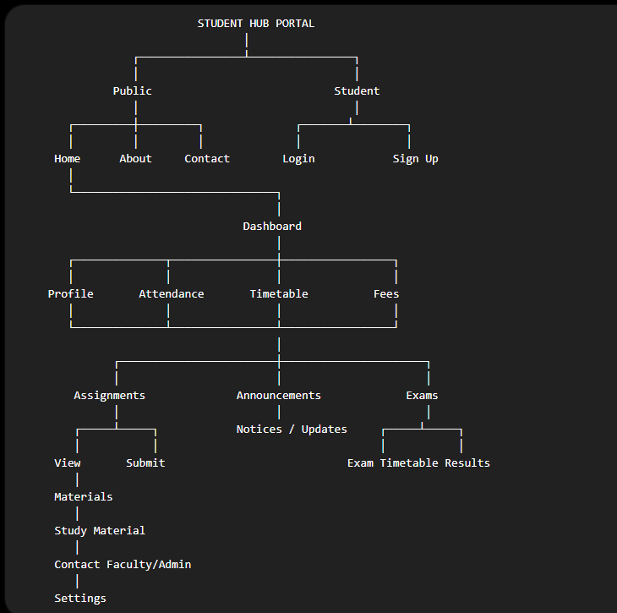

WIREFRAME :

LOGIN :
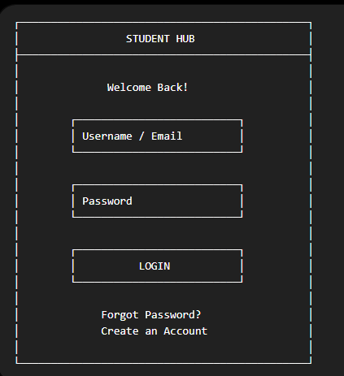
DASHBOARD:
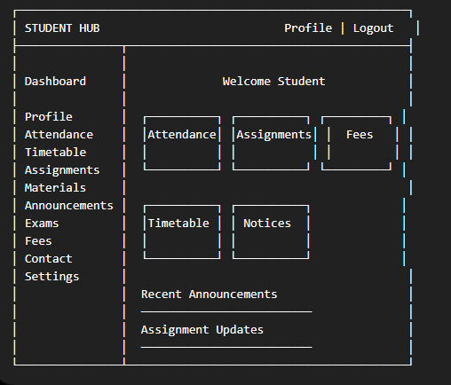

STUDENT PROFILE :
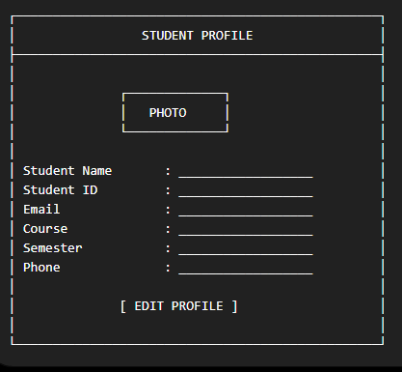
ASSIGNMENT :
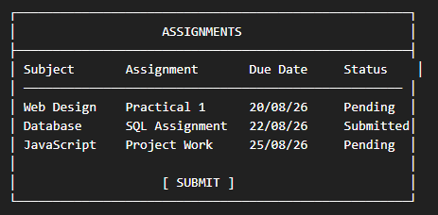
ATTENDENCE :
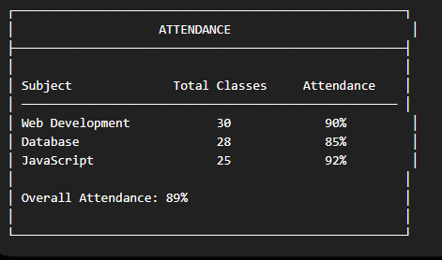
TIMETABLE :
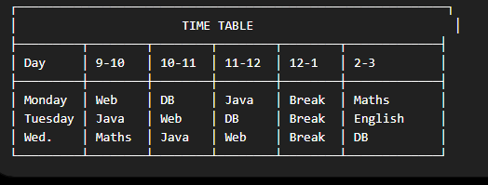

KEY QUESTIONS :

1. What is URL and parts of URL?

- A URL (Uniform Resource Locator) is the address of a resource on the internet. It tells a web browser where to find a webpage or file and how to access it. The main parts of a URL are:
- Protocol (Scheme)
- Domain Name (Host)
- Path
- Parameters
- Anchor

2. How does HTML file processed in web browser?

- When you open an HTML file in a browser, it is processed roughly as follows:
- Request / Loading
- Parsing HTML
- Processing CSS and JavaScript
- Rendering the Page

3. How will page navigation flow managed among all HTML pages?

- Page navigation is managed using hyperlinks (<a> tags) in HTML. Each link contains the URL or filename of another HTML page.

Home → Login → Dashboard → Profile / Attendance / Timetable / Assignments / Fees / Exams → Logout

4.How will GitHub commits be maintained after each practical?

- GitHub commits are maintained after completing each practical by saving the changes in the Git repository with a meaningful commit message. The basic process is:
- Make changes to the project
- Test the changes
- Add the changed files
- Create a commit with a meaningful message
- Push the commit to GitHub

