PRACTICAL-2

AIM : Develop static HTML5 skeletons for at least 10 StudentHub pages such as Home, About, Register, Login, Dashboard, Events, Profile, Contact, Admin, FAQ, and Feedback. Use semantic tags and accessibility-friendly structure.

INDEX.HTML :

<!DOCTYPE html>
<html lang="en">
<head>
<meta charset="UTF-8">
<meta name="viewport" content="width=device-width, initial-scale=1.0">
<title>StudentHub</title>

</head>
<body>
<header class="pagelist">
<img src="./studenthub.png" class="studenthub" alt="StudentHub Logo">
<h1>Welcome to StudentHub</h1>
<nav>
<a href="./login.html">Login</a>
<a href="./signup.html">Sign Up</a>
</nav>
</header>

<main>
<p>Your one-stop portal for attendance, timetables, fees, announcements, assignments, and more.</p>
</main>

<footer>
<p>&copy; 2026 Student Hub Portal</p>
</footer>
</body>
</html>

PREVIEW:

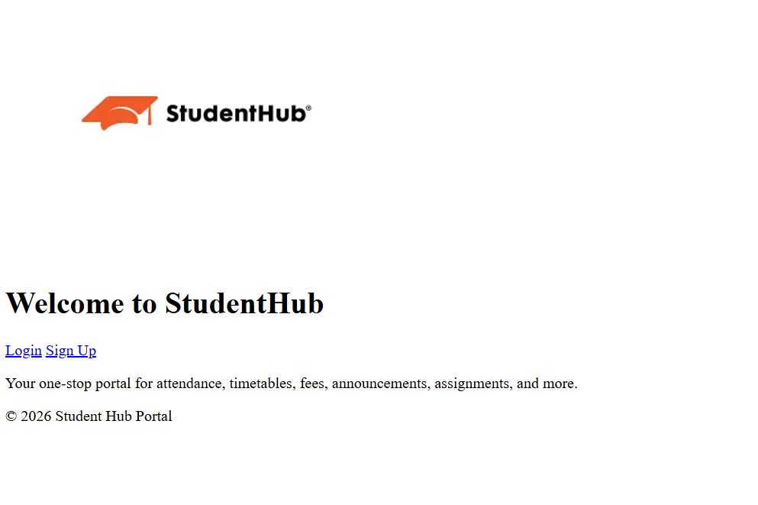

LOGIN.HTML :
<!DOCTYPE html>
<html lang="en">
<head>
<meta charset="UTF-8">
<meta name="viewport" content="width=device-width, initial-scale=1.0">
<title>Login - Student Hub Portal</title>
</head>
<body>
<header>
<h1>Student Hub Portal</h1>
</header>

<main>
<div class="auth-container">
<h2>Login</h2>
<form action="./home.html" method="post">

<label for="username">Username:</label>
<input type="text" id="username" name="username" required><br><br>

<label for="password">Password:</label>
<input type="password" id="password" name="password" required><br><br>

<label>
<input type="checkbox" name="remember"> Remember Me
</label><br><br>

<input type="submit" value="Login">
</form>
<div class="auth-links">
<p><a href="./signup.html">Don't have an account? Sign up here</a></p>
<p><a href="./forgot-password.html">Forgot Password?</a></p>
</div>
</div>
</main>

<footer>
<p>&copy; 2026 Student Hub Portal</p>
</footer>
</body>
</html>

PREVIEW :
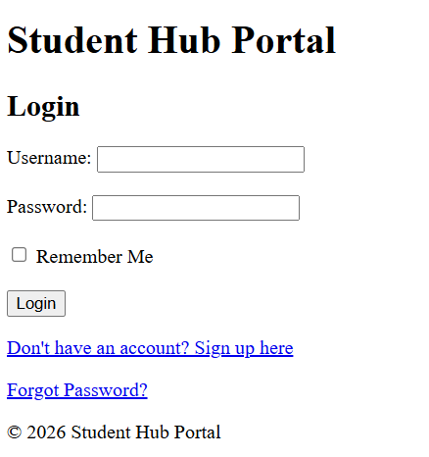

SIGN-UP.HTML :
<!DOCTYPE html>
<html lang="en">
<head>
<meta charset="UTF-8">
<meta name="viewport" content="width=device-width, initial-scale=1.0">
<title>Sign Up - Student Hub Portal</title>
<!-- <link rel="stylesheet" type="text/css" href="class.css"> -->
</head>
<body>
<header>
<h1>Student Hub Portal</h1>
</header>

<main>
<div class="auth-container">
<h2>Create Your Account</h2>
<form action="./home.html" method="post">
<fieldset>
<legend>Sign Up</legend>

<label for="username">Username:</label>
<input type="text" id="username" name="username" required><br><br>

<label for="email">Email:</label>
<input type="email" id="email" name="email" required><br><br>

<label for="password">Password:</label>
<input type="password" id="password" name="password" required autocomplete="new-password"><br><br>

<label for="confirm-password">Confirm Password:</label>
<input type="password" id="confirm-password" name="confirm-password" required><br><br>

<input type="submit" value="Sign Up">
</fieldset>
</form>
<div class="auth-links">
<p><a href="./login.html">Already have an account? Login here</a></p>
</div>
</div>
</main>

<footer>
<p>&copy; 2026 Student Hub Portal</p>
</footer>
</body>
</html>

PREVIEW :

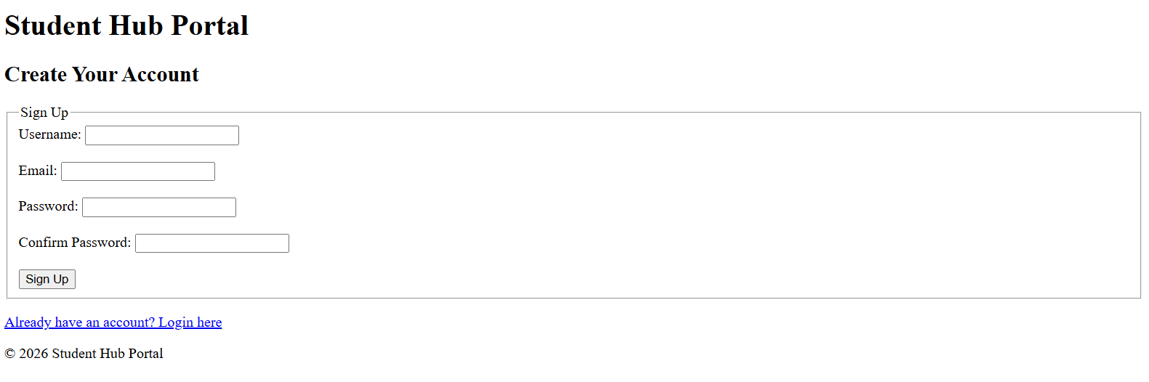

HOME :
<!DOCTYPE html>
<html lang="en">
<head>
<meta charset="UTF-8">
<meta name="viewport" content="width=device-width, initial-scale=1.0">
<title>Home - Student Hub Portal</title>
</head>
<body>
<header>
<h1>Student Hub Portal</h1>
<nav>

<a href="./profile.html">Profile</a>
<a href="./dashboard.html">Dashboard</a>
<a href="./contact.html">Contact Us</a>
<a href="./aboutus.html">About Us</a>
<a href="./settings.html">Settings</a>
<a href="./index.html">Logout</a>

</nav>
</header>

<main>
<h2>Welcome</h2>
<p>Select an option from the navigation menu to access your academic information.</p>
</main>

<footer>
<p>&copy; 2026 Student Hub Portal</p>
</footer>
</body>
</html>

PREVIEW:
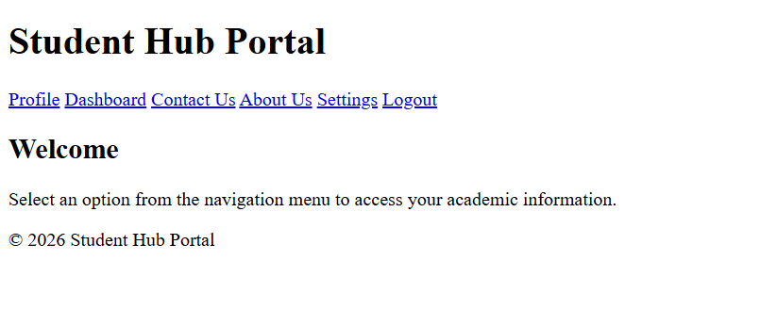
PROFILE.HTML :
<!DOCTYPE html>
<html lang="en">
<head>
<meta charset="UTF-8">
<meta name="viewport" content="width=device-width, initial-scale=1.0">
<title>Profile - Student Hub Portal</title>
</head>
<body>
<header>
<h1>Student Hub Portal</h1>
<nav>
<a href="./home.html">Home</a>
<a href="./dashboard.html">Dashboard</a>
<a href="./contact.html">Contact Us</a>
<a href="./settings.html">Settings</a>
<a href="./index.html">Logout</a>
</nav>
</header>

<main>
<h2>My Profile</h2>
<section class="profile-info">
<img src="./default-profile.png" alt="Profile Picture" class="profile-pic">
<p><strong>Name:</strong> AARAV HITESHKUMAR PATEL</p>
<p><strong>Roll Number:</strong> 25DCE072</p>
<p><strong>Course:</strong> B.Tech Computer Engineering</p>
<p><strong>Semester:</strong> 3</p>
<p><strong>Email:</strong> 25dce072@charusat.edu.in</p>
<p><strong>Phone:</strong> +91 84xxxxxx09</p>
</section>

<section class="academic-summary">
<h3>Academic Summary</h3>
<p><strong>Attendance:</strong> 85%</p>
<p><strong>Fees Status:</strong> Paid</p>
<p><strong>Latest Exam Result:</strong> SGPA 8.2</p>
</section>

<button onclick="window.location.href='./edit-profile.html'">Edit Profile</button>
</main>

<footer>
<p>&copy; 2026 Student Hub Portal</p>
</footer>
</body>
</html>

PREVIEW :

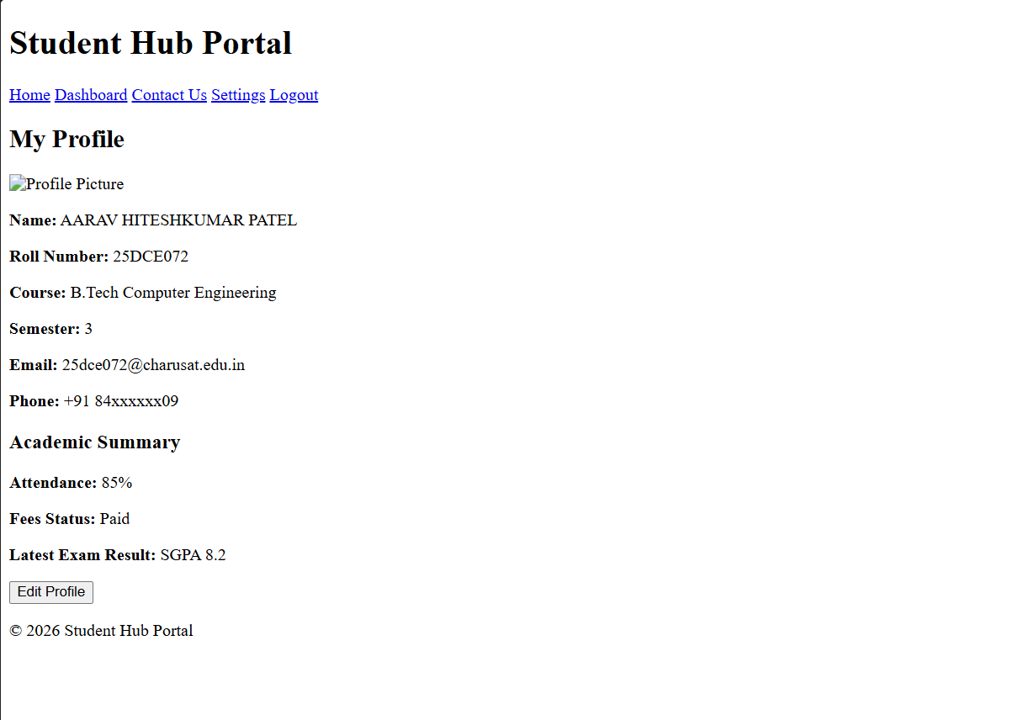

DASHBOARD.HTML :

<!DOCTYPE html>
<html lang="en">
<head>
<meta charset="UTF-8">
<meta name="viewport" content="width=device-width, initial-scale=1.0">
<title>Dashboard - Student Hub Portal</title>
</head>
<body>
<header>
<h1>Student Hub Portal</h1>
<nav>
<a href="./home.html">Home</a>
<a href="./profile.html">Profile</a>
<a href="./contact.html">Contact Us</a>
<a href="./settings.html">Settings</a>
<a href="./index.html">Logout</a>
</nav>
</header>

<main>
<h2>Welcome, [Student Name]</h2>
<section class="dashboard-cards">
<div class="card"><a href="./attendance.html">Attendance</a></div>
<div class="card"><a href="./timetable.html">Timetable</a></div>
<div class="card"><a href="./fees.html">Fees</a></div>
<div class="card"><a href="./announcement.html">Announcements</a></div>
<div class="card"><a href="./assignment.html">Assignments</a></div>
<div class="card"><a href="./exam.html">Exams</a></div>
</section>

<section class="notifications">
<h3>Latest Announcements</h3>
<ul>
<li>Exam schedule released for Semester 4</li>
<li>Assignment submission deadline: July 25</li>
</ul>
</section>
</main>

<footer>
<p>&copy; 2026 Student Hub Portal</p>
</footer>
</body>
</html>

PREVIEW :
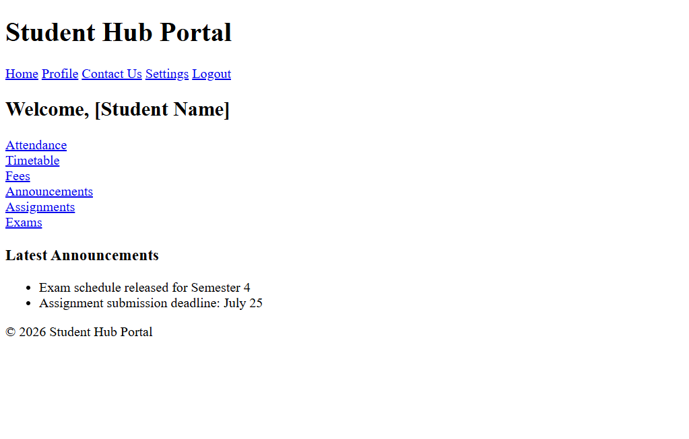

ATTENDANCE.HTML :
<!DOCTYPE html>
<html lang="en">
<head>
<meta charset="UTF-8">
<meta name="viewport" content="width=device-width, initial-scale=1.0">
<title>Attendance - Student Hub Portal</title>
</head>
<body>
<header>
<h1>Student Hub Portal</h1>
<nav>
<a href="./home.html">Home</a>
<a href="./dashboard.html">Dashboard</a>
<a href="./profile.html">Profile</a>
<a href="./contact.html">Contact Us</a>
<a href="./settings.html">Settings</a>
<a href="./index.html">Logout</a>
</nav>
</header>

<main>
<h2>Attendance Record</h2>
<section class="attendance-summary">
<p><strong>Overall Attendance:</strong> 85%</p>
<div class="progress-bar">
<div class="progress" style="width:85%"></div>
</div>
</section>

<section class="attendance-details">
<h3>Subject-wise Attendance</h3>
<table>
<thead>
<tr>
<th>Subject</th>
<th>Total Classes</th>
<th>Attended</th>
<th>Percentage</th>
</tr>
</thead>
<tbody>
<tr>
<td>Web Development</td>
<td>40</td>
<td>34</td>
<td>85%</td>
</tr>
<tr>
<td>Data Structures</td>
<td>35</td>
<td>30</td>
<td>86%</td>
</tr>
<tr>
<td>Database Management</td>
<td>28</td>
<td>24</td>
<td>85%</td>
</tr>
<tr>
<td>Operating Systems</td>
<td>32</td>
<td>26</td>
<td>81%</td>
</tr>
<tr>
<td>Computer Networks</td>
<td>30</td>
<td>27</td>
<td>90%</td>
</tr>
</tbody>
</table>
</section>
</main>

<footer>
<p>&copy; 2026 Student Hub Portal. All rights reserved.</p>
</footer>
</body>
</html>

PREVIEW :
